Name: Abdul Hadi
Reg No: 2026(S)-CYS-90
Section: B

University Of Engineering and Technology, Lahore
Computer Engineering Department

Course Name: | Course Code: CMPE-112L
Assignment Type: | Dated: 16 FEB 2026
Semester: | Session:
Lab/Project/Assignment #: 1 | CLOs to be covered: CLO1
Lab Title: | Teacher Name: Hafiz Muhammad Mubashar
Lab Evaluation:

CLO1 | Apply appropriate programming techniques to create executable programs to solve well defined problems
 | Level1 | Level2 | Level3 | Level4 | Level5 | Level6
(5)
Total |  |  |  |  |  | /5
Rubrics for Current Lab Evaluation
Scale | Marks | Level | Rubric
Excellent | 5 | L1 | Submitted all lab tasks, BONUS task, have good understanding.
Very Good | 4 | L2 | Submitted the lab tasks but have good understanding
Good | 3 | L3 | Submitted the lab tasks but have weak understanding.
Basic | 2 | L4 | Submitted the lab tasks but have no understanding.
Barely Acceptable | 1 | L5 | Submitted only one lab task.
Not Acceptable | 0 | L6 | Did not attempt
LAB No 1
Lab Goals/Objectives:
• To understand the basics of Python programming.
• To learn how to take input from the user and display output.
• To identify and use different data types in Python.
• To perform arithmetic, relational, logical, and assignment operations.
• To implement decision-making using if, elif, and else statements

Equipment Required:
• Computer/Laptop
• Python 3.x
• VS Code / PyCharm / IDLE

Theory:
Python is a popular programming language that is simple to understand and commonly used for creating software, websites, and automation tasks. It provides the input() function to receive data from the user and the print() function to display results on the screen. Python includes different data types, such as integers, floating-point numbers, strings, and boolean values, which help store different kinds of information.
Python also offers various operators for performing calculations, comparing values, assigning data, and working with logical conditions. Decision-making in Python is done using if, elif, and else statements, which allow the program to execute different actions depending on whether a given condition is true or false.

Lab Work:

Task 1:
Write a python code that prints the word on the screen

Result:
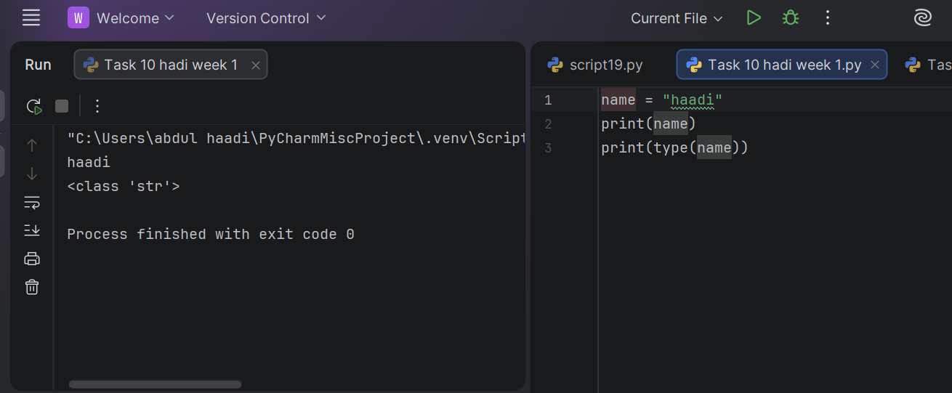

Task 2:
Use print( ) statement to display a star pattern in the shape shown below
Result:

Task 3:
Write a Python program to convert a temperature from celsius to Fahrenheit

Result:
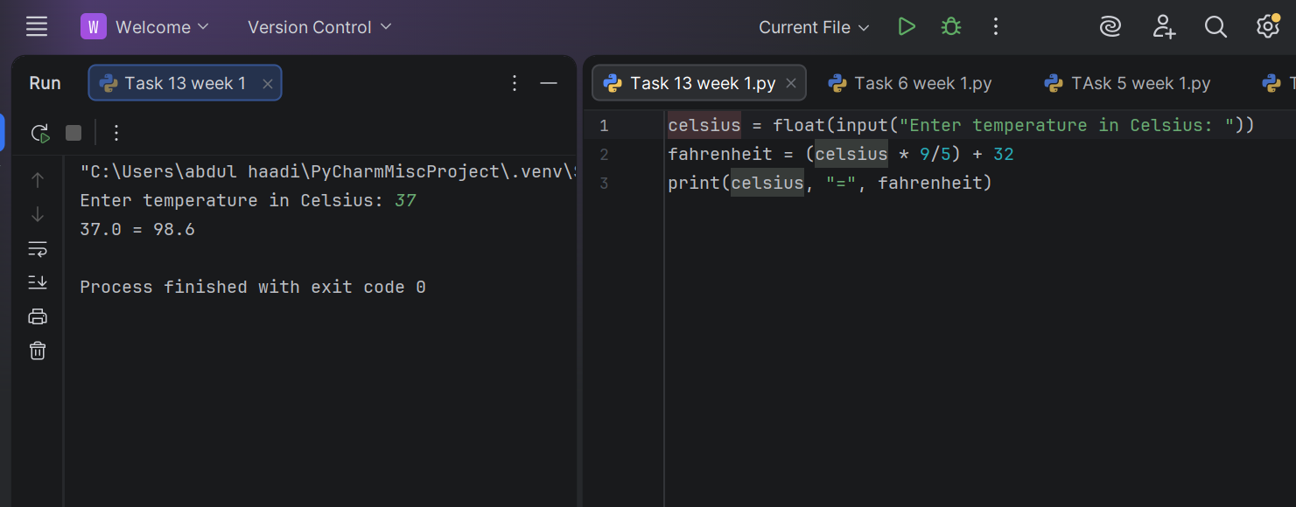

Task 4:

Write a python program that takes input from the user and prints the output

Result:

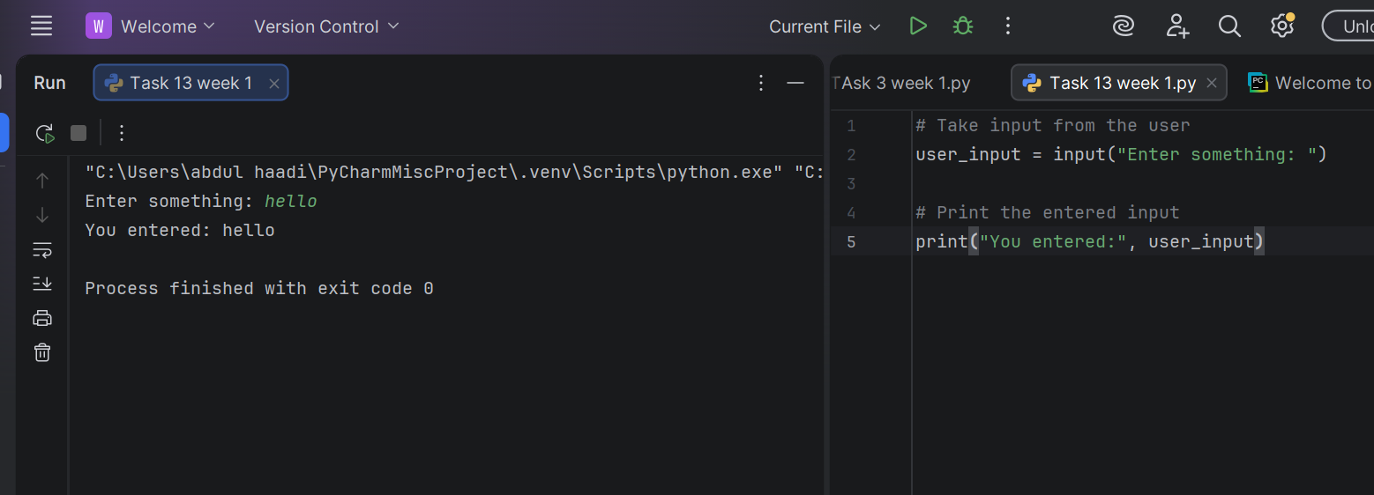

Task 5:

Write a python program that takes input and convert number of
bytes into mega bytes and gigabytes

Result:
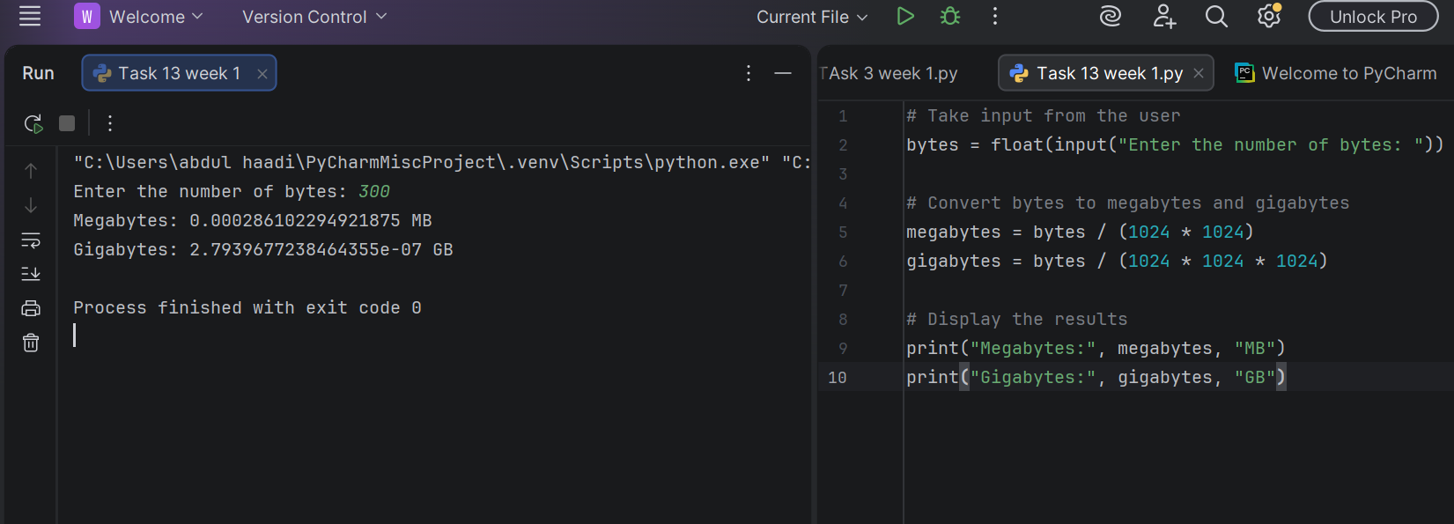

Task 6:

Write a Python program to calculate a student's aggregate percentage using ECAT 33%, Intermediate 50%, and Matric 17% weights and display it rounded to 2 decimal places.

Result:
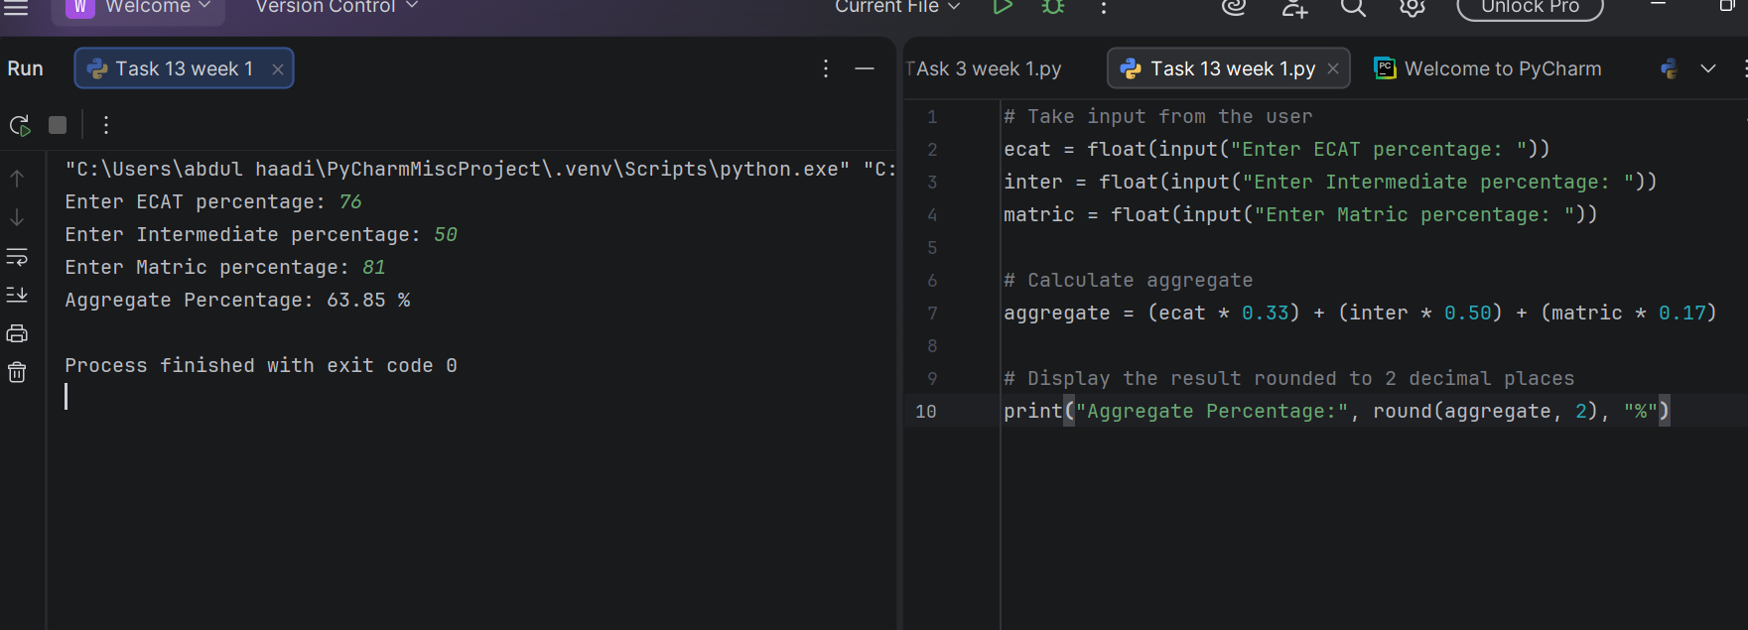

Task 7:

Write a Python program that prints the type of the variable

Result:
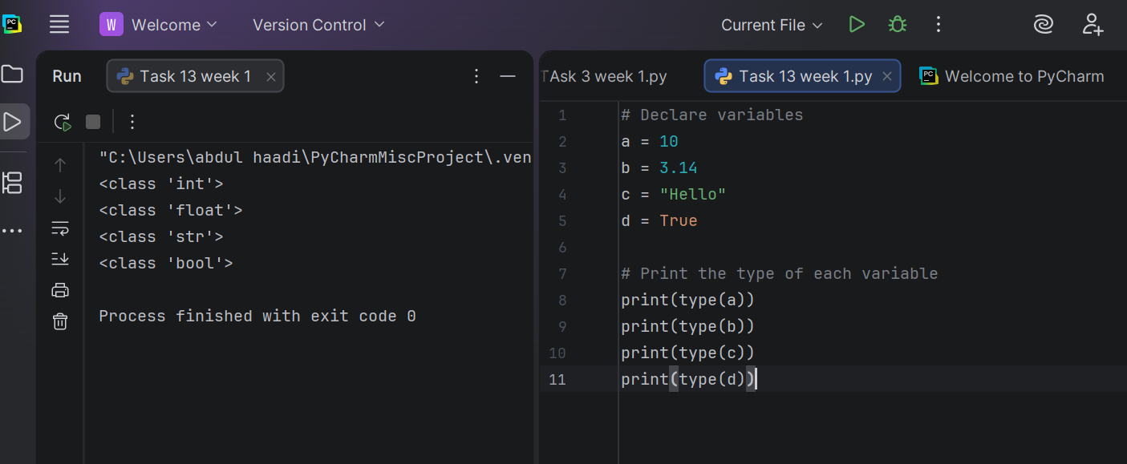

Task 8
Identify the data type of the variable age in the program.

Result

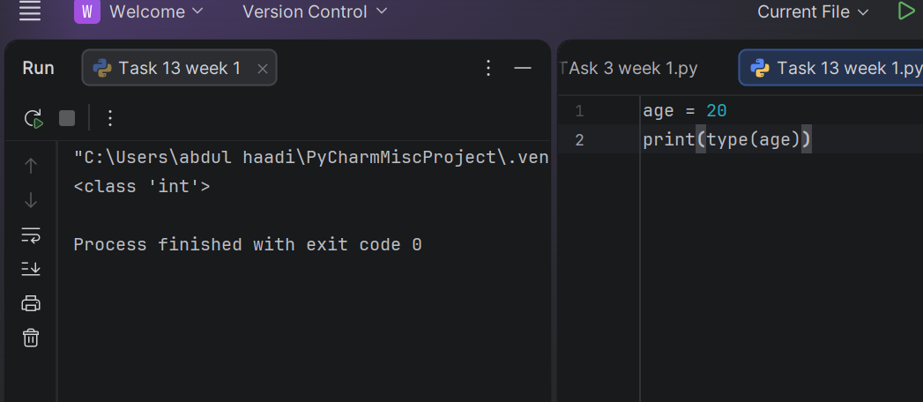

Task 9
Identify the data type in the program.

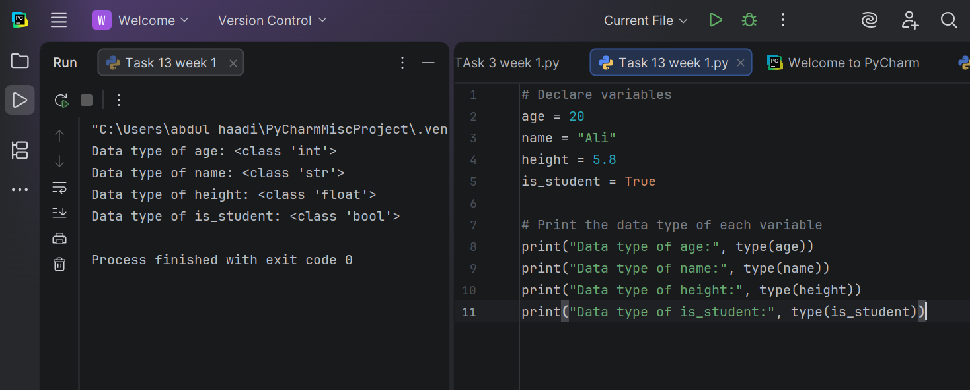

Task 11
Explain the use of int() and float() type casting functions with example in code.

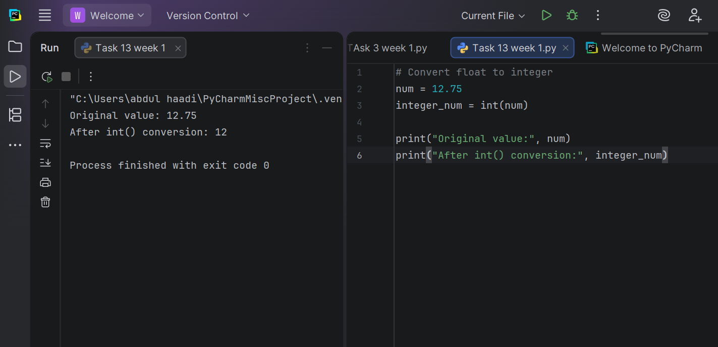

Task 12
What will be the output if int() was removed and we wrote a=1 and b=2 ?
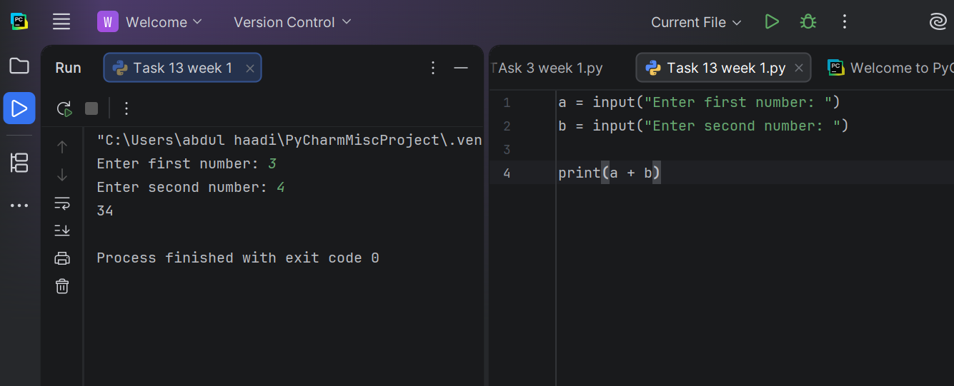

Task 13

Write a python program that takes input from user for obtained marks and total marks.

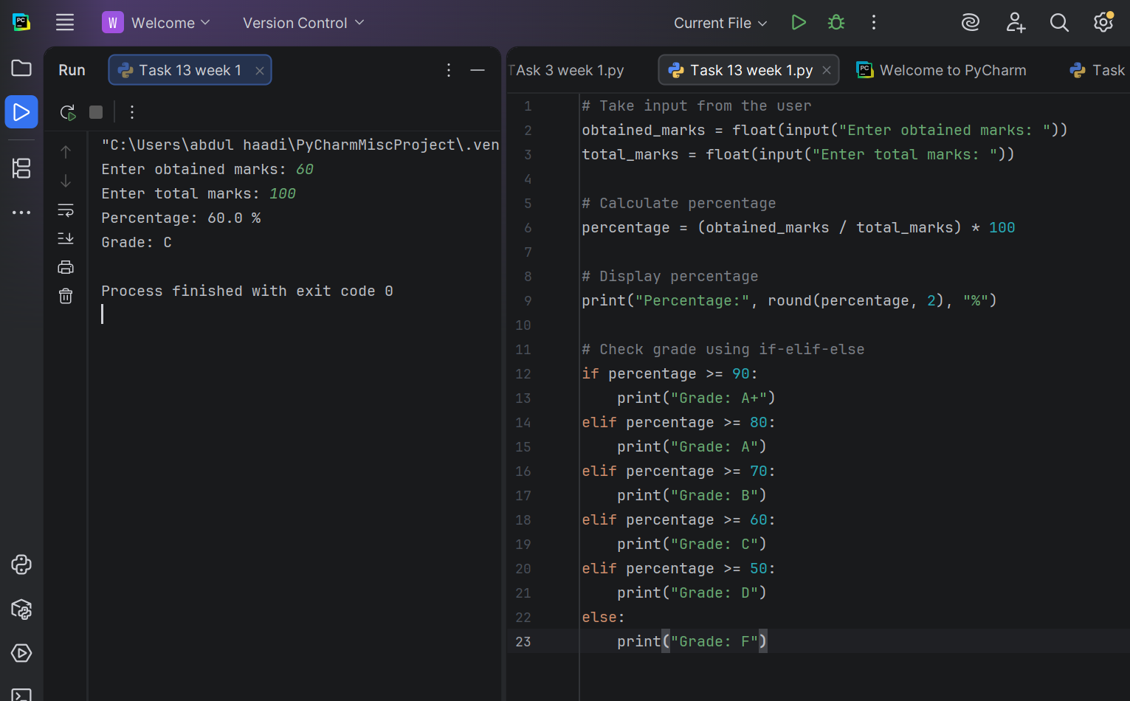

Task 14
Write a python program to find the roots of a quadratic equation.

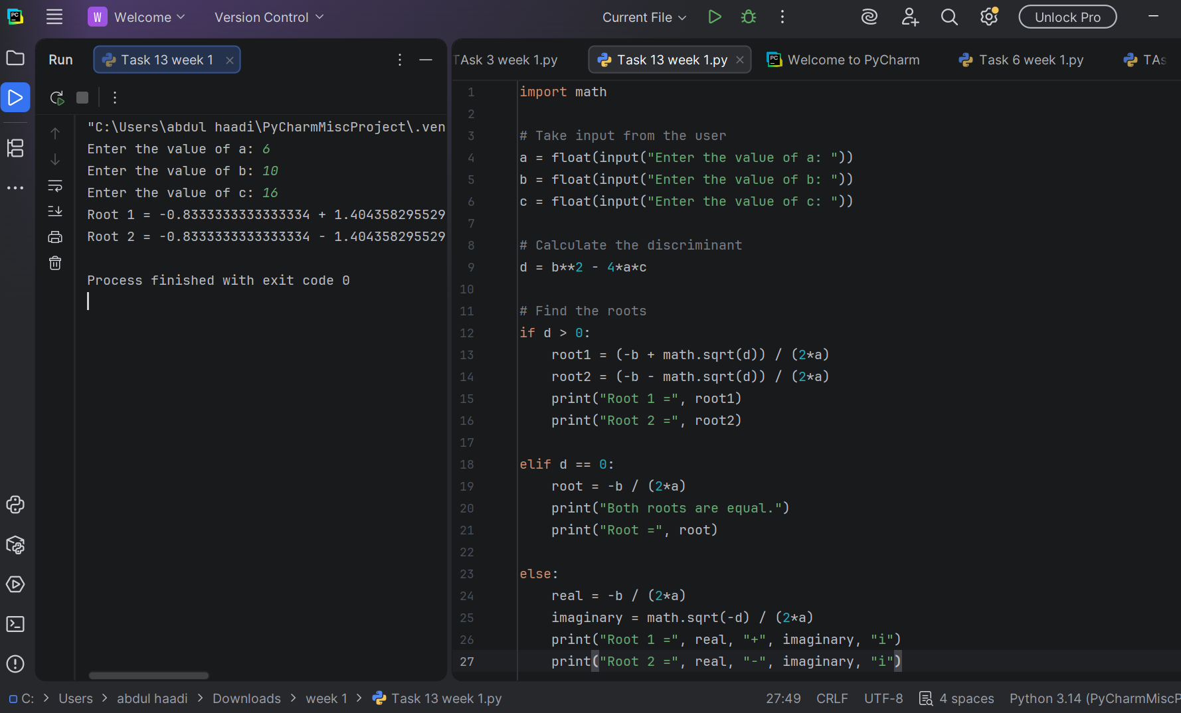

Task 15
Write a python program to check whether a given number is a Palindrome Number or not.

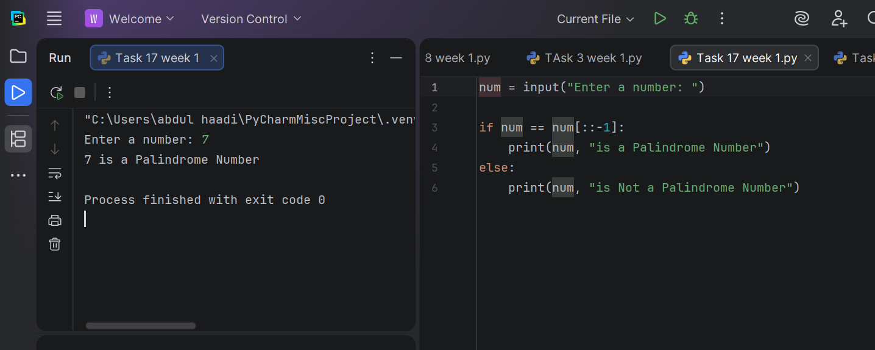
Task 16
Write a python program that works with two points in a 2D Cartesian Plane.

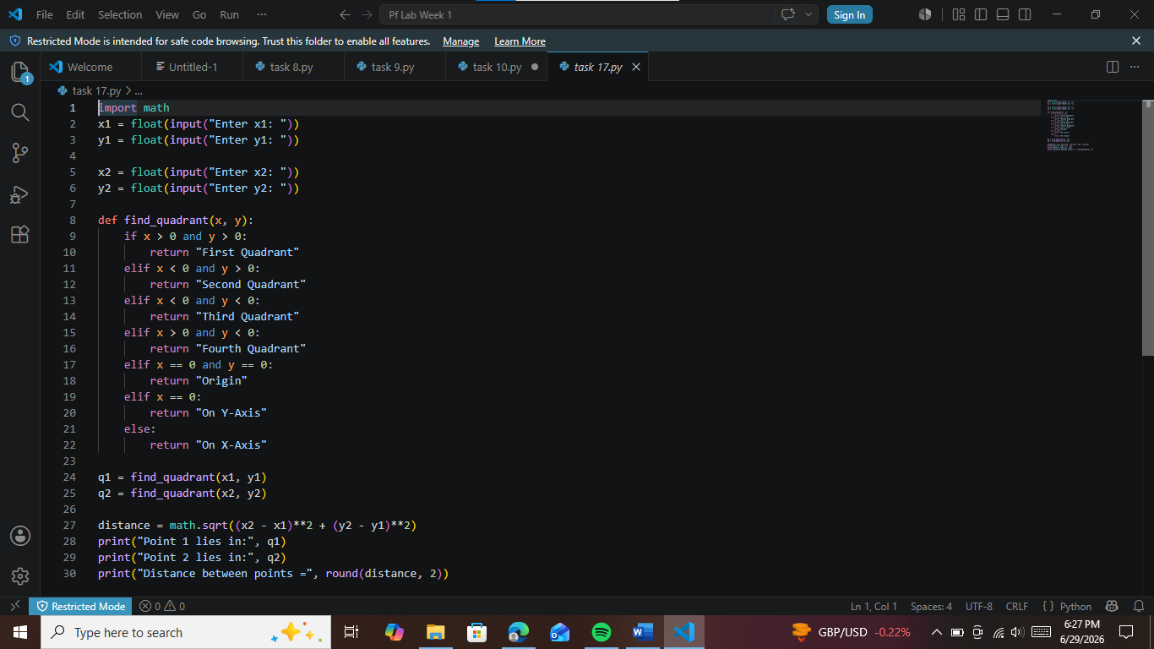

Conclusions:
Students learned basic Python concepts including input/output, data types, operators, and decision-making using conditional statements.

Week 2

University Of Engineering and Technology, Lahore Computer Engineering Department

Course Name: | Course Code: CMPE-112L
Assignment Type: | Dated: 2march2026
Semester: | Session:
Lab/Project/Assignment #: 2 | CLOs to be covered: CLO1
Lab Title: for loop | Teacher Name: Hafiz Muhammad Mubashar

Lab Evaluation:

CLO1 | Apply appropriate programming techniques to create executable programs to solve well defined problems
 | Level1 | Level2 | Level3 | Level4 | Level5 | Level6
(5)
Total |  |  |  |  |  | /5

Rubrics for Current Lab Evaluation

Scale | Marks | Level | Rubric
Excellent | 5 | L1 | Submitted all lab tasks, BONUS task, have good understanding.
Very Good | 4 | L2 | Submitted the lab tasks but have good understanding
Good | 3 | L3 | Submitted the lab tasks but have weak understanding.
Basic | 2 | L4 | Submitted the lab tasks but have no understanding.
Barely Acceptable | 1 | L5 | Submitted only one lab task.
Not Acceptable | 0 | L6 | Did not attempt

LAB No 2
Lab Goals/Objectives:
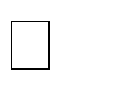


Understand the concept of loops in Python. Learn how to use a for loop for repetition. Perform repeated tasks efficiently.

Understand iteration through sequences.




Equipment Required: Computer/Laptop Python IDE
Python Interpreter

Theory:
A for loop is used to repeat a block of code a specific number of times or to go through each item in a list, string, etc.Think of it like: "do this task for every item"

Lab Work:

Task 1
Write a python code to convert a binary number entered by the user into its equivalent decimal number.
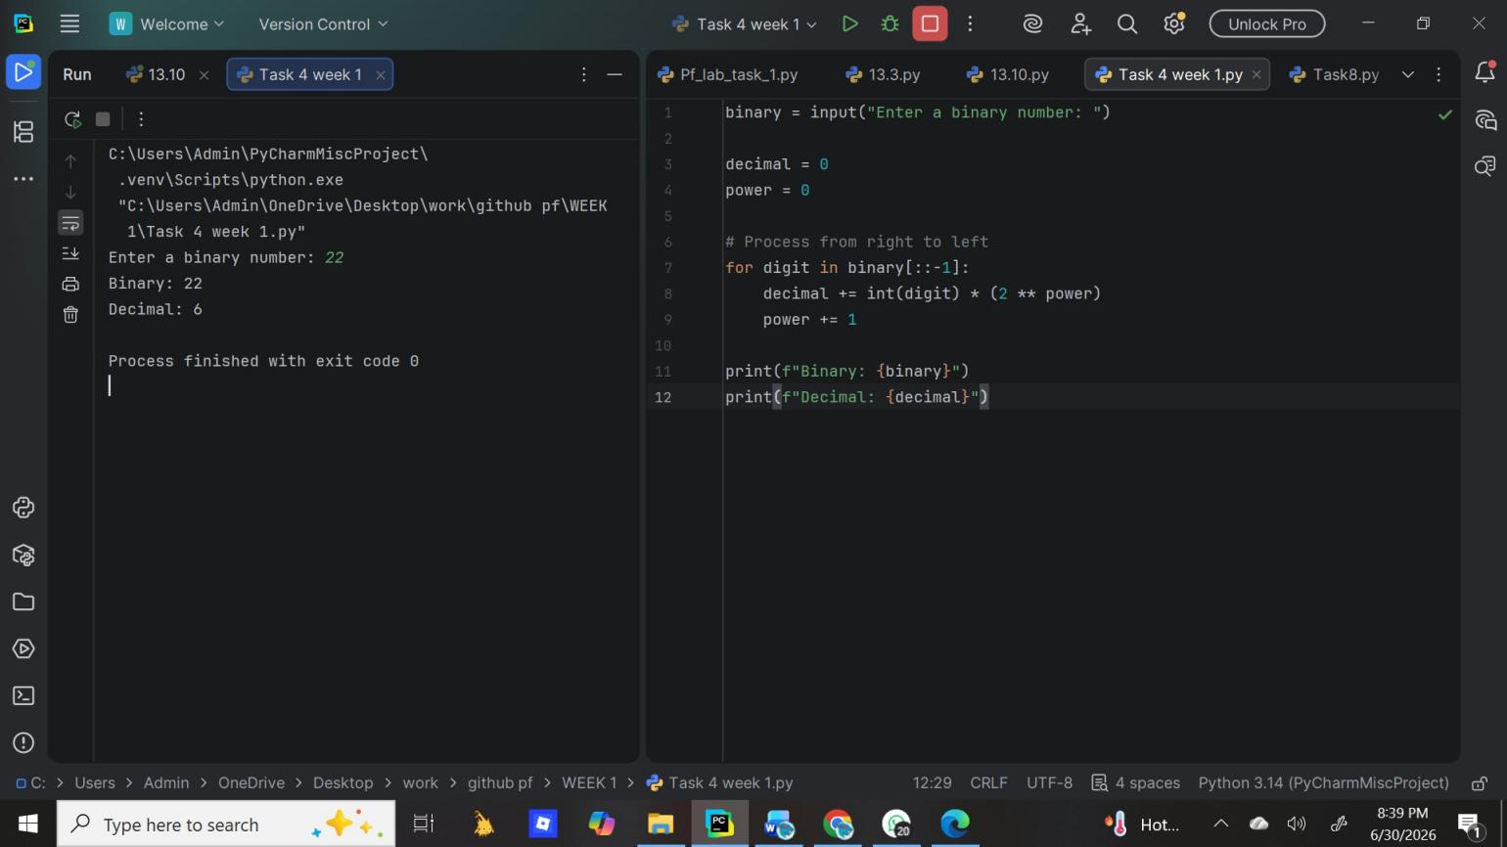

Task 2
Write a python program that counts the number of vowels and consonants in a sentence entered by students.

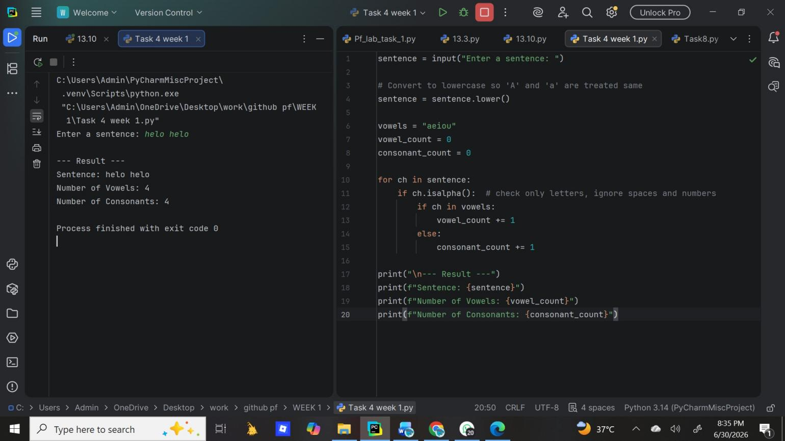

Task 3
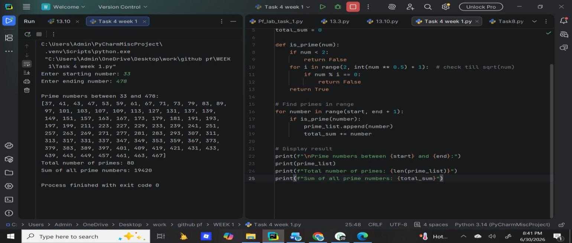
Write a python program that finds all prime numbers between a given starting and ending number and also calculate their sum.

Task 4
Write a python program to generate a random password based on user preferences.

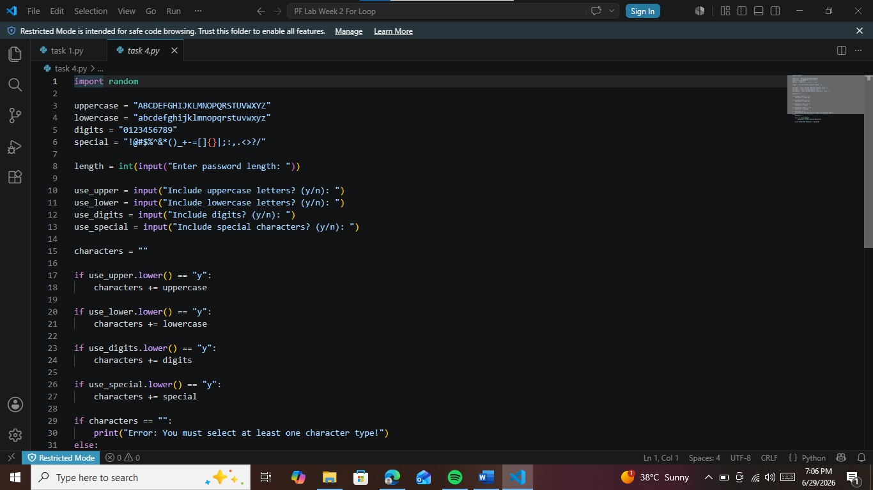

Task 5
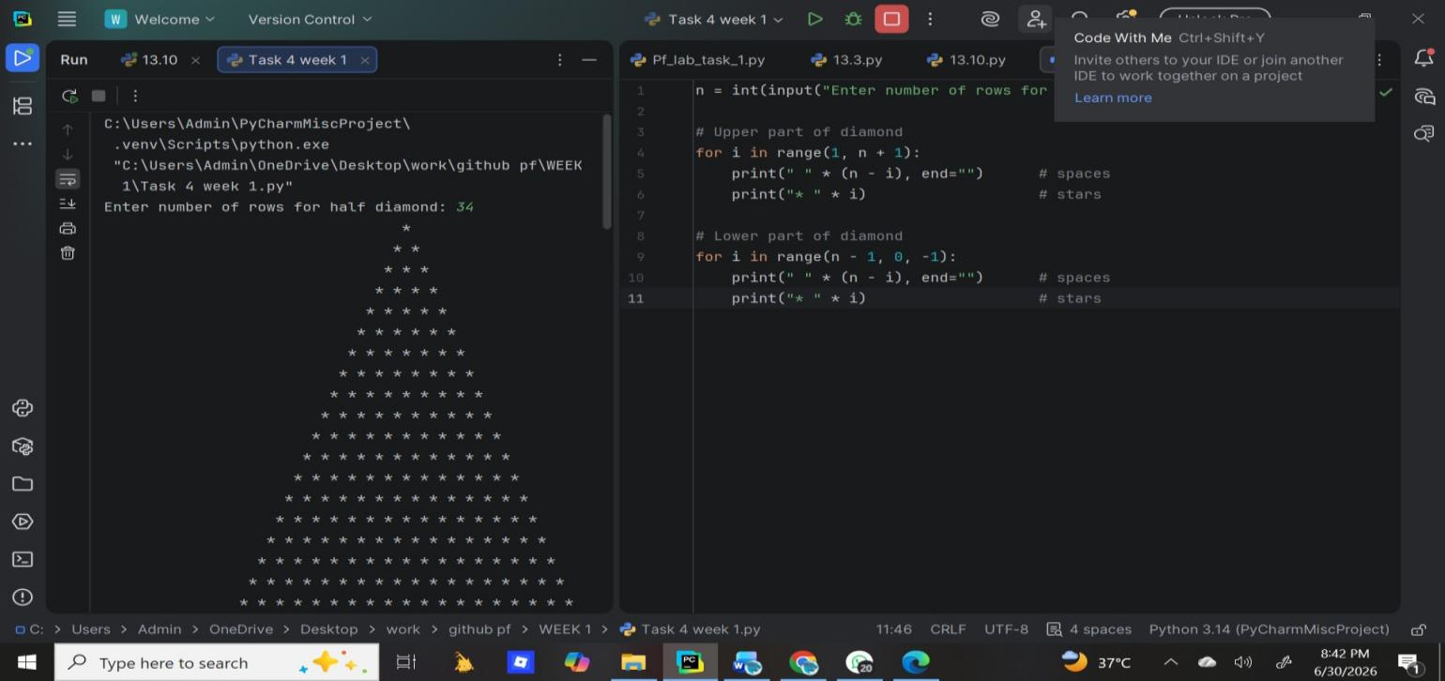
Write a python program to print a diamond shaped pattern using asterisks.

Task 6
Write a python program to calculate the percentage and grade for multiple students.

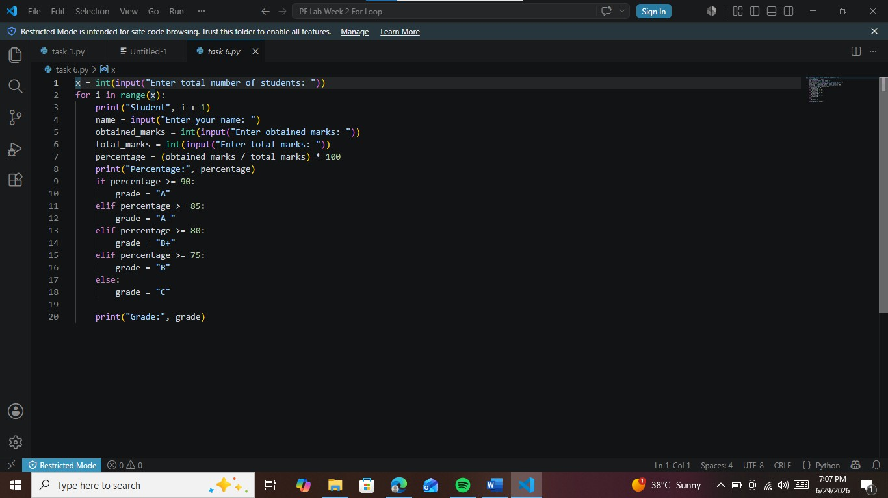

Conclusions:
The for loop is one of the most used loops in Python. Key Points:Purpose: It is used to repeat a block of code a specific number of times, or to go through each item in a sequence like list, string, or range.When to use: Use for loop when you know in advance how many times you want to repeat, or when you want to process every element one by one.Advantage: It makes code shorter, cleaner, and easier to read compared to writing the same code again and again.

Week 3
University Of Engineering and Technology, Lahore Computer Engineering Department

Course Name: | Course Code: CMPE-112L
Assignment Type: | Dated: 16march2026
Semester: 1st | Session: spring
Lab/Project/Assignment #: 1 | CLOs to be covered: CLO1
Lab Title: while loop | Teacher Name: Hafiz Muhammad Mubashar

Lab Evaluation:

CLO1 | Apply appropriate programming techniques to create executable programs to solve well defined problems
 | Level1 | Level2 | Level3 | Level4 | Level5 | Level6
(5)
Total |  |  |  |  |  | /5

Rubrics for Current Lab Evaluation

Scale | Marks | Level | Rubric
Excellent | 5 | L1 | Submitted all lab tasks, BONUS task, have good understanding.
Very Good | 4 | L2 | Submitted the lab tasks but have good understanding
Good | 3 | L3 | Submitted the lab tasks but have weak understanding.
Basic | 2 | L4 | Submitted the lab tasks but have no understanding.
Barely Acceptable | 1 | L5 | Submitted only one lab task.
Not Acceptable | 0 | L6 | Did not attempt

LAB No 3
Lab Goals/Objectives:


Understand the working of while loops. Learn condition-based repetition.


Create programs using indefinite loops. Understand loop control.




Equipment Required: Computer/Laptop Python IDE
Python Interpreter

Theory:
A while loop executes a block of code repeatedly as long as a given condition remains true. The loop contains:
- A condition
- A statement block
- Updating value to avoid infinite loops
While loops are useful when the number of repetitions is not known before execution.

Lab Work:

Task 1
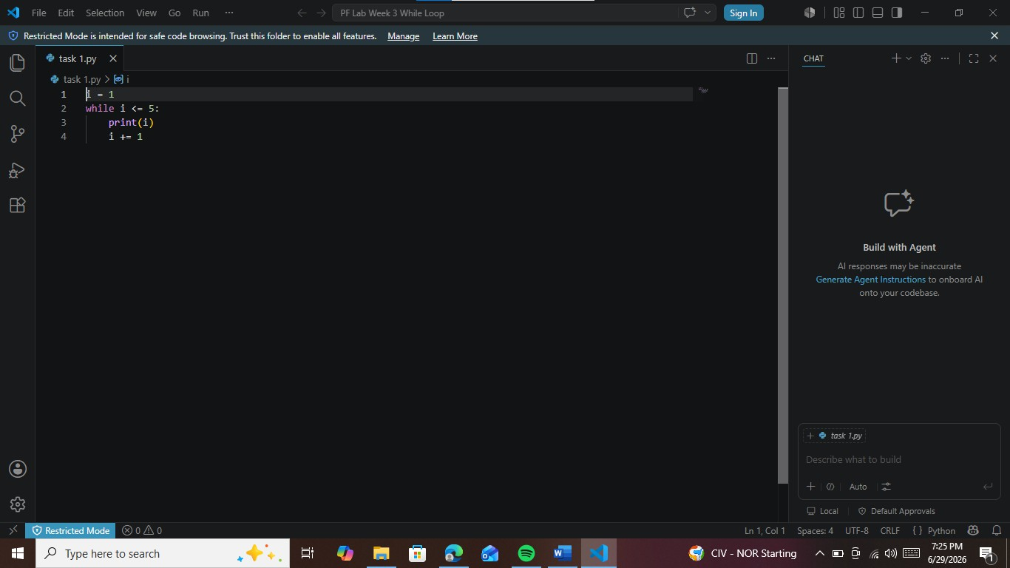
Write a python code to print numbers from 1 to 5 using a while loop.

Task 2
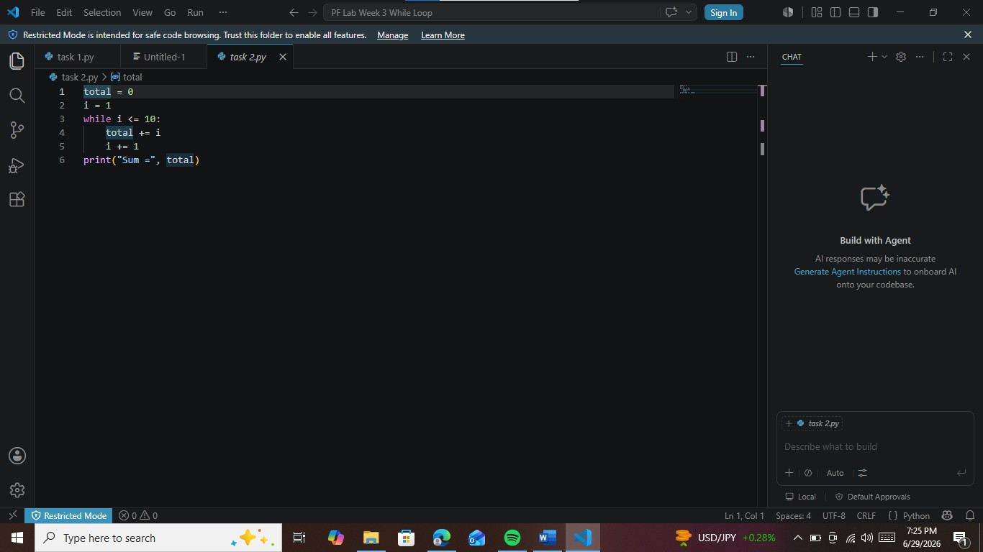
Write a python program to find the sum of numbers from 1 to 10 using while loop.

Task 3
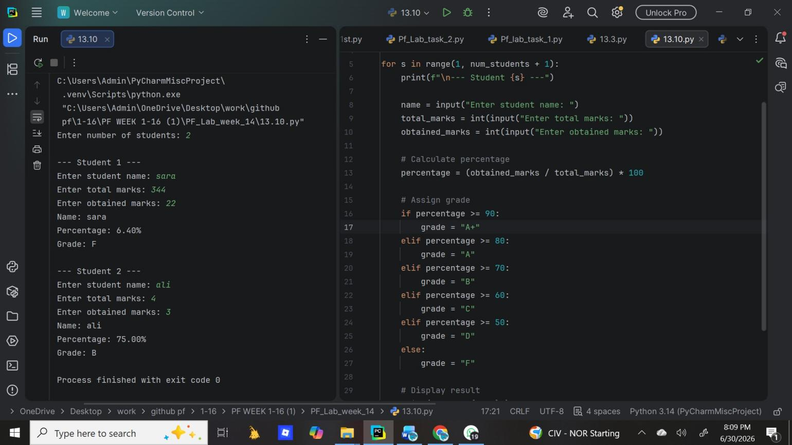
Write a python program to calculate percentage and assign grades for multiple students.

Task 4
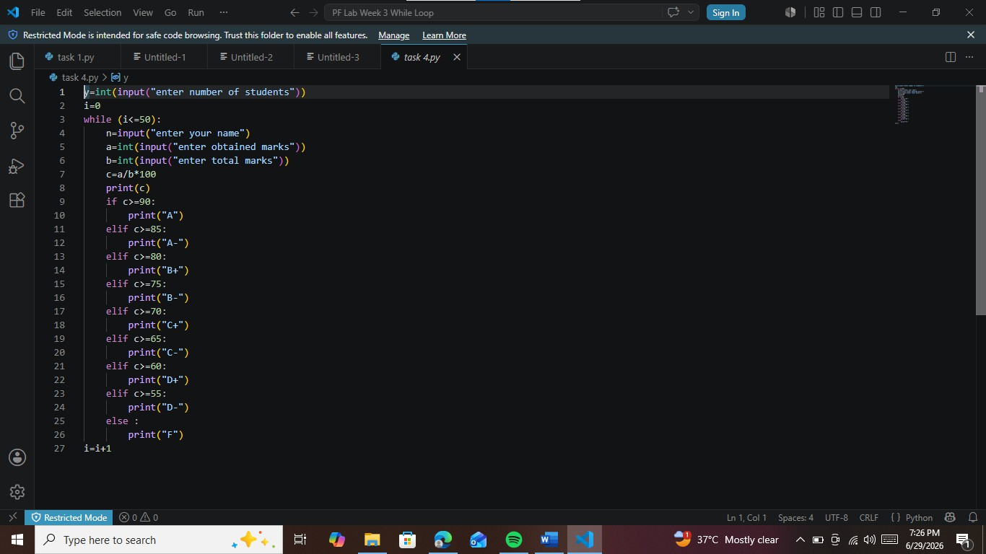
Write a python program to calculate percentage and assign grades to them.

Conclusions:
The while loop helps us repeat code as long as a condition is true.Unlike for loop which runs a fixed
number of times, while is used when we don’t know how many times we need to repeat.

Week 4
University Of Engineering and Technology, Lahore
Computer Engineering Department

Course Name: PF | Course Code: CMPE-112L
Assignment Type: Lab | Dated: 23 March,2026
Semester: 1 | Session: Spring 2026
Lab/Project/Assignment #: 4 | CLOs to be covered: CLO
Lab Title: Nested Loop | Teacher Name: Hafiz Muhammad Mubashar
Lab Evaluation:

CLO1 | Apply appropriate programming techniques to create executable programs to solve well defined problems
 | Level1 | Level2 | Level3 | Level4 | Level5 | Level6
(5)
Total |  |  |  |  |  | /5
Rubrics for Current Lab Evaluation
Scale | Marks | Level | Rubric
Excellent | 5 | L1 | Submitted all lab tasks, BONUS task, have good understanding.
Very Good | 4 | L2 | Submitted the lab tasks but have good understanding
Good | 3 | L3 | Submitted the lab tasks but have weak understanding.
Basic | 2 | L4 | Submitted the lab tasks but have no understanding.
Barely Acceptable | 1 | L5 | Submitted only one lab task.
Not Acceptable | 0 | L6 | Did not attempt
LAB No 4
Lab Goals/Objectives:
• Understand the concept of loops inside loops.
• Learn how nested loops work.
• Use nested loops for complex problems.
• Generate patterns and multi-dimensional outputs.

Equipment Required:
• Computer/Laptop
• Python IDE
• Python Interpreter

Theory:
A nested loop is created when one loop is written inside another loop. During execution, the inner loop runs from start to finish each time the outer loop completes one iteration.
Nested loops are especially useful for tasks such as:
- Creating different types of number and star patterns.
- Processing information arranged in rows and columns.
- Performing calculations on matrices.
- Solving problems that involve repeated actions at more than one level.

Lab Work:

Task 1
Write a python program to print a centered pyramid pattern using nested while loop.

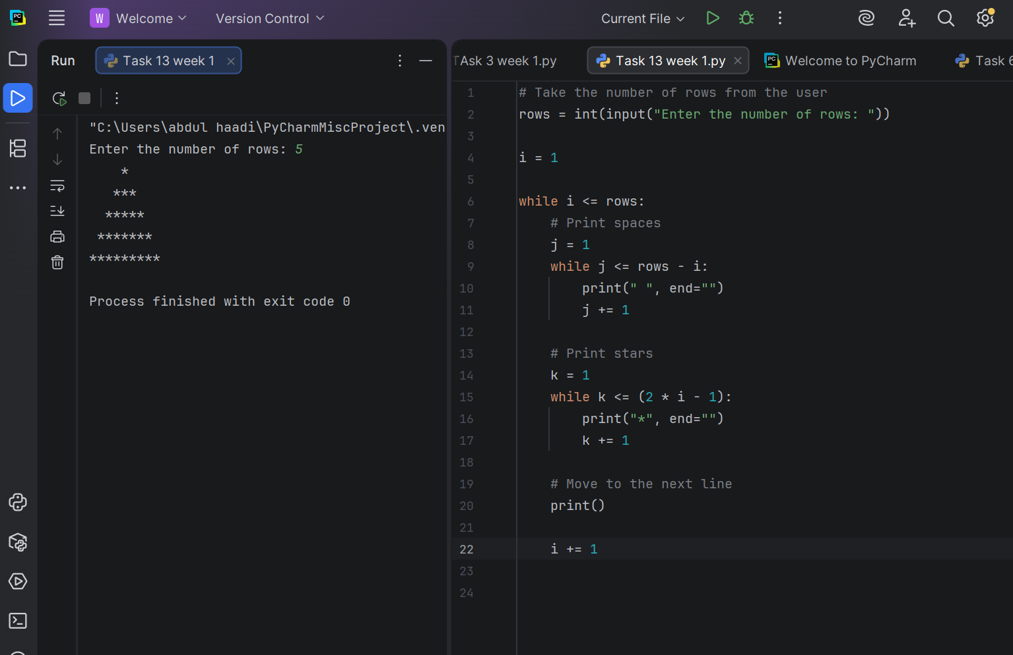

Task 2
Write a python program to print a left aligned right aligned triangle of stars using nested for loop.

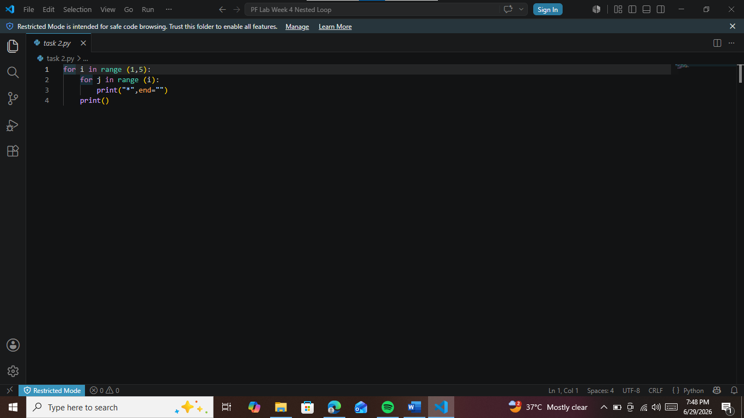

Task 3
Write a python program to print a eft aligned right aligned triangle of stars using nested gor loop.

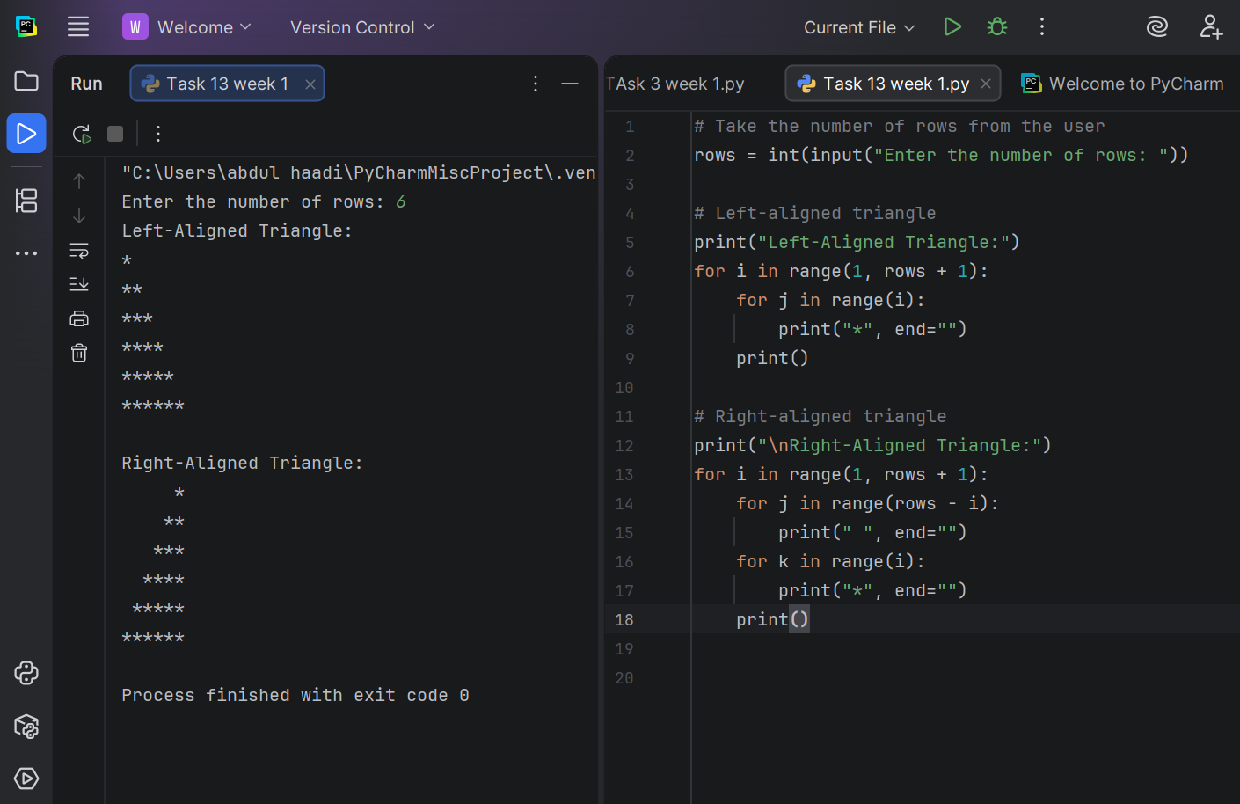

Task 4
Write a python program using nested for loop to display how the outer and inner loop counters change.

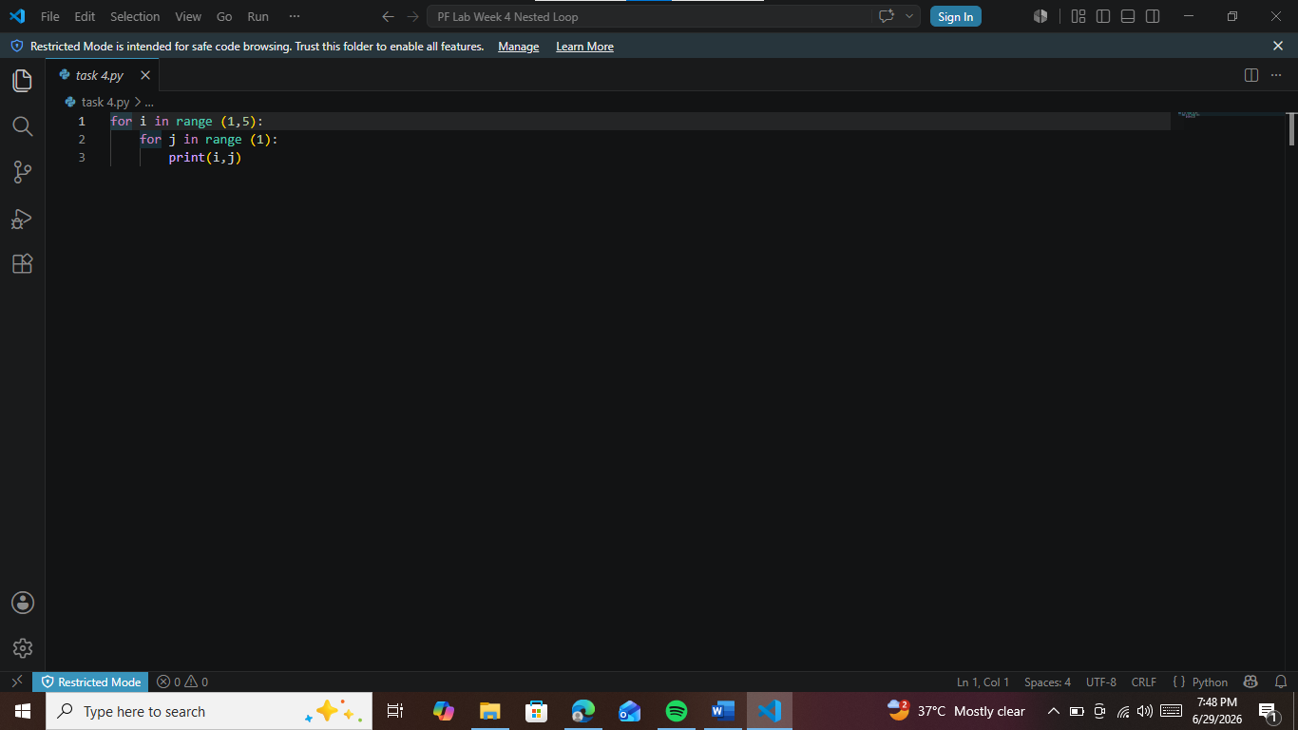

Task 5
Write a python program to print a number pattern where each row prints the row number multiple time using nested for loop.
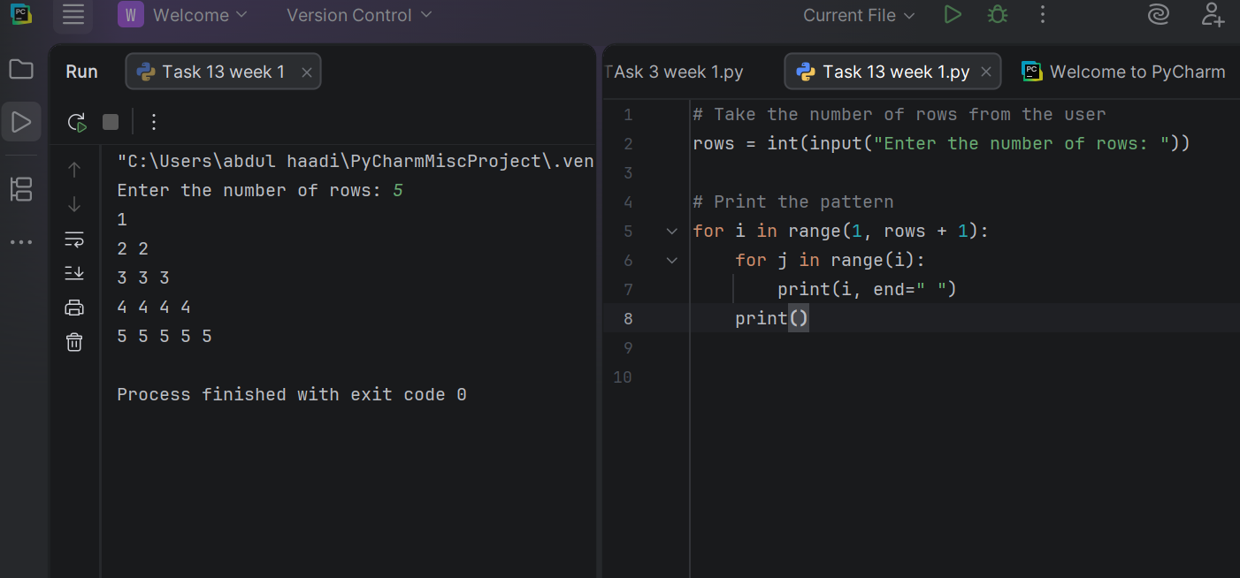
Task 6
Write a python program to coordinate pairs (i,j) in a triangular pattern .

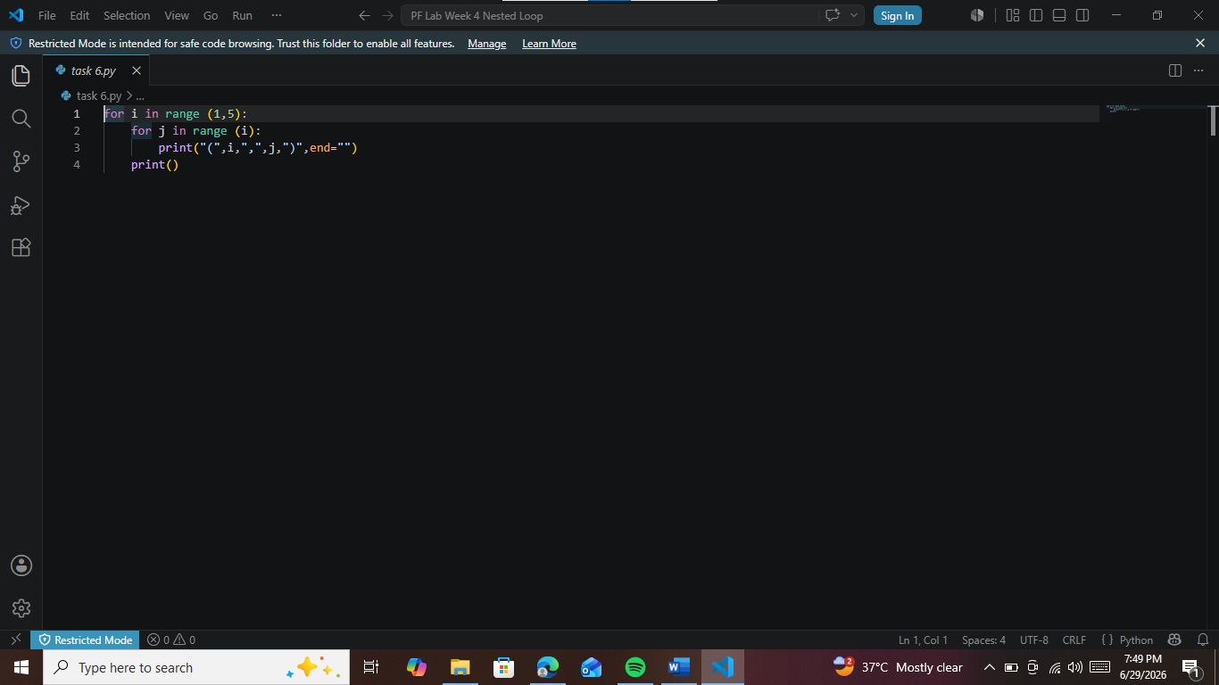

Task 7
Write a python program to print a pattern with decreasing 1 and increasing in each row using nested for loop.

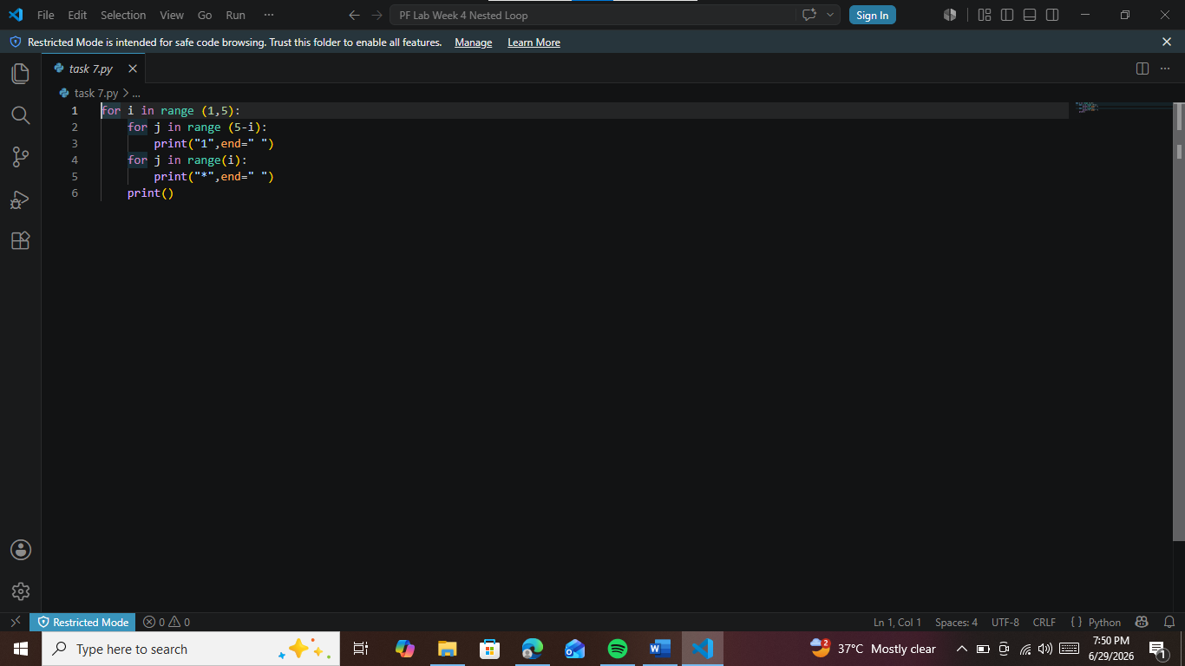
Task 8
Write a python program to print a centered pyramid of stars using nested for loop.

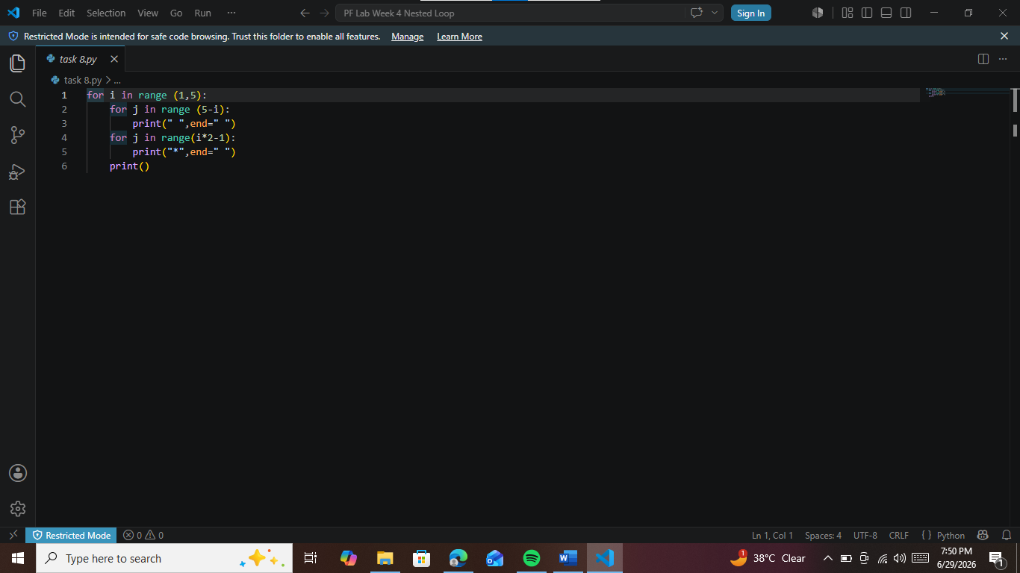

Task 9
Write a python program to print a centered pyramid of stars using nested while loop.

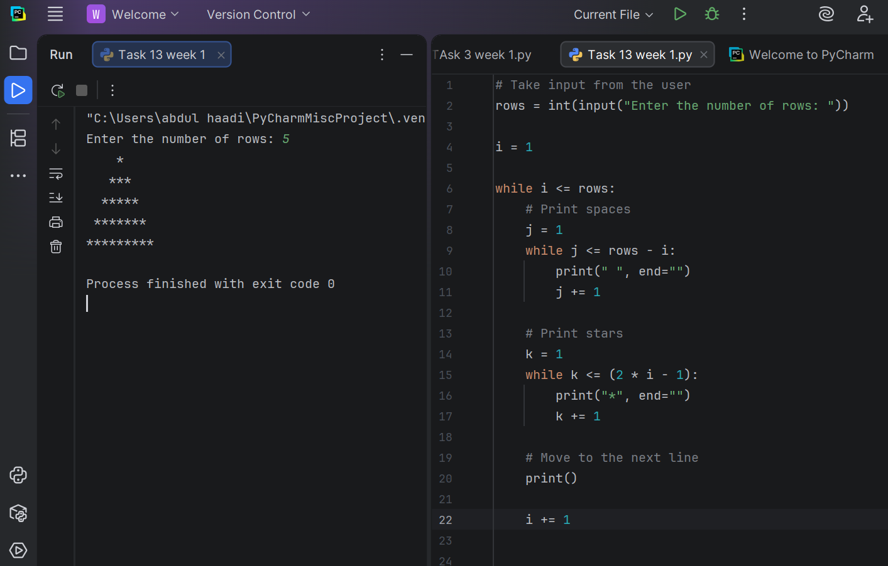

Conclusions:
In this lab, we explored the concept of nested loops in Python, where one loop is placed inside another to perform repeated tasks. We observed that the inner loop executes completely every time the outer loop runs once.
We practiced using nested loops to create different patterns and solve problems that require multiple levels of repetition. This approach is also helpful when working with rows and columns, tables, and other structured data.
Overall, this lab improved our understanding of loop control and strengthened our logical thinking. Learning nested loops enables us to write more efficient programs for tasks that involve repetitive operations within other repetitive operations.

Week 5
University Of Engineering and Technology, Lahore
Computer Engineering Department

Course Name: PF | Course Code: CMPE-112L
Assignment Type: Lab | Dated: 30 march 2026
Semester: 1 | Session: Spring 2026
Lab/Project/Assignment #: 1 | CLOs to be covered: CLO 2
Lab Title: Functions | Teacher Name: Hafiz Muhammad Mubashar
Lab Evaluation:

CLO1 | Apply appropriate programming techniques to create executable programs to solve well defined problems
 | Level1 | Level2 | Level3 | Level4 | Level5 | Level6
(5)
Total |  |  |  |  |  | /5
Rubrics for Current Lab Evaluation
Scale | Marks | Level | Rubric
Excellent | 5 | L1 | Submitted all lab tasks, BONUS task, have good understanding.
Very Good | 4 | L2 | Submitted the lab tasks but have good understanding
Good | 3 | L3 | Submitted the lab tasks but have weak understanding.
Basic | 2 | L4 | Submitted the lab tasks but have no understanding.
Barely Acceptable | 1 | L5 | Submitted only one lab task.
Not Acceptable | 0 | L6 | Did not attempt
LAB No 5
Lab Goals/Objectives:
• Understand the concept of functions in Python.
• Learn how to create and call functions.
• Understand parameters and return values.
• Improve code organization and reusability.

Equipment Required:
• Computer/Laptop
• Python IDE
• Python Interpreter

Theory:
A function is a separate section of a program that is written to complete a particular job. Instead of writing the same instructions multiple times, a function can be called whenever that task needs to be performed.
Using functions provides several advantages:
- They keep the program organized and easier to understand.
- They avoid writing duplicate code.
- They simplify testing, updating, and fixing programs.
A function may:
- Accept values from the user or another part of the program through parameters.
- Process those values to perform a specific task.
- Send the final result back to the program using a return statement.
In Python, a function is defined by using the def keyword followed by the function name and its parameters.

Lab Work
Task 1
Write a python program with functions to calculate Factorial, Permutation and Combinations.

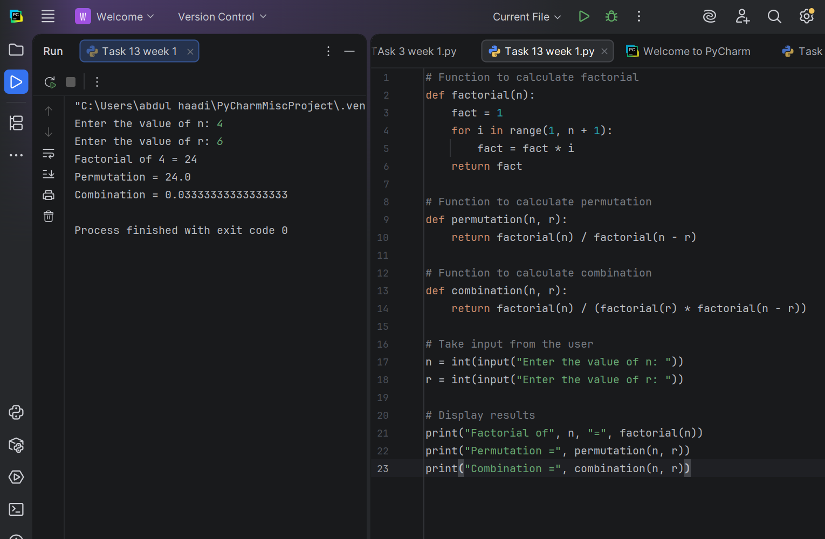

Task 2
Write a python program that uses a lambda function and a regular function to find the larger of two numbers and print its multiplication table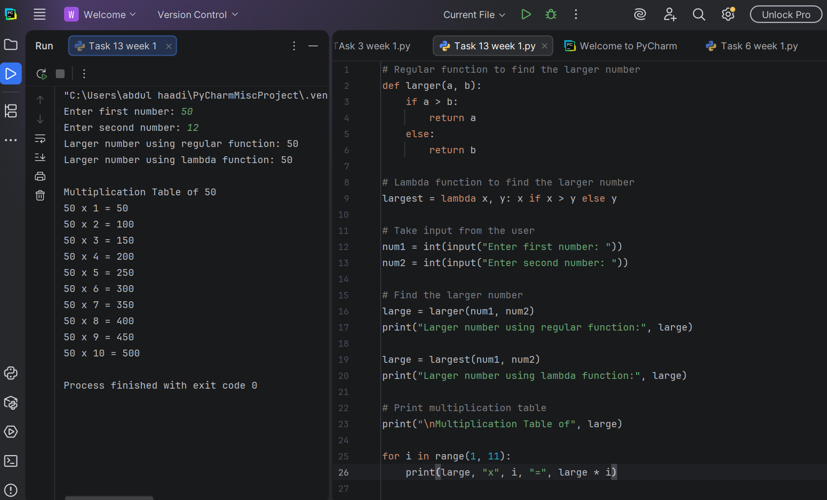

Task 3
Write a python program that uses a lambda function and a normal function to process a string.
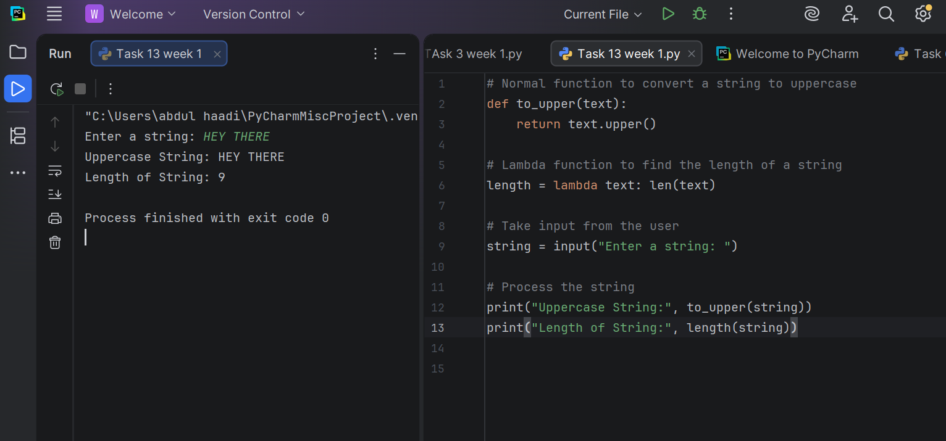
Task 4
Write a python program to calculate a student’s GPA .

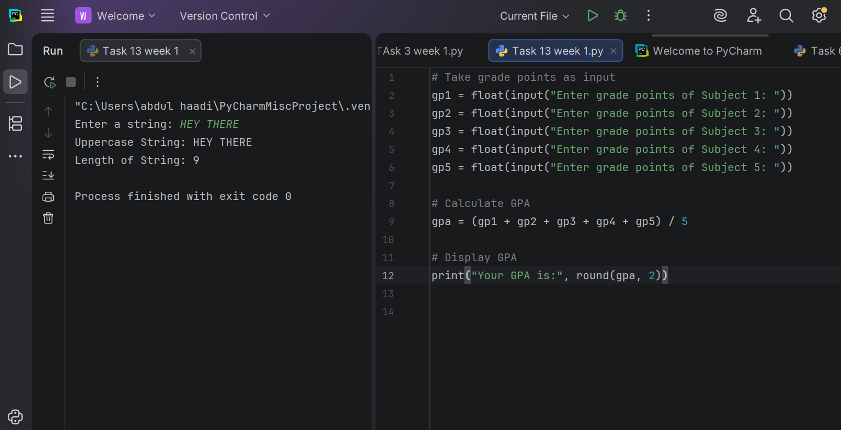

Task 5
Write a python function that defines a function to add two numbers and tests it with different inputs.
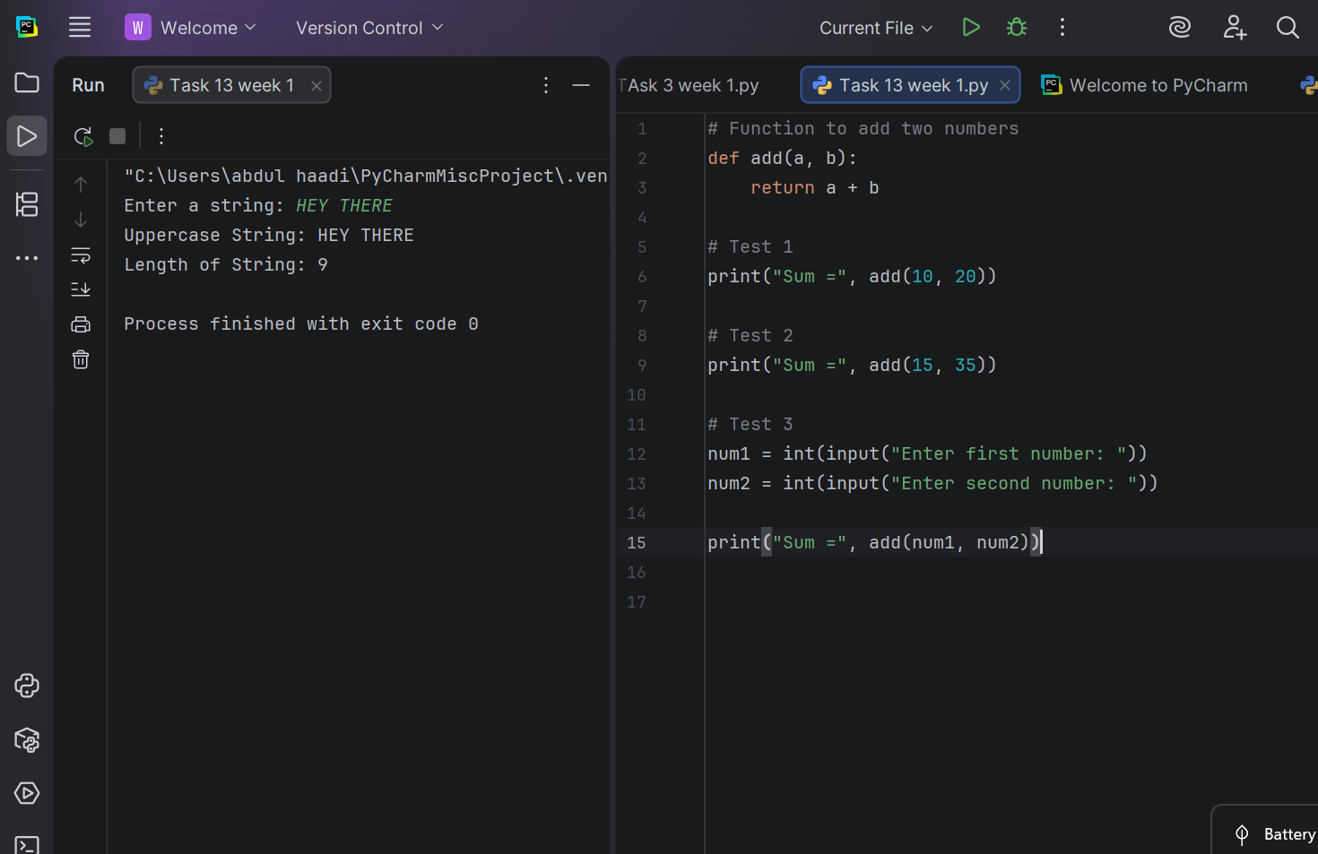

Task 6
Write a python program to demonstrate function definition and reuse by printing text multiple times.

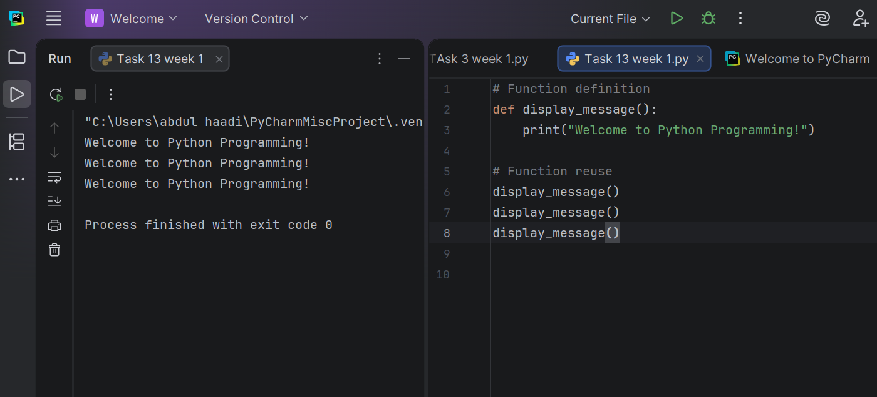

Conclusion

In this lab, we explored how functions are used in Python and why they are an important part of programming. We learned that functions help break a program into smaller, organized parts, making the code simpler to read, debug, and maintain.
We practiced defining functions with the def keyword, passing information through parameters, and returning values using the return statement. We also saw how functions eliminate the need to write the same code repeatedly, resulting in cleaner and more efficient programs.
Overall, this lab strengthened our understanding of modular programming and demonstrated how reusable functions improve code organization and make program development more effective. Learning to use functions is a fundamental step toward writing well-structured Python applications.

Week 6
University Of Engineering and Technology, Lahore Computer Engineering Department

Course Name: PF | Course Code: CMPE-112L
Assignment Type: LAB | Dated: 20 April 2026
Semester: 1st | Session: 2026 Spring
Lab/Project/Assignment #: 6 | CLOs to be covered: CLO2
Lab Title: Local and Global Variable | Teacher Name: Hafiz Muhammad Mubashar

Lab Evaluation:

CLO1 | Apply appropriate programming techniques to create executable programs to solve well defined problems
 | Level1 | Level2 | Level3 | Level4 | Level5 | Level6
(5)
Total |  |  |  |  |  | /5

Rubrics for Current Lab Evaluation

Scale | Marks | Level | Rubric
Excellent | 5 | L1 | Submitted all lab tasks, BONUS task, have good understanding.
Very Good | 4 | L2 | Submitted the lab tasks but have good understanding
Good | 3 | L3 | Submitted the lab tasks but have weak understanding.
Basic | 2 | L4 | Submitted the lab tasks but have no understanding.
Barely Acceptable | 1 | L5 | Submitted only one lab task.
Not Acceptable | 0 | L6 | Did not attempt

LAB No 6
Lab Goals/Objectives:

- Understand the concept of Global and Local Variables in Python.
- Learn the scope and accessibility of variables inside and outside functions.
- Create programs using global and local variables.
- Understand variable control and data handling within functions.

Equipment Required:
- Computer/Laptop
- Python IDE
- Python Interpreter

Theory:
- Local VariableDefinition: A variable declared inside a function or a block.Scope: Can only be accessed within that function/block where it was declared.Lifetime: Created when the function is called, and destroyed when the function ends.

- Global VariableDefinition: A variable declared outside all functions, usually at the top of the program/file.Scope: Can be accessed from any function in the entire program.Lifetime: Created when the program starts and destroyed when the program ends.

Lab Work:

Task 1:
Create a global variable x = 6. Write a function that prints the value of x from inside the function. Also print x outside the function.

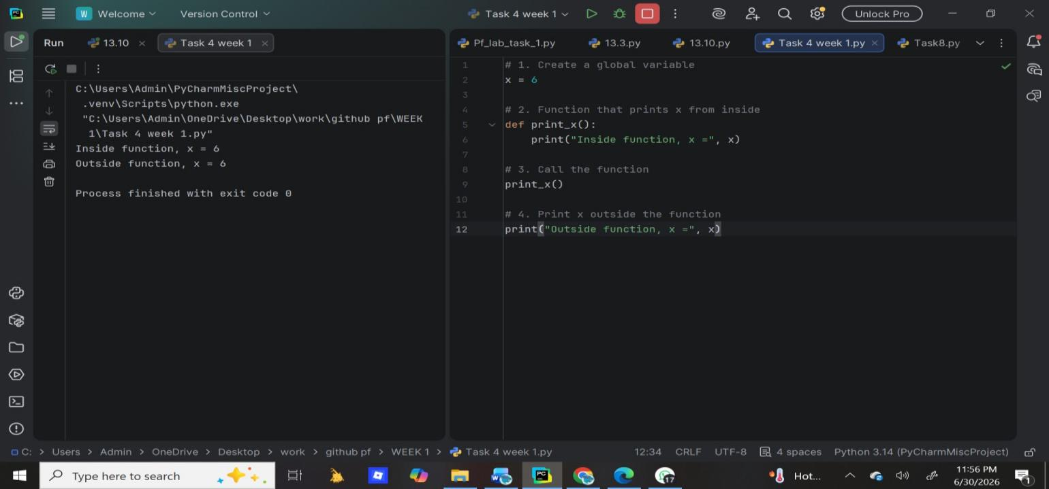
Result:

Task2:

Create a function that defines a local variable y = 5 and prints it inside the function. Try to print y outside the function and observe the error.
Result:
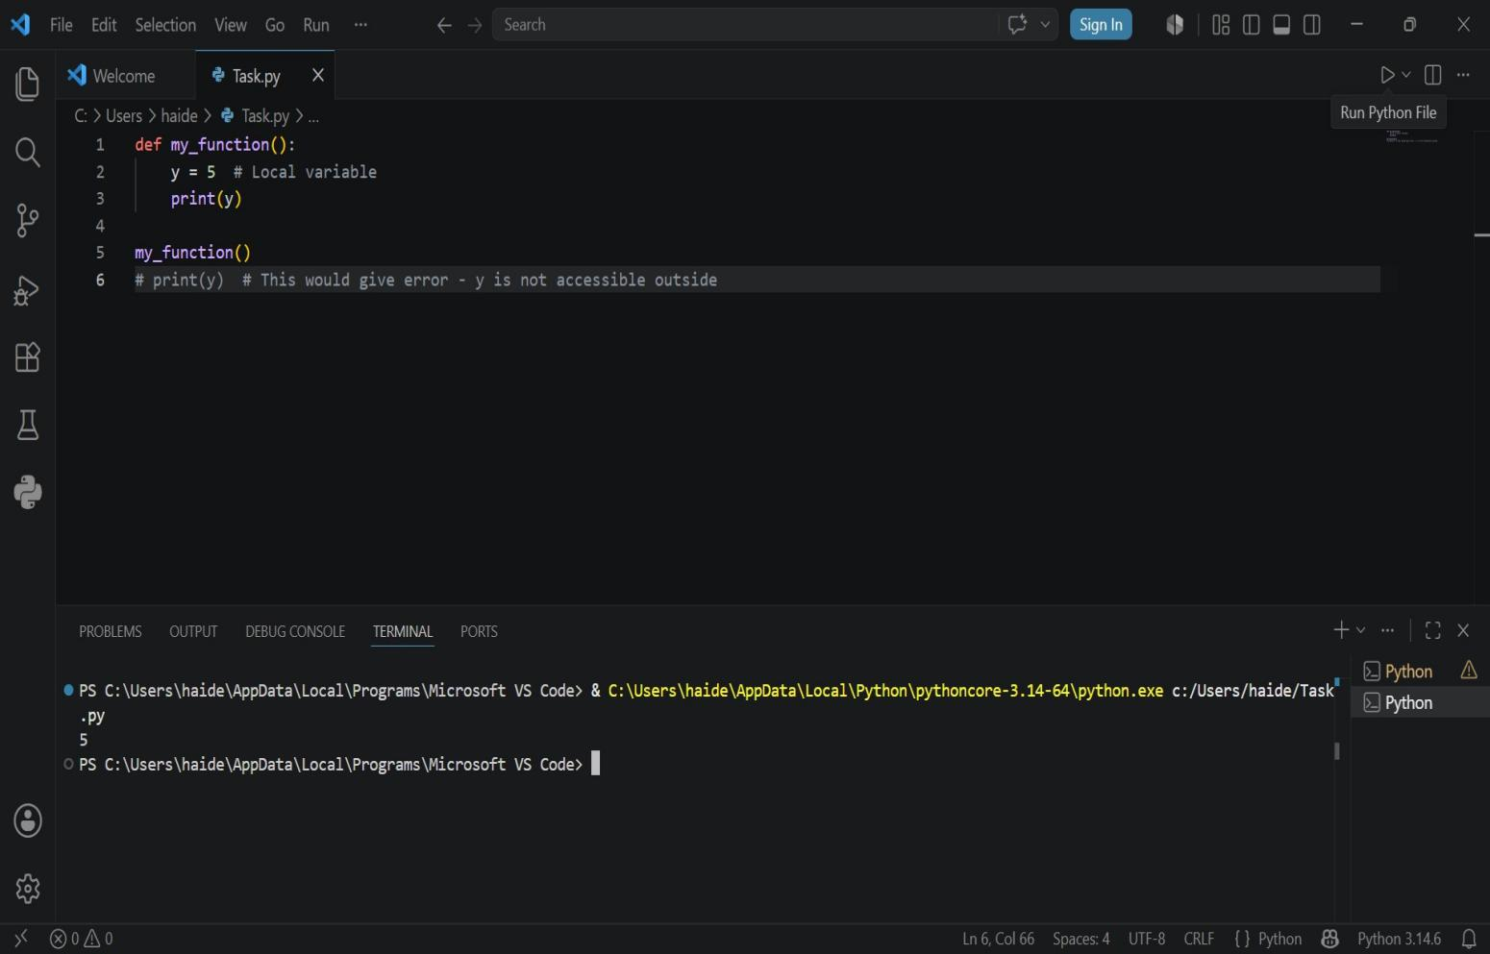

Task 3:
Create a global variable name = "shayan". Inside a function, create a local variable with the same name name = "Sara". Print both inside and outside the function to see the difference.

Result:
Task 4:
Create a global variable count = 0. Write a function that increments count by 1 using the global keyword. Print the value inside and outside the function.

Result:

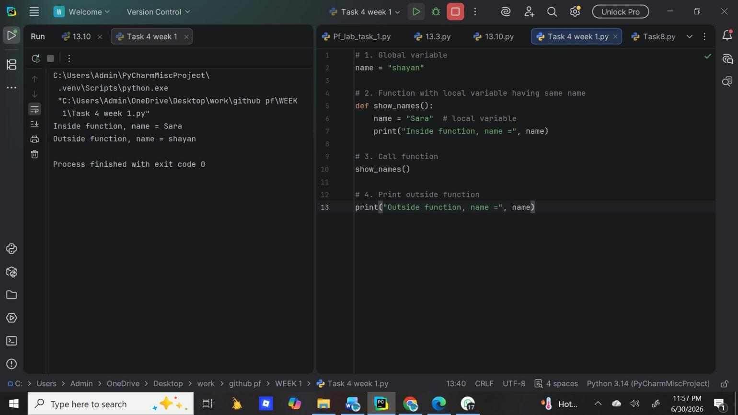

Task 5:
Create a global variable total = 80. Inside a function, define a local variable discount = 20 and calculate the final price using both variables. Print the result inside the function and print the original total outside.

Result:
Task 6:
Create a global variable number = 5. Write two functions - one that prints the square of the number and another that prints the cube. Use the global variable inside both functions.

Result:

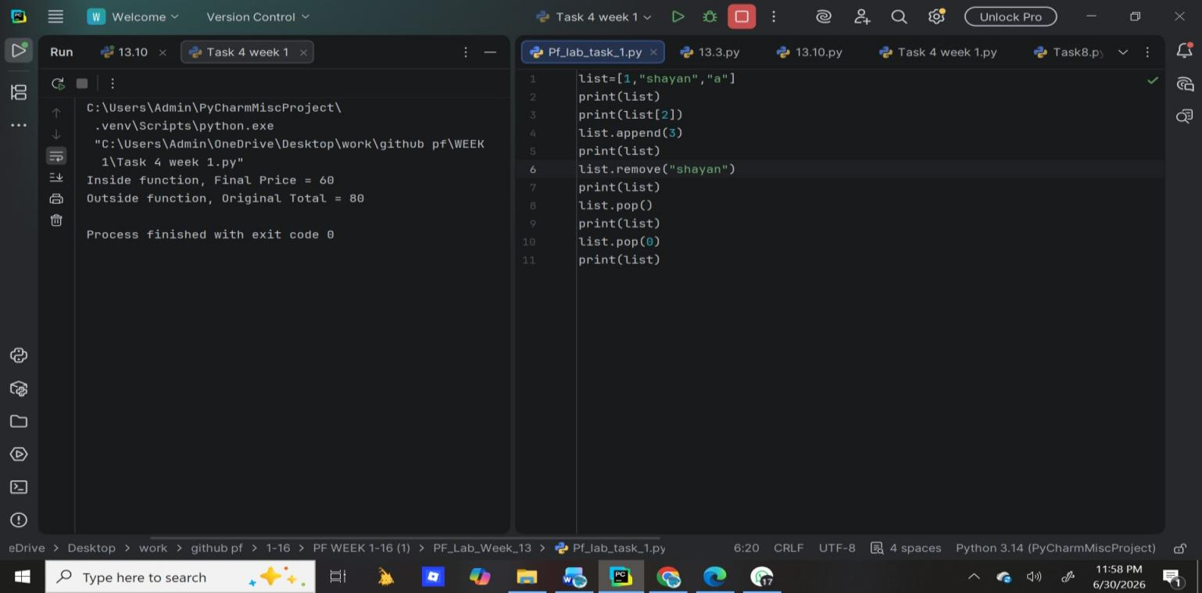

Conclusion:
- Local variables are safer and preferred because they avoid conflicts. Each function manages its own data, so one function cannot accidentally change another function's data.
- Global variables are useful when many functions need to share the same data, like configuration settings. But overuse can make code hard to debug because any function can change them.
- Best Practice: Use local variables as much as possible. Use global variables only when necessary, and keep their number small.

Week 7
University Of Engineering and Technology, Lahore
Computer Engineering Department

Course Name: PF | Course Code: CMPE-112L
Assignment Type: LAB | Dated: 27 April 2026
Semester: 1st | Session: 2026 Spring
Lab/Project/Assignment #: 7 | CLOs to be covered: CLO3
Lab Title: List and Tuples | Teacher Name: Hafiz Muhammad Mubashar
Lab Evaluation:

CLO1 | Apply appropriate programming techniques to create executable programs to solve well defined problems
 | Level1 | Level2 | Level3 | Level4 | Level5 | Level6
(5)
Total |  |  |  |  |  | /5
Rubrics for Current Lab Evaluation
Scale | Marks | Level | Rubric
Excellent | 5 | L1 | Submitted all lab tasks, BONUS task, have good understanding.
Very Good | 4 | L2 | Submitted the lab tasks but have good understanding
Good | 3 | L3 | Submitted the lab tasks but have weak understanding.
Basic | 2 | L4 | Submitted the lab tasks but have no understanding.
Barely Acceptable | 1 | L5 | Submitted only one lab task.
Not Acceptable | 0 | L6 | Did not attempt
LAB No 7
Lab Goals/Objectives:
- Understand the concept of Lists and Tuples in Python.
- Learn how to store and organize multiple values in collections.
- Create programs using list and tuple operations.
- Understand accessing, updating, and managing collection data.

Equipment Required:
- Computer/Laptop
- Python IDE
- Python Interpreter

Theory:
A List in Python is an ordered collection of elements that is mutable, meaning values can be added, removed, or changed after creation. Lists are useful for storing and managing multiple items.

A Tuple in Python is an ordered collection of elements that is immutable, meaning its values cannot be changed after creation. Tuples are useful for storing fixed data securely.

The collection contains:
- Elements stored in sequence
- Indexing for accessing data
- Methods and operations for managing values

Lab Work:

Task 1:
Create a list containing mixed data types (integer, string, and number). Add an element to the end of the list and print the updated list.

Result:

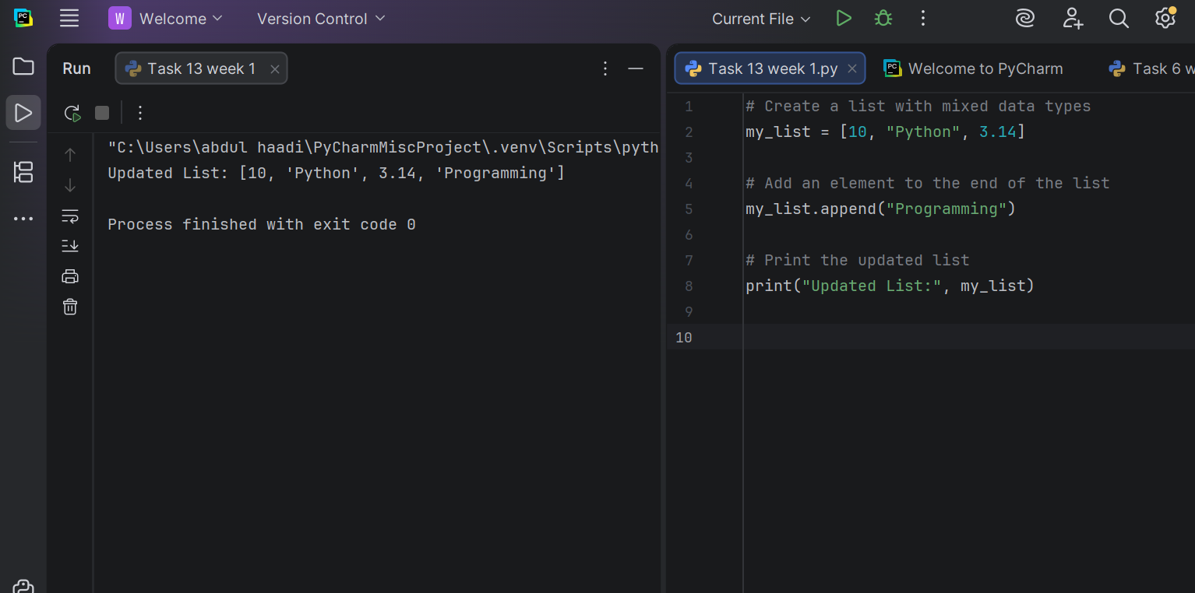 Task 2:
Create a list of fruits (apple, banana, mango) and print the entire list.

Result:
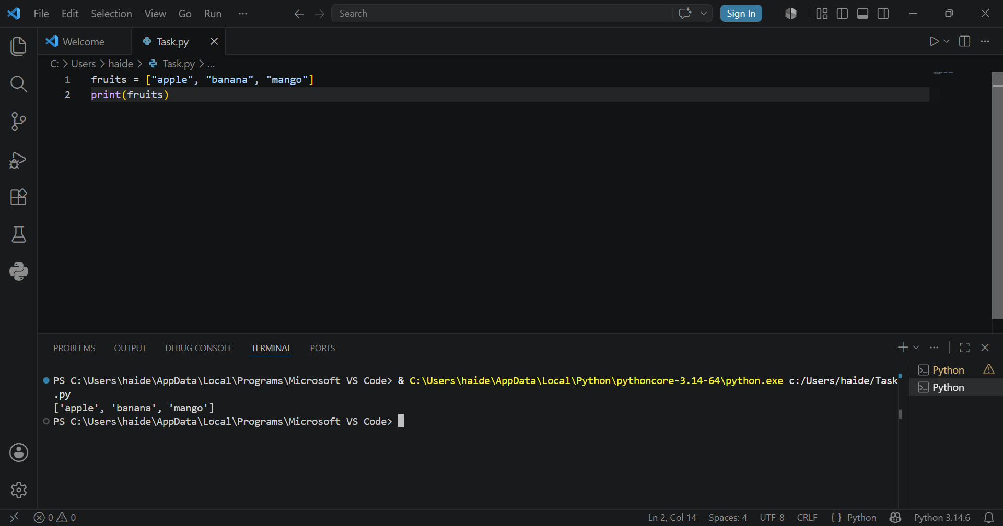

Task 3:
Write a Python program that creates a list of numbers containing 10, 20, 30, 40, and 50. The program should use built-in functions to find and display the largest number, the smallest number, and the sum of all the numbers in the list.

Result: 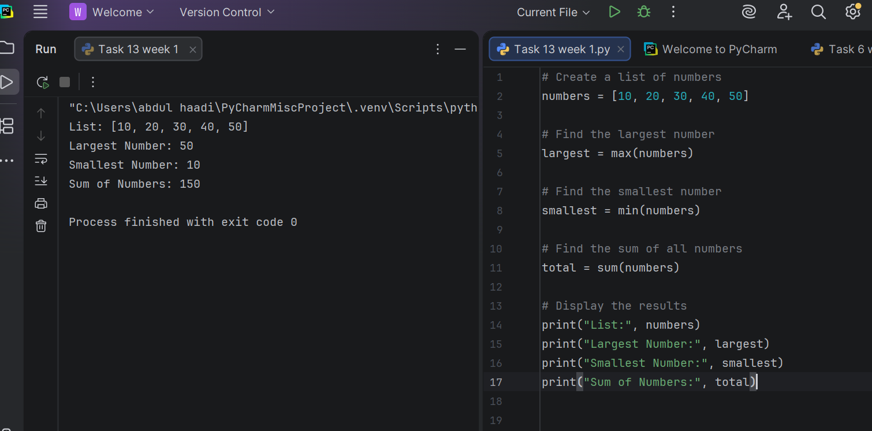
Task 4:
Create a tuple containing three fruit names and print the tuple.

Result:
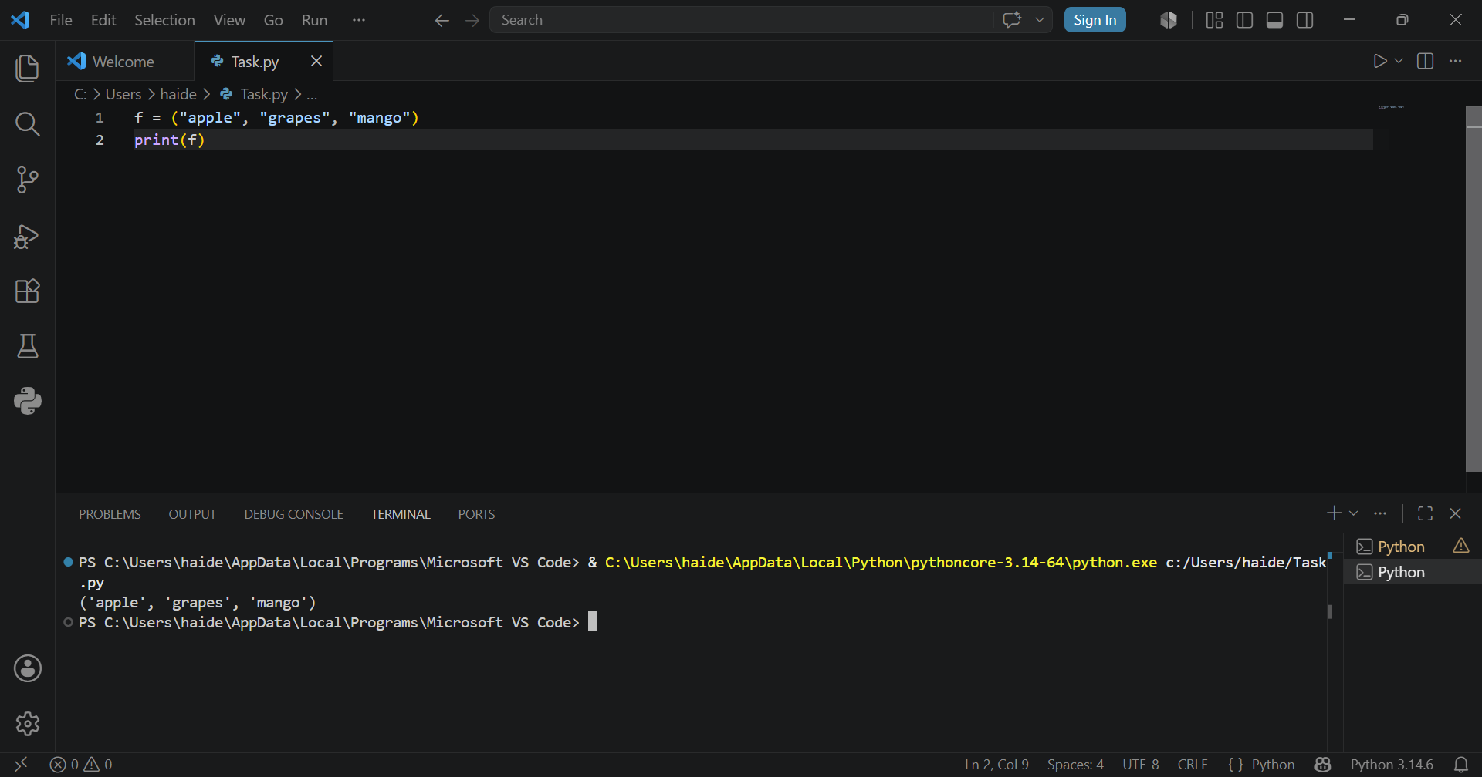

Task 5:
Create a tuple with mixed data types. Try to append an element to it and observe the error. (Note:
This will generate an AttributeError)
Result: 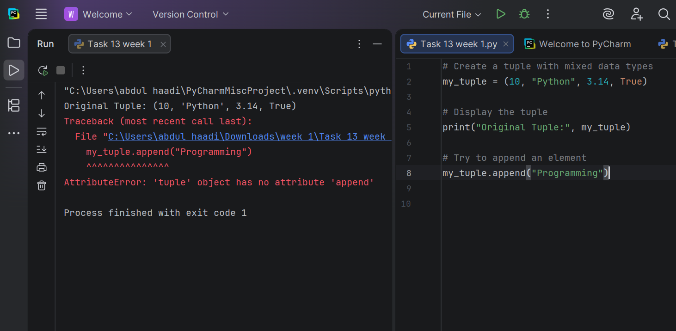

Task 6:
Create a tuple of fruits. Try to change the first element to "grape" and observe the error. (Note: This
will generate a TypeError)

Result:

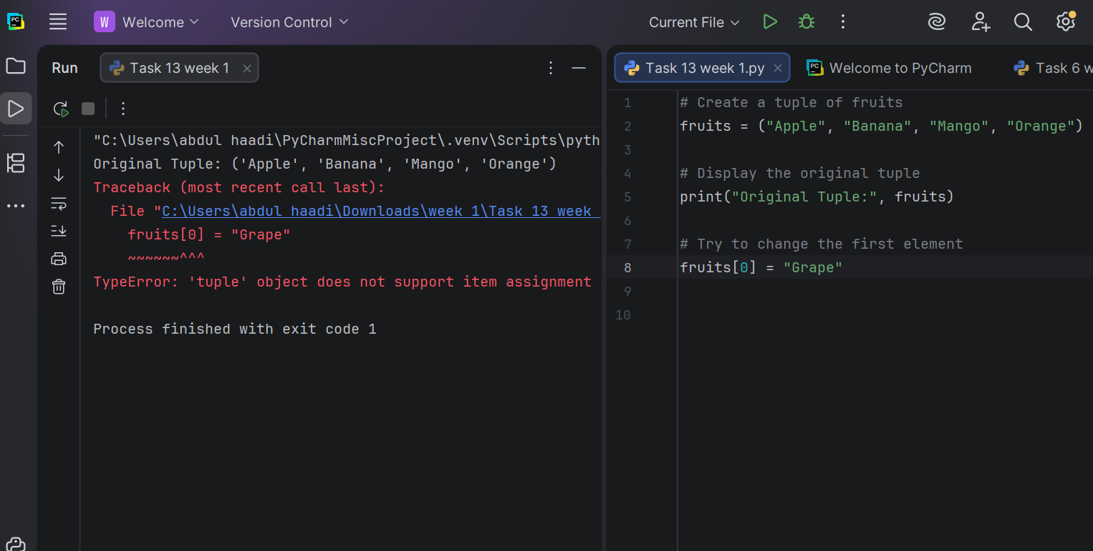

Task 7:
Create a tuple with three numbers and print its type using the type() function.

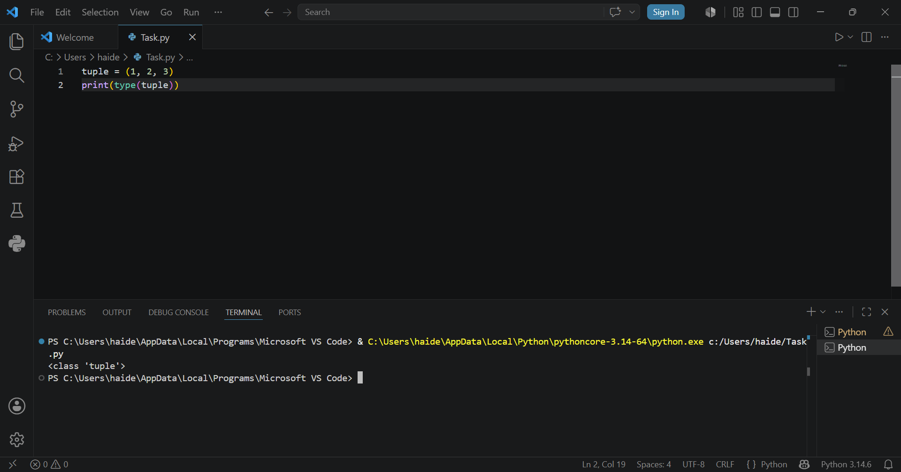
Result:
Conclusion:
Lists and tuples are both fundamental data structures in Python used to store collections of items, but they have a crucial difference: mutability. Lists are mutable, meaning their elements can be changed, added, or removed after creation, as demonstrated when we appended an element to a list. Tuples, on the other hand, are immutable – once created, their elements cannot be modified, added, or removed. This immutability was clearly shown when we tried to append to a tuple (getting an AttributeError) and when we attempted to change an element (getting a TypeError). Both structures can store mixed data types (integers, strings, etc.) and are accessed using indexing. While lists are more flexible and commonly used for dynamic data, tuples are preferred for fixed data that shouldn't change, offering better performance and serving as dictionary keys. Understanding when to use each is essential for writing efficient and bug-free Python code!

Result:
Week 8
University Of Engineering and Technology, Lahore Computer Engineering Department

Course Name: PF | Course Code: CMPE-112L
Assignment Type: LAB | Dated: 18 May 2026
Semester: 1st | Session: 2026 Spring
Lab/Project/Assignment #: 8 | CLOs to be covered: CLO
Lab Title: Dictionaries and Sets | Teacher Name: Hafiz Muhammad Mubashar

Lab Evaluation:

CLO1 | Apply appropriate programming techniques to create executable programs to solve well defined problems
 | Level1 | Level2 | Level3 | Level4 | Level5 | Level6
(5)
Total |  |  |  |  |  | /5

Rubrics for Current Lab Evaluation

Scale | Marks | Level | Rubric
Excellent | 5 | L1 | Submitted all lab tasks, BONUS task, have good understanding.
Very Good | 4 | L2 | Submitted the lab tasks but have good understanding
Good | 3 | L3 | Submitted the lab tasks but have weak understanding.
Basic | 2 | L4 | Submitted the lab tasks but have no understanding.
Barely Acceptable | 1 | L5 | Submitted only one lab task.
Not Acceptable | 0 | L6 | Did not attempt

LAB No 8

Lab Goals/Objectives:
- Understand the concept of Sets and Dictionaries in Python.
- Learn how to store and manage data using sets and key–value pairs.
- Create programs using set operations and dictionary methods.
- Understand accessing, updating, and manipulating data collections.

Equipment Required:
- Computer/Laptop

- Python IDE
- Python Interpreter

Theory:
A dictionary is an unordered collection of data stored in key : value pairs.Key Points:Mutable : You can add, remove, or change itemsKeys must be unique and immutable : int, string, tupleValues can be anything : int, string, list, dict, etcAccessed by key, not by indexSyntax : dict = {"name": "Ali", "age": 20}

Lab Work:

Task 1:
Create a dictionary with English words as keys and their Urdu translations as values. Access and print the translations for "apple" and "mango". Then add a new pair "dates":langoor" and print the updated dictionary.
Result:
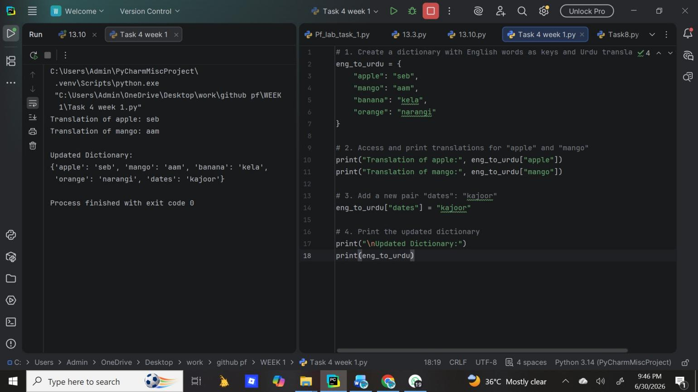

Task 2:
Create a dictionary with at least 3 key-value pairs (like fruits and their translations). Access and print the value of only one specific key using square bracket notation.

Result:
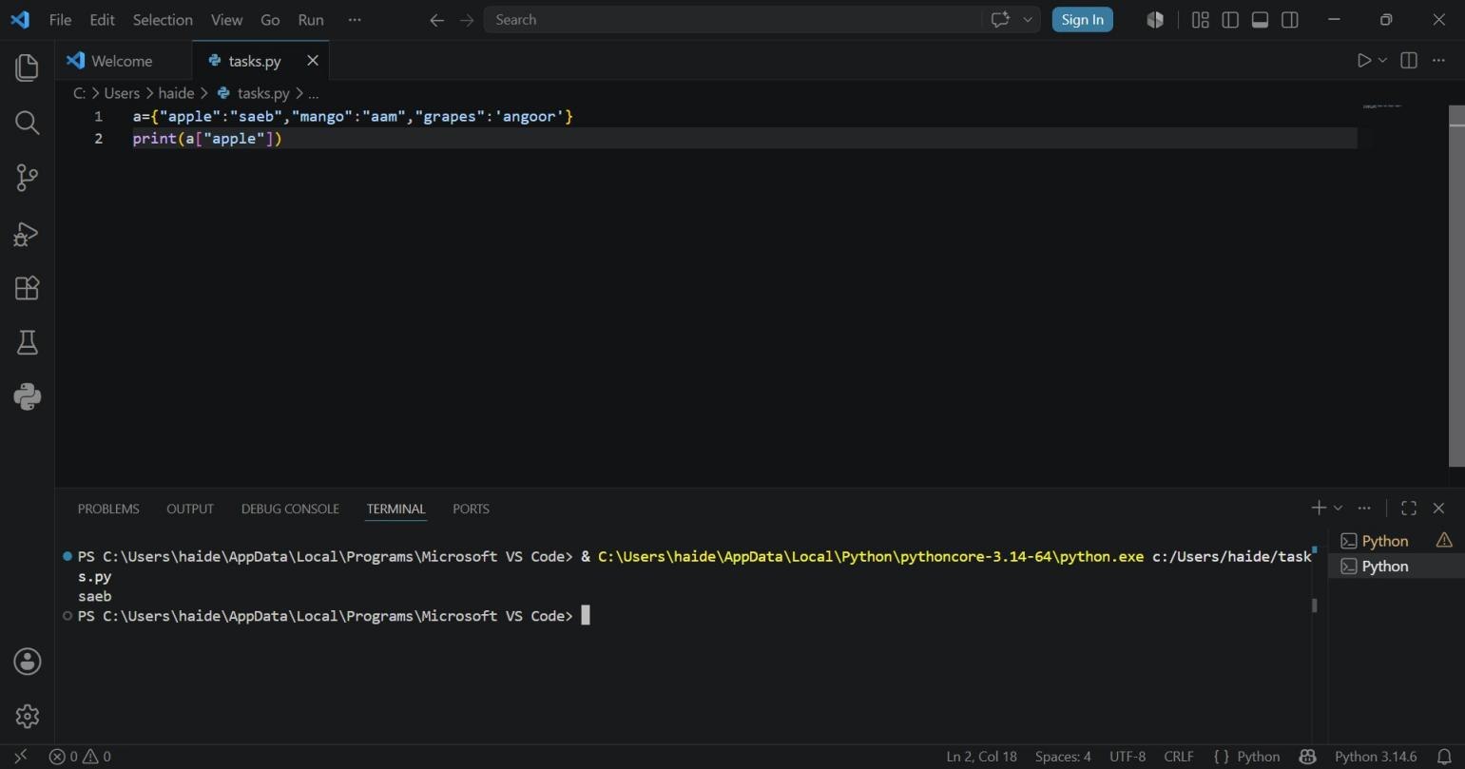

Task 3:
Write a Python program to create a dictionary of student information and demonstrate the use of the following dictionary functions: keys(), values(), items(), get(), update(), pop(), and clear(). Display the output after each operation.

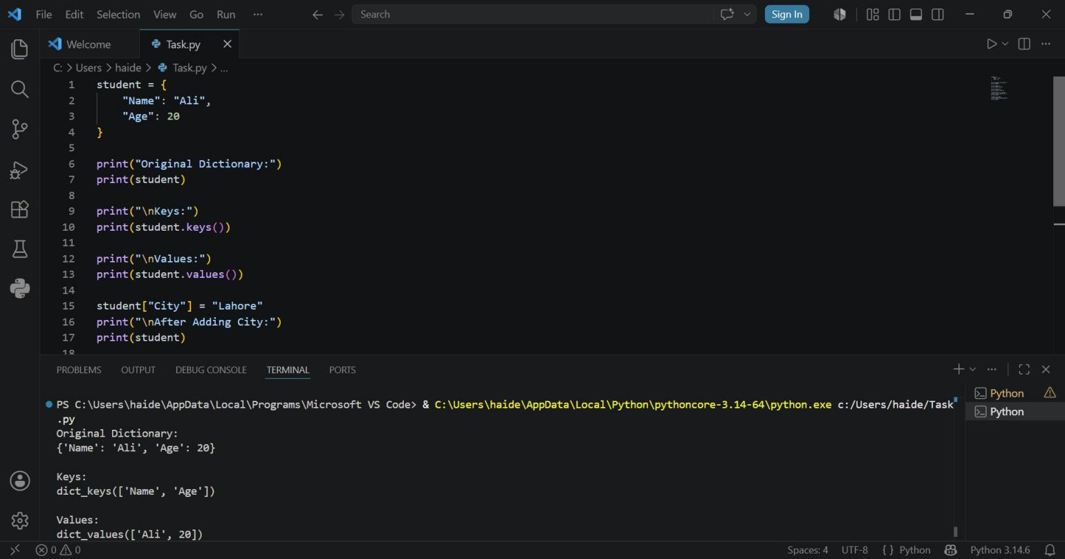
Result:

Task 4:
Create an empty set and an empty dictionary. Print both their types to show the difference between them.
Result:
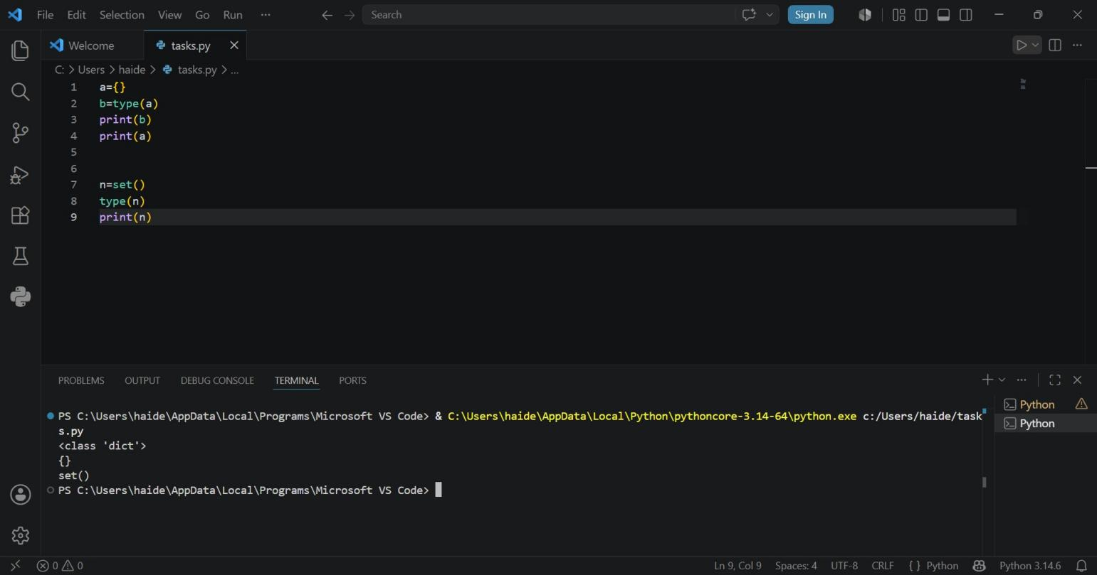

Task 5:
Create a set with some names. Ask the user to input a name and check if it exists in the set, printing an appropriate message.

Result:
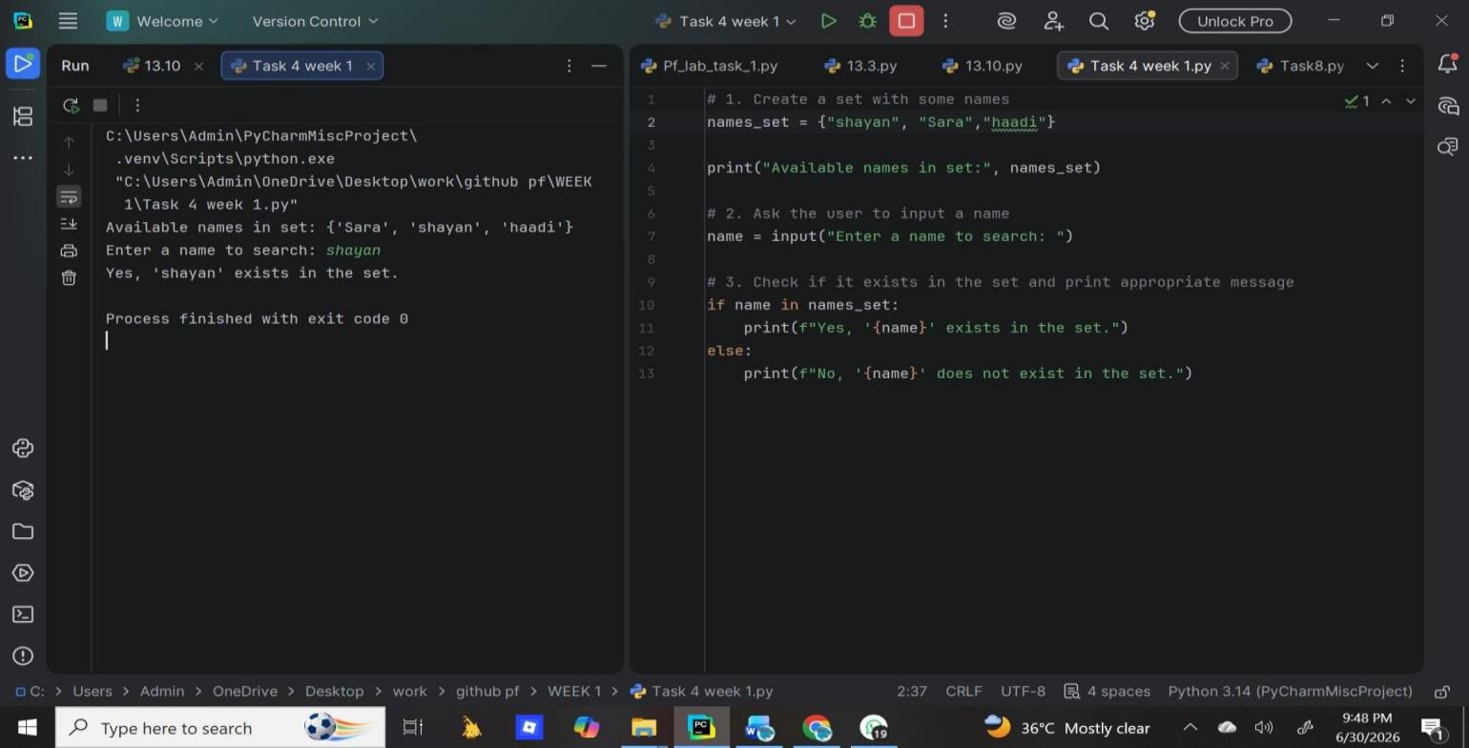

Task 6:
Create a set with initial elements. Add a new element, remove an existing element, and try to remove a non-existent element using the discard() method (which won't raise an error). Print the final set.
Result:

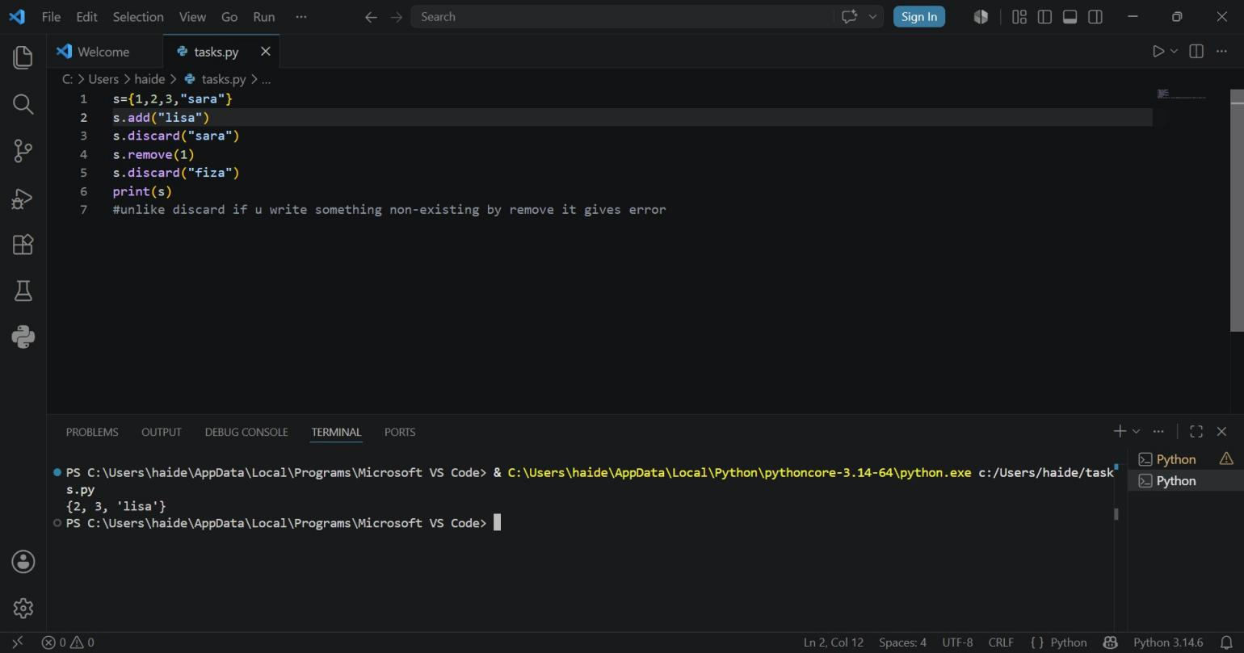
Task 7:
Create a set with some elements. Remove a random element using pop(), print the remaining set, then clear all elements and print the empty set.

Result:
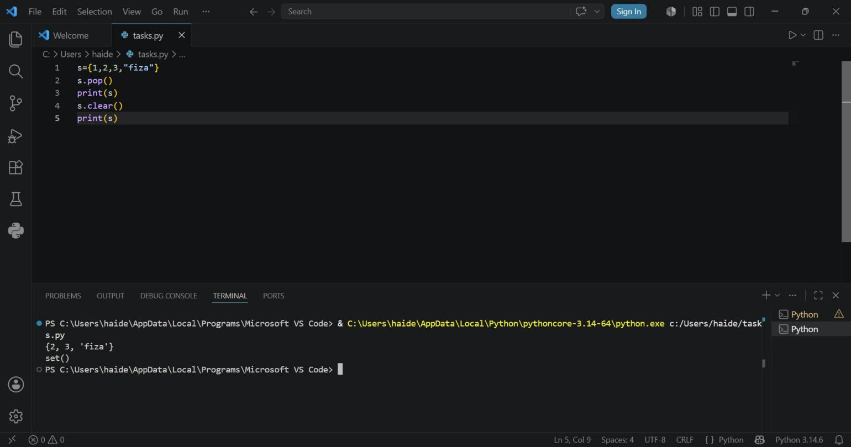
Task 8:
Create three sets and find their union using set.union() method. Print the result.

Result:
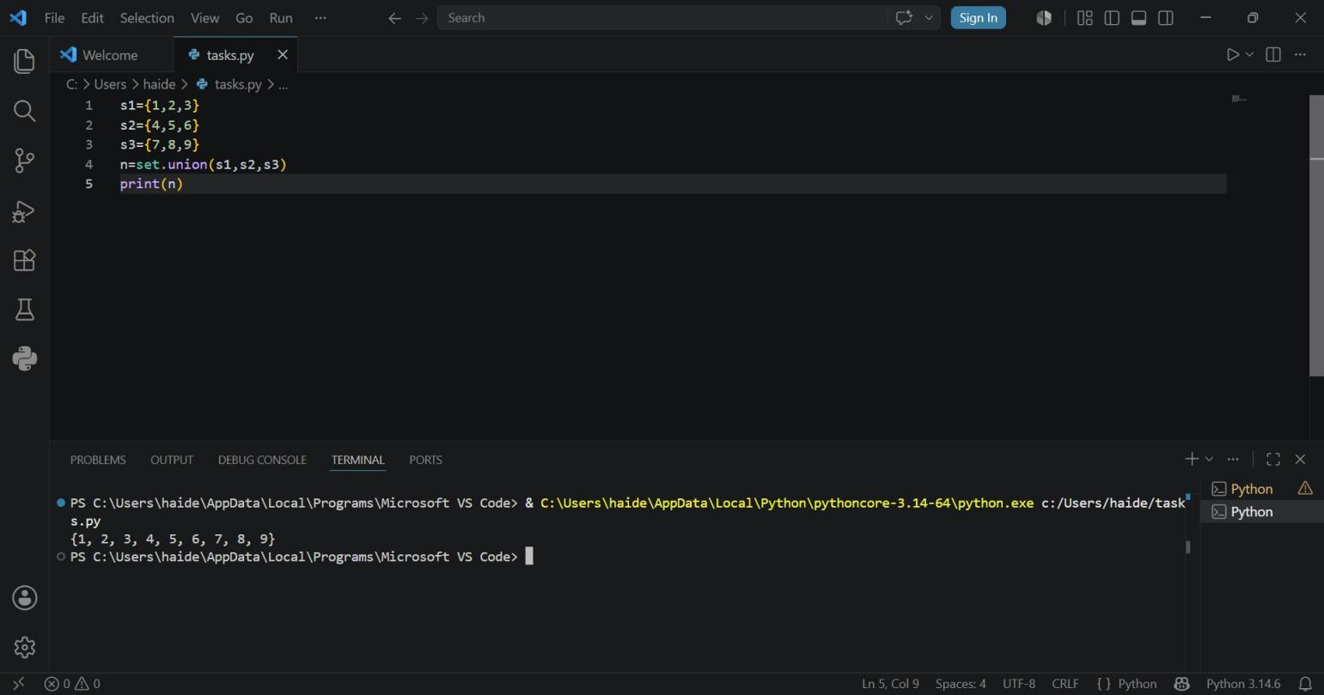

Task 9:
Create three sets. Update the second set with elements from the third set, then update the first set with elements from the updated second set. Print all three sets to see the changes.
Result:
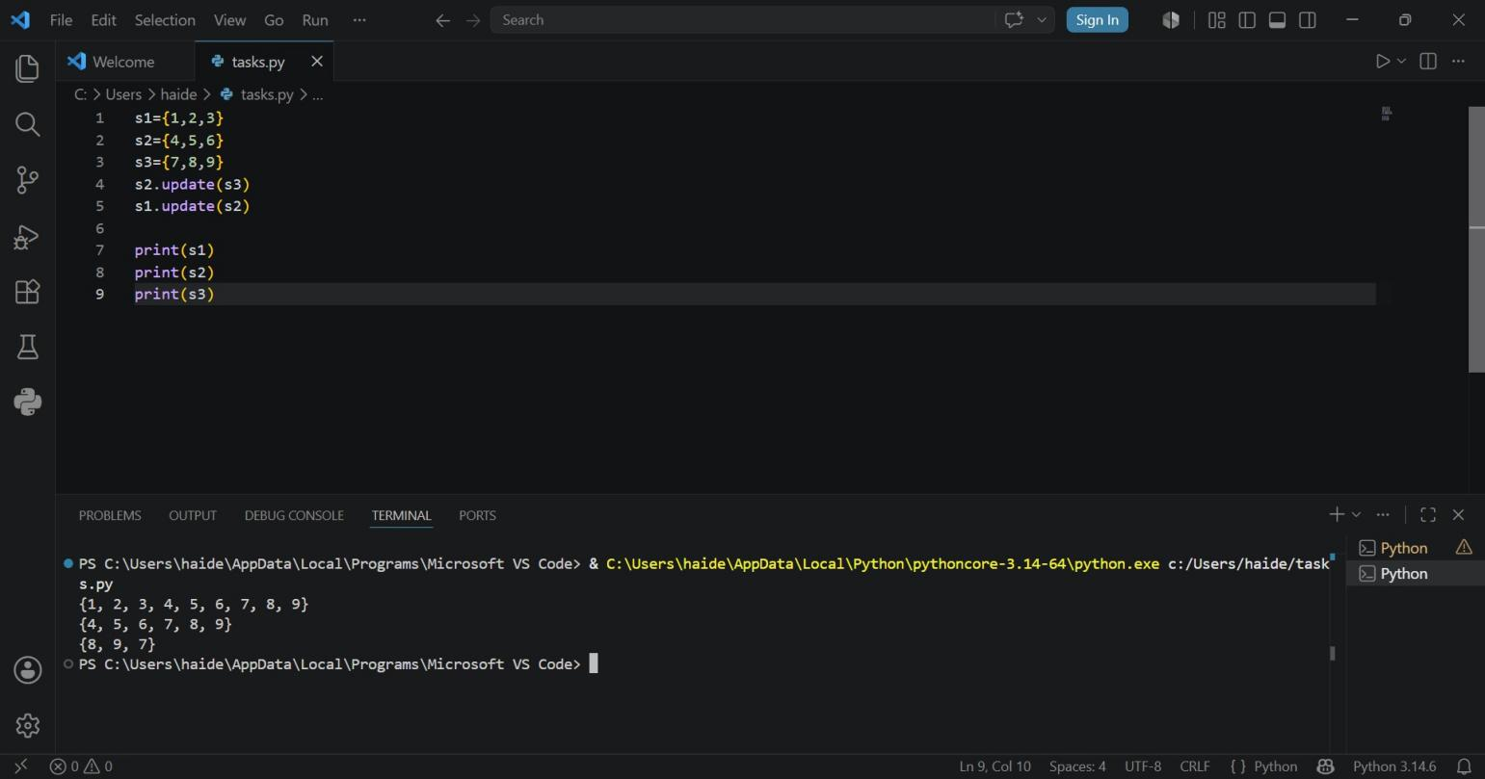
Task 10:

Create three sets with some common elements. Find their intersection using set.intersection() and print the result. Also demonstrate intersection_update() by modifying the first set.
Result:
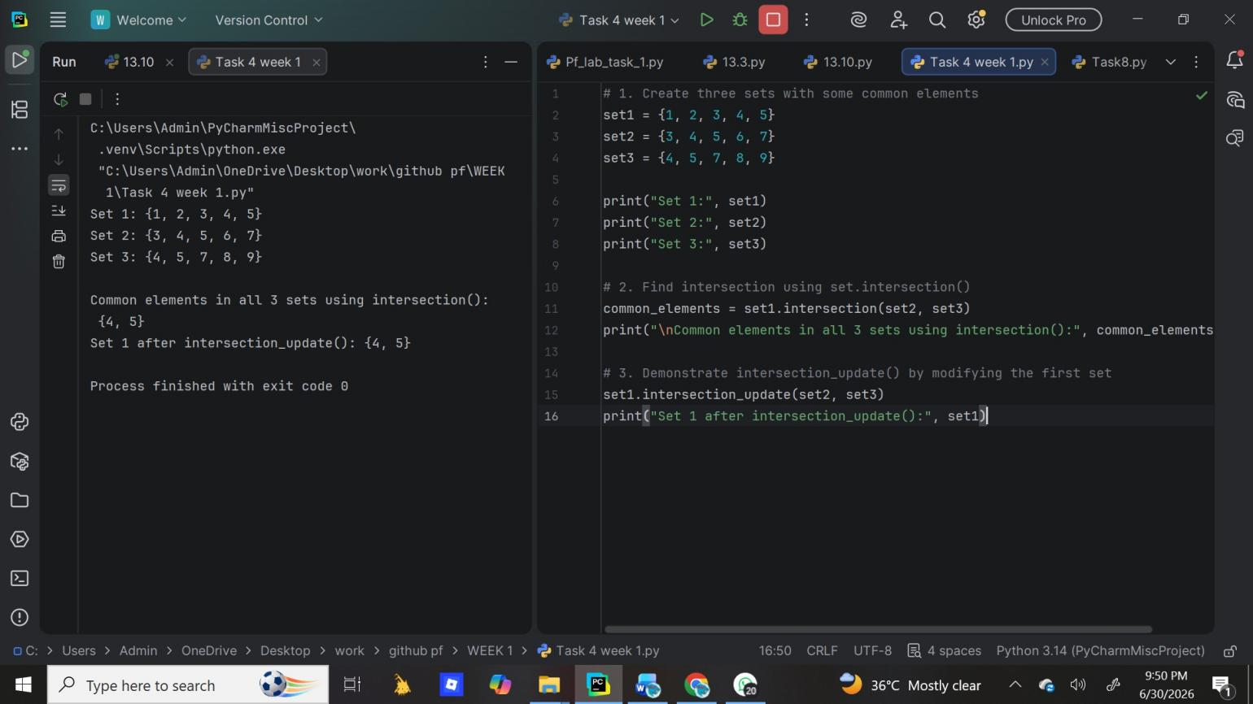

Task 11:
Create two sets. Check if they have any common elements using the isdisjoint() method and print the boolean result.

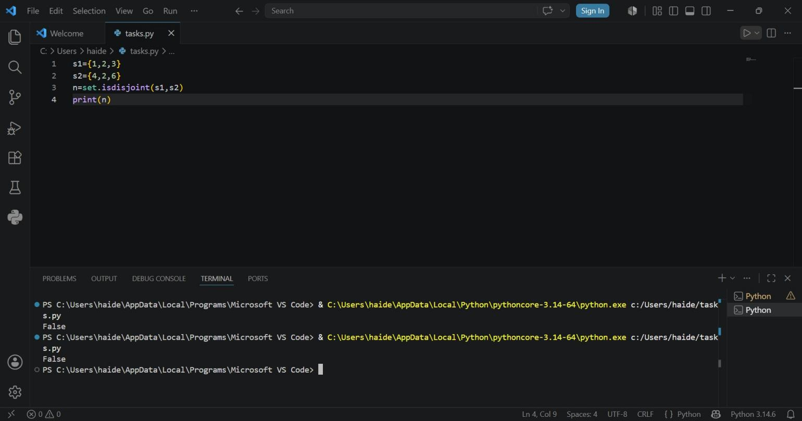
Result:

Task 12:
Create a set with duplicate values and observe that duplicates are automatically removed. Then create another set with duplicate string values and print both sets. Finally, convert a list [1,2,3,7] into a set using the set() constructor and print the resulting set.

Result:
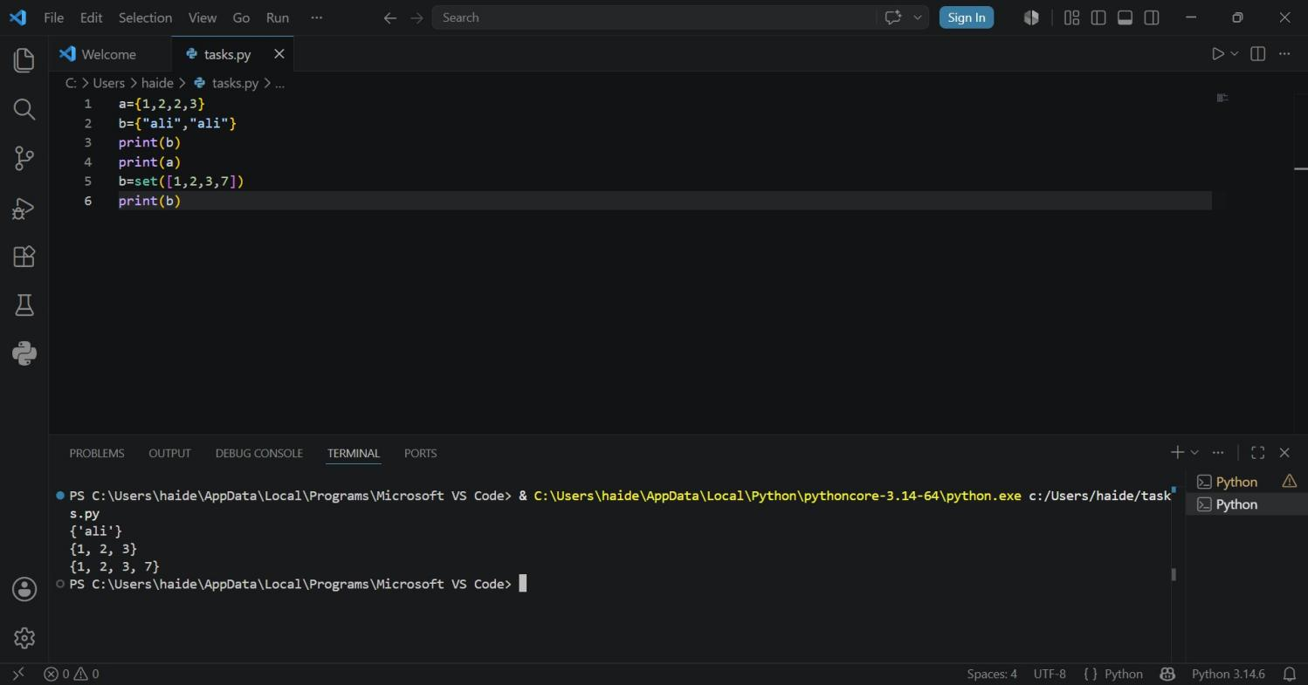

Conclusion:
In this lab we learned that Dictionary and Set are both very useful built-in data structures in Python.Dictionary helps us store related data with labels. It is best when we need to map a key to a value, like roll no to student name.
Set helps us store only unique items and perform fast membership checks and mathematical operations.Both structures make our programs more efficient.
Dict is used for structured data storage, while Set is used for uniqueness and set logic.Together, dict and set reduce code complexity and improve performance compared to using only lists.

Week 10
University Of Engineering and Technology, Lahore Computer Engineering Department

Course Name: PF | Course Code: CMPE-112L
Assignment Type: LAB | Dated: 18 May 2026
Semester: 1st | Session: 2026 Spring
Lab/Project/Assignment #: 10 | CLOs to be covered: CLO
Lab Title: Recursion | Teacher Name: Hafiz Muhammad Mubashar

Lab Evaluation:

CLO1 | Apply appropriate programming techniques to create executable programs to solve well defined problems
 | Level1 | Level2 | Level3 | Level4 | Level5 | Level6
(5)
Total |  |  |  |  |  | /5

Rubrics for Current Lab Evaluation

Scale | Marks | Level | Rubric
Excellent | 5 | L1 | Submitted all lab tasks, BONUS task, have good understanding.
Very Good | 4 | L2 | Submitted the lab tasks but have good understanding
Good | 3 | L3 | Submitted the lab tasks but have weak understanding.
Basic | 2 | L4 | Submitted the lab tasks but have no understanding.
Barely Acceptable | 1 | L5 | Submitted only one lab task.
Not Acceptable | 0 | L6 | Did not attempt

LAB No 10
Lab Goals/Objectives:
- Understand the concept and working of Recursion.
- Learn how a function can call itself repeatedly.
- Create programs using recursive functions.
- Understand the importance of base case and recursive case.

Equipment Required:
- Computer/Laptop

- Python IDE
- Python Interpreter

Theory:
1. Definition Recursion is a programming technique where a function calls itself directly or indirectly to solve a problem. The problem is broken down into smaller, similar subproblems until it reaches a simplest case that can be solved directly.2. Key Components of a Recursive FunctionBase Case: The condition that stops the recursion. Without it, the function will call itself infinitely and cause a stack overflow.Recursive Case: The part where the function calls itself with a smaller/simpler input, moving toward the base case.Recursive Call: The function invokes a new copy of itself.3.
2. How Recursion Works When a recursive function is called, each call is stored in the call stack. The function keeps calling itself until the base case is reached. Then the results start returning back up the stack and combine to give the final answer.4. Types of RecursionDirect Recursion: Function calls itself directly. func() -> func()Indirect Recursion: Function A calls B, and B calls A.Tail Recursion: Recursive call is the last statement in the function.Head Recursion: Recursive call is the first statement.

Lab Work:

Task 1:
Create a function that takes two numbers as parameters, adds them, and returns the result. Call the function with values 1 and 2, and print the returned value.

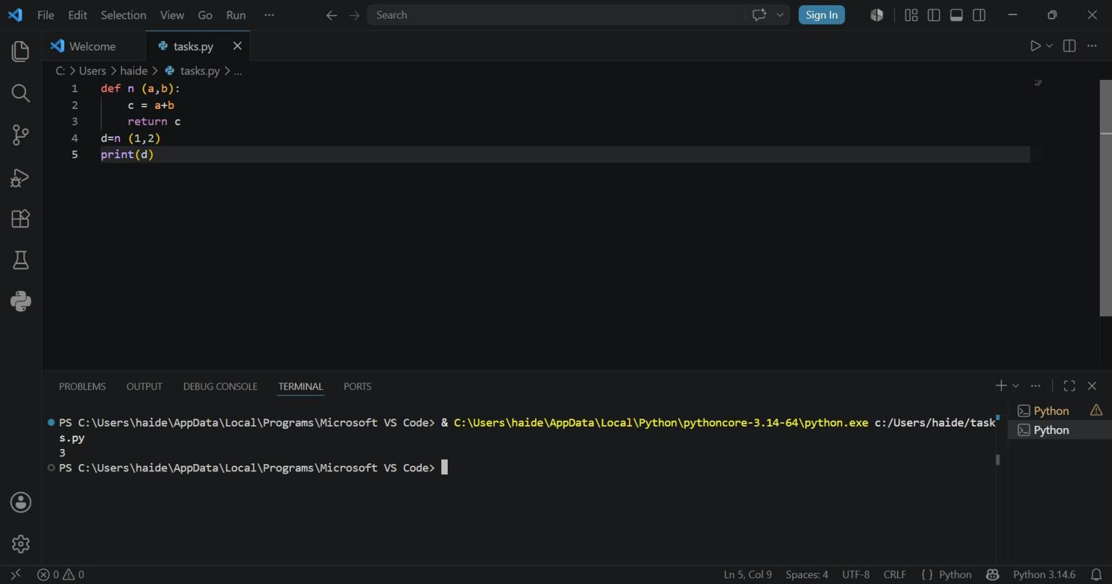
Result:

Task 2:
Write a recursive function that prints numbers from a given number down to 0. Call the function with the value 5.

Result:
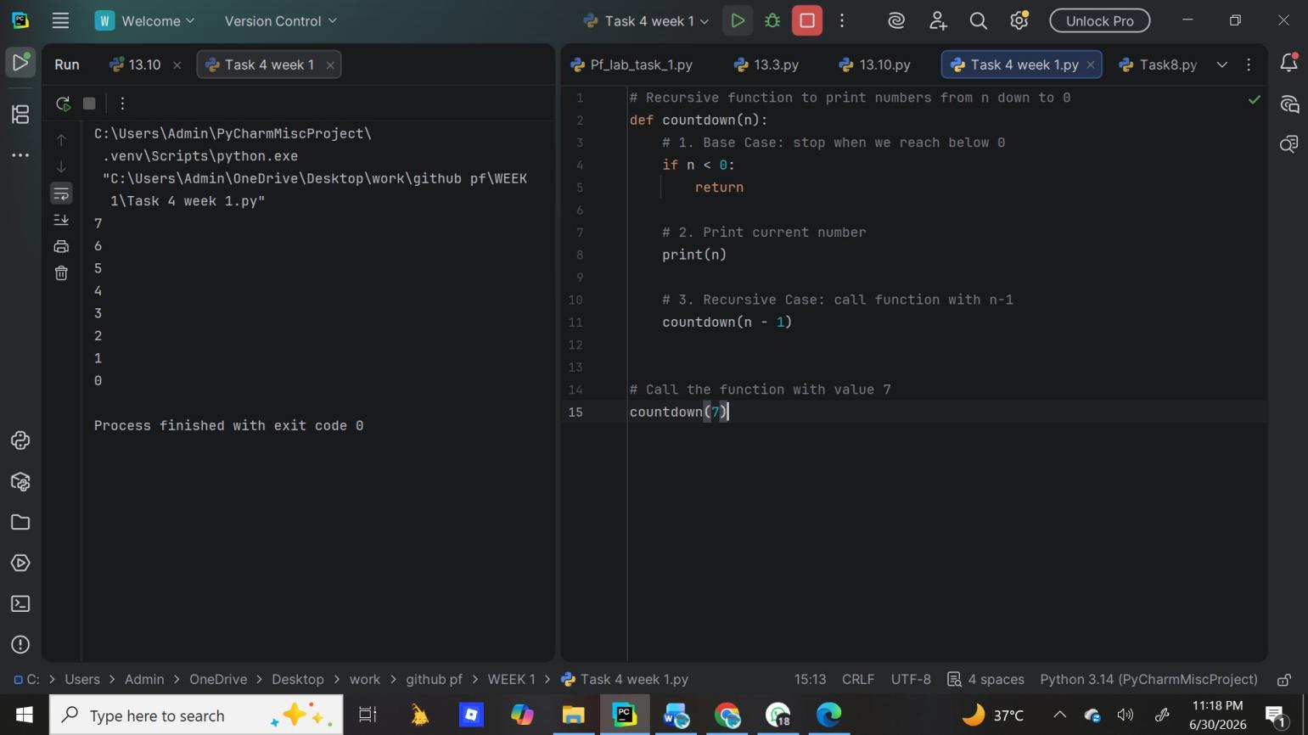

Task 3:
Write a recursive function that returns 1 if the number is 0 or 1, otherwise calls itself with (n-1). Call the function with 6 and print the result.
Result:

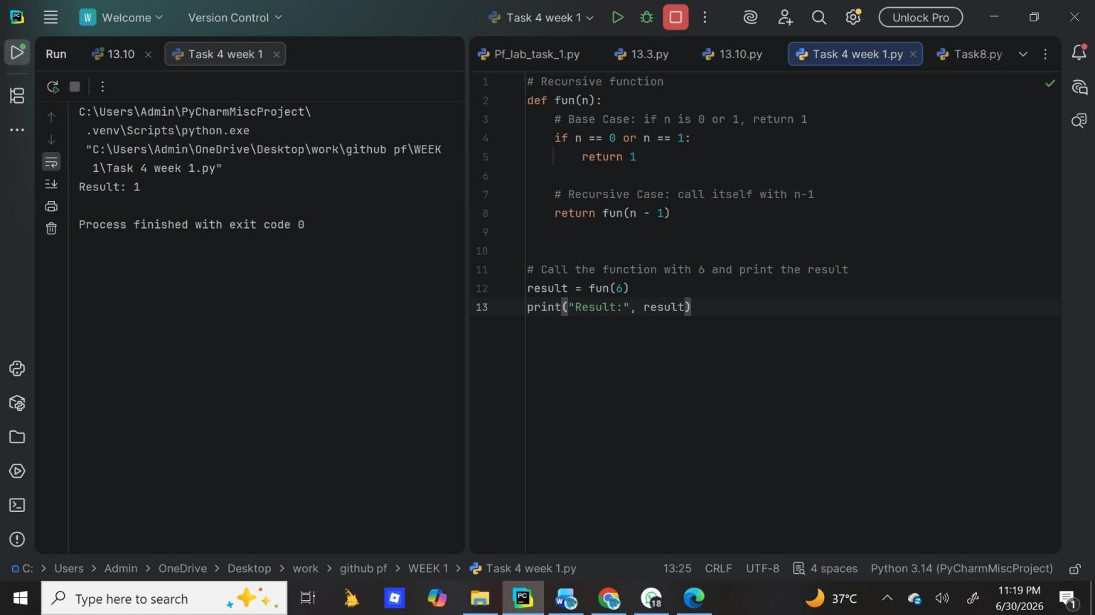

Task 4:
Write a recursive function that returns 1 for base cases (0 or 1), otherwise calls itself with (n-1). Call the function with 6 and print the result.

Result:
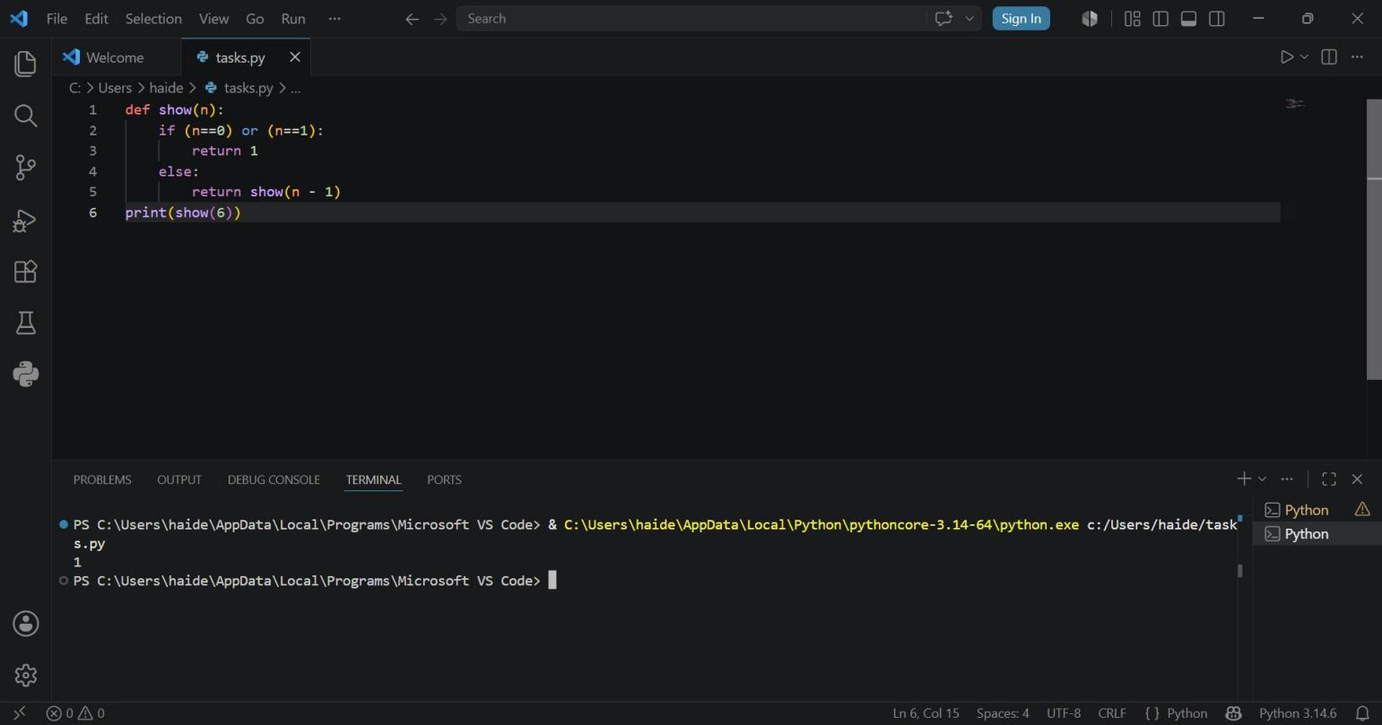

Task 5:
Write a recursive function to calculate the factorial of a number. Take user input, check if it's negative, and print the factorial result.

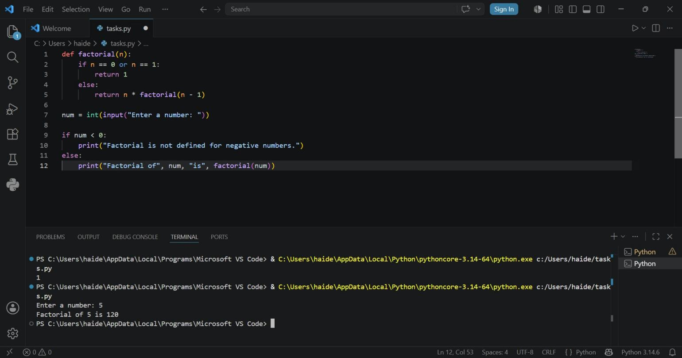
Result:

Task 6:
Write a recursive function to generate the Fibonacci sequence. Print the first 8 Fibonacci numbers using a loop.

Result:
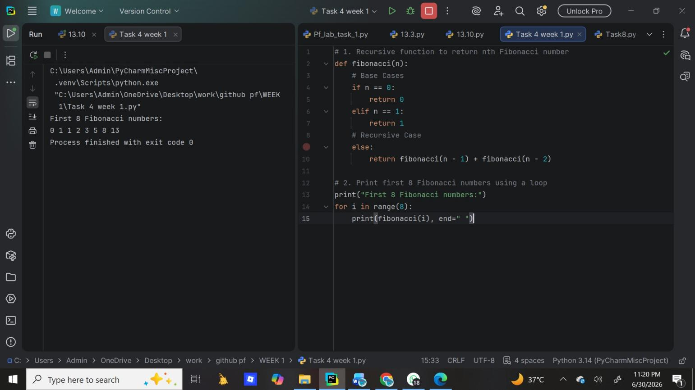

Conclusion:
Recursion is a powerful problem-solving approach that simplifies complex problems by dividing them into smaller sub-problems of the same type. It improves code readability and is ideal for problems with recursive structure like trees and divide-and-conquer algorithms. However, it should be used carefully because of higher memory usage and performance overhead compared to iteration. In practice, recursion is best when clarity is more important than performance, and when the recursion depth is limited. For large data, iterative solutions or tail recursion optimization are preferred.

Week 11
University Of Engineering and Technology, Lahore Computer Engineering Department

Course Name: PF | Course Code: CMPE-112L
Assignment Type: LAB | Dated:
Semester: 1st | Session: 2026 spring
Lab/Project/Assignment #: 11 | CLOs to be covered: CLO4
Lab Title: Exceptional Handling | Teacher Name: Hafiz Muhammad Mubashar

Lab Evaluation:

CLO1 | Apply appropriate programming techniques to create executable programs to solve well defined problems
 | Level1 | Level2 | Level3 | Level4 | Level5 | Level6
(5)
Total |  |  |  |  |  | /5

Rubrics for Current Lab Evaluation

Scale | Marks | Level | Rubric
Excellent | 5 | L1 | Submitted all lab tasks, BONUS task, have good understanding.
Very Good | 4 | L2 | Submitted the lab tasks but have good understanding
Good | 3 | L3 | Submitted the lab tasks but have weak understanding.
Basic | 2 | L4 | Submitted the lab tasks but have no understanding.
Barely Acceptable | 1 | L5 | Submitted only one lab task.
Not Acceptable | 0 | L6 | Did not attempt

LAB No 11

Lab Goals/Objectives:
- To understand exceptions and errors in Python.
- To learn how to handle runtime errors.
- To use try, except, else, and finally blocks.
- To improve program reliability.

Equipment Required:
- Computer/Laptop
- Python
- Visual Studio Code / PyCharm / IDLE
- Window operating system

Theory:
Exception handling is a technique used to prevent a program from crashing when an error occurs during execution. Python provides the try and except blocks to detect and handle errors gracefully. The else block executes when no exception occurs, while the finally block alway executes regardless of whether an exception is raised. Exception handling improves the reliability and user-friendliness of a program.

Lab Work:

Task 1:
Write a Python program using try-except to take an integer age input and display an error message if the user enters letters instead of a number.
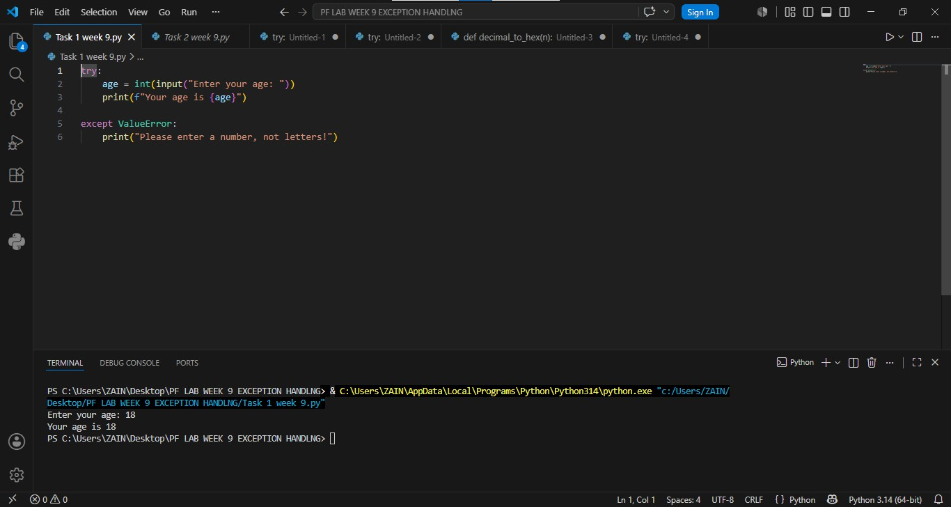
Result:

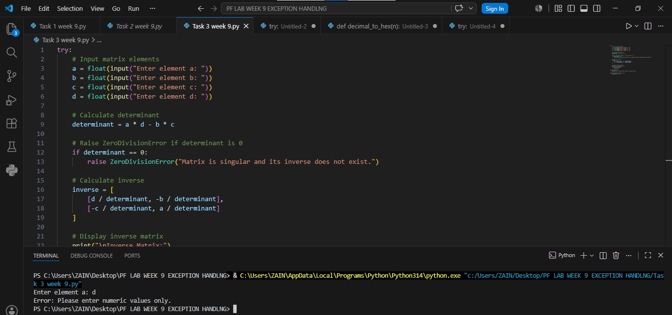
Task 2:
Write a Python program using try-except to take age as an integer input from the user and handle ValueError if the input is not a number.

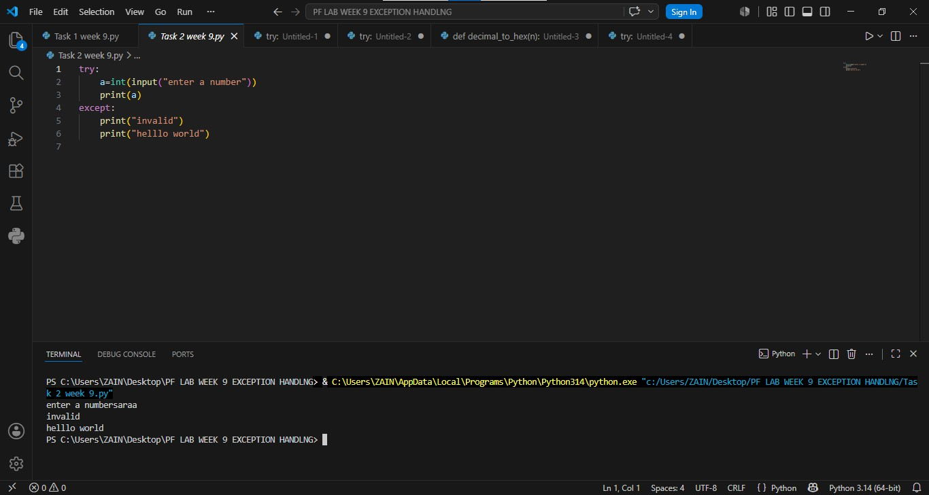
Result:

Task 3:
Write a Python program to take four float inputs for a 2x2 matrix, calculate its determinant and inverse, and handle ValueError for non-numeric input and ZeroDivisionError if the determinant is zero.
Result:

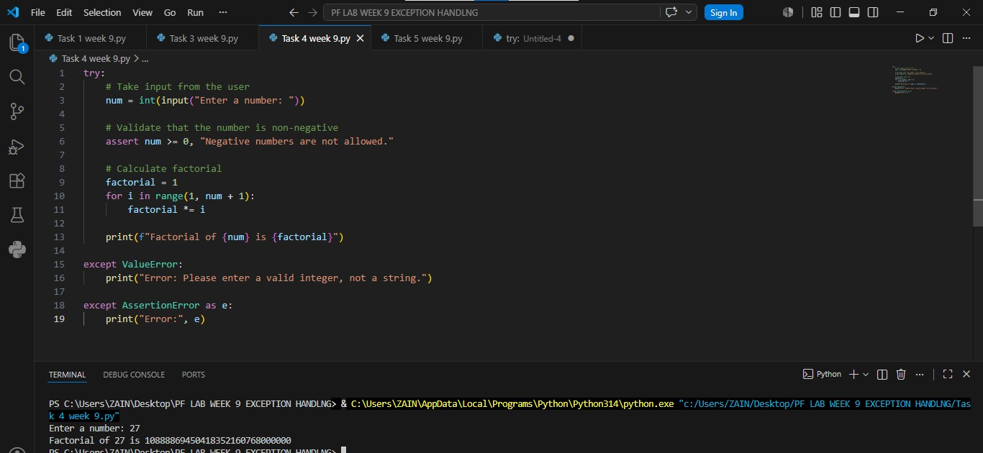
Task 4:
Write a Python program with a function that converts a decimal number to hexadecimal, raises a TypeError if the input is a string, and handles the exception to display an error message.

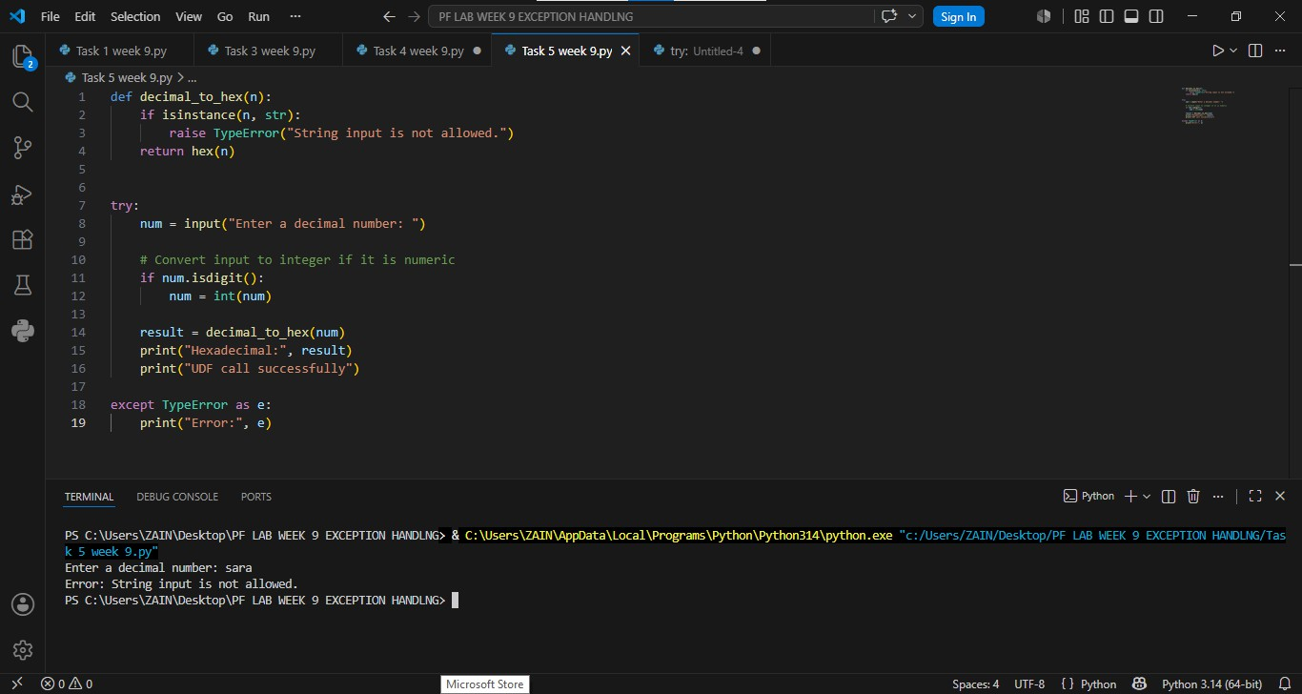
Result:

Task 5:
Write a Python program to take an integer input, use assert to ensure the number is non-negative, calculate its factorial, and handle ValueError for invalid input and AssertionError for negative numbers.

Result:

Task 6:

Write a Python program to take name, address, contact number, age, and gender as input, validate each field with specific conditions using exceptions, and display the biodata only if all inputs are valid.

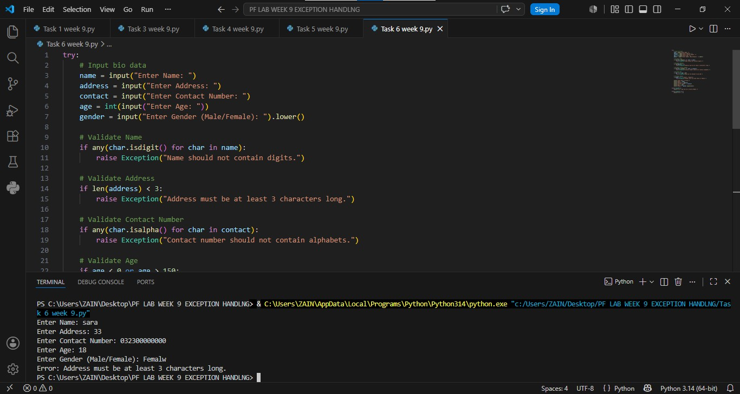
Result:

Conclusion:
This lab helped us understand the importance of exception handling in Python programs. We learned how to use try, except blocks to detect and handle runtime errors effectively. By using these techniques, programs become more reliable, user-friendly, and less likely to terminate unexpectedly due to errors

Week 12
University Of Engineering and Technology, Lahore Computer Engineering Department

Course Name: PF | Course Code: CMPE-112L
Assignment Type: lab | Dated: 25 MAY 2026
Semester: 1st | Session: Spring 2026
Lab/Project/Assignment #: 12 | CLOs to be covered: CLO2
Lab Title: Lambda functions | Teacher Name: Hafiz Muhammad Mubashar

Lab Evaluation:

CLO1 | Apply appropriate programming techniques to create executable programs to solve well defined problems
 | Level1 | Level2 | Level3 | Level4 | Level5 | Level6
(5)
Total |  |  |  |  |  | /5

Rubrics for Current Lab Evaluation

Scale | Marks | Level | Rubric
Excellent | 5 | L1 | Submitted all lab tasks, BONUS task, have good understanding.
Very Good | 4 | L2 | Submitted the lab tasks but have good understanding
Good | 3 | L3 | Submitted the lab tasks but have weak understanding.
Basic | 2 | L4 | Submitted the lab tasks but have no understanding.
Barely Acceptable | 1 | L5 | Submitted only one lab task.
Not Acceptable | 0 | L6 | Did not attempt

LAB No 12

Lab Goals/Objectives:
- To understand anonymous functions.
- To create and use lambda functions.
- To write short and efficient code.
- To use lambda functions with built-in functions

Equipment Required:
- Computer/Laptop

- Python 3.x
- VS Code / PyCharm / IDLE

Theory:
A lambda function in Python is a small, anonymous function. "Anonymous" means it does not have a name like normal functions defined with def.It was introduced to write functions quickly without formally defining them.

Lab Work:

Task 1:
write the given Python program that uses normal `def` functions to calculate cube and square of a number by using lambda functions instead.

Result:
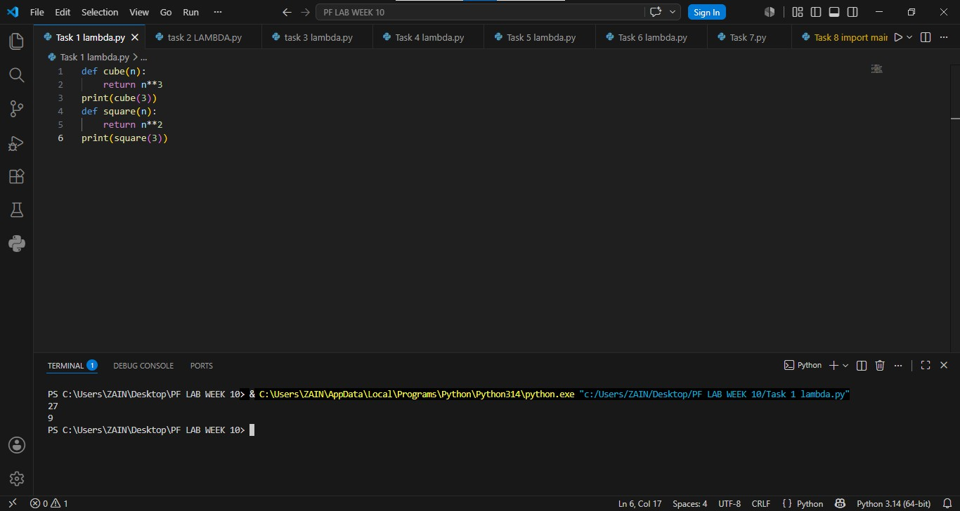

Task 2:

Write a Python program using a lambda function to calculate the cube of a number and print the result.

Result:
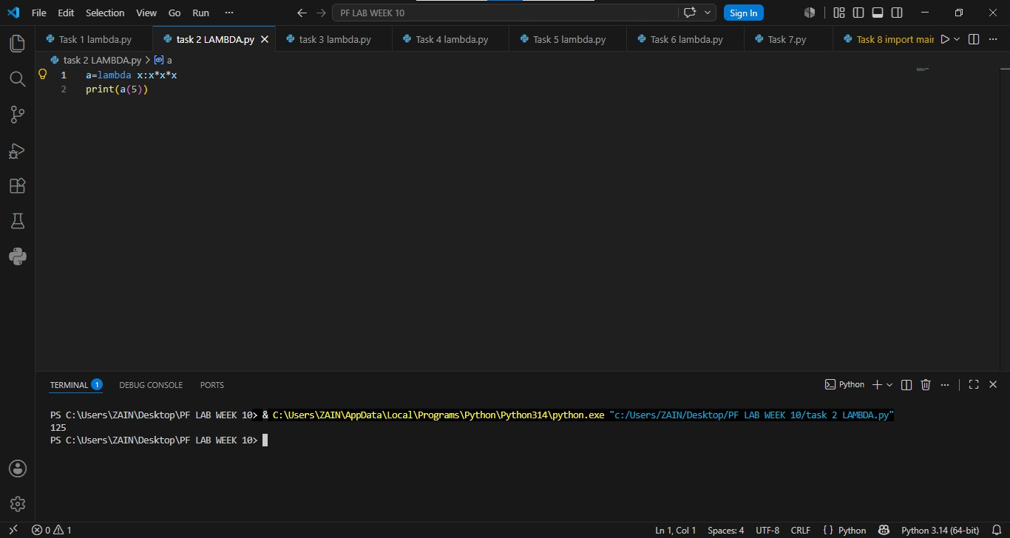

Task 3:
Write a Python program that uses a lambda function to calculate the sum of three numbers then print the result.
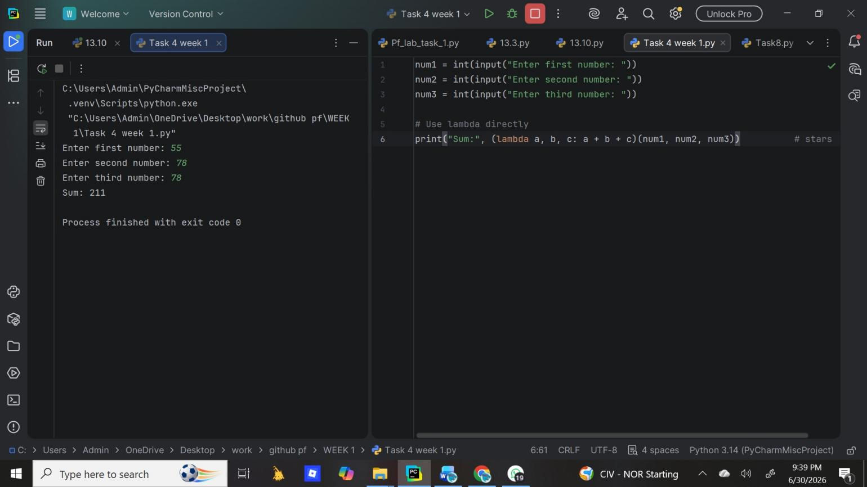
Result:

Task 4:

Result:

Write a Python program to create a lambda function that takes three numbers as input and returns their sum

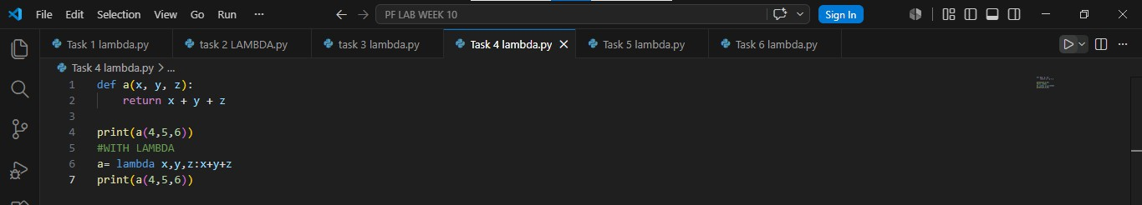

Task 5:
Write a Python program using a lambda function with the square all elements in the list and print the updated list.
Result:

Task 6:

Write a Python program using two lambda functions —
one to add two numbers and one to multiply two numbers

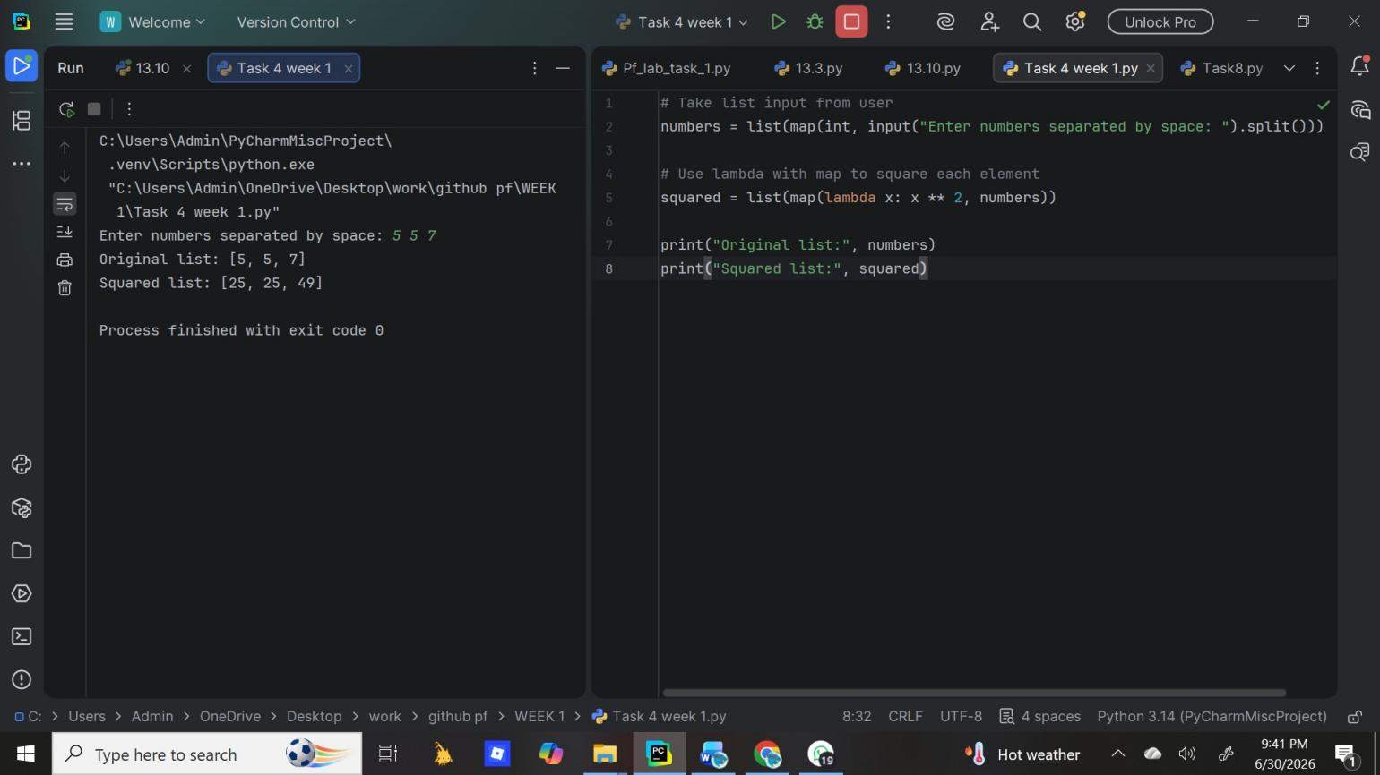
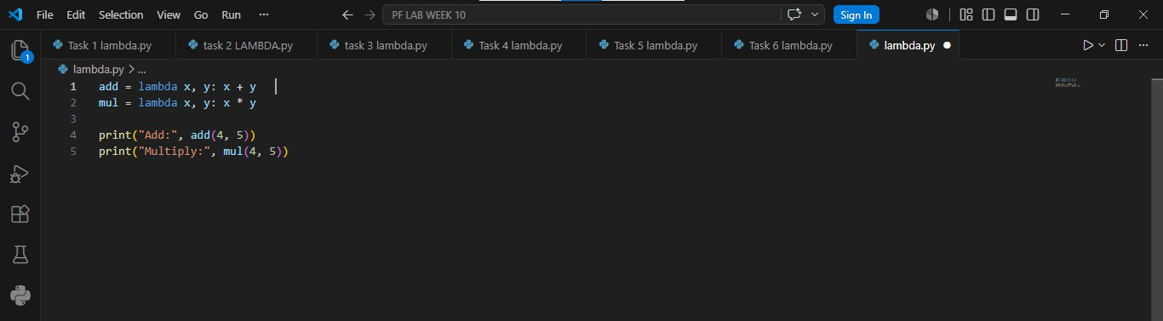

Result:

Conclusion
Lambda functions provide a quick way to write small functions inline. They make code shorter and cleaner, especially when used with map, filter, and sorted. However, for complex logic, normal def functions are preferred because they are more readable.

Week 13
University Of Engineering and Technology, Lahore Computer Engineering Department

Course Name: PF | Course Code: CMPE-112L
Assignment Type: Lab | Dated: 25 may 2026
Semester: 1st | Session: Spring 2026
Lab/Project/Assignment #: 13 | CLOs to be covered: CLO2
Lab Title: MAP, Filter and Reduce | Teacher Name: Hafiz Muhammad Mubashar

Lab Evaluation:

CLO1 | Apply appropriate programming techniques to create executable programs to solve well defined problems
 | Level1 | Level2 | Level3 | Level4 | Level5 | Level6
(5)
Total |  |  |  |  |  | /5

Rubrics for Current Lab Evaluation

Scale | Marks | Level | Rubric
Excellent | 5 | L1 | Submitted all lab tasks, BONUS task, have good understanding.
Very Good | 4 | L2 | Submitted the lab tasks but have good understanding
Good | 3 | L3 | Submitted the lab tasks but have weak understanding.
Basic | 2 | L4 | Submitted the lab tasks but have no understanding.
Barely Acceptable | 1 | L5 | Submitted only one lab task.
Not Acceptable | 0 | L6 | Did not attempt

LAB No 13
Lab Goals/Objectives:
- To understand functional programming concepts.
- To use map(), filter(), and reduce().
- To process collections efficiently.
- To combine lambda functions with built-in functions

Equipment Required:
- Computer/Laptop
- Python
- Visual Studio Code / PyCharm / IDLE
Theory:
Python provides built-in functions such as map(), filter(), and reduce() for processing collections of data. The map() function applies a specified function to every item in an iterable, while filter() selects only those elements that satisfy a given condition. The reduce() function, available in the functools module, combines all elements into a single result. These functions simplify data processing and promote efficient programming.

Lab Work:

Task 1:

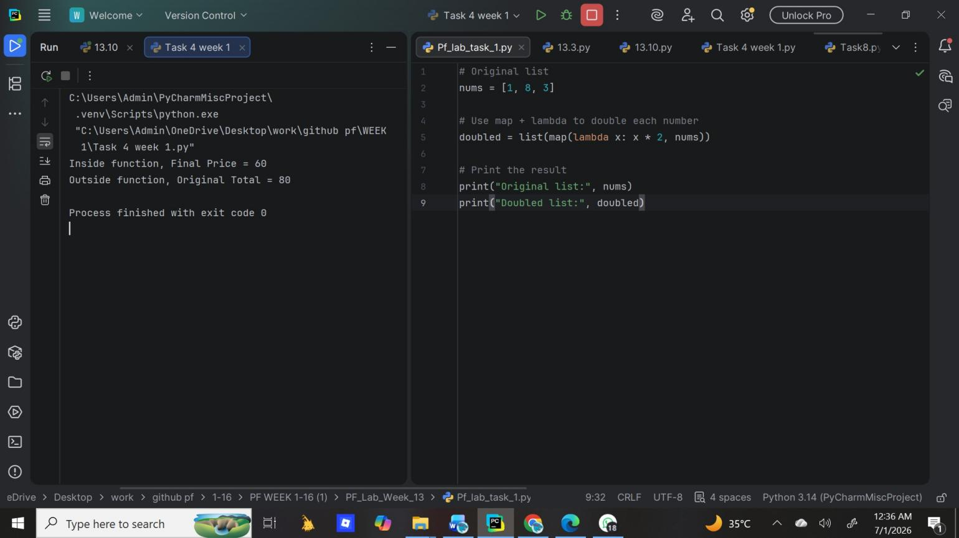
Result:

Write a Python program using `map` and a `lambda` function to double each number in the list `[1, 8, 3]` and print the result.

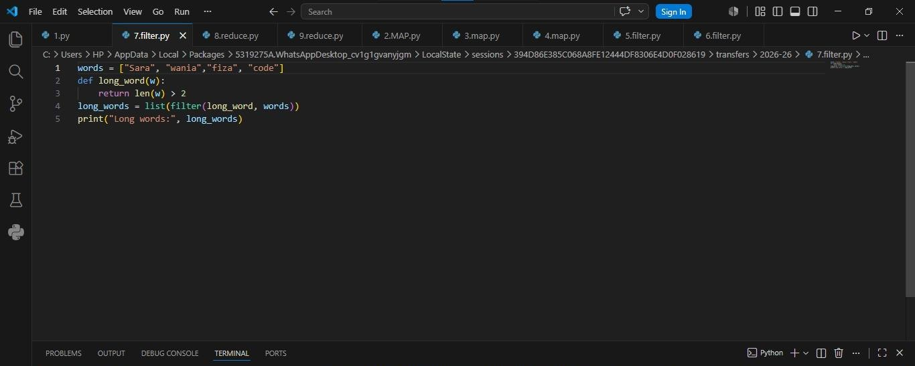

Task 2:
Write a Python program that defines a list `words , creates a `long_word(w)` function that returns `True` if `len(w) > 2`, uses `filter` with that function to get
all long words, and prints `Long words:` followed by the result.
Result:

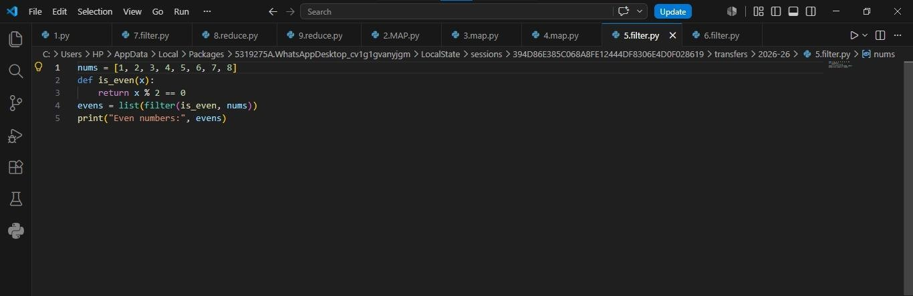

Task 3:
Write a Python program that defines an `is_even(x)` function returning `True` if `x % 2 == 0`, uses
`filter` with that function on a list, and prints `Even numbers:` followed by the result.
Result:

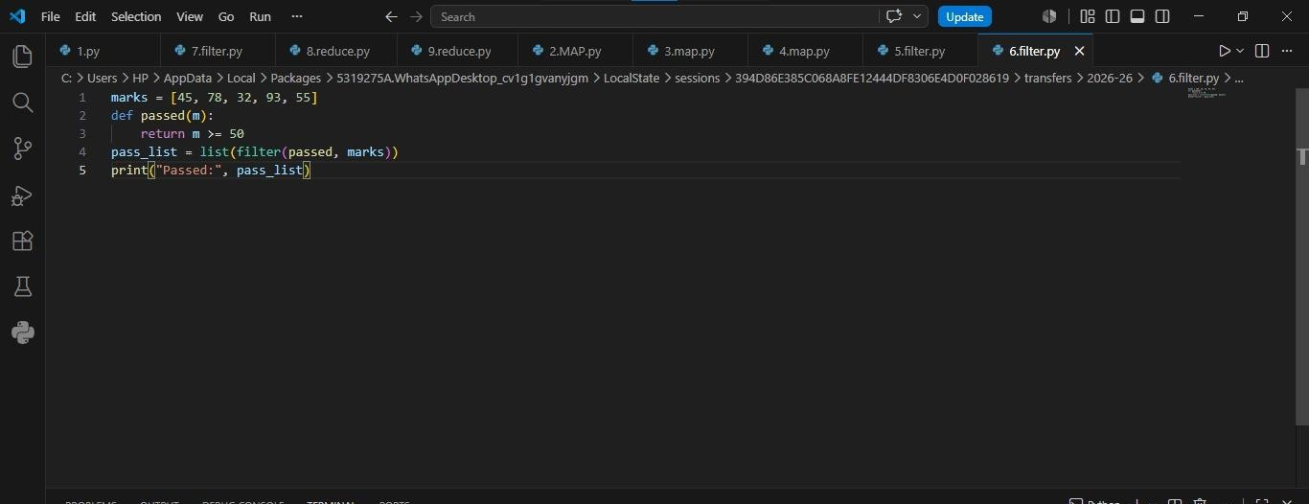

Task 4:
Write a Python program that defines a `passed(m)` function returning `True` if `m >= 50`, uses `filter` with that function on a list and prints `Passed:` followed by the result.
Result:

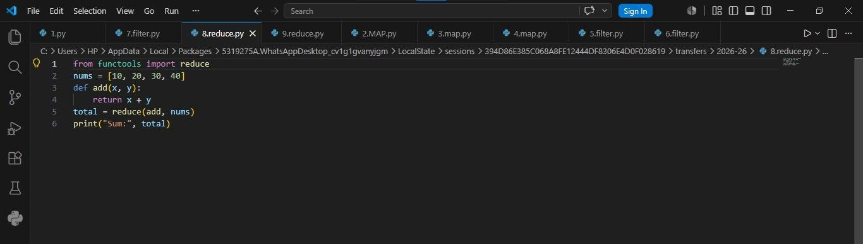

Task 5:
Write a Python program that imports `reduce` from `functools`, defines an `add(x, y)` function that returns `x + y`, uses `reduce` with that function on a list and prints `Sum:` followed by the result. Result:

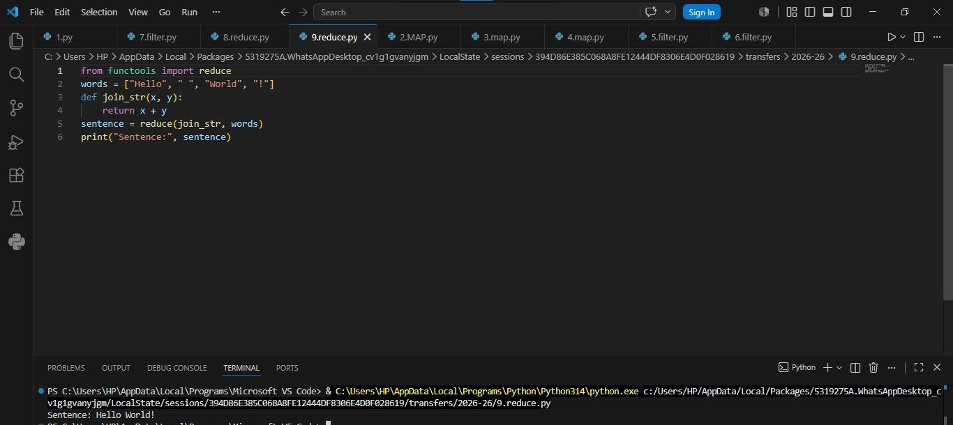

Task 6:
Write a Python program that imports `reduce` from `functools`, defines a `join_str(x, y)` function that returns `x + y`, uses `reduce` with that function on a list `["Hello", " ", "World", "!"]`, and prints `Sentence:` followed by the result.

Result:

Task 8:
Write a Python program that defines a `capitalize(name)` function returning `name.title()`, uses `map` with that function on a list converts the result to a list, and prints `Names:` followed by the result.
Result:
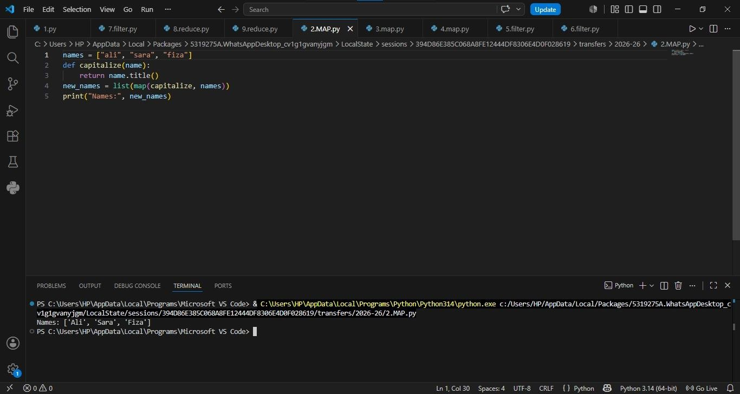

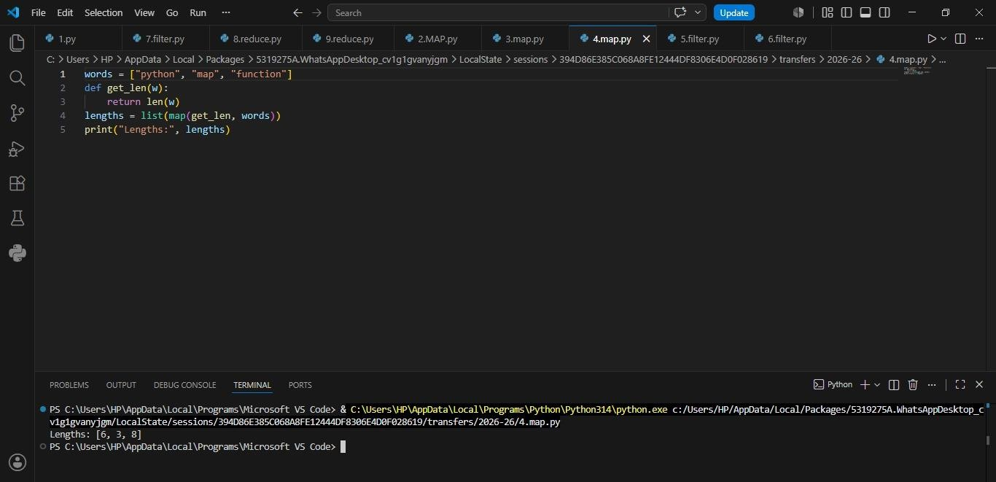
Task 9:
Write a Python program that defines a `calc(x)` function returning `x**2 + 11`, uses `map` with that function on a list, converts the result to a list, and prints `Result:` followed by the result.
Result:
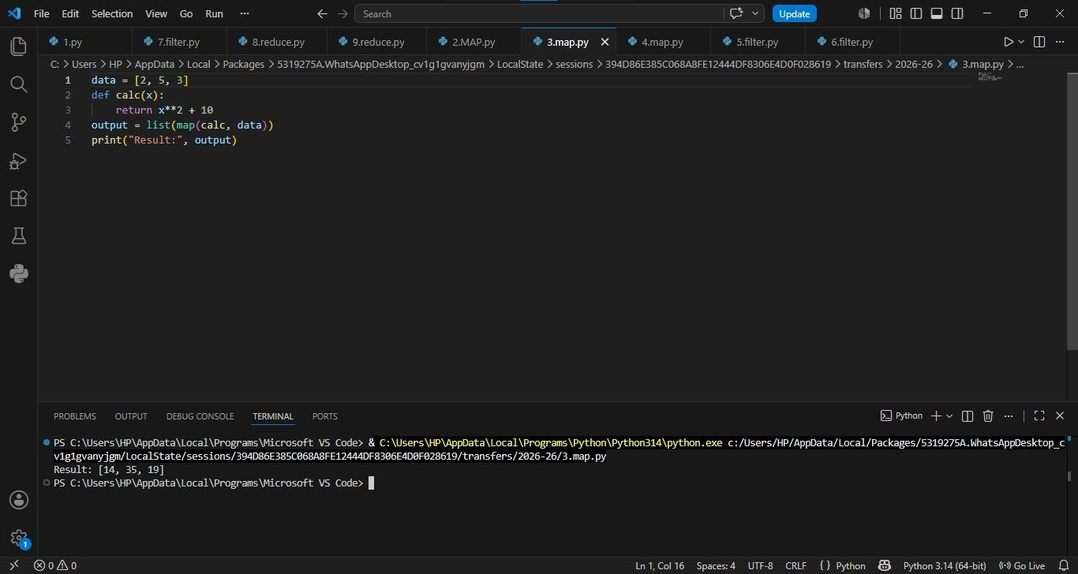
Task 10:
Write a Python program that defines a `get_len(w)` function returning `len(w)`, uses `map` with that function on a list `["python", "map", "function"]`, converts the result to a list, and prints
`Lengths:` followed by the result.

Result:

Conclusion
MAP = For transformation. Use when you need to change every item.

Ex: Convert prices to dollars, uppercase all namesFILTER = For selection. Use when you need a subset based on condition.

Ex: Get passing students, get products > 1000rsREDUCE = For aggregation. Use when you need 1 final result from all items.

Ex: Sum, Product, Max, Min

Week 14
University Of Engineering and Technology, Lahore
Computer Engineering Department

Course Name: PF | Course Code: CMPE-112L
Assignment Type: Lab | Dated: 01 June 2026
Semester: 1st | Session: Spring 2026
Lab/Project/Assignment #: 14 | CLOs to be covered: CLO2
Lab Title: OS Library, if __name__ == "__main__", is vs == | Teacher Name: Hafiz Muhammad Mubashar
Lab Evaluation:

CLO1 | Apply appropriate programming techniques to create executable programs to solve well defined problems
 | Level1 | Level2 | Level3 | Level4 | Level5 | Level6
(5)
Total |  |  |  |  |  | /5
Rubrics for Current Lab Evaluation
Scale | Marks | Level | Rubric
Excellent | 5 | L1 | Submitted all lab tasks, BONUS task, have good understanding.
Very Good | 4 | L2 | Submitted the lab tasks but have good understanding
Good | 3 | L3 | Submitted the lab tasks but have weak understanding.
Basic | 2 | L4 | Submitted the lab tasks but have no understanding.
Barely Acceptable | 1 | L5 | Submitted only one lab task.
Not Acceptable | 0 | L6 | Did not attempt
LAB No 14
Lab Goals/Objectives:
• To learn basic functions of the OS library.
• To understand the purpose of if __name__ == "__main__".
• To improve knowledge of Python modules

Equipment Required:
- Computer/Laptop
- Python
- Visual Studio Code / PyCharm / IDLE

Theory:
The os module allows Python programs to interact with the operating system by providing functions for tasks such as creating folders, handling files, and retrieving system-related information. The if __name__ == "__main__" statement makes sure that a Python script is executed only when it is run directly, and not when it is imported into another program. The == operator is used to compare the values of two objects, while the is operator checks whether both variables point to the same object in memory. Learning these concepts helps programmers write cleaner, more organized, and efficient Python code.

Lab Work:

Task 1:
Write a Python program to define and call a `welcome()` function.
Result:
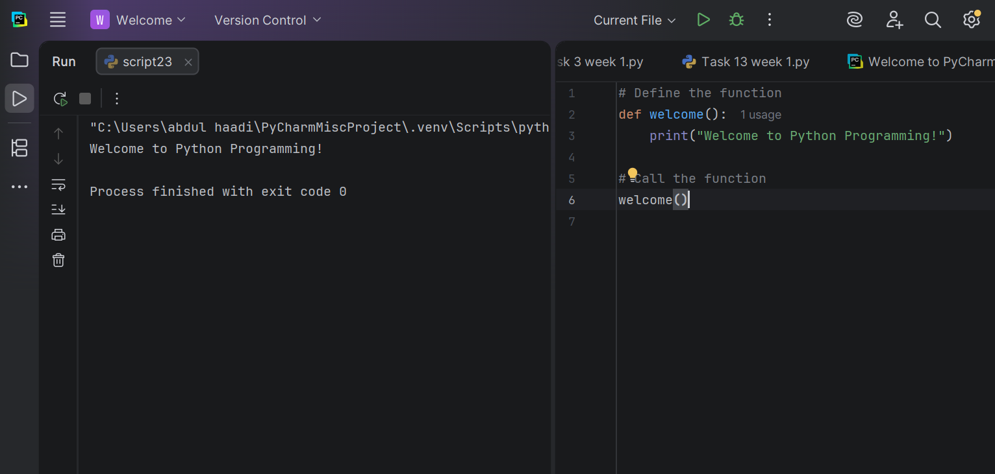

Task 2:
Write a Python program using the `os` module to create a folder named `meta` and then create 100 folders named `meta1` to `meta100`.
Result:

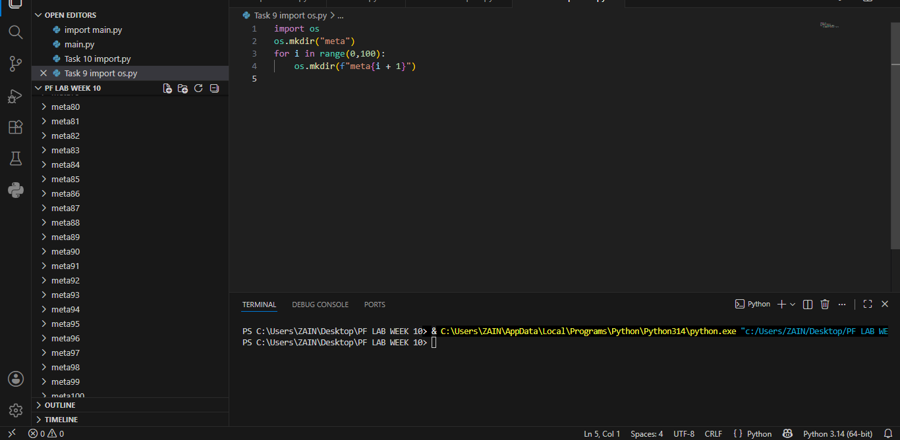

Task 3:
Write a Python program using the `os` module to create
a folder named `NewFolder` and print `Folder created`.
Result:
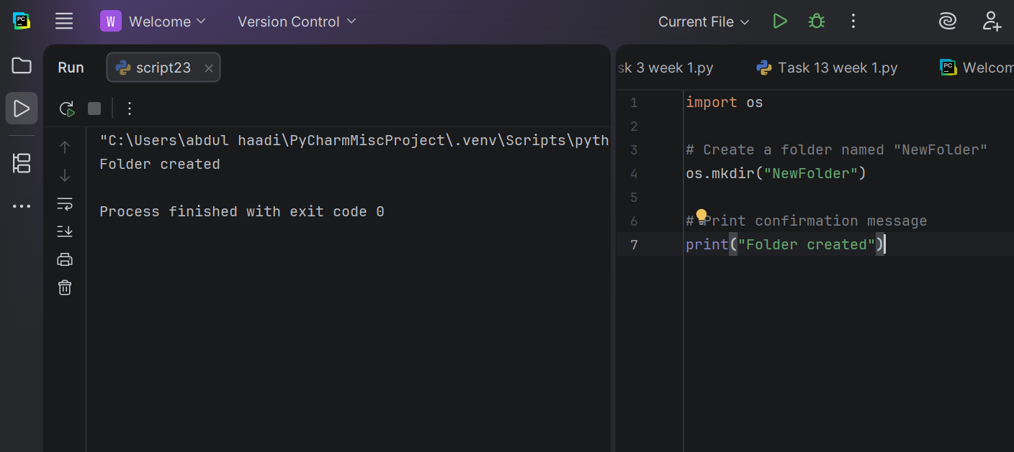
Task 4:
Write a Python program using the `os` module to list and
print all files and folders in the current directory.
Result:
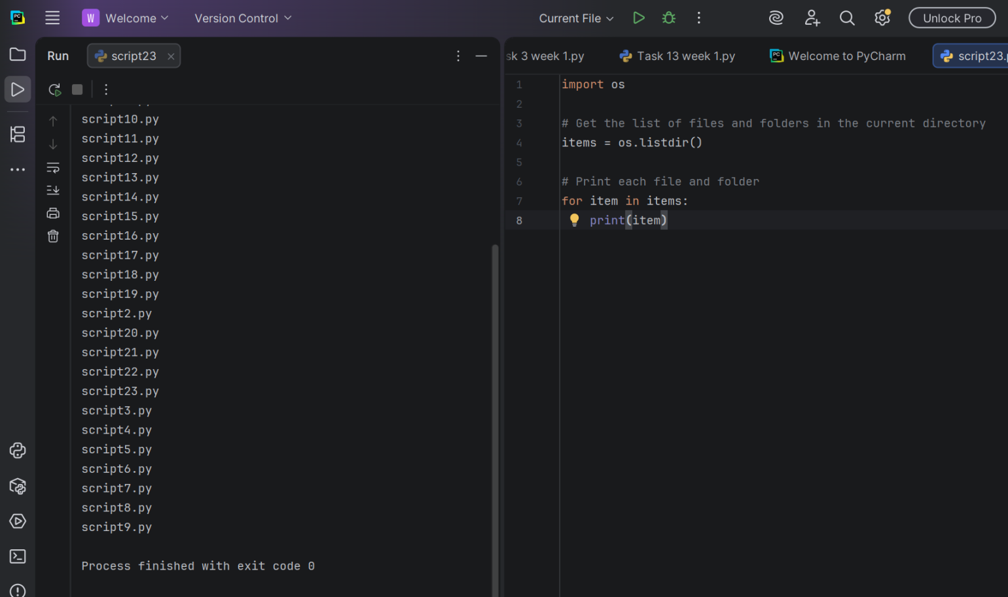

Task 5:

Write a Python program using the `os` module to
rename a file from `old.txt` to `new.txt` and print `File renamed`.
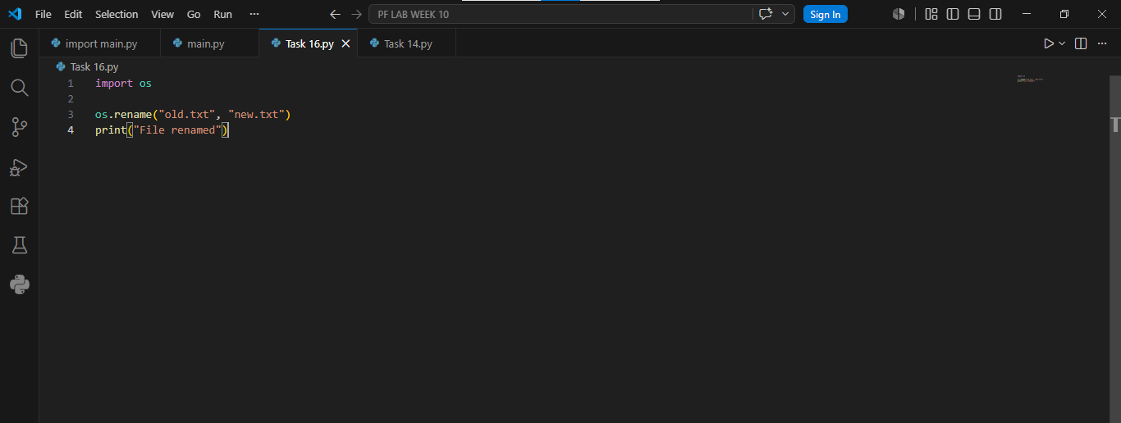
Result
Task 6:
Write a Python program using the `os` module to check if data.txt exists,
print whether the file exists or not
Result:

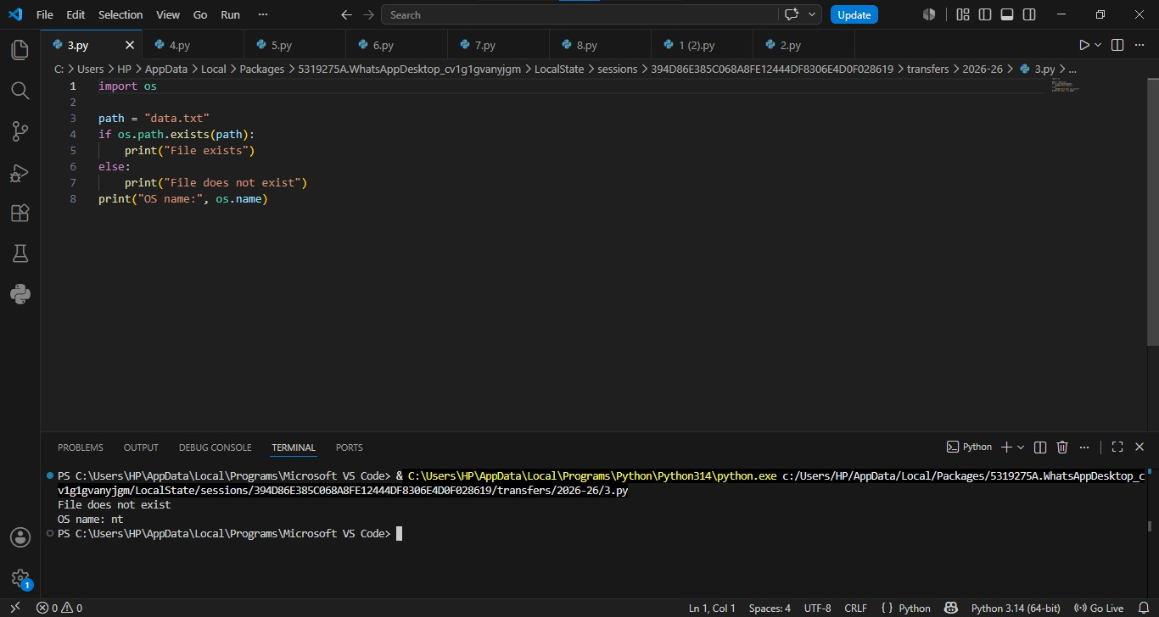

Task 7:
Write a Python program with a `greet()` function that prints `Hello`, and use `if *name* == "*main*":` to print `This runs only when file is executed directly` and call `greet()`.
Result:
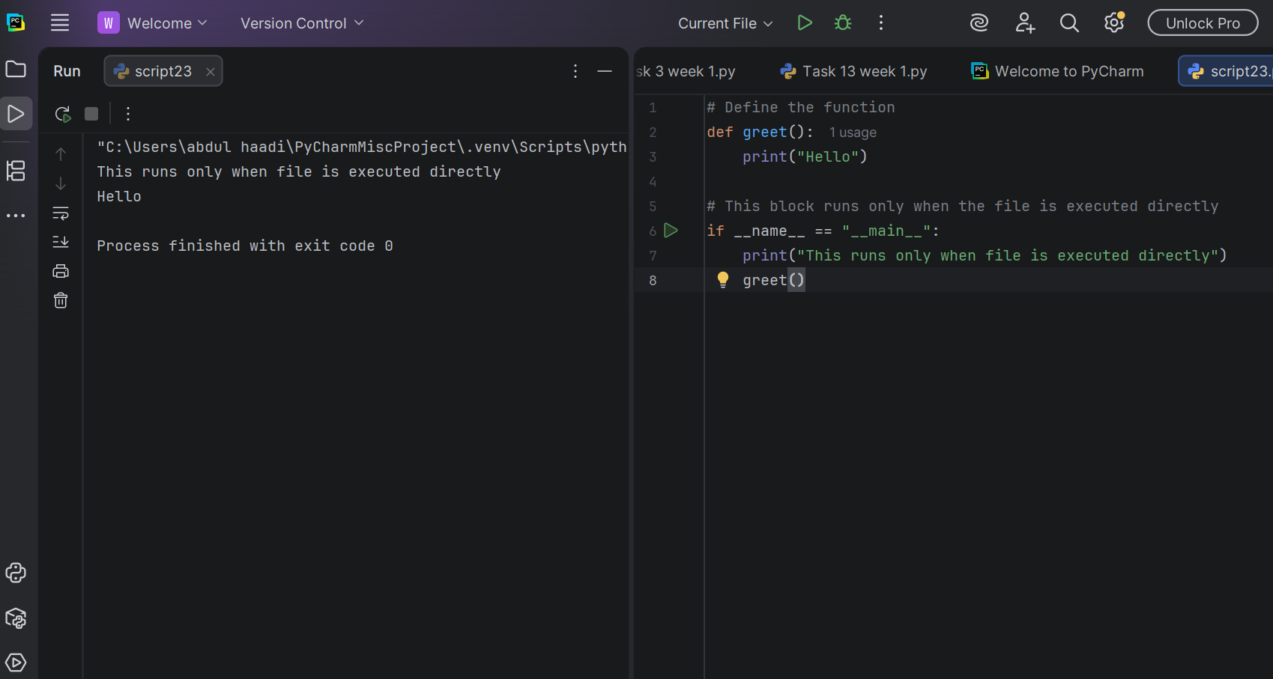
Task 8:
Write a Python program with an `add(a, b)` function that returns the sum of two numbers, and use `if *name* == "*main*":` to add and print the result.
Result:
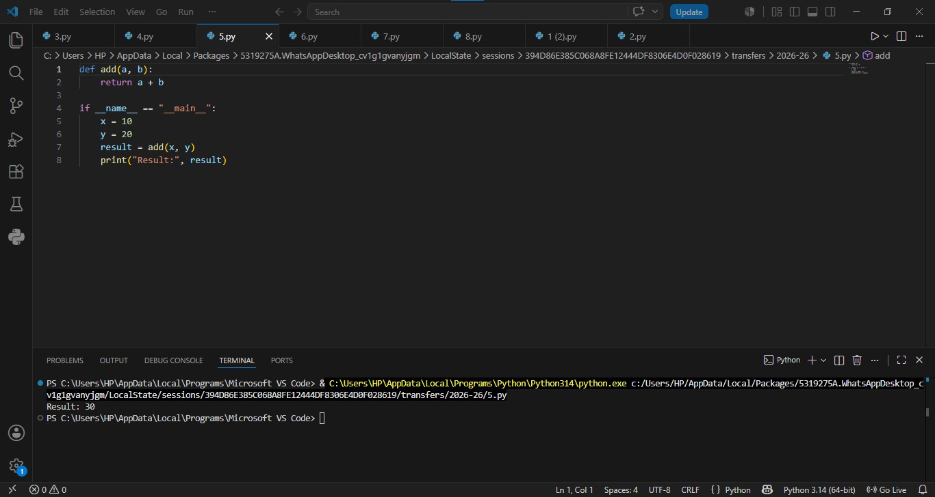

Task 9:
Write a Python program with an `square(n) and cube(n) functions that return the square and cube of a number and use if name == “main”: to set num and print square and cube.
Result:
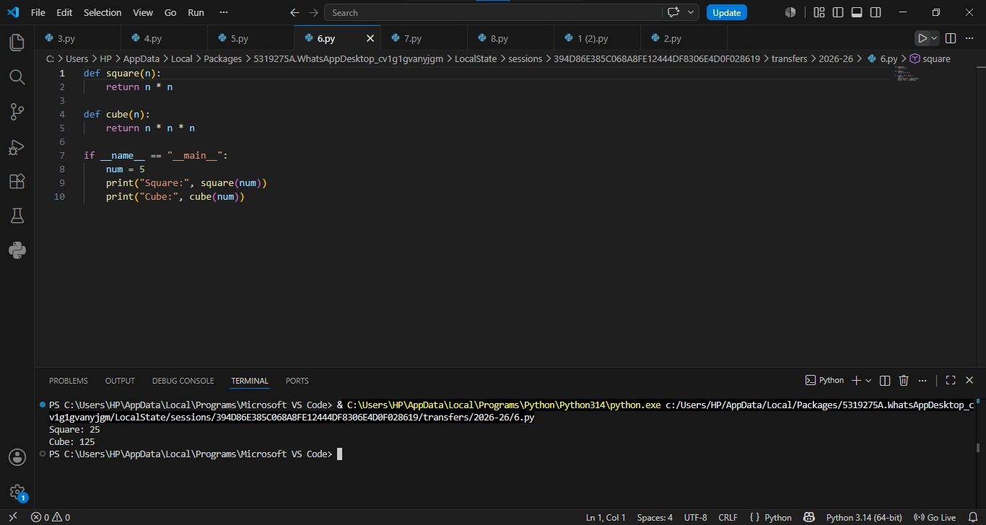

Task 10:
Write a Python program to demonstrate the difference
between == and is by comparing two int and two lists.
Result:

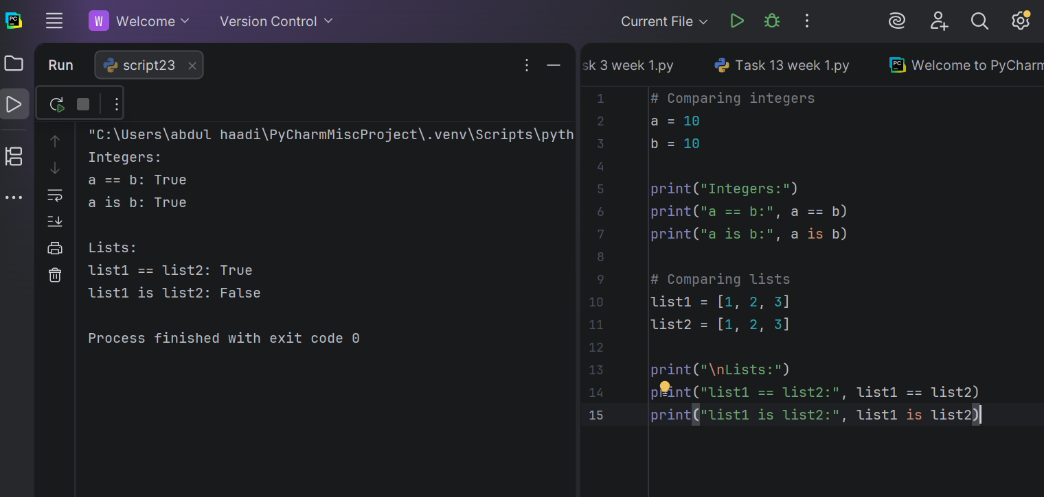

Task 11
Write a Python program to demonstrate `==` vs `is` using `val1 = None` and `val2 = None`, and also check `name with `name
Result:

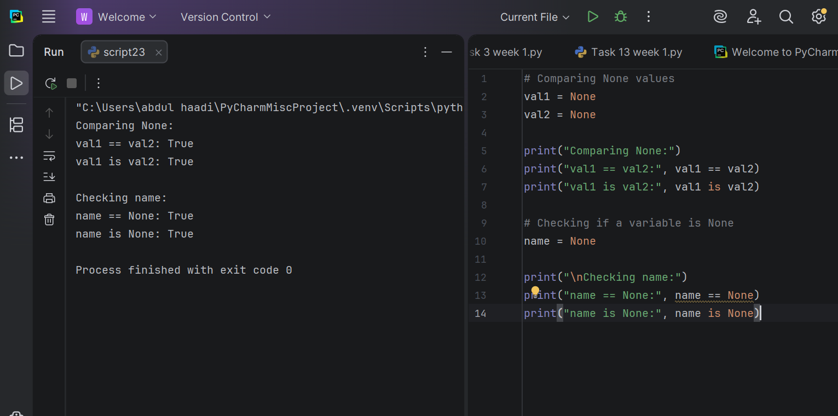 Conclusion
This lab improved our knowledge of several key Python concepts. We learned how to use the os module to work with files and directories, understood the role of the if __name__ == "__main__" statement in controlling when a program executes, and explored the difference between the is operator, which checks object identity, and the == operator, which compares values. These concepts are important for writing organized, efficient, and reliable Python programs.
.

Week 15
University Of Engineering and Technology, Lahore Computer Engineering Department

Course Name: PF | Course Code: CMPE-112L
Assignment Type: | Dated: 07june2026
Semester: 1st | Session: spring
Lab/Project/Assignment #: 15 | CLOs to be covered: CLO
Lab Title: | Teacher Name: Hafiz Muhammad Mubashar

Lab Evaluation:

CLO1 | Apply appropriate programming techniques to create executable programs to solve well defined problems
 | Level1 | Level2 | Level3 | Level4 | Level5 | Level6
(5)
Total |  |  |  |  |  | /5

Rubrics for Current Lab Evaluation

Scale | Marks | Level | Rubric
Excellent | 5 | L1 | Submitted all lab tasks, BONUS task, have good understanding.
Very Good | 4 | L2 | Submitted the lab tasks but have good understanding
Good | 3 | L3 | Submitted the lab tasks but have weak understanding.
Basic | 2 | L4 | Submitted the lab tasks but have no understanding.
Barely Acceptable | 1 | L5 | Submitted only one lab task.
Not Acceptable | 0 | L6 | Did not attempt

LAB No 15

Lab Goals/Objectives:
- To understand graphical user interfaces (GUI).
- To design user interface using Qt Designer.

Equipment Required:
- Computer/Laptop
- Qt Designer

Theory:

A Graphical User Interface (GUI) allows users to interact with software through windows, buttons, labels, text boxes, and other visual components instead of command-line instructions. Qt Designer is a drag-and-drop tool used to create GUI layouts quickly without manually writing interface code. GUI applications provide a more interactive and user-friendly experience compared to console-based program

Lab Work:

Task 1:

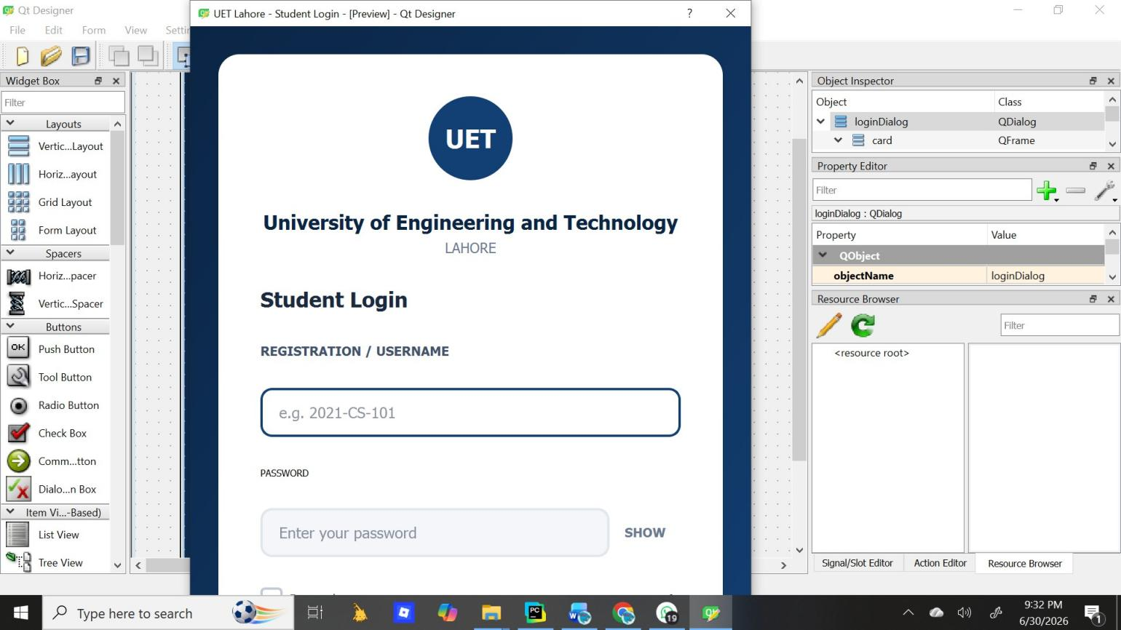
Result:

Create a login page

Conclusion
In this lab, we explored the basics of GUI development with Qt Designer. We learned how to design interactive windows by placing and configuring widgets like buttons, labels, and input fields without writing code manually. The drag-and-drop approach helped us understand layout management,

properties, and how to connect the visual design to Python logic. Overall, this lab gave us practical experience in building clean and functional user interfaces.

