Feature Engineering, Model Optimization & Performance Comparison

Title: Feature Engineering, Model Optimization & Performance Comparison
1. Introduction
This project focuses on improving a machine learning model for house price prediction using the California Housing dataset. In Task 1, a basic Linear Regression model was created. In this task, the workflow is extended by applying feature scaling, training multiple regression models, and comparing their performances.
The main objective of this project is to understand how machine learning engineers improve model accuracy and select the best-performing model using proper evaluation techniques. This project also introduces important preprocessing methods and model comparison strategies commonly used in real-world machine learning applications.
2. Dataset
The California Housing dataset from Scikit-learn was used for this project. The dataset contains real housing-related information collected from districts in California.
Input Features:
• Median Income
• House Age
• Average Rooms
• Average Bedrooms
• Population
• Latitude and Longitude
Target Variable:
• Median House Value (House Price)
The dataset is well-suited for regression problems because the target variable is continuous.
3. Data Preprocessing and Feature Scaling
Before training the models, preprocessing steps were performed to prepare the data properly.
One of the most important preprocessing techniques used in this project was Feature Scaling. Since different features in the dataset have different numerical ranges, scaling helps ensure that no single feature dominates the learning process.
The StandardScaler method was used to standardize the features so that they have a mean close to 0 and a standard deviation close to 1.
This improved model stability and helped certain algorithms perform more effectively.
4. Train-Test Split
The dataset was divided into training and testing sets using an 80:20 ratio.
• Training data was used to train the models
• Testing data was used to evaluate model performance on unseen data
This approach helps reduce overfitting and provides a fair evaluation of the model.
5. Models Used
In this project, multiple regression models were trained and compared.
a) Linear Regression
Linear Regression was used as the baseline model. It assumes a linear relationship between the input features and the target variable.
y = β₀ + β₁x₁ + β₂x₂ + ... + βₙxₙ
b) Ridge Regression
Ridge Regression is an improved version of Linear Regression that helps reduce overfitting by adding regularization.
min(Σ(yᵢ − ŷᵢ)² + λΣβⱼ²)
This helps the model generalize better on unseen data.
c) Decision Tree Regressor
Decision Tree Regression captures non-linear relationships between features and target values. Unlike Linear Regression, it can learn more complex patterns from the data.
6. Model Evaluation
The models were evaluated using two important regression metrics:
RMSE (Root Mean Squared Error)
RMSE measures the average prediction error. Lower RMSE values indicate better model performance.
RMSE = √(1/n * Σ(yᵢ − ŷᵢ)²)
R² Score
The R² score measures how well the model explains the variance in the target variable.
R² = 1 − (SSres / SStot)
Higher R² values indicate better predictive performance.
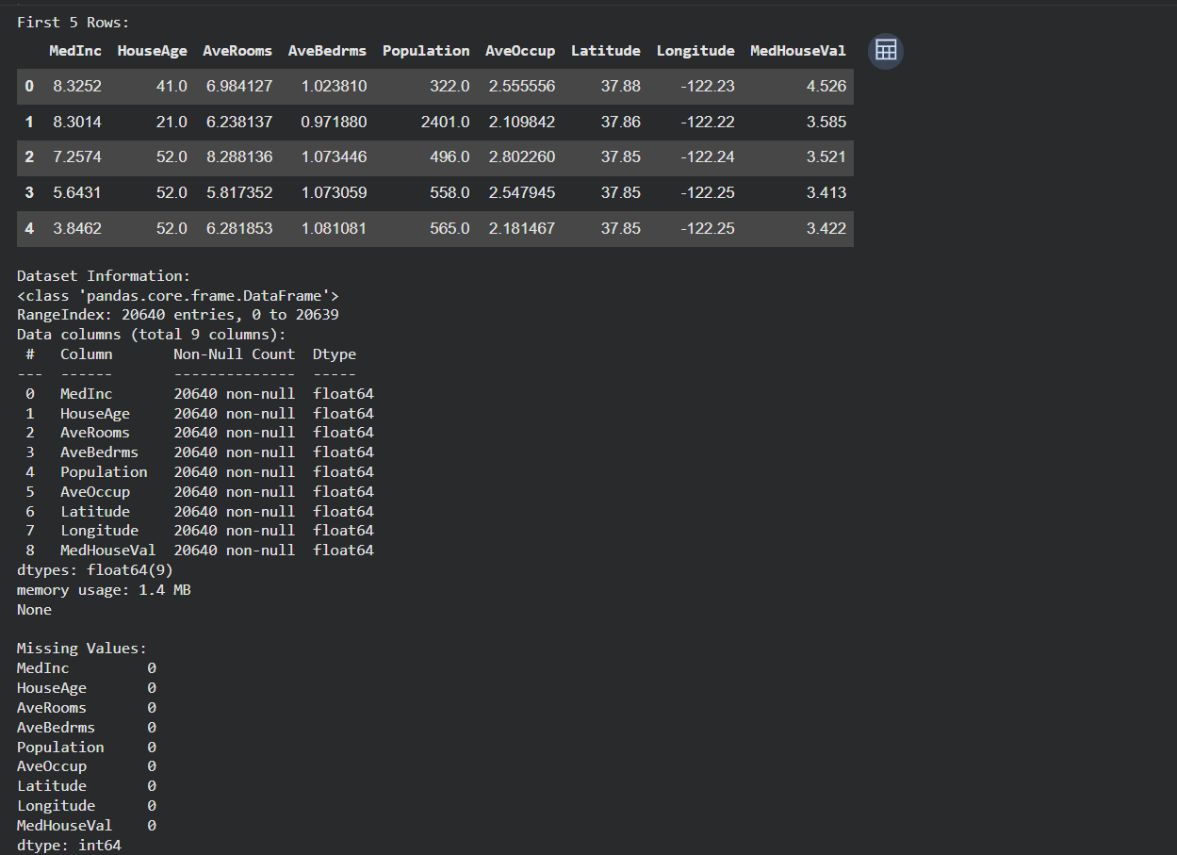
7. Results and Comparison
After training and evaluating all models, their performances were compared based on RMSE and R² scores.
Key observations:
• Linear Regression provided a solid baseline performance.
• Ridge Regression slightly improved stability and reduced overfitting.
• Decision Tree Regressor captured more complex relationships but may risk overfitting if not tuned properly.
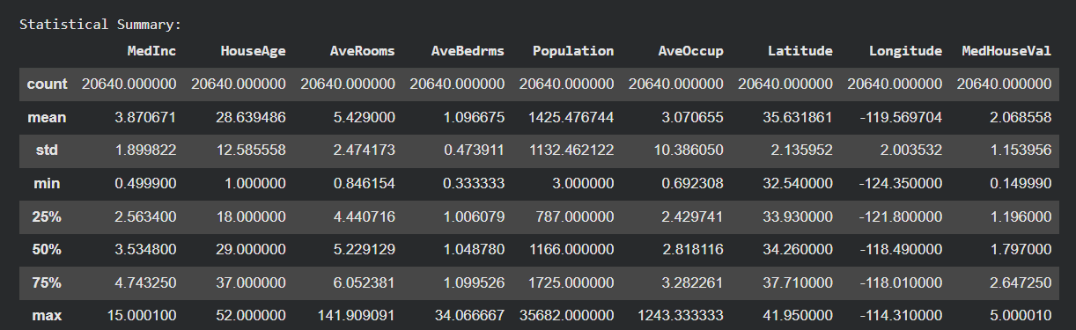
Among the tested models, the best-performing model was selected based on lower RMSE and higher R² score.
The comparison process helped identify which algorithm was most suitable for the dataset.
8. Visualization
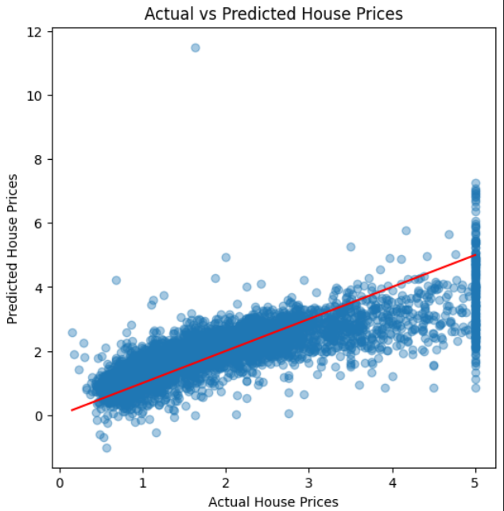
Several visualizations were used to better understand model performance:
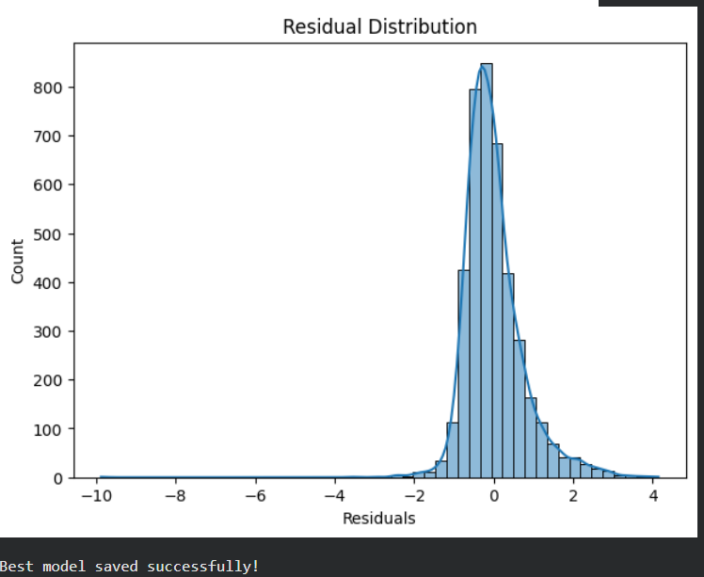
• Correlation heatmaps helped identify relationships between variables.
• Actual vs Predicted scatter plots showed how closely predictions matched real house prices.
• Performance comparison tables made it easier to compare multiple models side by side.
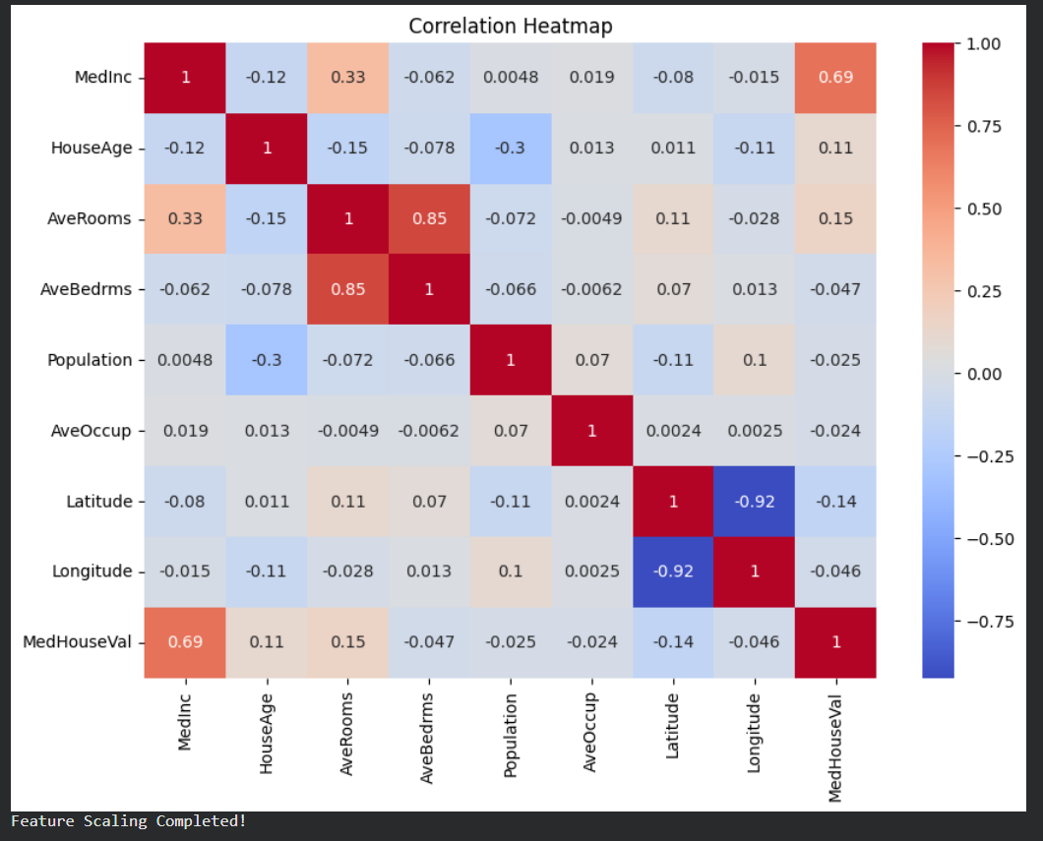
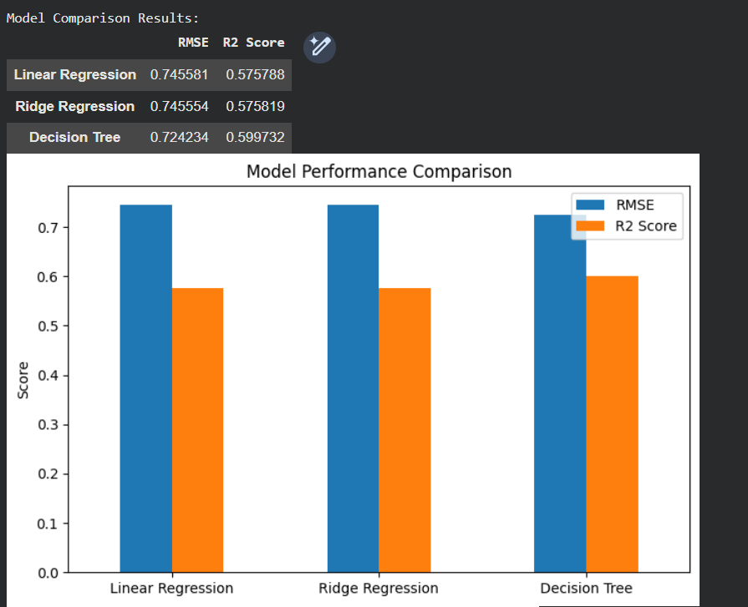
The scatter plots showed that predictions were reasonably aligned with actual values, although some variation and prediction error were still present.
9. Conclusion
This project demonstrated how machine learning models can be improved using preprocessing techniques and model optimization strategies.
By applying feature scaling and comparing multiple regression models, it became easier to evaluate model quality more professionally. The project also highlighted the importance of selecting the right algorithm instead of relying on a single model.
Overall, this task provided practical experience with industry-style machine learning workflows and performance evaluation techniques.
10. Future Improvements
The project can be improved further using advanced techniques such as:
• Hyperparameter tuning
• Cross-validation
• Ensemble methods like Random Forest and XGBoost
• Better feature engineering
• Outlier detection and removal
• More advanced visualization techniques
These improvements may lead to better prediction accuracy and more reliable machine learning models.

