Rush Hour
Video link:
https://drive.google.com/file/d/1u6Orw0MBu80ipf0-aHwRyxdbER5I70CG/view?usp=sharing
All game variables, strings, board data, colors, player states, mode settings, and counters are declared in the .data segment. Every feature of the game is implemented through separate procedures to keep the code organized.
Board & Value Handling
getValue
Calculates the board index using row * cols + col and returns the value stored in that cell.
setValue
Writes a value to a specific board cell using the same indexing formula.
displayValue
Checks the value of a cell (road, building, taxi, passenger, destination)
and prints the correct string with the correct color.
displayBoard
Draws the entire 20×20 board with left/right/top/bottom boundaries.
Displays each cell using displayValue
Player Movement Procedures
moveUp / moveDown / moveLeft / moveRight
Each movement procedure:
- Checks boundary limits
- Reads the next cell
- If road → moves the taxi
- If building → applies score penalty
- Updates taxi position
- Calls setPlayerOnBoard to redraw the taxi
setPlayerOnBoard
Places the taxi (value 2) at its current coordinates on the board.
Passenger & Destination System
pickOrDropPassenger
Handles pressing SPACE:
- If taxi has no passenger → look for nearby passenger and pick them
- If taxi has passenger → look for destination and drop them
- Toggles the flag
- Adjusts score and spawns new objects
spawnPassenger
Randomly chooses an empty road cell and places a passenger.
spawnDestination
Generates a random valid destination (not on buildings).
maintainPassengerCount
Ensures there are always at least 3 passengers on the map.
If fewer than 3 → spawns more passengers.
Menu & UI Procedures
displayMenu
Shows main menu options.
showInstructions
Displays control instructions to the user.
showDifficulty
Allows user to choose taxi color / difficulty level.
showLeaderboard
Displays placeholder leaderboard text.
selectModeMenu
Lets the player select:
- Career Mode
- Time Attack Mode
- Endless Mode
displayScore
Displays current score.
Also shows:
- Time remaining (Time Mode)
- Passenger count (Career Mode)
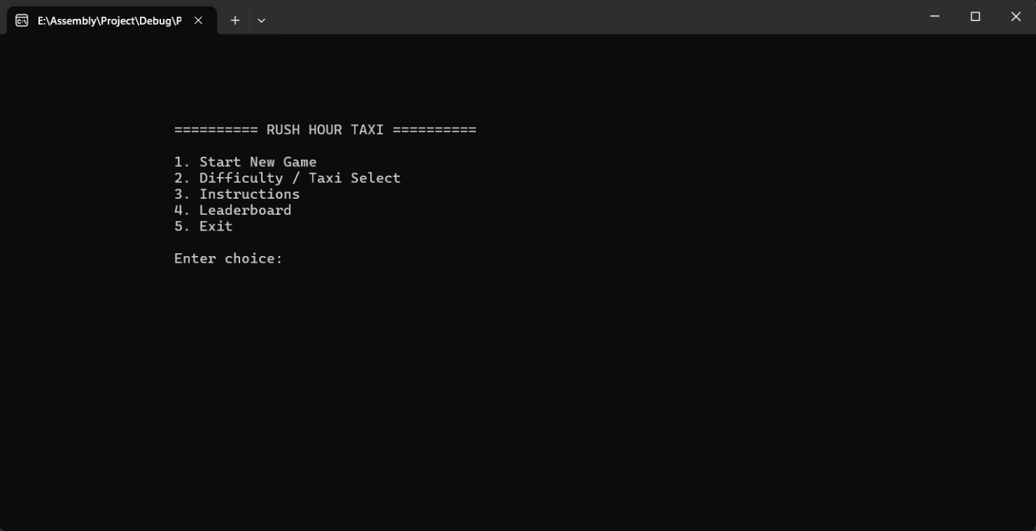
Game State Procedures
resetGame
Resets score, taxi position, flags, board, and clears non-building cells.
pauseGame
Displays a “Paused” message; resumes when user presses P.
inputPlayerName
Reads user’s name using ReadString.
setTaxiAttributes
Applies taxi color and collision penalties based on selected difficulty.
PlayClickSound
Plays a short beep sound for UI feedback.
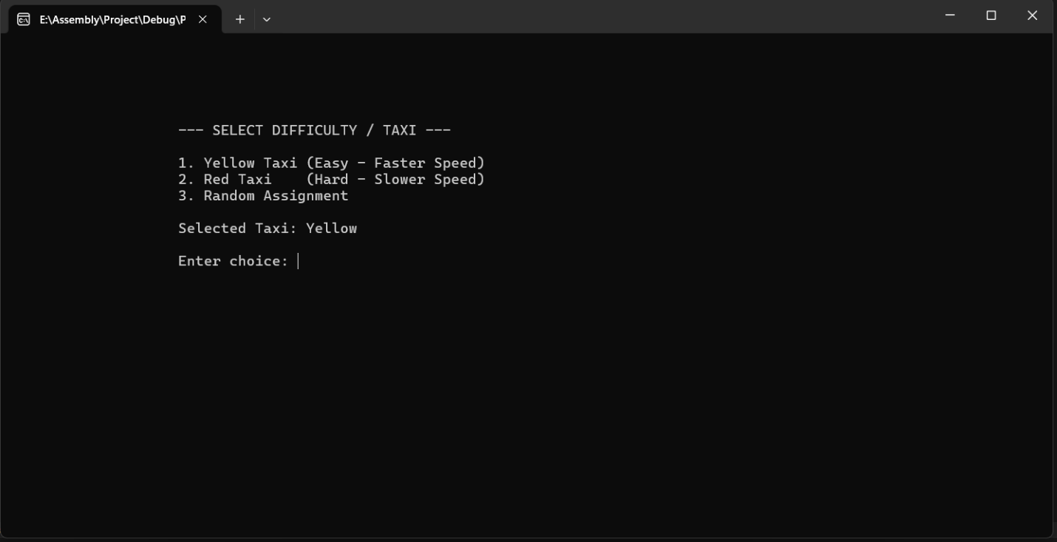
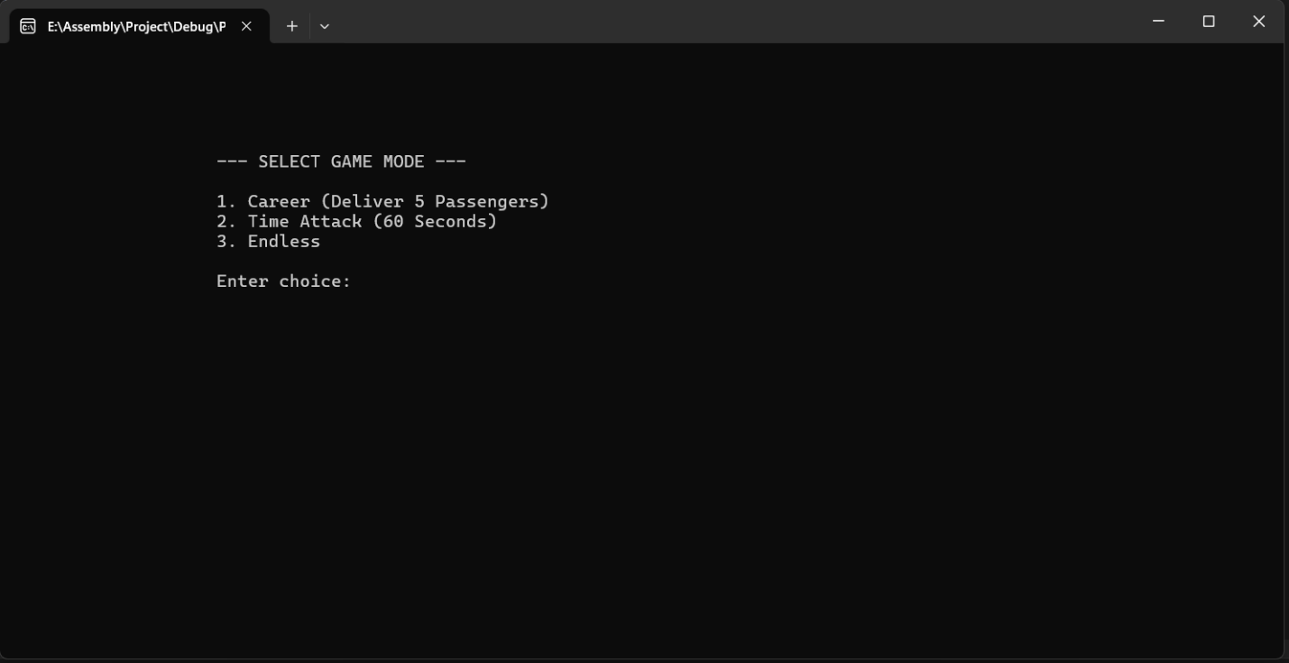
Main Procedure
main
Controls entire game flow:
- Shows menu
- Handles user choice
- Initializes game state
- Draws board
- Runs the GameLoop:
  - Updates timer
  - Maintains passenger count
  - Checks win/lose conditions
  - Processes keyboard input
  - Moves taxi or picks/drops passenger
Ends with win or lose screen, returns to menu.
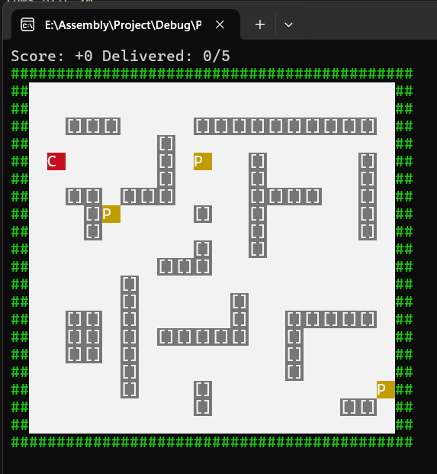

All game variables, board data, color codes, strings, and state flags are defined in the .data segment, while every feature of the game is organized into separate procedures for clarity. The board is a 20×20 grid where the player moves a taxi using arrow keys, picks passengers with the spacebar, and drops them at random destinations to earn points. Independent procedures handle movement, board rendering, passenger spawning, destination generation, scoring, collisions, menus, difficulty selection, game modes, pause functionality, player name input, and sound effects. The main procedure connects all modules, runs the game loop, updates the timer, checks win/loss conditions, refreshes the UI, and manages user input.

