Tugas Final Makassar, 20 Agustus 2020

**PEMROGRAMAN JAVA LANJUT**



B

Nama : Abdul Hakim Assari

Stambuk 13020170076

Kelas : C2

# PROGRAM STUDI TEKNIK INFORMATIKA FAKULTAS ILMU KOMPUTER UNIVERSITAS MUSLIM INDONESIA MAKASSAR

**2020**

Source Code :

package stream;

import java.io.FileInputStream; import java.io.FileNotFoundException; import java.io.FileOutputStream; import java.io.PrintWriter;

import java.util.logging.Level; import java.util.logging.Logger; import javax.swing.JOptionPane;

/**

*

* @author User

*/

public class menampilkan extends javax.swing.JFrame {

/**

* Creates new form menampilkan

*/

public menampilkan() { initComponents();

}

/**

* This method is called from within the constructor to initialize the form.
* WARNING: Do NOT modify this code. The content of this method is always
* regenerated by the Form Editor.

*/ @SuppressWarnings("unchecked")

// <editor-fold defaultstate="collapsed" desc="Generated Code"> private void initComponents() {

jPanel1 = new javax.swing.JPanel(); jLabel1 = new javax.swing.JLabel();

jScrollPane1 = new javax.swing.JScrollPane(); jTextArea1 = new javax.swing.JTextArea(); jButton1 = new javax.swing.JButton(); jButton2 = new javax.swing.JButton(); jButton3 = new javax.swing.JButton();

setDefaultCloseOperation(javax.swing.WindowConstants.EXIT_ON_CLOSE);

jLabel1.setFont(new java.awt.Font("Tahoma", 0, 14)); // NOI18N jLabel1.setText("IMPORT FILE BY STREAM");

jTextArea1.setColumns(20); jTextArea1.setRows(5); jScrollPane1.setViewportView(jTextArea1);

jButton1.setText("Tampilkan");

jButton1.addActionListener(new java.awt.event.ActionListener() { public void actionPerformed(java.awt.event.ActionEvent evt) {

jButton1ActionPerformed(evt);

}

});

jButton2.setText("Edit");

jButton2.addActionListener(new java.awt.event.ActionListener() { public void actionPerformed(java.awt.event.ActionEvent evt) {

jButton2ActionPerformed(evt);

}

});

jButton3.setText("Delete");

jButton3.addActionListener(new java.awt.event.ActionListener() { public void actionPerformed(java.awt.event.ActionEvent evt) {

jButton3ActionPerformed(evt);

}

});

javax.swing.GroupLayout jPanel1Layout = new javax.swing.GroupLayout(jPanel1); jPanel1.setLayout(jPanel1Layout);

jPanel1Layout.setHorizontalGroup( jPanel1Layout.createParallelGroup(javax.swing.GroupLayout.Alignment.LEADING)

.addGroup(jPanel1Layout.createSequentialGroup()

.addGap(134, 134, 134)

.addComponent(jLabel1)

.addContainerGap(112, Short.MAX_VALUE))

.addGroup(jPanel1Layout.createSequentialGroup()

.addContainerGap()

.addGroup(jPanel1Layout.createParallelGroup(javax.swing.GroupLayout.Alignment.LEADING)

.addComponent(jScrollPane1)

.addComponent(jButton1, javax.swing.GroupLayout.Alignment.TRAILING, javax.swing.GroupLayout.DEFAULT_SIZE, javax.swing.GroupLayout.DEFAULT_SIZE, Short.MAX_VALUE)

.addComponent(jButton2, javax.swing.GroupLayout.Alignment.TRAILING, javax.swing.GroupLayout.DEFAULT_SIZE, javax.swing.GroupLayout.DEFAULT_SIZE, Short.MAX_VALUE)

.addComponent(jButton3, javax.swing.GroupLayout.DEFAULT_SIZE,

javax.swing.GroupLayout.DEFAULT_SIZE, Short.MAX_VALUE))

.addContainerGap())

);

jPanel1Layout.setVerticalGroup( jPanel1Layout.createParallelGroup(javax.swing.GroupLayout.Alignment.LEADING)

.addGroup(jPanel1Layout.createSequentialGroup()

.addContainerGap()

.addComponent(jLabel1)

.addPreferredGap(javax.swing.LayoutStyle.ComponentPlacement.UNRELATED)

.addComponent(jScrollPane1, javax.swing.GroupLayout.PREFERRED_SIZE, 197, javax.swing.GroupLayout.PREFERRED_SIZE)

.addGap(18, 18, 18)

.addComponent(jButton1)

.addPreferredGap(javax.swing.LayoutStyle.ComponentPlacement.RELATED)

.addComponent(jButton2)

.addPreferredGap(javax.swing.LayoutStyle.ComponentPlacement.RELATED)

.addComponent(jButton3)

.addContainerGap(25, Short.MAX_VALUE))

);

javax.swing.GroupLayout layout = new javax.swing.GroupLayout(getContentPane()); getContentPane().setLayout(layout);

layout.setHorizontalGroup( layout.createParallelGroup(javax.swing.GroupLayout.Alignment.LEADING)

.addComponent(jPanel1, javax.swing.GroupLayout.DEFAULT_SIZE, javax.swing.GroupLayout.DEFAULT_SIZE, Short.MAX_VALUE)

);

layout.setVerticalGroup( layout.createParallelGroup(javax.swing.GroupLayout.Alignment.LEADING)

.addComponent(jPanel1, javax.swing.GroupLayout.DEFAULT_SIZE, javax.swing.GroupLayout.DEFAULT_SIZE, Short.MAX_VALUE)

);

pack();

}// </editor-fold>

private void jButton1ActionPerformed(java.awt.event.ActionEvent evt) { FileInputStream input = null;

int data;

try {

input = new FileInputStream ("I:/Data.txt");

} catch (FileNotFoundException fn) { System.out.print("file tidak ditemukan");

}

try {

while ((data = input.read()) != -1){ jTextArea1.append(String.valueOf((char)data));

}

} catch (Exception e) { System.out.println();

}

// TODO add your handling code here:

}

private void jButton3ActionPerformed(java.awt.event.ActionEvent evt) { jTextArea1.setText(""); // TODO add your handling code here:

}

private void jButton2ActionPerformed(java.awt.event.ActionEvent evt) { try {

FileOutputStream fos = new FileOutputStream ("I:/Data.txt");

PrintWriter pw = new PrintWriter(fos);

pw.print(jTextArea1.getText()); pw.close();

JOptionPane.showMessageDialog(rootPane, "Data Berhasil Di Edit");

} catch (FileNotFoundException ex) { Logger.getLogger(menampilkan.class.getName()).log(Level.SEVERE,

null, ex);

}

System.out.println(); // TODO add your handling code here:

}

/**

* @param args the command line arguments

*/

public static void main(String args[]) {

/* Set the Nimbus look and feel */

//<editor-fold defaultstate="collapsed" desc=" Look and feel setting code (optional) ">

/* If Nimbus (introduced in Java SE 6) is not available, stay with the default look and feel.

* For details see <http://download.oracle.com/javase/tutorial/uiswing/lookandfeel/plaf.html>

*/

try {

for (javax.swing.UIManager.LookAndFeelInfo info : javax.swing.UIManager.getInstalledLookAndFeels()) { if ("Nimbus".equals(info.getName())) {

javax.swing.UIManager.setLookAndFeel(info.getClassName()); break;

}

}

ex);

ex);

ex);

ex);

} catch (ClassNotFoundException ex) { java.util.logging.Logger.getLogger(menampilkan.class.getName()).log(java.util.logging.Level.SEVERE, null,

} catch (InstantiationException ex) { java.util.logging.Logger.getLogger(menampilkan.class.getName()).log(java.util.logging.Level.SEVERE, null,

} catch (IllegalAccessException ex) { java.util.logging.Logger.getLogger(menampilkan.class.getName()).log(java.util.logging.Level.SEVERE, null,

} catch (javax.swing.UnsupportedLookAndFeelException ex) { java.util.logging.Logger.getLogger(menampilkan.class.getName()).log(java.util.logging.Level.SEVERE, null,

}

//</editor-fold>

/* Create and display the form */ java.awt.EventQueue.invokeLater(new Runnable() {

public void run() {

new menampilkan().setVisible(true);

}

});

}

// Variables declaration - do not modify private javax.swing.JButton jButton1; private javax.swing.JButton jButton2; private javax.swing.JButton jButton3; private javax.swing.JLabel jLabel1; private javax.swing.JPanel jPanel1;

private javax.swing.JScrollPane jScrollPane1; private javax.swing.JTextArea jTextArea1;

// End of variables declaration

}

Screenshoot :

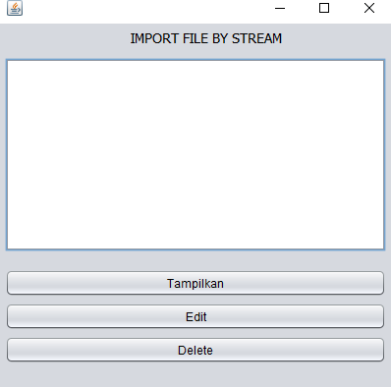

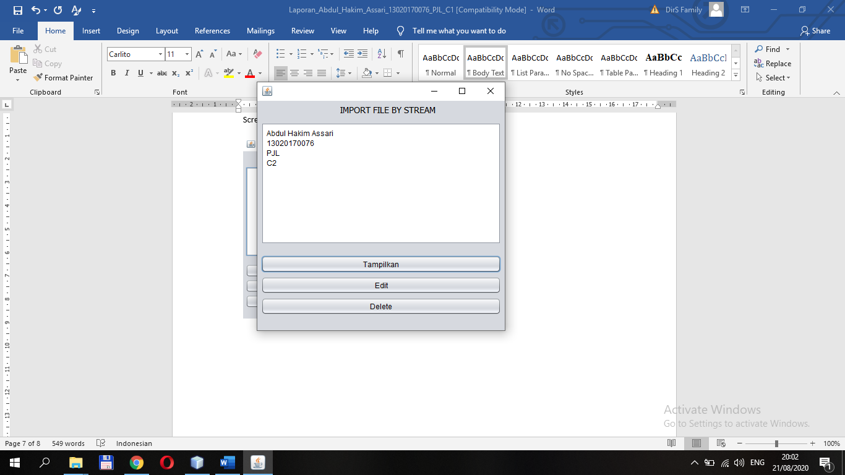

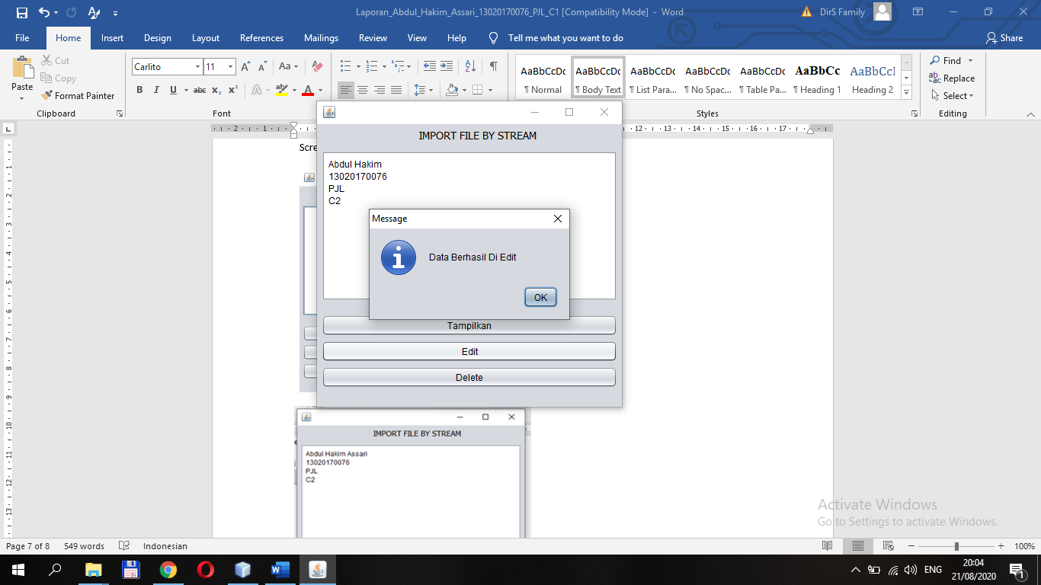

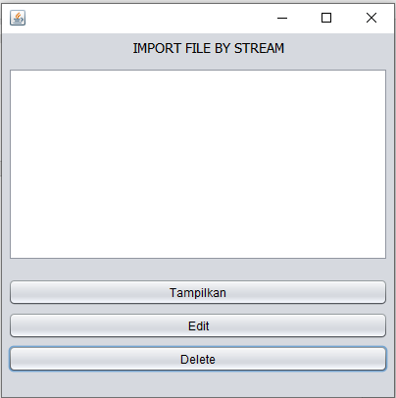Delete :