Technologies used for this project: Angular4, BootStrap, Maven, Spring Boot, JPA, H2

Please follow the below steps

Type on [http://localhost:4200](http://localhost:4200/)

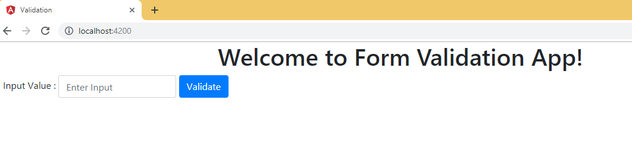

Enter invalid input value. The message will be displayed as “Invalid input. Allowed only alphabets”

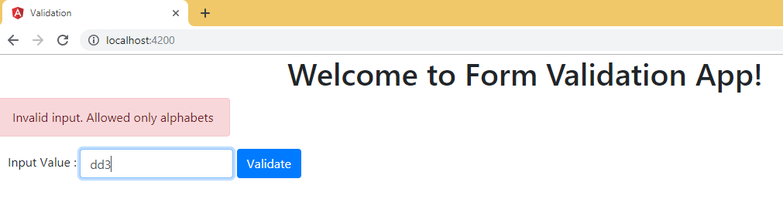

The above validation is available in Service layer as well

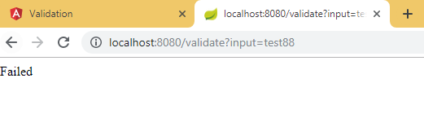

For valid input value, it will be displayed like below.

<http://localhost:8080/validate?input=dfsdE>

It will return the value as “DFSDe”

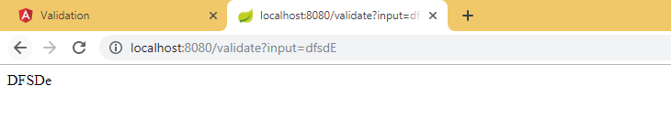

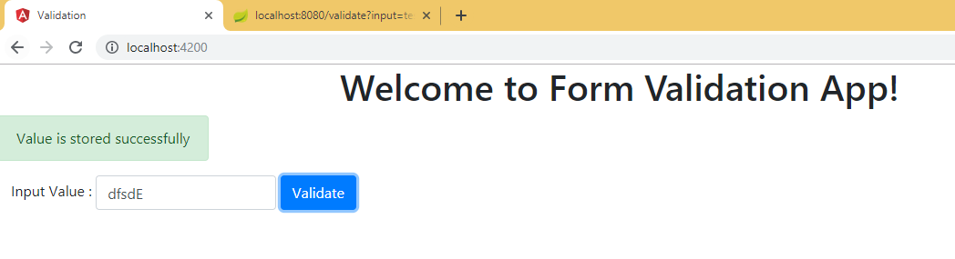

Valid values are storing in H2 (In memory DB)