Technologies used for this project: Spring Boot, JPA, H2, Maven

Please follow the below steps

1. Do maven clean install
2. Start the application

Sample data:

List<Product> products = **new** ArrayList<Product>();

Product p1= **new** Product();

p1.setType("ABC");

p1.setPrice(**new** Long(100));

p1.setDisCounted(0);

products.add(p1);

Product p2= **new** Product();

p2.setType("ABC");

p2.setPrice(**new** Long(200));

p2.setDisCounted(1);

products.add(p2);

Product p3= **new** Product();

p3.setType("XYZ");

p3.setPrice(**new** Long(500));

p3.setDisCounted(0);

products.add(p3);

Type below url in browser, the above sample product details will save in H2 DB.

<http://localhost:8080/sampleData>

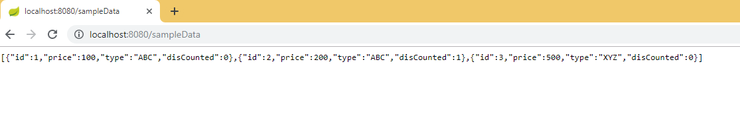

1. Type below url to identify product is discounted or not.

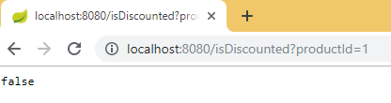

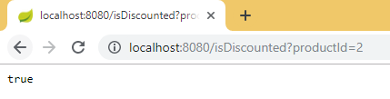

1. Display all products – price with the | separator , discounted products on the top with price in parenthesis()

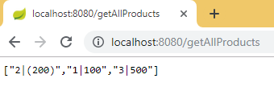

1. Display sum of qty sold per type of the product

