Time transaction report final scripts
="SELECT LTRIM(E.EMPID,'0') AS EMPID,E.EMPNAME,D.DEPARTMENT,T.IOFLAG,T.ACTUALIOFLAG,T.OPFLAG,TO_CHAR(T.PUNCHEDTIME,'HH:MI AM') AS T_TIME,T.TRANSTIME,T.ATTENDANCEDATE,T.BOUTPASSHRS,T.REMARKS,T.BADGEREADERNO,T.RCODE,T.NYR,G.GROUPS,T.IOFLAG || ' ' || CASE T.RCODE WHEN '01' THEN '#' WHEN '02' THEN '$' WHEN '03' THEN '&' WHEN '04' THEN '@' WHEN '05' THEN '%' WHEN '06' THEN '+' WHEN '07' THEN '>' ELSE '' END AS T_TYPE FROM TBLDAILYTRANSACTIONS T INNER JOIN TBLEMPMAST E ON E.EMPID=T.EMPID LEFT JOIN TBLGROUPS G ON G.GROUPID=E.GROUPID LEFT JOIN TBLDEPARTMENTS D ON D.DEPTID=E.DEPTID AND D.CADREID=E.CADREID AND D.GROUPID=E.GROUPID LEFT JOIN V_FUNCTION_KEYS F ON F.RCODE=T.RCODE WHERE T.EMPID IN (SELECT EMPLOYEE_ID FROM V_TEMP_EMPLOYEE_IDS WHERE TOKEN=:my_token) AND T.ATTENDANCEDATE=:dateof AND T.PUNCHEDTIME BETWEEN :date_in_time AND :date_out_time ORDER BY E.EMPID,T.PUNCHEDTIME"

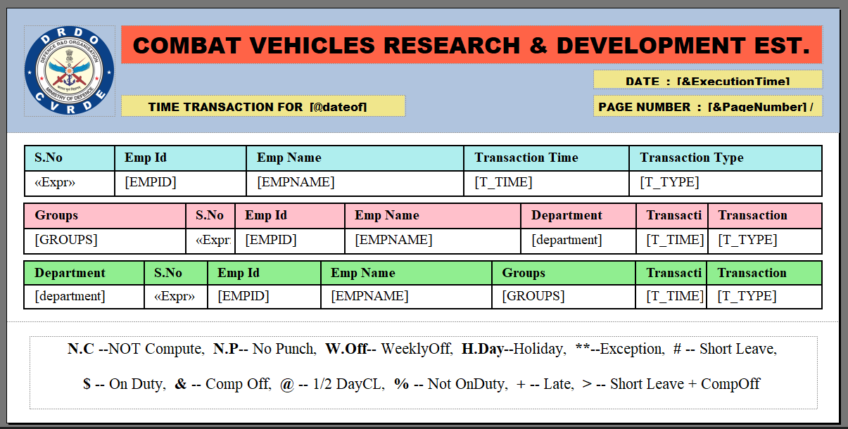

Monthly average report for 12 months (working hours only)
Table structure
CREATE TABLE TBLTEMP_MONTHLY_WORKHRS_PIVOT (
EMPID VARCHAR2(20) NOT NULL,
YEARID NUMBER(4) NOT NULL,

COL_1_HEADER VARCHAR2(20), -- e.g., Dec-2024
COL_1_DATA VARCHAR2(20), -- e.g., 130 Hrs

COL_2_HEADER VARCHAR2(20),
COL_2_DATA VARCHAR2(20),

COL_3_HEADER VARCHAR2(20),
COL_3_DATA VARCHAR2(20),

COL_4_HEADER VARCHAR2(20),
COL_4_DATA VARCHAR2(20),

COL_5_HEADER VARCHAR2(20),
COL_5_DATA VARCHAR2(20),

COL_6_HEADER VARCHAR2(20),
COL_6_DATA VARCHAR2(20),

COL_7_HEADER VARCHAR2(20),
COL_7_DATA VARCHAR2(20),

COL_8_HEADER VARCHAR2(20),
COL_8_DATA VARCHAR2(20),

COL_9_HEADER VARCHAR2(20),
COL_9_DATA VARCHAR2(20),

COL_10_HEADER VARCHAR2(20),
COL_10_DATA VARCHAR2(20),

COL_11_HEADER VARCHAR2(20),
COL_11_DATA VARCHAR2(20),

COL_12_HEADER VARCHAR2(20),
COL_12_DATA VARCHAR2(20),

USERID VARCHAR2(50), -- Report created by
REPORTID NUMBER(10), -- Current report id
CREATED_DATE DATE DEFAULT SYSDATE
);

CREATE OR REPLACE PROCEDURE STARS.V_FILL_MONTHLY_WORKHRS_PIVOT_DYNAMIC (
p_EMPID IN VARCHAR2,
p_FROM_MONTH IN NUMBER,
p_FROM_YEAR IN NUMBER,
p_TO_MONTH IN NUMBER,
p_TO_YEAR IN NUMBER,
p_USERID IN VARCHAR2,
p_REPORTID IN NUMBER
) IS
TYPE t_month_header IS TABLE OF VARCHAR2(20) INDEX BY PLS_INTEGER;
TYPE t_month_data IS TABLE OF VARCHAR2(10) INDEX BY PLS_INTEGER;

v_headers t_month_header;
v_data t_month_data;
v_col_index NUMBER := 1;

v_current_date DATE;
v_end_date DATE;

v_total_work VARCHAR2(10);
v_avg_work VARCHAR2(10);

-- Variables for month/year
v_current_month NUMBER;
v_current_year NUMBER;

BEGIN
-- Initialize start and end dates
v_current_date := TO_DATE(p_FROM_MONTH || '-01-' || p_FROM_YEAR,'MM-DD-YYYY');
v_end_date := LAST_DAY(TO_DATE(p_TO_MONTH || '-01-' || p_TO_YEAR,'MM-DD-YYYY'));

-- Loop through each month in the range
WHILE v_current_date <= v_end_date LOOP

v_current_month := TO_NUMBER(TO_CHAR(v_current_date,'MM'));
v_current_year := TO_NUMBER(TO_CHAR(v_current_date,'YYYY'));

-- Calculate total working hours (in your logic, weekdays only, excluding weekends, holidays, not-on-duty)
SELECT
-- Sum total working hours for the month
TO_CHAR(FLOOR(NVL(SUM(hs.hrsworked),0)/60)) || ':' ||
LPAD(TO_CHAR(MOD(NVL(SUM(hs.hrsworked),0),60)),2,'0'),
-- Average working hours
TO_CHAR(FLOOR(NVL(SUM(hs.hrsworked),0)/COUNT(*))) || ':' ||
LPAD(TO_CHAR(MOD(NVL(SUM(hs.hrsworked),0),60)),2,'0')
INTO
v_total_work,
v_avg_work
FROM tblmuster hs
LEFT JOIN year_calendar yc ON hs.tdate = yc.date_of_day
LEFT JOIN tblholiday th ON hs.tdate = th.holiday
WHERE hs.empid = p_EMPID
AND EXTRACT(MONTH FROM hs.tdate) = v_current_month
AND EXTRACT(YEAR FROM hs.tdate) = v_current_year
AND yc.week_off != '1'
AND th.description IS NULL
AND (hs.RSCODE IS NULL OR INSTR(hs.RSCODE,'%') = 0);

-- Store in collections
v_headers(v_col_index) := TO_CHAR(TO_DATE(v_current_month,'MM'),'MON') || '_' || v_current_year;
v_data(v_col_index) := v_total_work;

-- Move to next month
v_current_date := ADD_MONTHS(v_current_date,1);
v_col_index := v_col_index + 1;
END LOOP;

-- Insert single pivot row into TBLTEMP_MONTHLY_WORKHRS_PIVOT
INSERT INTO TBLTEMP_MONTHLY_WORKHRS_PIVOT (
EMPID,
COL_1_HEADER, COL_1_DATA,
COL_2_HEADER, COL_2_DATA,
COL_3_HEADER, COL_3_DATA,
COL_4_HEADER, COL_4_DATA,
COL_5_HEADER, COL_5_DATA,
COL_6_HEADER, COL_6_DATA,
COL_7_HEADER, COL_7_DATA,
COL_8_HEADER, COL_8_DATA,
COL_9_HEADER, COL_9_DATA,
COL_10_HEADER, COL_10_DATA,
COL_11_HEADER, COL_11_DATA,
COL_12_HEADER, COL_12_DATA,
USERID,
REPORTID
) VALUES (
p_EMPID,
v_headers(1), v_data(1),
v_headers(2), v_data(2),
v_headers(3), v_data(3),
v_headers(4), v_data(4),
v_headers(5), v_data(5),
v_headers(6), v_data(6),
v_headers(7), v_data(7),
v_headers(8), v_data(8),
v_headers(9), v_data(9),
v_headers(10), v_data(10),
v_headers(11), v_data(11),
v_headers(12), v_data(12),
p_USERID,
p_REPORTID
);

COMMIT;

EXCEPTION
WHEN OTHERS THEN
DBMS_OUTPUT.PUT_LINE('Error: ' || SQLERRM);
ROLLBACK;
END V_FILL_MONTHLY_WORKHRS_PIVOT_DYNAMIC;
/

commit;

Sample sql call
BEGIN
STARS.V_FILL_MONTHLY_WORKHRS_PIVOT_DYNAMIC(
p_EMPID => '00000B05008', -- Employee ID
p_FROM_MONTH => 7, -- From Month (July)
p_FROM_YEAR => 2025, -- From Year
p_TO_MONTH => 9, -- To Month (September)
p_TO_YEAR => 2025, -- To Year
p_USERID => '1', -- Report created by
p_REPORTID => 1 -- Report ID
);
END;
/

