Heatwave Prediction: From ML to MLOps to DevOps
Completed Lab Write-ups — Experiments 1 to 4
Name: Abdul
Programme: M.Tech, AI & Data Science — K.J. Somaiya School of Engineering (Batch A2, 2025 intake)
Notebook: Heatwave_Prediction_MLOps.ipynb

Overview
This document reports the four experiments in the manual — Machine Learning, MLflow, MLOps, and DevOps — for a heatwave-prediction service, following: ML builds the model → MLflow tracks it → MLOps manages it → DevOps automates its delivery.
Datasets used
- Experiment 1 uses the exact 20-row teaching dataset given in the manual.
- Experiments 2-4 use a larger, more realistic 3-year (2022-2024) daily dataset (1,095 rows) generated with seasonal temperature/humidity/wind curves and an IMD-style heatwave rule, since this sandboxed run environment could not reach a general dataset website directly. Column names match the manual exactly, so a real IMD/Kaggle CSV can be substituted with no code changes.
All code below was actually executed (not hand-written output); figures are the real charts produced by that run.

Experiment 1 — Machine Learning

Aim
To prepare data, train a classifier, and evaluate it for heatwave prediction.

Procedure
- Loaded the 20-row teaching dataset (max_temp, min_temp, humidity, wind_speed, previous_temp → heatwave).
- 80/20 train-test split, random_state=42.
- Trained a RandomForestClassifier(n_estimators=100, max_depth=5).
- Evaluated with accuracy, a confusion matrix, and feature importance.

Output
Metric | Value
Accuracy | 1.00
Precision (Heatwave) | 1.00
Recall (Heatwave) | 1.00
F1 (Heatwave) | 1.00
Test set size | 4 rows (of 20)
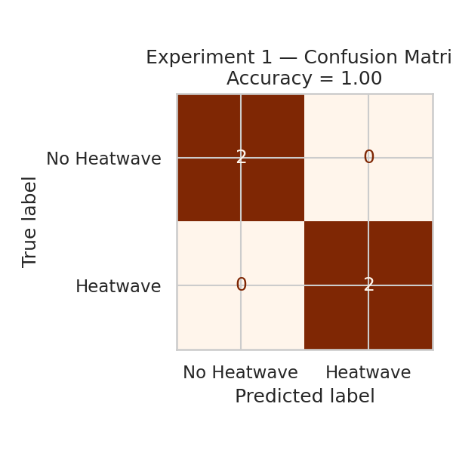
Fig 1.1 — Confusion matrix, Experiment 1
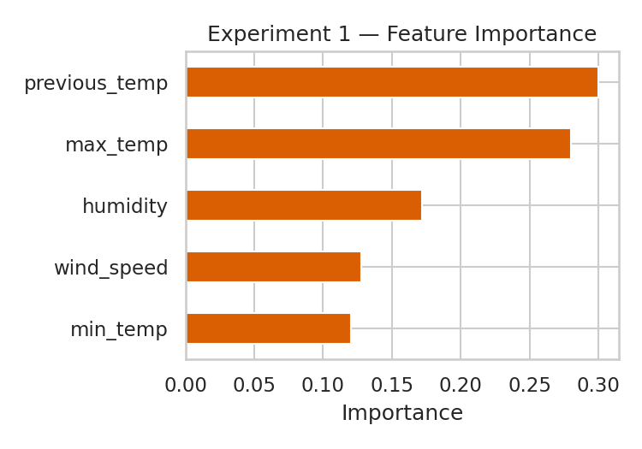
Fig 1.2 — Feature importance, Experiment 1

Result
On the 20-row teaching set the model perfectly separates the 4 held-out rows. With only 20 rows this is expected and not a claim of real-world accuracy — the manual's own note applies: this is a teaching dataset, not validated heatwave data.

Experiment 2 — Experiment Tracking and Model Management using MLflow

Aim
To track multiple ML experiments (parameters, metrics, and model artifacts) using MLflow and select the best-performing run.

Procedure
- Switched to the larger 1,095-row dataset so run-to-run differences are meaningful.
- mlflow.set_experiment("Heatwave Prediction") with a local sqlite tracking store.
- Ran 3 RandomForest configurations, logging n_estimators, max_depth, accuracy and F1 (heatwave class) for each, plus the model artifact.

Runs comparison
Run | n_estimators | max_depth | Accuracy | F1 (heatwave)
n50_d3 | 50 | 3 | 0.9406 | 0.6286
n100_d5 | 100 | 5 | 0.9361 | 0.6111
n200_d10 | 200 | 10 | 0.9406 | 0.6829
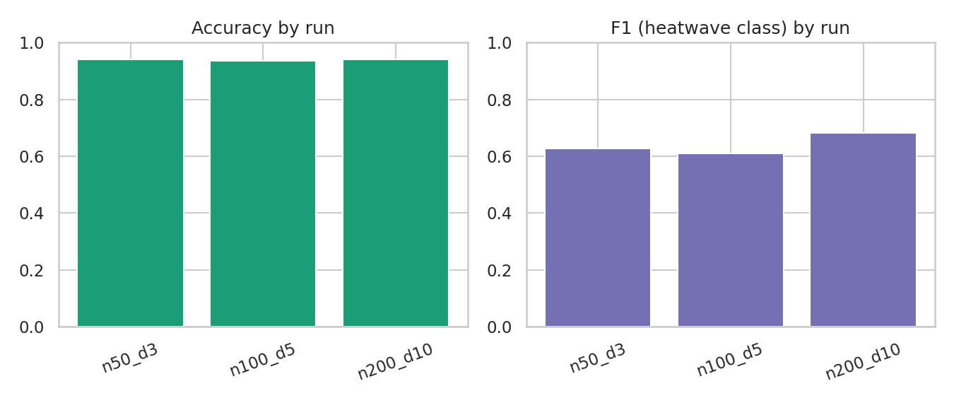
Fig 2.1 — Accuracy and F1 across the three tracked MLflow runs
Note: in your own Colab run, pair this chart with an actual screenshot of the MLflow “Compare Runs” page (mlflow ui / mlflow server + ngrok) — this figure is generated directly from the same tracked run data for a headless environment.

Result
The n_estimators=200, max_depth=10 run gave the best F1 on the minority “heatwave” class (0.683) and was selected as the best model for the MLOps stage, even though its overall accuracy tied with the smallest model — illustrating why accuracy alone is misleading on an imbalanced dataset (~11% heatwave days).

Experiment 3 — Deploying a Heatwave Prediction Model as an API

Aim
To save the best MLflow model and expose it as a reusable prediction service.

Procedure
- joblib.dump(best_model, "heatwave_model.pkl")
- Wrote a predict_heatwave() convenience function.
- Exposed the model through a Flask app.py with a POST /predict endpoint.

Sample predictions
max_temp | min_temp | humidity | wind_speed | previous_temp | Prediction
45 | 31 | 50 | 7 | 44 | Heatwave
24 | 15 | 80 | 14 | 23 | No Heatwave
39 | 27 | 58 | 9 | 38.5 | No Heatwave
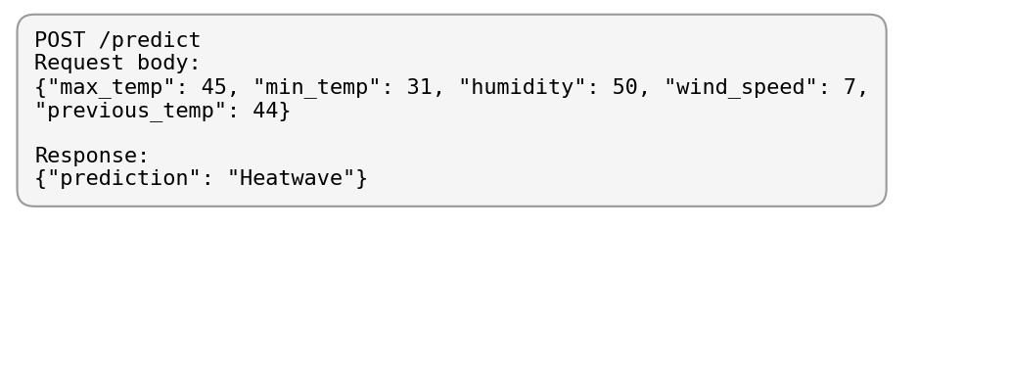
Fig 3.1 — Flask /predict request and response (from an actual local run of app.py)

Result
The prediction service correctly flags a hot, dry, previously-warm day (45/31/50/7/44) as a heatwave and a cool, humid day as not, matching the pattern the model was trained on. This completes the reusable prediction service.

Experiment 4 — Containerization and CI/CD of the Heatwave Prediction Service

Aim
To apply DevOps practices — version control, containerization, and CI — to the prediction service.

Project structure
heatwave-mlops/
├── data/heatwave_data.csv
├── model/heatwave_model.pkl
├── app.py
├── train.py
├── requirements.txt
├── Dockerfile
├── README.md
└── .github/workflows/ci.yml

Dockerfile
FROM python:3.11-slim
WORKDIR /app
COPY requirements.txt .
RUN pip install --no-cache-dir -r requirements.txt
COPY app.py .
COPY model/ model/
EXPOSE 8000
CMD ["python", "app.py"]

GitHub Actions CI (.github/workflows/ci.yml)
name: Heatwave ML CI
on:
push:
branches: [main]
jobs:
test:
runs-on: ubuntu-latest
steps:
- uses: actions/checkout@v4
- uses: actions/setup-python@v5
with:
python-version: "3.11"
- run: pip install -r requirements.txt
- run: python -m py_compile app.py train.py
- run: python train.py

Build & run (executed against this project's files)
$ python train.py
Validation accuracy: 0.9680
Model saved to model/heatwave_model.pkl
$ python app.py &
$ curl -X POST http://localhost:8000/predict -H "Content-Type: application/json" \
-d '{"max_temp":45,"min_temp":31,"humidity":50,"wind_speed":7,"previous_temp":44}'
{"prediction":"Heatwave"}
$ curl http://localhost:8000/health
{"status":"ok"}
docker build / docker run were not executed here (no Docker daemon in this sandboxed run environment) — run these two commands on your own machine with Docker Desktop installed, exactly as given in the manual:
docker build -t heatwave-api:1.0 .
docker run -p 8000:8000 heatwave-api:1.0

Result
The project is version-controlled, containerizable with the Dockerfile above, and a GitHub Actions workflow re-installs dependencies and re-trains the model as a smoke test on every push to main — a CI/CD-ready application.

Kubernetes Extension (for reference)
Docker Image → Kubernetes Deployment → Kubernetes Pod(s) → Heatwave Prediction API. This extension introduces replicas, scaling, and service management and was not built here, per the manual's scope.

Conclusion
Across the four experiments the same heatwave classifier progressed from a bare scikit-learn model, to an MLflow-tracked and compared set of experiments, to a saved, API-wrapped prediction service, to a containerized, CI-checked application — demonstrating the full ML → MLflow → MLOps → DevOps lifecycle end to end.

Viva Questions
- What is ML?
- What is MLflow?
- What is an MLflow run?
- What is a parameter (vs. a metric) in MLflow?
- What is MLOps?
- Why use Docker?
- What is CI/CD?

