Electronic supplementary information for: Screening tahini for sunflower and peanut paste on unseen production lots: a multitask neural network and partial least squares on ATR–FTIR spectra

S1 Why the preliminary analysis was rebuilt
The analysis began from a preliminary run in which the 1554 scans were divided at random into training and test sets (80/20). Reproducing that division (scikit-learn train_test_split, seed 42) showed that replicate scans of 54 of the 55 physical samples fell on both sides, so the test set consisted largely of near-copies of training scans (audit/check_split.py in the repository). The preliminary run reported an AUC of 0.9998 and two misclassified test scans; its figures are kept in originals_preliminary/ of the repository. All results in the article come from the rebuilt analysis, whose plan was fixed before any grouped result was seen (DESIGN.md).

S2 Amendments to the analysis plan
Two amendments were made and are dated in DESIGN.md. Amendment A1 was made after seeing only the training histories of the random scheme: the class-head loss dominated and rose on unseen samples from the first epochs, so the composition loss was weighted by 10, label smoothing (0.05), weight decay (10−4) and a minimum of 20 epochs were added, and the MT-DNN regression route was added to the comparison. Amendment A2 was made after the first lot-out results, when an independent review of the code showed that the network never trained on its early-stopping samples, which in lot-out validation removed one (15 of the 25 fold–seed fits) or two (5 fits) of the four authentic training lots from training (results/a2_val_split.json, audit/a2_val_split.py). The network is now retrained on all training samples for the number of epochs chosen by early stopping. Table S6 compares the results before and after A2. The same review found that duplicate draws were merged in the sample-level bootstrap; this was corrected for all reported intervals. Table S8 collects analyses added at the review stage: a paired test of the two decision routes, detection by nominal level, results without the pure-adulterant samples and the lot-wise blank of PLS. Table S9 gives an exploratory one-class baseline (principal-component T² and Q fitted on authentic training scans only).

S3 Training histories
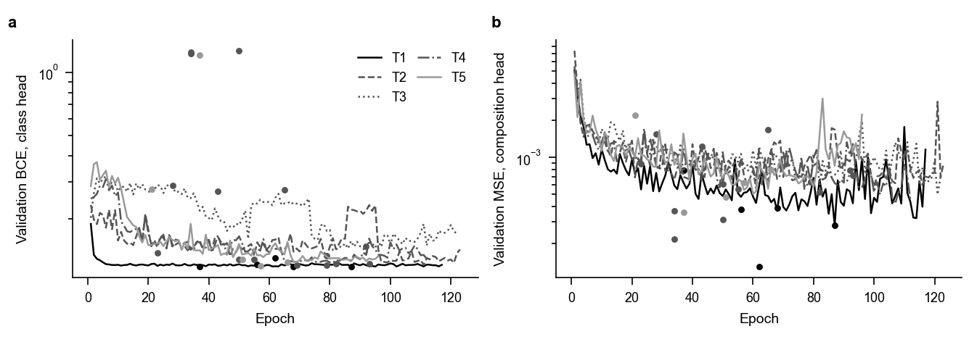
Fig. S1 MT-DNN training histories in leave-one-lot-out validation: (a) inner-validation binary cross-entropy of the class head and (b) mean squared error of the composition head (fractions scaled to 0–1), median over five seeds for each withheld lot; dots mark the epoch chosen by early stopping for each seed.

S4 Hold-out quantification
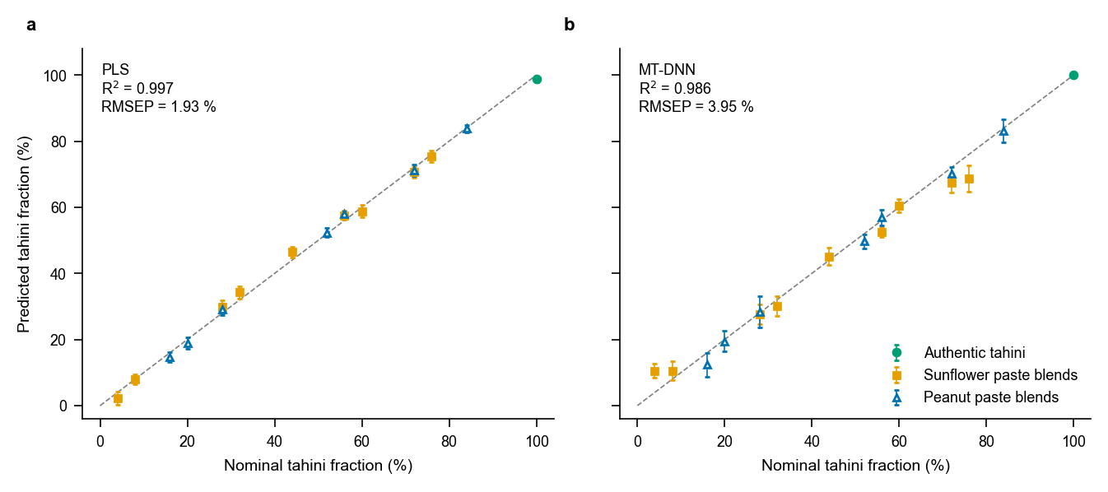
Fig. S2 Quantification on the grouped hold-out test set (17 samples, one authentic lot): predicted against nominal tahini fraction for (a) PLS regression and (b) the MT-DNN composition head. Points are sample means and bars ±1 SD over scans.

S4b Second-derivative spectra of the authentic lots
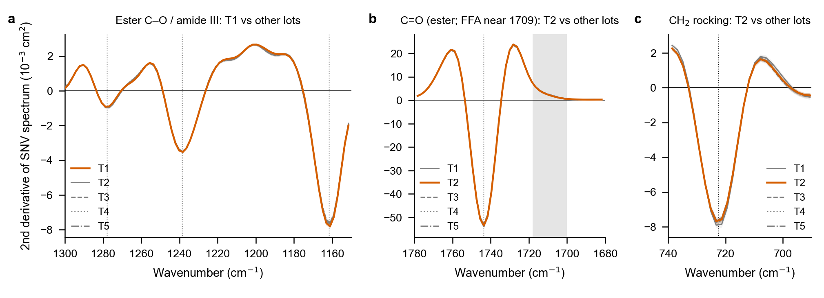
Fig. S3 Second-derivative spectra (Savitzky–Golay, 13 points = 23 cm−1, second-order polynomial, of the SNV spectra) of the five authentic lots, lot means with ±1 SD bands: (a) 1150–1300 cm−1, lot T1 against the other lots; (b) 1680–1780 cm−1 and (c) 690–740 cm−1, lot T2 against the other lots. Dotted lines mark the band minima of the other four lots; the shaded band in (b) is 1700–1718 cm−1, where free fatty acids absorb. Band positions agree within 0.3 cm−1 in all lots, and no separate component is resolved near 1215, 1248, 1709 or 717 cm−1; windows of 9 and 17 points give the same result (results/derivative_bands.json).

S5 Supplementary tables
Table S1 Settings chosen inside each leave-one-lot-out training set (chemically informative regions).
Withheld lot | Training scans | Test scans | PLS2 latent variables | PLS-DA latent variables | PLS-R threshold (% adulterant) | MT-DNN-R threshold, range over seeds (% adulterant) | MT-DNN best epoch (seeds 0–4)
T1 | 1243 | 311 | 14 | 22 | 7.06 | 0.40–0.78 | 87, 68, 62, 56, 37
T2 | 1243 | 311 | 14 | 4 | 8.55 | 1.82–3.70 | 93, 55, 34, 50, 65
T3 | 1244 | 310 | 14 | 2 | 8.02 | 3.65–5.16 | 92, 23, 50, 79, 43
T4 | 1243 | 311 | 11 | 3 | 6.36 | 2.56–4.46 | 82, 79, 34, 69, 28
T5 | 1243 | 311 | 15 | 3 | 6.08 | 3.70–4.88 | 66, 51, 37, 57, 21
Source: results/run_info_lolo_chem.json.
Table S2 Results for each withheld lot (scan level; MT-DNN routes: mean of five seeds).
Withheld lot | Route | Authentic scans flagged (%) | Blend scans missed (%) | RMSEP (% tahini) | R² | Identification (%)
T1 | MT-DNN | 98.0 | 0.0 | 5.46 | 0.966 | 95.3
T1 | MT-DNN-R | 100.0 | 0.0
T1 | PLS-DA | 100.0 | 0.0
T1 | PLS-R | 1.3 | 9.9 | 3.16 | 0.989 | 99.4
T2 | MT-DNN | 3.0 | 0.0 | 2.36 | 0.994 | 95.1
T2 | MT-DNN-R | 0.3 | 0.0
T2 | PLS-DA | 52.3 | 0.0
T2 | PLS-R | 0.0 | 0.0 | 3.82 | 0.985 | 93.8
T3 | MT-DNN | 0.0 | 0.0 | 3.05 | 0.991 | 99.7
T3 | MT-DNN-R | 0.0 | 0.3
T3 | PLS-DA | 0.0 | 30.2
T3 | PLS-R | 0.0 | 0.0 | 3.40 | 0.989 | 100.0
T4 | MT-DNN | 0.0 | 0.2 | 4.06 | 0.986 | 95.9
T4 | MT-DNN-R | 0.0 | 0.0
T4 | PLS-DA | 0.0 | 26.9
T4 | PLS-R | 0.0 | 3.1 | 4.35 | 0.984 | 93.1
T5 | MT-DNN | 0.0 | 0.0 | 4.03 | 0.988 | 100.0
T5 | MT-DNN-R | 0.0 | 0.0
T5 | PLS-DA | 0.0 | 0.6
T5 | PLS-R | 100.0 | 0.0 | 7.97 | 0.952 | 100.0
Source: results/metrics_lot.csv. R² within one lot is computed over that lot’s 11 samples only.
Table S3 Exploratory: how each authentic lot departs from the other four.
Lot | RMS departure (pooled SD) | Largest departures, cm⁻¹ (SD units) | Projected PLS adulterant shift (points) | Observed PLS-R mean (% adulterant) | Observed MT-DNN mean (% adulterant)
T1 | 1.61 | 1215 (-8.35); 1273 (-5.48); 1248 (-4.90); 733 (-3.50); 1190 (-2.34); 1362 (-2.07) | +3.0 | 3.58 | 2.92
T2 | 1.11 | 717 (+4.25); 1709 (+4.05); 743 (+2.31); 1117 (-2.17); 781 (+2.06); 3015 (+2.02) | +0.8 | 3.82 | 0.41
T3 | 1.36 | 1620 (+2.28); 1711 (-2.26); 1574 (+2.22); 1670 (+2.17); 1645 (+2.14); 1317 (+2.05) | +1.5 | 3.98 | 0.08
T4 | 1.31 | 1246 (+5.40); 1217 (+3.71); 717 (-3.70); 1273 (+2.98); 1134 (-2.39); 1352 (+2.36) | -12.6 | 2.33 | 0.02
T5 | 1.26 | 1213 (+4.10); 908 (+3.01); 1134 (+2.69); 1452 (-2.66); 883 (+2.52); 1703 (-2.51) | +8.9 | 10.34 | 0.12
Source: results/lot_departure.json (src/s03_lots.py). The projected shift is the unscaled departure multiplied by the sunflower and peanut PLS2 coefficients of the model that withheld the lot, before clipping; observed values are the mean predicted adulterant fraction of the lot’s authentic scans.
Table S4 Largest differences between the pure adulterant pastes and authentic tahini (mean SNV spectra).
Paste | Scans | Wavenumber, cm⁻¹ (difference, SNV units)
sunflower paste, 100 % | 17 | 2920 (-0.287); 989 (+0.250); 602 (+0.249); 669 (+0.224); 2851 (-0.220); 1051 (+0.203); 623 (+0.202); 644 (+0.178)
peanut paste, 100 % | 16 | 2920 (+0.637); 2853 (+0.498); 1655 (-0.294); 1041 (-0.283); 1101 (-0.261); 1063 (-0.232); 1749 (+0.214); 1132 (-0.208)
Source: results/lot_departure.json.
Table S5 Exploratory sample-level agreement rule (leave-one-lot-out; 5 authentic and 50 blend samples).
Rule | Seed | Authentic lots flagged | Blends missed (level, adulterant, lot)
PLS-R | – | T5 | 4 % peanut (T1)
MT-DNN-R | 0 | T1 | none
PLS-R and MT-DNN-R | 0 | none | 4 % peanut (T1)
MT-DNN-R | 1 | T1 | none
PLS-R and MT-DNN-R | 1 | none | 4 % peanut (T1)
MT-DNN-R | 2 | T1 | none
PLS-R and MT-DNN-R | 2 | none | 4 % peanut (T1)
MT-DNN-R | 3 | T1 | none
PLS-R and MT-DNN-R | 3 | none | 4 % peanut (T1)
MT-DNN-R | 4 | T1 | none
PLS-R and MT-DNN-R | 4 | none | 4 % peanut (T1)
Source: results/consensus.json (src/s04_consensus.py).
Table S6 MT-DNN results before / after amendment A2 (refit on all training samples; chemically informative regions; point estimates, means over five seeds). PLS results are not affected by A2.
Validation | Level | Route | Sensitivity (%) | Specificity (%) | AUC | RMSEP (% tahini) | LOD (%)
holdout | sample | MT-DNN | 100.0 / 100.0 | 100.0 / 100.0 | 1.000 / 1.000 | 3.98 / 3.79 | 0.07 / 0.03
holdout | sample | MT-DNN-R | 100.0 / 100.0 | 100.0 / 100.0 | 1.000 / 1.000 | 3.98 / 3.79
holdout | scan | MT-DNN | 99.6 / 100.0 | 100.0 / 100.0 | 1.000 / 1.000 | 4.02 / 3.95
holdout | scan | MT-DNN-R | 100.0 / 100.0 | 100.0 / 100.0 | 1.000 / 1.000 | 4.02 / 3.95
lolo | sample | MT-DNN | 100.0 / 100.0 | 84.0 / 80.0 | 0.998 / 0.998 | 4.64 / 4.55 | 3.81 / 4.10
lolo | sample | MT-DNN-R | 100.0 / 100.0 | 80.0 / 80.0 | 0.998 / 1.000 | 4.64 / 4.55
lolo | scan | MT-DNN | 99.7 / 100.0 | 83.5 / 79.9 | 0.995 / 0.996 | 4.11 / 3.95
lolo | scan | MT-DNN-R | 99.3 / 100.0 | 80.6 / 80.1 | 0.999 / 1.000 | 4.11 / 3.95
random | sample | MT-DNN | 99.6 / 100.0 | 96.0 / 100.0 | 0.998 / 1.000 | 2.80 / 3.15 | 0.75 / 0.37
random | sample | MT-DNN-R | 97.1 / 97.6 | 100.0 / 100.0 | 1.000 / 1.000 | 2.80 / 3.15
random | scan | MT-DNN | 99.3 / 99.9 | 95.7 / 100.0 | 0.991 / 1.000 | 2.52 / 2.75
random | scan | MT-DNN-R | 97.8 / 97.8 | 100.0 / 100.0 | 1.000 / 1.000 | 2.52 / 2.75
Source: results/v1_A1/metrics.csv (before) and results/metrics.csv (after).
Table S7 Sensitivity analysis: chemically informative regions (752 channels) / full 600–4000 cm⁻¹ range (scan level).
Validation | Route | Sensitivity (%) | Specificity (%) | RMSEP (% tahini)
holdout | PLS-DA | 90.3 / 91.8 | 100.0 / 100.0 | 1.93 / 2.02
holdout | PLS-R | 100.0 / 100.0 | 100.0 / 100.0 | 1.93 / 2.02
holdout | MT-DNN | 100.0 / 100.0 | 100.0 / 100.0 | 3.95 / 4.04
holdout | MT-DNN-R | 100.0 / 99.8 | 100.0 / 100.0 | 3.95 / 4.04
lolo | PLS-DA | 88.5 / 92.1 | 69.6 / 79.4 | 4.87 / 5.32
lolo | PLS-R | 97.4 / 99.5 | 79.7 / 74.3 | 4.87 / 5.32
lolo | MT-DNN | 100.0 / 100.0 | 79.9 / 80.1 | 3.95 / 5.73
lolo | MT-DNN-R | 100.0 / 97.2 | 80.1 / 79.9 | 3.95 / 5.73
random | PLS-DA | 95.0 / 91.9 | 99.3 / 100.0 | 1.79 / 1.97
random | PLS-R | 95.0 / 95.0 | 100.0 / 100.0 | 1.79 / 1.97
random | MT-DNN | 99.9 / 99.4 | 100.0 / 100.0 | 2.75 / 2.73
random | MT-DNN-R | 97.8 / 97.5 | 100.0 / 100.0 | 2.75 / 2.73
Source: results/metrics.csv (regions chem and full).
Table S8 Supplementary analyses (leave-one-lot-out, chemically informative regions; added at review stage).
Analysis | Seed | Result
Paired routes, PLS | – | class right / regression wrong: 2; reverse: 8; exact McNemar p = 0.11
Paired routes, MT-DNN | seed 0 | class right / regression wrong: 0; reverse: 0; exact McNemar p = 1.00
Paired routes, MT-DNN | seed 1 | class right / regression wrong: 0; reverse: 0; exact McNemar p = 1.00
Paired routes, MT-DNN | seed 2 | class right / regression wrong: 0; reverse: 0; exact McNemar p = 1.00
Paired routes, MT-DNN | seed 3 | class right / regression wrong: 0; reverse: 0; exact McNemar p = 1.00
Paired routes, MT-DNN | seed 4 | class right / regression wrong: 0; reverse: 0; exact McNemar p = 1.00
Detection by level, PLS-DA | – | every level ≥ 56 % flagged in ≥ 95 % of scans; levels below 95 %: 12 %: 0; 16 %: 3; 32 %: 66; 36 %: 62; 52 %: 81
Detection by level, PLS-R | – | every level ≥ 20 % flagged in ≥ 95 % of scans; levels below 95 %: 4 %: 50; 16 %: 84
Detection by level, MT-DNN | – | every level ≥ 4 % flagged in ≥ 95 % of scans; levels below 95 %: none
Detection by level, MT-DNN-R | – | every level ≥ 4 % flagged in ≥ 95 % of scans; levels below 95 %: none
Without pure adulterants, PLS-DA | – | sample sensitivity 88.0 % (50 blends) / 87.5 % (48 blends)
Without pure adulterants, PLS-R | – | sample sensitivity 98.0 % (50 blends) / 97.9 % (48 blends)
Without pure adulterants, MT-DNN | – | sample sensitivity 100.0 % (50 blends) / 100.0 % (48 blends)
Without pure adulterants, MT-DNN-R | – | sample sensitivity 100.0 % (50 blends) / 100.0 % (48 blends)
Without pure adulterants, PLS-R | – | slope 0.940 / 0.937; LOD 11.1 / 11.1 % adulterant
Without pure adulterants, MT-DNN | – | slope 0.976 / 0.986; LOD 4.1 / 4.1 % adulterant
PLS-R blank by lot | – | T1: 3.6 ± 1.4 %; T2: 3.8 ± 1.8 %; T3: 4.0 ± 1.4 %; T4: 2.3 ± 0.7 %; T5: 10.3 ± 1.6 %
PLS-R LOD, lot left out of the blank | – | T1: 11.9 %; T2: 11.9 %; T3: 12.1 %; T4: 11.4 %; T5: 5.2 %
Source: results/extra.json (src/s05_extra.py). Each nominal level occurs in one lot only, so detection by level is confounded with the lot effect (lot T1 holds the 4 % blends).
Table S9 Exploratory one-class baseline: PCA fitted on authentic training scans only, flag when T² or Q exceeds its limit (leave-one-lot-out, chemically informative regions; added at review stage).
Setting (components, limit) | Scan sensitivity (%) | Scan specificity (%) | Sample sensitivity (%, 50 blends) | Sample specificity (%, 5 lots) | Blends missed (% adulterant) | Authentic scans flagged T1/T2/T3/T4/T5 (%)
k2, sd3 | 81.4 | 86.3 | 78 | 100 | 4, 4, 8, 12, 12, 16, 16, 20, 20, 24, 36 | 0 / 34 / 34 / 0 / 1
k2, p99 | 80.9 | 88.5 | 80 | 100 | 4, 4, 12, 12, 16, 16, 20, 20, 24, 36 | 0 / 40 / 17 / 0 / 0
k2, combined, sd3 | 74.0 | 95.0 | 72 | 100 | 4, 4, 8, 8, 12, 12, 16, 16, 20, 20, 24, 24, 32, 36 | 0 / 1 / 23 / 0 / 2
k5, sd3 | 81.4 | 97.5 | 82 | 100 | 4, 4, 8, 12, 12, 16, 20, 32, 36 | 2 / 11 / 0 / 0 / 0
k5, p99 | 82.8 | 97.6 | 84 | 100 | 4, 4, 8, 12, 12, 16, 32, 36 | 2 / 10 / 0 / 0 / 0
k5, combined, sd3 | 76.4 | 98.7 | 78 | 100 | 4, 4, 8, 12, 12, 16, 20, 32, 36, 40, 52 | 0 / 7 / 0 / 0 / 0
k10, sd3 | 81.4 | 94.7 | 82 | 100 | 4, 8, 8, 12, 12, 16, 20, 28, 32 | 27 / 0 / 0 / 0 / 0
k10, p99 | 84.6 | 95.0 | 84 | 100 | 4, 4, 8, 8, 12, 12, 16, 28 | 25 / 0 / 0 / 0 / 0
k10, combined, sd3 | 75.6 | 93.1 | 76 | 100 | 4, 8, 8, 12, 12, 16, 20, 28, 32, 36, 48, 52 | 35 / 0 / 0 / 0 / 0
main, sd3 | 82.4 | 91.4 | 82 | 100 | 4, 8, 8, 12, 12, 16, 20, 28, 32 | 43 / 0 / 0 / 0 / 0
main, p99 | 86.0 | 92.7 | 86 | 100 | 4, 8, 8, 12, 12, 16, 28 | 37 / 0 / 0 / 0 / 0
main, combined, sd3 | 78.2 | 91.5 | 78 | 100 | 8, 8, 12, 12, 16, 20, 28, 32, 36, 48, 52 | 43 / 0 / 0 / 0 / 0
Source: results/oneclass.json. sd3: mean + 3 SD of out-of-fold statistics (leave-one-training-lot-out), the rule used for the regression routes; p99: 99th percentile; combined: T²/T²₀ + Q/Q₀. The 99 % explained-variance rule reached the cap of 15 components in every fold.

