# Statistics and Trends

**Assignment**

**Title:** Exploring Economic Trends: A Comparative Analysis of European Countries

**Name:**

# Student Number:

# GitHub Repository: <https://github.com/abdulhaq111/Statistics-and-Trend>

# Dataset Link: [https://databank.worldbank.org/source/world-development-indicators#](https://databank.worldbank.org/source/world-development-indicators)

# Exploring Economic Trends: A Comparative Analysis of Various European Countries

**Introduction:**

This investigation conducts a comparative analysis of economic trends across different European countries. By examining key economic indicators such as GDP, inflation, employment rates, and population using the internet, this analysis aims to uncover insights into each country's economic performance and identify potential interrelations between these factors. Through this exploration, a deeper understanding of the economic landscape of these nations and the dynamics shaping their economies over time can be gained.

**Countries GDP Analysis:**

A simple bar graph was created to visualize the GDP of six European countries from 2018 to 2022. It is evident from the graph that all countries, except Ireland, experienced negative GDP growth in the year 2020. This can be correlated with the onset of the COVID-19 pandemic, which significantly impacted the GDP of nations worldwide. Notably, Ireland maintained a positive GDP even in 2020, indicating strong decision-making and measures implemented by the country to mitigate the effects of the pandemic on its economy. However, Ukraine exhibited a significantly low GDP of -29%, which may be attributed to the ongoing conflict with Russia that escalated in February 2022.

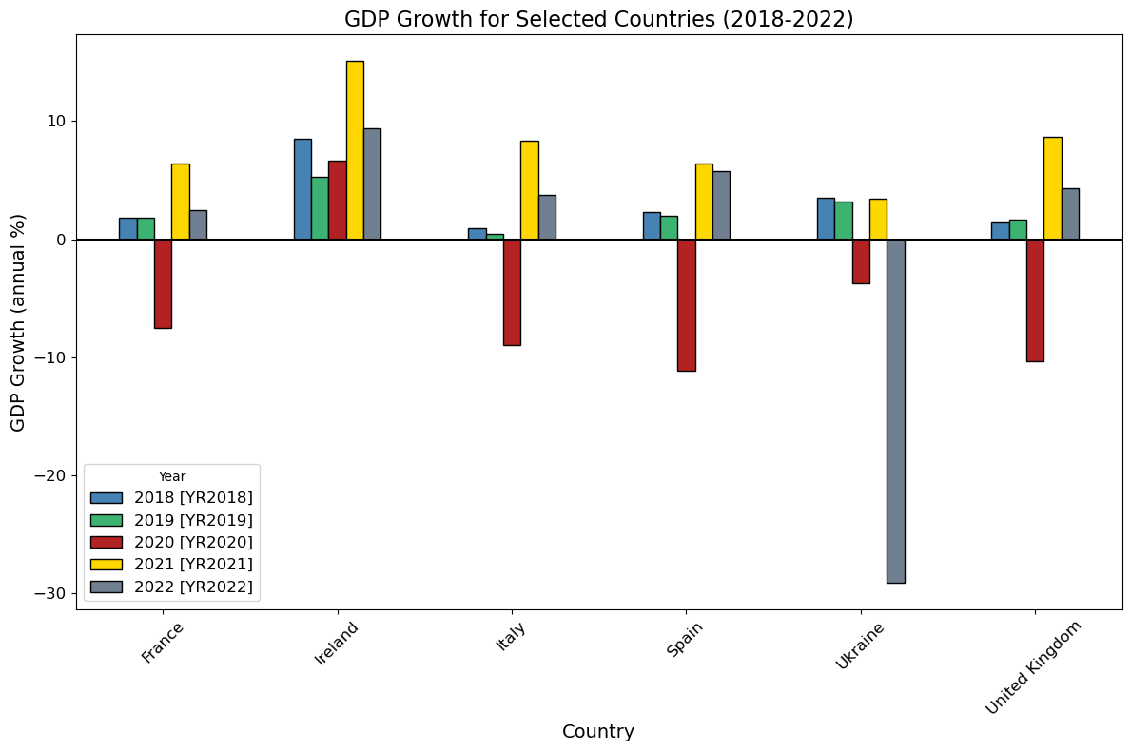

**Countries Inflation Rate Analysis:**

A bar graph was utilized to visualize the inflation rates of six European countries from 2018 to 2022. The graph illustrates a consistent increase in inflation across all countries during this period, with the highest inflation rates observed in 2022. However, it is noteworthy that Ireland, Italy, and Spain exhibited negative inflation rates in the year 2020. Italy and Ireland show a similar trend in inflation rates over the years, indicating potential similarities in economic policies or external factors affecting these countries.

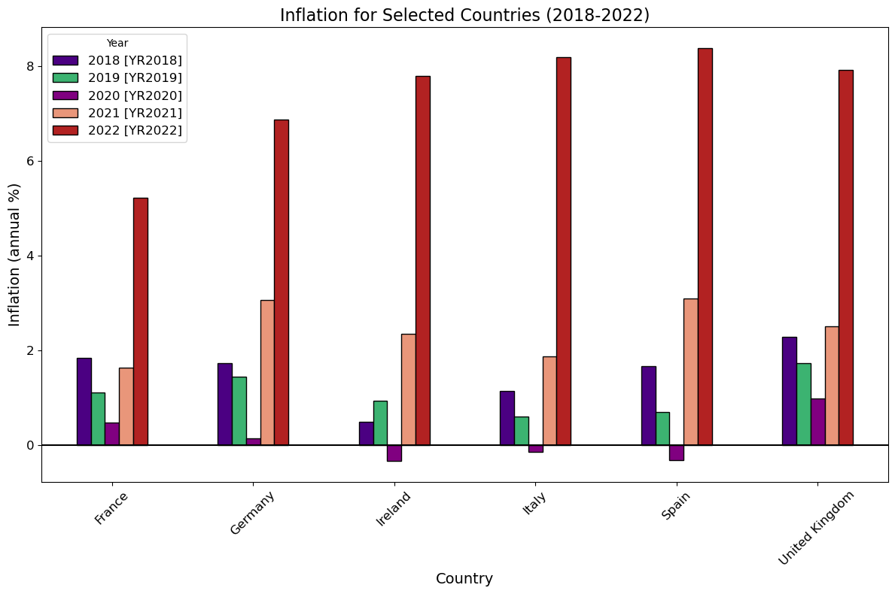

**Employment Rate Analysis:**

A line graph depicting the employment rates from 2012 to 2022 reveals intriguing insights into the labor markets of Greece, Germany, France, Norway, the United Kingdom, and Italy. Notably, Greece exhibits the highest employment rate among these countries throughout the period under consideration. Conversely, Norway experiences the lowest employment rate, characterized by a continuous decline over the years.

Furthermore, France and Germany demonstrate similar employment rate trends, maintaining rates between 4-5 percent consistently over the observed years. This stability suggests robust labor market conditions in both countries.

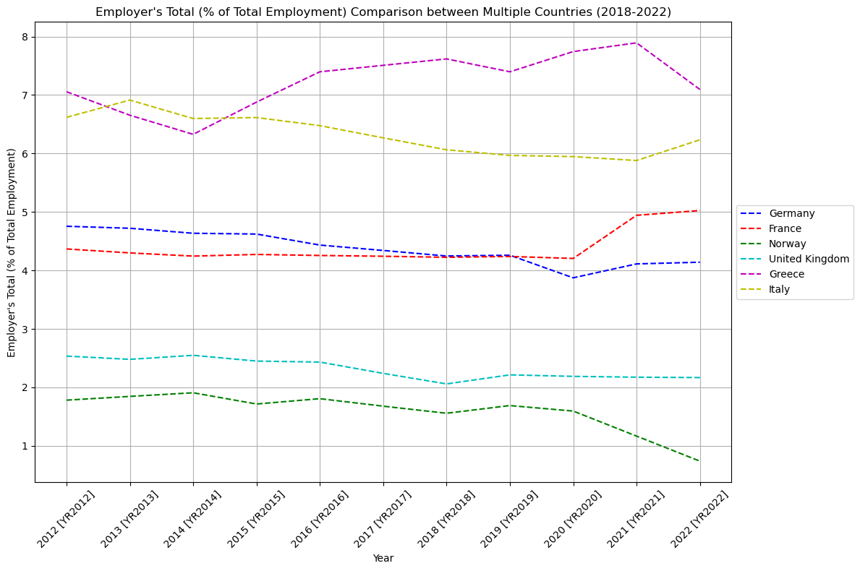

**No. of Internet Users Analysis:**

A line graph illustrating the percentage of internet users from 2012 to 2022 unveils intriguing trends among the selected countries: Norway, Italy, Greece, France, and Germany,.

Norway emerges as the leader in internet adoption, consistently maintaining the highest percentage of internet users throughout the observed period. Meanwhile, Italy and Greece exhibit notable growth trajectories, experiencing sharp rises in internet usage over the years. This upward trend positions them competitively with France in terms of internet penetration.

Germany, surpassing France in internet adoption, demonstrates a steady increase in the percentage of internet users, reflecting the pervasive influence of digital connectivity across various aspects of society.

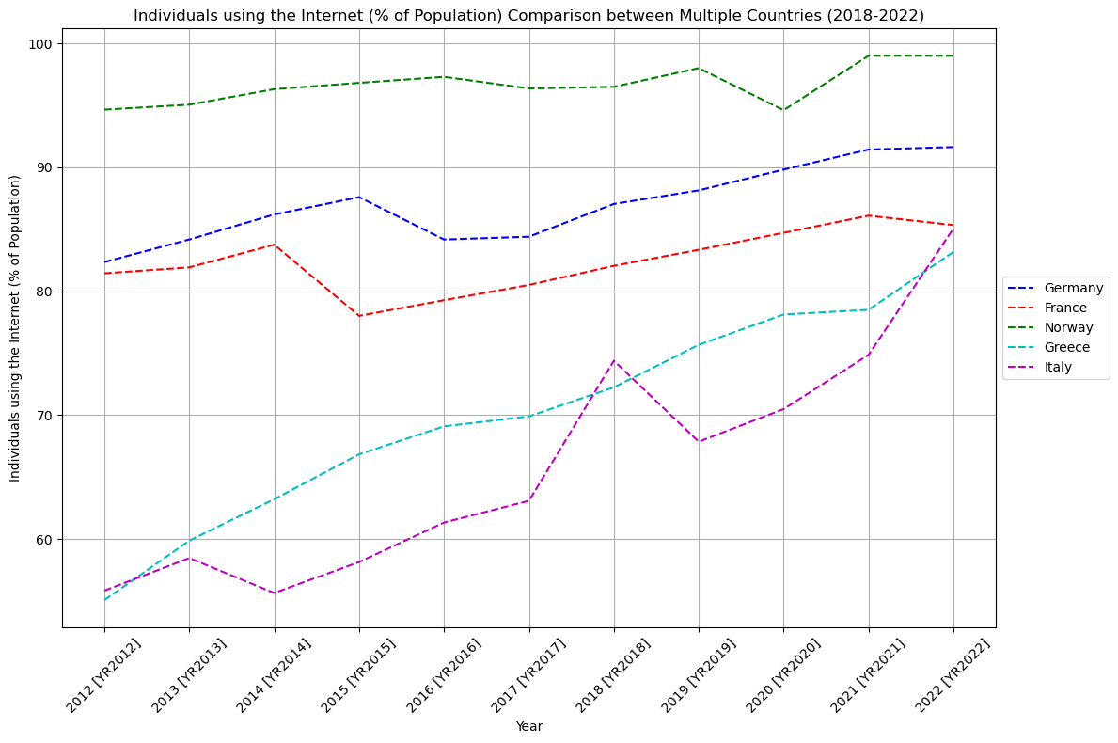

**Insights on the Heatmap of Germany:**

The heatmap reveals a robust positive correlation between GDP and employment, indicating that as the GDP of Germany rises, employment levels also tend to increase. Additionally, the heatmap demonstrates a noteworthy correlation between internet usage and literacy rate, suggesting that regions with higher internet usage tend to exhibit higher literacy rates. This underscores the role of internet access in facilitating education and information dissemination, potentially contributing to higher literacy levels among the population.

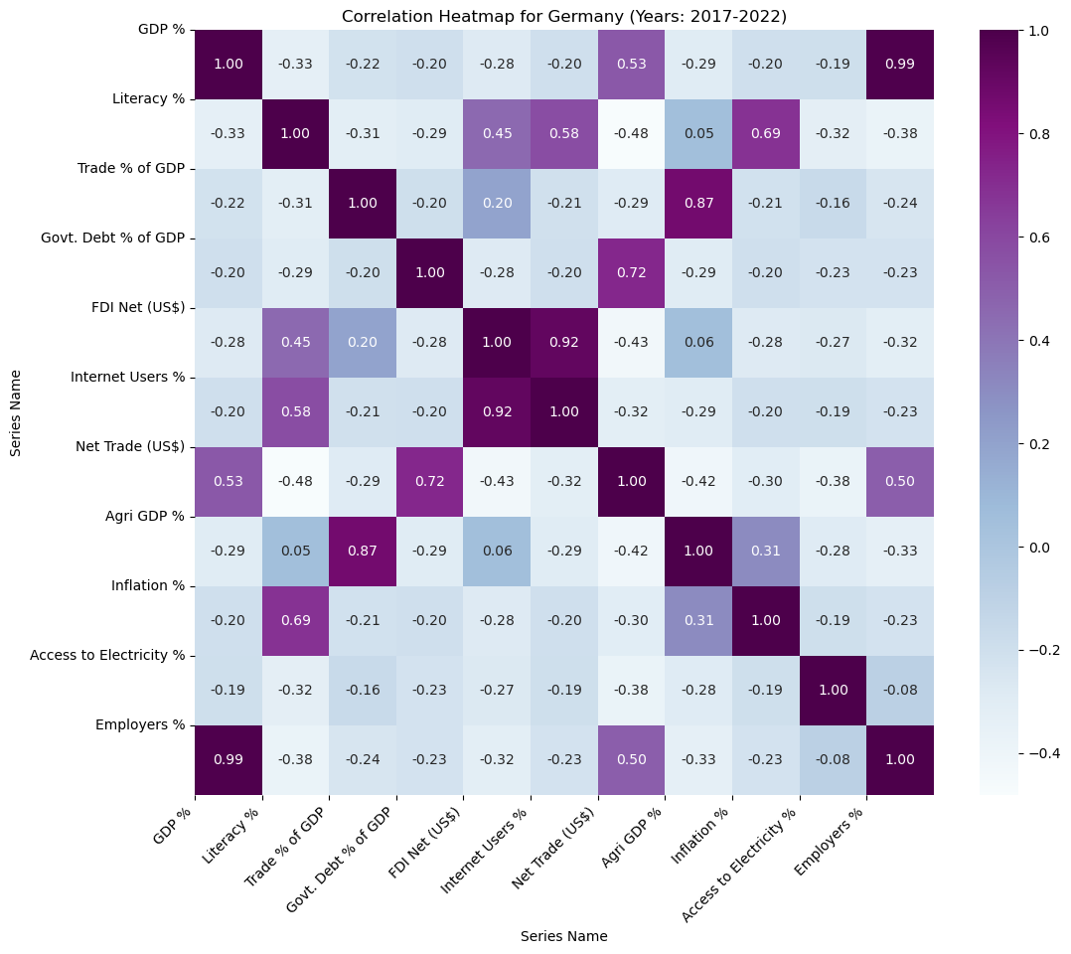

**Insights on the Heatmap of Ukraine:**

Similar to Germany, the heatmap of Ukraine illustrates a significant positive correlation between GDP and employment, indicating that as GDP increases, there is a corresponding rise in employment levels, potentially influenced by factors such as the number of employers. Additionally, the heatmap suggests a positive relationship between net trade and GDP, highlighting the potential impact of trade activities on the country's economic output and growth.

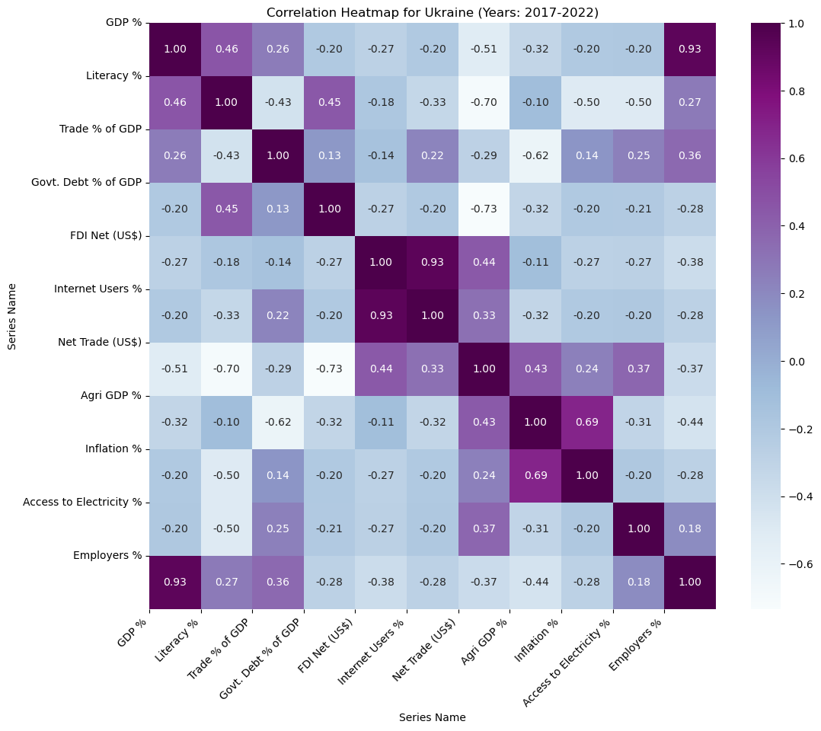

**Conclusion:**

In conclusion, the comparative analysis of economic indicators across various European countries, revealed diverse trends and correlations. The examination of GDP, inflation rates, employment rates, and internet usage provided valuable insights into each country's economic performance and interrelations between these factors. Notably, fluctuations in GDP and inflation rates shed light on the economic impacts of events such as the COVID-19 pandemic and geopolitical tensions. Overall, this analysis deepened our understanding of the economic landscape of the selected European countries and the multifaceted factors influencing their economic trajectories over time.