
UID ASSIGNMENT
Smart Library Management System
Submitted by
Name | ABDUL HASEEB
Roll No. | AV.SC.U4CSE25001
YEAR/SEM/SECTION | 1st Year/2/CSE-A
CREDITS | 4

Submitted To
Name | Dr.RajKumar Batchu
Designation | ASST.PROFFESSOR(S l .Grade)
Department | School Of Computing

Assignment:-
Aim:- To Select a website and clone its UI as much as possible.
Website selected:- https://www.binance.com/en-IN

Cloning done by me:-

Main Page HTML Code:-

index.html:-

<!doctype html>

<html lang="en">

<head>

<meta charset="utf-8">

<meta name="viewport" content="width=device-width, initial-scale=1">

<meta name="description" content="A simple Binance-inspired cryptocurrency website made with HTML, CSS, and JavaScript.">

<title>Binance Inspired Crypto</title>

<link rel="stylesheet" href="styles.css">

</head>

<body>

<header class="header">

<a class="logo" href="#home" aria-label="Home">

<img src="assets/binance-logo.svg" alt="Binance inspired logo">

</a>

<button class="menu-btn" id="menuBtn" type="button" aria-label="Toggle navigation">

Menu

</button>

<nav class="nav" id="nav">

<a href="#home">Home</a>

<a href="#trending">Trending</a>

<a href="#markets">Markets</a>

<a href="#buy">Buy Crypto</a>

<a href="#auth">Login</a>

</nav>

<a class="login-btn" href="#auth">Login</a>

<a class="signup-btn" href="#auth">Sign Up</a>

<button class="theme-btn" id="themeBtn" type="button" aria-label="Toggle dark and light mode">

Dark

</button>

</header>

<main>

<section class="hero" id="home">

<div class="hero-text">

<p class="tagline">Crypto exchange project</p>

<h1>Buy, trade, and track cryptocurrency</h1>

<p>

A clean Binance-inspired university web development project using only

HTML, CSS, and vanilla JavaScript.

</p>

<div class="hero-actions">

<a class="primary-btn" href="#buy">Buy Crypto</a>

<a class="secondary-btn" href="#markets">View Markets</a>

</div>

</div>

<div class="hero-card">

<div class="hero-card-top">

<img src="assets/coin-btc.svg" alt="Bitcoin">

<div>

<span>BTC / USDT</span>

<strong id="heroPrice">$0.00</strong>

</div>

</div>

<div class="mini-chart" aria-hidden="true">

<span></span><span></span><span></span><span></span><span></span>

<span></span><span></span><span></span><span></span><span></span>

</div>

<p>Live-style prices update every few seconds for demonstration.</p>

</div>

</section>

<section class="stats">

<article>

<strong>350+</strong>

<span>Coins listed</span>

</article>

<article>

<strong>24/7</strong>

<span>Market access</span>

</article>

<article>

<strong>0.10%</strong>

<span>Sample fee</span>

</article>

</section>

<section class="section" id="trending">

<div class="section-title">

<p class="tagline">Trending</p>

<h2>Popular coins</h2>

</div>

<div class="coin-grid" id="trendingCoins"></div>

</section>

<section class="section" id="markets">

<div class="section-title">

<p class="tagline">Markets</p>

<h2>Market overview</h2>

</div>

<div class="table-wrap">

<table>

<thead>

<tr>

<th>Coin</th>

<th>Price</th>

<th>24h Change</th>

<th>Market Cap</th>

</tr>

</thead>

<tbody id="marketTable"></tbody>

</table>

</div>

</section>

<section class="section buy-section" id="buy">

<div class="section-title">

<p class="tagline">Calculator</p>

<h2>Buy crypto</h2>

<p>Enter an INR amount and choose a coin to estimate how much crypto you receive.</p>

</div>

<form class="buy-card" id="buyForm">

<label for="amountInput">Amount in INR</label>

<input id="amountInput" type="number" min="0" value="5000">

<label for="coinSelect">Choose coin</label>

<select id="coinSelect"></select>

<div class="result-box">

<span>You receive</span>

<strong id="resultText">0 BTC</strong>

</div>

<button class="primary-btn" type="submit">Calculate</button>

</form>

</section>

<section class="section auth-section" id="auth">

<div class="section-title">

<p class="tagline">Account</p>

<h2>Login or create an account</h2>

</div>

<div class="auth-card">

<div class="auth-tabs">

<button class="active" id="loginTab" type="button">Login</button>

<button id="signupTab" type="button">Sign Up</button>

</div>

<form class="auth-form" id="loginForm">

<label for="loginEmail">Email</label>

<input id="loginEmail" type="email" placeholder="example@email.com">

<label for="loginPassword">Password</label>

<input id="loginPassword" type="password" placeholder="Enter password">

<button class="primary-btn" type="submit">Login</button>

</form>

<form class="auth-form hidden" id="signupForm">

<label for="signupName">Full name</label>

<input id="signupName" type="text" placeholder="Your name">

<label for="signupEmail">Email</label>

<input id="signupEmail" type="email" placeholder="example@email.com">

<label for="signupPassword">Password</label>

<input id="signupPassword" type="password" placeholder="Create password">

<button class="primary-btn" type="submit">Create Account</button>

</form>

<p class="form-message" id="authMessage"></p>

</div>

</section>

</main>

<footer class="footer">

<div>

<img src="assets/binance-logo.svg" alt="Binance inspired logo">

<p>This is a student project inspired by Binance. It is not connected to real trading.</p>

</div>

<div class="footer-links">

<a href="#home">Home</a>

<a href="#trending">Trending</a>

<a href="#markets">Markets</a>

<a href="#buy">Buy Crypto</a>

</div>

</footer>

<script src="app.js"></script>

</body>

</html>

Main Page CSS Code:-

Style.css:-

:root {

--bg: #0b0e11;

--card: #181a20;

--card-2: #1f2329;

--text: #f5f5f5;

--muted: #9aa4b2;

--border: #2b3139;

--yellow: #f0b90b;

--green: #0ecb81;

--red: #f6465d;

--shadow: 0 18px 40px rgba(0, 0, 0, 0.28);

}

body.light {

--bg: #f5f5f5;

--card: #ffffff;

--card-2: #f0f2f5;

--text: #181a20;

--muted: #707a8a;

--border: #e5e7eb;

--shadow: 0 14px 32px rgba(24, 26, 32, 0.1);

}

* {

box-sizing: border-box;

}

html {

scroll-behavior: smooth;

}

body {

margin: 0;

color: var(--text);

background: radial-gradient(circle at top right, rgba(240, 185, 11, 0.13), transparent 32%), var(--bg);

font-family: Arial, Helvetica, sans-serif;

transition: background 0.25s, color 0.25s;

}

a {

color: inherit;

text-decoration: none;

}

button,

input,

select {

font: inherit;

}

img {

max-width: 100%;

display: block;

}

.header {

position: sticky;

top: 0;

z-index: 10;

display: flex;

align-items: center;

gap: 22px;

min-height: 72px;

padding: 0 32px;

background: rgba(11, 14, 17, 0.88);

border-bottom: 1px solid var(--border);

backdrop-filter: blur(14px);

}

body.light .header {

background: rgba(255, 255, 255, 0.9);

}

.logo img {

width: 170px;

}

.nav {

display: flex;

gap: 8px;

margin-left: auto;

}

.nav a,

.theme-btn,

.menu-btn,

.login-btn,

.signup-btn {

padding: 10px 13px;

color: var(--text);

background: transparent;

border: 0;

border-radius: 8px;

font-weight: 700;

cursor: pointer;

}

.nav a:hover,

.theme-btn:hover,

.menu-btn:hover,

.login-btn:hover {

background: var(--card-2);

}

.theme-btn {

color: #181a20;

background: var(--yellow);

}

.signup-btn {

color: #181a20;

background: var(--yellow);

}

.menu-btn {

display: none;

}

.hero,

.section,

.stats,

.footer {

width: min(1180px, calc(100% - 32px));

margin: 0 auto;

}

.hero {

display: grid;

grid-template-columns: 1.15fr 0.85fr;

gap: 34px;

align-items: center;

min-height: calc(100vh - 72px);

padding: 60px 0;

}

.tagline {

margin: 0 0 10px;

color: var(--yellow);

font-size: 0.78rem;

font-weight: 800;

text-transform: uppercase;

}

h1,

h2,

p {

letter-spacing: 0;

}

h1 {

max-width: 760px;

margin: 0;

font-size: clamp(3rem, 7vw, 5.8rem);

line-height: 0.95;

}

h2 {

margin: 0;

font-size: clamp(1.8rem, 4vw, 2.6rem);

}

.hero-text p:not(.tagline),

.section-title p,

.footer p {

color: var(--muted);

line-height: 1.6;

}

.hero-actions {

display: flex;

flex-wrap: wrap;

gap: 12px;

margin-top: 28px;

}

.primary-btn,

.secondary-btn {

display: inline-flex;

justify-content: center;

align-items: center;

min-height: 46px;

padding: 0 20px;

border: 0;

border-radius: 8px;

font-weight: 800;

cursor: pointer;

}

.primary-btn {

color: #181a20;

background: var(--yellow);

}

.secondary-btn {

color: var(--text);

background: var(--card-2);

}

.primary-btn:hover,

.secondary-btn:hover,

.coin-card:hover {

transform: translateY(-2px);

}

.hero-card,

.coin-card,

.table-wrap,

.buy-card,

.stats article {

background: linear-gradient(180deg, var(--card), var(--card-2));

border: 1px solid var(--border);

border-radius: 12px;

box-shadow: var(--shadow);

}

.hero-card {

padding: 22px;

}

.hero-card-top {

display: flex;

align-items: center;

gap: 14px;

}

.hero-card-top img {

width: 64px;

}

.hero-card-top span,

.result-box span {

color: var(--muted);

font-weight: 700;

}

.hero-card-top strong {

display: block;

margin-top: 5px;

font-size: 1.8rem;

}

.mini-chart {

display: flex;

align-items: end;

gap: 7px;

height: 120px;

margin: 24px 0;

padding: 16px;

background: var(--bg);

border-radius: 10px;

}

.mini-chart span {

flex: 1;

height: 40%;

background: var(--yellow);

border-radius: 8px 8px 0 0;

}

.mini-chart span:nth-child(2) { height: 65%; }

.mini-chart span:nth-child(3) { height: 45%; }

.mini-chart span:nth-child(4) { height: 76%; }

.mini-chart span:nth-child(5) { height: 54%; }

.mini-chart span:nth-child(6) { height: 82%; }

.mini-chart span:nth-child(7) { height: 62%; }

.mini-chart span:nth-child(8) { height: 88%; }

.mini-chart span:nth-child(9) { height: 72%; }

.mini-chart span:nth-child(10) { height: 96%; }

.stats {

display: grid;

grid-template-columns: repeat(3, 1fr);

gap: 16px;

padding-bottom: 38px;

}

.stats article {

padding: 20px;

}

.stats strong {

display: block;

font-size: 2rem;

}

.stats span {

color: var(--muted);

font-weight: 700;

}

.section {

padding: 54px 0;

}

.section-title {

margin-bottom: 22px;

}

.coin-grid {

display: grid;

grid-template-columns: repeat(4, 1fr);

gap: 16px;

}

.coin-card {

padding: 18px;

transition: transform 0.2s;

}

.coin-card img {

width: 52px;

margin-bottom: 16px;

}

.coin-card strong,

.coin-card span {

display: block;

}

.coin-card .price {

margin: 10px 0 4px;

font-size: 1.25rem;

}

.up {

color: var(--green);

}

.down {

color: var(--red);

}

.table-wrap {

overflow-x: auto;

}

table {

width: 100%;

min-width: 680px;

border-collapse: collapse;

}

th,

td {

padding: 17px 18px;

text-align: right;

border-bottom: 1px solid var(--border);

}

th:first-child,

td:first-child {

text-align: left;

}

th {

color: var(--muted);

font-size: 0.8rem;

text-transform: uppercase;

}

tr:last-child td {

border-bottom: 0;

}

.coin-cell {

display: flex;

align-items: center;

gap: 12px;

}

.coin-cell img {

width: 38px;

}

.buy-section {

display: grid;

grid-template-columns: 1fr 430px;

gap: 28px;

align-items: start;

}

.buy-card {

display: grid;

gap: 13px;

padding: 22px;

}

.auth-section {

display: grid;

grid-template-columns: 1fr 430px;

gap: 28px;

align-items: start;

}

.auth-card {

display: grid;

gap: 16px;

padding: 22px;

background: linear-gradient(180deg, var(--card), var(--card-2));

border: 1px solid var(--border);

border-radius: 12px;

box-shadow: var(--shadow);

}

.auth-tabs {

display: grid;

grid-template-columns: repeat(2, 1fr);

gap: 8px;

padding: 5px;

background: var(--bg);

border-radius: 10px;

}

.auth-tabs button {

min-height: 40px;

color: var(--muted);

background: transparent;

border: 0;

border-radius: 8px;

font-weight: 800;

cursor: pointer;

}

.auth-tabs button.active {

color: #181a20;

background: var(--yellow);

}

.auth-form {

display: grid;

gap: 13px;

}

.auth-form.hidden {

display: none;

}

.form-message {

min-height: 22px;

margin: 0;

color: var(--muted);

font-weight: 700;

}

label {

color: var(--muted);

font-weight: 800;

}

input,

select {

width: 100%;

min-height: 46px;

padding: 0 12px;

color: var(--text);

background: var(--bg);

border: 1px solid var(--border);

border-radius: 8px;

}

.result-box {

padding: 16px;

background: var(--bg);

border: 1px solid var(--border);

border-radius: 8px;

}

.result-box strong {

display: block;

margin-top: 6px;

font-size: 1.4rem;

}

.footer {

display: flex;

justify-content: space-between;

gap: 24px;

padding: 38px 0;

border-top: 1px solid var(--border);

}

.footer img {

width: 160px;

margin-bottom: 8px;

}

.footer-links {

display: grid;

grid-template-columns: repeat(2, auto);

gap: 10px 22px;

align-content: start;

color: var(--muted);

font-weight: 700;

}

@media (max-width: 850px) {

.header {

flex-wrap: wrap;

gap: 10px;

padding: 14px 16px;

}

.menu-btn {

display: inline-block;

margin-left: auto;

}

.nav {

display: none;

width: 100%;

margin-left: 0;

padding-top: 8px;

}

.nav.open {

display: grid;

gap: 6px;

}

.theme-btn {

order: 2;

}

.hero,

.buy-section,

.auth-section {

grid-template-columns: 1fr;

}

.hero {

min-height: auto;

padding-top: 42px;

}

.coin-grid,

.stats {

grid-template-columns: repeat(2, 1fr);

}

}

@media (max-width: 560px) {

.hero,

.section,

.stats,

.footer {

width: min(100% - 24px, 1180px);

}

h1 {

font-size: 3rem;

}

.coin-grid,

.stats {

grid-template-columns: 1fr;

}

.hero-actions,

.footer {

flex-direction: column;

}

.primary-btn,

.secondary-btn,

.login-btn,

.signup-btn {

width: 100%;

}

.footer-links {

grid-template-columns: 1fr;

}

}

Main Page JS Code:-

App.js:-

const coins = [
{
symbol: "BTC",
name: "Bitcoin",
price: 73556.45,
change: -0.5,
cap: "1.45T",
icon: "assets/coin-btc.svg"
},
{
symbol: "ETH",
name: "Ethereum",
price: 2001.97,
change: -1.19,
cap: "241B",
icon: "assets/coin-eth.svg"
},
{
symbol: "BNB",
name: "BNB",
price: 714.29,
change: 1.34,
cap: "104B",
icon: "assets/coin-bnb.svg"
},
{
symbol: "XRP",
name: "XRP",
price: 1.33,
change: -1.33,
cap: "76B",
icon: "assets/coin-xrp.svg"
},
{
symbol: "NEAR",
name: "NEAR Protocol",
price: 5.12,
change: 4.18,
cap: "6.2B",
icon: "assets/coin-near.svg"
},
{
symbol: "CYBER",
name: "Cyber",
price: 4.67,
change: 7.13,
cap: "1.2B",
icon: "assets/coin-cyber.svg"
}
];

const inrPerUsd = 83.4;

const nav = document.getElementById("nav");
const menuBtn = document.getElementById("menuBtn");
const themeBtn = document.getElementById("themeBtn");
const trendingCoins = document.getElementById("trendingCoins");
const marketTable = document.getElementById("marketTable");
const coinSelect = document.getElementById("coinSelect");
const amountInput = document.getElementById("amountInput");
const resultText = document.getElementById("resultText");
const heroPrice = document.getElementById("heroPrice");
const buyForm = document.getElementById("buyForm");
const loginTab = document.getElementById("loginTab");
const signupTab = document.getElementById("signupTab");
const loginForm = document.getElementById("loginForm");
const signupForm = document.getElementById("signupForm");
const authMessage = document.getElementById("authMessage");

function formatPrice(price) {
return "$" + price.toLocaleString("en-US", {
minimumFractionDigits: 2,
maximumFractionDigits: 2
});
}

function changeClass(change) {
return change >= 0 ? "up" : "down";
}

function changeText(change) {
return (change >= 0 ? "+" : "") + change.toFixed(2) + "%";
}

function renderCoins() {
trendingCoins.innerHTML = "";
marketTable.innerHTML = "";
coinSelect.innerHTML = "";

coins.slice(0, 4).forEach(function (coin) {
trendingCoins.innerHTML += `
<article class="coin-card">
<img src="${coin.icon}" alt="${coin.name}">
<span>${coin.name}</span>
<strong>${coin.symbol}</strong>
<strong class="price">${formatPrice(coin.price)}</strong>
<span class="${changeClass(coin.change)}">${changeText(coin.change)}</span>
</article>
`;
});

coins.forEach(function (coin) {
marketTable.innerHTML += `
<tr>
<td>
<div class="coin-cell">
<img src="${coin.icon}" alt="${coin.name}">
<div>
<strong>${coin.name}</strong><br>
<span>${coin.symbol}</span>
</div>
</div>
</td>
<td>${formatPrice(coin.price)}</td>
<td class="${changeClass(coin.change)}">${changeText(coin.change)}</td>
<td>$${coin.cap}</td>
</tr>
`;
coinSelect.innerHTML += `<option value="${coin.symbol}">${coin.symbol}</option>`;
});
heroPrice.textContent = formatPrice(coins[0].price);
calculateCrypto();
}
function calculateCrypto() {
const amountInr = Number(amountInput.value);
const selectedSymbol = coinSelect.value;
const coin = coins.find(function (item) {
return item.symbol === selectedSymbol;
});
if (!coin || amountInr <= 0) {
resultText.textContent = "0 " + selectedSymbol;
return;
}
const amountUsd = amountInr / inrPerUsd;
const cryptoAmount = amountUsd / coin.price;
resultText.textContent = cryptoAmount.toFixed(6) + " " + coin.symbol;
}
function updatePrices() {
coins.forEach(function (coin) {
const movement = (Math.random() - 0.5) * 0.01;
coin.price = coin.price + coin.price * movement;
coin.change = coin.change + movement * 100;
});
renderCoins();
}
menuBtn.addEventListener("click", function () {
nav.classList.toggle("open");
});
themeBtn.addEventListener("click", function () {
document.body.classList.toggle("light");
themeBtn.textContent = document.body.classList.contains("light") ? "Light" : "Dark";
});
amountInput.addEventListener("input", calculateCrypto);
coinSelect.addEventListener("change", calculateCrypto);
buyForm.addEventListener("submit", function (event) {
event.preventDefault();
calculateCrypto();
});
loginTab.addEventListener("click", function () {
loginTab.classList.add("active");
signupTab.classList.remove("active");
loginForm.classList.remove("hidden");
signupForm.classList.add("hidden");
authMessage.textContent = "";
});
signupTab.addEventListener("click", function () {
signupTab.classList.add("active");
loginTab.classList.remove("active");
signupForm.classList.remove("hidden");
loginForm.classList.add("hidden");
authMessage.textContent = "";
});
loginForm.addEventListener("submit", function (event) {
event.preventDefault();
authMessage.textContent = "Login successful for demo account.";
});
signupForm.addEventListener("submit", function (event) {
event.preventDefault();
authMessage.textContent = "Signup successful. Demo account created.";
});
document.querySelectorAll(".nav a").forEach(function (link) {
link.addEventListener("click", function () {
nav.classList.remove("open");
});
});
renderCoins();
setInterval(updatePrices, 5000
output:-
cloned home page:-

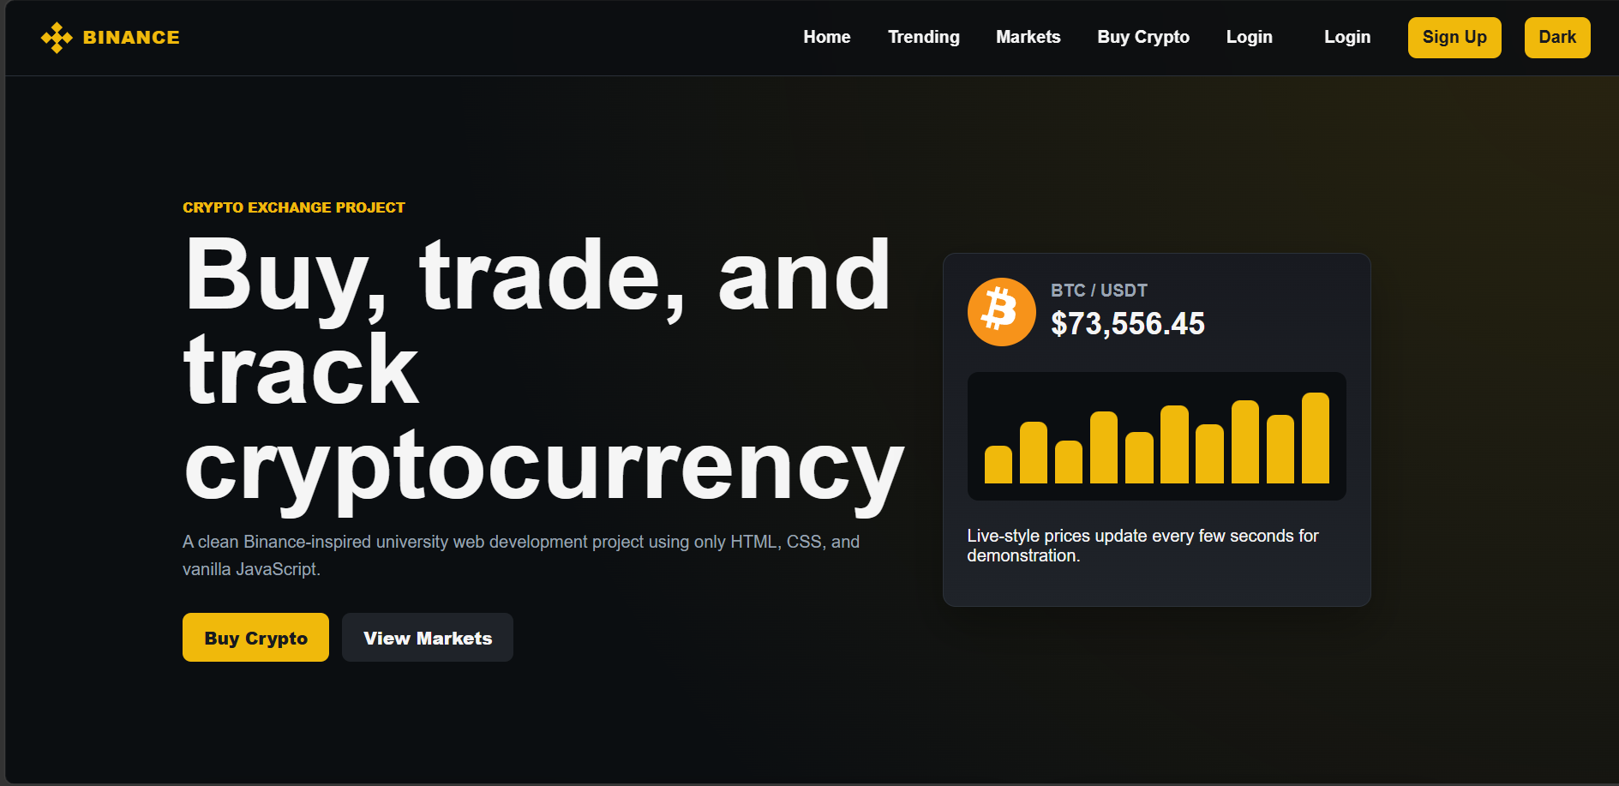

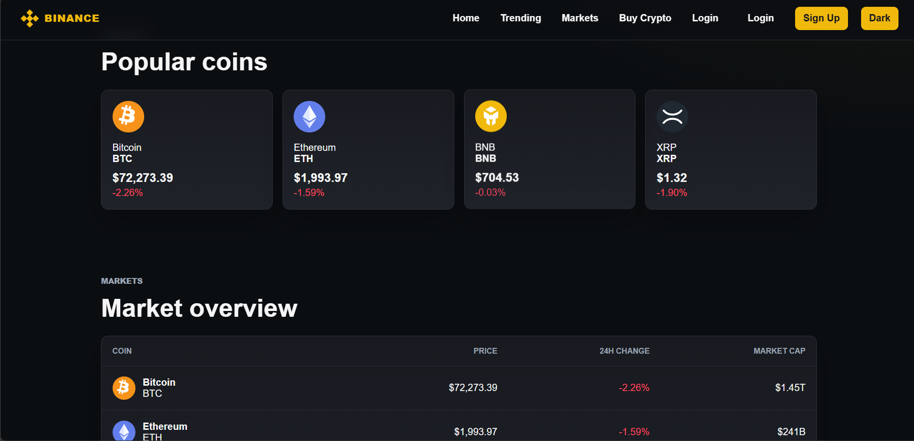

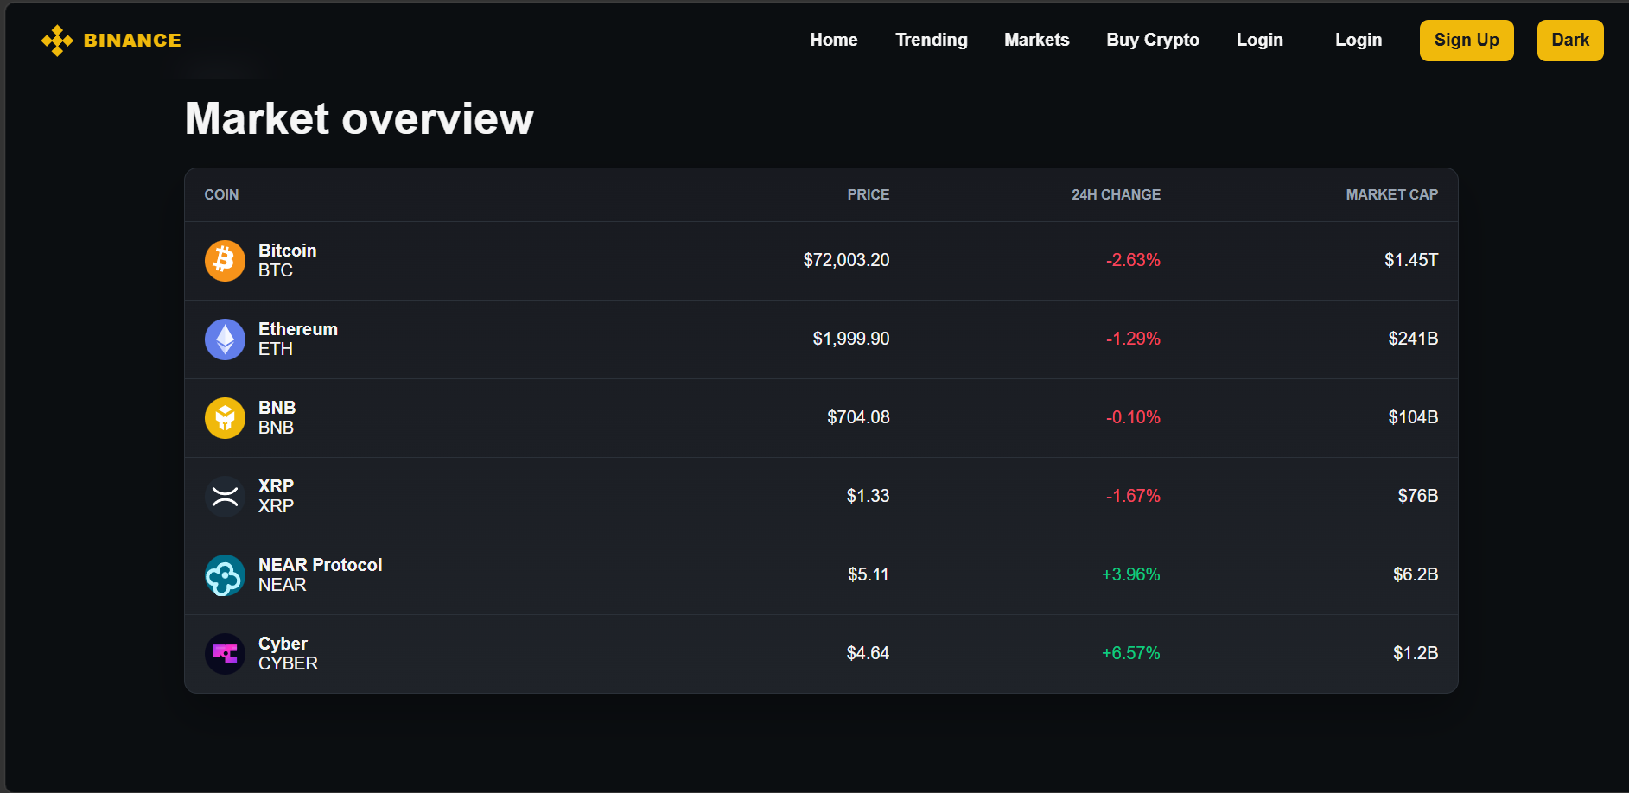
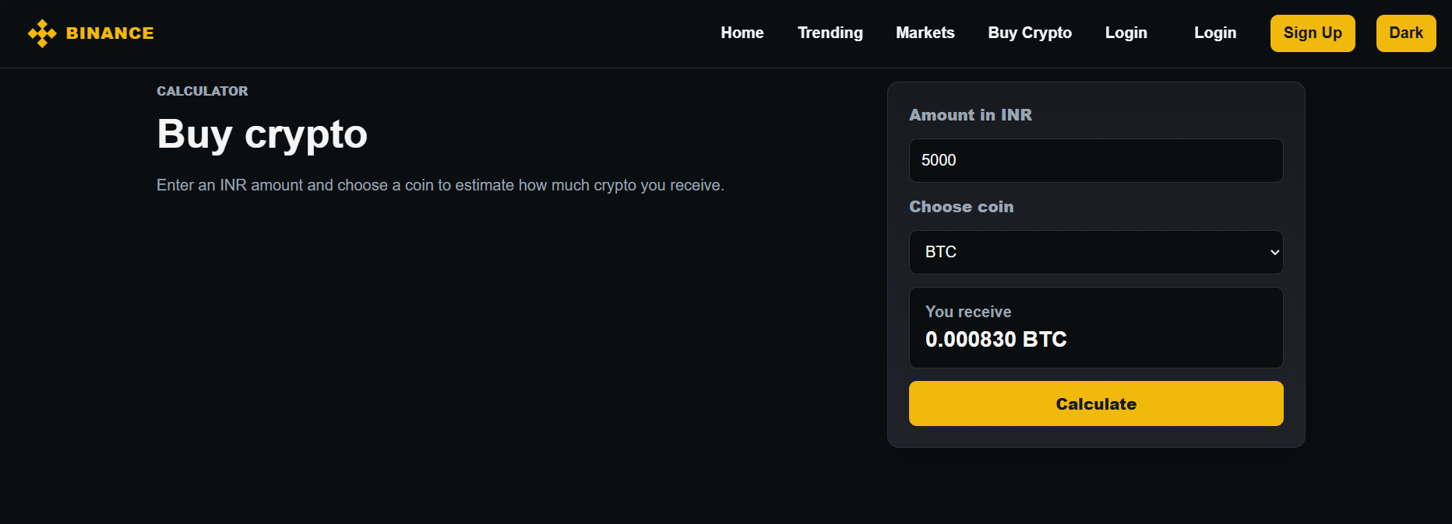

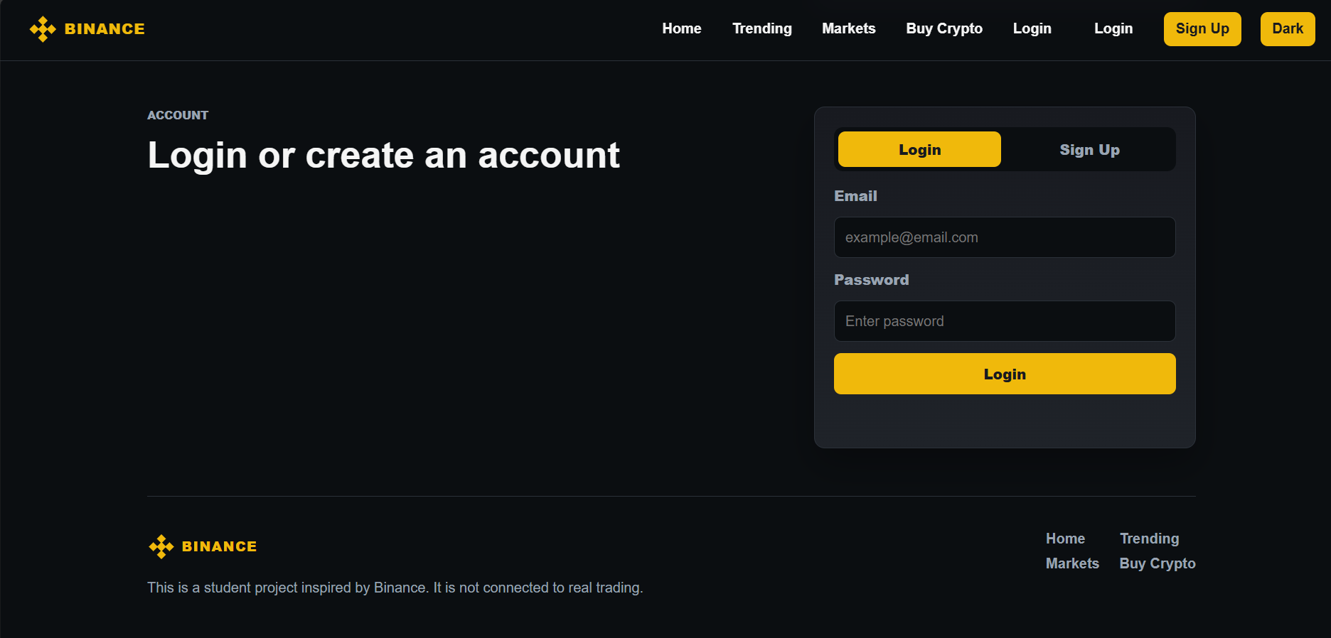

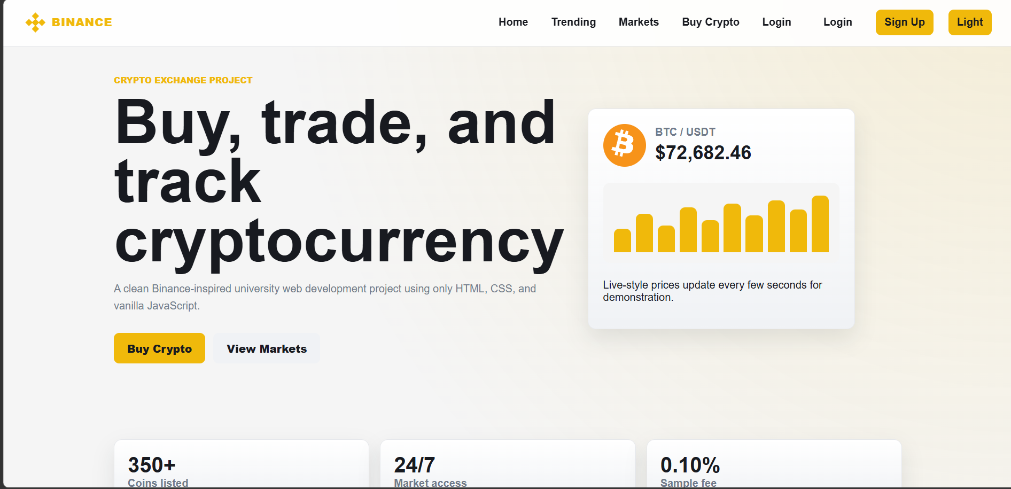
Explanation:

Tag Explanation
<!DOCTYPE html> Declares that the document is an HTML5 document.
<html> Root element of the webpage. Everything is placed inside it.
<head> Contains metadata, title, CSS links, and styles.
<meta charset="UTF-8"> Sets character encoding to UTF-8 for special characters.
<meta name="viewport"> Makes the webpage responsive on mobile devices.
<title> Sets the title shown in the browser tab.
<link> Connects external resources such as Google Fonts.
<style> Contains internal CSS styling for the webpage.
<body> Contains all visible webpage content.
<nav> Creates the navigation bar section.
<div> Generic container used for grouping elements.
<ul> Unordered list. Used for navigation menu items.

<li> List item inside a list.

Tag Explanation
<a> Hyperlink used for navigation or buttons.
<section> Defines a major section of the webpage.
<h1> Main heading of a section.
<h2> Secondary heading, used in product cards.
<h3> Smaller heading, used in services section.
<p> Paragraph text.
<img> Displays images on the webpage.
<footer> Footer section containing copyright information.

Features of the Binance Clone

1. User-Friendly Interface
The application provides a clean and modern cryptocurrency trading dashboard inspired by the Binance platform. Users can easily navigate through different sections such as markets, trading pairs, and account information.
2. Responsive Design
The website is fully responsive and adapts to different screen sizes including desktops, tablets, and mobile devices, ensuring a smooth user experience across platforms.
3. Live Cryptocurrency Market Display
The platform displays popular cryptocurrencies along with their current prices, percentage changes, and market trends. This helps users monitor market movements efficiently.
4. Trading Dashboard
A dedicated trading section allows users to view cryptocurrency pairs, market data, and simulated trading options. The layout resembles a real-world trading environment.
5. Dark and Light Theme Toggle
Users can switch between dark mode and light mode using the theme toggle button. This improves accessibility and user comfort during extended usage.
6. Interactive Navigation Menu
The navigation bar provides quick access to major sections such as Markets, Trade, Futures, Earn, Wallet, and Support, enhancing usability and navigation speed.
7. Cryptocurrency Price Cards
The homepage contains dynamic cryptocurrency cards displaying important information such as:
- Coin Name
- Coin Symbol
- Current Price
- Market Performance
- Price Change Percentage
8. Modern UI Components
The project utilizes modern web design principles including:
- Glassmorphism effects
- Smooth animations
- Hover effects
- Professional typography
- Gradient backgrounds
9. Wallet Overview Section
A wallet dashboard is included to display user balances, assets, and portfolio summaries, simulating the functionality of a real cryptocurrency exchange.
10. Trading Pair Information
Users can view different cryptocurrency trading pairs such as:
- BTC/USDT
- ETH/USDT
- BNB/USDT
- SOL/USDT
This provides a realistic exchange experience.
11. Market Statistics Section
The platform displays important market information including:
- Trading Volume
- Market Capitalization
- Trending Coins
- Top Gainers and Losers
12. Secure User Experience Design
The interface is designed with security-oriented elements such as account controls, wallet management sections, and authentication pages to mimic real cryptocurrency exchange standards. Binance itself uses features such as 2FA, wallet protection, and secure asset management, which inspired the design of this clone.
13. Smooth Animations and Transitions
CSS animations and JavaScript interactions are used throughout the project to create a modern and engaging user experience.
14. Educational Crypto Sections
The platform includes informational sections that help users understand cryptocurrencies, blockchain technology, and digital asset trading.
15. Professional Landing Page
The homepage includes:
- Hero Banner
- Cryptocurrency Highlights
- Feature Sections
- Call-to-Action Buttons
- Footer with Important Links

.

