

# **Home_Screen.java**

package com.example.dbdemo;

import androidx.appcompat.app.AppCompatActivity;

import android.content.Intent;

import android.os.Bundle;

import android.view.View;

public class Home_screen extends AppCompatActivity {

@Override

protected void onCreate(Bundle savedInstanceState) {

super.onCreate(savedInstanceState);

setContentView(R.layout.*activity_home_screen*);

}

public void insert(View view)

{

Intent intent=new Intent(this,Insert_page.class);

startActivity(intent);

}

public void update(View view)

{

Intent intent=new Intent(this,update_page.class);

startActivity(intent);

}

public void all(View view)

{

Intent intent=new Intent(this,MainActivity.class);

startActivity(intent);

}

}

**Output**

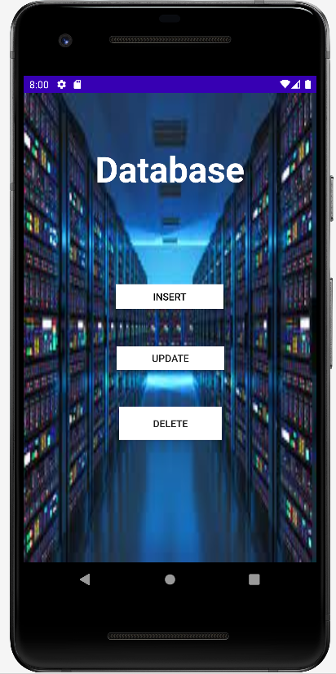

# **main_activity.java**

package com.example.dbdemo;

import androidx.appcompat.app.AppCompatActivity;

import android.os.Bundle;

import android.util.Log;

import android.widget.ArrayAdapter;

import android.widget.ListView;

import com.example.dbdemo.data.MyDbHandler;

import com.example.dbdemo.model.Contact;

import java.util.ArrayList;

import java.util.List;

public class MainActivity extends AppCompatActivity {

ListView listView;

@Override

protected void onCreate(Bundle savedInstanceState) {

super.onCreate(savedInstanceState);

setContentView(R.layout.*activity_main*);

MyDbHandler db = new MyDbHandler(MainActivity.this);

ArrayList<String> contacts = new ArrayList<>();

listView = findViewById(R.id.*listview*);

List<Contact> allContacts = db.getAllContacts();

for(Contact contact: allContacts){

Log.*d*("Contacts", "\nId: " + contact.getId() + "\n" +

"Name: " + contact.getName() + "\n"+

"Phone Number: " + contact.getPhoneNumber() + "\n" );

contacts.add("Name: "+contact.getName() + " Phone Number: " + contact.getPhoneNumber() );

}

ArrayAdapter<String> arrayAdapter = new ArrayAdapter<>(this, android.R.layout.*simple_list_item_1*, contacts);

listView.setAdapter(arrayAdapter);

}

}

# **DbHandler.java**

package com.example.dbdemo.data;

import android.content.ContentValues;

import android.content.Context;

import android.database.Cursor;

import android.database.sqlite.SQLiteDatabase;

import android.database.sqlite.SQLiteOpenHelper;

import android.util.Log;

import com.example.dbdemo.model.Contact;

import com.example.dbdemo.params.Params;

import java.util.ArrayList;

import java.util.List;

public class MyDbHandler extends SQLiteOpenHelper {

public MyDbHandler(Context context) {

super(context, Params.*DB_NAME*, null, Params.*DB_VERSION*);

}

@Override

public void onCreate(SQLiteDatabase db) {

String create = "CREATE TABLE " + Params.*TABLE_NAME* + "("

+ Params.*KEY_ID* + " INTEGER PRIMARY KEY," + Params.*KEY_NAME*

+ " TEXT, " + Params.*KEY_PHONE* + " TEXT" + ")";

Log.*d*("Contacts", "Query being run is : "+ create);

db.execSQL(create);

}

@Override

public void onUpgrade(SQLiteDatabase db, int oldVersion, int newVersion) {

}

public void addContact(Contact contact){

SQLiteDatabase db = this.getWritableDatabase();

ContentValues values = new ContentValues();

values.put(Params.*KEY_NAME*, contact.getName());

values.put(Params.*KEY_PHONE*, contact.getPhoneNumber());

db.insert(Params.*TABLE_NAME*, null, values);

Log.*d*("dbharry", "Successfully inserted");

db.close();

}

public List<Contact> getAllContacts(){

List<Contact> contactList = new ArrayList<>();

SQLiteDatabase db = this.getReadableDatabase();

*// Generate the query to read from the database*

String select = "SELECT * FROM " + Params.*TABLE_NAME*;

Cursor cursor = db.rawQuery(select, null);

*//Loop through now*

if(cursor.moveToFirst()){

do{

Contact contact = new Contact();

contact.setId(Integer.*parseInt*(cursor.getString(0)));

contact.setName(cursor.getString(1));

contact.setPhoneNumber(cursor.getString(2));

contactList.add(contact);

}while(cursor.moveToNext());

}

return contactList;

}

public int updateContact(Contact contact){

SQLiteDatabase db = this.getWritableDatabase();

ContentValues values = new ContentValues();

values.put(Params.*KEY_NAME*, contact.getName());

values.put(Params.*KEY_PHONE*, contact.getPhoneNumber());

*//Lets update now*

return db.update(Params.*TABLE_NAME*, values, Params.*KEY_ID* + "=?",

new String[]{String.*valueOf*(contact.getId())});

}

}

# **Insert_Page.java**

package com.example.dbdemo;

import androidx.appcompat.app.AppCompatActivity;

import android.content.Intent;

import android.os.Bundle;

import android.view.View;

import android.widget.Button;

import android.widget.EditText;

import com.example.dbdemo.data.MyDbHandler;

import com.example.dbdemo.model.Contact;

import android.widget.TextView;

import org.w3c.dom.Text;

public class Insert_page extends AppCompatActivity {

@Override

protected void onCreate(Bundle savedInstanceState) {

super.onCreate(savedInstanceState);

setContentView(R.layout.*activity_insert_page*);

EditText name = findViewById(R.id.*nam*);

EditText phone = findViewById(R.id.*num*);

Button addButton = findViewById(R.id.*button4*);

MyDbHandler db = new MyDbHandler(Insert_page.this);

addButton.setOnClickListener(new View.OnClickListener() {

@Override

public void onClick(View v) {

String contactName = name.getText().toString();

String contactPhone = phone.getText().toString();

Contact newContact = new Contact(contactName, contactPhone);

db.addContact(newContact);

db.close();

}

});

}

}

**Output**

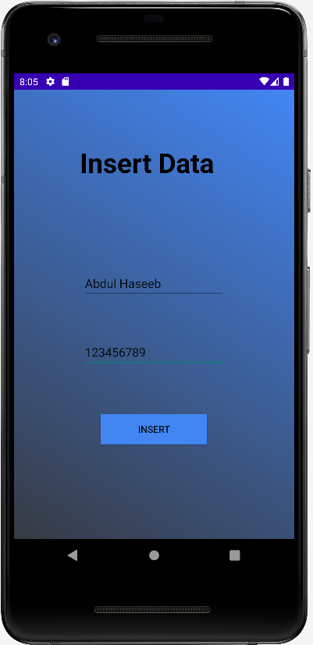

# **update_Page.java**

package com.example.dbdemo;

import androidx.appcompat.app.AppCompatActivity;

import android.content.Intent;

import android.os.Bundle;

import android.view.View;

import android.widget.Button;

import android.widget.EditText;

import com.example.dbdemo.data.MyDbHandler;

import com.example.dbdemo.model.Contact;

import android.widget.TextView;

import org.w3c.dom.Text;

public class update_page extends AppCompatActivity {

@Override

protected void onCreate(Bundle savedInstanceState) {

super.onCreate(savedInstanceState);

setContentView(R.layout.*activity_update_page*);

EditText names = findViewById(R.id.*nams*);

EditText phones = findViewById(R.id.*nums*);

Button addButton = findViewById(R.id.*up_button*);

MyDbHandler db = new MyDbHandler(update_page.this);

addButton.setOnClickListener(new View.OnClickListener() {

@Override

public void onClick(View v) {

EditText keys = findViewById(R.id.*key*);

String contactName = names.getText().toString();

String contactPhone = phones.getText().toString();

Contact newContact = new Contact(contactName, contactPhone);

newContact.setId(2);

db.updateContact(newContact);

db.close();

*// show success message or go back to previous activity*

}

});

}

}

**Output**

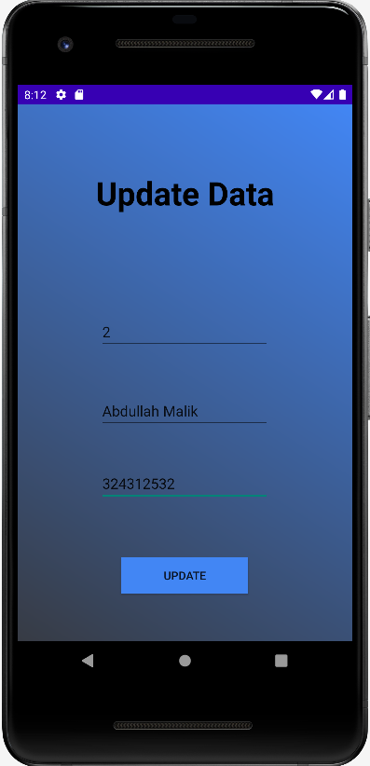

# **Contact.java**

package com.example.dbdemo.model;

public class Contact {

private int id;

private String name;

private String phoneNumber;

public Contact(int id, String name, String phoneNumber) {

this.id = id;

this.name = name;

this.phoneNumber = phoneNumber;

}

public Contact(String name, String phoneNumber) {

this.name = name;

this.phoneNumber = phoneNumber;

}

public Contact() {

}

public int getId() {

return id;

}

public void setId(int id) {

this.id = id;

}

public String getName() {

return name;

}

public void setName(String name) {

this.name = name;

}

public String getPhoneNumber() {

return phoneNumber;

}

public void setPhoneNumber(String phoneNumber) {

this.phoneNumber = phoneNumber;

}

}

**Output**

