CS DEPARTMENT MANAGEMENT SYSTEM

MANAGEMENT SYSTEM

**Project Summary:**

**This Project is a Data Management System for CS Department. It deals with the information of both FACULTY & STUDENTS. The main Characteristics of this program are:**

* **Entering New Data for both FACULTY & STUDENTS.**
* **Reading SPECIFIC RECORD of any Student & Faculty Member.**
* **Viewing Full List of STUDENTS & FACULTY.**
* **It Stores SEMESTER wise & SECTION wise Data of Students.**
* **Data is Stored on TEXT FILES.**
* **It Enters & Retrieves Data from Respective TEXT FILES.**

**CODE INFORMATION:**

* **Whole Program is Divided into PARTS. Each of them performs a separate function.**
* **Program is made using METHODS and CALLING them.**
* **It Starts from Main METHOD and then according to user’s input Respective METHODS are called.**
* **It allows user to repeat the same task more than one time and to leave the current task and move on to the next one.**
* **After Executing Program one time it allows user to run the program again without leaving the CONSOLE.**
* **Program terminates when user wants.**

**CODE:**

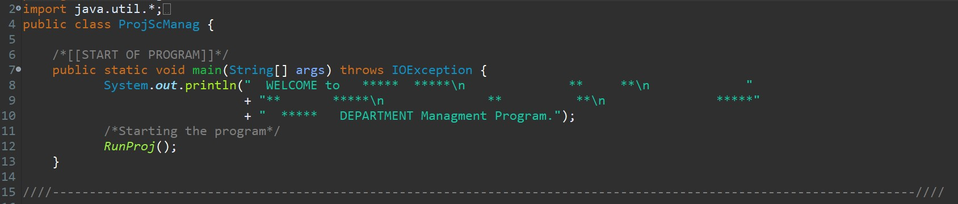**MAIN MENU of program// Asks User Which Action To Perform:**

* **Choice B/W Faculty & Students.**
* **Read/Write Choice.**
* **Displays INVALID INPUT in case of wrong choice.**

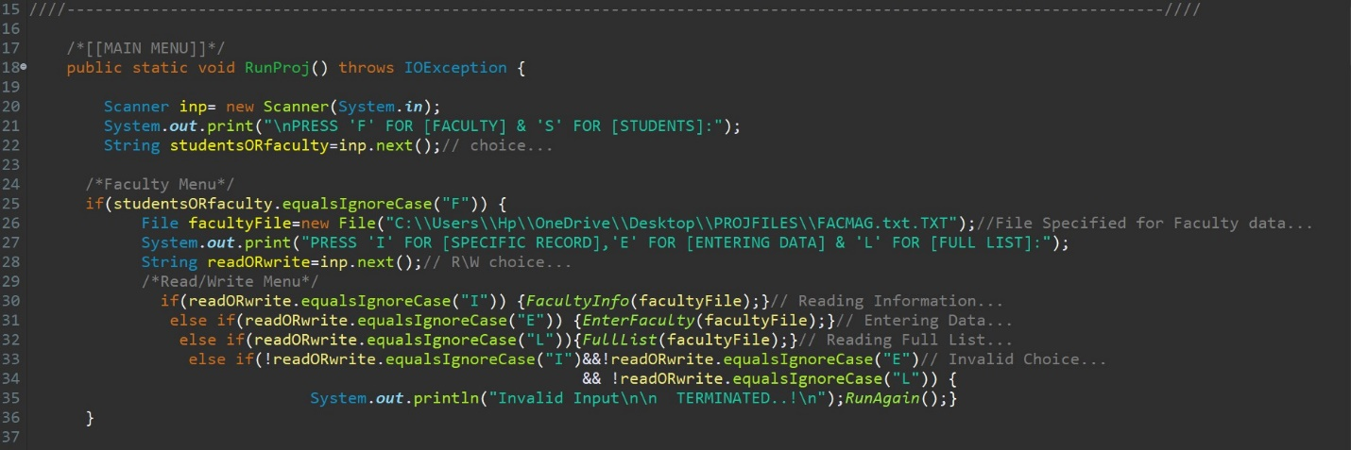

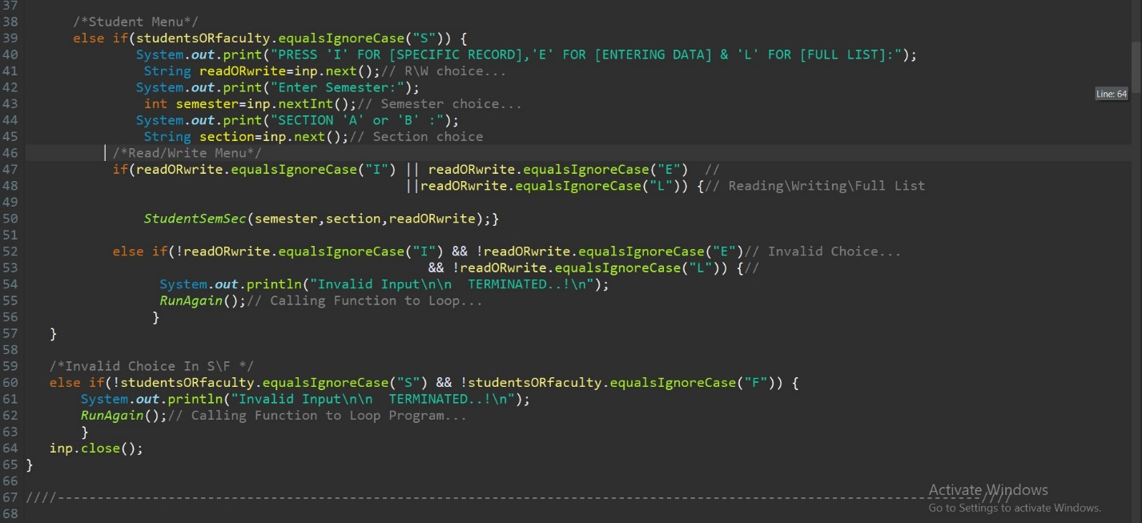

**(READING FACULTY INFORMATION.)**

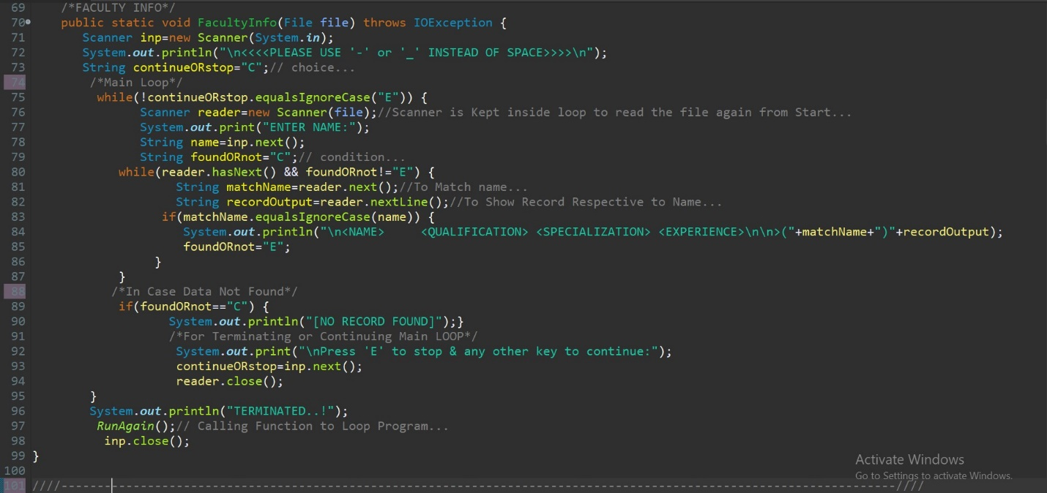

**(ENTERING FACULTY INFORMATION.)**

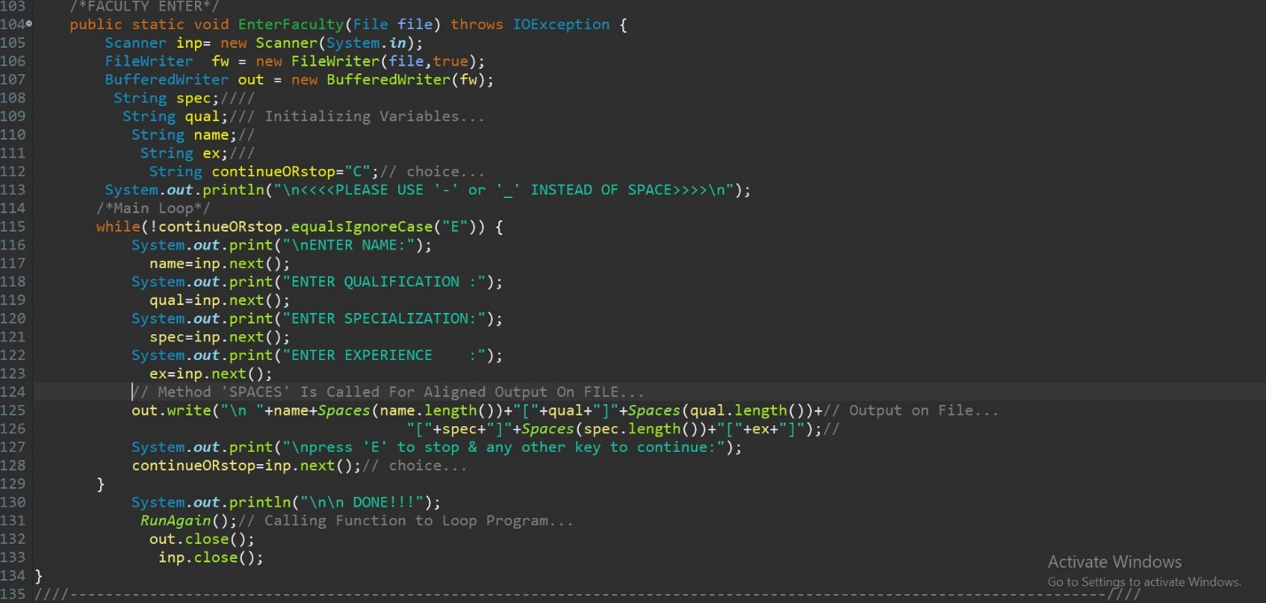

**(SELECTING SEMESTER/SECTION FOR STUDENTS.)**

* **Allocates Respective Files.**
* **Calls Function To Read/Write Students Data.**

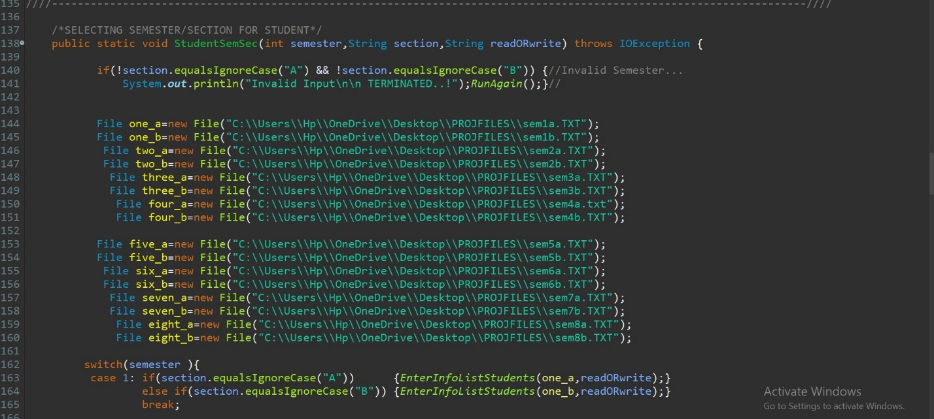

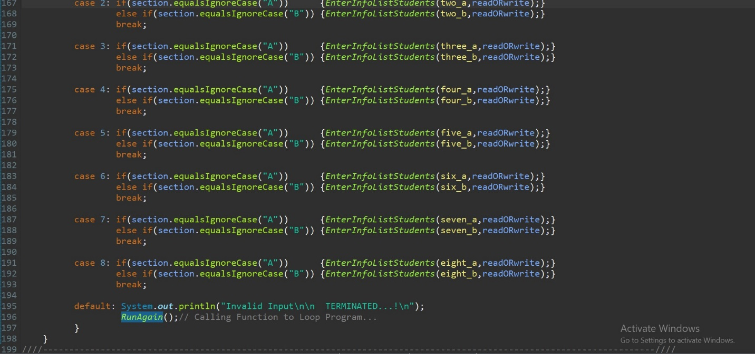

**(ENTERING OR RETRIEVING STUDENTS DATA FROM FILES.)**

* **Stores/Retrieves Data From Respective Files.**

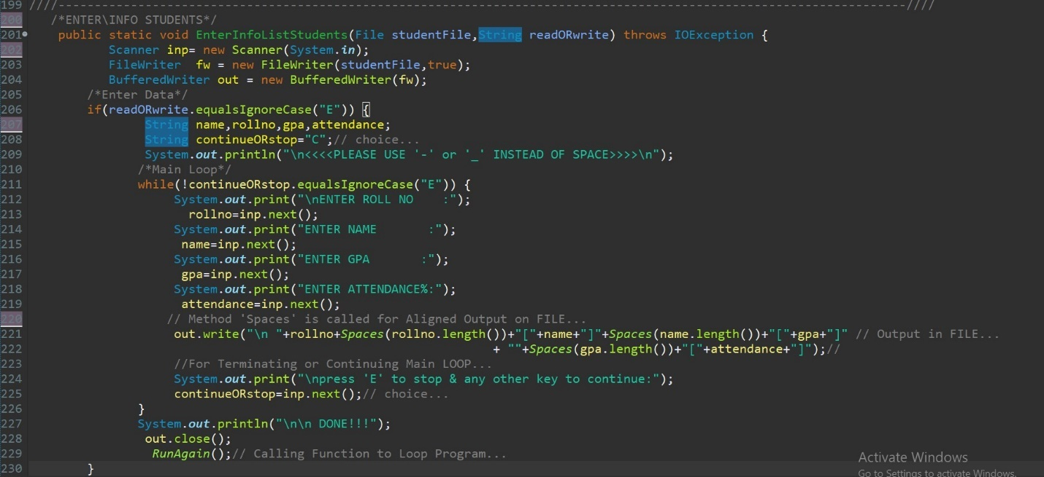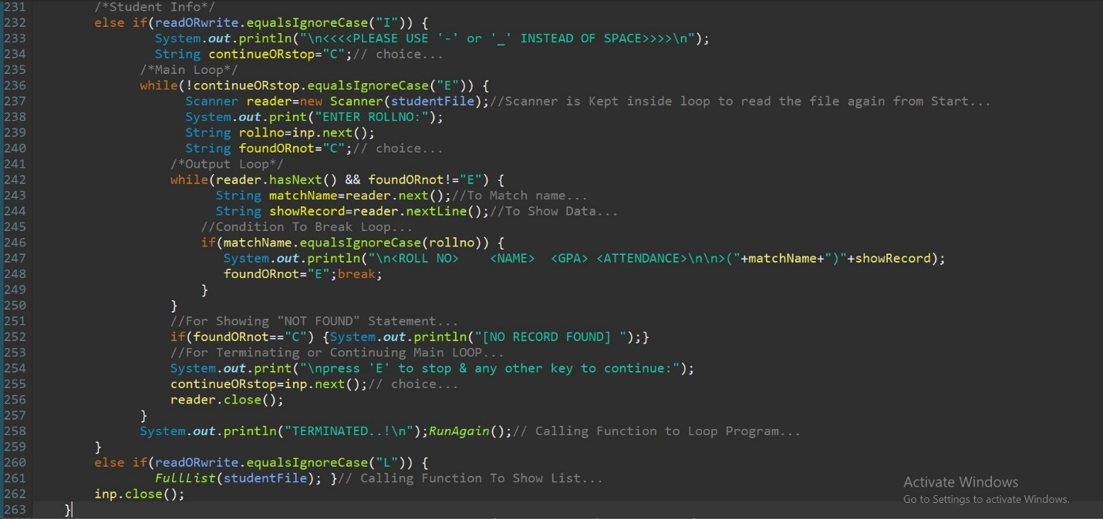

**(SHOWING FULL LIST.)**

* **Shows full list for Faculty & Students of a Section.**

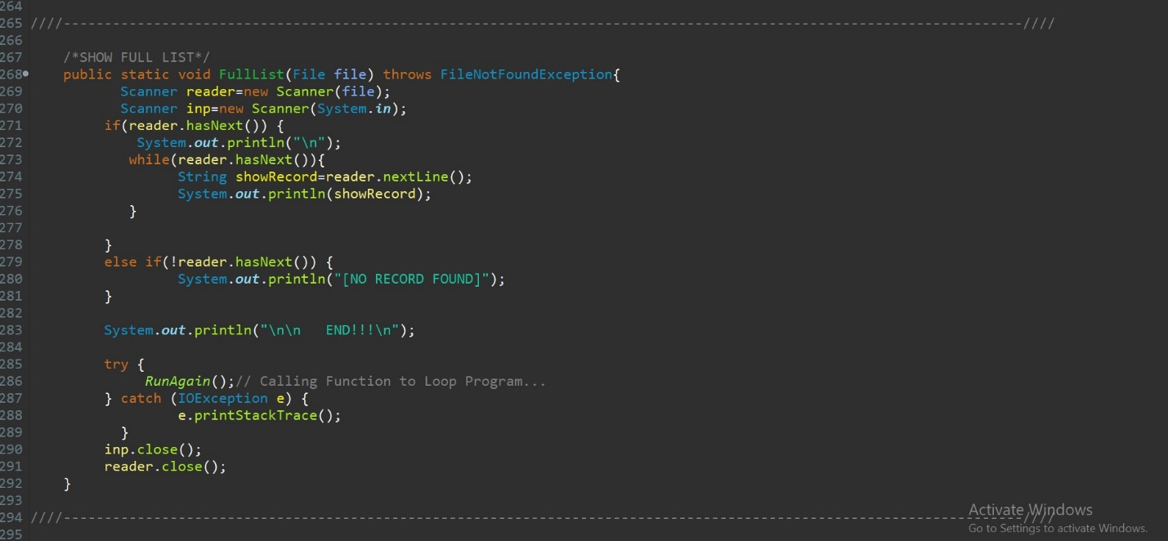

**(Puts Required No of Spaces B/W Fields To Show Aligned Output.)**

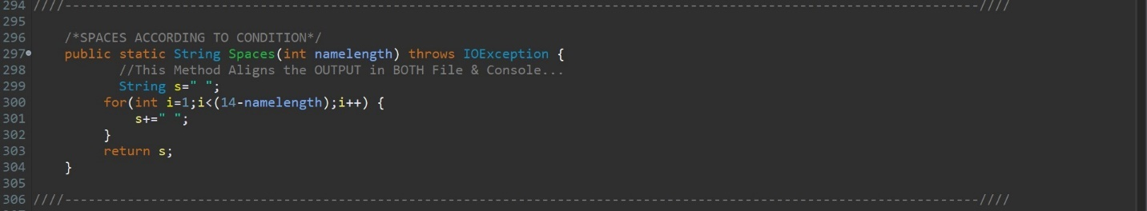

**(Looping or Ending Program According to User’s Choice.)**

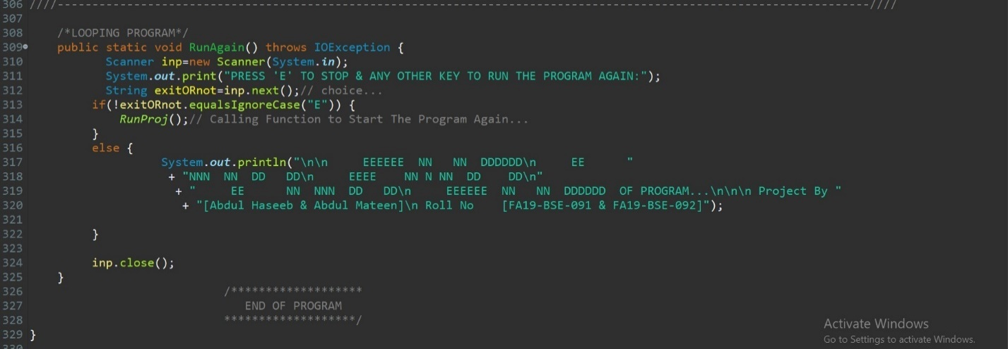

**OUTPUTS>> (ENTERING DATA):**

**(FOR FACULTY.)**

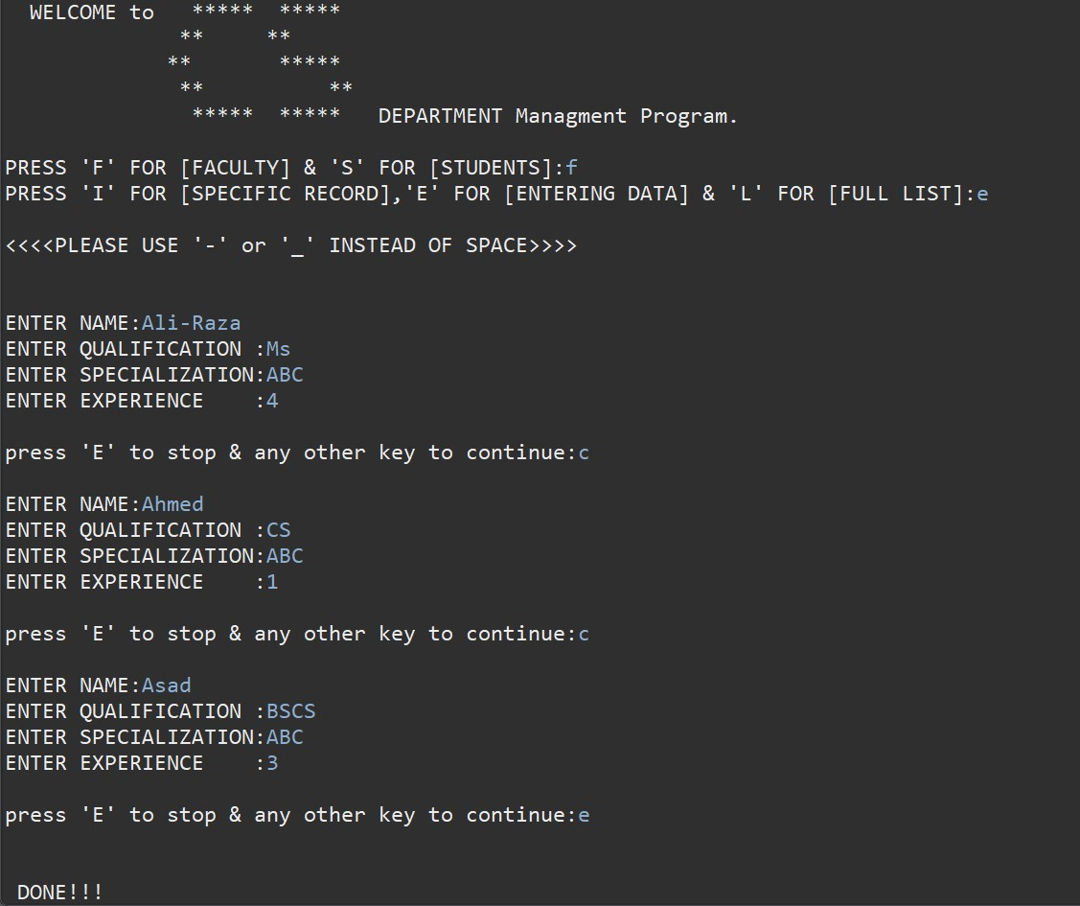

**(STORED IN FILE.)**

* **Aligned Output.**

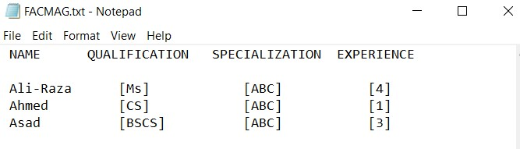

**(ENTERING FOR STUDENTS.)**

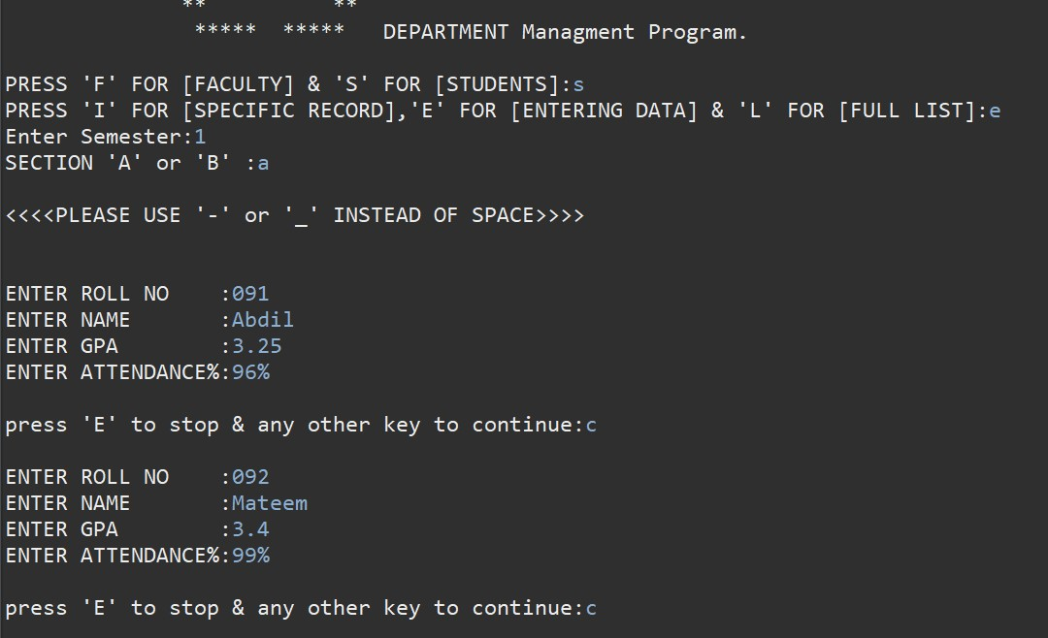

**(DATA STORED ON FILE.)**

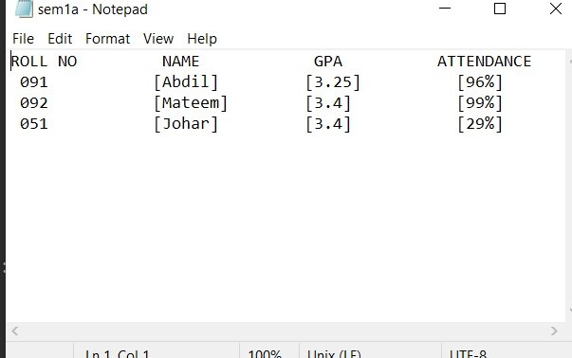

**OUTPUTS>> (READING DATA):**

**(FOR FACULTY.)**

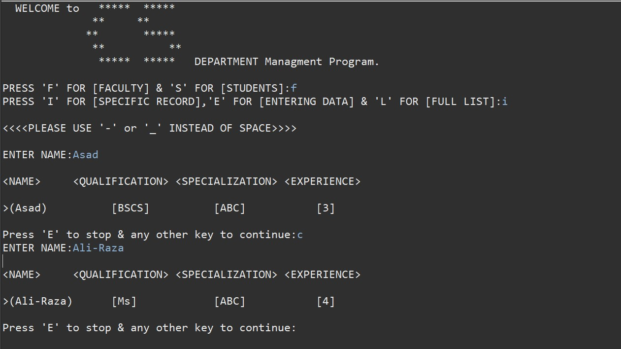

**(FOR STUDENTS.)**

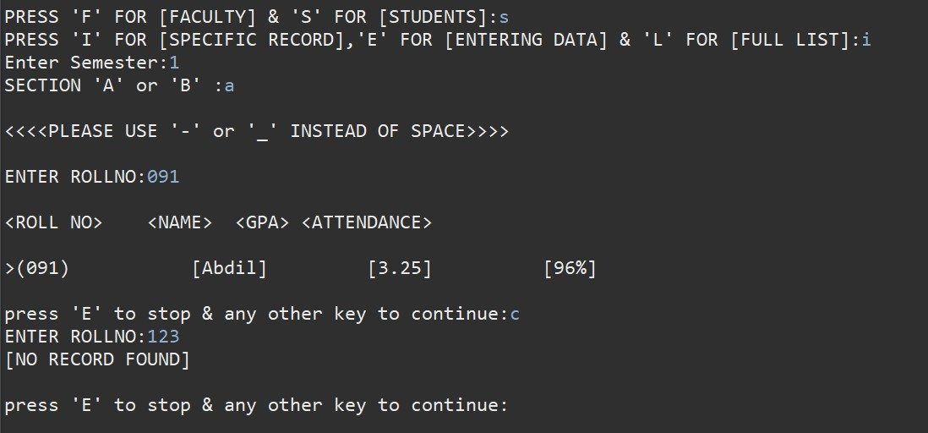

**OUTPUTS>> (FULL LISTS):**

* **Current Task is Terminated after one time Execution.**

**(FOR FACULTY.)**

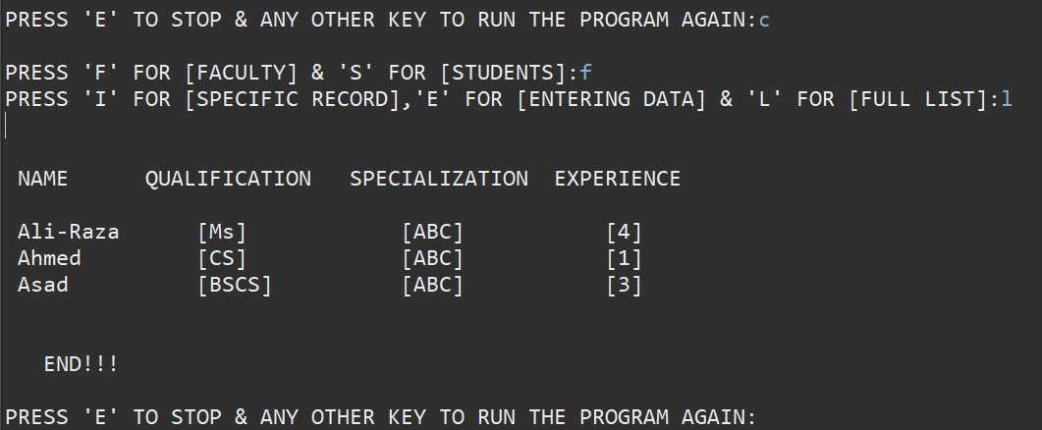

**(FOR STUDENTS.)**

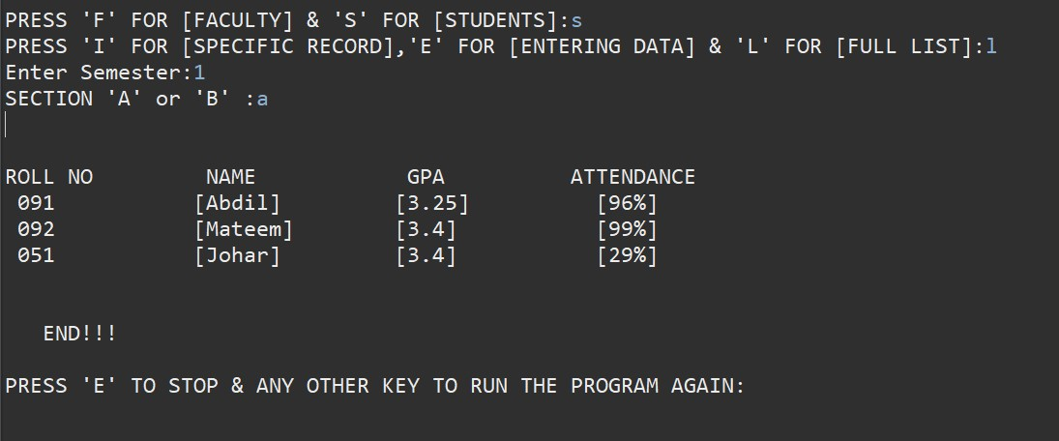

**OUTPUTS>> (DATA NOT FOUND):**

**(FOR FACULTY.)**

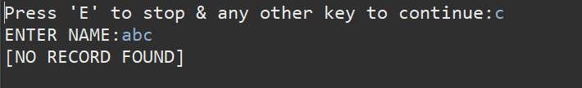

* **Displays NO RECORD FOUND.**
* **Then asks user to run again or stop.**

**(FOR STUDENTS.)**



* **Displays NO RECORD FOUND.**
* **Then asks user to run again or stop.**

**OUTPUTS>> (WRONG INPUTS):**

**(WRONG CHOICE.)**

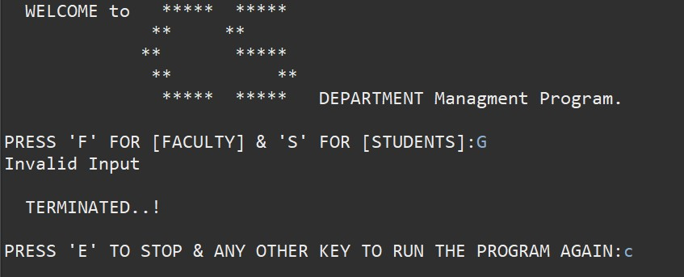

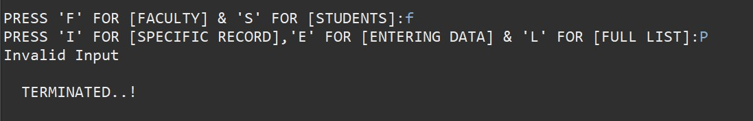

**(WRONG SEMESTER.)**

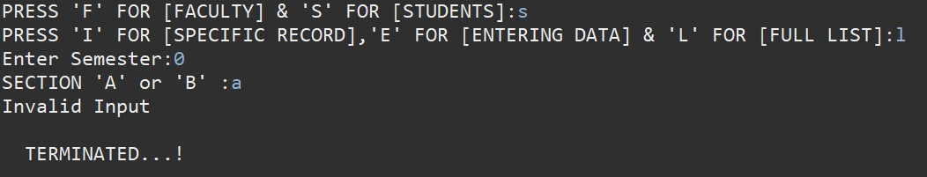

**(WRONG SECTION.)**

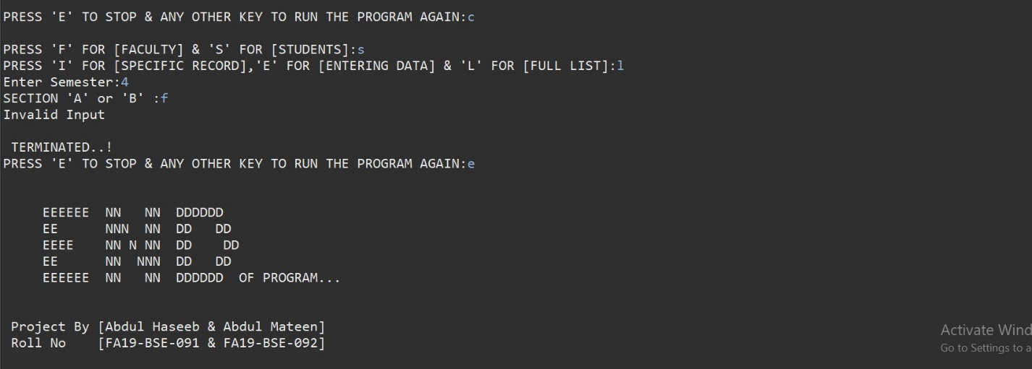**FLOWCHART**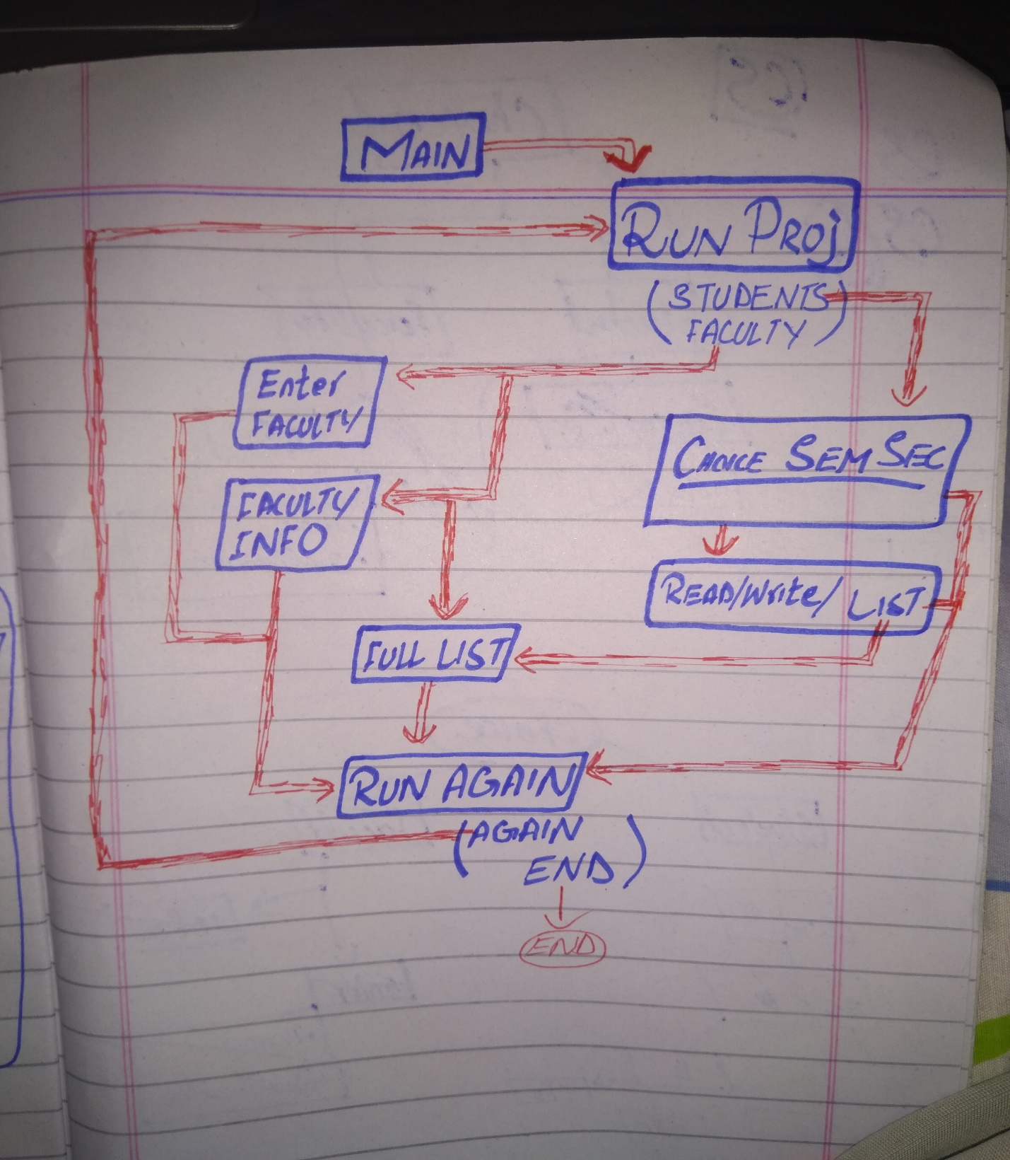

***END.***