1.

By default, when a user launches the application the log-in screen should come not the main menu.

2. Once the login has been successful, there is no need for the prompt “Login Successful”, instead the application should go the main page:

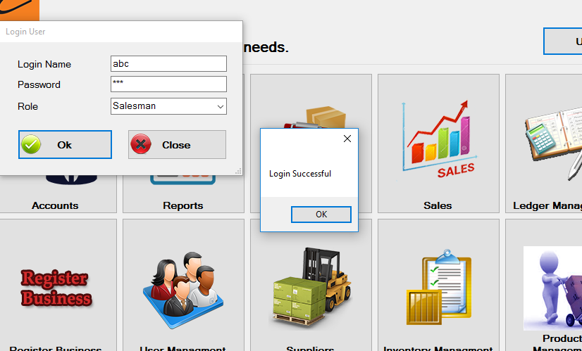

3. When the user clicks on log-off, it should again go the default log-in page.

4. Once logged in, following information should be present on the screen:

* Logged in: Haseeb Ahmed
* Role: Administrator
* Rather then placing the current date, place a drop down calendar option, like it shows the present date, but the user can drop down and see the calendar too.

5. When giving in credentials for the login, in-case they are not valid, an appropriate message should come, whether the username/password is invalid or the role type.

6. Once the help menu -> About us is open, it cannot be closed, add that function.

7. Need to give administrator the rights to add new users.

8. Add login option in the File menu present in top left corner.

9. Is it possible to add a minimize feature for the app?

10. Decide what type of rights will a salesman have, administrator will have all rights be default.

11. Give the option to add a new business type to the user.