**Artificial Intelligence (CS-323)  
Assignment 01  
  
 Syed Abdul Kabir Qadri   
 CS-22039**

**Question 1:  
  
Code:**import numpy as np

def get_user_parameters():

initial_weights = np.array([float(x) for x in input("Provide the initial weights

// (e.g., 0.5 0.5):").split()])

alpha = float(input("Provide the learning rate: "))

offset = float(input("Provide the bias: "))

num_samples = int(input("Provide the number of training samples: "))

data_samples = [ ]

for i in range(num_samples):

sample = input(f"Input values and expected output for sample {i+1} (e.g., 1 0 1): ").split()

data_samples.append(([int(sample[0]), int(sample[1])], int(sample[2])))

return initial_weights, alpha, offset, data_samples

def train_perceptron(initial_weights, alpha, offset, data_samples):

for iteration in range(100):

for input_vals, target_output in data_samples:

weighted_sum = np.dot(input_vals, initial_weights) + offset

prediction = 1 if weighted_sum >= 0 else 0

error = target_output - prediction

initial_weights += alpha * error * np.array(input_vals)

offset += alpha * error

return initial_weights, offset

def test_perceptron(trained_weights, offset):

while True:

test_vals = input("Provide test inputs (e.g., 1 0) or type 'exit' to finish: ")

if test_vals == 'exit':

break

input_vector = np.array([int(x) for x in test_vals.split()])

weighted_sum = np.dot(input_vector, trained_weights) + offset

prediction = 1 if weighted_sum >= 0 else 0

print(f"Predicted output: {prediction}")

#Execution

initial_weights, alpha, offset, data_samples = get_user_parameters()

trained_weights, offset = train_perceptron(initial_weights, alpha, offset, data_samples)

print("Training process completed.")

test_perceptron(trained_weights, offset)  
  
  
**OUTPUT:**

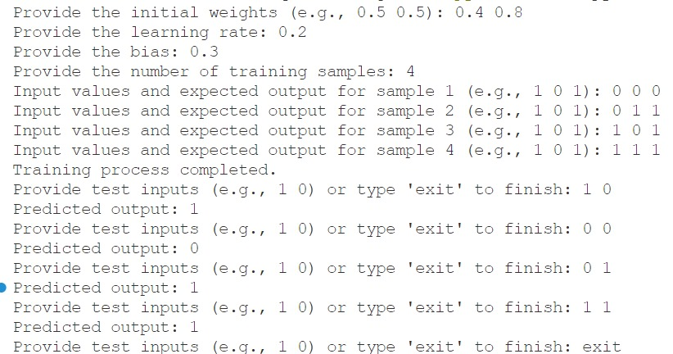

**QUESTION 2:**

**Code:**

import numpy as np

def activation_function(x):

return 1 / (1 + np.exp(-x))

def activation_derivative(x):

return x * (1 - x)

def get_user_settings():

alpha = float(input("Please input the learning rate: "))

offset = float(input("Please input the bias: "))

num_epochs = int(input("Please input the number of iterations: "))

print("Specify the number of training samples: ")

num_samples = int(input())

data_samples = []

for i in range(num_samples):

sample = input(f"Provide the input values and target output for sample {i+1}

//(e.g., 1 0 1):").split()

data_samples.append(([int(sample[0]), int(sample[1])], int(sample[2])))

return alpha, offset, num_epochs, data_samples

def init_weights(input_dim, hidden_dim, output_dim):

weights_input_hidden = np.random.rand(input_dim, hidden_dim)

weights_hidden_output = np.random.rand(hidden_dim, output_dim)

return weights_input_hidden, weights_hidden_output

def train_neural_net(weights_input_hidden, weights_hidden_output, offset, alpha, num_epochs, data_samples):

for epoch in range(num_epochs):

for input_vals, target_output in data_samples:

input_vals = np.array(input_vals)

target_output = np.array(target_output)

# Forward propagation

hidden_input = np.dot(input_vals, weights_input_hidden) + offset

hidden_output = activation_function(hidden_input)

final_input = np.dot(hidden_output, weights_hidden_output) + offset

final_output = activation_function(final_input)

# Calculate error

output_error = target_output - final_output

# Backpropagation

delta_output = output_error * activation_derivative(final_output)

hidden_layer_error = delta_output.dot(weights_hidden_output.T)

delta_hidden_layer = hidden_layer_error * activation_derivative(hidden_output)

# Update weights

weights_hidden_output += hidden_output.reshape(-1, 1).dot(delta_output.reshape(1, -1)) * alpha

weights_input_hidden += input_vals.reshape(-1, 1).dot(delta_hidden_layer.reshape(1, -1)) * alpha

return weights_input_hidden, weights_hidden_output

def evaluate_neural_net(weights_input_hidden, weights_hidden_output, offset):

while True:

test_data = input("Enter test inputs (e.g., 1 0) or 'exit' to stop: ")

if test_data == 'exit':

break

input_vals = np.array([int(x) for x in test_data.split()])

hidden_input = np.dot(input_vals, weights_input_hidden) + offset

hidden_output = activation_function(hidden_input)

final_input = np.dot(hidden_output, weights_hidden_output) + offset

final_output = activation_function(final_input)

prediction = 1 if final_output >= 0.5 else 0

print(f"Predicted output: {prediction}")

# Execution

alpha, offset, num_epochs, data_samples = get_user_settings()

input_dim = 2

hidden_dim = 2

output_dim = 1

weights_input_hidden, weights_hidden_output = init_weights(input_dim, hidden_dim, output_dim)

weights_input_hidden, weights_hidden_output = train_neural_net(weights_input_hidden, weights_hidden_output, offset, alpha, num_epochs, data_samples)

print("Training completed successfully.")

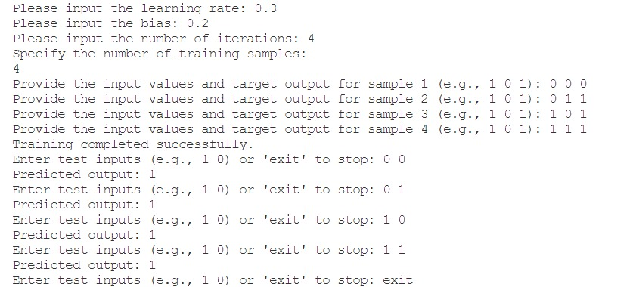evaluate_neural_net(weights_input_hidden, weights_hidden_output, offset)  
  
**OUTPUT:**