 | Description | Input | Expected Result | Actual Result | Status
1 | Valid URL Shortening | URL : https://jojozhuang.github.io/algorithm/data-structure-hashmap/  Brand Name : hashmap | http://localhost:8080/hashmap | http://localhost:8080/hashmap | Pass
2 | Alias Already Exists | URL : https://jojozhuang.github.io/algorithm/data-structure-hashmap/  Brand Name : hashmap | 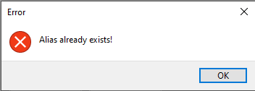 |  | Pass
3 | Invalid URL Format | URL: fdfgaghfd  Brand Name: empty | 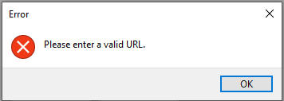 |  | Pass
4 | Empty Alias (Auto-Generated) | URL : https://portalpwa.miuegypt.edu.eg/#/exam-schedule | http://localhost:8080/(Auto Generated Code) | http://localhost:8080/iG2Kb7 | Pass
5 | Empty Input Fields in GUI | URL:  Brand Name: | 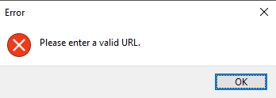 |  | Pass
6 | Entering Brand Name without an URL | URL :  Brand Name : brandName |  |  | Pass

