**Project Title:** Jewelry-Shop Ecommerce

**Project Introduction**: This documentation aims to provide a detailed overview of the various sections present on our e-commerce website. Each section serves a specific purpose in enhancing user experience, driving engagement, and facilitating seamless navigation. By understanding the functionality and significance of each section, we can optimize the website layout for improved usability and customer satisfaction.

**Font Usage**

To ensure a consistent and visually appealing design, we use the Mercellus font as our primary typeface and DM Sans as our secondary typeface across the entire website. These fonts are chosen for their readability, elegance, and versatility, enhancing the overall user experience.

**Primary Font: Mercellus**

Mercellus is the primary font used for all text elements on the website, including:

* **Headings:** Use Mercellus for all headings (H1, H2, H3, etc.) to maintain a cohesive look and create a clear visual hierarchy.
* **Body Text:** Apply Mercellus to all main content paragraphs, product descriptions, and general text to ensure consistency and readability.
* **Buttons and Call-to-Actions (CTAs):** Use Mercellus for text on buttons and CTAs to draw attention and encourage user interaction.

**Secondary Font: DM Sans**

DM Sans is used as the secondary font to complement Mercellus. It is applied in areas where a modern, clean, and easily readable font is desired. Uses include:

* **Subheadings:** Use DM Sans for subheadings to provide a clear distinction from the main headings set in Mercellus.
* **Captions and Annotations:** Apply DM Sans to smaller text elements like captions, annotations, and notes for enhanced clarity.
* **Navigation Links:** Use DM Sans for all navigation links in the header, footer, and other navigational elements to ensure a clean and modern appearance.
* **Forms and Input Fields:** Apply DM Sans to text within forms, input fields, and labels to provide a straightforward and readable user interface.

**Specific Areas and Font Assignments**

1. **Header with Navbar**
   * Navigation Links: DM Sans
   * Search Bar Placeholder Text: DM Sans
   * Account, Wishlist, Shopping Bag Links: DM Sans
2. **Hero Banner**
   * Main Headline/Text: Mercellus
   * Subheadline/Text: DM Sans (if applicable)
3. **Product Categories**
   * Category Names: Mercellus
4. **Featured Products**
   * Product Names: Mercellus
   * Product Descriptions: Mercellus
5. **Promotions and Deals**
   * Promotional Text: Mercellus
   * Details or Fine Print: DM Sans
6. **Product Sections (Earrings, Bracelets, Necklaces, Rings, Journals)**
   * Section Headings: Mercellus
   * Product Names: Mercellus
   * Product Descriptions: Mercellus
7. **Newsletter Signup**
   * Signup Prompt/Heading: Mercellus
   * Form Labels and Inputs: DM Sans
8. **Footer**
   * Navigation Links: DM Sans
   * Contact Information and Other Text: Mercellus for headings, DM Sans for details

**Homepage Sections**

1. **Header with Navbar**: The header section typically includes the website logo, navigation menu, search bar, and user account options.
2. **Hero Banner**: The hero banner is a prominent section located at the top of the homepage, showcasing featured products, promotions, or brand messages.
3. **Product Categories**: This section displays a grid or list of product categories, allowing users to browse products based on their interests or needs.
4. **Featured Products**: Highlight specific products or collections in this section. Featured products may include best-sellers, new arrivals, or seasonal items.
5. **Promotions and Deals**: Showcase ongoing promotions, discounts, or special offers to incentivize purchases. This section may include banners, countdown timers, or promotional codes.
6. **Earrings**: Discover our elegant collection of earrings, from classic studs to dazzling drop earrings, designed to add a touch of sophistication to any look.
7. **Bracelets**: Wrap your wrist in sophistication with our collection of bracelets, featuring sleek bangles, intricate cuffs, and stylish chains designed to complement every outfit.
8. **Necklaces**: Adorn yourself with our stunning range of necklaces, from delicate chains to statement pendants, crafted to elevate your look with elegance and grace.
9. **Rings**: Seal your moments with our exquisite selection of rings, from sparkling engagement rings to timeless bands, each crafted with precision and adorned with brilliant gemstones.
10. **Journals**: Explore our collection of journals, featuring high-quality paper and elegant designs, perfect for capturing your thoughts, plans, and creativity.
11. **Newsletter Signup**: Encourage visitors to subscribe to the newsletter for updates on new products, promotions, and company news. Offer incentives such as discounts or exclusive content to incentivize sign-ups.
12. **Footer**: The footer section includes important links, contact information, social media icons, and legal disclaimers. It provides easy access to additional resources and essential information.

**Header with Navbar**



**Header**

The header section is the topmost part of the homepage. It is divided into three main areas: the top section, the center, and the right side.

**Top Section**

The top section is a slim strip that runs across the width of the header, offering quick links and essential information.

**Left Side:**

* **Find Store**: A clickable link with a map pin icon and the text "Find Store," directing users to a store locator page where they can find the nearest physical store.
* **Follow Us**: Social media icons (Facebook, Instagram, Twitter) with the text "Follow Us," allowing users to quickly access and follow the brand's social media profiles.
* **Contact Us**: A clickable link with a phone or email icon and the text "Contact Us," providing quick access to the contact page or a dropdown with contact details.

**Center:**

* **Search Bar**: Centrally located for easy access, the search bar allows users to quickly find products, categories, or any other content on the website. It includes a placeholder text such as "Search for products, brands, and more..." and a magnifying glass icon to initiate the search.

**Right Side:**

* **My Account**: An icon of a user or profile with the text "My Account," which when clicked, leads users to their account dashboard where they can manage personal information, order history, and settings.
* **My Wishlist**: A heart icon with the text "My Wishlist," allowing users to save products they are interested in for future purchase. Clicking this icon takes users to their Wishlist page.
* **Shopping Bag**: A shopping bag or cart icon with the text "Shopping Bag" showing the number of items currently in the cart, providing a quick link to the shopping cart page for easy checkout.

**Navbar**

Beneath the top section, the main navigation bar (navbar) is situated, providing links to the primary sections of the website. This part of the header includes:

**Left Side:**

* **Logo:** The website logo is prominently displayed, usually on the left side, and serves as a clickable link that redirects to the homepage.

**Center:**

* **Navigation Links:** A series of links to the main categories or pages of the website, such as Home, New, Best Sellers, Earrings, Rings, Necklaces, Bracelets. These links may have dropdown menus for subcategories or additional pages.

**Right Side:**

* **Sign In/Create Account:** Links for users to sign in or create an account. These options help users manage their accounts and access personalized features.

**Hero Banner**

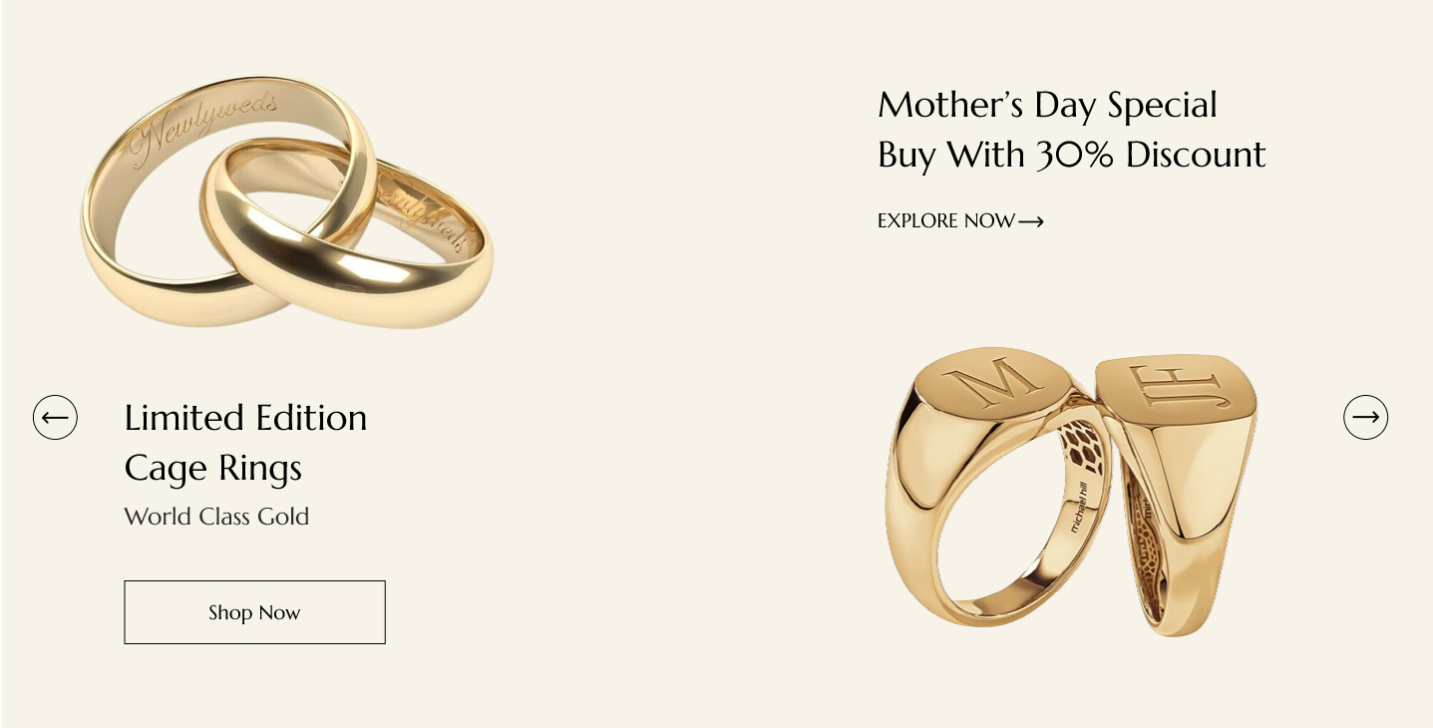

The hero banner is a prominent section located at the top of the homepage, designed to showcase featured products, promotions, or brand messages. This section uses a swiper slider to present multiple slides, each highlighting different aspects of the store's offerings.

**Slide 1:**

**Left Side:**

* **Top:** An image of a product (e.g., a featured ring).
* **Below the Image:**
  + **Header:** "Limited Edition\nCage Rings" (displayed in two lines)
  + **Subheader:** "World Class Gold"
  + **Button:** "Shop Now"

**Right Side:**

* **Top:**
  + **Header:** "Mother's Day Special\nBuy with 30% Discount" (displayed in two lines)
  + **Button:** "Explore Now"
* **Below the Button:** An image related to the Mother's Day promotion.

**Slide 2:**

**Left Side:**

* **Top:** Image of a diamond necklace.
* **Below the Image:**
  + **Header:** "Timeless Elegance\nDiamond Necklace" (displayed in two lines)
  + **Subheader:** "Crafted with Brilliance"
  + **Button:** "Discover Now"

**Right Side:**

* **Top:**
  + **Header:** "Summer Sale Event" (displayed in one line)
  + **Text:** "Up to 50% Off Selected Items"
  + **Button:** "Shop Sale"

**Slide 3:**

**Left Side:**

* **Top:** Image of a pair of sapphire earrings.
* **Below the Image:**
  + **Header:** "Royal Blue\nSapphire Earrings" (displayed in two lines)
  + **Subheader:** "Luxurious Statement"
  + **Button:** "Explore Collection"

**Right Side:**

* **Top:**
  + **Header:** "New Arrivals" (displayed in one line)
  + **Text:** "Discover the Latest Trends"
  + **Button:** "Shop Now"

**Slide 4:**

**Left Side:**

* **Top:** Image of a collection of gold bracelets.
* **Below the Image:**
  + **Header:** "Golden Touch\nBracelet Collection" (displayed in two lines)
  + **Subheader:** "For Every Occasion"
  + **Button:** "View Collection"

**Right Side:**

* **Top:**
  + **Header:** "Exclusive Offer" (displayed in one line)
  + **Text:** "Limited Edition Pieces"
  + **Button:** "Shop Exclusive"

**Slide 5:**

**Left Side:**

* **Top:** Image of a vintage style engagement ring.
* **Below the Image:**
  + **Header:** "Timeless Romance\nEngagement Rings" (displayed in two lines)
  + **Subheader:** "Celebrate Your Love"
  + **Button:** "Find Yours"

**Right Side:**

* **Top:**
  + **Header:** "Clearance Sale" (displayed in one line)
  + **Text:** "Last Chance to Save Big"
  + **Button:** "Shop Clearance"

**Font Usage for Hero Banner**

* **Headers:** Use Mercellus to maintain a cohesive and elegant look.
* **Subheaders:** Use Mercellus for consistency and readability.
* **Buttons:** Use Mercellus to draw attention and encourage user interaction.

**Product Categories**

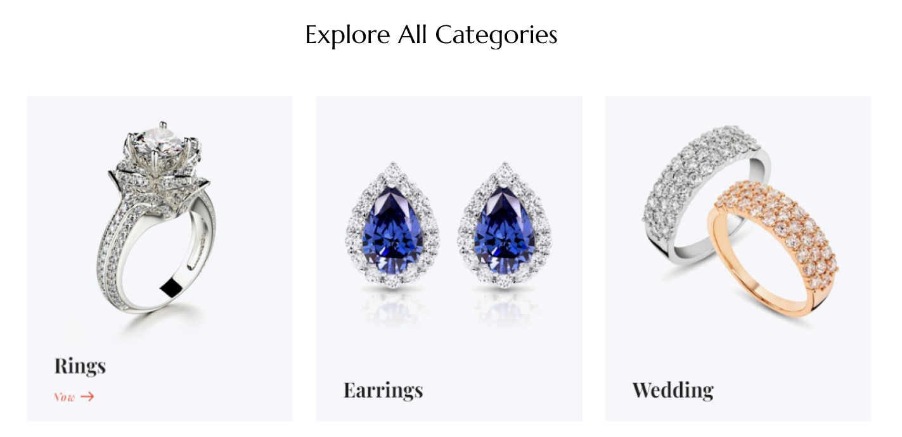

1. **Earrings**
   * **Card Design:** Image covering the entire height and width of the card.
   * **On Hover:** "Shop Now" button appears below the category name.
2. **Rings**
   * **Card Design:** Image covering the entire height and width of the card.
   * **On Hover:** "Shop Now" button appears below the category name.
3. **Necklaces**
   * **Card Design:** Image covering the entire height and width of the card.
   * **On Hover:** "Shop Now" button appears below the category name.
4. **Bracelets**
   * **Card Design:** Image covering the entire height and width of the card.
   * **On Hover:** "Shop Now" button appears below the category name.
5. **Chains**
   * **Card Design:** Image covering the entire height and width of the card.
   * **On Hover:** "Shop Now" button appears below the category name.
6. **Bangles**
   * **Card Design:** Image covering the entire height and width of the card.
   * **On Hover:** "Shop Now" button appears below the category name.
7. **Pearl Jewelry**
   * **Card Design:** Image covering the entire height and width of the card.
   * **On Hover:** "Shop Now" button appears below the category name.

**Font Usage for Category Name and Button**

1. **Category Name:**
   * **Font:** Mercellus
   * **Usage:** Use Mercellus for displaying the category name. This ensures clarity and elegance, aligning with the overall design aesthetic of the website.
2. **Button ("Shop Now"):**
   * **Font:** Mercellus
   * **Usage:** Use Mercellus for the button text ("Shop Now") to draw attention and encourage user interaction. Mercellus' bold and clear appearance will make the button text stand out effectively.

### Featured Products Section

### 

1. **Options for Featured Products:**
   * **Featured**
   * **New Arrivals**
   * **Best Sellers**
2. **Swiper Slider:**
   * Each option (Featured, New Arrivals, Best Sellers) will display related product cards in a swiper slider format.
   * Product cards will include:
     + **Image:** Representing the product, with the promotion label displayed on the top left corner.
     + **Product Details:**
       - Category (e.g., Earrings, Necklaces).
       - Product Name.
       - Price (Original and discounted if applicable).
     + **On Hover:**
       - **Select Options Icon:** Allows users to choose product options before adding to cart.
       - **Actions:** Add to Cart, Quick View and Add to Wishlist.

### Example Product Cards:

#### For Featured Products (Example):