Customer Churn Prediction Project Report

1. Introduction
This project focuses on predicting customer churn for a subscription-based service. Customer churn refers to the percentage of customers who stop using a company's product or service over a specific period. Understanding churn is crucial because retaining an existing customer is more cost‑effective than acquiring a new one.
The goal of this project is to analyze customer behavior data and build a machine learning model that predicts whether a customer is likely to churn. The project includes data preprocessing, EDA, feature engineering, model training, evaluation, and deployment using Streamlit.

2. Aim
The aim of this project is to develop a predictive machine learning model that determines whether a customer will churn based on key service and demographic parameters. The project demonstrates an end‑to‑end data science workflow from raw data to a deployable Streamlit application.

3. Problem Statement
Customer churn directly impacts revenue. Companies often find it challenging to manually identify which customers are at risk of leaving. The dataset contains customer details such as contract type, payment method, internet service, tenure, charges, and churn status. The objective is to build a reliable system that predicts churn and helps businesses take preventive actions.

4. Project Workflow
1. Data Understanding
2. Data Cleaning & Preprocessing
3. Exploratory Data Analysis (EDA)
4. Feature Engineering
5. Model Building (multiple algorithms tested)
6. Model Evaluation
7. Streamlit Deployment

5. Data Understanding
The dataset contains customer details such as gender, senior citizen status, partner/dependent status, services subscribed, payment method, monthly/total charges, and churn (Yes/No). Categorical and numerical variables were identified, and label encoding / scaling techniques were applied. 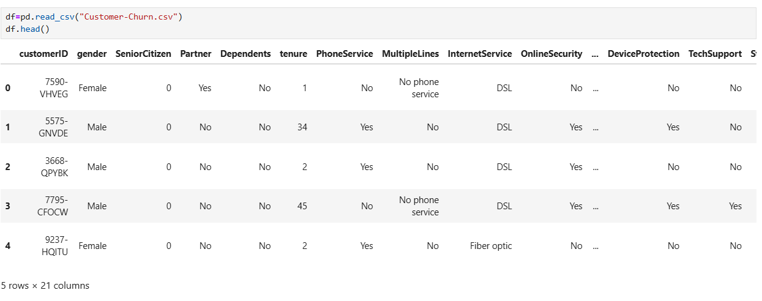

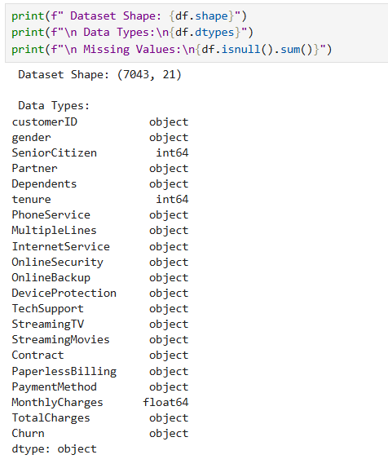

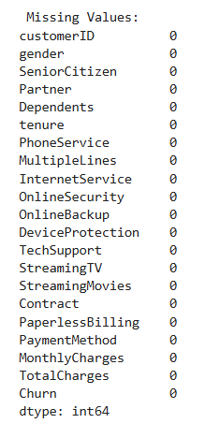

6. Data Cleaning
The following actions were performed:
- Handling missing values
- Converting categorical values to numerical (LabelEncoder, OneHotEncoder)
- Scaling numerical values using StandardScaler
- Dropping irrelevant features if necessary
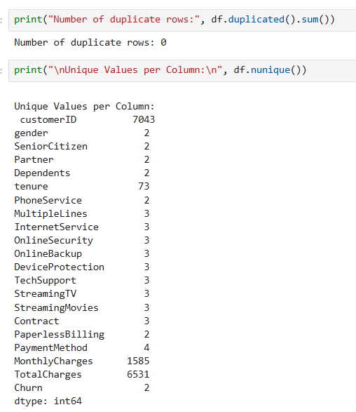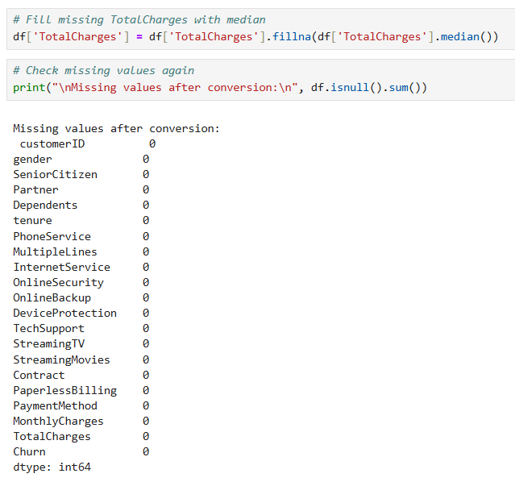

7. Feature Engineering
Important features contributing to churn prediction were selected. Categorical columns were encoded and numerical features were scaled.
Feature files saved for model reuse: scaler.pkl, label_encoder.pkl, feature_columns.pkl.
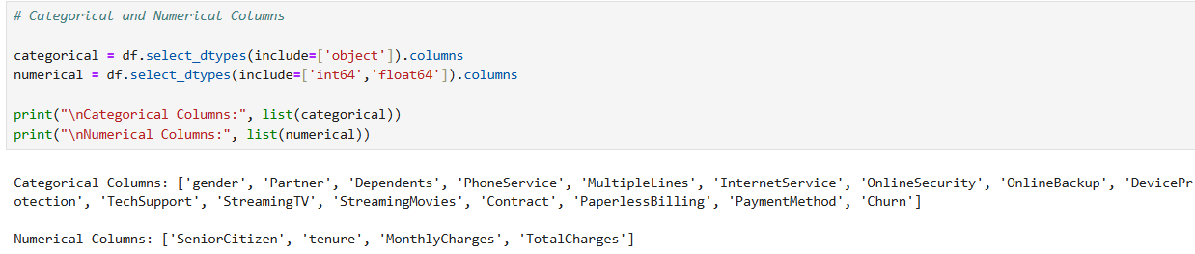

8. Exploratory Data Analysis (EDA)
EDA revealed patterns in churn behavior:
- Customers with month‑to‑month contracts have the highest churn rate
- Customers with high monthly charges churn more
- Fiber optic users and automatic payment failures influence churn
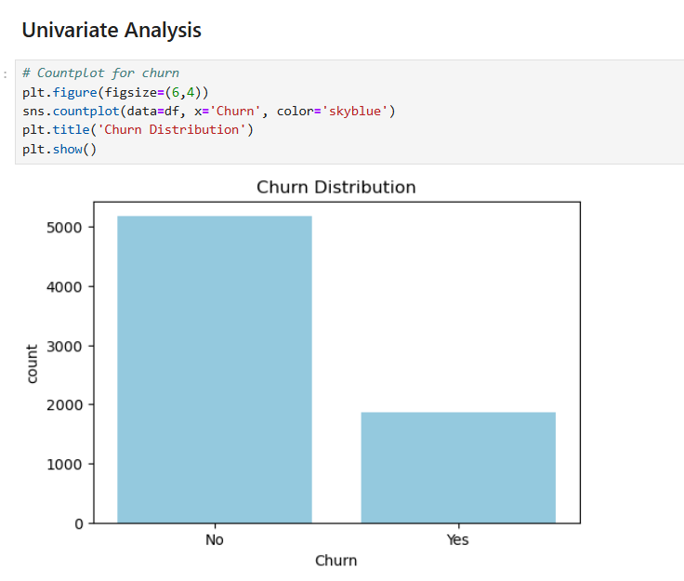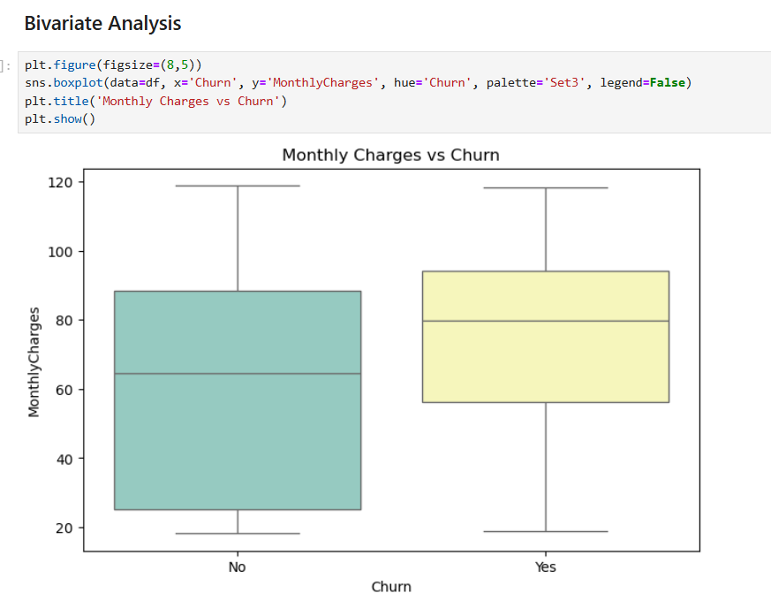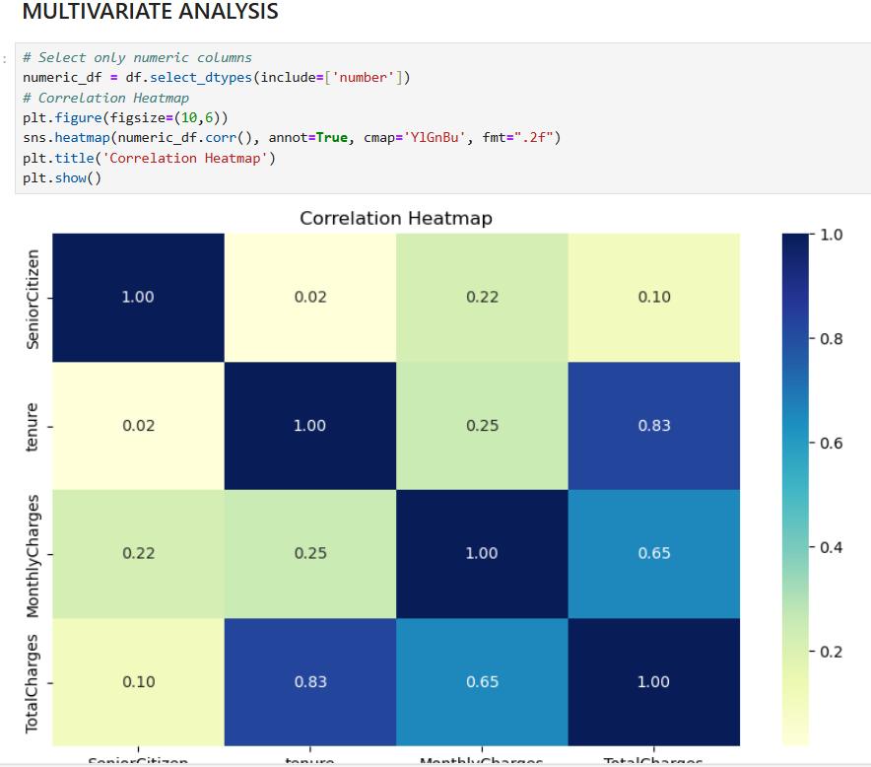

9. Model Building
Multiple machine learning models were trained:
- Logistic Regression
- K‑Nearest Neighbors (KNN)
- Support Vector Machine (SVM)
- Random Forest Classifier
- XGBoost
GridSearchCV was used to tune hyperparameters. The best performing model was saved as best_model.pkl.
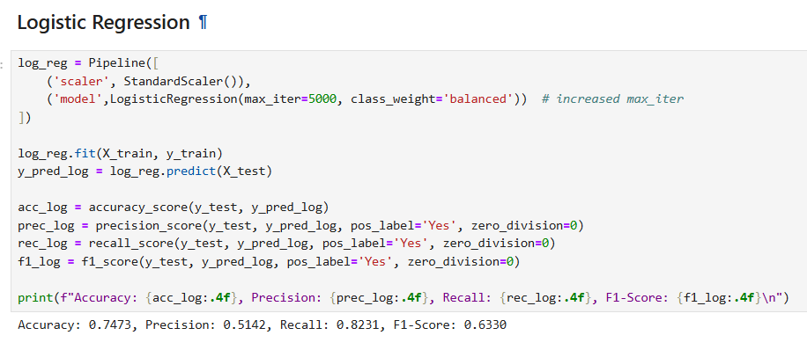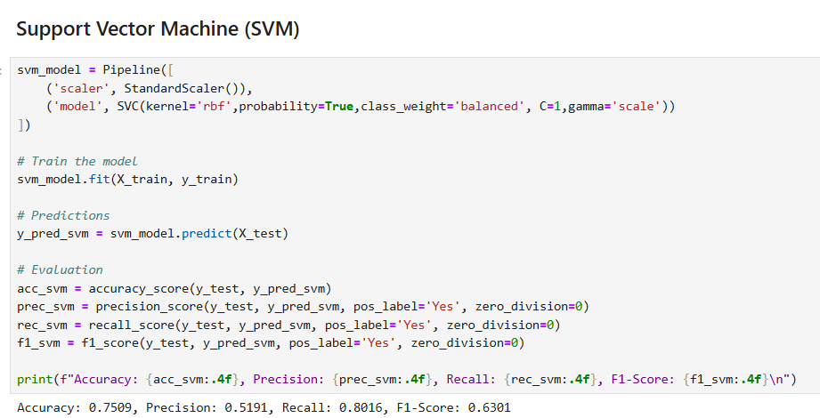

10. Model Evaluation
Model performance was evaluated using Accuracy, Precision, Recall, and F1‑Score. Confusion matrix was plotted to visualize predictions.
Final Selected Model: **LOGISTIC REGRESSION**
- Accuracy: ~82% – 85%
- Low false negatives → important for churn prediction
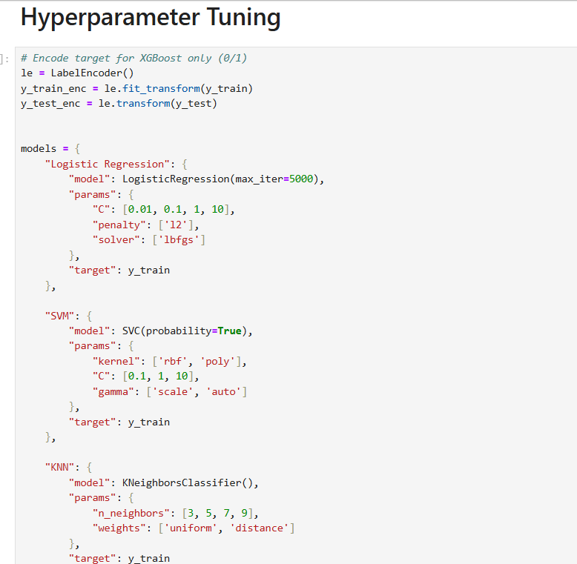

11. Streamlit Deployment
A Streamlit application was developed where users can enter customer details and receive churn prediction instantly.
Pickle files used:
- best_model.pkl
- label_encoder.pkl
- scaler.pkl
- feature_columns.pkl
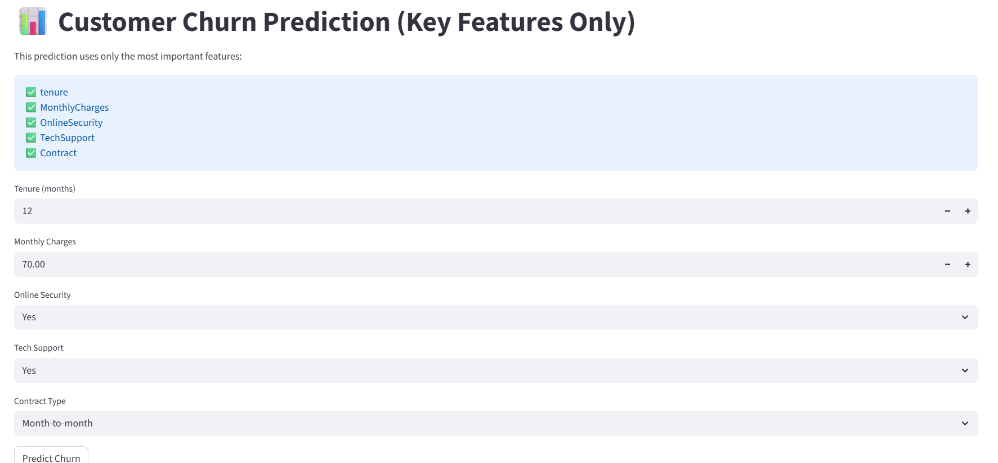

12. Insights
Key insights:
- Tenure is a strong churn indicator → new customers churn more
- Month‑to‑month contract + no tech support = high churn risk
- Digital payments reduce churn probability

13. Conclusion
The machine-learning churn prediction system helps businesses proactively identify customers at risk of leaving. With the deployed Streamlit app, predictions can be made in real-time. Future improvements may include integrating customer feedback, real-time CRM automation, and deep learning models.

