Jamhuriya University of Science and Technology
Course Title: PHP & MySQL

Assignment 1 (due date September 29, 2029)
- Write a program that compares three integer numbers then specifies and prints the greatest and smallest one (do not use built-in function such as min or max).
- Write a program that prints whether the number is divisible by 3, 5, both, or none of them.
- Write a program that prints odd numbers from 2 to 20, another prints even numbers from 35 to 7.
- Write a program that prints numbers divisible by 2 and 5 at the same time from 50 to 2.
- Write a program to find the reverse of a given number (for example, the reverse of 12345 = 54321, do not use any built-in function such as the strrev function).
- Write a program that calculates lowest common multiplier (LCM) of two positive integer numbers (for example, LCM of 8 and 12 = 24).
- Write a program that calculates highest common factor (HCF) of two integer numbers (if any) (for example, HCF of 18 and 24 = 6).
- Write a program that produces multiplication table (up to 12*12) using nested loops. Format the output in in table as shown in the following figure.
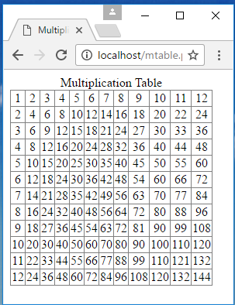
- Write a program that prints whether the number is a prime or non-prime.
- Write a program that prints prime numbers from 10 to 50.

