DOKUZ EYLUL UNIVERSITY
ENGINEERING FACULTY
DEPARTMENT OF COMPUTER ENGINEERING

CME 3201
DATABASE MANAGEMENT SYSTEMS

Super Market

by
Eren Çiçek
Gürkan Bıyık
Abdulkadir Öksüz
Problem Domain
The web application project is intended to have an efficient and user-friendly online supermarket platform where products, user information, orders, and stock statuses can be managed properly. The intended web application should be secure, scalable, and responsive in order to ease transactions while providing a pleasant user experience. It will assist a variety of market operations. Customers should be able to easily perform actions such as registration, login, product search, and adding things to the basket, as well as create orders and check their purchase history.
Specifications of the Project
User Roles:
- Customer
- Admin
Key Features:
- Responsive and Simple Design
- User Registration and Authentication
- Editing User Informantions
- Admin Panel for System Management
- Warehouse Stock Management According to Areas
- Product Listings
- Shopping Cart, Update and Checkout
- Order History and Tracking
- Search and Filter Functionality
Technologies:
- Frontend: HTML, CSS
- Backend: Django (Python)
- Database (RDBMS): SQLite3

Description of Solution System
A web application will be developed using the Django web framework, containing tables in the database such as users, products, categories, areas, warehouses, warehouse-stocks, and orders, orders-details, cart, cart-products. The website will handle basic user actions such as login, logout, viewing and searching products, adding products to the cart, placing orders, and examining order history. The system offers an easy-to-use user interface, secure transaction processing, and comprehensive backend capabilities.
Go to SETUP manual by clicking here

User-Friendly Interface:
- Intuitive navigation for customers.
- Responsive design for seamless user experience.
User Authentication and Authorization:
- Secure user registration and login.
- Role-based access control (Customer, Admin).
Product Management:
- Customer can easily search and find the desired product.
- Customers can view detailed product information and add items to their cart.
Cart Management:
- Shopping cart functionality with the ability to add, edit, and remove items.
- Checkout process to order the current cart.
Order Management:
- Order history for customer.
Admin Panel:
- System management.
- Update warehouse stocks.
- Create, update, and delete product listings.
- Create new categories.

List of System Services and Constraints
Services:
- User Registration and Authentication
- Product Listing and Management
- Shopping Cart and Checkout
- Admin Panel Management
- Search and Filter Functionality
Constraints:
- Security measures must be implemented to protect user data.
- Compliance with data protection regulations.
- Adherence to schedule and budget constraints.
- Consideration of commercial off-the-shelf (COTS) products and other relevant constraints placed on both product and processes.
- Scalability to handle varying levels of user activity.
- Responsive design for optimal user experience.
- Data normalization to ensure efficient storage and minimize redundancy in the database.
- Database consistency to maintain accurate and reliable data across the system.
- Database redundancy to ensure data availability in case of failures or disasters.
- Database integrity to guarantee the accuracy and reliability of data stored in the database.

Entity Relationship DIAGRAM

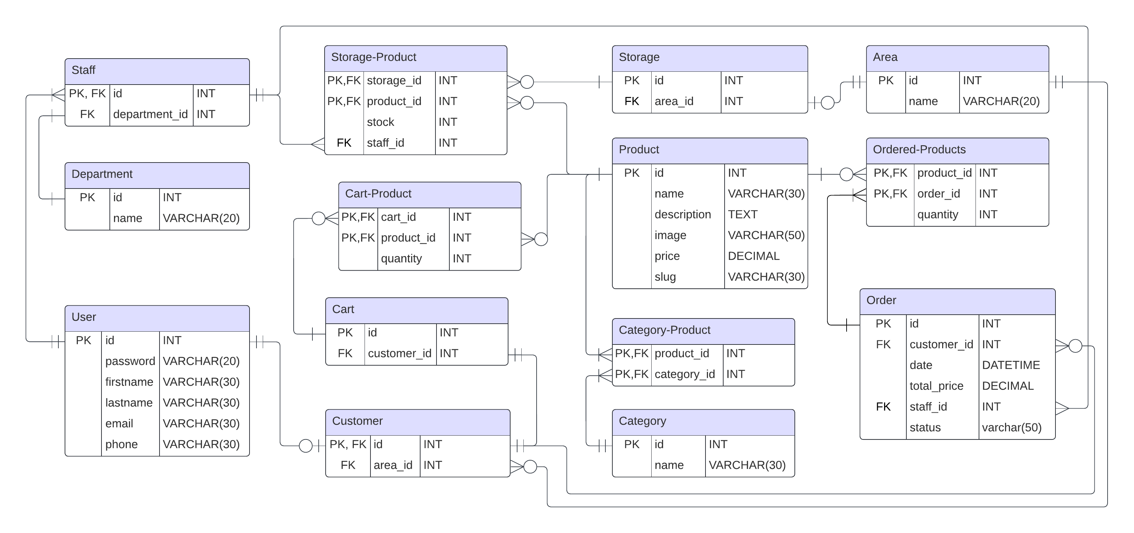

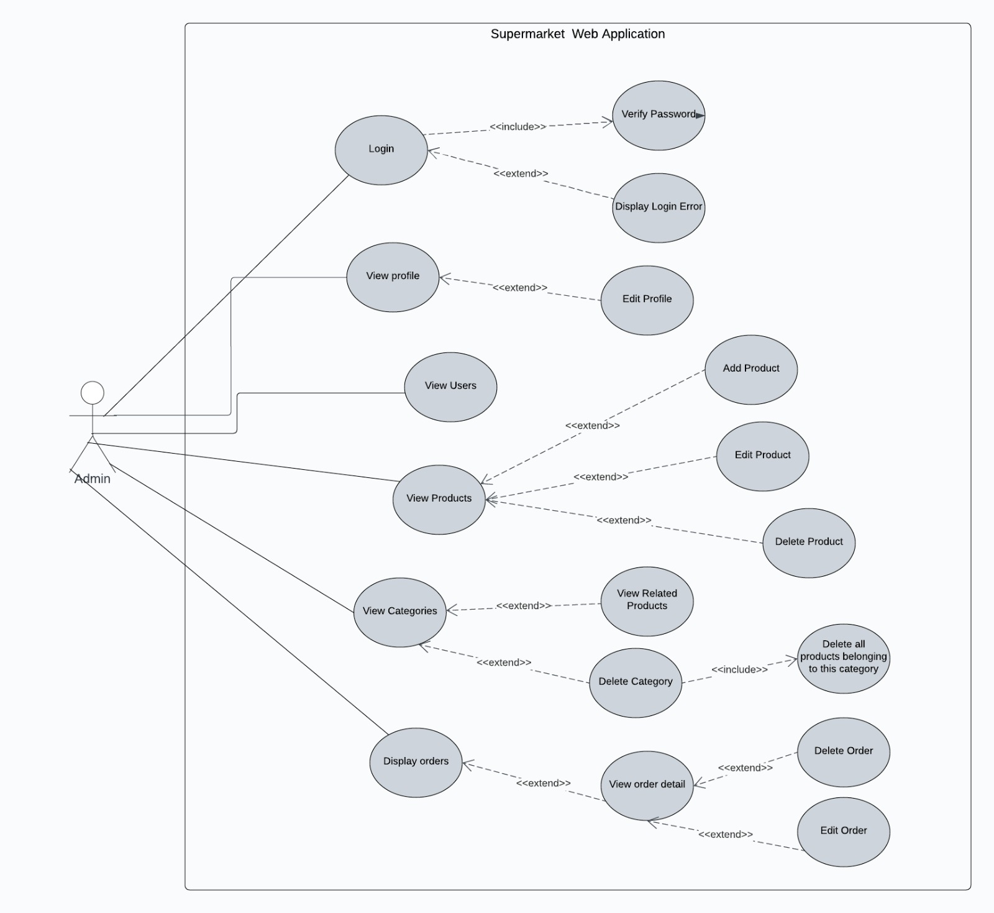
USE CASE DIAGRAMS

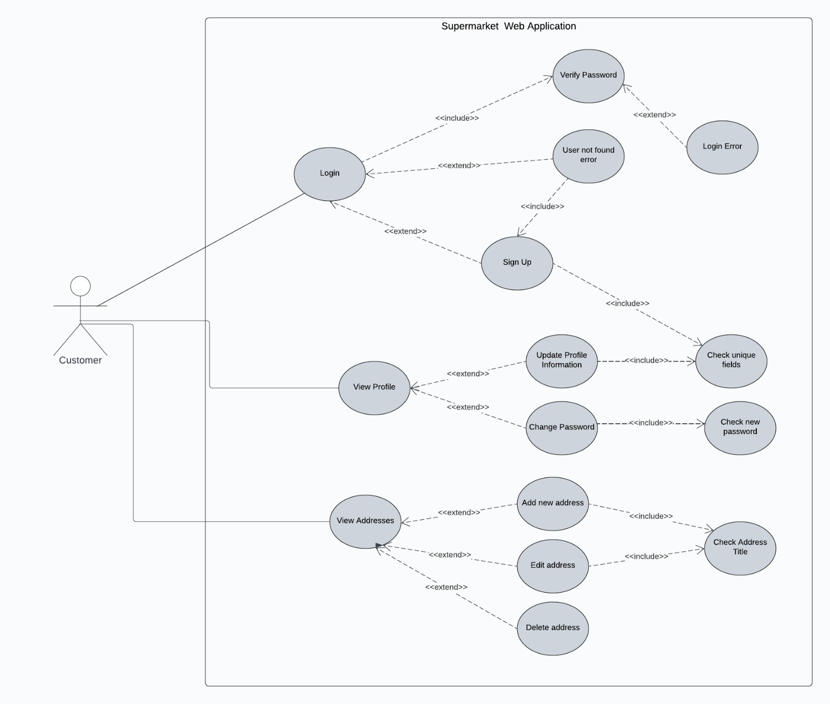

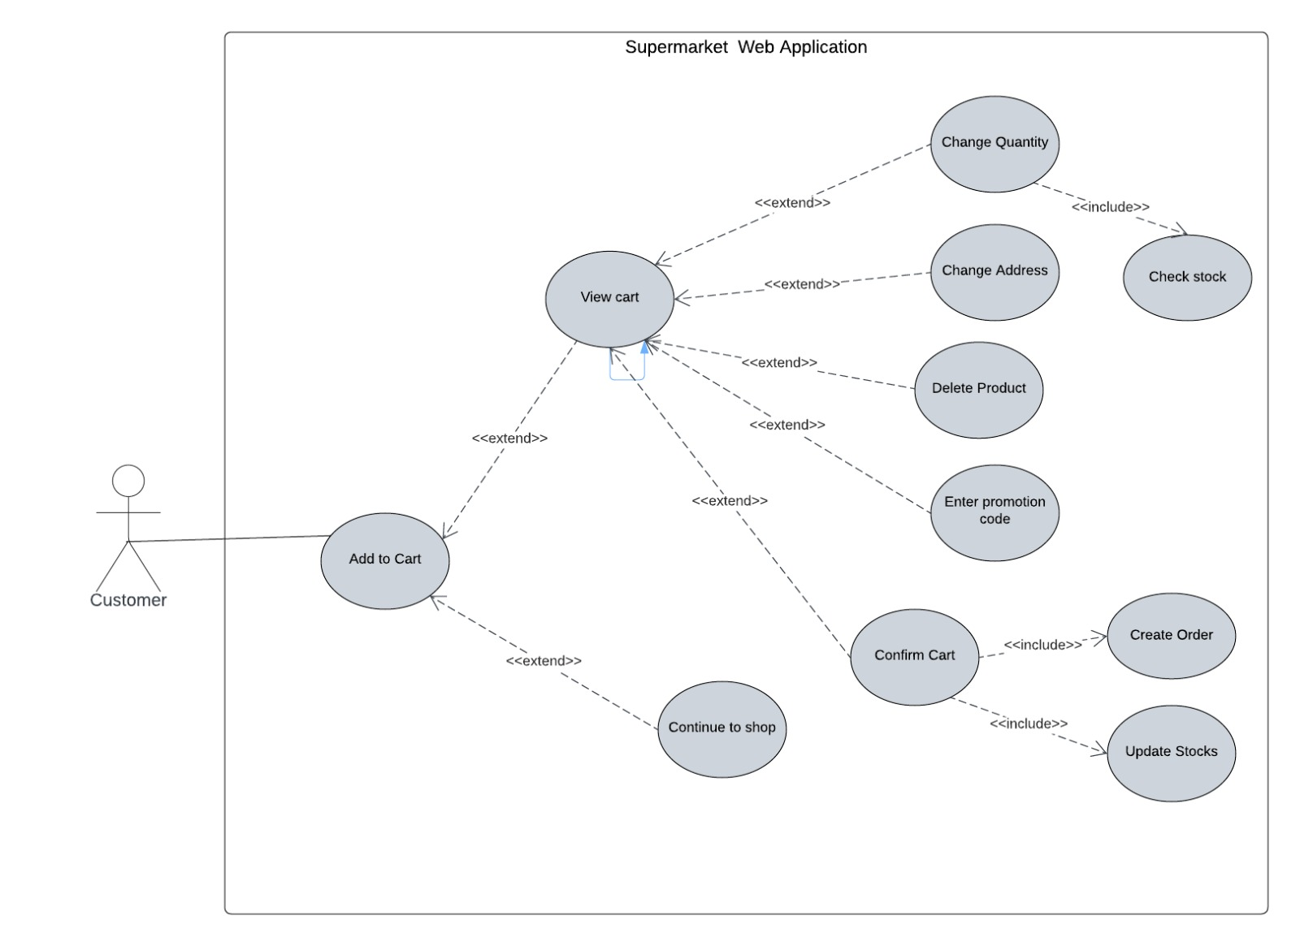

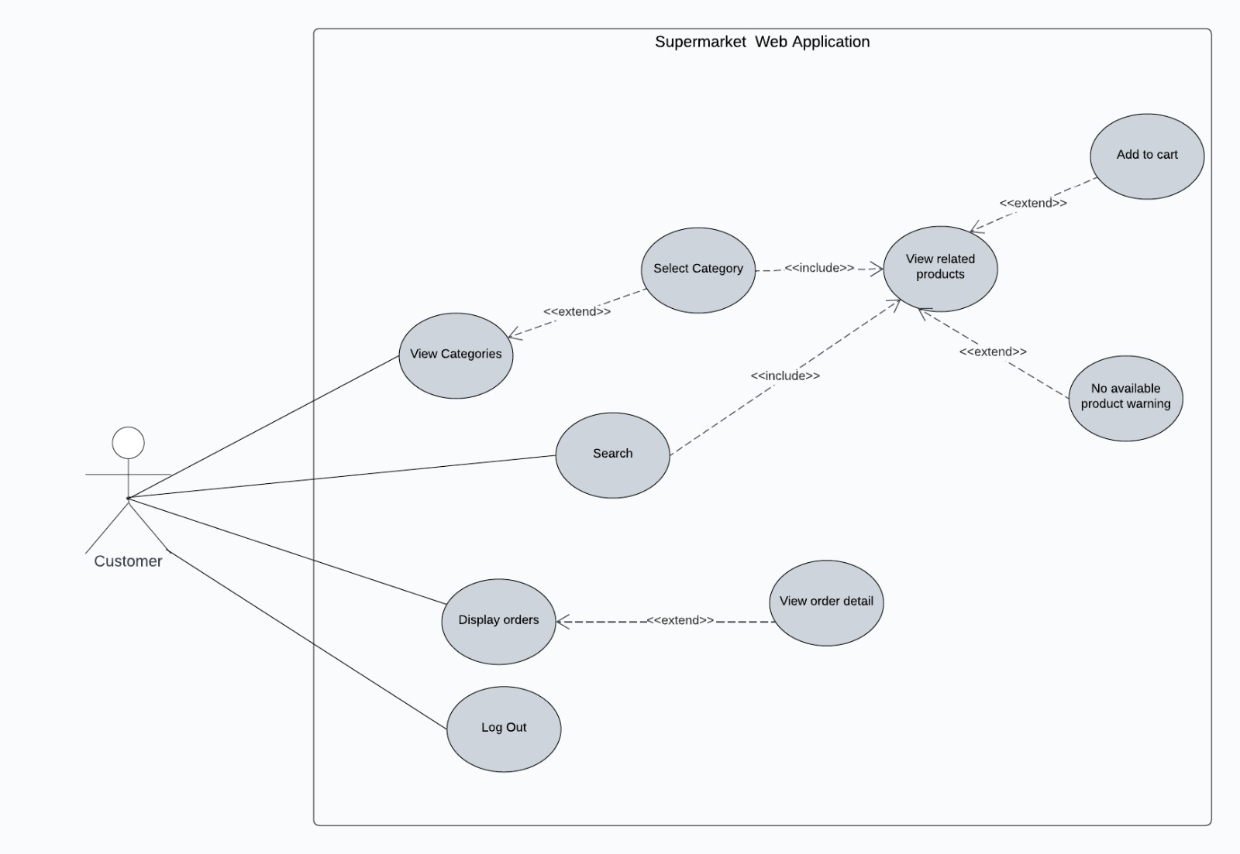

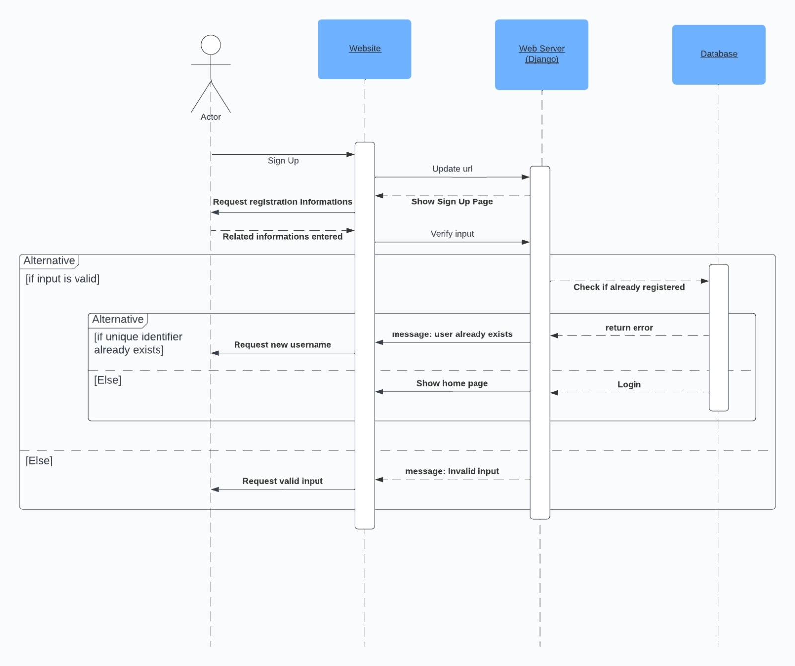
SEQUENCE DIAGRAMS

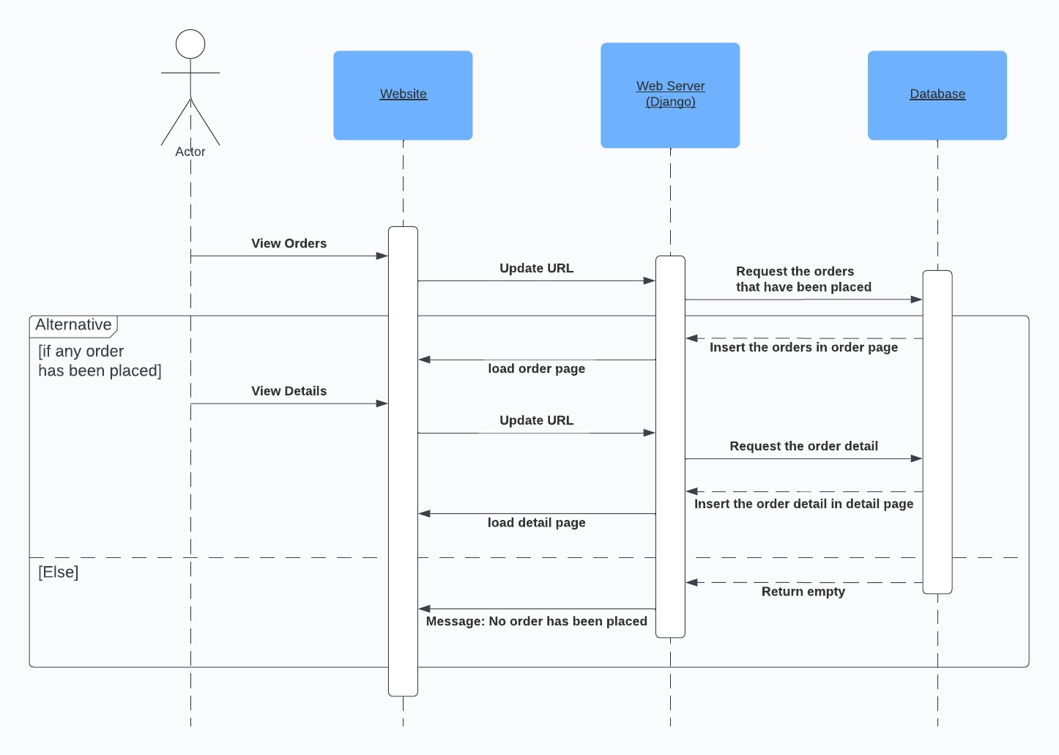

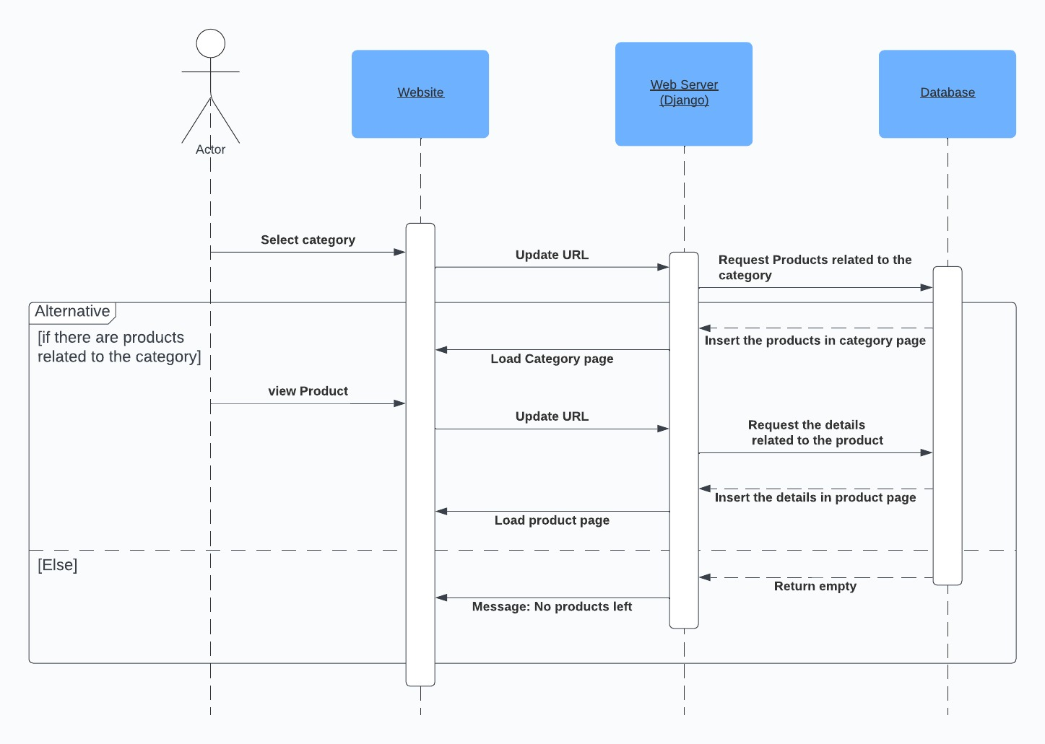

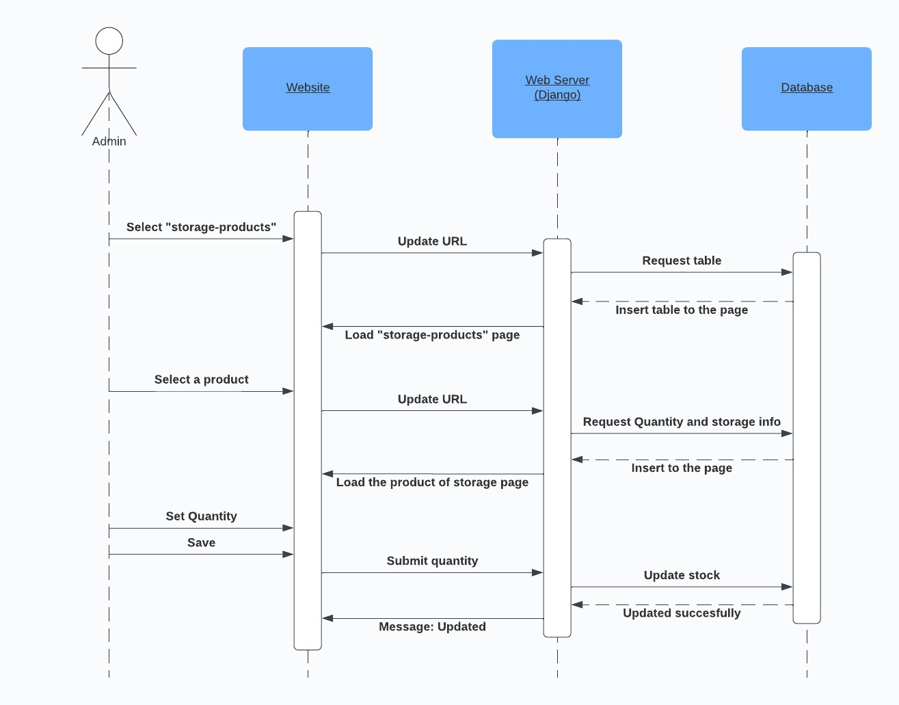

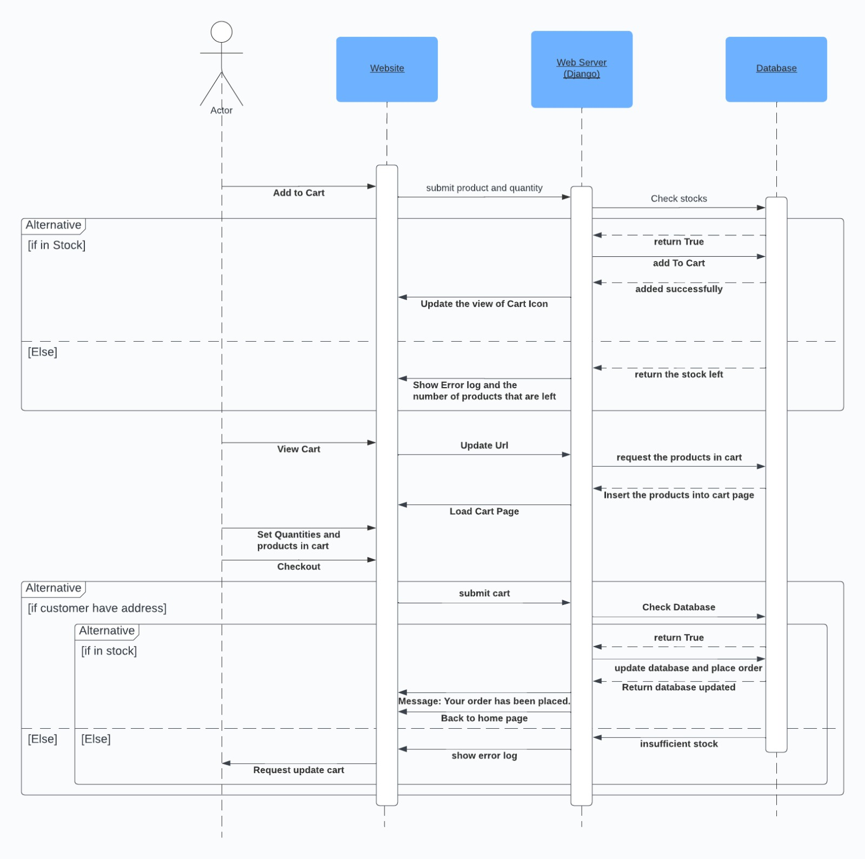

ACTIVITY DIAGRAMS
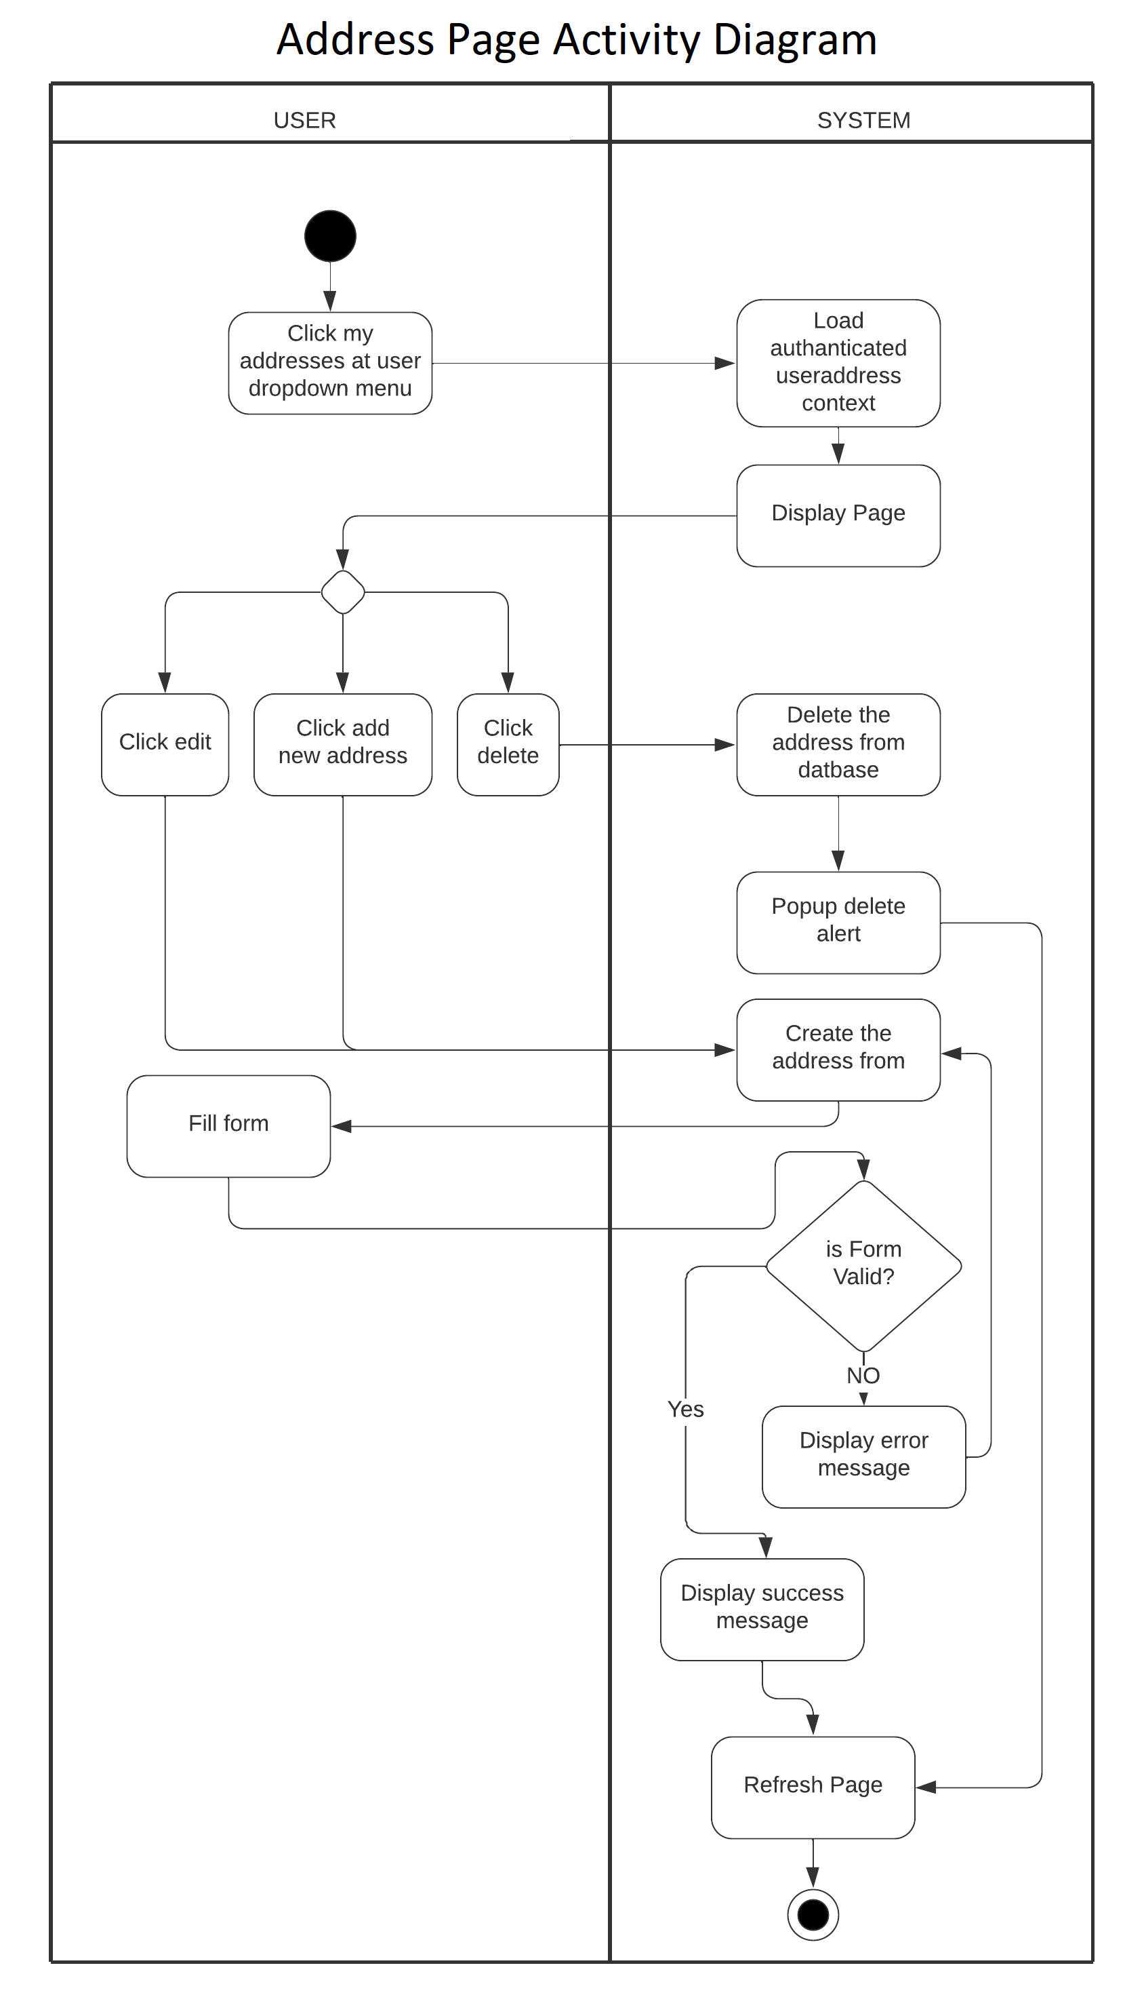
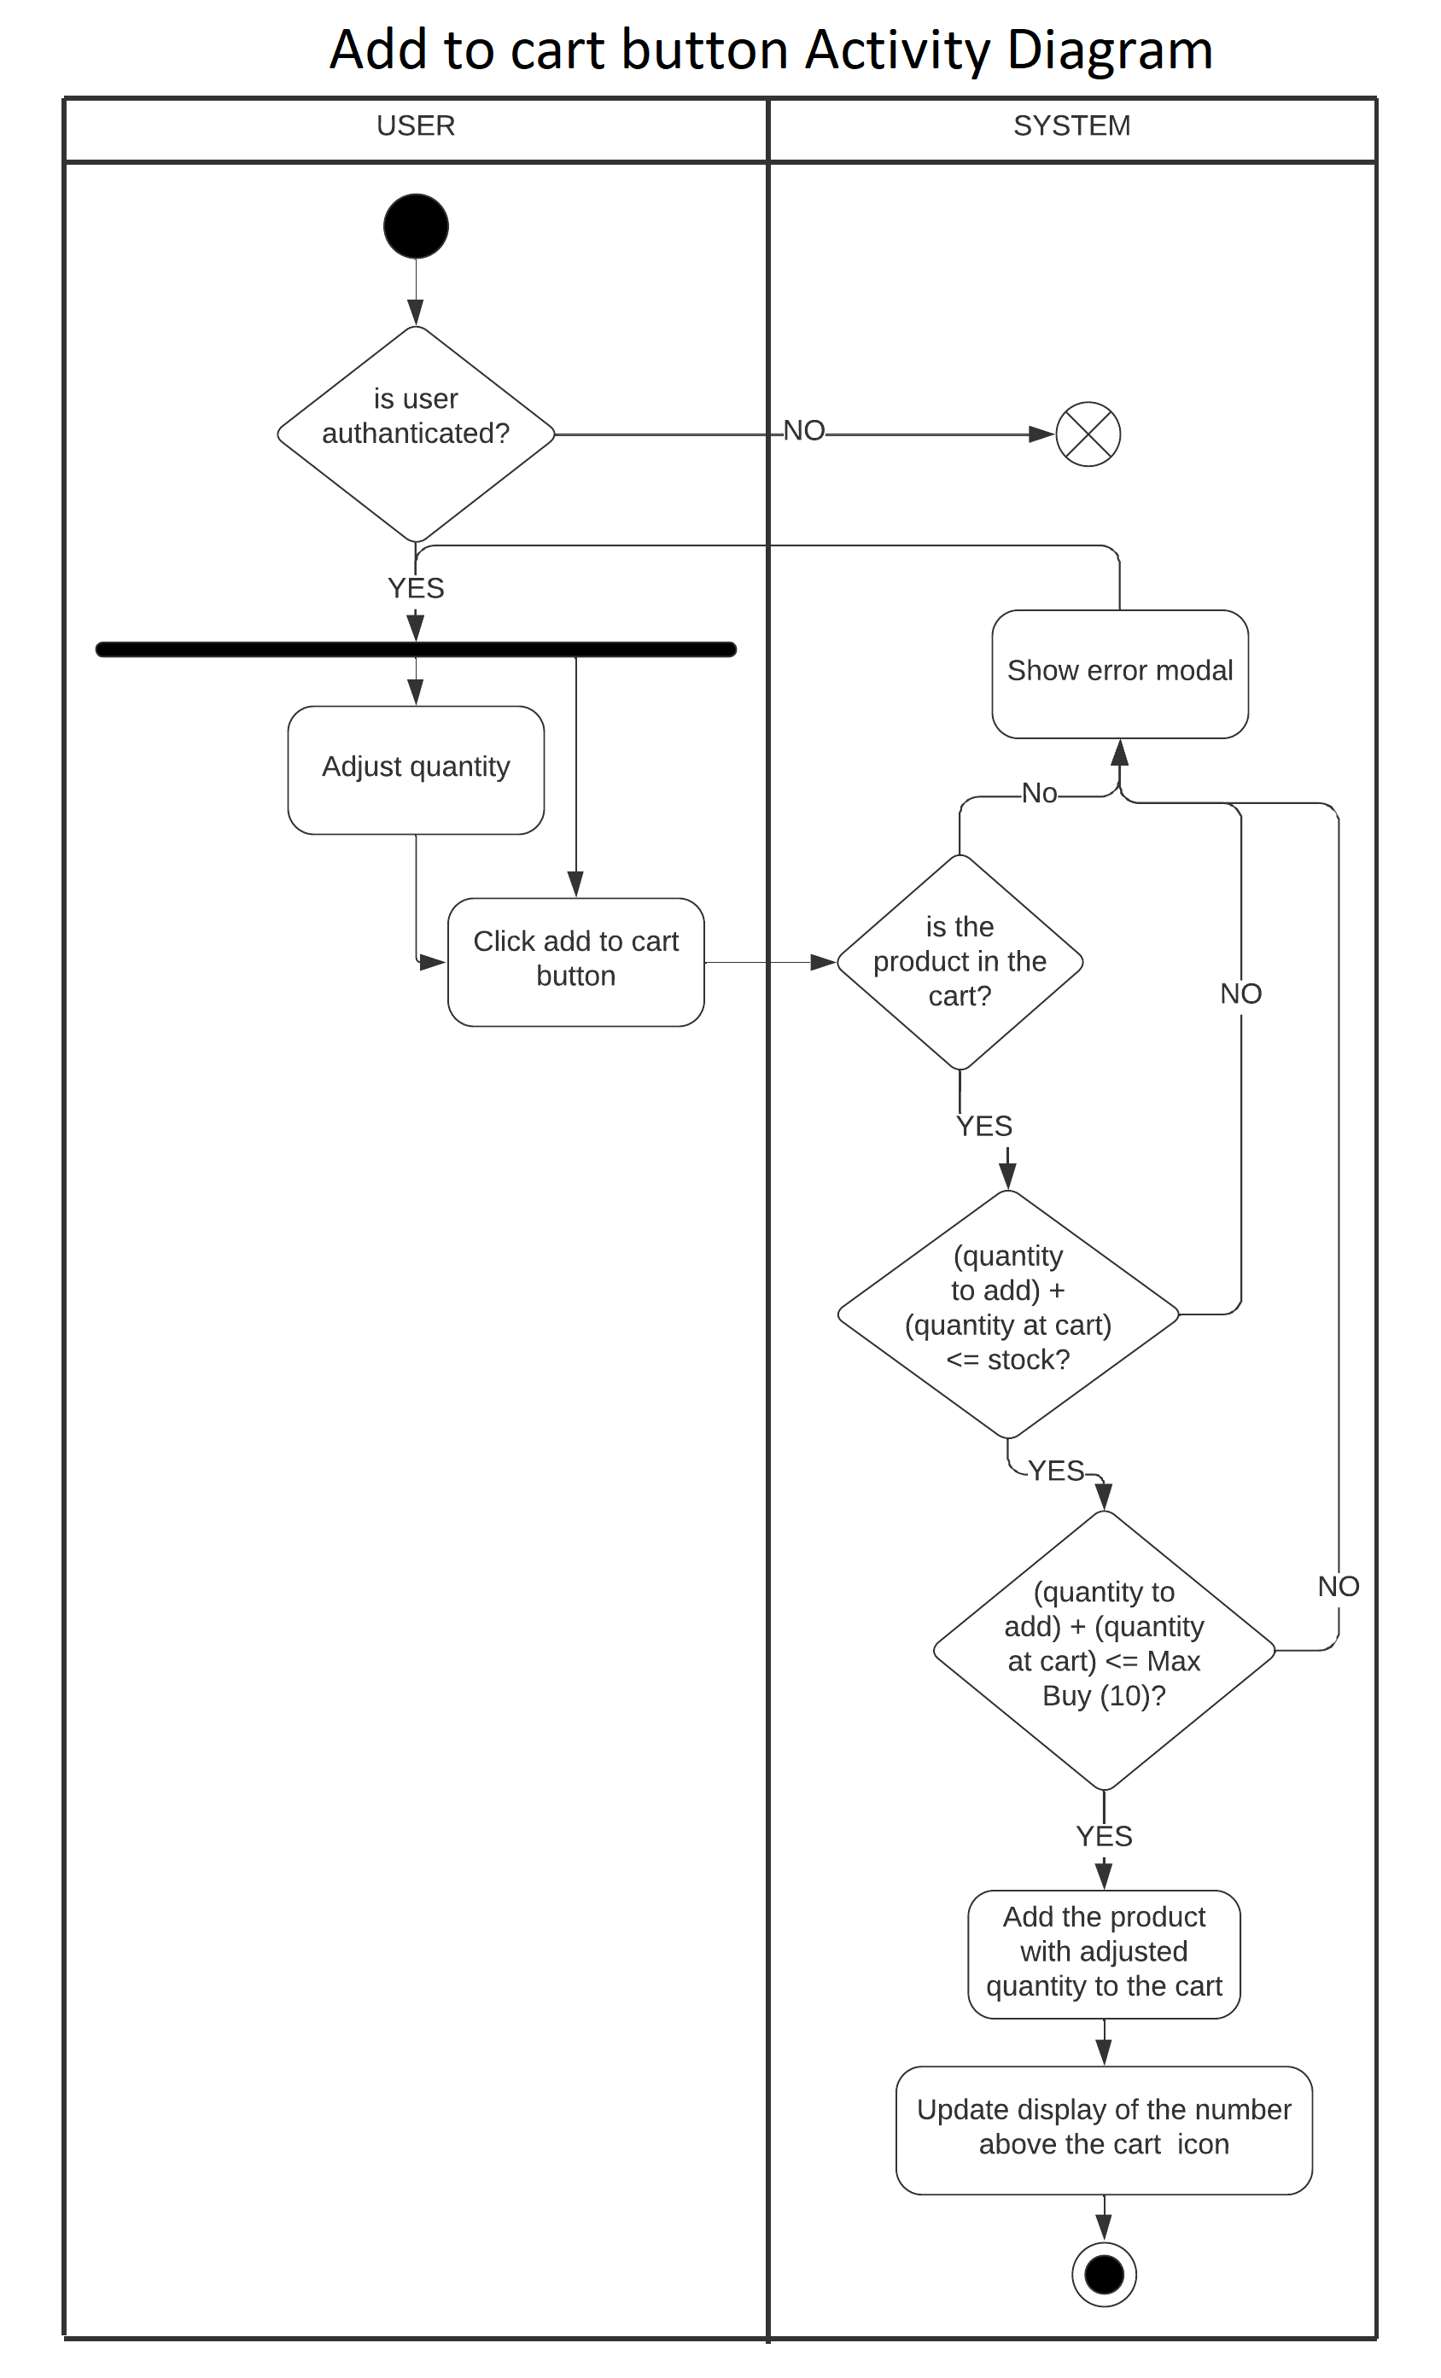
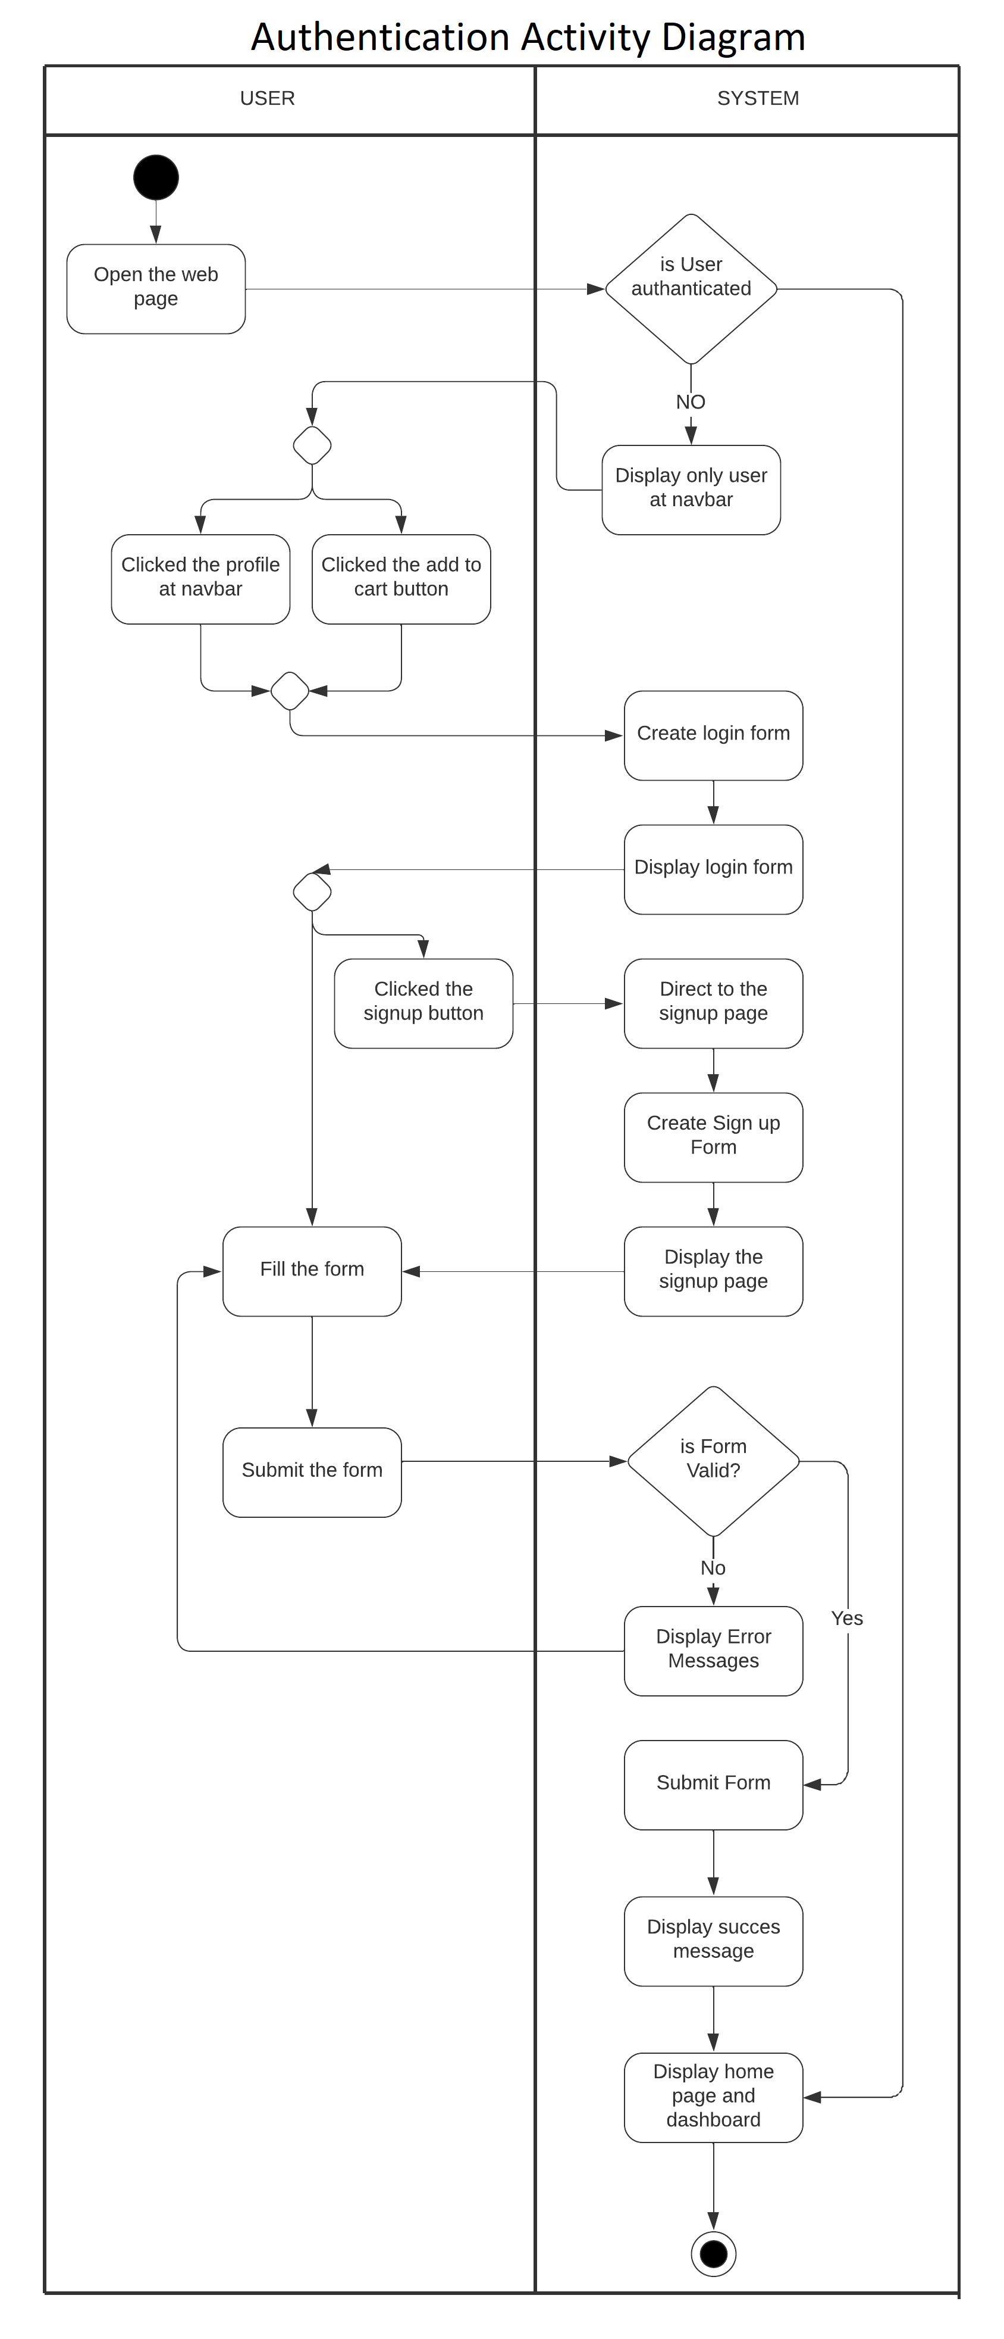
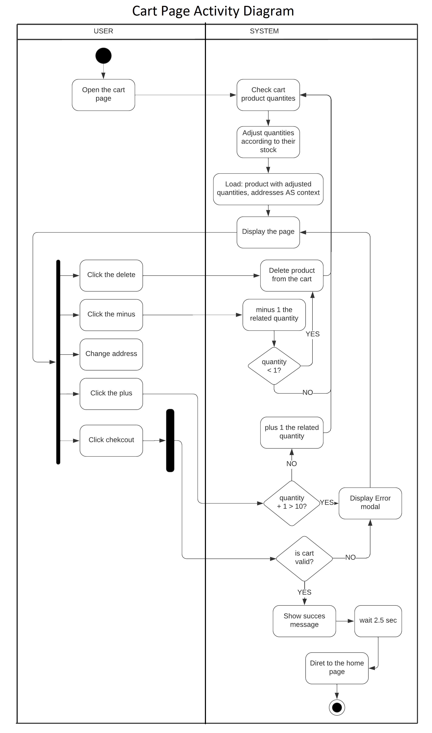
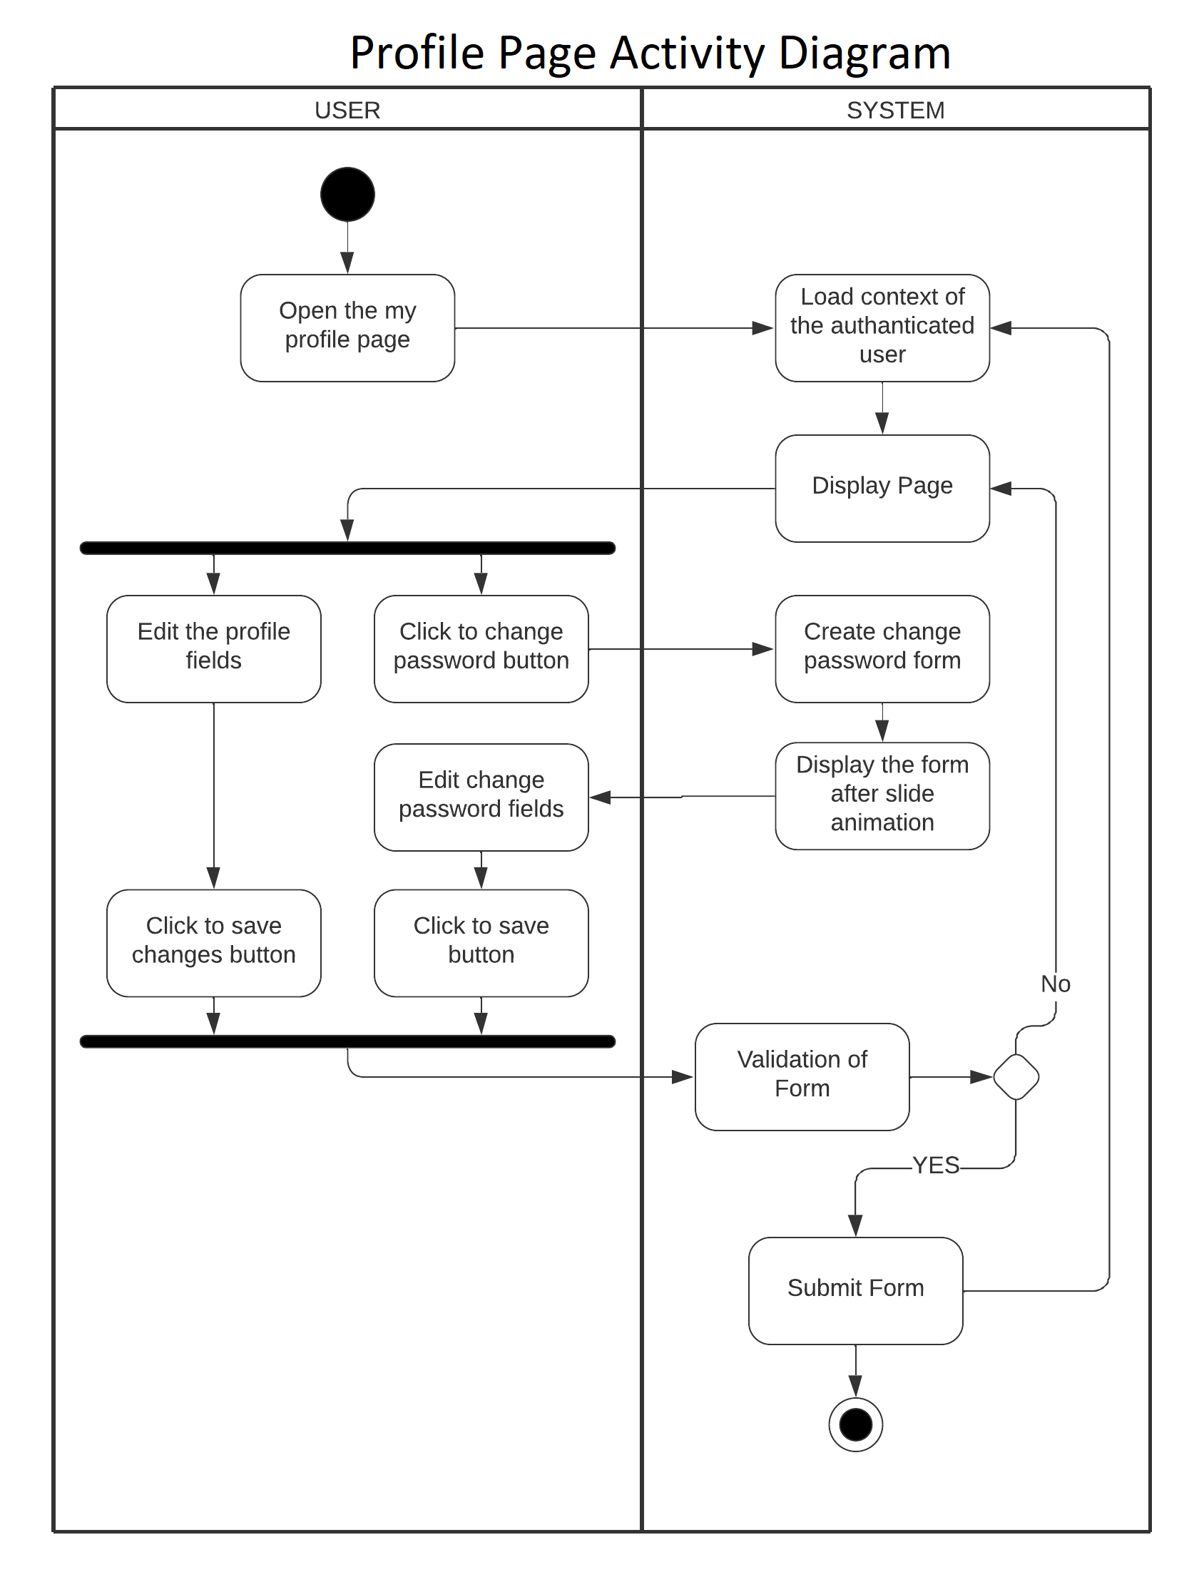
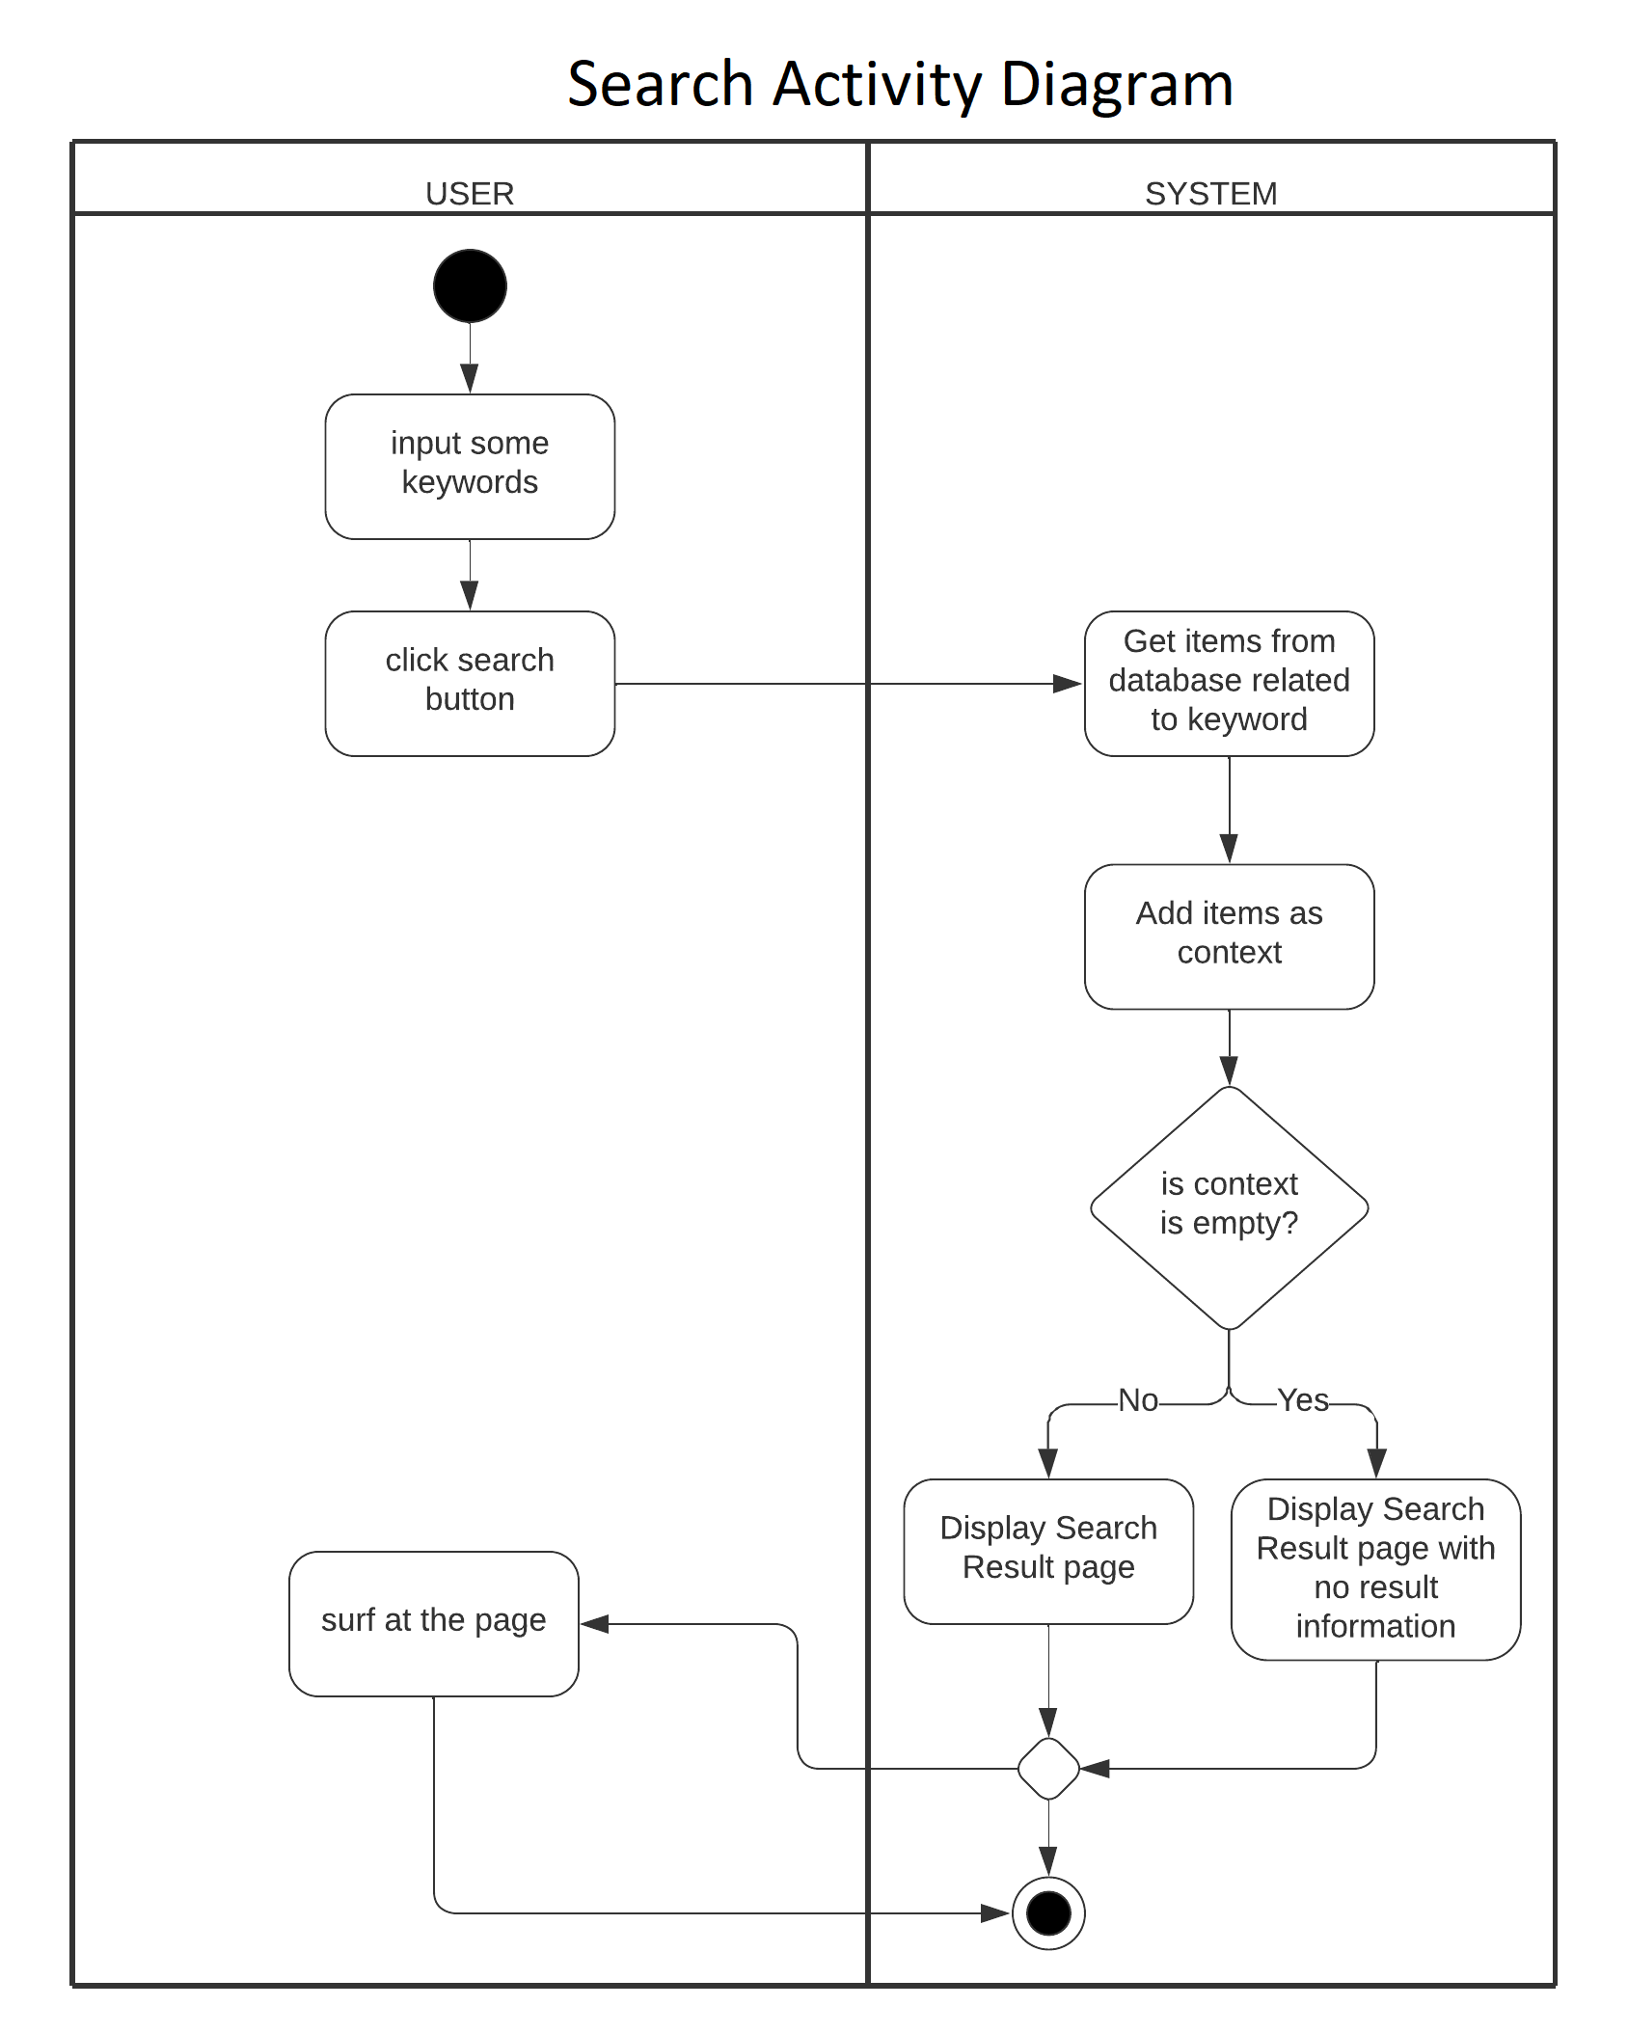
Future work
Given the scope and timeline of the project, several potential avenues for future enhancements and improvements can be explored:
- Enhanced User Interface (UI):
Implementing a more intuitive and visually appealing UI to elevate the overall user experience.
- Integration of Additional Features:
Incorporating advanced features such as personalized recommendations, promotional offers, and a real-time chat support system.
- Mobile Application Development:
Extending the platform's accessibility by developing dedicated mobile applications for iOS and Android devices.
- Enhanced Security Measures:
Conducting regular security audits and implementing additional measures to fortify the platform against potential cybersecurity threats.
- Advanced Analytics and Reporting:
Incorporating analytics tools to provide administrators with insights into user behavior, product preferences, and sales trends.
- Implementing a Loyalty Program:
Designing and implementing a customer loyalty program to incentivize repeat purchases and foster long-term customer relationships.
- Enhanced Search and Filtering Functionality:
Improving the product search and filtering capabilities to facilitate quicker and more precise product discovery for users.
- Integration with External APIs:
Exploring partnerships and integrating with external APIs to expand the range of available products and services.
- Scalability Improvements:
Conducting performance tests and optimizing the system for scalability to ensure seamless operation, even during peak usage periods.

