

**Education management software**

Dear Managing Director,  
  
We at BRtech are pleased to submit our proposal for the design and development of a comprehensive Education management software for your organization. Our solution aims to streamline academic, administrative, and financial operations while enhancing communication between students, teachers, and administrators.  
  
With our expertise in developing enterprise-level solutions, we are confident that our platform will deliver efficiency, transparency, and scalability tailored to your institution's needs.  
  
We look forward to the opportunity to collaborate with you.  
  
Sincerely,  
BRtech Team

# Technical Proposal

## 1. Introduction

The Education Management Software is a **comprehensive web-based solution** designed to streamline academic, administrative, and communication processes within schools and colleges. The platform aims to bring all stakeholders—administrators, teachers, students, and parents—into a single, unified digital ecosystem.

The system will be developed using **modern, scalable technologies** with a focus on **security, reliability, and user-friendliness**. It will provide an end-to-end solution covering essential modules such as **admissions, student information management, attendance, examinations, grading, library, finance & accounts, HR & payroll, communication, and reporting/analytics**.

The platform is envisioned as a **role-based, multi-user system** accessible from desktops, tablets, and mobile devices. It will support both **cloud-based deployment** for easy scalability and **on-premise installation** for institutions requiring localized hosting.

## 2. Modules

* **Dashboard module**  
  The dashboard provides a quick snapshot of important information through reports, charts, and notifications. Each user (admin, teacher, student, or parent) gets a personalized view of attendance, performance, fees, and upcoming events for easy decision-making.  
    
  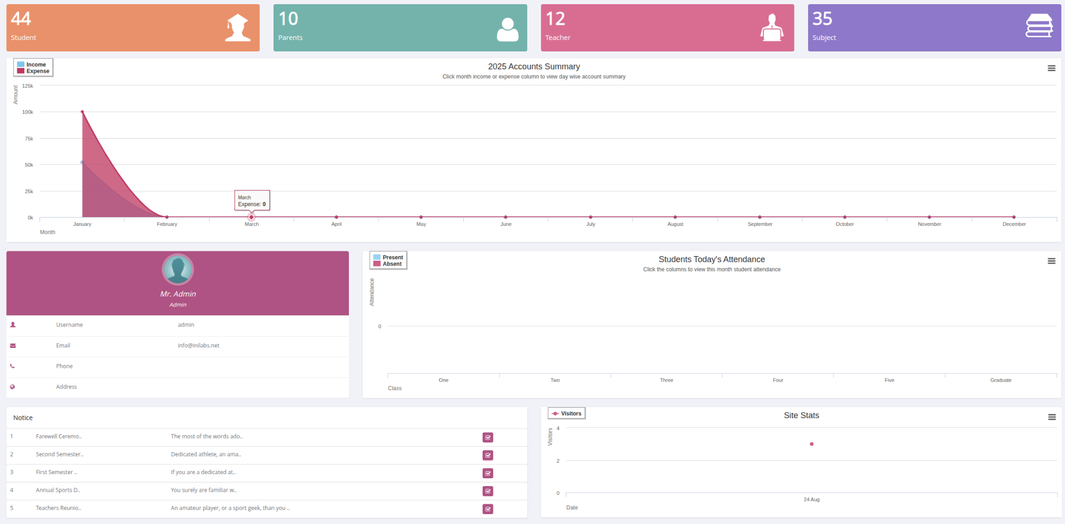
* **User module**The User Module manages all types of users, such as students, teachers, staff, and parents. It handles roles, permissions, and access control to ensure secure and organized use of the system.

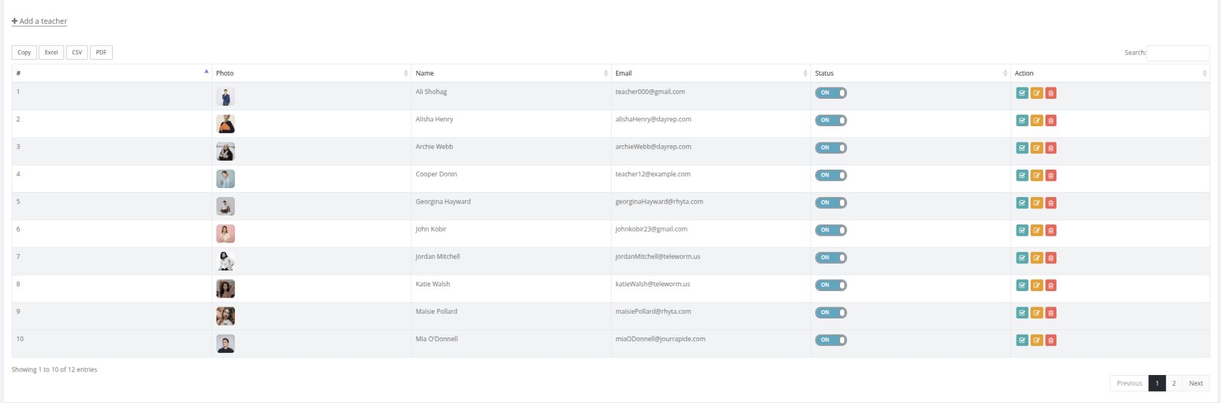

* **Academic module**The Academic Module manages core academic operations, including classes, sections, subjects, syllabus, assignments, and class routines. It ensures structured curriculum planning, organized schedules, and smooth learning management.

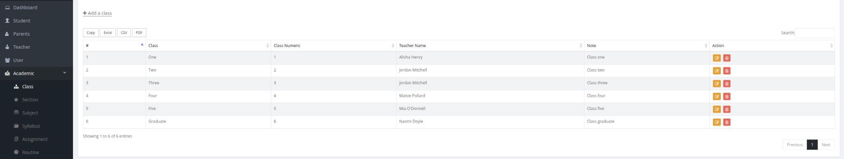

* **Attendance module**The Attendance Module tracks daily attendance for students, teachers, and other users. It provides accurate records, reports, and insights to ensure discipline and improve accountability.  
    
  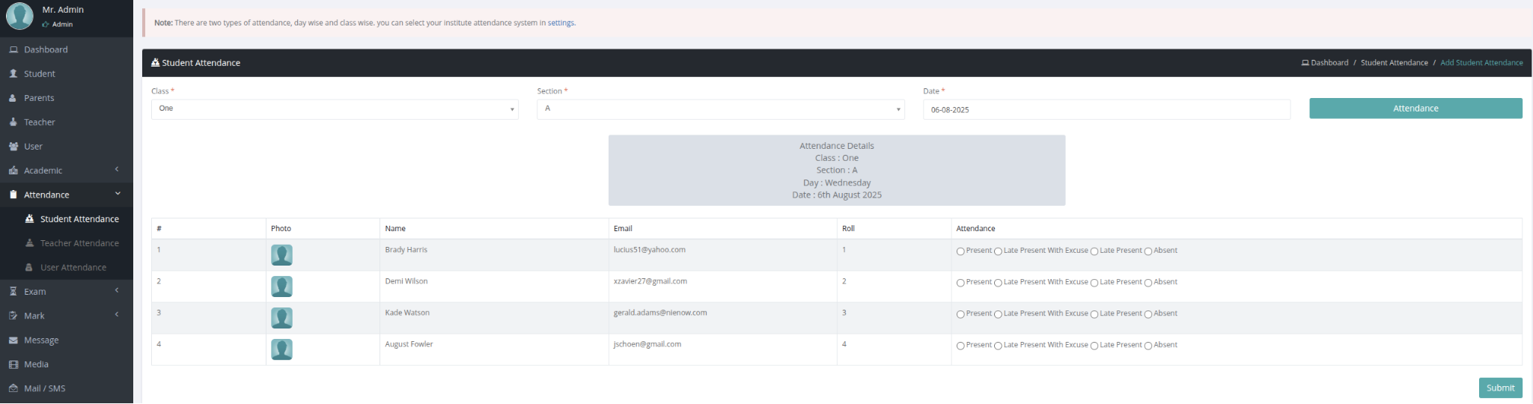
* **Exam module**This module manages all academic examinations, including schedules, grading, attendance, marks, and student promotions. It also supports online exams with features like question banks, levels, instructions, and exam-taking. Additionally, it streamlines student admission and re-admission processes for better efficiency and record management.  
  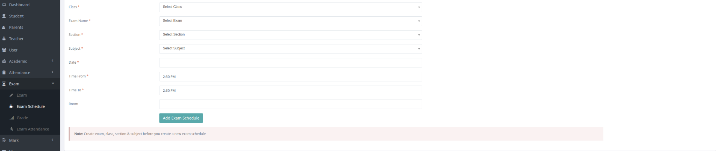

* **Payroll module**The Payroll Module automates staff salary management, covering salary templates, hourly wages, overtime, and deductions. It allows administrators to manage salary structures, process payments efficiently, and ensure accurate payroll records with minimal effort.  
    
  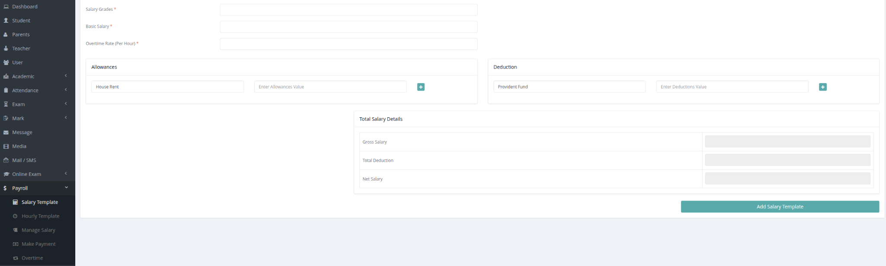
* **Asset management module**The Asset Management Module helps institutions efficiently manage and track their assets. It includes vendor management, asset categorization, purchase records, and assignment to specific locations or users. This ensures proper utilization, accountability, and streamlined asset lifecycle management.  
  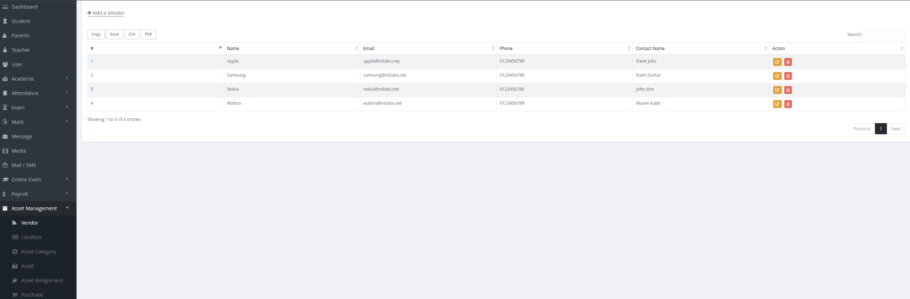
* **Inventory module**The Inventory Module manages all items and supplies within the institution. It covers product categorization, supplier management, warehouses, purchases, and sales, ensuring efficient stock control, tracking, and reporting.  
    
  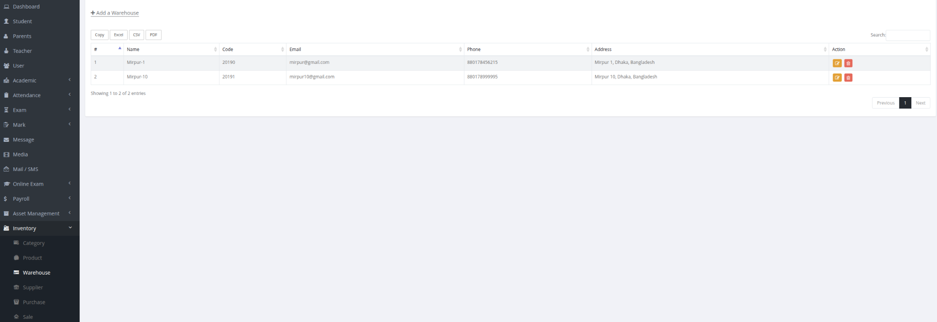
* **Leave module**  
  The Leave Application Module manages staff and teacher leaves efficiently. It includes leave categories, leave assignment, application submission, and approval workflows, ensuring proper tracking and smooth HR operations.  
    
  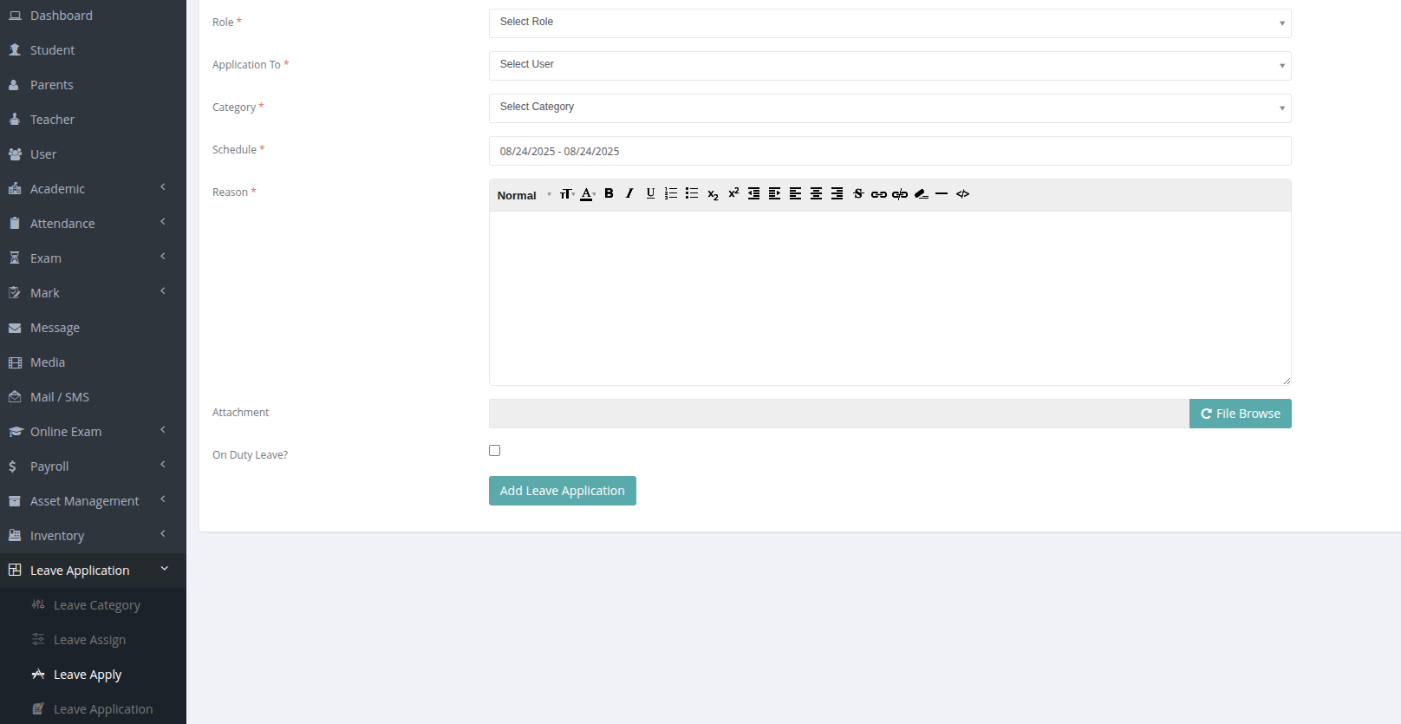
* **Transport & Hostel module**This module manages the institution’s transportation and accommodation services. It includes vehicle and transport management, student/staff member assignments, tracking support, hostels, room categories, and occupancy management to ensure safe, organized, and efficient operations.  
    
  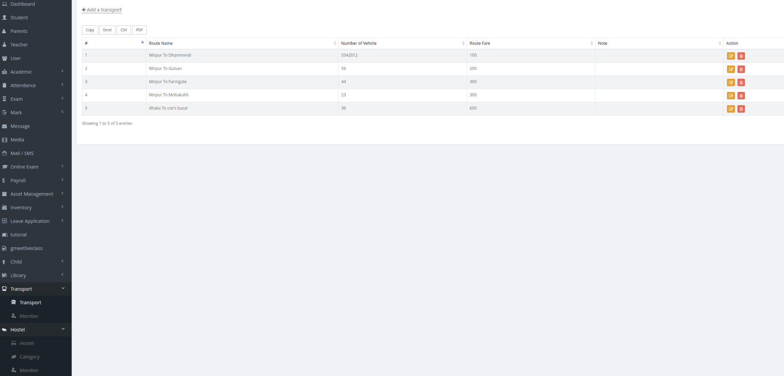
* **Accounts module**The Account Module manages all financial operations within the institution. It covers fee types, invoicing, payments, income, expenses, and global payment tracking, ensuring accurate financial records and streamlined accounting processes.

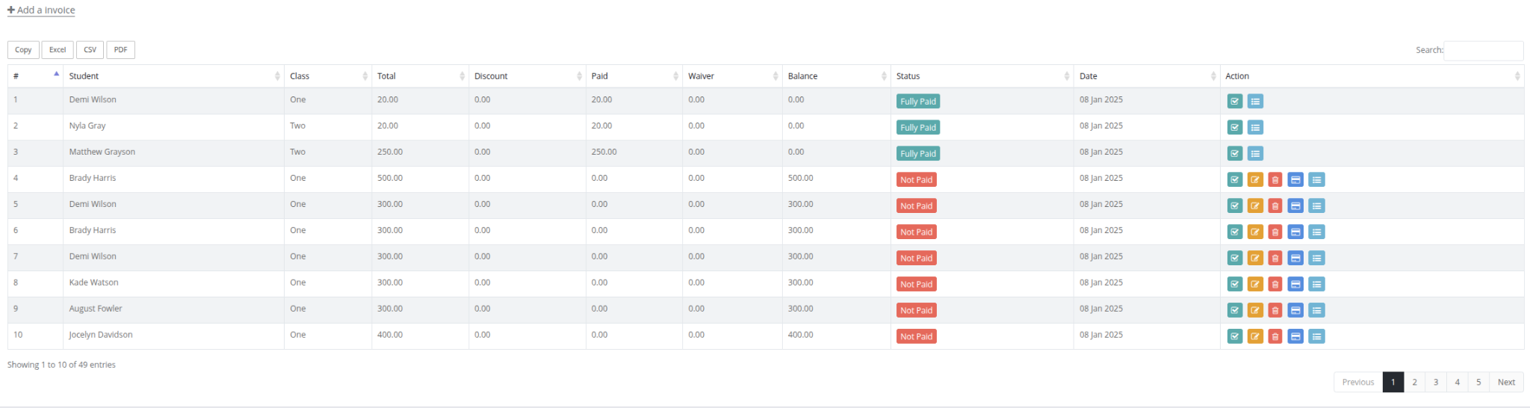

* **Announcement module**The Announcement Module manages all institutional notifications. It covers notices, events, and holidays, ensuring timely communication to students, staff, and parents.  
    
  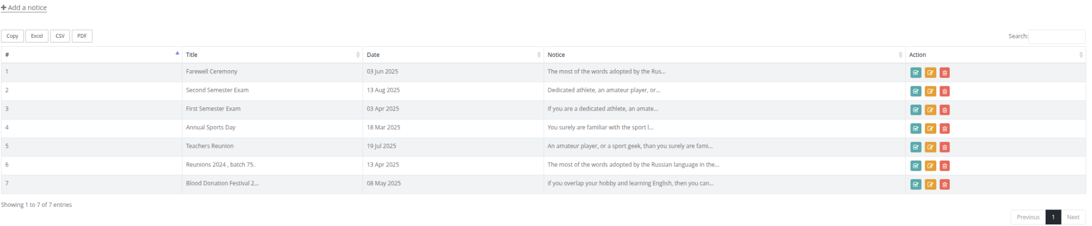
* **Library module**  
  The Library Management Module manages all library operations, including member management, book cataloging, issue/return tracking, and e-book access, ensuring efficient and organized library services for students and staff.

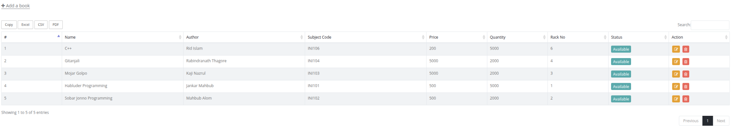

## 

* **Administrator Module**The Administrator Module provides complete control over the system’s configuration and management. It includes academic year setup, student groups, complaint handling, certificate templates, system administration, role & permission management, backup & import functions, communication templates, and user account updates.
* **Report Module**  
  The Report Module provides comprehensive insights across all institutional operations. It generates detailed reports on classes, students, exams, attendance, library, finances, payroll, online exams, admissions, certificates, and more, enabling administrators to make data-driven decisions efficiently.
* **Settings & CMS module**The Settings & CMS Module manages the institution’s website content and system configurations. It includes post categories, posts, pages, menus, and settings for general system preferences, frontend, payments, SMS, email, and marks, ensuring smooth administration and flexible content management.

## 3. Technology Stack

* **Backend:** Laravel (PHP Framework), C# (for specialized services like payroll, biometrics integration)
* **Frontend:** Next.js (React Framework)
* **Database:** MySQL / PostgreSQL
* **Hosting / Cloud:** AWS / DigitalOcean / Azure (scalable and secure)
* **Authentication & Security:**
* Role-Based Access Control (RBAC)
* Two-Factor Authentication (2FA)
* Email & Mobile OTP verification
* Biometric authentication (fingerprint/face ID integration for attendance & login)
* **APIs / Integration:** RESTful APIs for external systems, payment gateways, SMS, email, and biometric devices
* **Reporting & Analytics:** Built-in dashboards, charts, exportable reports
* **DevOps / CI-CD:** Docker, GitHub Actions / GitLab CI, automated backups, monitoring

## 4. Project Timeline

| **Phase** | **Description** | **Duration** |
| --- | --- | --- |
| **Phase 1: Requirement Gathering & Analysis** | Collect detailed requirements from stakeholders, define scope, workflows, and module specifications. | 3 weeks |
| | **Phase 2: UI/UX Design** | | --- | | Design user interfaces and experiences for web and mobile applications, including dashboards, forms, and reports. | 3 weeks |
| | **Phase 3: Core Development** | | --- | | Develop core modules: User Management, Academic, Attendance (with biometric integration), Fees & Accounts, Exams, Payroll. | 7 weeks |
| **Phase 4: Extended Modules Development** | Develop Transport & Hostel, Library, Inventory, Leave Management, Communication, CMS, Settings, Reports & Analytics, and Online Exams. | 6 weeks |
| | **Phase 5: Testing & QA** | | --- | | Perform functional, integration, performance, security, and user acceptance testing. Deploy system on cloud/on-premise, perform data migration, and provide training to staff and administrators. (UAT). | 4 weeks |
| **Phase 6: Deployment & Training** | Deploy system on cloud/on-premise, perform data migration, and provide training to staff and administrators. | 3 weeks |
| **Total** |  | 26 weeks |

# Financial Proposal

## 1. Cost Breakdown

| **Phase** | **Description** | **Estimated Cost(BDT)** |
| --- | --- | --- |
| **Requirement Gathering & Analysis** | Stakeholder workshops, system specifications, workflow mapping, and SRS documentation. | 1,00,000.00 |
| | **UI/UX Design** | | --- | | Web mockups, dashboards, user journey flows, and responsive design. | 1,00,000.00 |
| | **Backend & API Development** | | --- | | Core system architecture, multi-tenant setup, database design, RESTful APIs, and role-based access control. | 4,00,000.00 |
| **Frontend Development (Web)** | Admin dashboards, portals (students, parents, staff), reports, CMS, responsive layouts. | 2,00,000.00 |
| | **Testing & QA** | | --- | | Unit testing, integration testing, performance/security testing, and user acceptance testing. | 1,00,000.00 |
| **Deployment & Training** | Cloud/on-premise deployment, configuration, data migration, and admin/staff training. | 1,00,000.00 |
| **Total** |  | 10,00,000.00 |

## 2. Payment Terms

* **30% Advance Payment** – Upon project initiation (covers requirement analysis, design kickoff, and initial setup).
* **40% Development Milestone** – Upon completion of core development phase (backend, frontend, APIs).
* **20% UAT & Testing Milestone** – Upon successful User Acceptance Testing and QA approval.
* **10% Final Payment** – After deployment, training, and handover of source code/documentation.

## 3. Maintenance & Support

* **Post-Deployment Support (Free):** We provide **6 months of complimentary support** after deployment. This includes bug fixes, minor adjustments, and technical assistance to ensure smooth system operation.
* **Extended Maintenance:** After the free support period, we offer an **Annual Maintenance Contract (AMC)** at **15% of the total project cost**.
* **Scope of Maintenance:**
* Regular security patches & updates
* Bug fixes and performance improvements
* Minor feature enhancements
* Server & database optimization
* Priority technical support

**Note on Pricing Model**In addition to the project-based development cost outlined above, BRtech also offers a running Education Management System with flexible pricing based on the number of students. This includes:

* **Per-Student Pricing**: Annual or monthly subscription fees calculated per enrolled student.
* **One-Time Installation Cost**: Covers setup, configuration, and initial data migration.
* **Server/Hosting Cost**: Depending on cloud or on-premise hosting requirements.
* **Device/Hardware Cost (if applicable)**: Biometric devices, attendance terminals, or other hardware required for full system operation.
* **Summary of cost:**

| **Description** | **Cost** | **Total** |
| --- | --- | --- |
| **Per student (Monthly)** | **13.00** | **13.00** |
| **Per student (yearly)** | **120.00** | **120.00** |
| **Attendance device** |  | **20,000.00** |
| **Installation cost** |  | **15000.00** |
| **Basic company website** |  | **Free** |
| **Website domain, hosting** |  | **10,000.00** |
| **SMS** |  | **Based on the provider rate** |

This model allows institutions to scale usage based on enrollment size while keeping costs transparent and predictable.  
  
Demo URL: <https://heritage.edminy.com/>  
Username: heritage  
Password: 123  
  
  
**Contact details:**Company URL**:** <https://binary-recontech.vercel.app/>  
Email: abdulkarim.pust@gmail.com  
Phone: 01715331233