**http://luthuli.cs.uiuc.edu/~daf/courses/AML-18-Fall/AML-F18-HW-1.html**

**Homework 1: Due 10 Sep 2018 23h59 (Mon; midnight)**

You should do this homework on your own -- one submission per student, and by submitting you are certifying the homework is your work.

**Submission:** Course submission policy is [here](http://luthuli.cs.uiuc.edu/~daf/courses/AML-18/submission-policy.html)

1. **Problem 1**

I strongly advise you use the R language for this homework (but word is out on Piazza that you could use Python; note I don't know if packages are available in Python). You will have a place to upload your code with the submission. **BUT** it's not required.

A famous collection of data on whether a patient has diabetes, known as the Pima Indians dataset, and originally owned by the National Institute of Diabetes and Digestive and Kidney Diseases can be found at Kaggle. Download this dataset from<https://www.kaggle.com/kumargh/pimaindiansdiabetescsv>. This data has a set of attributes of patients, and a categorical variable telling whether the patient is diabetic or not. For several attributes in this data set, a value of 0 may indicate a missing value of the variable. There are a total of 767 data-points.

* + **Part 1A**Build a simple naive Bayes classifier to classify this data set. You should use a normal distribution to model each of the class-conditional distributions. You should write this classifier yourself (it's quite straight-forward). Compute an estimate of the accuracy of the classifier by averaging over 10 test-train splits. Each split should randomly assign 20% of the data to test, and the rest to train.
  + **Part 1B** Now adjust your code so that, for attribute 3 (Diastolic blood pressure), attribute 4 (Triceps skin fold thickness), attribute 6 (Body mass index), and attribute 8 (Age), it regards a value of 0 as a missing value when estimating the class-conditional distributions, and the posterior. R uses a special number NA to flag a missing value. Most functions handle this number in special, but sensible, ways; but you'll need to do a bit of looking at manuals to check. Compute an estimate of the accuracy of the classifier by averaging over 10 test-train splits. Each split should randomly assign 20% of the data to test, and the rest to train.
  + **Part 1-C** There is now no part 1-C
  + **Part 1-D** Now install SVMLight, which you can find at [http://svmlight.joachims.org](http://svmlight.joachims.org/). Use this to to train and evaluate an SVM to classify this data. For training the model, use:

svmlight (features, labels, pathsvm)

You don't need to understand much about SVM's to do this as we'll do that in following exercises. You should NOT substitute NA values for zeros for attributes 3, 4, 6, and 8. Compute an estimate of the accuracy of the classifier by averaging over 10 test-train splits. Each split should randomly assign 20% of the data to test, and the rest to train.

**Hint**If you are having trouble invoking svmlight from within R Studio, make sure your svmlight executable directory is added to your system path. Here are some instructions about editing your system path on various operating systems: <https://www.java.com/en/download/help/path.xml> You would need to restart R Studio (or possibly restart your computer) afterwards for the change to take effect.

1. **Problem 2**

The MNIST dataset is a dataset of 60,000 training and 10,000 test examples of handwritten digits, originally constructed by Yann Lecun, Corinna Cortes, and Christopher J.C. Burges. It is very widely used to check simple methods. There are 10 classes in total ("0" to "9"). This dataset has been extensively studied, and there is a history of methods and feature construc- tions at [**https://en.wikipedia.org/wiki/MNIST_database**](https://en.wikipedia.org/wiki/MNIST_database)and at the original site, [**http://yann.lecun.com/exdb/mnist/**](http://yann.lecun.com/exdb/mnist/). You should notice that the best methods perform extremely well.

You **MUST**use a version of the data we have set up as a Kaggle competition at <https://www.kaggle.com/t/beaf4aad43984309aaa62e6674966205>. We will use this version, with test-train splits that we have made. You can find this on the Kaggle competition page for this course, at <https://www.kaggle.com/t/beaf4aad43984309aaa62e6674966205>.

The dataset consists of 28 x 28 images. These were originally binary images, but appear to be grey level images as a result of some anti-aliasing. I will ignore mid grey pixels (there aren't many of them) and call dark pixels "ink pixels", and light pixels "paper pixels"; you can modify the data values with a threshold to specify the distinction, as described here [**https://en.wikipedia.org/wiki/Thresholding_(image_processing)**](https://en.wikipedia.org/wiki/Thresholding_(image_processing)). The digit has been centered in the image by centering the center of gravity of the image pixels, but as mentioned on the original site, this is probably not ideal. Here are some options for re-centering the digits that I will refer to in the exercises.

* + Untouched: Do not re-center the digits, but use the images as is.
  + Bounding box: Construct a 20 x 20 bounding box so that the horizontal (resp. vertical) range of ink pixels is centered in the box.
  + Stretched bounding box: Construct a 20 x 20 bounding box so that the horizontal (resp. vertical) range of ink pixels runs the full horizontal (resp. vertical) range of the box. Obtaining this representation will involve rescaling image pixels: you find the horizontal and vertical ink range, cut that out of the original image, then resize the result to 20 x 20. Once the image has been re-centered, you can compute features.

Here are some pictures, which may help

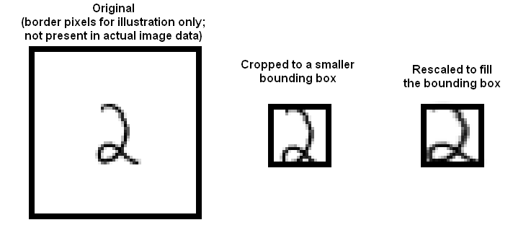

* + **Part 2A**

Investigate classifying MNIST using naive Bayes. Compute the accuracy values for the four combinations of Gaussian v. Bernoulli distributions and untouched images v. stretched bounding boxes. Please use 20 x 20 for your bounding box dimensions.

* + **Part 2B**Investigate classifying MNIST using a decision forest. For this you should use a library. For your forest construction, you should investigate four cases. Your cases are: number of trees = (10, 30) X maximum depth = (4, 16). You should compute your accuracy for each of the following cases: untouched raw pixels; stretched bounding box. This yields a total of 8 slightly different classifiers. Please use 20 x 20 for your bounding box dimensions.

**Submission:**

For part 1, you must submit a PDF file containing 3 numbers (the average accuracy over 10 folds for each part). For part 2, you will do two things. First, you will submit a screenshot showing your results for a private competition on Kaggle for each of the 12 cases (4 in A, 8 in B). These entries will be named "netid_x" for x 1:12. Each x should be as given in the table below.

|  |  |
| --- | --- |
| **x** | **Method** |
| 1 | Gaussian + untouched |
| 2 | Gaussian + stretched |
| 3 | Bernoulli + untouched |
| 4 | Bernoulli + stretched |
| 5 | 10 trees + 4 depth + untouched |
| 6 | 10 trees + 4 depth + stretched |
| 7 | 10 trees + 16 depth + untouched |
| 8 | 10 trees + 16 depth + stretched |
| 9 | 30 trees + 4 depth + untouched |
| 10 | 30 trees + 4 depth + stretched |
| 11 | 30 trees + 16 depth + untouched |
| 12 | 30 trees + 16 depth + stretched |

This means that my submission for 30 trees, 4 depth, and stretched would be **daf_10**. Graders will check you have submitted 12, and each is above a magic number. Here is an example screenshot (but yours should have 12 lines, not 3). Your submissions should be **sorted by name**.

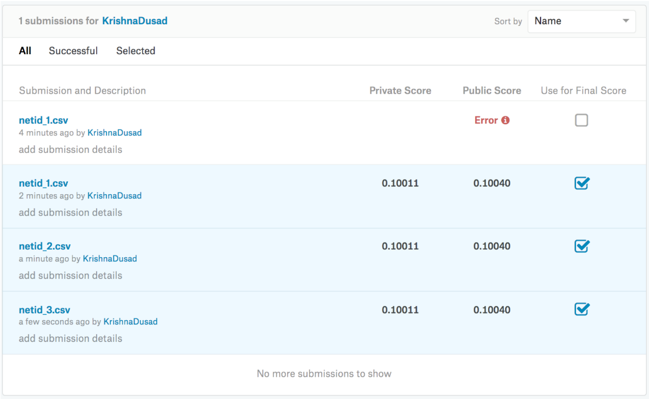

Second, you must submit a PDF file showing each submission value. Your file should also show, as images **and all on a single page**, the mean of the class distribution for each digit, for each of the four cases in 2A. This is a total of 40 digit images. The class means will be an image where each pixel is between 0 and 1. Please put all class means on a single page, four rows of 10 digits. You should use the convention that 1 is bright and 0 is dark.

**Further Submission Instructions**

We will be using Gradescope (pdf submissions) and compass (code submissions) for all your homework submissions this semester.

Compass will be set up and it might take a couple of days that you will see the course online.

The homework deadline still remains the same. Submit the pdf on Gradescope by Monday.

HW1 codes is due as soon as the compass is set up (you will be notified when the course on the compass is online).

**Submission on gradescope:**

Course code: MWV5GB

Sign up on Gradescope ONLY by using your Illinois email. We will NOT grade submissions that come from other email ids.

Please follow the following format for submitting your pdf on Gradescope.

* + Page 1: Three accuracies for 1A, 1B, 1D
  + Page 2: Screenshot of your code (ONLY ONE PAGE READABLE CODE that shows test-train split, probability calculations and evaluations)
  + Page 3:
    - Table of accuracies for all 12 cases.
    - Screenshot of Kaggle (READABLE SCREENSHOT)
    - Note: Both table and screenshot on the same page.
  + Page 4: 40 mean images (4x10 of part 2A)
  + Page 5: Screenshot of your code (ONLY ONE PAGE READABLE CODE that shows appropriate library used and evaluations)