# Homework 2

**Problem 1：**

1. **Screenshot of leaderboard accuracy**

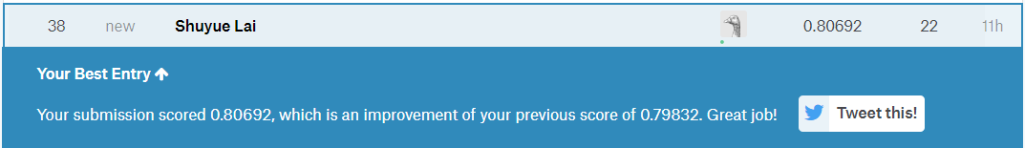

**Best test dataset accuracy: 80.692%**

1. **Plot of the accuracy:**

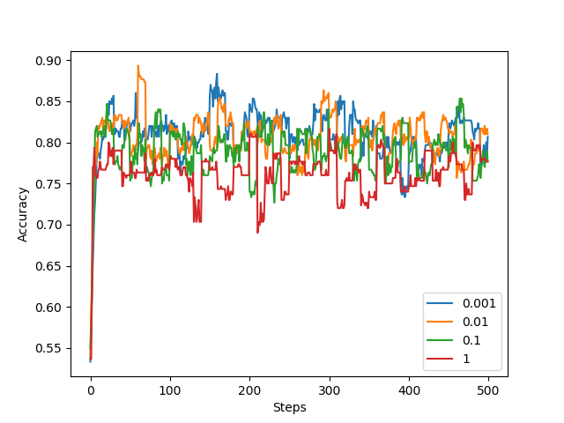

1. **Plot of the magnitude:**

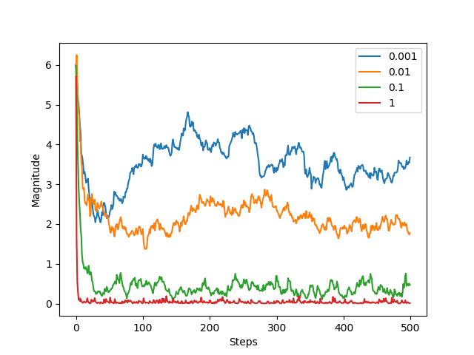

* 1. **Best value of the regularization constant:**

0.01. The best value means the regularization generate the highest accuracy of validation after training. In my project, I compare the result with each regularization constant and the result turns out to be 0.01.

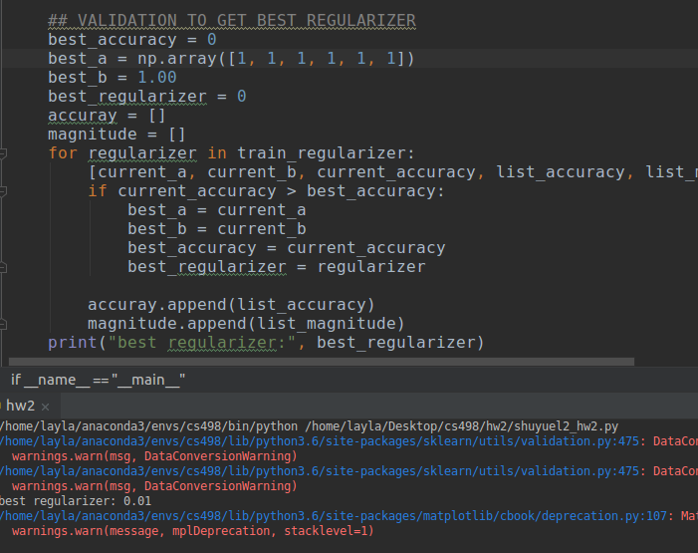

* 1. **Learning rate:**



The learning rate I chose is negative relate to the current Round of epoch. At the beginning, the learning rate should be large to speed up to train. After a while, the learning rate is closer to the best value. Thus, the learning rate should be smaller in case of miss the best value.

1. **Screenshot of code:**
   1. **Library:**

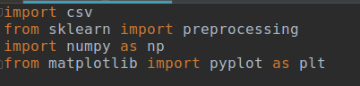

* 1. **Stochastic Gradient Descent:**

