# Homework 3

1. **Screenshot of 50 MSE numbers**

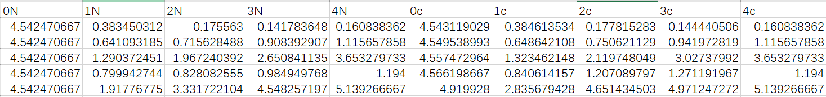

1. **Screenshot of code:**

