# Homework 4

1. **A single plot of error(use mean squared error) vs category(1-10)**

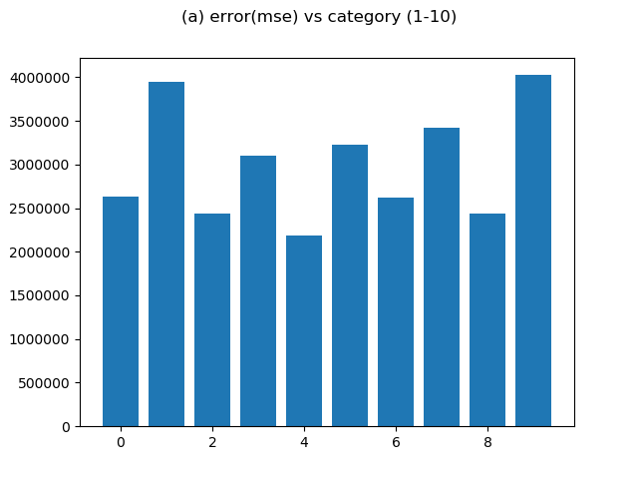

1. **A single 2D plot with the results of principal coordinate analysis applied to pairs of means:**

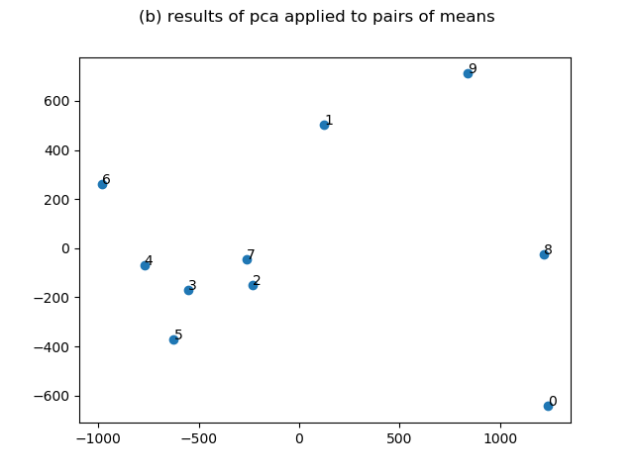

1. **Snapshot of code:**
   1. **Principal Component Computation**

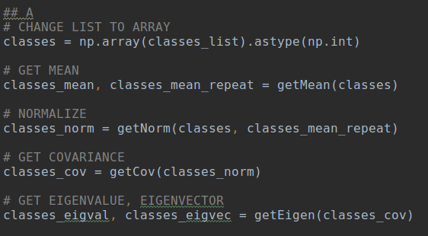

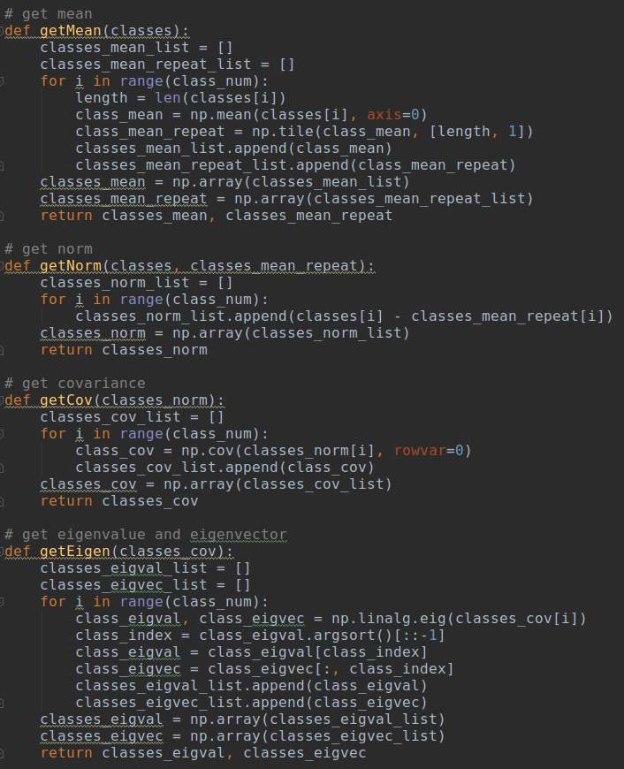

* 1. **Representing input image using the 20 principal components**

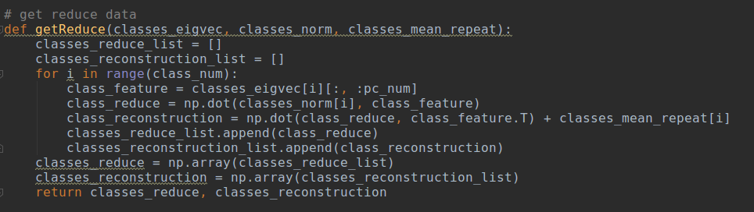

* 1. **Principal coordinate analysis on pairs of mean images**

