# Homework 8

1. **Image 1 ie trees ie 2cf92c40c3f3306321d789f7e9c12893.jpg - segmented into 10, 20 and 50 segments**
2. **10**

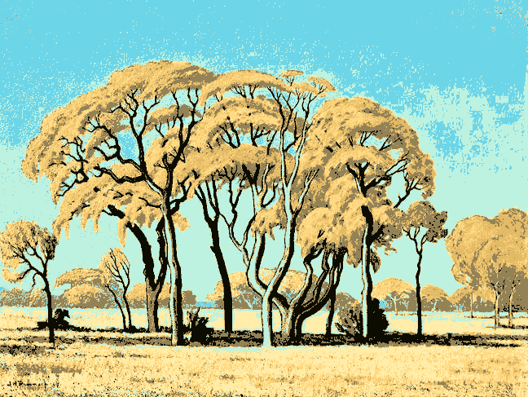

1. **20**

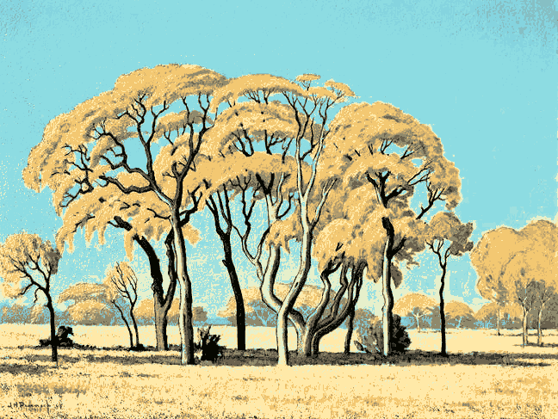

1. **50**

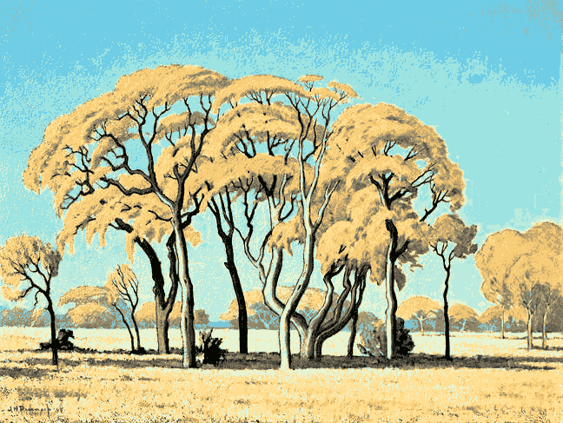

1. **Image 2 ie RobertMixed03.jpg segmented into 10,20,50 segments**
2. **10**

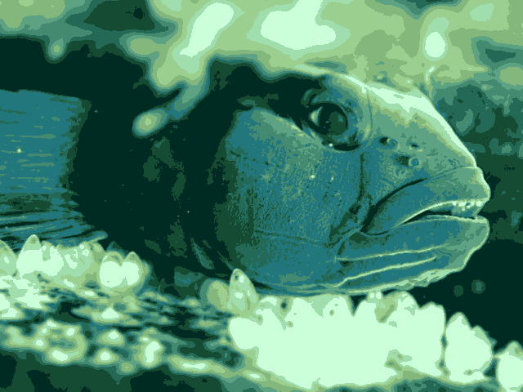

1. **20**

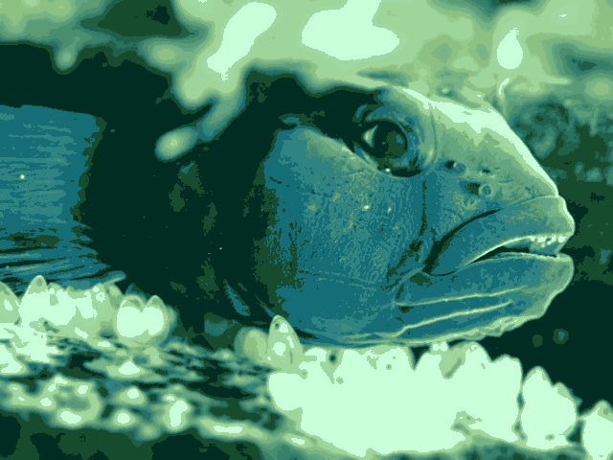

1. **50**

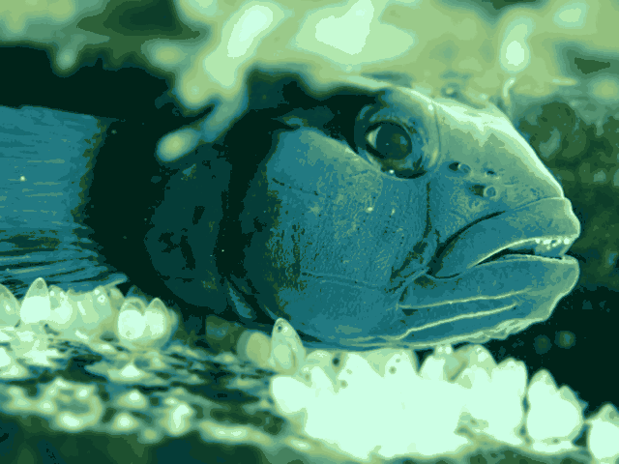

1. **Image 3 ie smallstrelitzia.jpg segmented into 10, 20 and 50 segments**
2. **10**

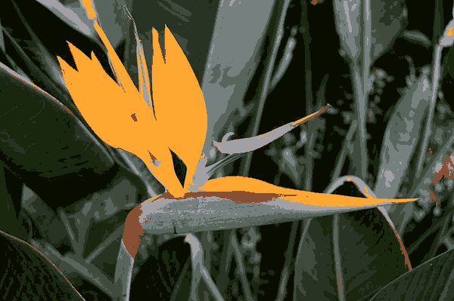

1. **20**

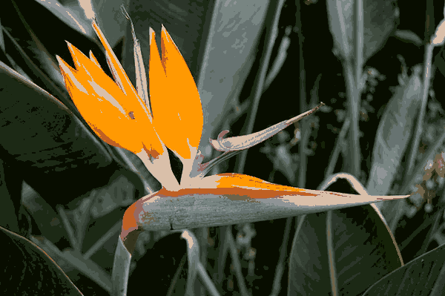

1. **50**

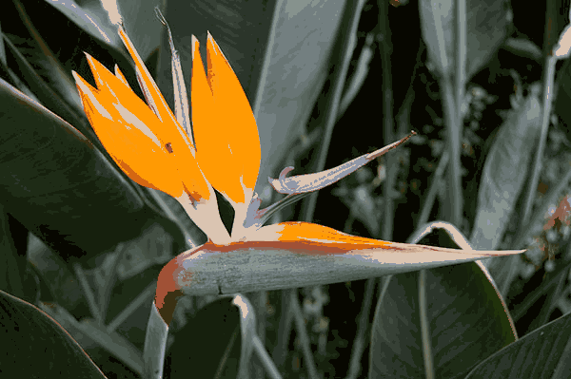

1. **Image 4 ie smallsunset.jpg segmented into 10,20 and 50 segments**
2. **10**

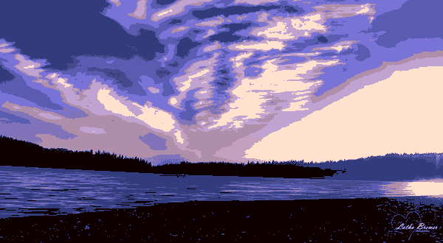

1. **20**

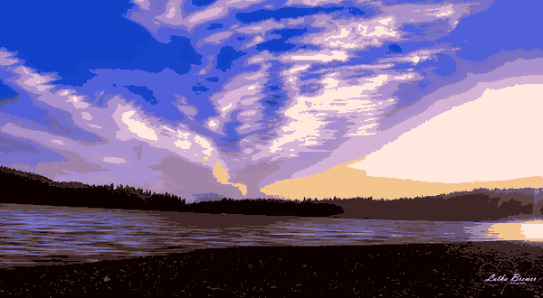

1. **50**

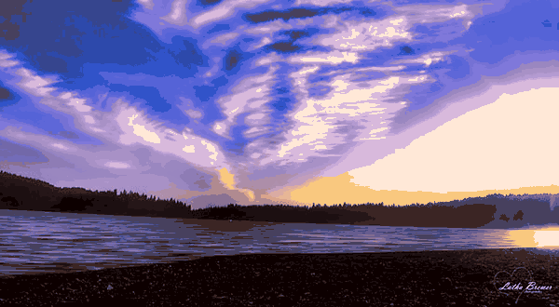

1. **Display of tree image with 20 segments with 5 different initial points**

 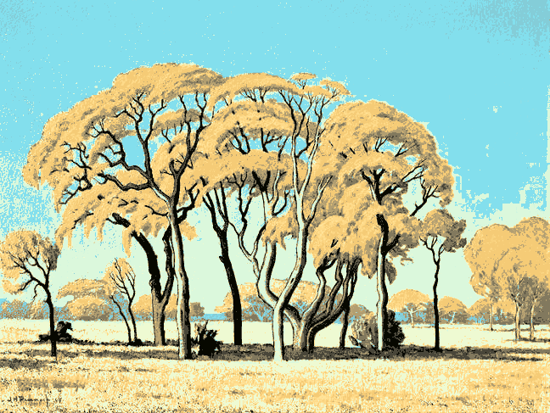

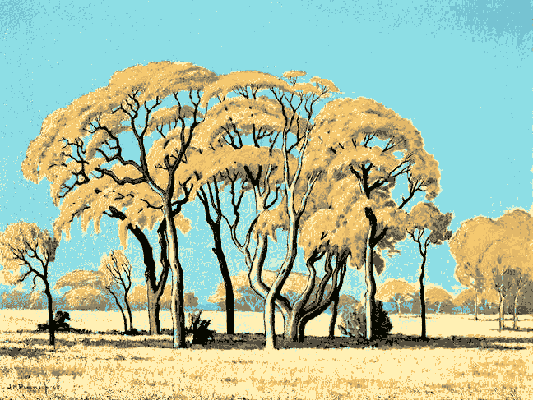 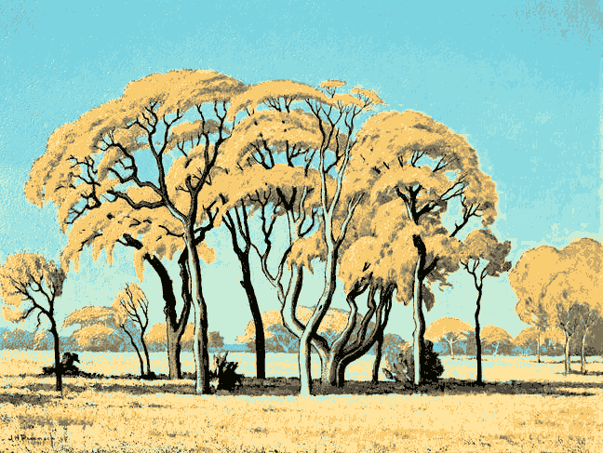

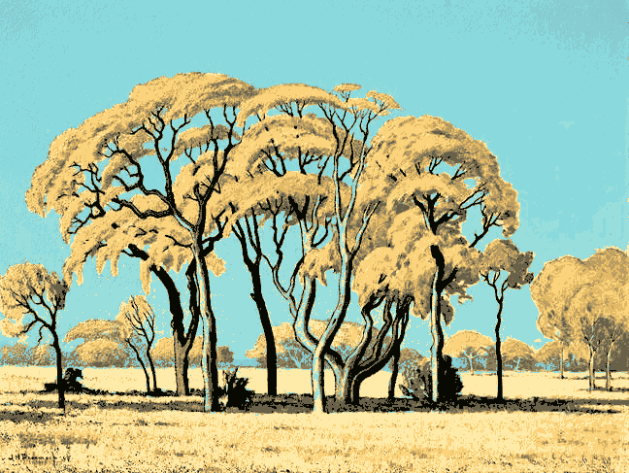

1. **Code snippets for EM initialisation, updates**

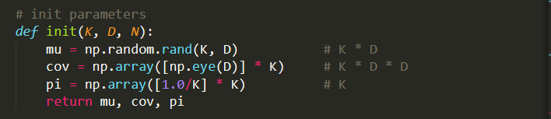

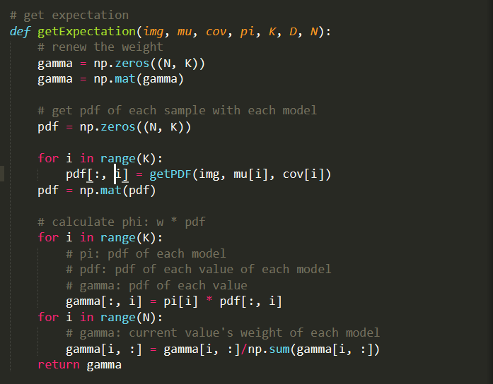

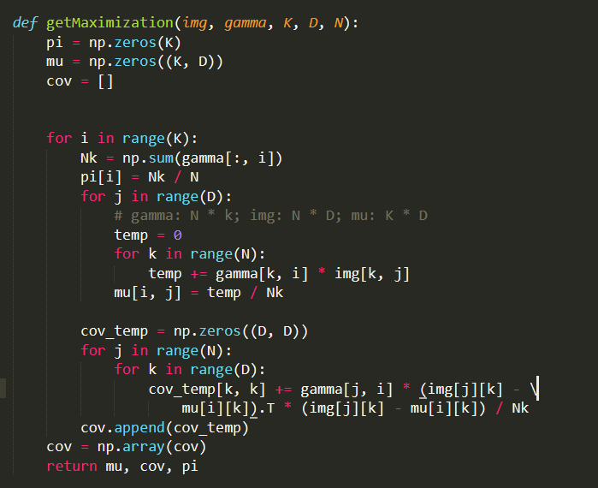

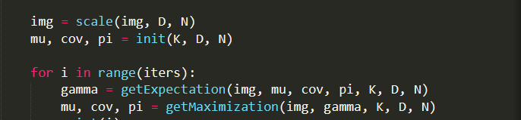

1. **Other relevant code (optional)**

