# Homework 9

1. **Average accuracy on the first 500 images**

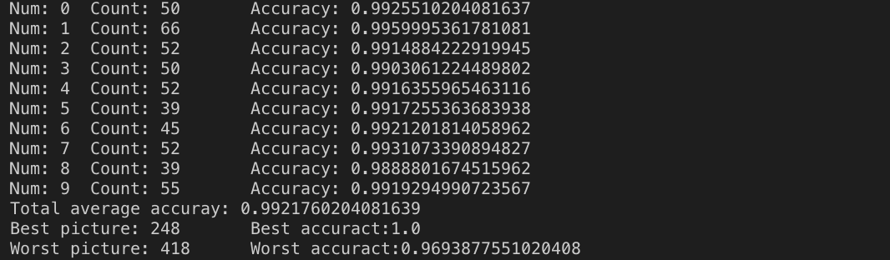

1. One set of sample images for each digit -- For each digit you should put up a row of a (sample image, noised version, denoised version via MFI). This means should have a total of 30 images (10 rows, 3 columns).

|  |  |  |
| --- | --- | --- |
| Sample Image | Noised Version | Denoise Version |
|  |  |  |
|  |  |  |
|  |  |  |
|  |  |  |
|  |  |  |
|  |  |  |
|  |  |  |
|  |  |  |
|  |  |  |
|  |  |  |

1. **Best reconstruction (original, noisy, denoised)\***

|  |  |  |
| --- | --- | --- |
| Sample Image | Noised Version | Denoise Version |
|  |  |  |

Accuracy: 0.994

1. **Worst reconstruction (original, noisy, denoised)\***

|  |  |  |
| --- | --- | --- |
| Sample Image | Noised Version | Denoise Version |
|  |  |  |

Accuracy: 0.954

1. **ROC curve:**

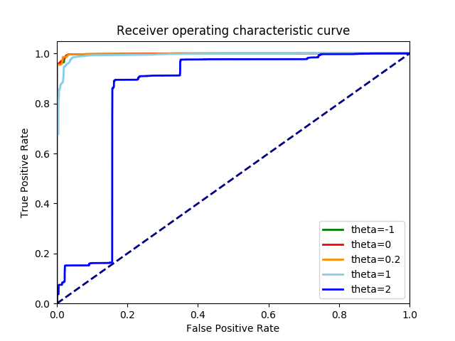

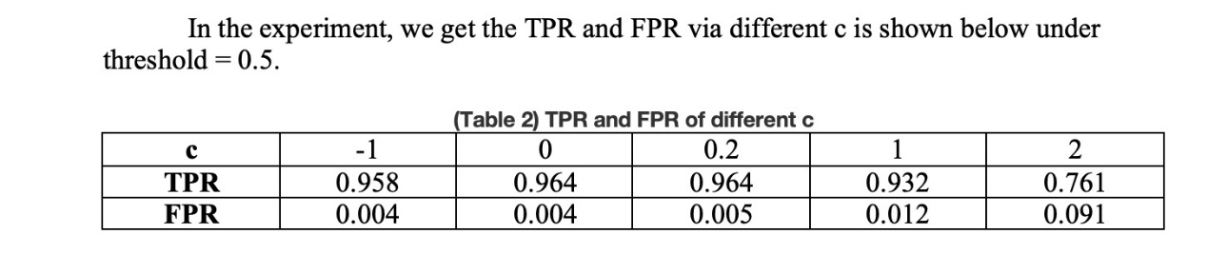

1. **Code Snippet**

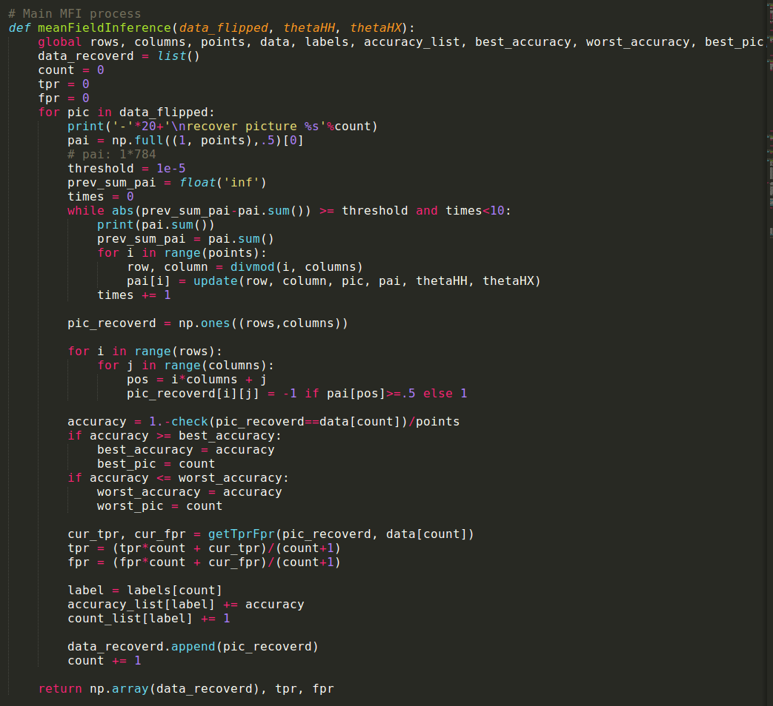

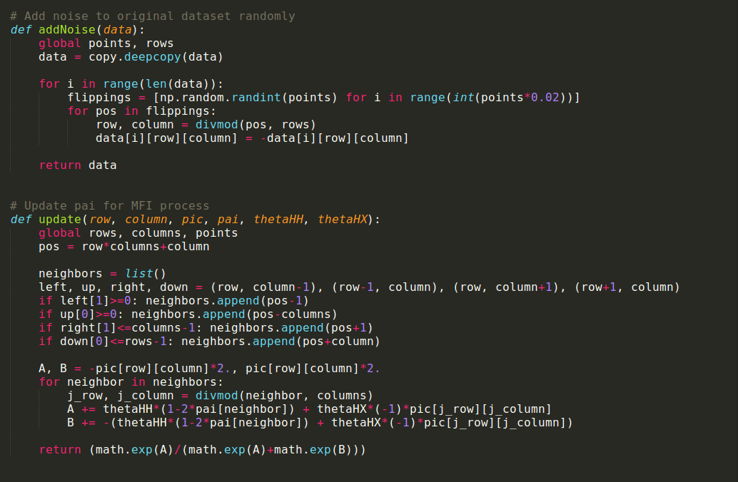

1. **Any other relevant code**

