TABLE OF CONTENTS
Abstract
1. Introduction
2. Problem Description and Analysis
3. Proposed Solution and Objectives
4. Computational Thinking
5. Algorithm Design
6. Pseudocode
7. Flowchart Explanation
8. Variables, Data Types and Logical Design
9. Functional Modules
10. Sample Scenarios and Expected Outputs
11. SDG Alignment
12. Open Source Software Justification
13. Digital Public Goods Justification
14. Community Impact and Sustainability
15. Limitations and Future Enhancements
16. Conclusion
References

ABSTRACT
Solid waste accumulation is a community problem that can contribute to blocked drains, unpleasant surroundings, flooding risks, pests and possible public-health concerns. In some communities, residents may not know where or how to report overflowing bins, illegal dumping or missed collection. This report presents the logical design of a Solid Waste Reporting System for a Sierra Leone community. The proposed system allows a resident to enter a name, location and description of a waste problem. It checks whether the required fields have been completed, asks the resident to correct incomplete information, and, when the entry is valid, creates a report identifier, assigns an initial status of “Pending”, records the intended collection-team assignment and displays the report details. The design uses variables, input and output, Boolean logic, a decision structure and a repetition structure for re-entering invalid information. It is presented through an algorithm, pseudocode, flowchart explanation, functional modules and sample outputs rather than a complete source-code application, in accordance with the assignment brief. The proposal aligns particularly with Sustainable Development Goal 11 on sustainable cities and communities and Goal 12 on responsible consumption and production. Open-source development and Digital Public Goods principles could support adaptation, transparency and wider community benefit.

1. INTRODUCTION
Communities in Sierra Leone face practical service-delivery challenges, including the reporting and management of solid waste. Residents may observe waste dumped in an open space, a full public bin, missed collection or waste obstructing a drain. If reports are made informally and are not recorded consistently, important details can be lost and residents may have difficulty following up.
Programming logic and design provides a structured way to plan a solution before software is built. The assignment brief requires a real-world community problem to be analysed and represented using an algorithm, pseudocode, flowchart, decision structures, repetition, modules and functions. It also asks students to explain the relationship of the proposal to Sustainable Development Goals (SDGs), Open Source Software and Digital Public Goods (DPGs).
This project therefore designs a simple Solid Waste Reporting System. It is a logical prototype, not a claim that reports are already being transmitted to a municipal authority or stored in a permanent database. The flowchart models validation and confirmation of a report; real deployment would require secure storage, staff access, communications and an agreed process for handling submitted reports.

2. PROBLEM DESCRIPTION AND ANALYSIS

2.1 The community problem
The problem addressed is the difficulty of submitting clear, complete and traceable reports about solid waste issues. Reports that omit the location or a useful description can be difficult for a collection team to investigate. A consistent reporting process can help organise information and make follow-up more manageable.

2.2 Who is affected?
- Residents who live near illegal dumping points, overflowing bins or uncollected waste.
- Waste collection teams and local service providers who need accurate locations and descriptions.
- Community leaders and local councils that need information to identify recurring waste problems.
- Businesses, schools, pedestrians and other people who use affected streets and public spaces.

2.3 Why the problem exists
Possible contributing factors include inconsistent reporting channels, incomplete descriptions, uncertainty about which service should receive a report, limited feedback to residents and the absence of a shared record. These are problem-analysis assumptions for the proposed design and should be validated through consultation with residents and the relevant local authority before implementation.

2.4 How the problem affects the community
Accumulated waste can make public spaces unpleasant, attract pests, obstruct drainage and increase the risk of localised flooding when drains are blocked. Burning or poorly handled waste can also create environmental and health concerns. The system cannot remove waste by itself; its purpose is to improve the quality and traceability of the information sent to the people responsible for collection and response.

3. PROPOSED SOLUTION AND OBJECTIVES
The proposed system provides a simple, guided reporting sequence. It asks the resident to enter a name, location and description of the waste issue. The program validates that these fields are not empty. If any required field is missing, it displays an error message and returns to the input steps. If all required fields are present, the system creates a report ID, assigns the status “Pending”, records the intended assignment to the collection team and displays the report details.

3.1 Objectives
- Collect the minimum information required to understand a waste problem.
- Reject incomplete submissions and guide the resident to correct them.
- Give each accepted report an identifier for reference.
- Set a consistent initial status of Pending.
- Indicate the collection team responsible for follow-up.
- Display a confirmation containing the report ID, status and assigned team.

3.2 Scope and assumptions
The current Flowgorithm design is a classroom logic model. It demonstrates data entry, validation, a decision, a repetition path and report confirmation. A fixed sample ID such as RPT001 is suitable only for illustrating output; a working system must generate IDs that do not repeat. Likewise, an output message such as “Report saved successfully” simulates saving. Permanent saving requires a database or another persistent storage mechanism, which is outside the current flowchart.

4. COMPUTATIONAL THINKING

4.1 Decomposition
The problem is divided into smaller tasks: collect resident details, validate the input, request correction when needed, create a report reference, set the status, assign a team and display confirmation.

4.2 Pattern recognition
Each report follows the same basic pattern: information is entered, required fields are checked, and a valid report receives a reference and initial status. Reusing this pattern makes the process easier to understand and maintain.

4.3 Abstraction
The prototype focuses on the information needed to submit a report. It does not model every operational detail, such as GPS coordinates, staff rosters, vehicle routing, photos, notifications or payment.

4.4 Algorithmic thinking
The steps are placed in a definite order. A Boolean condition decides whether the program proceeds or returns to data entry. This gives the process predictable behaviour for valid and invalid submissions.

5. ALGORITHM DESIGN
- Start the program.
- Declare the required variables and initialise any counters or ID-generation values.
- Display the welcome message for the Solid Waste Reporting System.
- Prompt the resident to enter their name and read residentName.
- Prompt the resident to enter the waste-problem location and read location.
- Prompt the resident to describe the waste problem and read wasteDescription.
- Check whether residentName, location and wasteDescription are all non-empty.
- If any required value is missing, display an invalid-entry message and return to the input steps.
- If all required values are present, generate a unique reportID.
- Assign reportStatus the string value “Pending”.
- Record assignedTeam as “Collection Team”.
- Display the report ID, report status and assigned team.
- End the program.

6. PSEUDOCODE
BEGIN
DECLARE residentName AS STRING
DECLARE location AS STRING
DECLARE wasteDescription AS STRING
DECLARE reportID AS STRING
DECLARE reportStatus AS STRING
DECLARE assignedTeam AS STRING
DECLARE isValid AS BOOLEAN
REPEAT
OUTPUT "Welcome to the Solid Waste Reporting System"
OUTPUT "Enter resident name:"
INPUT residentName
OUTPUT "Enter waste location:"
INPUT location
OUTPUT "Describe the waste problem:"
INPUT wasteDescription
isValid = (residentName != "" AND
location != "" AND
wasteDescription != "")
IF isValid = FALSE THEN
OUTPUT "Invalid entry. Please complete all required fields."
END IF
UNTIL isValid = TRUE
reportID = GenerateUniqueReportID()
reportStatus = "Pending"
assignedTeam = "Collection Team"
OUTPUT "Report saved successfully."
OUTPUT "Report ID: " + reportID
OUTPUT "Report Status: " + reportStatus
OUTPUT "Assigned Team: " + assignedTeam
END
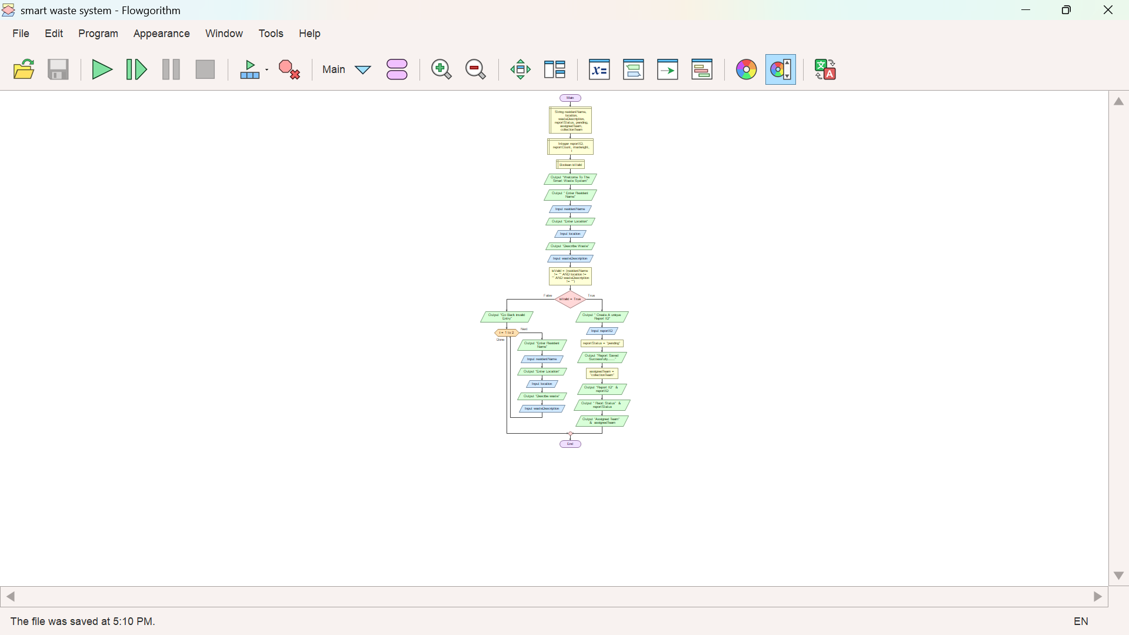

Implementation note: GenerateUniqueReportID() is a conceptual function in the pseudocode. If the Flowgorithm version does not yet implement functions, use a counter-based ID for the demonstration and explain its limitations. The variable reportStatus must receive the text value "Pending" with quotation marks; otherwise, Flowgorithm may interpret pending as an undeclared variable. The validation expression must be assigned to isValid before the decision checks isValid.

7. FLOWCHART EXPLANATION
The flowchart begins with Start and variable declarations, then displays a welcome message. Output symbols prompt the resident for a name, location and description, while Input symbols receive the values. An assignment/process step calculates isValid by checking that the required strings are not empty. The decision diamond tests isValid.
The False branch displays an invalid-entry message and loops back to the input steps so the resident can correct the missing information. The True branch proceeds to report creation, status assignment and team assignment. Output symbols display confirmation and report details before the flow reaches End. This structure demonstrates sequence, selection and repetition.

7.1 flowchart sequence
- Start
- Declare variables
- Display welcome message
- Input resident name
- Input location
- Input waste description
- Assign isValid = (residentName != "" AND location != "" AND wasteDescription != "")
- Decision: isValid?
- False → Display error → Return to input
- True → Generate report ID
- Assign reportStatus = "Pending"
- Assign assignedTeam = "Collection Team"
- Display report saved message and report details
- END
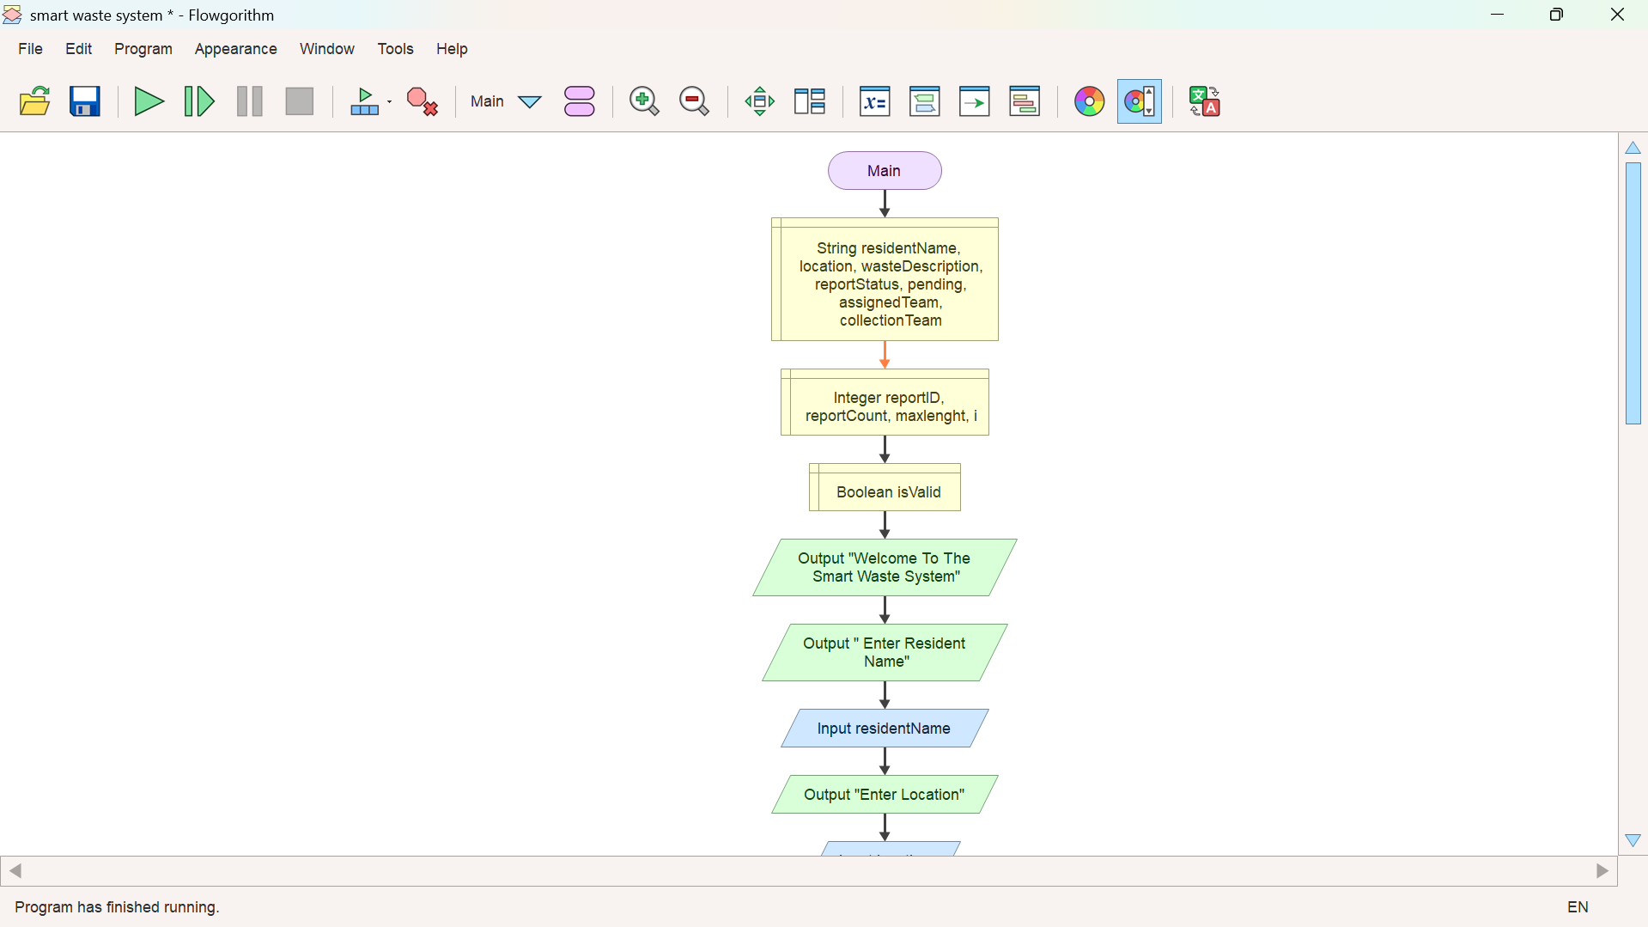
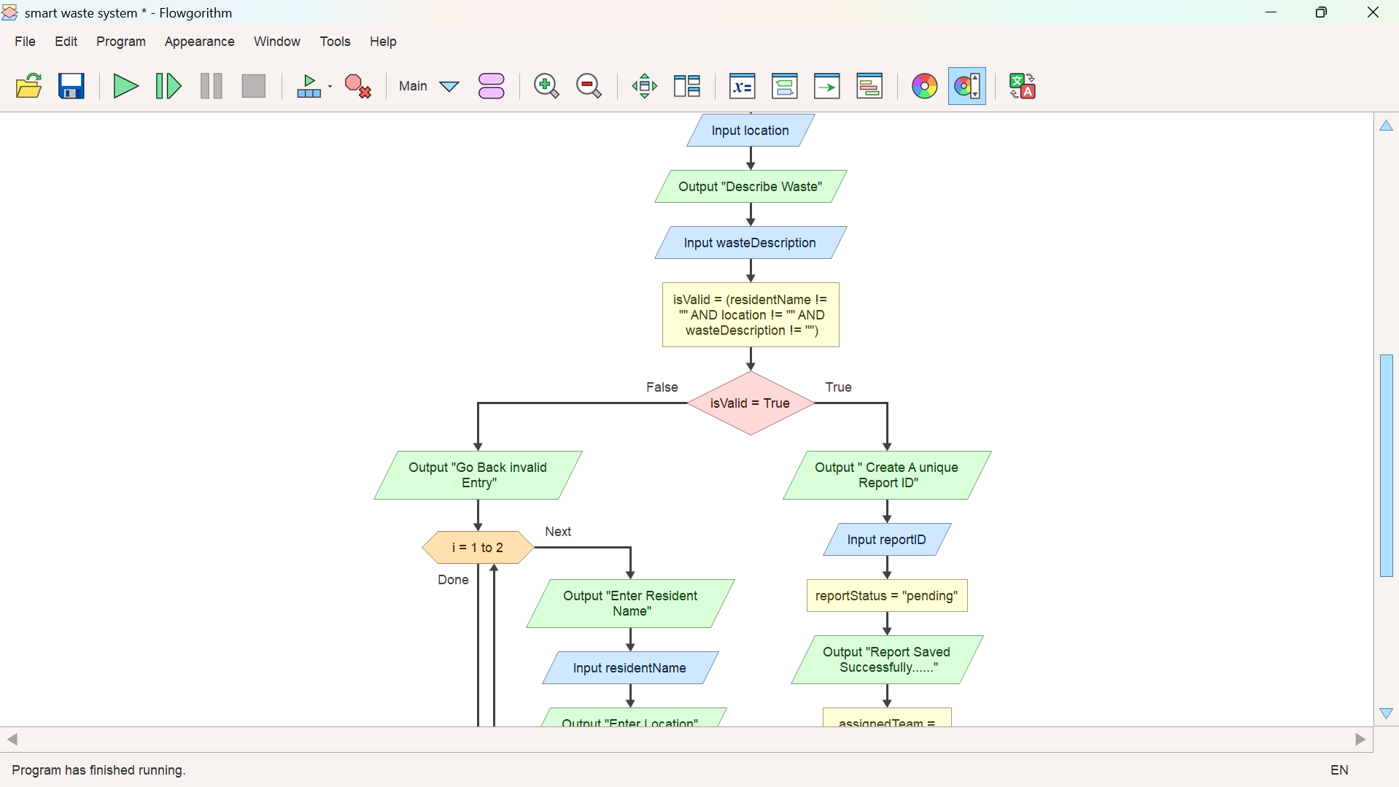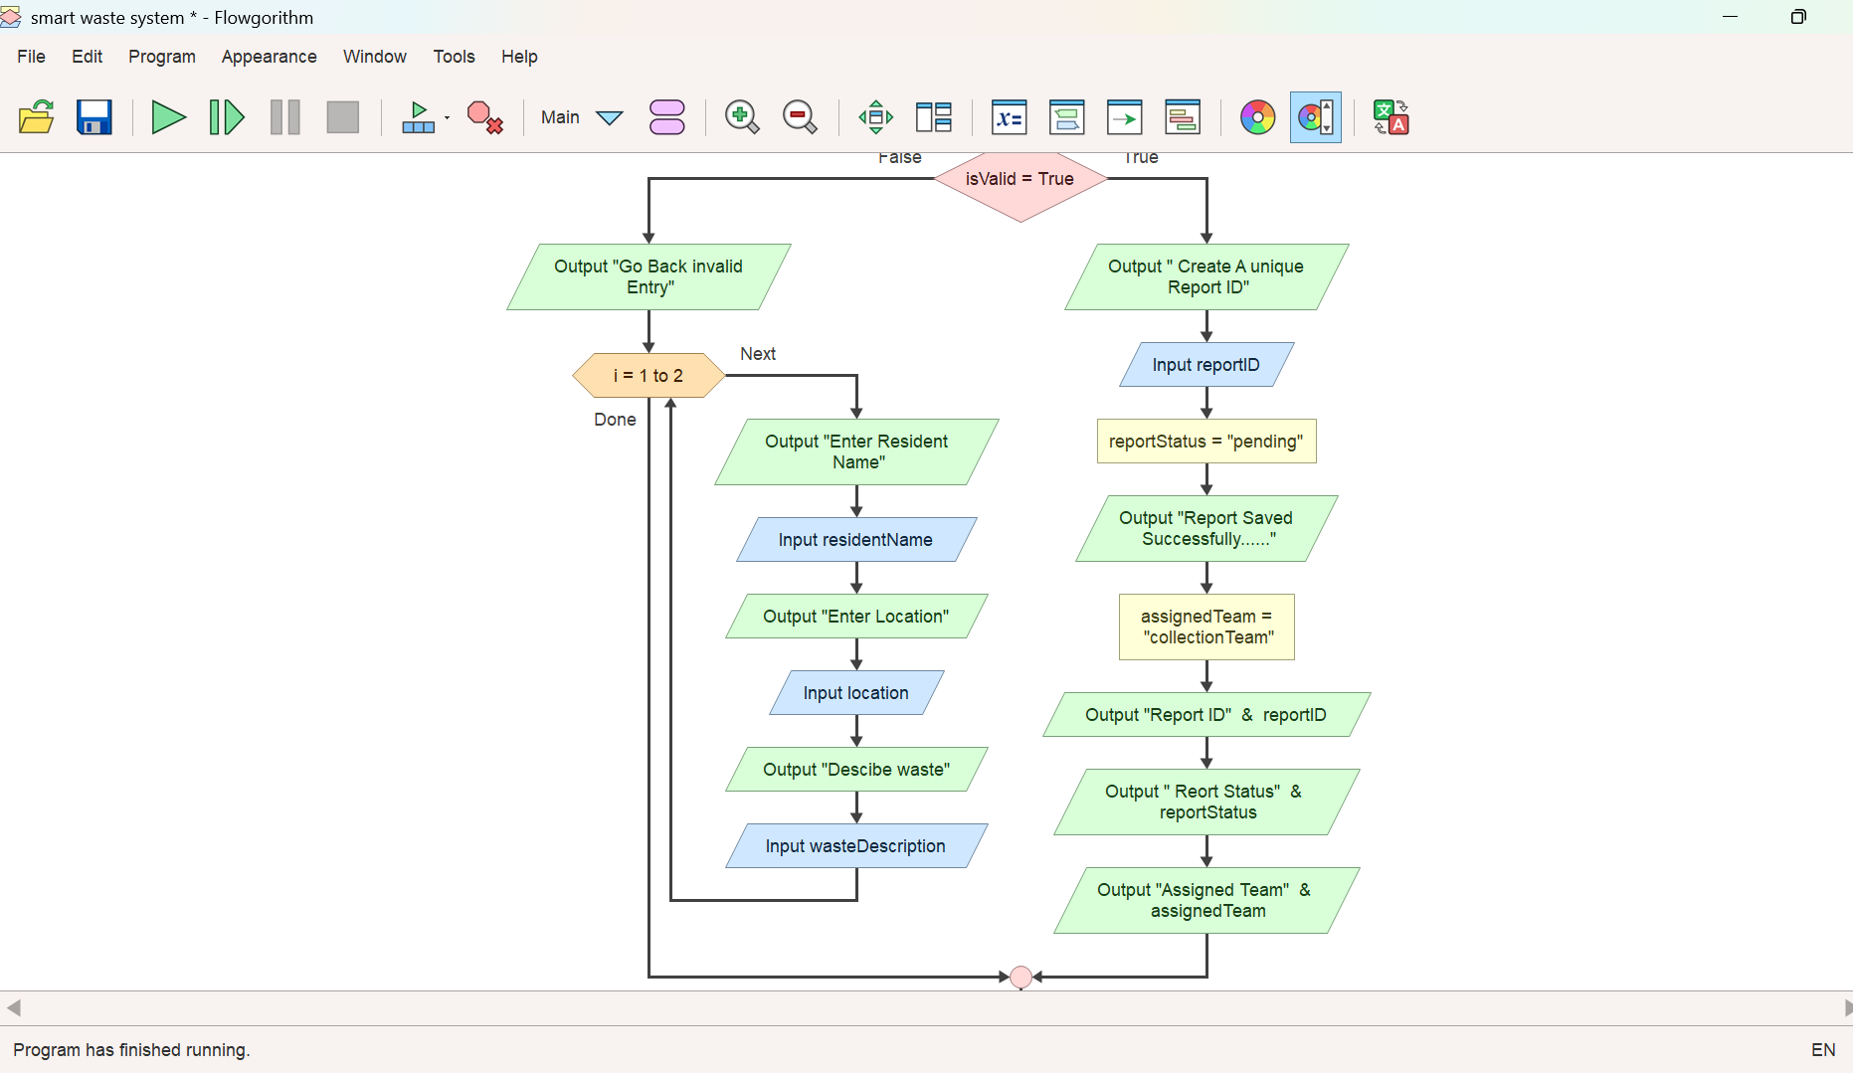

8. VARIABLES, DATA TYPES AND LOGICAL DESIGN
Variable | Data type | Purpose
residentName | String | Stores the resident's name.
location | String | Stores where the waste issue is located.
wasteDescription | String | Stores details about the waste problem.
isValid | Boolean | Stores the result of the input validation condition.
reportID | String | Stores the identifier assigned to the report.
reportStatus | String | Stores the report's current status, initially Pending.
assignedTeam | String | Stores the team intended to handle the report.

8.1 Decision structure
The decision uses the Boolean expression: residentName is not empty AND location is not empty AND wasteDescription is not empty. The AND operator means all three conditions must be true. If one or more conditions are false, the report is rejected for correction.

8.2 Repetition structure
The repeat-and-validate pattern continues until all required fields are completed. In the current visual flowchart, ensure that the False branch actually returns to the input symbols and that the loop can exit only when isValid is True. Initialise isValid by assigning the validation expression before reading it in the decision diamond.

8.3 Modular design and functions
The process can be divided into modules: CollectReportDetails, ValidateReportDetails, GenerateUniqueReportID, SetInitialStatus, AssignCollectionTeam and DisplayReportSummary. In a fuller design, each module would have one clear responsibility. The ID generator should prevent duplicates, while validation should return a Boolean result.

9. FUNCTIONAL MODULES
CollectReportDetails: Prompts for and receives the resident's name, location and waste description.
ValidateReportDetails: Checks required values and returns True only when all fields are complete.
GenerateUniqueReportID: Creates a report identifier that is not already in use.
SetInitialStatus: Sets the new report's status to Pending.
AssignCollectionTeam: Records the intended collection team for follow-up.
DisplayReportSummary: Shows the report ID, status and assigned team to the resident.

10. SAMPLE SCENARIOS AND EXPECTED OUTPUTS
Scenario | Input | Expected system behaviour | Result
Valid report | Name, location and description supplied | Generate ID, set Pending, assign team and display summary | Accepted
Missing location | Name and description supplied; location blank | Display error and request the missing information again | Rejected until corrected
Missing description | Name and location supplied; description blank | Display error and return to input | Rejected until corrected
All fields corrected | Resident re-enters complete details | Validation becomes True and processing continues | Accepted

10.1 Example output for a valid report
Welcome to the Solid Waste Reporting System
Report saved successfully.
Report ID: RPT-2026-0001
Report Status: Pending
Assigned Team: Collection Team

10.2 Example output for an invalid report
Invalid entry. Please complete all required fields.
Enter resident name:
Enter waste location:
Describe the waste problem:

11. SUSTAINABLE DEVELOPMENT GOAL ALIGNMENT

11.1 SDG 11: Sustainable Cities and Communities
The project supports SDG 11 in principle by helping residents communicate local waste concerns in a structured way. Better reporting can help local service providers identify problem locations and organise responses. The system contributes to information and coordination; it does not itself guarantee collection or improved municipal services.

11.2 SDG 12: Responsible Consumption and Production
The system can also support SDG 12 by making it easier to report dumping and waste-management problems. Over time, aggregated reports could help communities identify recurring issues and plan awareness activities or improvements to collection. This benefit depends on accurate data, responsible handling and action by the relevant authorities.

12. OPEN SOURCE SOFTWARE JUSTIFICATION
The proposed system could be developed as open-source software, with its source code and documentation made available under a clearly stated open-source licence. This would allow qualified developers, students, community organisations and local authorities to inspect the design, identify defects, adapt forms to local needs and contribute improvements. Open collaboration can reduce dependence on a single developer and support learning and maintenance.
For Sierra Leone, potential benefits include local-language adaptation, low-cost experimentation, reuse by different communities and opportunities for ICT students to contribute. Open source does not mean that personal information should be public. Any deployed version must protect resident details, restrict staff access, minimise collected data and document how reports are used. Community contributions should be reviewed and tested before release. Having my personal and professional GitHub @ : abdulkarimmarrah075-wq · he/him

13. DIGITAL PUBLIC GOODS JUSTIFICATION
A Digital Public Good is a digital solution that can contribute to sustainable development and meet relevant openness, privacy, security and other safeguards. The Solid Waste Reporting System could move towards this model if it were made reusable by the public, documented clearly, licensed openly and designed to protect users. It would also need governance and maintenance arrangements so that public benefit is sustained after the initial project.
Accessibility could be improved through a mobile-friendly interface, plain language, low-bandwidth operation, support for local languages and a non-digital reporting alternative for residents without internet access. The project should not publish names, phone numbers or precise personal information in a public report feed. Public summaries should use aggregated or appropriately anonymised data.

14. COMMUNITY IMPACT AND SUSTAINABILITY

14.1 Expected impact
- Residents have a clearer and more consistent way to describe waste problems.
- Reports include a location and description that can help a collection team investigate.
- A report ID provides a reference for follow-up and reduces confusion between reports.
- Local authorities may use aggregated report patterns to identify recurring waste hotspots.
- The system can support community awareness and more organised communication about waste management.

14.2 Beneficiaries
Potential beneficiaries include residents, community leaders, waste collection teams, local councils, schools, businesses and organisations involved in environmental health. Benefits will depend on whether the reporting channel is accessible and whether a responsible team reviews and acts on submissions.

14.3 Long-term sustainability
Sustainability requires an agreed owner, a clear response procedure, staff training, regular maintenance, secure data storage, backup procedures and a way to measure performance. Useful indicators could include the number of reports received, the proportion of reports with complete details, time to acknowledge a report, time to resolve an issue and the number of repeated reports from the same location. These indicators should be collected only where there is a practical and lawful reason to do so.

15. LIMITATIONS AND FUTURE ENHANCEMENTS
The present flowchart is a logical prototype. It does not demonstrate a connected database, real staff dispatch, GPS mapping, image upload, notifications or verified resolution of a waste problem. A message that says a report was saved is not proof of persistent storage unless a storage operation is implemented.
- Connect the reporting process to a secure database with backup and recovery.
- Generate unique report IDs using a counter, timestamp-based method or database-generated key.
- Add optional photo and GPS-location support, with clear consent and privacy safeguards.
- Provide staff authentication and a dashboard for reviewing, assigning and updating reports.
- Add statuses such as Pending, Assigned, In Progress and Resolved, with an audit trail.
- Send confirmation or status notifications where the resident has consented and contact details are necessary.
- Support local languages, accessible design and low-bandwidth devices.
- Test the system with residents and local waste-management staff before public deployment.

16. CONCLUSION
This report has presented a logical design for a Solid Waste Reporting System intended to address a practical community challenge in Sierra Leone. The design collects a resident's name, the location of the waste issue and a description, validates the required fields, repeats input when information is incomplete, and processes a valid report by generating an identifier, setting the initial status to Pending, assigning the intended collection team and displaying a summary. The design demonstrates computational thinking, variables, data types, Boolean logic, sequence, selection, repetition and modular decomposition.
The proposal is relevant to SDG 11 and SDG 12 because structured reporting can support better coordination and responsible waste management. Open-source development and Digital Public Goods principles could make the system easier to adapt and share, provided privacy, security, accessibility and governance are addressed. The current design is a prototype rather than a fully deployed service. Its success would depend on accurate reporting, reliable storage, responsible staff follow-up and cooperation between residents and the relevant local authorities.

REFERENCES
Open Source Initiative. (n.d.). The Open Source Definition. https://opensource.org/osd
United Nations. (n.d.). Goal 11: Make cities and human settlements inclusive, safe, resilient and sustainable. https://sdgs.un.org/goals/goal11
United Nations. (n.d.). Goal 12: Ensure sustainable consumption and production patterns. https://sdgs.un.org/goals/goal12
United Nations Development Programme. (n.d.). Digital Public Goods. https://www.undp.org/digital/digital-public-goods
Digital Public Goods Alliance. (n.d.). Digital Public Goods Standard. https://digitalpublicgoods.net/standard/
Limkokwing University of Creative Technology, Sierra Leone. (2026). PROG101 Principles of Programming Logic and Design: Designing Logical Solutions for Sierra Leone Community Challenges [Assignment brief]. Department of Information and Communication Technology.

