|  |  |
| --- | --- |
| App Name | Wordly |
| Developer Name | Abdul Mujeeb Khan |
| For Company | Singtel |
| Tech Stack | React Native, Typescript, JSON |
| React Version | 18.2.0 |
| React Native Version | 0.71.1 |
| Typescript Version | 4.8.4 |
| Android Download link | <https://install.appcenter.ms/users/abdulkhn8-gmail.com/apps/wordly-android/distribution_groups/testers> |

1. **Code Structure**

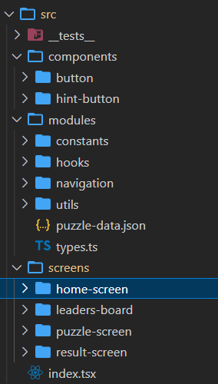

* 1. **Components**

It contains reusable components.

* 1. **Modules -> Constants**

It contains all type of constants being used all over the app

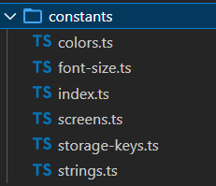

* 1. **Modules -> Hooks**

It contains custom hooks.

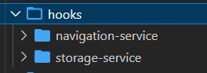

* 1. **Modules -> Navigation**

It contains navigation file where routing is specified.

* 1. **Modules -> Utils**

It contains all helper functions

* 1. **Modules -> puzzle-data.json**

It has game data.

* 1. **Modules -> types.ts**

It contains game related types.

* 1. **Screens**

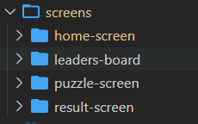

1. **Home-Screen**

This is the landing screen, where user selects puzzle type and starts the game

1. **Leaders-Board**

This screen shows all time high score

1. **Puzzle-Screen**

This screen is one where user will see a question and shuffled answer’s letters in a block, by tapping on that user can rearrange letters in correct form to win.

1. **Result-screen**

This page shows result of the game play.

1. **App Flow**

**2.1**

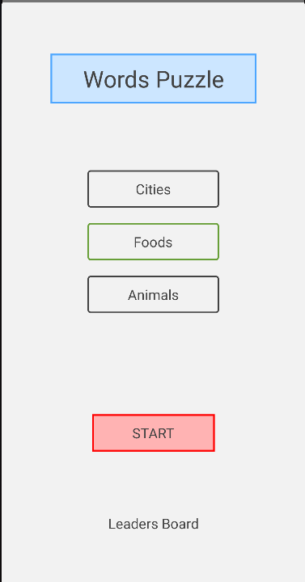

**Step 1.** Select type of **Puzzle**

**Step 2.** After selection **Start** button will appear, now press it to start the game

Note: - By pressing Leader Board user can navigate to leader board Screen.

**2.2 Puzzle screen**

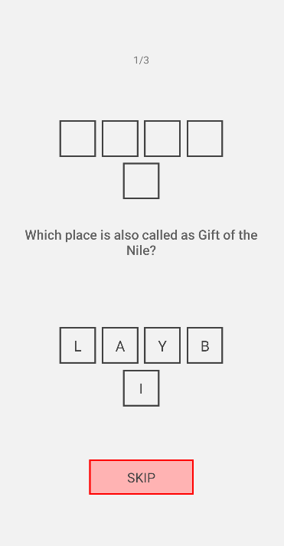

Here user can read the question and will see the answer’s letter in random order as hints.

By tapping on each hint, it will start appearing on above empty blocks.

Just like below -

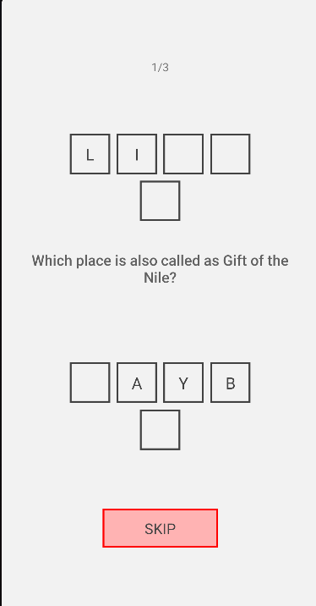

# If user taps on selected letters, it will come back to its original place. It is helpful if user wants to change that selected letter.

# If user does not want to play this puzzle, he can skip to next by pressing Skip button.

# If user is able to rearrange letter in correct order, then block will turn green and Next button will appear. And on pressing this he can go to navigate to next question.

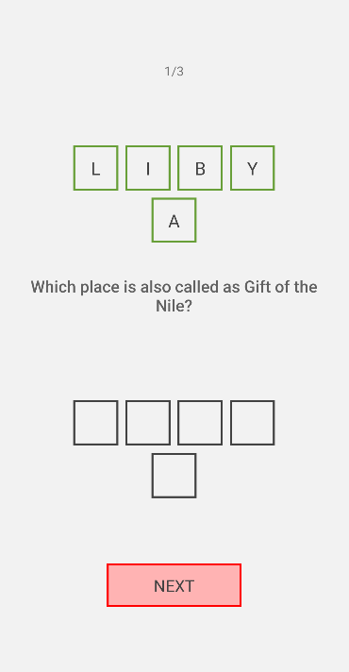

**2.3** After last question user will be redirected to result page.

Here he will see his score.

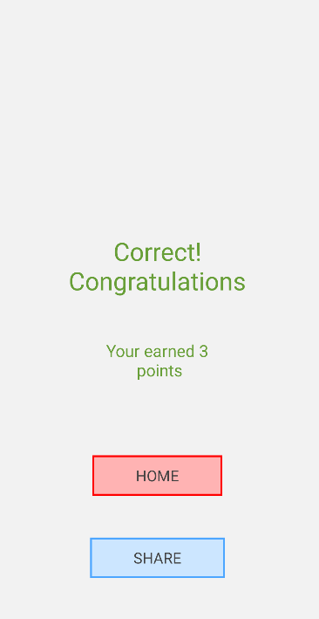

Here by pressing **Home**, he will return to home screen and by Pressing **Share** user can share his result.

**2.4** **Leader Board**, here user can see his all-time high score

