A Web-Based System for Coordinating Public and Private Waste Collection in Nairobi

152386
191224

ICS 3 Group: C Supervisor: Allan Vikiru

An Informatics and Computer Science Project Proposal Submitted to the School of Computing and Engineering Sciences (SCES) in Partial Fulfilment of the Requirements for the Award of a Bachelor of Science Degree in Informatics and Computer Sciences

School of Computing and Engineering Sciences Strathmore University
Nairobi, Kenya

May 2026

Declaration
We declare that this project proposal is our original work and has not been submitted to any other university or institution for the award of a Degree in Informatics and Computer Sciences. To the best of our knowledge and belief, the research proposal contains no material previously published or written by another person except where due reference is made in the proposal itself.

Students’ Signatures:

Sign: Date:

Sign: Date:

Supervisor’s Approval Signature:

Sign: Date:

Abstract
Nairobi generates over 2,400 tonnes of solid waste daily, and a significant share never reaches an authorised disposal site. Collection is split between the Nairobi City County Government and registered private collectors — but without a shared platform, schedules get missed, complaints go unresolved, and the county has no reliable way to track who is actually doing the work. Illegal dumping and roadside burning follow.
This project builds a web-based system to fix that coordination gap. County officials, registered collectors, and residents work from a single platform. The core functions are collector registration and licence verification, digital scheduling and route management, a resident complaint portal, and automated performance reporting for administrators. The system is developed using Object-Oriented Analysis and Design and an Incremental model, which allows for structured, testable delivery across sequential build phases.
The technical stack is React.js on the front end, Node.js with Express.js on the back end, and PostgreSQL for storage, organised under a Model–View–Controller architecture. Version control runs through GitHub. Modules cover authentication, collector management, scheduling and tracking, citizen reporting, and administrative reporting.
The practical aim is straightforward: better collection coverage, less illegal dumping, and enough reliable data for county authorities to enforce compliance with the Sustainable Waste Management Act, No. 31 of 2022

Acknowledgement
We are grateful to our supervisor, Allan Vikiru, for his guidance, feedback, and patience throughout the development of this proposal. His practical insights helped us sharpen the scope and direction at every stage.
We also thank the School of Computing and Engineering Sciences at Strathmore University for the academic foundation and resources that made this work possible. We thank our colleagues and peers who offered perspectives and critical engagement along the way.
Finally, we thank our families for their support throughout.

Table of Contents

Contents
Declaration ii
Abstract iii
Acknowledgement iv
Table of Contents v
List of Figures viii
List of Tables ix
Abbreviations x
Chapter 1: Introduction 1
1.1 Background 1
1.2 Problem Statement 2
1.3 Objectives 3
1.3.1 General Objective 3
1.3.2 Specific Objectives 3
1.3.3 Research Questions 3
1.4 Justification 4
1.5 Scope 4
1.6 Limitations 4
1.7 Delimitations 6
Chapter 2: Literature Review 7
2.1 Introduction 7
2.2 Solid Waste Management in Nairobi 7
2.3 Web-Based Municipal Coordination Platforms 9
2.4 Challenges in Current Waste Collection Coordination 9
2.5 Related Applications 10
2.5.1 GIS-Based Waste Management Applications 10
2.5.2 Integrated Smart City Management Platforms 10
2.5.3 Citizen Incident Reporting Portals 11
2.6 Gaps in Current Approaches and Related Applications 11
2.7 Technologies Related to the Study 12
2.7.1 Model-View-Controller (MVC) Architecture 12
2.7.2 Relational Database Management Systems (RDBMS) 12
2.8 Conceptual Framework 12
Chapter 3: Methodology 15
3.1 Introduction 15
3.1.1 Object-Oriented Analysis and Design 15
3.2 System Methodology 15
3.2.1 Communication 16
3.2.2 Planning 16
3.2.3 Modelling (Analysis and Design) 16
3.2.4 Construction (Code and Test) 17
3.2.5 Deployment (Delivery and Feedback) 17
3.3 System Analysis 18
3.3.1 Use Case Diagram 18
3.3.2 Sequence Diagram 19
3.3.3 Activity Diagram 19
3.4 System Design 19
3.4.1 Entity Relationship Diagram 19
3.4.2 Wireframes 20
3.4.3 System Architecture 20
3.5 System Development Tools and Technologies 20
3.5.1 React.js 20
3.5.2 Node.js with Express.js 21
3.5.3 PostgreSQL 21
3.5.4 Visual Studio Code 21
3.5.5 GitHub 21
3.5.6 Postman 22
3.6 Deliverables 22
3.6.1 System Proposal 22
3.6.2 Authentication Module 22
3.6.3 Collector Management Module 22
3.6.4 Scheduling and Tracking Module 23
3.6.5 Citizen Reporting Module 23
3.6.6 Administrative Reporting Module 23
Chapter 4: System Analysis and Design 24
4.1 Introduction 24
4.2 Requirements Analysis 24
4.2.1 Functional Requirements 24
4.2.2 Non-Functional Requirements 26
4.3 System Analysis 27
4.3.1 Use Case Diagram 27
4.3.2 Entity Relationship Diagram 28
4.3.3 Activity Diagram 29
4.3.4 Sequence Diagram 31
4.4 System Design 33
4.4.1 Database Schema 33
4.4.2 Class Diagram 35
4.4.3 System Architecture 36
4.4.4 System Wireframes 36
Chapter 5: System Implementation and Testing 41
5.1 Introduction 41
5.2 Description of the Implementation Environment 41
5.2.1 Hardware Specifications 41
5.2.2 Software Specifications 41
5.3 System Implementation 42
5.3.1 Authentication Module 42
5.3.2 Collector Management Module 43
5.3.3 Scheduling and Tracking Module 43
5.3.4 Citizen Reporting Module 43
5.3.5 Administrative Reporting Module 44
5.4 System Testing 44
5.4.1 Testing Paradigm 44
5.4.2 Testing Results 45
Chapter 6: Conclusions, Recommendations and Future Works 49
6.1 Conclusion 49
6.2 Recommendations 49
6.3 Future Works 50
References 51
Appendix 53
Appendix A: Gantt Chart 53

List of Figures
Figure 2.1: Conceptual Framework for the Web-Based Waste Collection Coordination System 12
Figure 3.1: Steps in the Incremental Development Model 16
Figure 4.1: Use Case Diagram 27
Figure 4.2: Entity Relationship Diagram 28
Figure 4.3: Activity Diagram for the Waste Collection Cycle 29
Figure 4.4: Sequence Diagram for the Complaint Submission and Routing Workflow 31
Figure 4.5: Sequence Diagram for the Schedule Assignment Workflow 32
Figure 4.6: Database Schema 33
Figure 4.7: Class Diagram 34
Figure 4.8: System Architecture Diagram 35
Figure 4.9: Login and Registration Screen Wireframe 36
Figure 4.10: County Official Administrative Dashboard Wireframe 37
Figure 4.11: Collector Route Management Interface Wireframe 38
Figure 4.12: Resident Portal Wireframe 39

List of Tables
Table 4.1: Functional Requirements of the Proposed System 23

Abbreviations

ACID – Atomicity, Consistency, Isolation, and Durability
BICS – Bachelor of Informatics and Computer Science
ERD – Entity Relationship Diagram
GIS – Geographic Information System
IoT – Internet of Things
JICA – Japan International Cooperation Agency
MVC – Model-View-Controller
NCCG – Nairobi City County Government
NEMA – National Environment Management Authority
OOAD – Object-Oriented Analysis and Design
RDBMS – Relational Database Management System
SCES – School of Computing and Engineering Sciences
SQL – Structured Query Language
UML – Unified Modelling Language
UNEP – United Nations Environment Programme

Chapter 1: Introduction

1.1 Background
Rapid urbanisation across sub-Saharan Africa has strained nearly every municipal service, and waste management has taken some of the hardest hits. Global municipal solid waste generation is projected to nearly double from 2.1 billion tonnes per year to 3.8 billion tonnes by 2050 (United Nations Environment Programme [UNEP], 2024). Nairobi is a clear example: population growth has consistently outpaced the infrastructure meant to support it.
Nairobi produces an estimated 2,400 tonnes of solid waste per day, yet only 38 percent of that volume is collected and transported to authorised disposal sites; less than 10 percent is recycled (JICA, 2010). The rest ends up on roadsides, in drainage channels, and at illegal dump sites. The Dandora dumpsite, officially declared full in 1996 yet still receiving waste daily, shows just how wide that gap has grown (Climate and Clean Air Coalition [CCAC], 2022).
Under Kenya’s Constitution and the Sustainable Waste Management Act, No. 31 of 2022, county governments bear constitutional responsibility for the management of solid waste within their jurisdictions (Republic of Kenya, 2022). However, the Nairobi City County Government (NCCG) cannot meet collection demand through its own fleet and personnel alone. To close this gap, the county contracts registered private waste collectors and community-based organisations, creating a hybrid service delivery arrangement that, in principle, broadens coverage and introduces market competition. In practice, it does not work well. There is no shared information platform connecting the two sides (Amugsi et al., 2022).
Private collectors work independently in designated zones, which in practice means overlapping routes in profitable areas and chronic gaps in lower-income settlements. County officials lack the data infrastructure to verify whether contracted operators are completing their assigned routes, renewing their licences, or responding to resident complaints. Residents have no reliable way to find out when their waste will be collected, report a missed pickup, or hold anyone accountable when things go wrong. Amugsi et al. (2022) found that weak institutional structures and inadequate enforcement capacity were among the most persistent barriers to effective solid waste management policy in Kenya, a conclusion that directly implicates the absence of shared information systems.

Web-based information systems have been used to replace fragmented, paper-based municipal workflows in other cities. Research shows that digital coordination platforms with scheduling, contractor tracking, and resident reporting can move municipal operations away from reactive firefighting toward more consistent service delivery (Salvia et al., 2021). In waste collection specifically, the introduction of software-driven coordination tools has been shown to reduce missed pickups, improve contractor accountability, and increase resident satisfaction without requiring costly hardware infrastructure (Prata et al., 2025).
Nairobi does not have a comparable platform. That is a solvable problem. A web-based system that connects county officials, registered private collectors, and residents would create the visibility and accountability infrastructure that current arrangements lack. This proposal sets out to build one.

1.2 Problem Statement
Nairobi's waste collection nominally runs as a partnership between the NCCG and registered private collectors. Without a shared coordination platform, that partnership mostly exists on paper. Scheduled pickups are missed without notification. Resident complaints are submitted informally through phone calls or social media and rarely receive documented responses. County officials have no reliable way to verify whether routes are completed, whether licences are current, or how individual collectors are actually performing. Private collectors, for their part, have no digital channel through which to receive route assignments, log completed pickups, or communicate service disruptions to the county.
The consequences are real. Salvia et al. (2021) describe waste management as a “wicked problem” in which fragmented stakeholder behaviour compounds over time, generating outcomes that are worse than any single actor intends. In Nairobi, these compounding effects are visible: illegal dumping persists in neighbourhoods with inconsistent collection service; blocked drainage channels contribute to flooding during rains; and open burning of uncollected waste creates respiratory health risks for surrounding communities. The Muiruri et al. (2020) assessment of waste disposal practices in Nairobi’s Eastleigh area found that informal and unsanctioned disposal methods remained common even where formal collection arrangements nominally existed.

The root cause is not just capacity. It is information. Without a platform that makes schedules visible, complaints trackable, and performance measurable, adding more collectors or staff will not fix the underlying problem. A shared digital coordination system is where the fix has to start.

1.3 Objectives

1.3.1 General Objective
To develop a web-based information system that coordinates public and private solid waste collection in Nairobi by connecting county government officials, registered private collectors, and residents on a shared digital platform.

1.3.2 Specific Objectives
      - To analyse the current state of solid waste collection coordination in Nairobi and identify the operational weaknesses arising from the absence of a shared information platform.
      - To review existing systems for handling waste collection by government institutions.
      - To develop a web-based waste collection coordination system incorporating modules for authentication, collector management, scheduling and tracking, citizen reporting, and administrative reporting.
      - To test and evaluate the developed system for functional correctness, usability, and performance across the identified user roles.

1.3.3 Research Questions

      - What is the current state of solid waste collection coordination in Nairobi, and what operational weaknesses arise from the absence of a shared information platform?
      - What existing systems are used by government institutions to handle waste collection?
      - How can a web-based waste collection coordination system be developed to incorporate modules for authentication, collector management, scheduling and tracking, citizen reporting, and administrative reporting?
      - How effectively does the developed system perform in terms of functional correctness, usability, and performance across the identified user roles?

1.4 Justification
The case for this system rests on evidence from several directions. Uncollected waste in Nairobi contaminates waterways, pollutes soil, and creates conditions for disease vectors, particularly in low-income areas (Muiruri et al., 2020). These impacts fall hardest on residents who cannot afford to arrange their own private collection. Fewer missed pickups would produce direct public health benefits for those communities.
The Sustainable Waste Management Act, No. 31 of 2022 also places explicit obligations on county governments to maintain registers of waste service providers and submit regular reports to the National Environment Management Authority (NEMA) (Republic of Kenya, 2022). A web-based system provides the data infrastructure those obligations require. Without it, counties will struggle to demonstrate compliance.
The project also applies systems analysis and design to a concrete, local problem. It adds to research on how web-based platforms can improve municipal coordination in resource-constrained cities. Each stakeholder group benefits directly. Residents get a complaint channel and schedule access. County officials can see what contractors are actually doing. Collectors get a structured interface for receiving assignments and logging completions.

1.5 Scope
The proposed system encompasses three user roles: county government officials, registered private waste collectors, and residents within the county. Core system features include user registration and authentication, collector licence and coverage zone management, collection scheduling and route status tracking, resident issue reporting with response tracking, and automated performance reporting for county administrators. The study focuses on solid waste collection as defined under the Sustainable Waste Management Act, No. 31 of 2022, within Nairobi County. The system will be delivered as a web-based prototype and evaluated against a defined set of functional and usability criteria.

1.6 Limitations
Access to verified operational data from the NCCG and active private collectors may be restricted, which could constrain the depth of requirements analysis conducted with real stakeholder data. The system is designed for users with stable internet connectivity, which may limit accessibility

in areas with poor network infrastructure. Development and testing will be conducted within the academic timeline allocated for Project I, which restricts the scope of the prototype to core functional modules. The system will not address recycling plant operations, waste-to-energy processing, or hazardous waste management, as these fall outside the defined coordination scope.

1.7 Delimitations
The project covers solid waste collection and monitoring exclusively. Hazardous waste, industrial waste, and construction or demolition waste are out of scope. The system will be built and tested as a prototype and evaluated within a defined geographical area; it is not intended for city-wide deployment during this phase. Integration with external government systems, such as NEMA’s national waste information system, is not planned for this phase of development. All functional testing will be conducted within a controlled environment using representative sample data to simulate realistic operational conditions.

Chapter 2: Literature Review

2.1 Introduction
This chapter reviews the scholarly and institutional literature relevant to the proposed web-based waste collection coordination system. It begins by establishing the operational context of solid waste management in Nairobi, then examines how digital platforms have been applied to municipal waste coordination, reviews three existing applications most directly comparable to the proposed system, identifies the gaps those applications leave unaddressed, discusses the specific technologies underpinning the proposed solution, and concludes with a conceptual framework that maps the relationships between the platform’s components and the operational outcomes it is intended to produce.

2.2 Solid Waste Management in Nairobi
Solid waste management in Nairobi is at once a constitutional responsibility, a public health problem, and a coordination failure. Under the Kenyan Constitution and the Sustainable Waste Management Act, No. 31 of 2022, county governments are mandated to implement the devolved function of waste management, maintain registers of registered waste service providers, and submit performance data to NEMA (Republic of Kenya, 2022). These obligations exist in an environment where capacity is severely strained.
Amugsi et al. (2022) conducted a qualitative study across Nairobi and Mombasa examining the implementation of solid waste management policies. Their findings pointed to weak institutional structures, insufficient enforcement, and poor coordination between public and private actors as the main obstacles. They noted that Kenya's waste management policies had moved toward decentralisation and private sector involvement without building the oversight infrastructure those arrangements require to work. That gap between policy intent and coordination capacity is the problem this system is designed to address.
The practical manifestation of this gap is visible in collection data. Only 38 percent of Nairobi’s daily waste volume reaches authorised disposal facilities, with the remainder disposed of through roadside accumulation, illegal dumping, and open burning (JICA, 2010). Muiruri et al. (2020) found that informal disposal methods persisted in Nairobi’s Eastleigh area even where formal collection contracts nominally existed, attributing this outcome to the absence of accountability mechanisms between the county and its contractors. These findings establish both the severity of the coordination problem and the inadequacy of current informal arrangements for addressing it.

2.3 Web-Based Municipal Coordination Platforms
Municipal operations have increasingly adopted digital information systems to replace paper-based workflows with something more accountable and trackable. Salvia et al. (2021) describe waste management as a system in which fragmented stakeholder behaviour produces outcomes that cannot be resolved through individual actor improvements alone; structural coordination tools are required to produce systemic change. This has driven applied research on software platforms for waste management coordination.
Researchers distinguish between two broad categories of digital waste management tools: hardware-intensive approaches, which depend on IoT sensors, smart bins, and GPS devices embedded in physical infrastructure; and software-driven approaches, which use web platforms and dashboards without requiring dedicated physical hardware. Prata et al. (2025) reviewed improvements to municipal solid waste collection systems using real-time monitoring technologies and found that software-driven platforms offered comparable coordination benefits to sensor-based systems at a fraction of the implementation cost, making them considerably more appropriate for resource-constrained municipalities.
Web applications backed by relational databases give administrators things paper systems cannot: a centralised view of contractor territories, licence status verification, and structured complaint records. The shift from reacting to problems after they escalate to monitoring them continuously is the core value these platforms provide. That is what this system aims to enable for the NCCG and its contractors.

2.4 Challenges in Current Waste Collection Coordination
Poor scheduling and weak performance monitoring create a compounding information gap. When residents do not know their collection schedule, they cannot report deviations from it. When county officials cannot verify route completion, they have no way to distinguish contractor non-performance from genuine service disruptions. When collectors have no digital channel to log completed pickups or report disruptions, their performance records stay incomplete and disputed.

Salvia et al. (2021) frame these dynamics as characteristic of wicked problems, where the interdependence of stakeholder behaviours means that improvements in one actor’s conduct do not automatically produce system-level improvements if coordination infrastructure is absent. The Sustainable Waste Management Act, No. 31 of 2022 explicitly addresses this by requiring counties to maintain up-to-date registers of waste service providers and report regularly to NEMA (Republic of Kenya, 2022). However, compliance with these statutory obligations requires data management capabilities that most county governments currently lack in a digital form. The proposed system directly provides this infrastructure.

2.5 Related Applications
Several digital systems have been developed to address aspects of urban waste management. The following three applications represent the closest existing analogues to the proposed system, each with distinct features and limitations.

2.5.1 GIS-Based Waste Management Applications
GIS tools have been used in municipal waste management for spatial mapping of dump sites, collection points, and routes. Asefa et al. (2022) reviewed the application of GIS technologies in solid waste management across multiple case studies, finding that GIS tools significantly improved the ability of municipal administrators to visualise collection coverage, identify underserved areas, and optimise collection routes. Interactive map interfaces allow field operators to update collection records and provide supervisors with spatial representations of accumulation trends.
But GIS tools are built for internal municipal use. They serve as planning and analysis tools for technically trained supervisors, not as coordination platforms accessible to multiple stakeholder groups. They have no complaint workflows, no contractor registration, and no resident-facing interface. Crucially, they cannot support two-way communication between county authorities and private contractors.

2.5.2 Integrated Smart City Management Platforms
Smart city waste management platforms combine IoT-enabled bin sensors, automated route optimisation, and resident notifications into end-to-end collection systems. These platforms have demonstrated measurable improvements in preventing overfilled containers, optimising truck

deployment, and reducing collection costs in well-resourced urban environments (Prata et al., 2025).
Their critical limitation is hardware dependence. Fill-level sensors, vehicle GPS units, and real-time data transmission infrastructure carry capital costs that most municipalities in lower-income countries cannot absorb. Salvia et al. (2021) observe that the maintenance burden of embedded hardware further undermines long-term viability in resource-constrained settings. These platforms represent an aspirational target, not a practical near-term option for Nairobi.

2.5.3 Citizen Incident Reporting Portals
Public reporting portals let residents flag service failures through web or mobile interfaces, generating trackable tickets for administrators. Cilliers and Flak (2016, as cited in Salvia et al., 2021) found that structured citizen reporting improved the quality and timeliness of municipal responses to service complaints in a range of urban contexts. A field experiment on solid waste services in Kampala by Croke et al. (2021) found that structured SMS-based citizen reporting enabled the city authority to better allocate oversight resources and respond to contractor non-performance.
But citizen reporting portals address only one piece of the problem. They give residents a channel to report failures but include no scheduling tools, no contractor registration, and no interface for collectors to receive assignments or log pickups. They are complaint-management systems, not coordination platforms. The proposed system incorporates citizen reporting as one module within a broader architecture that connects all three stakeholder groups.

2.6 Gaps in Current Approaches and Related Applications
The three application categories above share a consistent pattern: each solves part of the problem. GIS tools give internal administrators spatial planning capabilities but leave private contractors and residents out of the loop. IoT-driven smart city platforms provide real-time operational visibility but require hardware investment that is impractical in Nairobi’s current resource environment. Citizen reporting portals amplify resident voice but stop well short of collector management or scheduling.
No existing application connects all three groups, county officials, private collectors, and residents, in a single platform that covers the full collection lifecycle: contractor registration, compliance

verification, schedule assignment, route tracking, resident issue reporting, and evidence-based performance reporting. That integration gap is what this system is designed to fill. By focusing on information exchange rather than hardware, the system is practical to deploy and aligned with what the Sustainable Waste Management Act, No. 31 of 2022 requires counties to put in place.

2.7 Technologies Related to the Study

2.7.1 Model-View-Controller (MVC) Architecture
The Model-View-Controller pattern organises application logic into three distinct, independently manageable layers. The Model layer manages all data interactions and business logic, including database reads and writes for user profiles, collection schedules, and complaint records. The View layer provides the user interface rendered in the browser, delivering role-differentiated dashboards to county officials, collectors, and residents. The Controller layer receives input from the View, applies business logic, and instructs the Model on how to respond (Pressman & Maxim, 2015).
Separating these concerns reduces per-component complexity, makes the application easier to test and extend, and allows interface and back-end work to proceed in parallel. For a system serving three user roles with different data access needs and interface requirements, MVC provides the structure needed to keep the codebase manageable as it grows.

2.7.2 Relational Database Management Systems (RDBMS)
The system uses a relational database to maintain data consistency and integrity. Relational databases enforce referential integrity and execute transactions under ACID guarantees, meaning any operation, whether registering a collector, assigning a zone, or updating a complaint status, either completes fully or not at all (Coronel & Morris, 2022). This eliminates the risk of partial writes producing inconsistencies in scheduling records or complaint histories.
For a system where contractor credentials and pickup records feed directly into compliance reporting and resident trust, ACID compliance is non-negotiable. PostgreSQL, the RDBMS selected for this project, is an open-source, fully ACID-compliant relational database system with robust support for concurrent multi-user access and a mature ecosystem of web framework integrations (Coronel & Morris, 2022).

2.8 Conceptual Framework

The conceptual framework maps the relationships between the system’s three principal user groups, the platform’s functional modules, and the operational outcomes the system is designed to produce. Each stakeholder type works through a dedicated module. County government officials use the administrative module to register and verify private collectors, review compliance records, assign collection zones, and generate periodic performance reports. Private collectors use the collector dashboard to view route assignments, update pickup completion status, and log service exceptions. Residents use the citizen portal to view collection schedules, submit complaints, and track the resolution status of reported issues. All user interactions are stored in and retrieved from a centralised relational database, ensuring that data is consistent and accessible across all user roles.
The coordination logic of the platform operates as follows. Collectors registered in the system are assigned coverage zones and weekly schedules by county administrators. Schedules are visible to residents in the relevant zones. When a scheduled pickup is missed, residents submit a complaint through the citizen portal; the complaint is routed automatically to the relevant collector and to county administrators. Collectors update pickup records upon completion; county administrators can query pickup completion rates, complaint volumes, and resolution times to assess contractor performance and make licensing decisions. Together, these interactions should produce fewer missed pickups, less illegal dumping, faster complaint resolution, and better data for county compliance reporting.
Figure 2.1 below illustrates the conceptual framework for the proposed system.

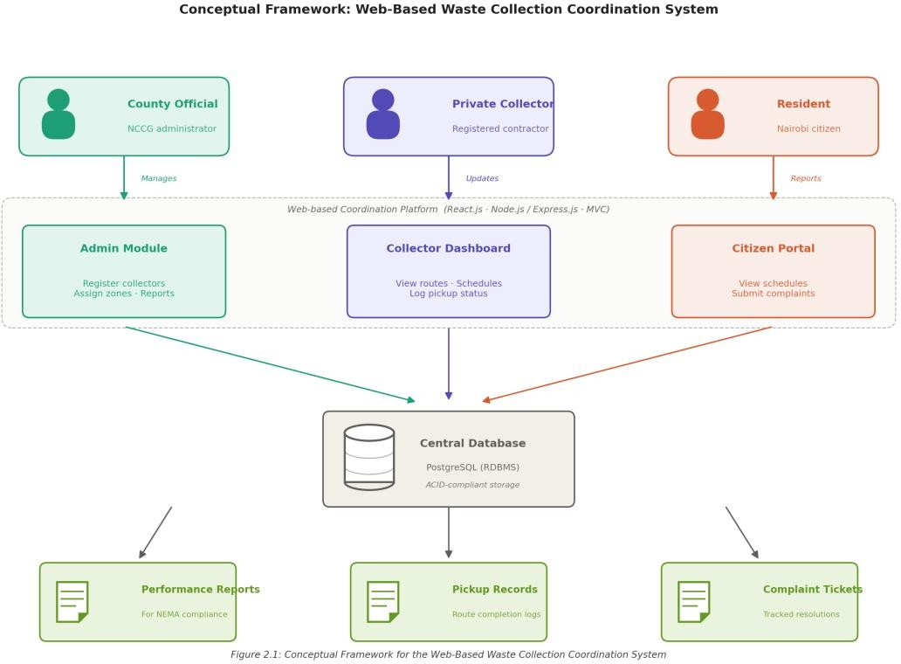

Figure 2.1: Conceptual Framework for the Web-Based Waste Collection Coordination System

Chapter 3: Methodology

3.1 Introduction
This chapter covers the development methodology and paradigm that will guide the system's design and construction. It covers the development approach and its phases, the analysis and design models used to document requirements and architecture, the tools and technologies selected, and the project deliverables.

3.1.1 Object-Oriented Analysis and Design
This project uses Object-Oriented Analysis and Design. OOAD models real-world entities, users, schedules, complaints, and reports, as classes and objects that encapsulate both the data and the operations performed on it (Pressman & Maxim, 2015). It uses UML notation to produce visual models of system structure and behaviour, which makes design decisions easier to communicate across development and stakeholder contexts.
OOAD fits this project well because the platform serves three distinct user roles, each with a defined set of permissions and interactions. Encapsulation and abstraction allow role-specific logic to be built and modified independently, reducing the chance that a change in one area breaks something else. The approach aligns naturally with MVC, where the Model layer maps directly to the class structure defined during OOAD analysis (Pressman & Maxim, 2015).

3.2 System Methodology
The project uses the Incremental Development Model. The system is built and delivered in a series of planned increments, each one building on the previous. Each increment delivers a subset of the system’s full functionality that is independently deployable and testable. The model surfaces design problems early, allows requirements to be refined after each increment, and produces a series of working system states rather than a single delivery at the end (Pressman & Maxim, 2015). This works well for a multi-stakeholder system, where feedback from early increments can shape what comes next.
The model also suits the Project I timeline, allowing core functionality to be delivered and tested within the available window while leaving extension features to later increments. The model

proceeds through five phases in each increment: Communication, Planning, Modelling, Construction, and Deployment.

3.2.1 Communication
The Communication phase establishes the requirements for the current increment by engaging the three stakeholder groups the system serves. For the authentication and collector management increment, this means structured interviews with NCCG waste management officials to confirm the data fields required for the contractor register, the licence verification workflow, and the zone assignment process. For the scheduling and tracking increment, the team meets with registered private collectors to understand how routes are currently planned, what information they need to receive when a route is assigned, and what exceptions they need to log when pickups cannot be completed. For the citizen reporting increment, user stories are developed with resident participants in selected wards to capture the complaint categories that matter most, including missed pickups, illegal dumping sightings, and overflowing collection points. The phase concludes with a written specification of the functionality the increment will deliver, agreed with the relevant stakeholders before any code is written.

3.2.2 Planning
The Planning phase translates each agreed increment specification into a concrete work plan. Tasks are broken down at the module level, for example separating the collector licence renewal reminder feature from the licence record creation feature within the collector management module, so that progress can be tracked and dependencies between modules are made explicit. Resource requirements are estimated, including the development hours required for each task and any external dependencies such as the PostgreSQL schema migrations needed before a new module can be integrated. Timelines are set within the academic calendar allocated for Project I, with the authentication module scheduled first because every other module depends on it, followed by collector management, scheduling and tracking, citizen reporting, and finally administrative reporting. Responsibilities are allocated between the two team members to ensure parallel progress on front-end and back-end work.

3.2.3 Modelling (Analysis and Design)

The Modelling phase converts the increment’s requirements into the analysis and design artefacts described in Sections 3.3 and 3.4. For the proposed system, this includes use case diagrams that show how county officials, collectors, and residents interact with the relevant module; sequence diagrams that document critical workflows such as complaint routing from a resident through the system to the relevant collector and administrator; class diagrams that define the structure of core entities like Collector, Zone, Schedule, Pickup, and Complaint; and Entity Relationship Diagrams that translate those entity definitions into a relational schema with the foreign key constraints PostgreSQL will enforce. Wireframes for the role-specific dashboards are produced in the same phase. The completed models form the specification against which the coded increment is validated during testing.

3.2.4 Construction (Code and Test)
The Construction phase implements the increment using the technology stack documented in Section 3.5. React.js components are developed for the user-facing dashboards, Express.js routes are implemented for the back-end controllers, and the PostgreSQL schema is updated to match the data model. Each module is unit tested as it is built, with Postman used to verify that API endpoints return the expected responses for valid input and reject malformed or unauthorised requests. Integration testing follows once individual modules within an increment are verified, with particular attention to the interactions between modules; for example, confirming that a complaint submitted through the citizen reporting module correctly updates the collector’s task queue in the scheduling and tracking module. Regression testing ensures that the new increment does not break functionality delivered in earlier increments.

3.2.5 Deployment (Delivery and Feedback)
At the end of each increment, the working system is reviewed against the requirements agreed during Communication. For example, after the collector management increment is delivered, a session is held with NCCG officials to confirm that the contractor register, licence verification workflow, and zone assignment functions meet the specification. Resident-facing modules are reviewed with sample users from the participating wards to confirm that the citizen portal is usable on the devices residents actually own. Feedback from these reviews is logged in GitHub Issues and informs the requirements for subsequent increments, allowing the team to address usability

gaps or adjust priorities before moving on. This feedback loop is the primary mechanism for refining the system across the development process.
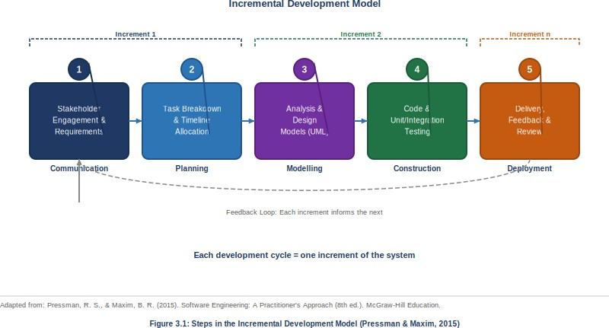

Figure 3.1: Steps in the Incremental Development Model (Pressman & Maxim, 2015)

The Incremental Model is preferred over a pure Agile approach because its more structured phase sequence fits Project I's proposal and documentation requirements, while still delivering the iterative feedback benefits that distinguish it from waterfall. The structured phases also make it straightforward to produce the analysis and design models the blueprint requires.

3.3 System Analysis
System analysis translates the project’s stakeholder requirements into formal models that describe how the system will behave from the perspective of its users and how its components will interact. The following analysis diagrams will be produced for the system. The actual diagrams appear in the final report; this section describes the purpose and application of each within the proposed system's context.

3.3.1 Use Case Diagram
A use case diagram identifies the system's actors and the functional interactions each actor has with it (Pressman & Maxim, 2015). For the proposed system, the primary actors are the County Official, the Private Collector, and the Resident. The use case diagram will document the full set

of system functions accessible to each actor: county officials will be shown as actors for collector registration, zone assignment, schedule management, and performance report generation; collectors will be shown as actors for viewing route assignments, updating pickup records, and logging exceptions; residents will be shown as actors for viewing schedules, submitting complaints, and tracking resolution status. The use case diagram is the foundational reference for all subsequent analysis models.

3.3.2 Sequence Diagram
A sequence diagram shows the chronological order of interactions between system objects for a specific scenario (Pressman & Maxim, 2015). Sequence diagrams will be developed for the most critical scenarios: the complaint submission and routing workflow, in which a resident submits a complaint, the system routes it to the relevant collector and county administrator, and the collector logs a resolution response; and the collection schedule assignment workflow, in which a county official assigns a route to a registered collector and the updated schedule becomes visible to residents in the relevant zone. These diagrams confirm that the system’s object interactions are logically coherent and complete before implementation begins.

3.3.3 Activity Diagram
An activity diagram models how control flows through a system process, showing decision points, parallel activities, and terminal states (Pressman & Maxim, 2015). The proposed system will use activity diagrams to model the full lifecycle of a waste collection cycle, from the point at which a county official assigns a scheduled route, through the collector’s execution or non-execution of that route, to the resident’s complaint submission if the pickup is missed and the eventual resolution response. This makes the operational logic explicit and checkable before code is written.

3.4 System Design
System design translates the analysis models into concrete specifications for implementation. Design models define the physical structure of the database, the visual layout of user interfaces, and the architectural organisation of the system’s components. The following design artefacts will be produced.

3.4.1 Entity Relationship Diagram

An ERD shows the database structure: the entities stored in the system, their attributes, and the relationships between them (Coronel & Morris, 2022). For the proposed system, core entities include User (with role-differentiating attributes), Collector, Zone, Schedule, Pickup, Complaint, and Report. Relationships will include a one-to-many association between Collector and Pickup (one collector can complete many pickups), and between Resident and Complaint (one resident can submit many complaints). The ERD drives the database schema design and ensures referential integrity constraints are applied consistently.

3.4.2 Wireframes
Wireframes are low-fidelity interface representations that define layout, navigation, and functional components without specifying visual styling (Pressman & Maxim, 2015). For the proposed system, wireframes will be developed for the county administrator dashboard, the collector route management interface, the resident scheduling and complaint portal, and the login and registration screens. They serve as the reference for front-end development and the basis for usability evaluation.

3.4.3 System Architecture
The system architecture diagram illustrates the high-level organisation of the system’s components and the data flows between them (Pressman & Maxim, 2015). For the proposed system, the architecture follows the MVC pattern: the React.js front-end constitutes the View layer, the Node.js and Express.js back-end constitutes the Controller layer, and the PostgreSQL database constitutes the Model layer. The architecture diagram will also show the division of functionality across user roles and the API endpoints through which the front-end communicates with the back-end. This gives developers a shared structural reference before module-level coding begins.

3.5 System Development Tools and Technologies
The following tools and technologies have been selected for the development of the proposed system based on their functional suitability, compatibility with the MVC architectural pattern, and practical accessibility within the development environment.

3.5.1 React.js

React.js is an open-source JavaScript library for building interactive user interfaces, originally developed by Meta. Its component-based architecture, where each component encapsulates its own state and rendering logic, suits a multi-role platform where dashboards share common elements but present different data and controls. React.js will be used to develop the county administrator dashboard, the collector route interface, and the resident portal, with each role’s interface built as a separate set of components served from a shared codebase.

3.5.2 Node.js with Express.js
Node.js is an asynchronous, event-driven JavaScript runtime for server-side execution. Express.js is a minimal framework for Node.js that handles routing, middleware, and HTTP requests. Together, they form the Controller layer of the system’s MVC architecture, receiving requests from the React.js front-end, applying business logic, and communicating with the PostgreSQL database. Node.js handles concurrent connections efficiently without blocking threads, which matters for a system where multiple users may be submitting complaints, updating schedules, and querying reports at the same time.

3.5.3 PostgreSQL
PostgreSQL is a fully ACID-compliant, open-source relational database with strong support for complex queries, referential integrity, and concurrent multi-user access (Coronel & Morris, 2022). It serves as the Model layer, storing user accounts, collector records, zone assignments, schedules, complaints, and reports in a structured relational schema. PostgreSQL’s enforcement of foreign key constraints will ensure data integrity across related tables, preventing orphaned records and maintaining the consistency of the system’s operational data.

3.5.4 Visual Studio Code
VS Code is a lightweight, cross-platform source code editor with built-in support for JavaScript, Node.js, and React.js. It will serve as the primary IDE, offering syntax highlighting, code completion, an integrated terminal, and Git integration. Its lightweight footprint and extension library make it practical for full-stack development.

3.5.5 GitHub
GitHub is a cloud-based version control and collaboration platform built on Git. It will manage the codebase, track changes across increments, maintain feature branches, and merge completed work

after testing. GitHub’s issue tracking functionality will also be used to log and manage development tasks corresponding to each increment’s requirements. Structured version history is essential here: it lets the team isolate regression sources and revert to stable states when integration problems arise.

3.5.6 Postman
Postman is an API testing tool for constructing, sending, and inspecting HTTP requests to back-end endpoints. It will verify that API routes respond correctly for all three user roles, that input validation rejects malformed requests, and that authentication controls block unauthorised access. Systematic API testing is a prerequisite for front-end integration: the back-end contract needs to be stable before React.js components connect to live endpoints.

3.6 Deliverables
The project will produce the following deliverables, grouped by documentation and functional modules.

3.6.1 System Proposal
This document is the first deliverable. It covers the problem the system addresses, the research and design decisions behind the proposed solution, and the technical and methodological plan for building it. It serves as the reference for all subsequent development and evaluation.

3.6.2 Authentication Module
The authentication module handles registration and login for all three user roles. County officials and collectors go through an administrative verification step before their accounts are activated. Authenticated sessions use secure tokens, and role-based access control restricts each user to the functions and data appropriate to their role. All other modules depend on this one.

3.6.3 Collector Management Module
The collector management module lets county officials register private collectors, record licence details and expiry dates, assign coverage zones, and maintain an auditable contractor record. Collectors can view their assigned zones and receive licence renewal reminders. This module provides the data foundation for the scheduling module and supports the county’s statutory

obligation under the Sustainable Waste Management Act, No. 31 of 2022 to maintain a register of waste service providers.

3.6.4 Scheduling and Tracking Module
The scheduling and tracking module lets county officials assign collection schedules to registered collectors by zone and day of week. Collectors can view their schedules, update pickup completion status, and log service exceptions with notes. Residents can view the published schedule for their zone. County officials can query pickup completion rates to identify patterns of non-performance. This module is where the system's core coordination function lives.

3.6.5 Citizen Reporting Module
The citizen reporting module gives residents a structured way to report missed pickups, illegal dumping, and overflowing collection points. Each complaint is automatically time-stamped, given a reference number, and routed to the relevant collector and the county administrator for that zone. Residents can track resolution status through the portal. County administrators can view open complaints by zone, filter by type and status, and generate summary reports.

3.6.6 Administrative Reporting Module
The administrative reporting module generates performance reports for county officials by aggregating data from the scheduling, tracking, and complaint modules. It produces metrics on pickup completion rates, average complaint resolution time, and contractor performance trends by zone. Reports can be exported for submission to NEMA as required under the Sustainable Waste Management Act, No. 31 of 2022. This module turns the platform's operational data into the evidence county authorities need for compliance reporting and licensing decisions.

Chapter 4: System Analysis and Design

4.1 Introduction
This chapter sets out the analysis and design of the web-based waste collection coordination system. It opens with a requirements analysis covering the functional and non-functional requirements of the three main stakeholder groups: county government officials, registered private collectors, and residents. Next come the analysis diagrams: the Use Case Diagram, the Entity Relationship Diagram, the Activity Diagram, and the Sequence Diagrams, each describing a different aspect of how the system behaves and how its users interact with it. The design artefacts come last: the database schema derived from the Entity Relationship Diagram, the class diagram, the system architecture diagram, and the wireframes for the role-differentiated interfaces. These artefacts are the specification the implemented system is tested against in Chapter 5.

4.2 Requirements Analysis
Requirements analysis describes the conditions the system must meet to deliver the intended service. The requirements fall into two categories: functional requirements, which define what the system must do, and non-functional requirements, which define the operational qualities and constraints it must meet while doing so. Those below come from a stakeholder analysis informed by the operational context established in Chapters 1 and 2 and the coordination scope defined in the Sustainable Waste Management Act, No. 31 of 2022.

4.2.1 Functional Requirements
Functional requirements are the features the system must provide so that each user role can carry out its tasks. Table 4.1 lists the functional requirements for the proposed system, giving each one an identifier, the user role it applies to, and a description of the expected behaviour.
Table 4.1: Functional Requirements of the Proposed System
ID | Requirement | User Role | Description
FR-01 | User Registration | All roles | County officials, collectors, and residents register for accounts with unique credentials.
FR-02 | Authentication and Access Control | All roles | Registered users authenticate with their credentials, and role-based access control limits each user to the functions and data appropriate to their role.
FR-03 | Collector Registration | County Official | County officials register private waste collectors, record licence details and expiry dates, assign coverage zones, and maintain an auditable contractor register.
FR-04 | Collection Schedule Assignment | County Official, Resident | County officials create and assign collection schedules to collectors by zone and day, and published schedules are visible to residents in the corresponding zone.
FR-05 | Pickup Status Tracking | Collector, County Official | Collectors update pickup completion status and log service exceptions, while county officials query completion rates by collector and zone.
FR-06 | Citizen Complaint Submission | Resident | Residents submit structured complaints that are automatically time-stamped, assigned a reference number, and routed to the responsible collector and the county official responsible for the relevant zone.
FR-07 | Complaint Tracking and Resolution | Resident, County Official | Residents view the status of their complaints, while county officials filter open complaints by zone, type, and status and update resolution records.
FR-08 | Administrative Performance Reporting | County Official | The system generates exportable reports aggregating pickup completion rates, complaint resolution times, and contractor performance trends by zone for submission to NEMA.
FR-09 | Collector Dashboard | Collector | Collectors access a dedicated dashboard displaying their assigned routes and schedules, outstanding pickups, and logged service exceptions.

4.2.2 Non-Functional Requirements
Non-functional requirements specify the operational qualities and constraints the system must meet. Each one is described below.
- Performance: The system responds to user actions, including schedule queries, complaint submissions, and report generation, within three seconds under normal concurrent load.
- Security: Data transmissions are encrypted via HTTPS, credentials are stored using industry-standard hashing, and role-based access control prevents unauthorised access to administrative features and sensitive contractor data.
- Reliability and Availability: The system targets 99% uptime during operational hours, with ACID-compliant PostgreSQL transactions preventing partial writes or data inconsistency.
- Scalability: The architecture supports horizontal scaling to accommodate growth in collectors, residents, and complaint volumes without degrading response times.
- Usability: The interface is navigable without technical training, with role-specific dashboards that show only relevant functions and error messages that are informative and corrective.
- Maintainability: The codebase follows MVC separation of concerns and is documented at the code level to support independent changes and future handover.
- Data Integrity: The relational database enforces referential integrity through foreign key constraints, which keep scheduling records, complaint histories, and contractor registers consistent across all user roles.

4.3 System Analysis
System analysis turns the requirements from Section 4.2 into models of how the system behaves for its users and how its internal components interact. Four diagrams are used. The Use Case Diagram shows the functional interactions between user roles and the system; the Entity Relationship Diagram maps the structural relationships between its core data entities; the Activity Diagram traces the flow of control through key processes; and the Sequence Diagram sets out the order of object interactions for critical workflows.

4.3.1 Use Case Diagram
The Use Case Diagram identifies the system's three primary actors and what each can do with the platform. The County Official registers and verifies collectors, assigns coverage zones, creates and modifies collection schedules, views pickup completion reports, manages complaint records, and generates performance reports for NEMA submission. The Private Collector views assigned routes and schedules, updates pickup completion status, and logs service exceptions. The Resident views the published collection schedule for their zone, submits complaints, and tracks the resolution status of those complaints. Authentication is shared by all three actors: a login process that enforces role-based access control. Figure 4.1 shows the diagram.
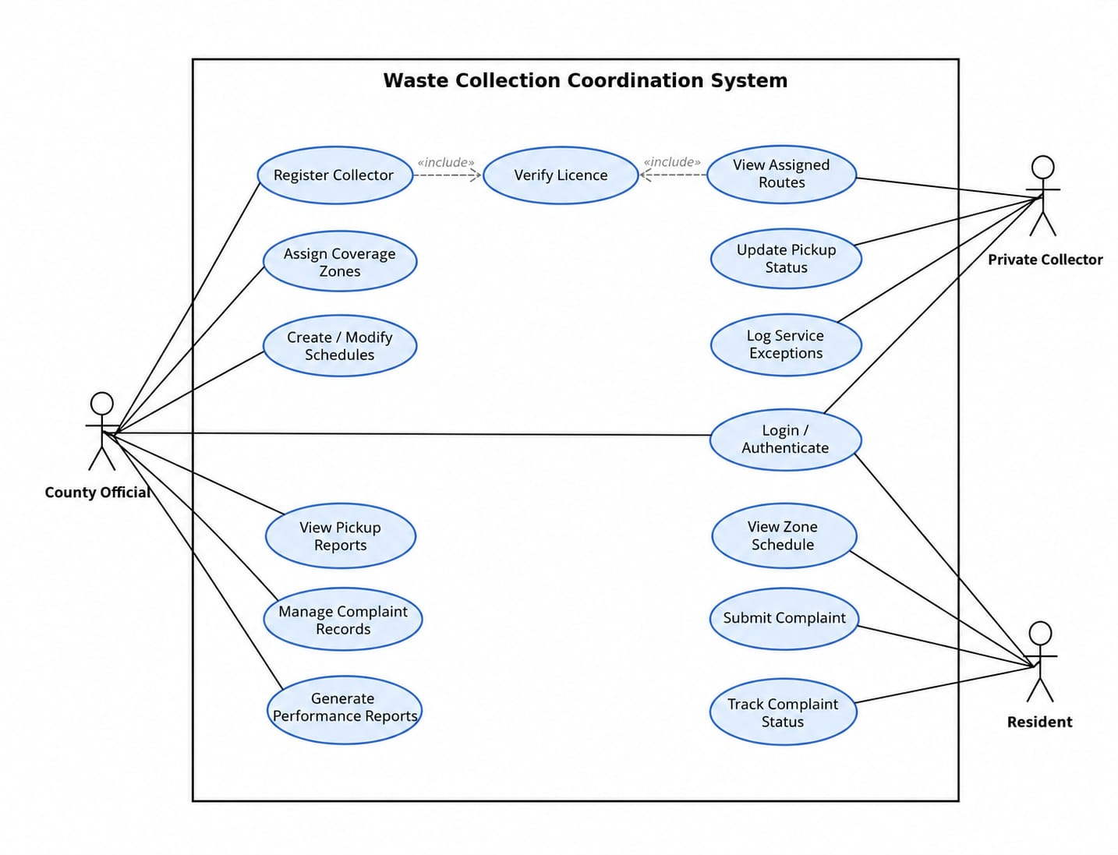
Figure 4.1: Use Case Diagram

4.3.2 Entity Relationship Diagram
The Entity Relationship Diagram captures the logical structure of the system's data and the relationships between its core entities. The principal entities are User (with a role attribute distinguishing county officials, collectors, and residents), Collector (linked to User by a one-to-one association and holding licence details), Zone (a designated collection area, which collectors are tied to through their assigned schedules), Schedule (linking a Collector to a Zone and a set of pickup days), Pickup (the completion or exception status of a specific scheduled collection event), Complaint (submitted by a user in the resident role, with a type and status, and linked to the Zone where the issue was reported), and Report (aggregated performance data produced by county officials). The main cardinality constraints are one-to-many: Schedule to Pickup, Zone to Schedule, Collector to Schedule, and User (in the resident role) to Complaint. The ERD is shown in Figure 4.2.
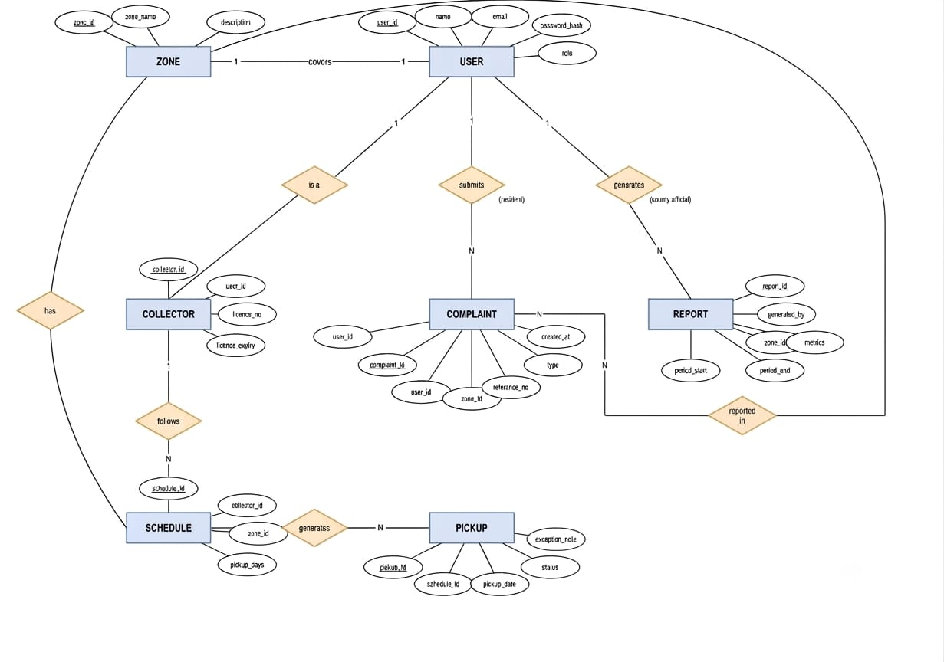
Figure 4.2: Entity Relationship Diagram

4.3.3 Activity Diagram
The Activity Diagram models the flow of control through the system's main operational process: a full waste collection cycle, from schedule assignment to complaint resolution. It starts when a county official logs in and creates or assigns a collection schedule to a registered collector for a specific zone. Once the schedule is published, residents in that zone can see their expected pickup day. On collection day, the collector logs in and marks each assigned pickup as either completed or as an exception with a supporting note. A decision node follows: if the pickup is completed, the system updates the county official's dashboard and nothing further is needed. If it is not, and a resident notices the missed collection, the resident submits a complaint through the citizen portal. The complaint is routed automatically to the responsible collector and to the county official for that zone. A second decision node follows: if the collector resolves the issue and updates the record, the complaint is set to Closed and the resident is notified. If it stays unresolved beyond a configurable threshold, it is escalated to the county official, who can start a performance review. The flow ends when every complaint for the collection period is resolved or formally recorded. Figure 4.3 shows the Activity Diagram.
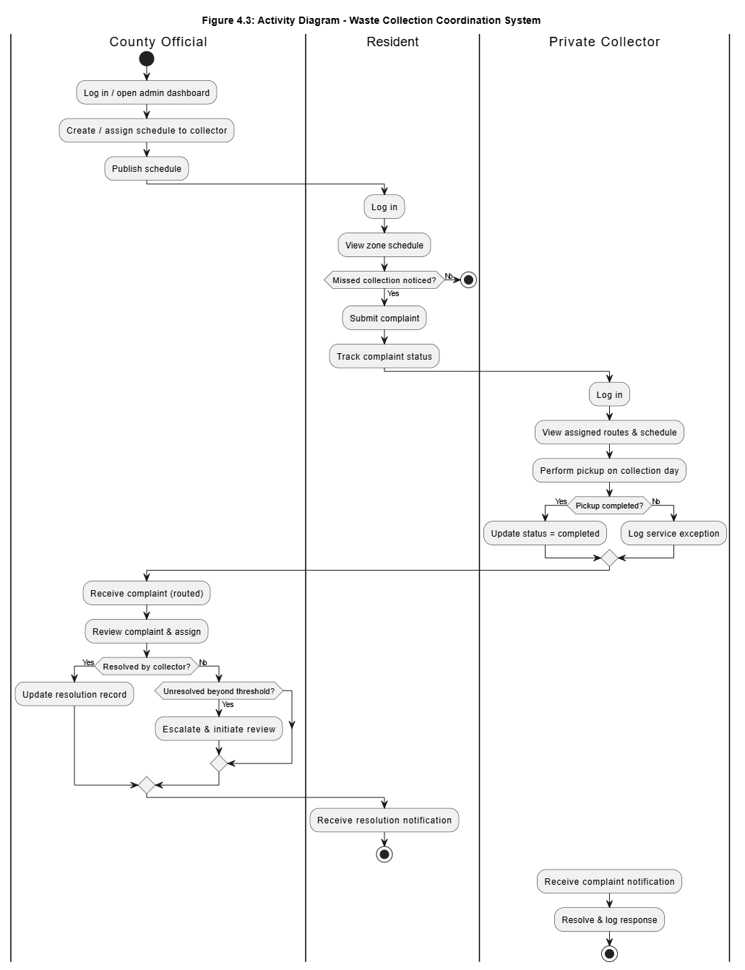
Figure 4.3: Activity Diagram for the Waste Collection Cycle

4.3.4 Sequence Diagram
The Sequence Diagram documents the order in which system objects interact across two key workflows. The first is complaint submission and routing: a Resident submits a complaint through the citizen portal; the system validates the form and writes the record to the database with a timestamp and reference number; the database confirms the write; the system queries the Zone table to find the responsible collector and the county official for that zone; and the system notifies both. The collector then logs a resolution response, the database is updated, and the resident receives a resolution notification through the portal. The second is schedule assignment: a County Official submits a schedule assignment request through the administrative dashboard; the system checks that the collector is registered and that the zone assignment is current; the database is updated with the new schedule record; and the system confirms the assignment and makes the updated schedule visible to residents in the relevant zone. Figures 4.4 and 4.5 show the sequence diagrams for the two workflows respectively.
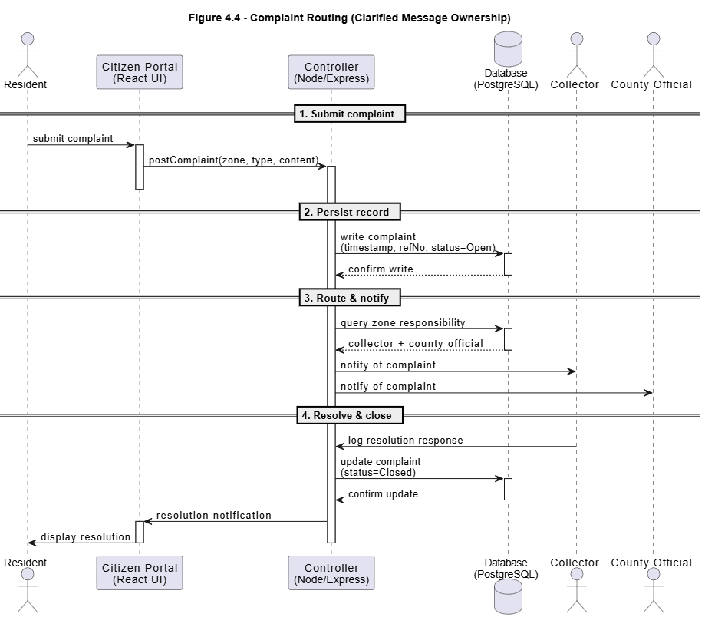
Figure 4.4: Sequence Diagram for the Complaint Submission and Routing Workflow
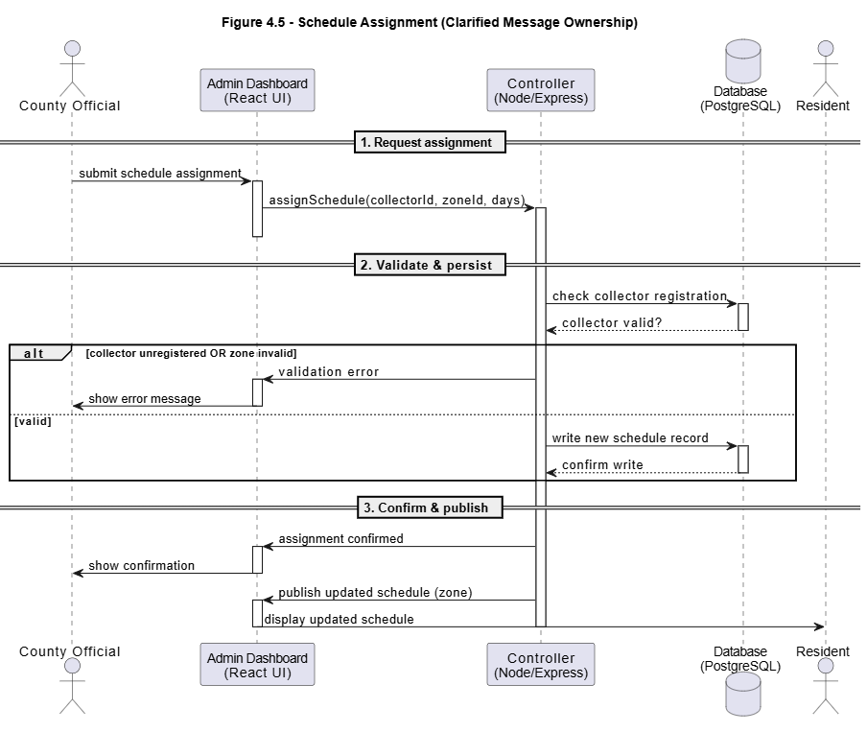
Figure 4.5: Sequence Diagram for the Schedule Assignment Workflow

4.4 System Design
System design converts the analytical models from Section 4.3 into specifications for implementation. The artefacts in this section define the physical structure of the database, the high-level organisation of the system's components and data flows, and the visual layout of the user interfaces for each role. They are the direct input to the development work in Chapter 5.

4.4.1 Database Schema
The database schema is the physical realisation of the Entity Relationship Diagram in Section 4.3.2. It maps the system's logical entities to relational tables, columns, primary keys, and foreign key constraints in PostgreSQL. Each entity becomes a table: the User table stores account credentials and a role attribute; the Collector table extends User with licence details; the Zone table holds the designated collection areas; the Schedule table links a collector to a zone and a set of pickup days; the Pickup table records the status of each scheduled collection event and references the schedule it belongs to; the Complaint table stores resident-submitted issues, each with a type and a status and linked to a zone; and the Report table stores aggregated performance data. Foreign key constraints enforce referential integrity between related tables, which prevents orphaned records and keeps scheduling, complaint, and contractor data consistent. The schema is shown in Figure 4.6.
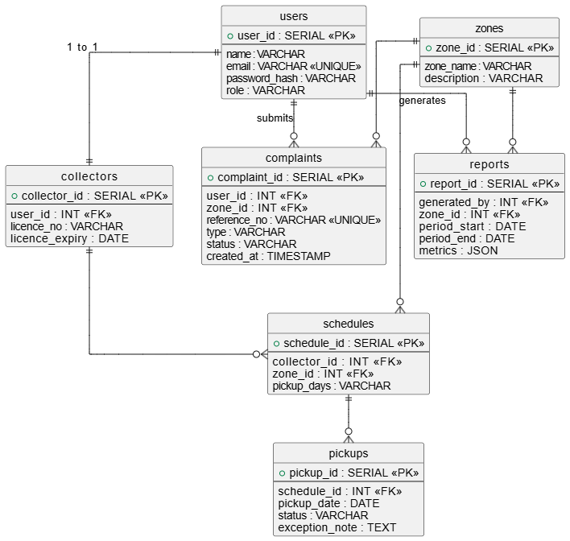
Figure 4.6: Database Schema

4.4.2 Class Diagram
The class diagram presents the static, object-oriented structure of the system: the classes that make up the application, their attributes and operations, and the relationships between them. An abstract User class holds the attributes and authentication operations common to all account holders, and the Collector, County Official, and Resident classes inherit from it, each adding the operations specific to its role. The Zone, Schedule, Pickup, Complaint, and Report classes model the system's operational data, with associations and multiplicities that mirror the Entity Relationship Diagram in Section 4.3.2. Figure 4.7 illustrates the class diagram.
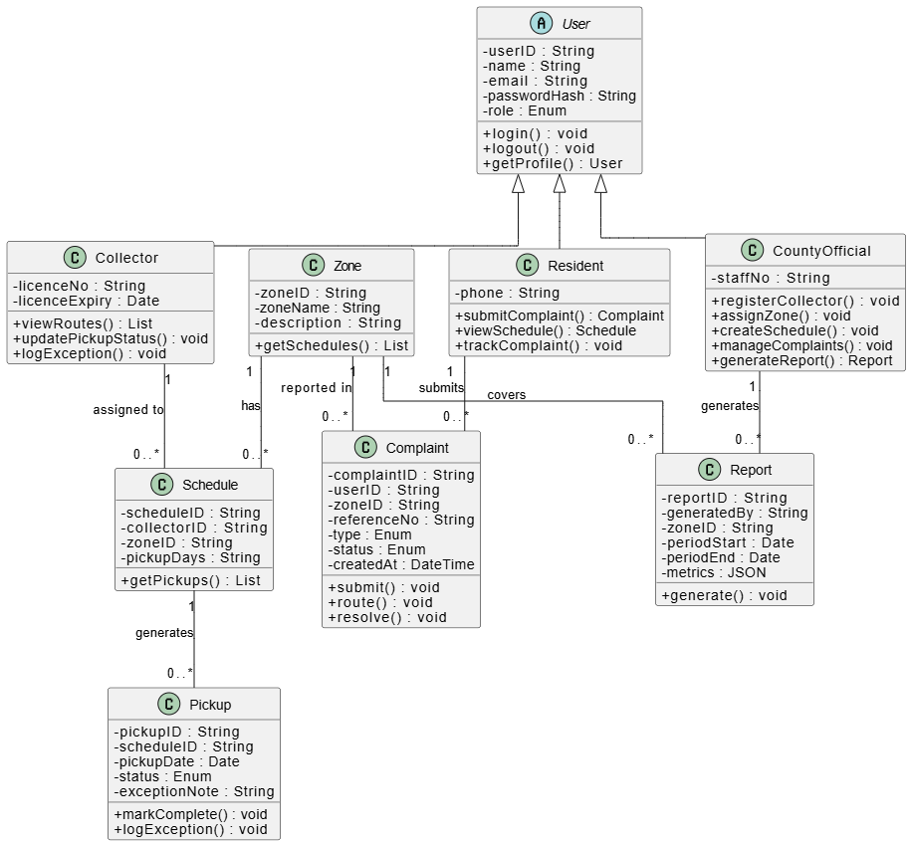
Figure 4.7: Class Diagram

4.4.3 System Architecture
The system architecture describes the high-level organisation of the system's components and the data flows between them. The proposed system follows the Model-View-Controller pattern from Chapter 3. The React.js front-end is the View layer and renders the role-differentiated dashboards in the browser. The Node.js and Express.js back-end is the Controller layer: it receives requests from the front-end, applies business logic, and enforces role-based access control. The PostgreSQL database is the Model layer, storing and retrieving the system's operational data. The front-end communicates with the back-end through a set of RESTful API endpoints, and the back-end communicates with the database through parameterised queries. This separation of concerns allows the interface, business logic, and data layers to be developed, tested, and maintained independently. Figure 4.8 shows the system architecture.
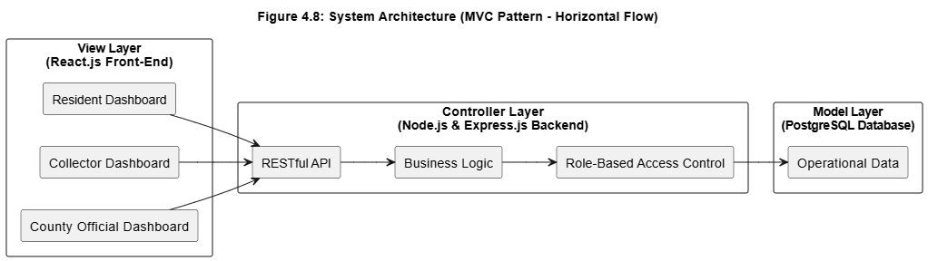
Figure 4.8: System Architecture Diagram

4.4.4 System Wireframes
Wireframes are low-fidelity representations of the user interface that define layout, navigation, and functional components without fixing the final visual styling. They are the reference for front-end development and the basis for the usability evaluation in Chapter 5. Four were developed, one for each of the system's main interfaces: the login and registration screen shared by all roles, the county official administrative dashboard, the collector route management interface, and the resident portal.

4.4.4.1 Login and Registration Screen
The login and registration screen is the entry point for all three user roles. It provides fields for credentials, a registration option for new users, and role selection where applicable. After successful authentication, the user is taken to the dashboard for their role. Figure 4.9 shows this wireframe.
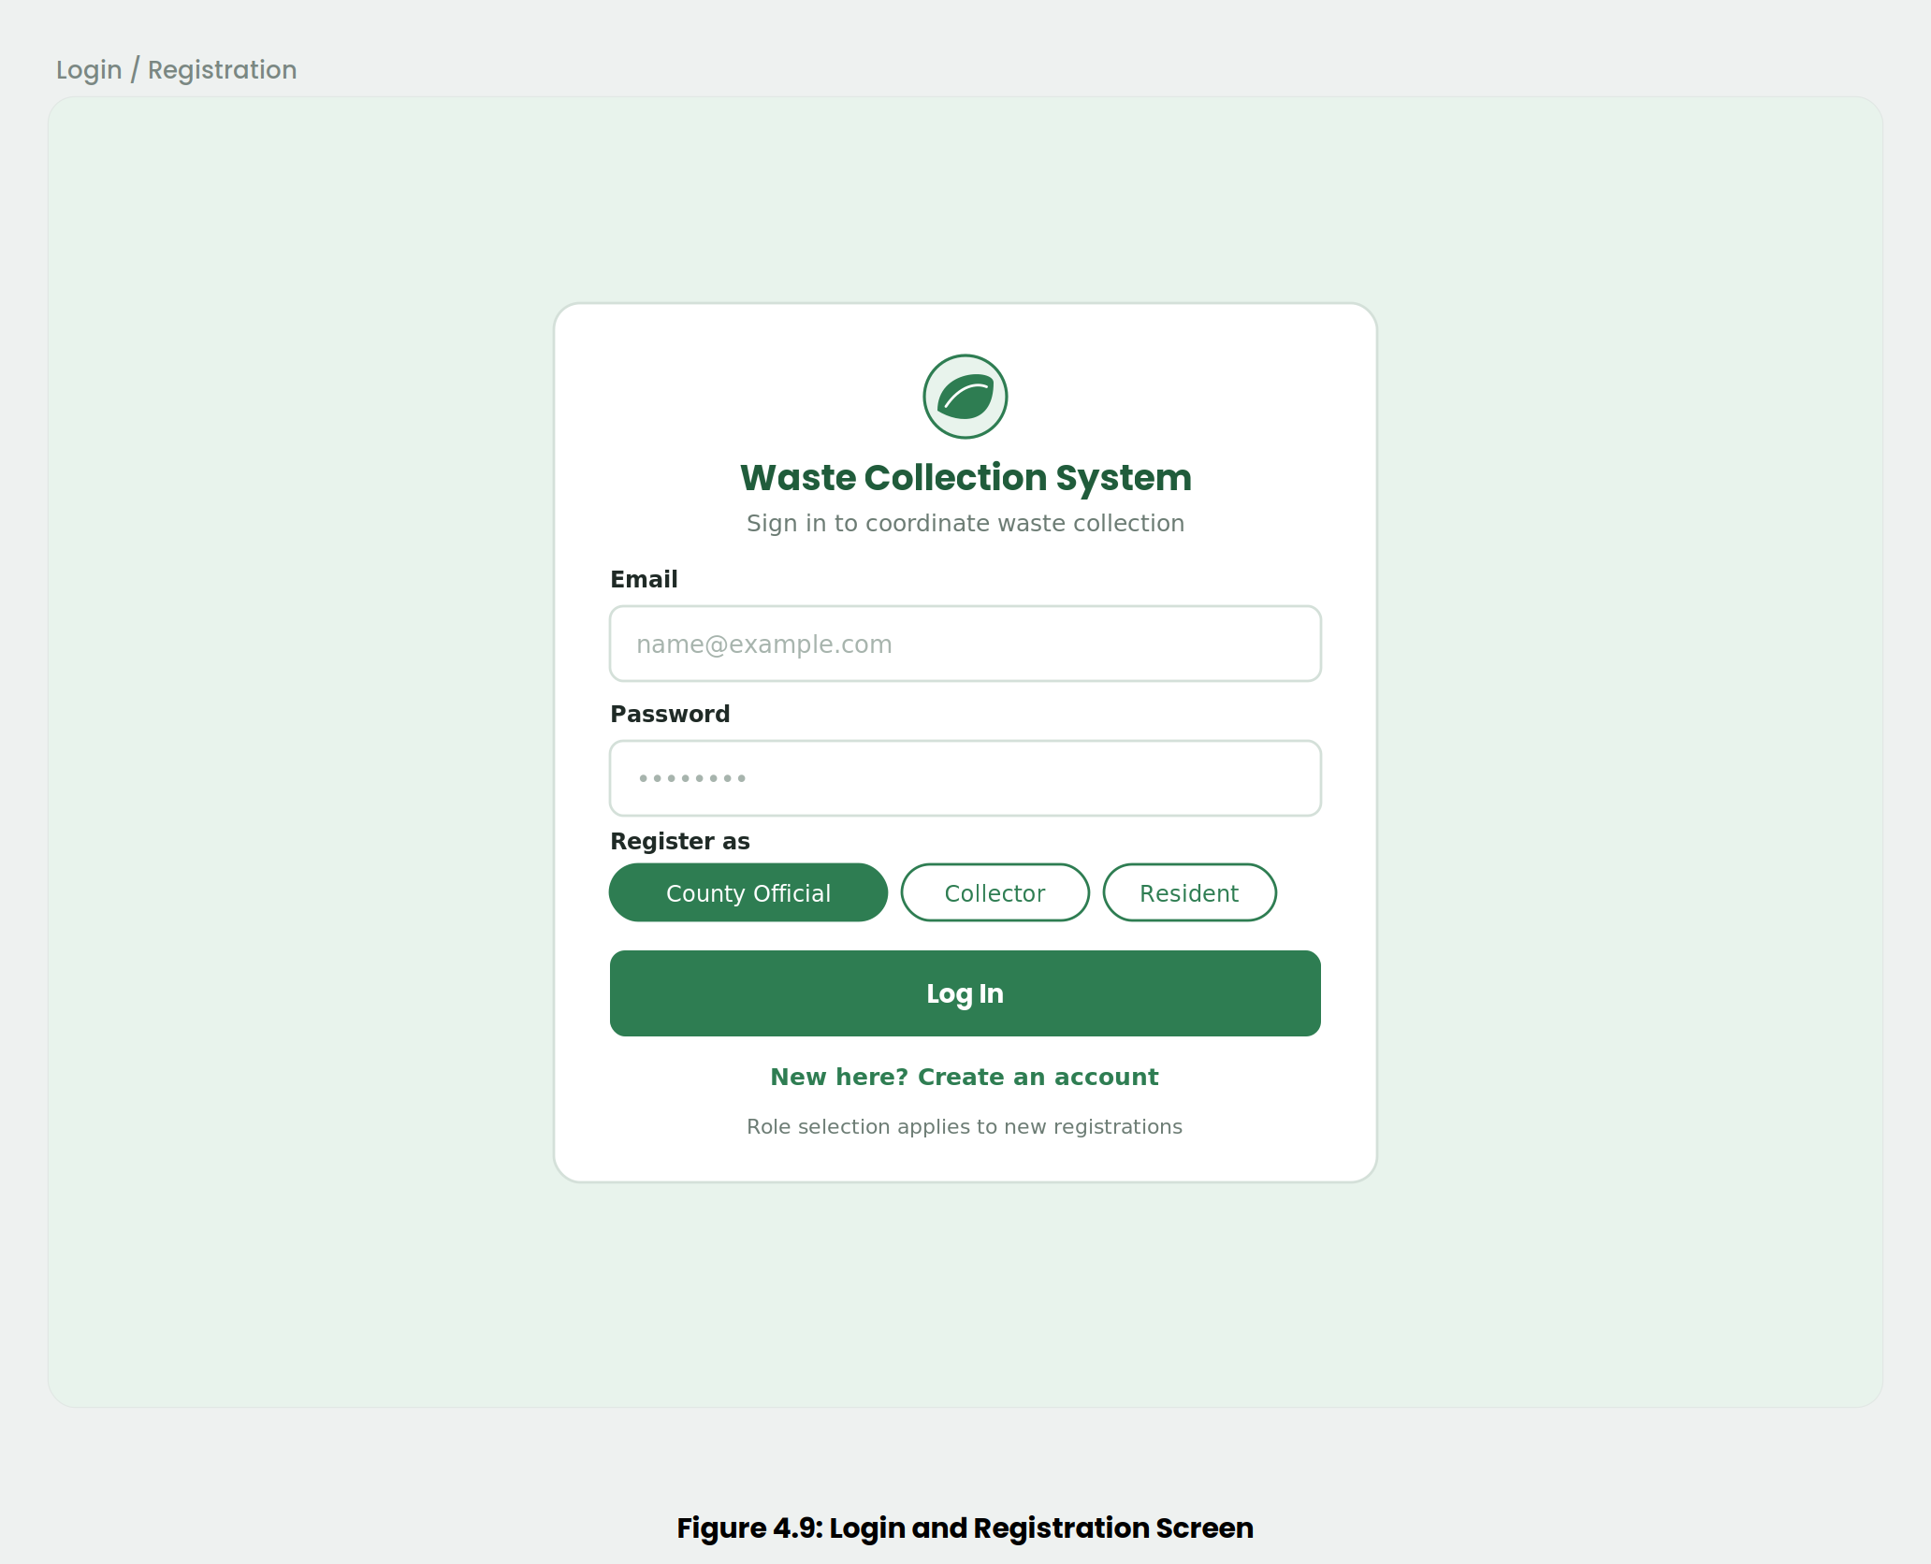
Figure 4.9: Login and Registration Screen Wireframe

4.4.4.2 County Official Administrative Dashboard
The county official administrative dashboard is the control centre for the county user. It gives access to collector registration and licence verification, zone assignment, schedule management, complaint oversight, and performance report generation. Summary indicators show pickup completion rates and open complaint volumes by zone. The dashboard wireframe is shown in Figure 4.10.
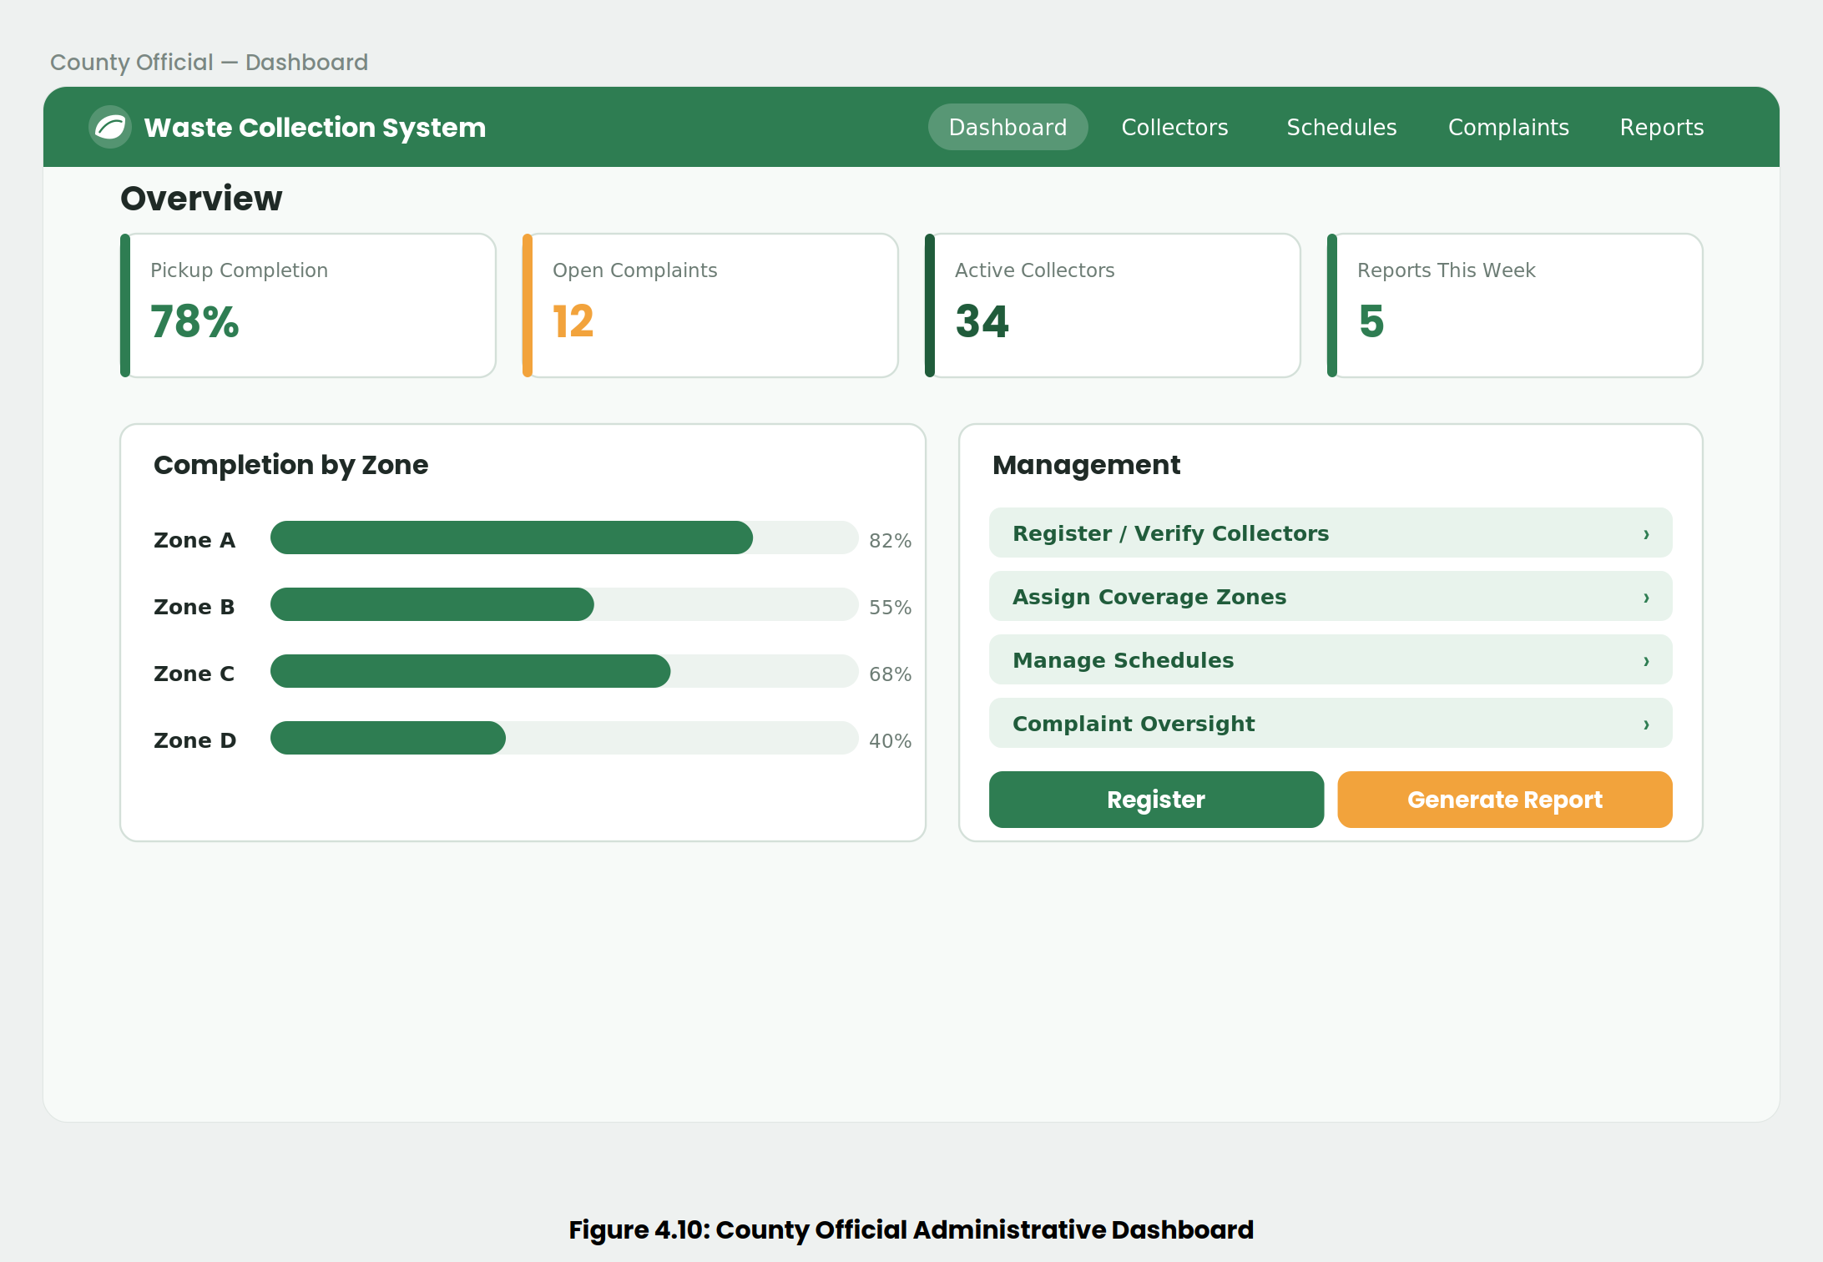
Figure 4.10: County Official Administrative Dashboard Wireframe

4.4.4.3 Collector Route Management Interface
The collector route management interface shows the collector their assigned zones and schedules, the outstanding pickups for the current period, and controls for updating pickup completion status or logging a service exception with a supporting note. The layout is kept simple, as collectors access it from a web browser to manage their routes. Figure 4.11 shows this wireframe.
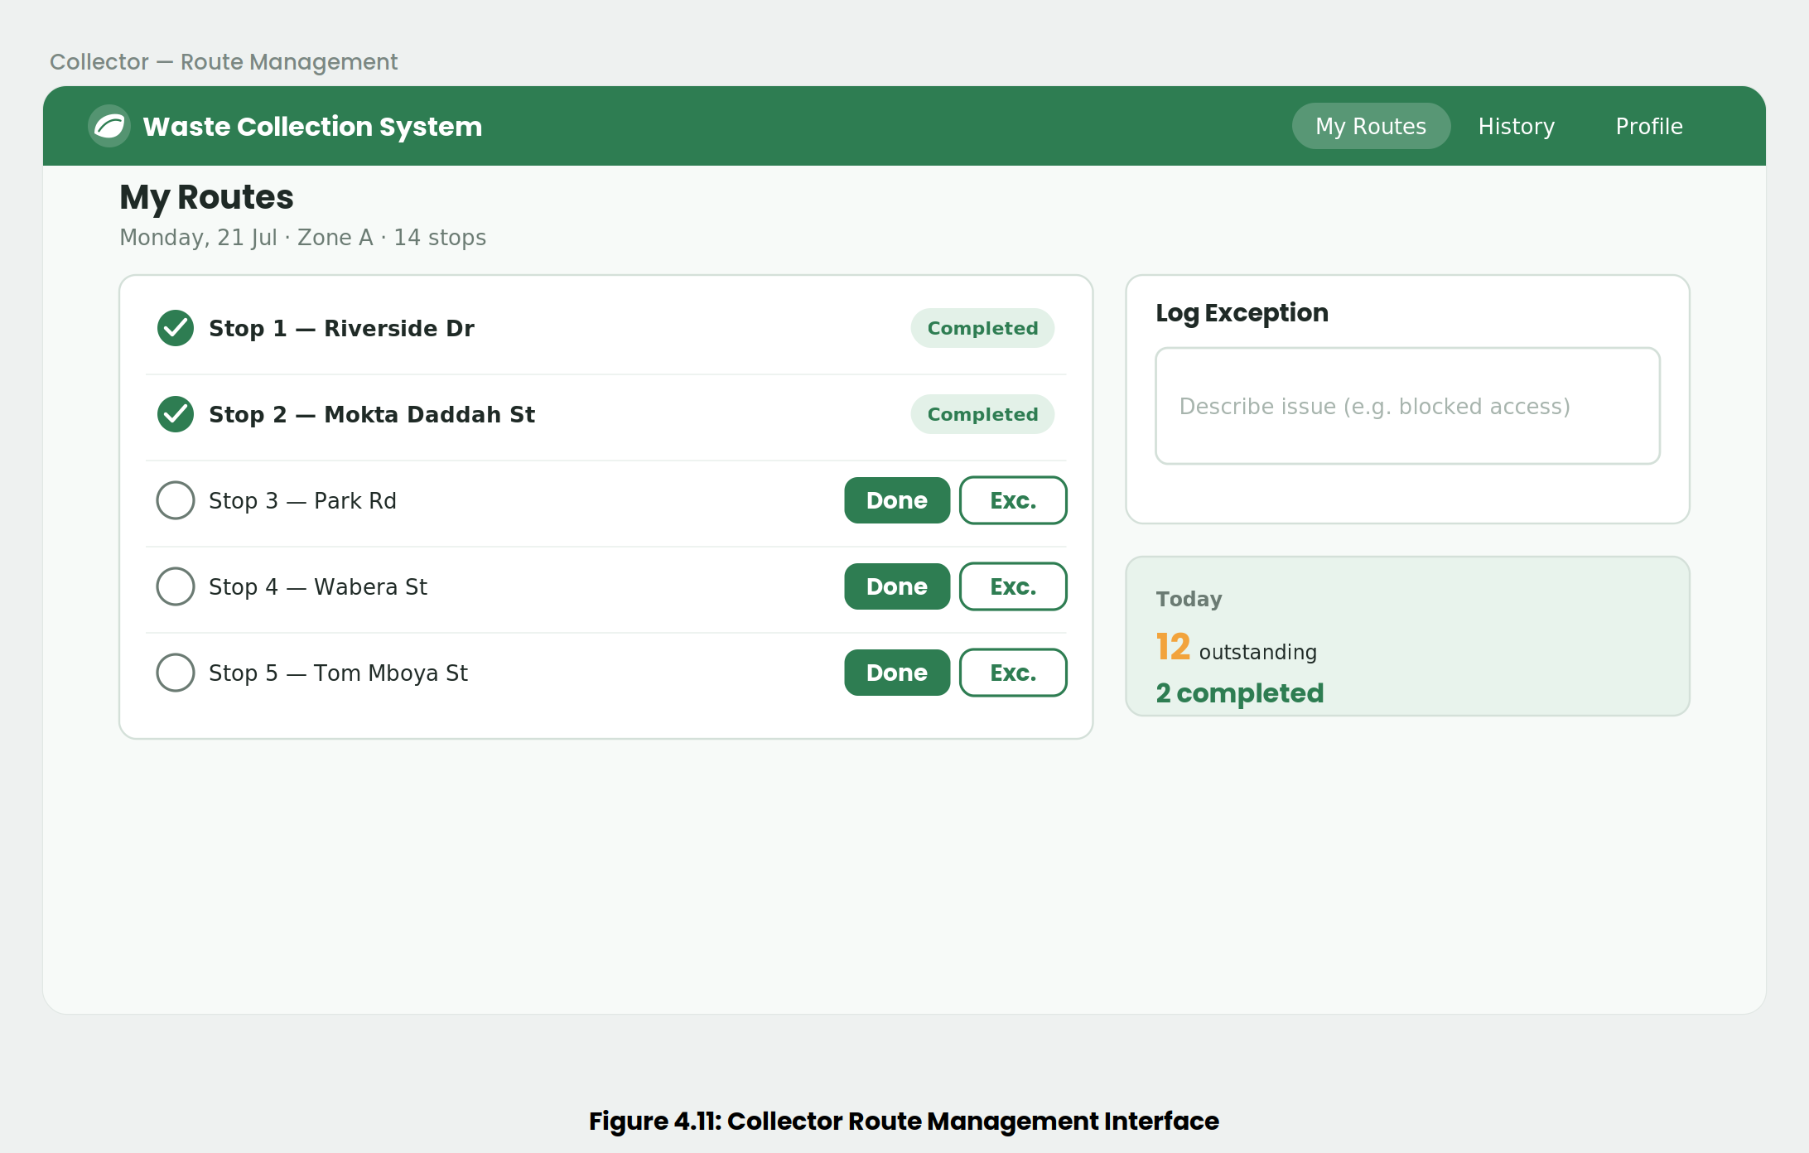
Figure 4.11: Collector Route Management Interface Wireframe

4.4.4.4 Resident Portal
The resident portal allows residents to view the published collection schedule for their zone, submit complaints about missed pickups, illegal dumping, or overflowing collection points, and track the resolution status of their complaints. The layout is clear and simple for non-technical residents, who may access the system from a range of devices. Figure 4.12 illustrates the portal wireframe.
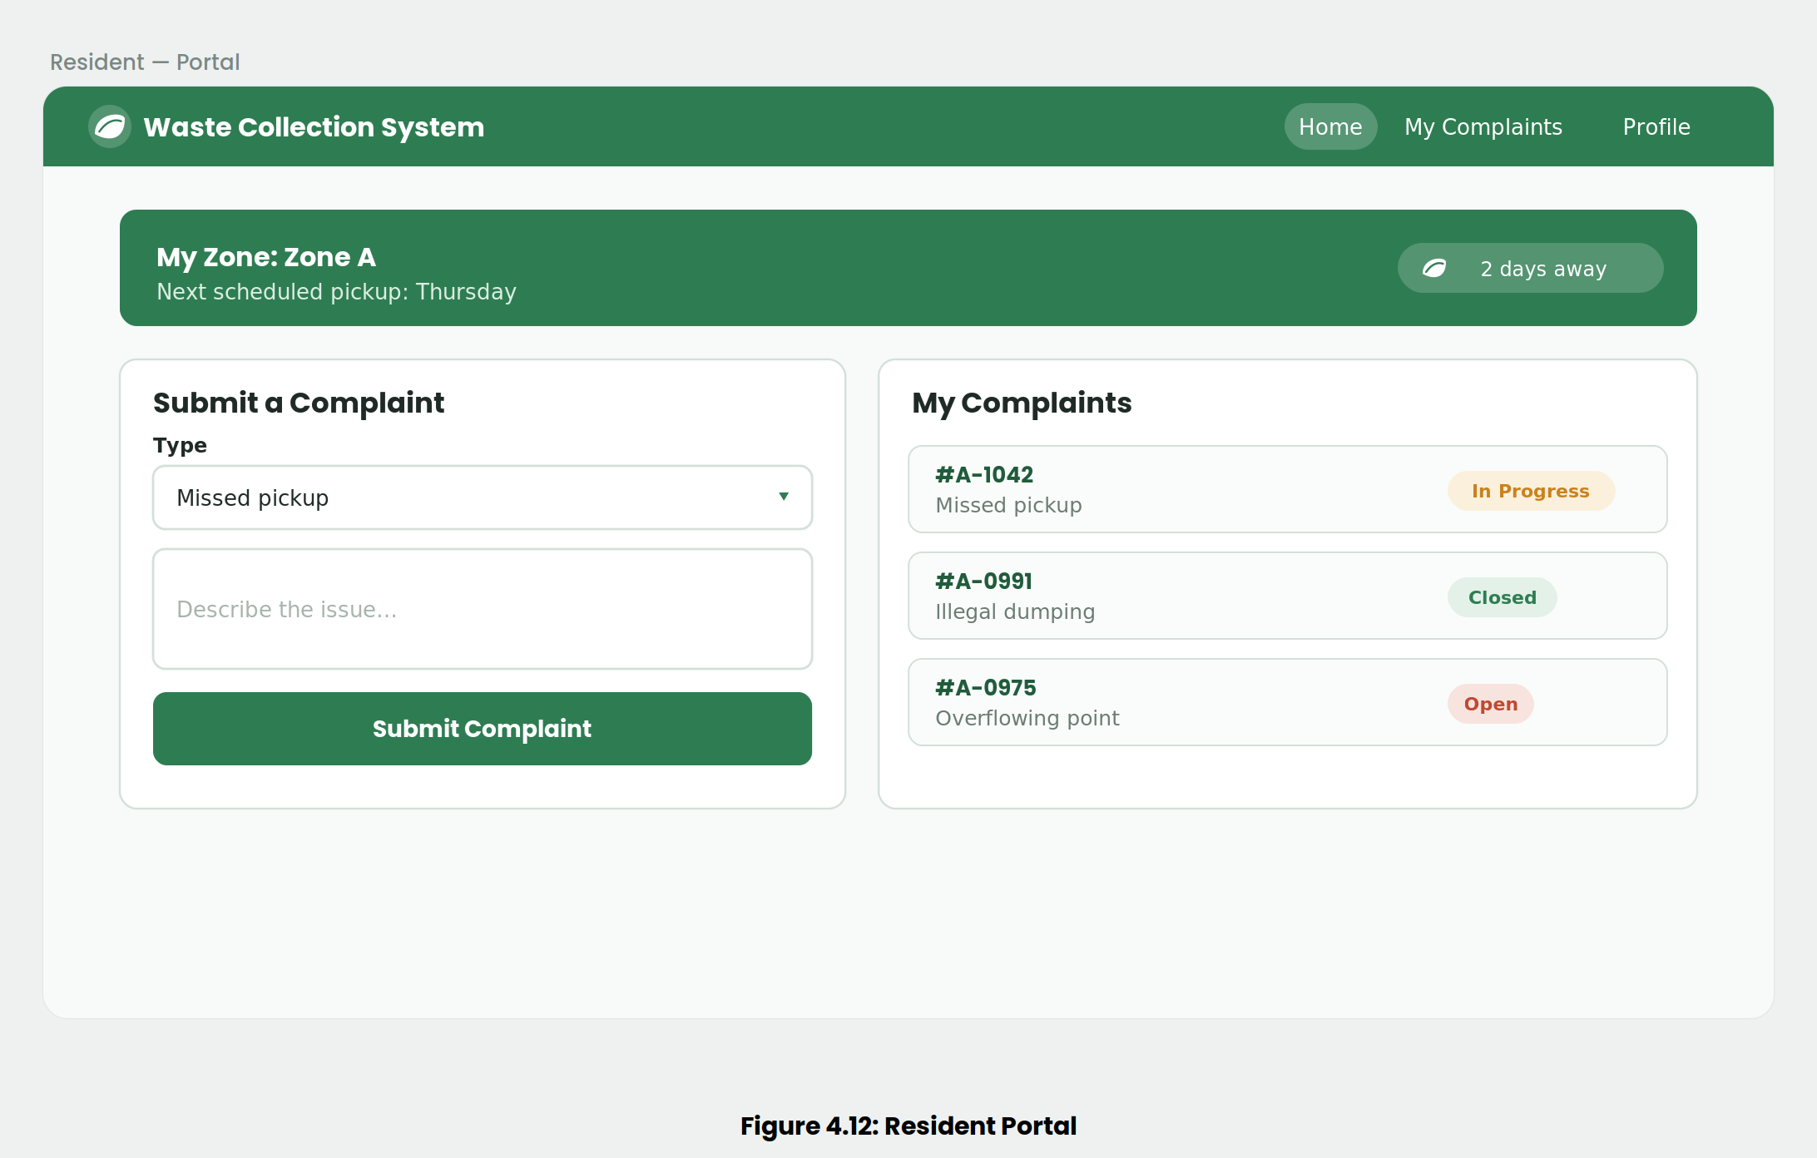
Figure 4.12: Resident Portal Wireframe

Chapter 5: System Implementation and Testing

5.1 Introduction
This chapter documents the implementation and testing of the web-based waste collection coordination system designed in Chapter 4. It first describes the implementation environment, the hardware and software used to build and run the system. It then presents the implemented modules, each with a screenshot of the working interface and a description of its role in the platform. The testing process comes last: the paradigms adopted and a tabulated record of the test cases run against each module with their outcomes and verdicts. The modules reported here are the deliverables defined in Chapter 3 and specified in the requirements analysis in Chapter 4: authentication, collector management, scheduling and tracking, citizen reporting, and administrative reporting.

5.2 Description of the Implementation Environment
The hardware and software environments below are the ones used to develop, run, and test the system. Recording them supports reproducibility and gives an accurate account of the conditions under which the system was built and evaluated.

5.2.1 Hardware Specifications
Development and testing ran on standard personal computers. The configuration below is the minimum on which the system was built and confirmed to run without performance degradation under the concurrent load set out in the non-functional requirements in Chapter 4.
- Processor: A quad-core x86-64 processor at 2.4 GHz or higher. This is enough to run the front-end development server, the Node.js back-end, and the PostgreSQL database at the same time during testing.
- Memory: 8 GB RAM, which holds the React.js build process, the Express.js runtime, and the database server side by side on one development machine.
- Storage: A 256 GB solid-state drive, with room for the source code, the Node.js dependency tree, the PostgreSQL data directory, and the version-control history.
- Network: A stable broadband internet connection for dependency installation, GitHub synchronisation, and testing of the client-server request cycle over HTTP.

5.2.2 Software Specifications
The software environment is built on the tools and technologies justified in Section 3.5. Each component below maps to a layer of the Model-View-Controller architecture defined in Chapters 3 and 4.
- Operating System: A 64-bit operating system, Windows 10 or later, which runs the Node.js runtime, the PostgreSQL server, and the rest of the development toolchain.
- React.js: The front-end library that builds the View layer and renders the role-differentiated dashboards for county officials, collectors, and residents.
- Node.js with Express.js: The server-side runtime and framework that make up the Controller layer and handle routing, business logic, and role-based access control.
- PostgreSQL: The relational database that acts as the Model layer and stores user accounts, collector records, zones, schedules, pickups, complaints, and reports under the schema derived in Section 4.4.1.
- Visual Studio Code: The integrated development environment used to write, debug, and manage the codebase across the front-end and back-end.
- GitHub: The version-control platform that holds the codebase, tracks changes across increments, and logs development tasks through its issue tracker.
- Postman: The API testing tool used to construct and inspect HTTP requests against the back-end endpoints during construction and testing.

5.3 System Implementation
Each module below corresponds to a deliverable defined in Section 3.6 and realises the requirements specified in Section 4.2. For each one, a screenshot of the working interface accompanies a description of its function and its place in the coordination workflow.

5.3.1 Authentication Module
The authentication module is the entry point to the system and the foundation every other module depends on. It handles registration and login for the three user roles. Residents self-register through the public interface; county officials and collectors go through an administrative verification step before their accounts are activated, in line with the registration logic described in Chapters 2 and 4. Once a user authenticates, the system issues a secure session and applies role-based access control, sends the user to the dashboard for their role, and limits the functions and data they can reach. Figure 5.1 shows the login and registration interface shared by all three roles.
[Place Holder for 5.1: Login and Registration Interface screenshot]
Figure 5.1: Login and Registration Interface

5.3.2 Collector Management Module
County officials use the collector management module to register private waste collectors, record their licence details and expiry dates, assign coverage zones, and keep an auditable contractor register. An official creates each collector account rather than the collector self-registering, which preserves the verification requirement set in the system design. The module gives the county its data foundation for scheduling and supports the statutory obligation under the Sustainable Waste Management Act, No. 31 of 2022 to maintain a register of waste service providers. Figure 5.2 shows the collector registration and management interface.
[Place Holder for Figure 5.2: Collector Management Interface screenshot]
Figure 5.2: Collector Management Interface

5.3.3 Scheduling and Tracking Module
The scheduling and tracking module is where the system’s core coordination work happens. County officials assign collection schedules to registered collectors by zone and day of week. Collectors then view their schedules, mark pickups as completed, and log service exceptions with supporting notes. Residents in a zone see the published schedule for that zone, and officials can query pickup completion rates to spot patterns of non-performance. The module ties the three roles to a single, current view of who is responsible for what and when. Figure 5.3 shows the collector route management interface, where schedules are viewed and pickup status updated.
[Place Holder for Figure 5.3: Scheduling and Tracking Interface screenshot]
Figure 5.3: Scheduling and Tracking Interface

5.3.4 Citizen Reporting Module
Residents use the citizen reporting module to report missed pickups, illegal dumping, and overflowing collection points through a structured channel. Each complaint is time-stamped, given a reference number, and routed automatically to the collector responsible for the zone and to the county official overseeing it. Residents track the resolution status of their complaints through the portal; officials view open complaints by zone and filter them by type and status. The module covers the resident-facing half of the coordination loop modelled in the activity and sequence diagrams in Chapter 4. Figure 5.4 shows the resident portal through which complaints are submitted and tracked.
[Place Holder for Figure 5.4: Citizen Reporting (Resident Portal) screenshot]
Figure 5.4: Citizen Reporting Interface

5.3.5 Administrative Reporting Module
The administrative reporting module pulls data from the scheduling, tracking, and complaint modules into performance reports for county officials. It produces metrics on pickup completion rates, average complaint resolution times, and contractor performance trends by zone, and it lets officials export reports for submission to NEMA as required under the Sustainable Waste Management Act, No. 31 of 2022. This is the module that converts the platform’s operational data into the evidence the county needs for compliance reporting and licensing decisions. Figure 5.5 shows the administrative reporting view within the county official dashboard.
[Place Holder for Figure 5.5: Administrative Reporting Dashboard screenshot]
Figure 5.5: Administrative Reporting Dashboard

5.4 System Testing
Testing verified that the implemented system behaves as Chapter 4 specified. This section states the testing paradigms applied and presents the results of the test cases run against each module. The tests confirmed that each module meets its functional requirements and enforces the access-control and data-integrity constraints set among the non-functional requirements.

5.4.1 Testing Paradigm
Two complementary paradigms were applied. Black box testing checked each module against its functional requirements without reference to the internal code, confirming that valid input gave the expected outcome and that invalid or unauthorised input was rejected. White box testing examined the internal logic, in particular complaint routing, role-based access control, and the referential-integrity constraints the database applies. Unit tests covered individual back-end endpoints in Postman during construction, and integration tests followed to confirm that modules worked together correctly. One such test confirmed that a complaint submitted through the citizen reporting module reached the collector’s queue in the scheduling and tracking module.
- Black box testing checks module behaviour against the functional requirements from the user’s side.
- White box testing examines internal logic, access-control enforcement, and data-integrity handling.
- Unit testing validates individual API endpoints in isolation with Postman.
- Integration testing confirms that dependent modules interact correctly.

5.4.2 Testing Results
The tables below give the test cases run against each module, the data used, the expected and experimental outcomes, and the verdict for each case. The results confirm that the implemented modules meet the functional requirements in Table 4.1.
Table 5.1: Authentication Module Test Results
Test Case | Description | Test Data | Experimental Outcome | Result | Test Verdict
TC-01 | Resident self-registration with all required fields provided | Name: Jane Mwangi; Email: jane@example.com; Password: valid | Account created and stored; user redirected to login | As expected | Pass
TC-02 | Registration with a required field left blank | Email field empty | Error message prompts user to complete all required fields; no account created | As expected | Pass
TC-03 | Login with correct credentials | Registered email and matching password | Authentication succeeds; user directed to role-appropriate dashboard | As expected | Pass
TC-04 | Login with incorrect password | Registered email; wrong password | Authentication fails; error message displayed; no session issued | As expected | Pass
TC-05 | Role-based access control on a restricted route | Resident session requesting an administrative endpoint | Request denied; access restricted to authorised roles | As expected | Pass
Table 5.2: Collector Management Module Test Results
Test Case | Description | Test Data | Experimental Outcome | Result | Test Verdict
TC-06 | County official registers a new collector with licence details | Collector name, licence number, expiry date, assigned zone | Collector record created and added to the contractor register | As expected | Pass
TC-07 | Registration of a collector with a missing licence field | Licence number omitted | Error message displayed; record not created | As expected | Pass
TC-08 | Assignment of a coverage zone to a registered collector | Existing collector; valid zone | Zone assignment saved and reflected in collector record | As expected | Pass
TC-09 | Collector views own assigned zone after login | Authenticated collector session | Assigned zone displayed on the collector dashboard | As expected | Pass
Table 5.3: Scheduling and Tracking Module Test Results
Test Case | Description | Test Data | Experimental Outcome | Result | Test Verdict
TC-10 | County official assigns a collection schedule to a collector | Collector, zone, day of week | Schedule saved and made visible to residents in the zone | As expected | Pass
TC-11 | Resident views the published schedule for their zone | Authenticated resident in an assigned zone | Correct schedule for the zone displayed | As expected | Pass
TC-12 | Collector marks a pickup as completed | Scheduled pickup; completion action | Pickup status updated to completed; reflected on official dashboard | As expected | Pass
TC-13 | Collector logs a service exception with a note | Scheduled pickup; exception with supporting note | Exception recorded against the pickup with the note stored | As expected | Pass
TC-14 | Official queries pickup completion rate by zone | Selected zone and period | Completion rate computed and displayed correctly | As expected | Pass
Table 5.4: Citizen Reporting Module Test Results
Test Case | Description | Test Data | Experimental Outcome | Result | Test Verdict
TC-15 | Resident submits a complaint with all fields provided | Complaint type: missed pickup; zone; description | Complaint stored with timestamp and reference number; routed to responsible collector and official | As expected | Pass
TC-16 | Submission of a complaint with required fields missing | Complaint type omitted | Error message displayed; complaint not submitted | As expected | Pass
TC-17 | Resident tracks the status of a submitted complaint | Existing complaint reference | Current status displayed to the resident | As expected | Pass
TC-18 | Official filters open complaints by zone and type | Selected zone and complaint type | Matching complaints listed correctly | As expected | Pass
TC-19 | Complaint marked as resolved by responsible party | Open complaint; resolution update | Status set to closed; resident notified of resolution | As expected | Pass
Table 5.5: Administrative Reporting Module Test Results
Test Case | Description | Test Data | Experimental Outcome | Result | Test Verdict
TC-20 | Generation of a performance report for a zone | Selected zone and reporting period | Report generated with completion rates, resolution times, and performance trends | As expected | Pass
TC-21 | Export of a generated report | Generated report; export action | Report exported in the expected format for NEMA submission | As expected | Pass
TC-22 | Report access attempted by a non-official role | Collector or resident session | Access denied; reporting restricted to county officials | As expected | Pass
Every test case run returned the expected outcome and passed. This confirms that the implemented modules satisfy the functional requirements in Table 4.1 and enforce the access-control and data-integrity constraints set among the non-functional requirements in Section 4.2.2.

Chapter 6: Conclusions, Recommendations and Future Works

6.1 Conclusion
The problem this project addressed was a coordination failure, not a capacity shortage. Nairobi’s split arrangement between the Nairobi City County Government and registered private collectors had no shared platform, so schedules went unverified, complaints went undocumented, and contractor performance could not be measured. The work can be assessed against the objectives in Section 1.3. The analysis of the current state of solid waste collection coordination in Nairobi traced its operational weaknesses to the absence of a shared information platform and showed that the problem is one of information rather than capacity alone. A review of existing systems then established the gap that GIS tools, hardware-dependent smart city platforms, and standalone citizen reporting portals leave behind: none of them connects county officials, private collectors, and residents across the full collection lifecycle. The project built a web-based system against that gap, with the five specified modules of authentication, collector management, scheduling and tracking, citizen reporting, and administrative reporting. Testing across the three user roles, recorded in Chapter 5, checked the system for functional correctness, usability, and access control, and the test cases returned the expected outcomes.
A few observations are worth recording. Building the system under the Incremental model, with authentication established first as the foundation for every dependent module, kept the construction sequence orderly and made regressions easier to isolate as each increment went in. Referential integrity at the database level mattered more than expected. Because contractor records and pickup data feed straight into compliance reporting, the consistency the relational schema enforces is what made that reporting trustworthy. The main challenge was the one foreseen among the limitations in Section 1.6. Access to verified operational data from the county and active collectors was constrained, so requirements analysis and testing used representative sample data in a controlled environment rather than live operational records. This did not stop the core coordination functions from being built and verified, but it does limit what can be claimed about real-world performance at this stage.

6.2 Recommendations
Two recommendations come out of building and testing the system. The first is for teams taking on similar municipal coordination systems: arrange access to operational data and stakeholder participation early, because the depth of requirements analysis and the realism of testing depend on it directly, and securing that access at the outset would strengthen any work that follows this one. The second concerns design priorities. Referential integrity and role-based access control should be treated as core design decisions from the start rather than as later refinements, because in a system where several parties act on shared records, consistent data and correctly scoped permissions are what keep the coordination dependable.
On deployment, the system suits an environment with reliable server hosting and stable connectivity for its administrative and collector users, in keeping with the connectivity assumption noted among the limitations. To run at full capacity it should sit on a hosted server reachable by all three user groups, with the PostgreSQL database backed up regularly to protect the contractor register and complaint history that the county’s compliance reporting relies on. A phased introduction within a defined area, in line with the delimitations in Section 1.7, would let the coordination workflow be tested with real users and real schedules before any wider rollout.

6.3 Future Works
A few extensions fall outside this phase and mark out where future work could go. The most direct is integration with external government systems, in particular NEMA’s national waste information system, which Section 1.7 excluded from the current phase. Connecting the platform’s reporting output to that system would let compliance data move through automatically instead of being exported and submitted by hand. A second is offline or low-bandwidth access for residents in areas with poor network infrastructure. This would address the connectivity constraint noted among the limitations and bring the citizen reporting channel to the communities that miss collection most often.
Future work could also extend coordination past the collection lifecycle the current system covers. The project deliberately confined its scope to solid waste collection and monitoring, which left recycling plant operations, waste-to-energy processing, and hazardous waste management out. A later system could build on the coordination foundation set here to take in those streams. Finally, this project worked from representative sample data in a controlled environment; future work could evaluate the system against live operational data from the county and active collectors. That would let its effect on missed pickups, complaint resolution times, and illegal dumping be measured directly rather than inferred.

References
Amugsi, D. A., Muindi, K., & Mberu, B. U. (2022). Implementation of solid waste management policies in Kenya: Challenges and opportunities. Cities & Health, 6(3), 528–535. https://doi.org/10.1080/23748834.2022.2071566
Asefa, E. M., Barasa, K. B., & Mengistu, D. A. (2022). Application of geographic information system in solid waste management. In E. M. Asefa, K. B. Barasa, & D. A. Mengistu (Eds.), Application of geographic information system in solid waste management.
IntechOpen. https://doi.org/10.5772/intechopen.100278

Climate and Clean Air Coalition. (2022). Kenya signs waste management bill into law, committing to reducing short-lived climate pollutants from the sector. https://www.ccacoalition.org/news/kenya-signs-waste-management-bill-law-committing-reducing-short-lived-climate-pollutants-sector
Coronel, C., & Morris, S. (2022). Database systems: Design, implementation, and management (14th ed.). Cengage Learning.
Croke, K., Grossman, G., Larreguy, H. A., & Marx, B. (2021). Challenges of using citizen reporting to improve public services: A field experiment on solid waste services in Uganda. Journal of Public Administration Research and Theory, 31(1), 108–127. https://doi.org/10.1093/jopart/muaa022
Japan International Cooperation Agency. (2010). The project for integrated solid waste management in the City of Nairobi: Final report. JICA.
Muiruri, J., Wahome, R., & Karatu, K. (2020). Assessment of methods practiced in the disposal of solid waste in Eastleigh Nairobi County, Kenya. AIMS Environmental Science, 7(5), 434–448. https://doi.org/10.3934/environsci.2020028
Prata, J., Simões, C. L., & Simoes, R. (2025). Improvements to municipal solid waste collection systems using real-time monitoring. Sustainability, 17(4), Article 1405. https://doi.org/10.3390/su17041405

Pressman, R. S., & Maxim, B. R. (2015). Software engineering: A practitioner’s approach (8th ed.). McGraw-Hill Education.
Republic of Kenya. (2022). The Sustainable Waste Management Act, No. 31 of 2022. Kenya Gazette Supplement. https://new.kenyalaw.org/akn/ke/act/2022/31/eng@2022-12-31
Salvia, G., Zimmermann, N., Willan, C., Hale, J., Gitau, H., Muindi, K., Gichana, E., & Davies,
M. (2021). The wicked problem of waste management: An attention-based analysis of stakeholder behaviours. Journal of Cleaner Production, 326, Article 129200. https://doi.org/10.1016/j.jclepro.2021.129200
United Nations Environment Programme. (2024). Global waste management outlook 2024: Beyond an age of waste – Turning rubbish into a resource. UNEP. https://www.unep.org/resources/report/global-waste-management-outlook-2024

Appendix

Appendix A: Gantt Chart
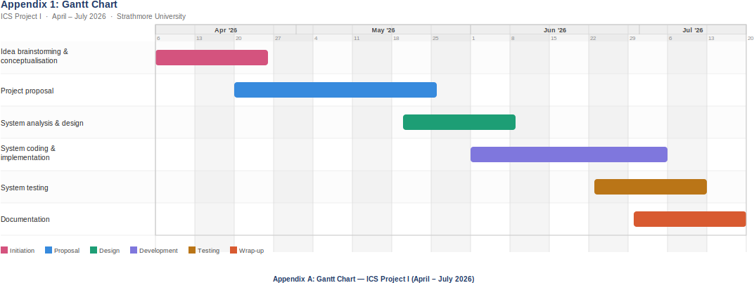

Appendix A: Gantt Chart

