Task 2
- Canny edge detection
steps :
- Apply sobel filter in x & y direction to get magnitude and direction.
- Pass magnitude and direction to non-maximum suppression to get largest value in the gradient direction.
[Function prototype] :
Image cannyNonMaxSuppression(Image &mag, Image &dir);
[Parameters] :
mag → magnitude values of the image from sobel.
dir → direction values of the image from sobel.
- Apply hysteresis threshold to convert image to binary image.
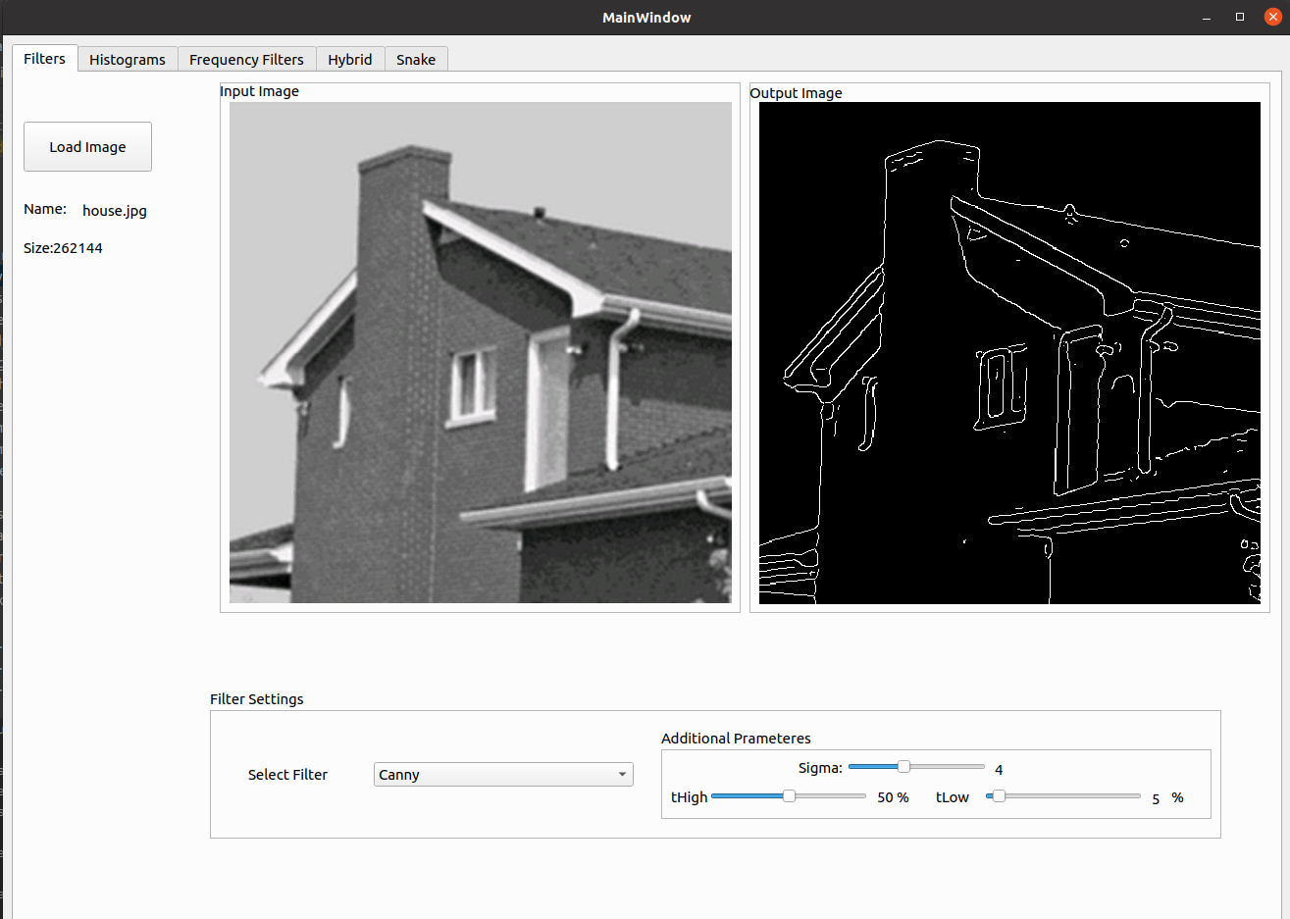
[Function prototype] :
Image cannyEdgeLink(int tHigh, int tLow, Image& image);
[Parameters] :
tHight→ high threshold of the image.
tLow → low threshold of the image.
Image → image to apply threshold on.

- Hough line detection
steps :
  - Check for image white pixels and loop through them to get possible lines passes by each point to form hough space and get votes for each line.
[Function prototype] :
HoughLineTransformData houghLineTransform(Image &bw, float thetaStep, float rohStep);
[Parameters] :
bw → output image after applying canny filter.
thetaStep → theta resolution.
rohStep → roh resolution.
[Returns] :
HoughLineTransformData which is struct contain votes, roh and theta arrays.
  - Sort the votes array and gets specified number of peaks.
[Function prototype] :
std::vector<_Point> linePeaks(Image &houghImage, int peaksNum)
[Parameters] :
houghImage→ votes array of hough space
peaksNum → number of peaks to return
[Returns] :
vector of peaks
  - Get lines from previous step and check for lines if true or not.
[Function prototype] :
std::vector<std::vector<_Point>> houghLines(Image &bw, std::vector<_Point> &peaks, std::vector<double> &thetaV, std::vector<double> &rohV, int maxGap);
[Parameters] :
bw → output image after applying canny filter.
Peaks → peaks from the previous step.
thetaV → array of theta of hough space.
rohV → array of roh of hough space.
maxGap → maximum distance allowed between two points on same line.

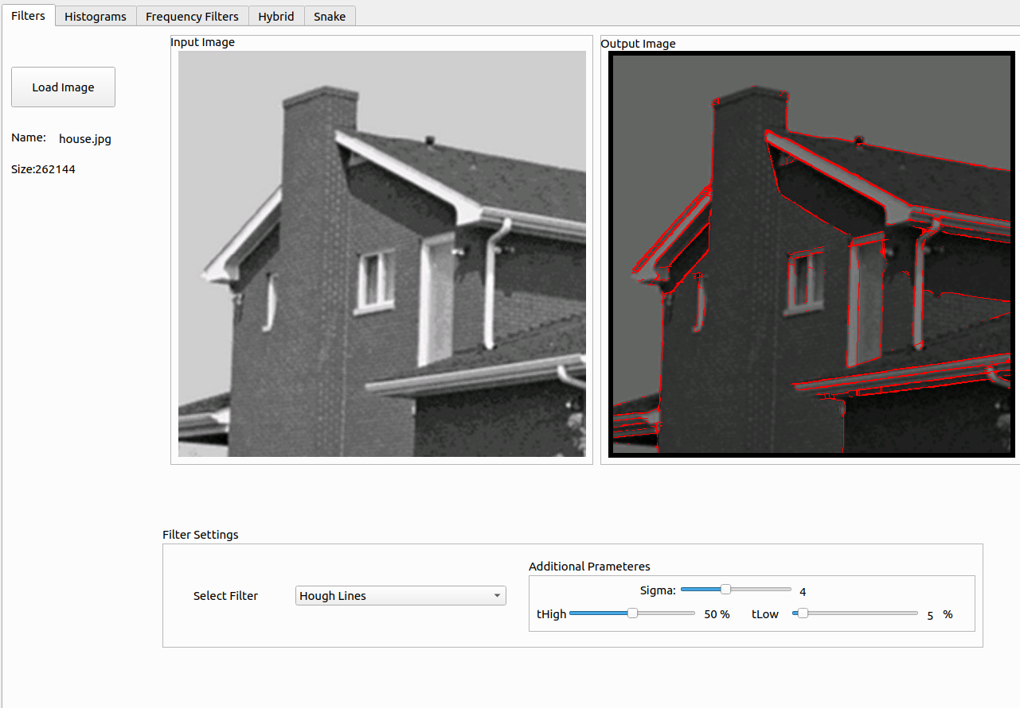

- Hough circle detection
steps :
  - Check for image white pixels and loop through them to get possible circles passes by each point for each radius to form hough space and get votes for each circle.
  - Then check votes which exceed threshold for reach radius.
  - Then use binary image to get the true circles.

[Function prototype] :
std::vector<Circle> houghCircles(Image &bw, std::pair<int, int> rohRange, int threshold)

[Parameters] :
bw → binary image

rohRange → range of circle radius

threshold → minimum acceptable number of votes for a circle

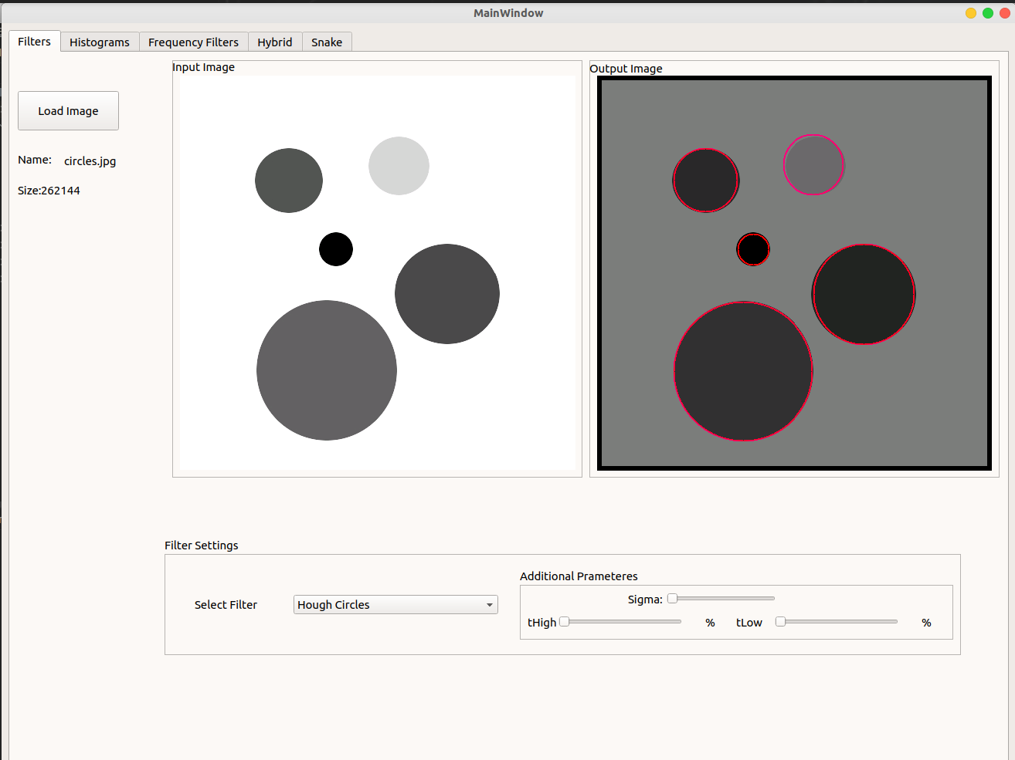
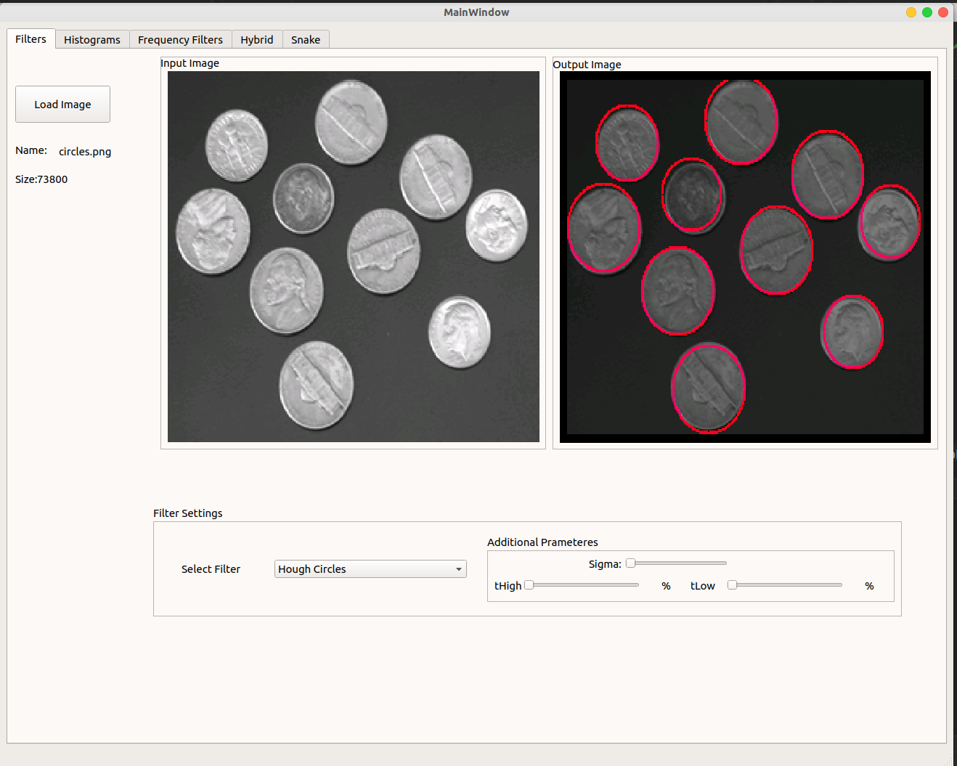

Active Contour (Sanke) :

we use greedy algorithm snake energy calculated :
E_{snake}(x, y) = α(s_{i})E_{ela} (x, y) + β(s_{i})E_{curv}(x, y) + γ(s_{i})E_{img}(x, y) ,

Where E_{ela}(x, y) is the elasticity energy, E_{curv}(x, y) is the curvature energy, E_{img}(x, y) is the image energy and (x, y) are the indices to the points in the neighborhood and (s) is the parametric representation of curve

- E_{ela}(x, y) :

E_{ela}(x, y) = d - || v(s_{i}) – v(s_{i} -1)|| ,

Where where (d) is the average distance between all the points in the snake, and v(s_{i}) is the point under study and
v(s_{i} -1) is the previous point on snake.

- E_{curv}(x, y) :

E_{curv}(x, y) = ||v(s_{i} +1 ) − 2v(s_{i}) + v(s _{i} −1 )||² .

- E_{img}(x, y) :

E_{img} = ||∇[G σ (x, y) ∗ I(x, y)]||²

Where ∇ is the gradient , G σ (x, y) represent guassian filter , I(x,y) represent the image.
Functions used :
in file → greedy_snake.cpp & greedy_snake.h :

- currentPrevNextPointIndex() :
get the index of previous and next points index

- averageDistance() :
get the average distance between all snake points

- imageEnergy() :
get the image enaergy

- greedySnake() :
function that represent the actual snake steps
Note :
we use scale space continuation : first use large sigma for Gaussian filter then reduce it after that

Drawing contour (circle) in two steps :
- click with mouse to determine the location of the center :
preferred to click on center of object
- click with mouse to represent the radius of circle : outside the object

Output :
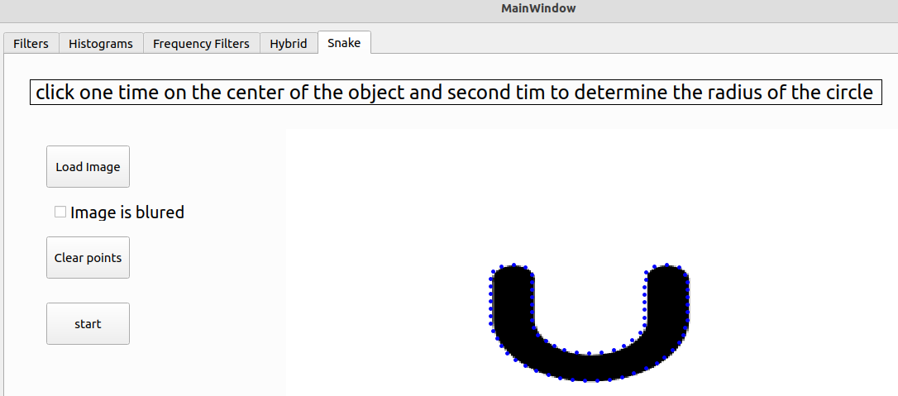
first test :
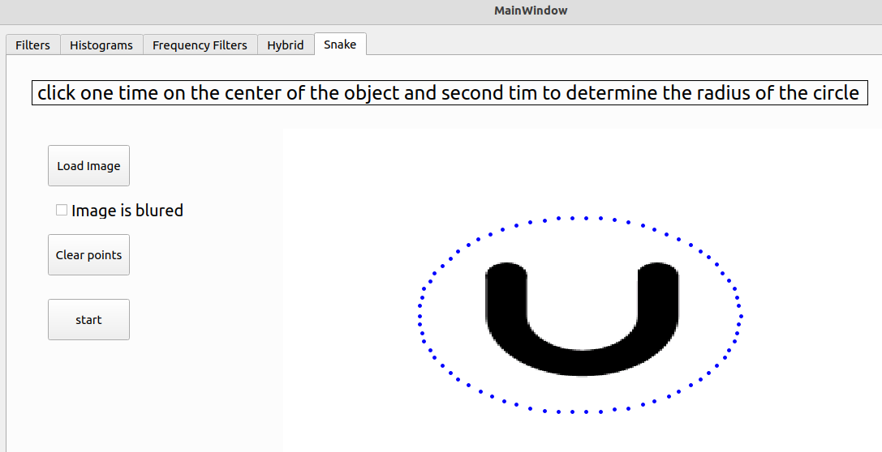
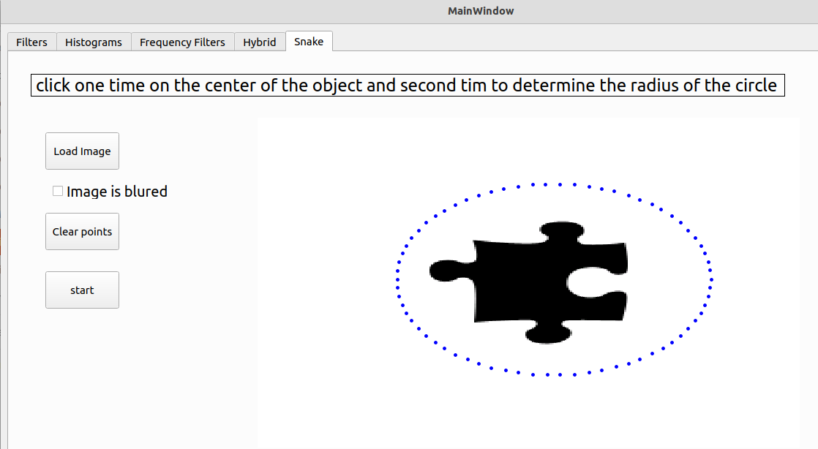
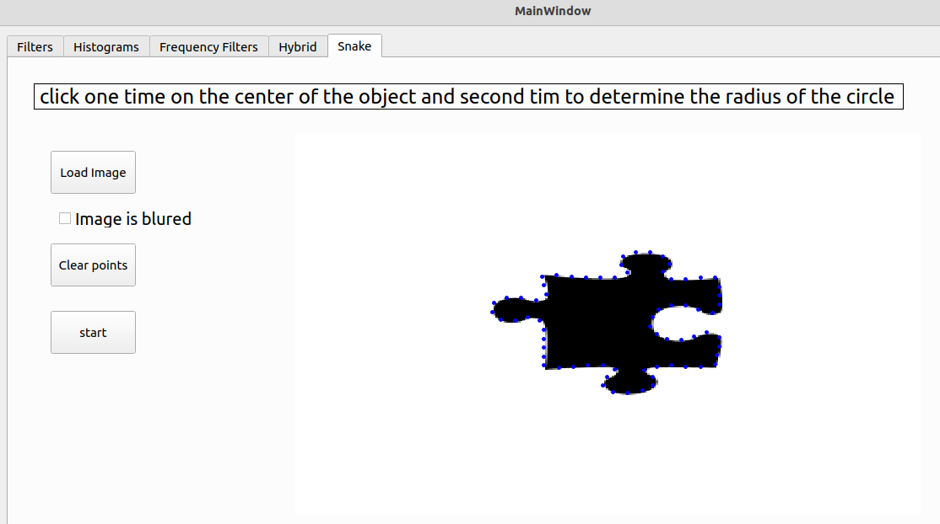
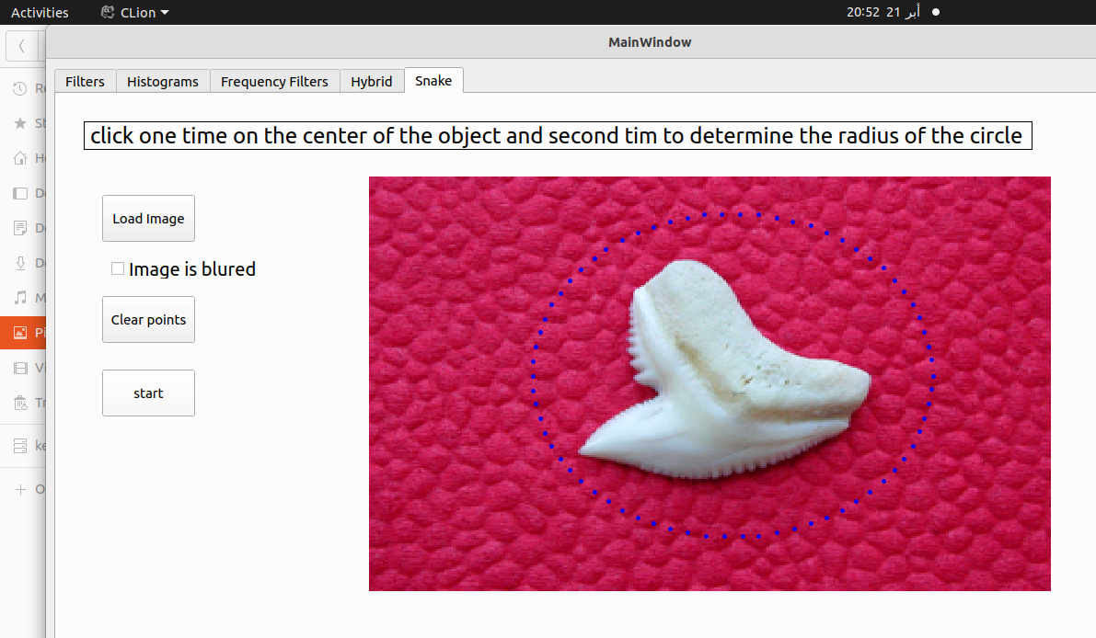
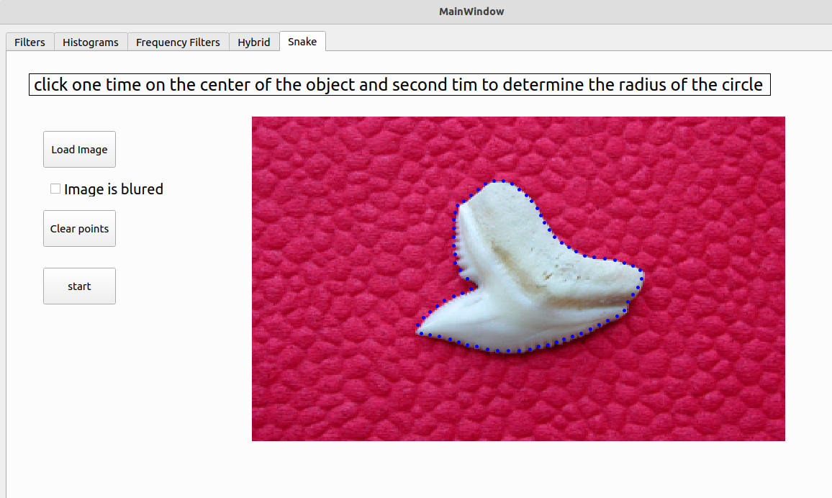
second test:

