Assignment 1
- Add additive noise
salt and papper noise
function prototype: Image saltPepper(Image &image, int count, int sizePixel);
image: reference to input image, count: number of points, sizePixel: size of each point
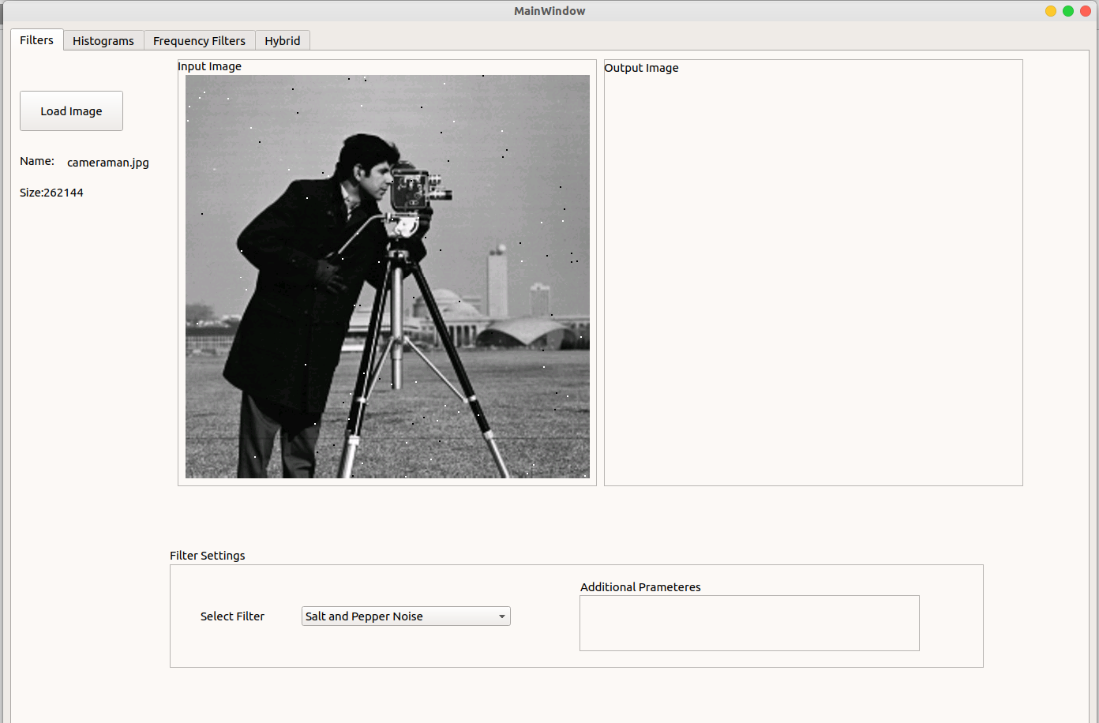
- Filtter using avg (7x7)
function prototype: Image avgFilter(Image &inputImg, char dim = 3)
dim: dimension of filter(dim x dim) square filter
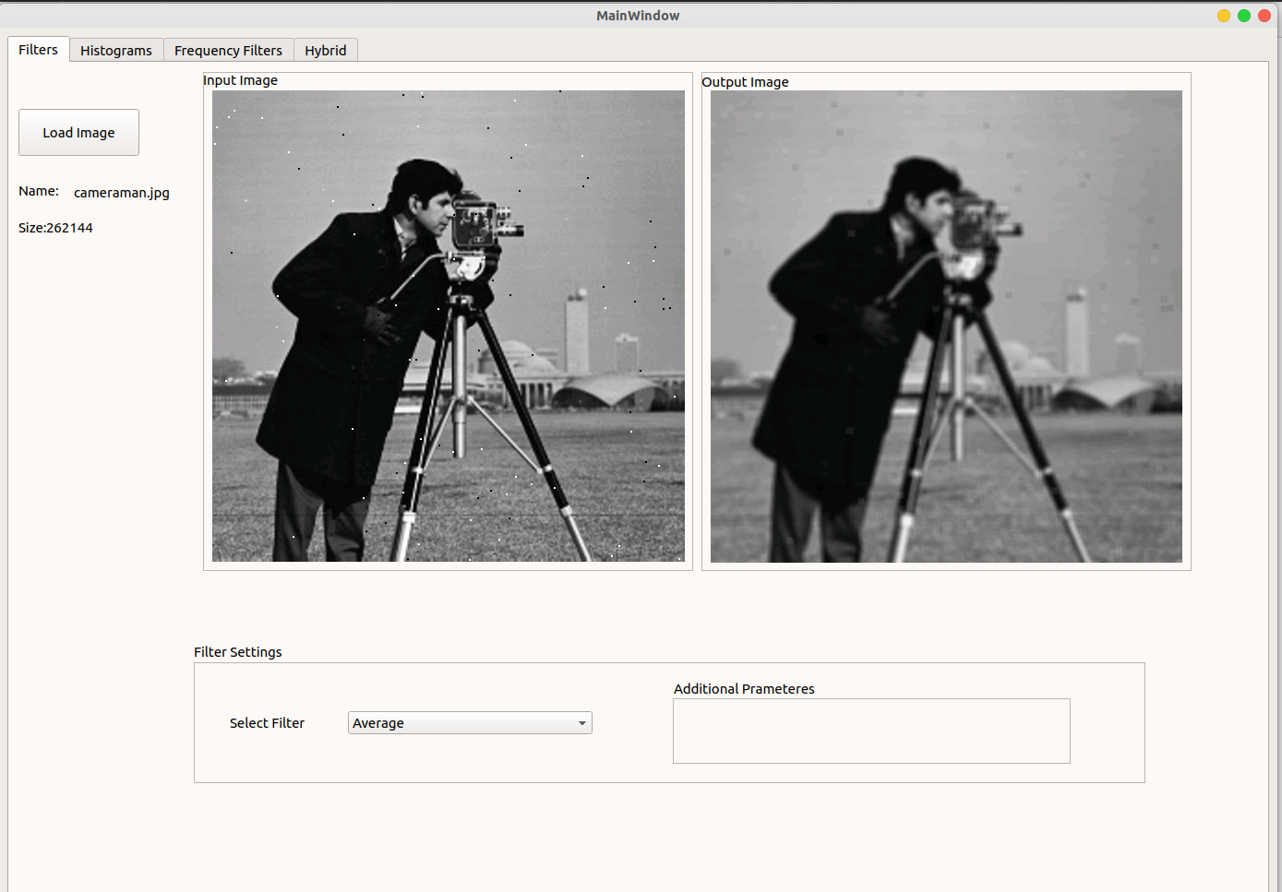
2. Filter using Gaussian(7x7)
function prototype: Image gaussianFilter(Image &inputImg, char dim = 3, float mean = 0, float sigma = 1)
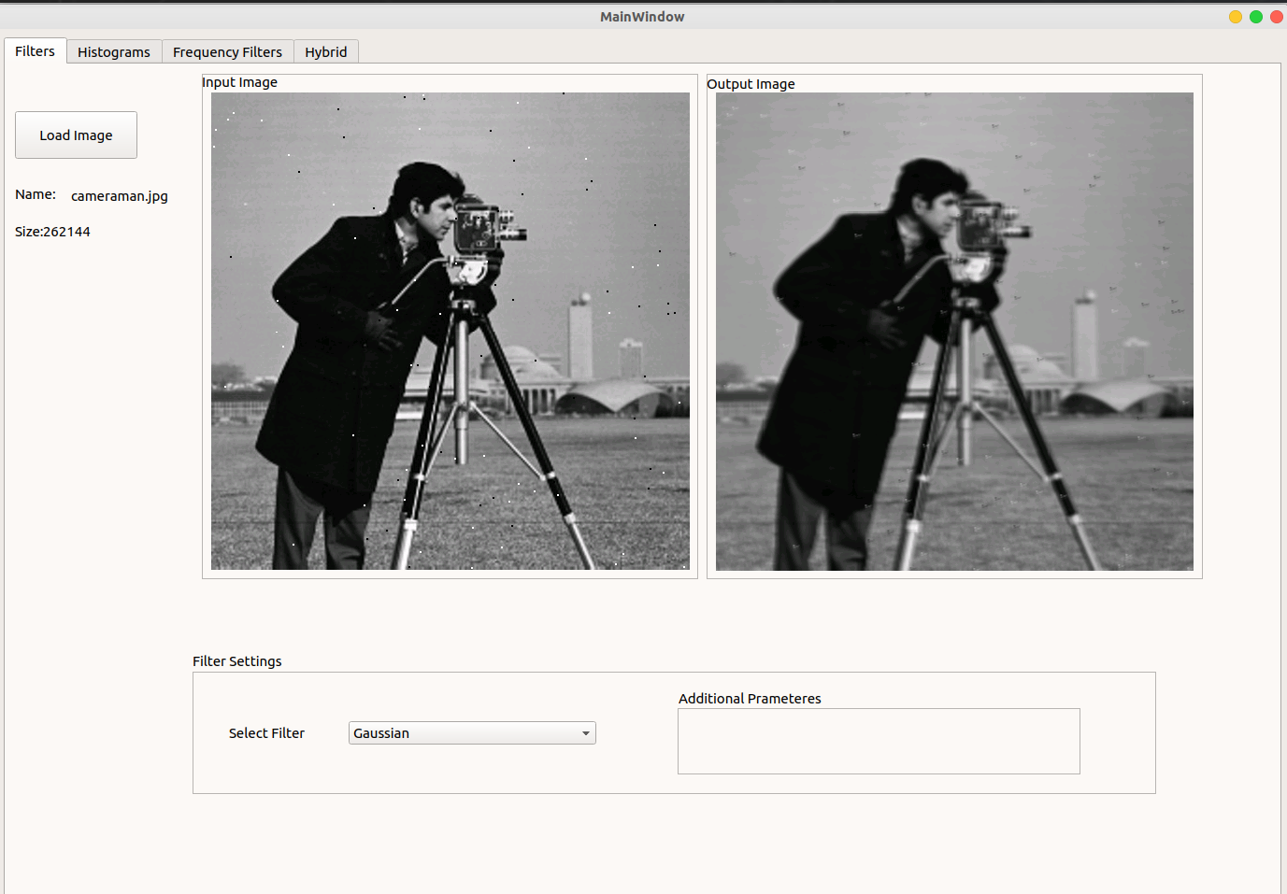
2. Filter using Median(7x7)
function prototype: Image medianFilter(Image &inputImg, int dim = 3)
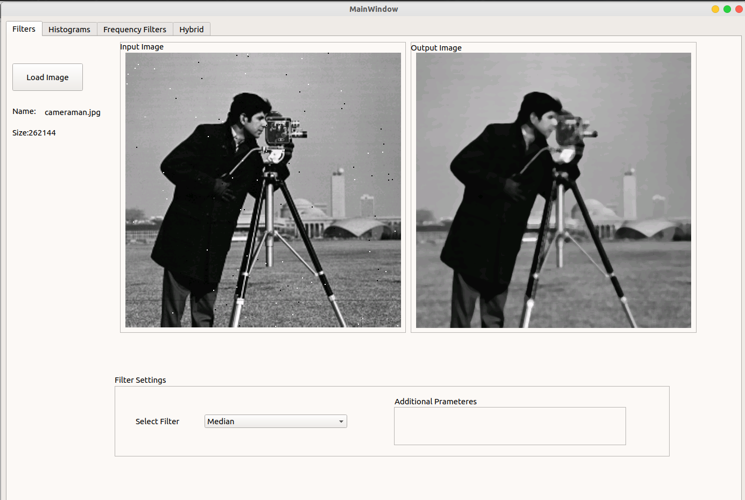
3. Detect edges using Sobel (3x3)
function prototype: Image sobelEdgeDetector(Image &inputImg)
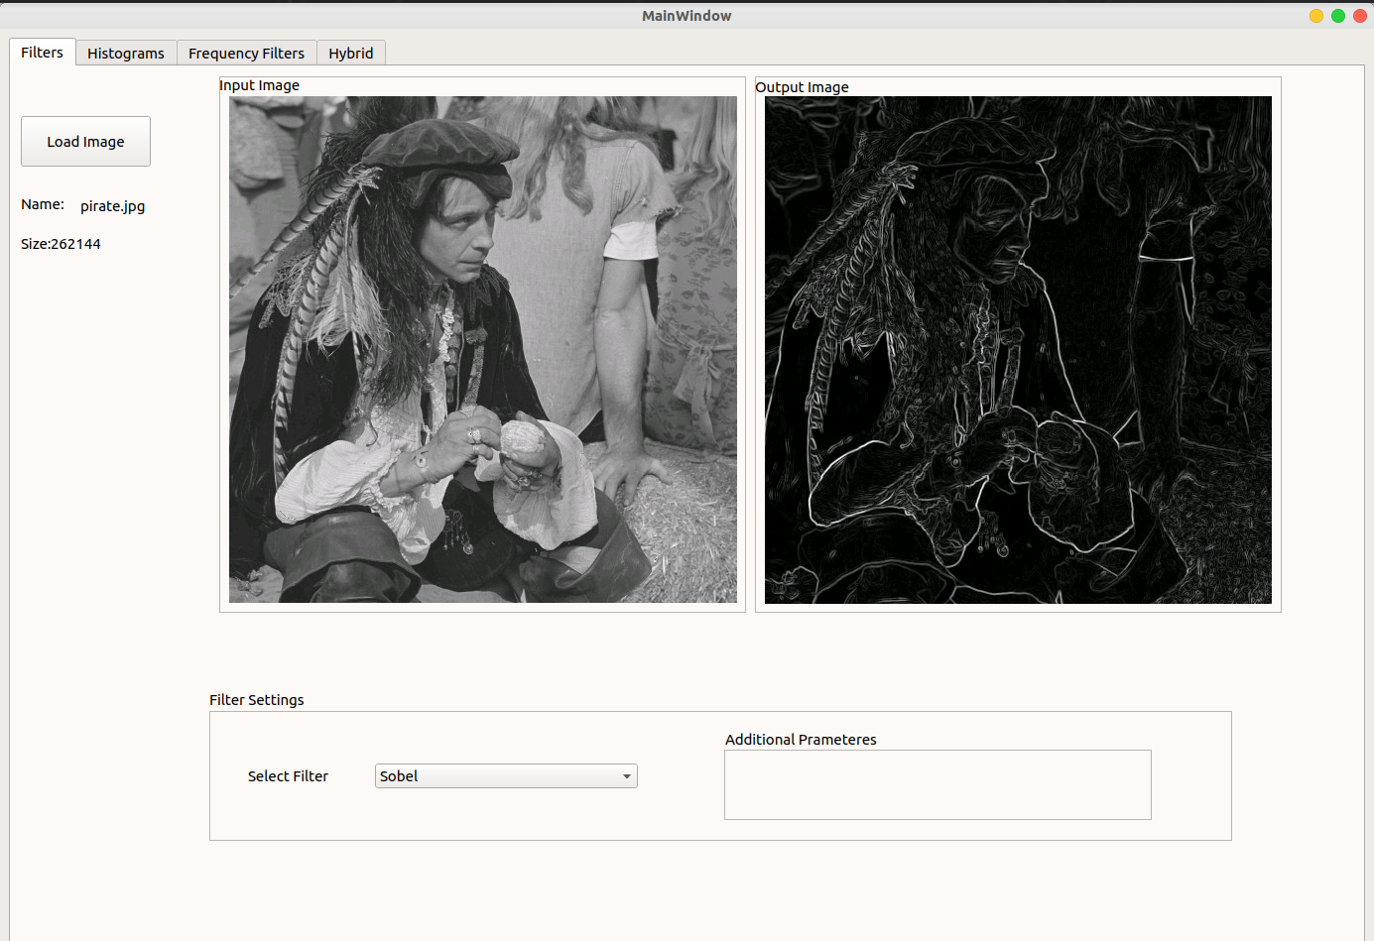
3. Detect edges using Prewitt(3x3)
function prototype: Image perwitEdgeDetector(Image &inputImg)
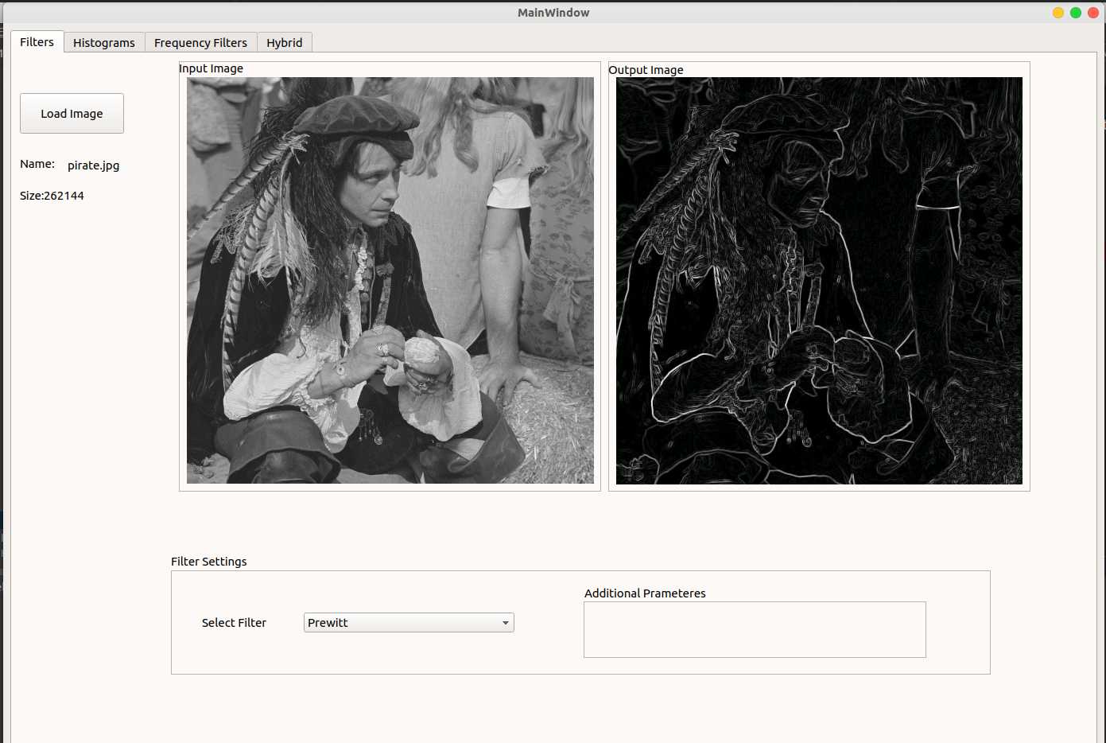
3. Detect edges using Roberts
function prototype: Image robertsEdgeDetector(Image &inputImg)
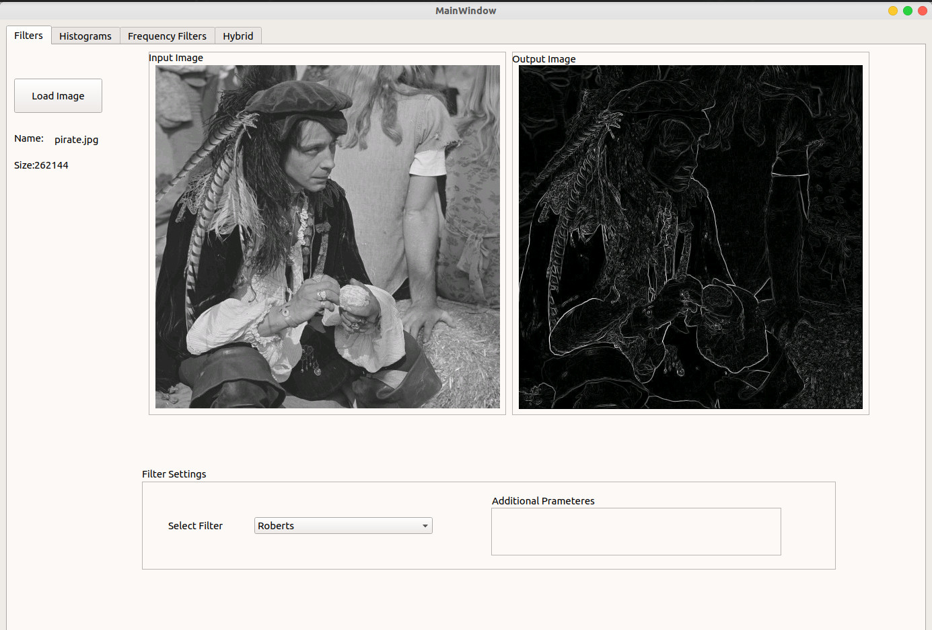

10. Hybrid Image
Gaussian Filter to Image A – Laplacian Filter to Image B

gaussianFilter(grayImage1) - laplacianFilter(grayImage2)

