**Part 1**

**User Stories:**

Summary: A user story is an informal, general explanation of a software feature written from the perspective of the end user. Its purpose is to articulate how a software feature will provide value to the customer.

1. As Boss, I want to invite my staff to my virtual space, so we can attend meeting.
2. As Employee, I want to invite my colleagues to present my work.
3. As a game user I invite my friends to my Virtual private room for a game.
4. As a shopkeeper I invite my customers to my online shop for selling my products.
5. As a Trainer I like to invite my students to my virtual class room to teach them.
6. As Sascha, I want to organize my work, so I can feel more in control.
7. As a manager, I want to be able to understand my colleagues progress, so I can better report our success and failures.
8. As a database administrator, I want to automatically merge datasets from different sources so that I can more easily create reports for my internal customers.
9. As a brand manager, I want to get alerts whenever a reseller advertises our products below agreed-upon prices so that I can quickly take action to protect our brand.
10. As the leader of a remote team, I want our team-messaging app to include file sharing and annotation so that my team can collaborate in real-time and keep an archive of their work in a single place.

**Use Cases:**

1. **Shopping**

Running an online store on Virtual Reality

1. Teaching

VR-based smart learning environment for teaching and Learning

1. Gaming

360° and 6DoF video streaming Interactive gaming Telepresence/Tactile VR

**UML Diagram**

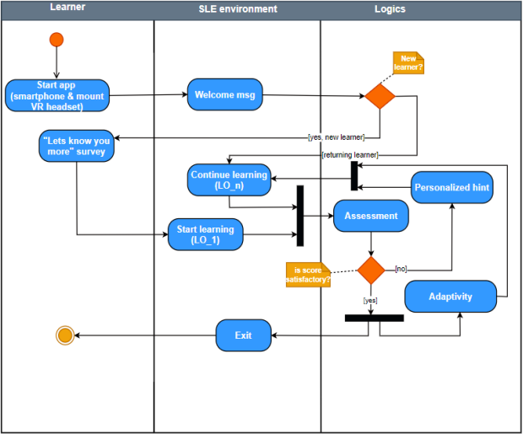

**Usability Requirements**

Interface Elements Should be easy to understand

The necessary information should be communicated across the expected range of user sensory abilities

System should be easy to learn and simple to use and used individually by the player

**Performance requirements**

High Capacity

Low Latency Computing

Low Latency Communication

**Reliability Requirements**

Establish the validity, intra- and inter-session reliability of the Wii Fit games in assessing balance

Establish the validity and reliability of WBB in assessing postural stability

Text Readability

Avoiding simulator sickness

**Plan for System Developers**

**Work break down:**

* Preproduction
* Prototyping
* Milestones
* Quality Assurance
* Distribution and Execution

**Critical Path**

**ABCDE**

* 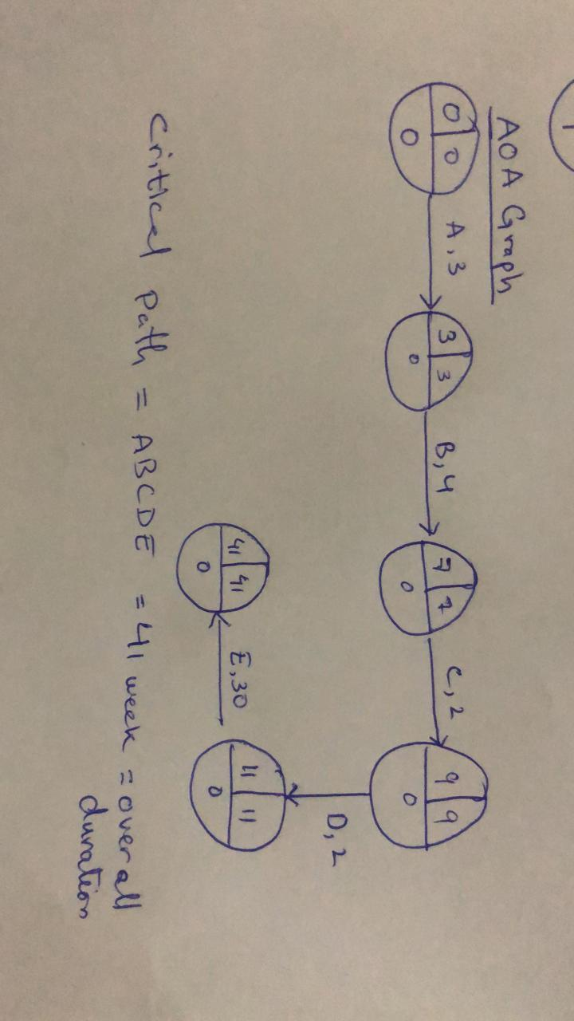

**Version Control:**

Distributed Version Control Architecture on Git.

One master/main branch and 5 sub branches.

Branch1: Front end Developer

Branch 2: Backend Developer

Branch 3: 3D Developer

Branch 4: Dev ops

Branch 5: Software Tester and QA

These branches should be created on the day when the project is setup on Git

These branches should be pushed when release date is near

Push on the release date

**Git commands:**

git clone

git checkout/b/branchname

git add .

git commit-m “message”

git push