Week 02 Assignment
IP Addressing (FLSM & VLSM) and VLAN Configuration


Submitted by:
Abdullah
Reg No NETB01-6847

Submitted to:
Network Administrator Crypto

Department of Network Administrator
IT Simplera Solutions Institute

Introduction
As modern computer networks continue to expand, efficient IP address management and network segmentation have become essential requirements for network administrators. Organizations need methods that allow them to utilize available address space effectively while maintaining performance, security, and scalability. Fixed Length Subnet Masking (FLSM), Variable Length Subnet Masking (VLSM), and Virtual Local Area Networks (VLANs) are fundamental technologies used to achieve these objectives. Understanding these concepts enables network professionals to design structured, efficient, and secure network infrastructures.

Fixed Length Subnet Masking (FLSM)
Fixed Length Subnet Masking is a subnetting technique in which all subnetworks are assigned the same subnet mask. Every subnet created from the original network contains an identical number of addresses and supports the same maximum number of hosts. This approach provides a simple and predictable network structure.
The primary advantage of FLSM is its simplicity. Since all subnets are identical in size, configuration, monitoring, and troubleshooting become straightforward. This method is commonly used in small networks where each department or segment requires approximately the same number of devices.
However, FLSM often leads to inefficient address utilization. If one subnet requires only ten hosts while another requires fifty hosts, both subnets still receive the same address allocation. Consequently, a significant number of addresses may remain unused.

Importance of FLSM in Network Design
FLSM provides a structured framework for dividing large networks into manageable segments. It helps reduce broadcast traffic, improves network organization, and simplifies administrative tasks. Although it is not the most efficient method for conserving IP addresses, it remains useful in environments where subnet requirements are uniform.

FLSM Subnetting Problems with Detailed Calculations
Problem 1
Given Network
IP Address: 192.168.1.0/24
Requirement: Create 4 Equal Subnets
Step 1: Determine Number of Subnets
Required Subnets = 4
Formula: 2ⁿ = Number of Subnets
2² = 4
Therefore:
Borrow 2 bits from the host portion.

Step 2: Original Network in Binary
IP Address:
192.168.1.0
Binary Form:
192 = 11000000
168 = 10101000
1 = 00000001
0 = 00000000
Therefore:
11000000.10101000.00000001.00000000
Original Prefix:
/24
Binary Subnet Mask:
11111111.11111111.11111111.00000000
Decimal:
255.255.255.0

Step 3: Borrow 2 Host Bits
Original:
11111111.11111111.11111111.00000000
After Borrowing 2 Bits:
11111111.11111111.11111111.11000000
Decimal:
255.255.255.192
New Prefix:
/26

Step 4: Calculate Number of Hosts
Remaining Host Bits:
8 − 2 = 6
Formula:
2⁶ − 2 = 64 − 2
= 62 Usable Hosts

Step 5: Find Block Size
Subnet Mask Last Octet: 192
Formula: 256 – 192 = 64
Block Size = 64
Subnet Increments:
0, 64, 128, 192

Step 6: Binary Representation of Subnets

Subnet 1
Network Address: 11000000.10101000.00000001.00000000
Decimal: 192.168.1.0
Broadcast Address: 11000000.10101000.00000001.00111111
Decimal: 192.168.1.63
Host Range: 192.168.1.1 – 192.168.1.62

Subnet 2
Network Address: 11000000.10101000.00000001.01000000
Decimal: 192.168.1.64
Broadcast Address: 11000000.10101000.00000001.01111111
Decimal: 192.168.1.127
Host Range: 192.168.1.65 – 192.168.1.126

Subnet 3

Network Address: 11000000.10101000.00000001.10000000
Decimal: 192.168.1.128
Broadcast Address: 11000000.10101000.00000001.10111111
Decimal: 192.168.1.191
Host Range: 192.168.1.129 – 192.168.1.190

Subnet 4
Network Address: 11000000.10101000.00000001.11000000
Decimal: 192.168.1.192
Broadcast Address: 11000000.10101000.00000001.11111111
Decimal: 192.168.1.255
Host Range: 192.168.1.193 – 192.168.1.254

Final Summary Table
Subnet | Network Address | First Host | Last Host | Broadcast Address
1 | 192.168.1.0 | 192.168.1.1 | 192.168.1.62 | 192.168.1.63
2 | 192.168.1.64 | 192.168.1.65 | 192.168.1.126 | 192.168.1.127
3 | 192.168.1.128 | 192.168.1.129 | 192.168.1.190 | 192.168.1.191
4 | 192.168.1.192 | 192.168.1.193 | 192.168.1.254 | 192.168.1.255

Variable Length Subnet Masking (VLSM)
Variable Length Subnet Masking is an advanced subnetting method that allows different subnet sizes within the same network. Unlike FLSM, VLSM allocates addresses according to the actual requirements of each subnet, ensuring efficient utilization of available IP space.
Suppose an organization owns the network 192.168.10.0/24 and has departments requiring 100, 50, and 25 hosts respectively. Using VLSM, the largest department receives a /25 subnet, the second receives a /26 subnet, and the third receives a /27 subnet. This approach minimizes address wastage and maximizes network efficiency.
VLSM follows a hierarchical design strategy. The largest subnet is allocated first, followed by progressively smaller subnetworks. This systematic allocation ensures that address blocks remain contiguous and manageable.

Importance of VLSM in Modern Networks
Modern enterprises rarely have departments of equal size. Some departments may require hundreds of devices, while others require only a few. VLSM accommodates these varying requirements without wasting valuable IP addresses. It is widely used in enterprise networks, service provider infrastructures, and large-scale organizational environments where efficient address management is essential.

VLSM Subnetting Problems with Detailed Calculations

Problem 1

Given Network
Network Address: 192.168.1.0/24
Host Requirements:
- HR Department = 100 Hosts
- IT Department = 50 Hosts
- Finance Department = 25 Hosts
- WAN Link = 2 Hosts

Step 1: Sort Host Requirements
Largest to Smallest: 100 Hosts, 50 Hosts, 25 Hosts, 2 Hosts
Step 2: Allocate Subnet for HR Department
Required Hosts = 100
Formula: 2⁷ − 2 = 126 Hosts
Subnet Needed = /25
Subnet Mask: 255.255.255.128
Network Address: 192.168.1.0/25
Host Range: 192.168.1.1 – 192.168.1.126
Broadcast Address: 192.168.1.127
Step 3: Allocate Subnet for IT Department
Required Hosts = 50
Formula: 2⁶ − 2 = 62 Hosts
Subnet Needed = /26
Subnet Mask: 255.255.255.192
Network Address: 192.168.1.128/26
Host Range: 192.168.1.129 – 192.168.1.190
Broadcast Address: 192.168.1.191
Step 4: Allocate Subnet for Finance Department
Required Hosts = 25
Formula: 2⁵ − 2 = 30 Hosts
Subnet Needed = /27
Subnet Mask: 255.255.255.224
Network Address: 192.168.1.192/27
Host Range: 192.168.1.193 – 192.168.1.222
Broadcast Address: 192.168.1.223
Step 5: Allocate Subnet for WAN Link
Required Hosts = 2
Formula: 2² − 2 = 2 Hosts
Subnet Needed = /30
Subnet Mask: 255.255.255.252
Network Address: 192.168.1.224/30
Host Range: 192.168.1.225 – 192.168.1.226
Broadcast Address: 192.168.1.227
Final Summary Table
Department | Network Address | Prefix | Host Range | Broadcast
HR | 192.168.1.0 | /25 | 192.168.1.1–126 | 192.168.1.127
IT | 192.168.1.128 | /26 | 192.168.1.129–190 | 192.168.1.191
Finance | 192.168.1.192 | /27 | 192.168.1.193–222 | 192.168.1.223
WAN | 192.168.1.224 | /30 | 192.168.1.225–226 | 192.168.1.227

Virtual Local Area Networks (VLANs)
A Virtual Local Area Network is a logical segmentation technology that divides a physical network into multiple independent broadcast domains. VLANs enable devices to communicate as though they are connected to the same physical network, even when they are located in different areas of a building or organization.
For instance, the Human Resources department, Finance department, and IT department may all connect to the same switch. By assigning each department to a separate VLAN, their traffic remains isolated, improving both security and performance.

Purpose of VLANs
The primary purpose of VLANs is to create logical separation within a network. This separation reduces unnecessary broadcast traffic and allows administrators to implement security policies more effectively. VLANs also simplify network management by allowing users to be grouped according to job functions rather than physical locations.

Advantages of VLANs
VLAN technology offers several significant benefits. It enhances security by restricting communication between different departments unless explicitly permitted. It improves network performance by limiting broadcast traffic to specific VLANs. VLANs also provide flexibility, allowing devices to be relocated without requiring major changes to the physical network infrastructure. Additionally, VLANs simplify network administration and support scalable organizational growth.

Relationship Between Subnetting and VLANs
Subnetting and VLANs are often used together in enterprise networks. Each VLAN is typically assigned its own IP subnet, creating clear boundaries between departments and services. This combination improves security, reduces congestion, and enables more efficient routing between network segments.

Configuring and Verifying VLANs on Switches Using Cisco Packet Tracer and GNS3
IP VLSM Subnetting and VLANS Topology Design and Implementation in Cisco Packet Tracer
As part of this assignment, a simple Virtual Local Area Network (VLAN) topology was designed and implemented to demonstrate basic network communication between multiple devices within the same VLANS. The topology consisted of two switch and 18 personal computers (PCs) connected through Ethernet cables . The switch acted as the central networking device, facilitating communication among all connected hosts and enabling efficient data exchange within the same VLANS. The purpose of creating this topology was to gain practical experience in network design, device connectivity, IP address configuration, and connectivity verification. By connecting multiple devices to a switch, it becomes possible to simulate a small office network environment where users can communicate and share resources over a common network infrastructure.
Devices Used & IP Address Configuration

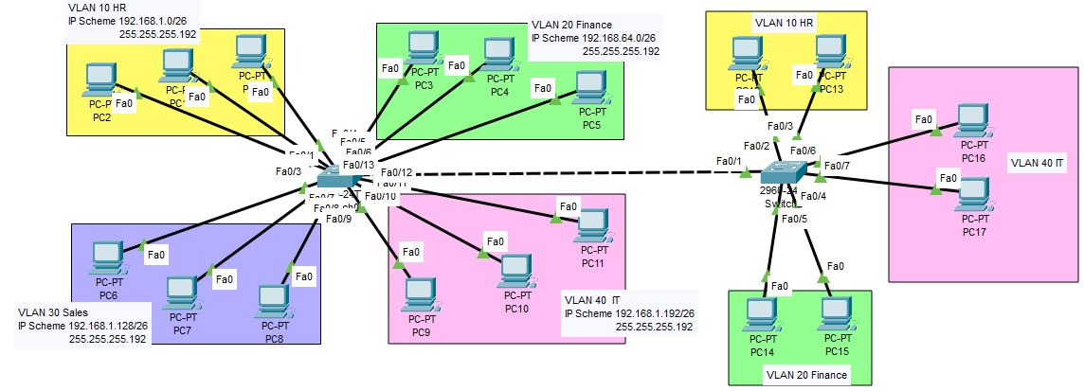

Working Principle of the Topology
The implemented network topology utilizes Virtual Local Area Networks (VLANs) and subnetting to logically divide the network into multiple departments while maintaining efficient communication and security. Two Layer 2 switches are connected through a trunk link, allowing VLAN information to be exchanged between switches.
Each VLAN is assigned a separate subnet:
VLAN | Department | Network Address
VLAN 10 | HR | 192.168.1.0/26
VLAN 20 | Finance | 192.168.1.64/26
VLAN 30 | Sales | 192.168.1.128/26
VLAN 40 | IT | 192.168.1.192/26
The switches operate at Layer 2 of the OSI model and forward data based on MAC addresses. When a device sends data to another device within the same VLAN, the switch examines the destination MAC address and forwards the frame only to the appropriate port. This process reduces unnecessary traffic and improves network efficiency.
The trunk link between the two switches carries traffic from multiple VLANs simultaneously using VLAN tagging. This allows devices belonging to the same VLAN to communicate with each other even when they are connected to different switches. For example, a PC in VLAN 10 connected to Switch 1 can successfully communicate with another PC in VLAN 10 connected to Switch 2 because the trunk link transports VLAN 10 traffic between both switches.
Since each VLAN belongs to a different subnet, devices in separate VLANs are isolated from one another and form separate broadcast domains. As a result, a device in VLAN 10 cannot directly communicate with a device in VLAN 20, VLAN 30, or VLAN 40 through the switches alone. Communication between different VLANs requires a Layer 3 device such as a router or Layer 3 switch configured for inter-VLAN routing.
As network communication occurs, the switches dynamically learn and store the MAC addresses of connected devices in their MAC address tables. This enables intelligent frame forwarding and ensures efficient communication within each VLAN.
By combining VLANs and subnetting, the topology improves network security, reduces broadcast traffic, simplifies network management, and allows departments to operate independently while sharing the same physical network infrastructure. This design is commonly used in enterprise networks to enhance scalability, performance, and administrative control.

VLAN Design Based on FLSM Subnets
VLAN | Subnet | Network Address | Subnet Mask | Host Range | Default Gateway | Broadcast Address
VLAN 10 | Subnet 1 | 192.168.1.0/26 | 255.255.255.192 | 192.168.1.1 – 192.168.1.62 | 192.168.1.1 | 192.168.1.63
VLAN 20 | Subnet 2 | 192.168.1.64/26 | 255.255.255.192 | 192.168.1.65 – 192.168.1.126 | 192.168.1.65 | 192.168.1.127
VLAN 30 | Subnet 3 | 192.168.1.128/26 | 255.255.255.192 | 192.168.1.129 – 192.168.1.190 | 192.168.1.129 | 192.168.1.191
VLAN 40 | Subnet 4 | 192.168.1.192/26 | 255.255.255.192 | 192.168.1.193 – 192.168.1.254 | 192.168.1.193 | 192.168.1.255

Connectivity Testing
After configuring the VLANs, assigning IP addresses, and establishing the trunk connection between the two switches, network connectivity was verified using the ping command. Connectivity tests were performed between devices belonging to the same VLAN and subnet to ensure successful communication across the network. The successful ping responses confirmed that:
- VLAN configuration was functioning correctly.
- The trunk link between the switches was operational.
- End-to-end communication had been established.
- Devices within the same VLAN could communicate successfully.
- Switches were forwarding traffic properly between connected hosts.

VLAN 10 (HR) CONNECTIVITY TESTING
A connectivity test was performed from PC1 (192.168.1.2) to PC12 (192.168.1.4) using the ping utility. The test returned successful replies from the destination host, indicating that packets were transmitted and received successfully without any loss. The successful result verified proper VLAN configuration, correct trunk operation, and reliable communication between devices belonging to VLAN 10 on different switches.
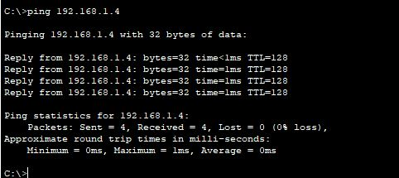

INTER-VLAN CONNECTIVITY TESTING
A connectivity test was performed from PC1 (VLAN 10) to PC6 (VLAN 30) using the ping command. The test failed and returned request timeout messages. This result was expected because VLAN 10 and VLAN 30 belong to different subnets and broadcast domains. Since no inter-VLAN routing device was configured, communication between different VLANs was not possible.
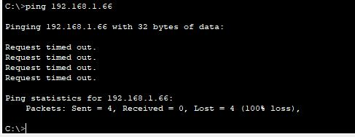
IP VLSM Subnetting and VLANS Topology Design and Implementation in GNS3
As part of this assignment, a simple Virtual Local Area Network (VLAN) topology was designed and implemented using GNS3 (Graphical Network Simulator-3) to demonstrate basic networking concepts and device communication in a virtual environment. The topology consisted of two Ethernet switch and four Virtual PCs (VPCS) interconnected through virtual Ethernet links. The switch served as the central networking device, enabling communication and data exchange among all connected hosts within the the same Vlans. The primary objective of creating this topology was to gain practical experience in network simulation, topology design, IP address configuration, and network troubleshooting using an industry-standard network emulation platform. GNS3 provided a realistic environment for testing network configurations without requiring physical networking equipment.
Devices Used & IP Address Configuration.
Each virtual PC was assigned a unique IPv4 address within the same network range. All devices were configured in the 192.168.10.0/26 network, allowing direct communication without the need for routing services but in the same vlans. The different subnet mask ensured that PC3 to PC4 broadcast domain and PC1 to PC2 broadcast domain.
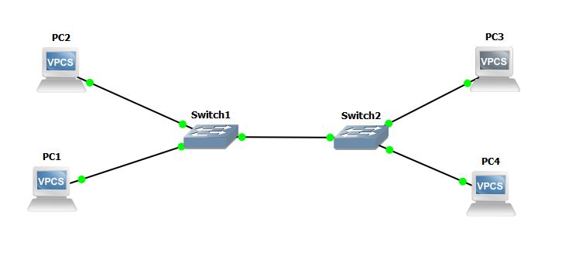
Working Principle of the Topology
The implemented network topology utilizes Virtual Local Area Networks (VLANs) and subnetting to logically divide the network into multiple departments while maintaining efficient communication and security. Two Layer 2 switches are connected through a trunk link, allowing VLAN information to be exchanged between switches.
Each VLAN is assigned a separate subnet:
VLAN | Department | Network Address
VLAN 10 | HR | 192.168.1.0/26
VLAN 20 | Finance | 192.168.1.64/26
The switches operate at Layer 2 of the OSI model and forward data based on MAC addresses. When a device sends data to another device within the same VLAN, the switch examines the destination MAC address and forwards the frame only to the appropriate port. This process reduces unnecessary traffic and improves network efficiency.
The trunk link between the two switches carries traffic from multiple VLANs simultaneously using VLAN tagging. This allows devices belonging to the same VLAN to communicate with each other even when they are connected to different switches. For example, a PC in VLAN 10 connected to Switch 1 can successfully communicate with another PC in VLAN 10 connected to Switch 2 because the trunk link transports VLAN 10 traffic between both switches.
Since each VLAN belongs to a different subnet, devices in separate VLANs are isolated from one another and form separate broadcast domains. As a result, a device in VLAN 10 cannot directly communicate with a device in VLAN 20, through the switches alone. Communication between different VLANs requires a Layer 3 device such as a router or Layer 3 switch configured for inter-VLAN routing.
As network communication occurs, the switches dynamically learn and store the MAC addresses of connected devices in their MAC address tables. This enables intelligent frame forwarding and ensures efficient communication within each VLAN.
By combining VLANs and subnetting, the topology improves network security, reduces broadcast traffic, simplifies network management, and allows departments to operate independently while sharing the same physical network infrastructure. This design is commonly used in enterprise networks to enhance scalability, performance, and administrative control.

Connectivity Testing
After configuring the VLANs, assigning IP addresses, and establishing the trunk connection between the two switches, network connectivity was verified using the ping command. Connectivity tests were performed between devices belonging to the same VLAN and subnet to ensure successful communication across the network. The successful ping responses confirmed that:
- VLAN configuration was functioning correctly.
- The trunk link between the switches was operational.
- End-to-end communication had been established.
- Devices within the same VLAN could communicate successfully.
- Switches were forwarding traffic properly between connected hosts.

VLAN 10 (HR) CONNECTIVITY TESTING
A connectivity test was performed from PC1 (192.168.1.2) to PC12 (192.168.1.4) using the ping utility. The test returned successful replies from the destination host, indicating that packets were transmitted and received successfully without any loss. The successful result verified proper VLAN configuration, correct trunk operation, and reliable communication between devices belonging to VLAN 10 on different switches.
