Assignment 2(Sprint 1)

# Fund. of SE

Team Members:  
Hamza Khan 20i-0583

Azka Asim 20i-2478

Abdullah Khan 20i-0894

# Modules Covered:

## Welcome Page

## Login Page

## Sign-up Page

## Homepage

# User Stories(Sprint 1):

## User Story #1:

### Title: Logging In and Signing Up

### Substory #1: Log-In

### Steps:

1. As a user, select the login button on his welcome page and the login page comes up.
2. As a user, selecting the login button, he may be greeted with two text boxes, one for the email, and another for the password.
3. There may be one checkbox below the password box clicking which as user will be shown his password which may other be hidden (***).
4. One button will be displayed below the checkbox for login through entered email and password.
5. As a user, select the login button, the details will be accepted and there will be a shift towards the home page of the application.

### Acceptance Criteria:

1. Entered information is verified to be present in the database during the time of login.
2. Once user information is verified during login and the user clicks the login button, the user will be redirected to the Homepage.

### Technical Details:

* On correct input, redirected to homepage.

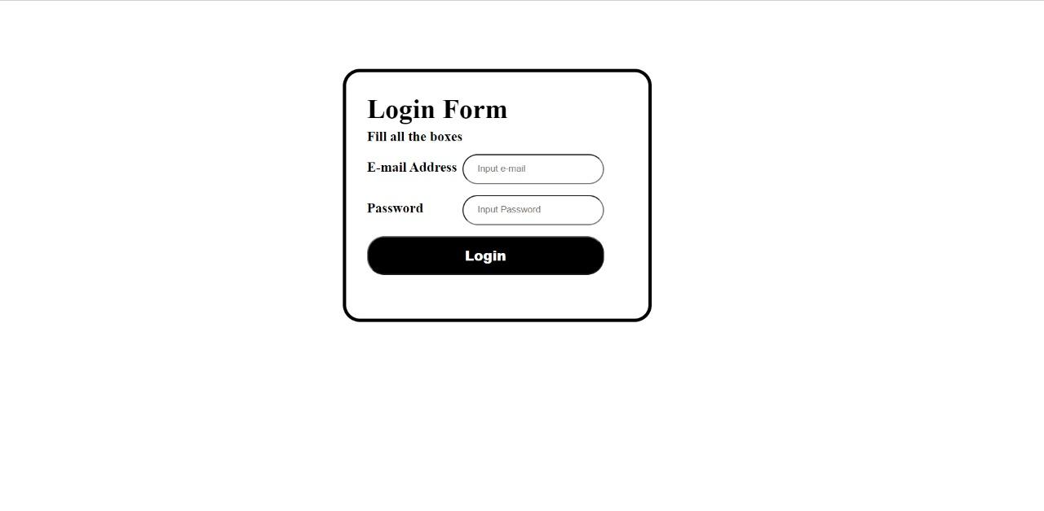

* On incorrect input, e.g. password not matching, or email address not in database, error message is displayed.

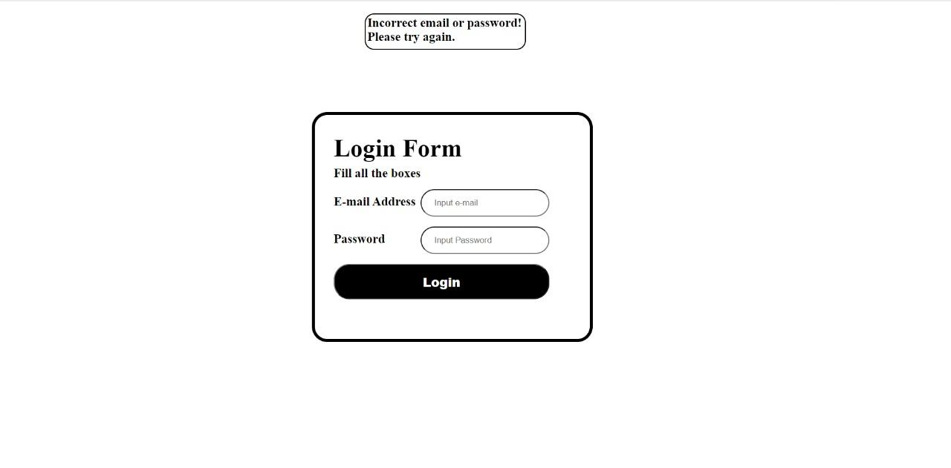

### Substory #2: Sign-Up

Steps:

1. As a user, select the signup button on his welcome page and the signup page comes up.
2. As a user, selecting the signup button, he may be greeted with five text boxes, one for the email, one for first name, one for last name, one for his phone number and the last one for password.
3. There may be one checkbox below the password box clicking which as user will be shown his password which may other be hidden (***).
4. As a user, after entering the details, I will click the signup button, the details will be accepted and there will be a shift towards the home page of the application.

### Acceptance Criteria:

### Person is able to sign-up using valid credentials.

1. Sign-up information is stored in the database.
2. Page redirects to Home page on successful signup.

### Technical Details:

* On correct input, redirected to homepage.

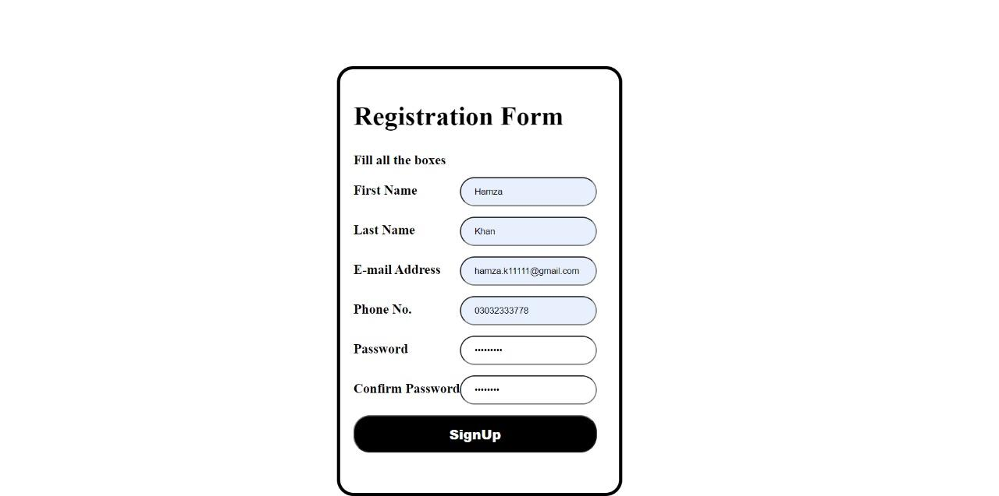

* On incorrect input, e.g. not all fields filled, an error message is displayed.

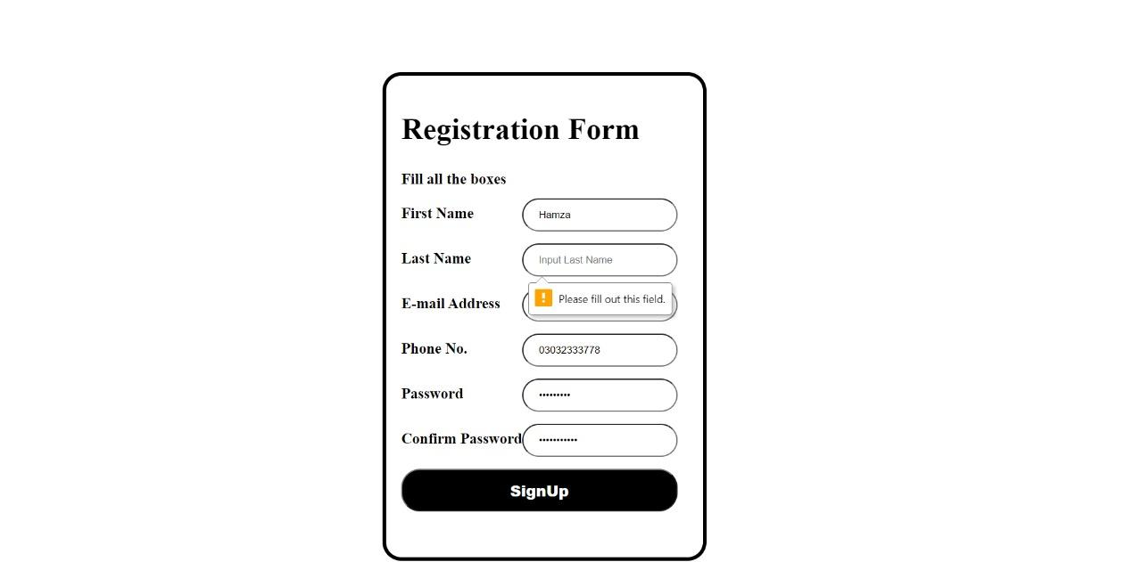

## User Story #2:

### Title: Homepage

### Steps:

1. As a user, select any of the given options on the homepage.
2. As a user, use the search bar for quick access to any of the features of the app.
3. As a user, touch your picture at the top to see your account details.

### Acceptance Criteria:

1. Users can click the search bar.
2. Users can scroll the page and click any of the buttons on the homepage.

### Technical Details:

* Homepage loads when the user is logged in.

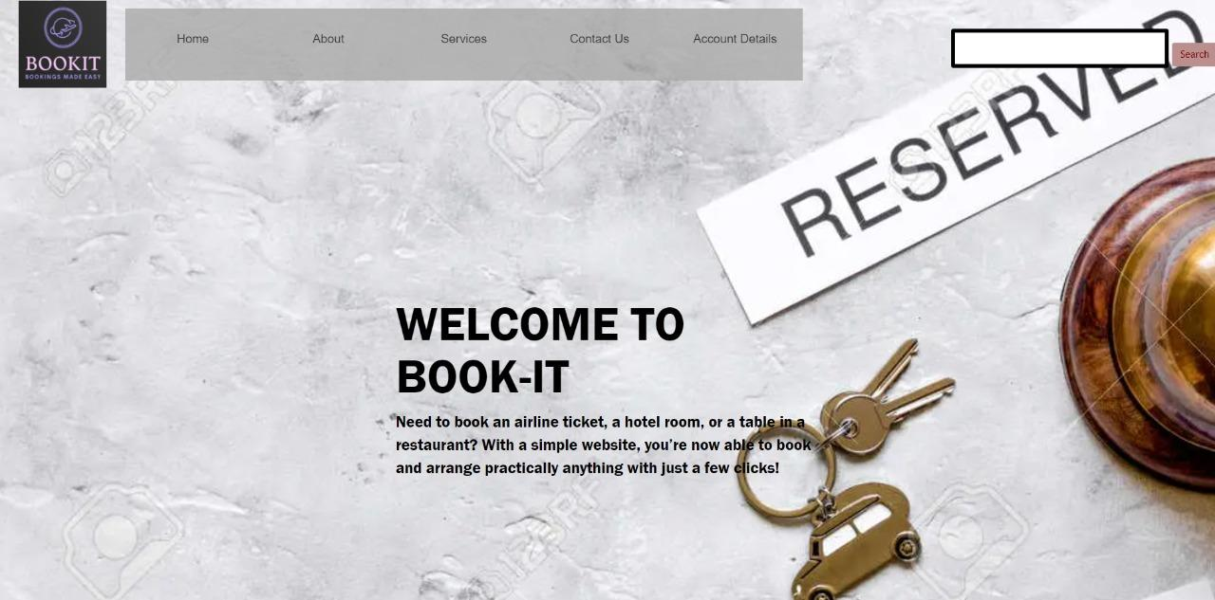

## User Story #3:

### Title: Welcome Page

### Steps:

1. Users are greeted with the welcome page.
2. User is shown two buttons, sign-up and login.
3. As a user, if I select the sign-up button, I will be redirected to the sign-up page, and if I select the login button, I will be redirected to the login page.

### Acceptance Criteria:

1. Users can click either of the two buttons and are redirected to the correct page.

### Technical Details:

### Welcome Page loads initially when website opened the first time.



# Kanban Boards(Sprint 1):

## Sprint Initial:

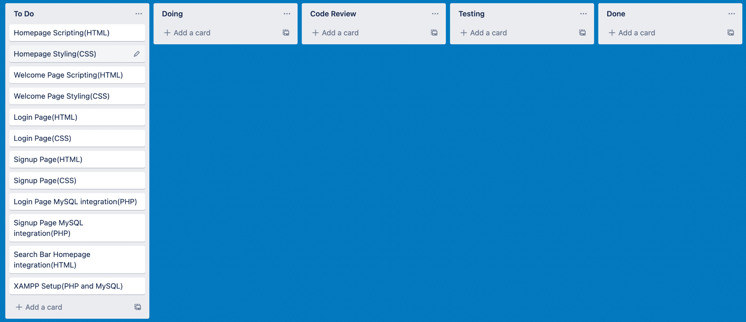

## Sprint Midway:

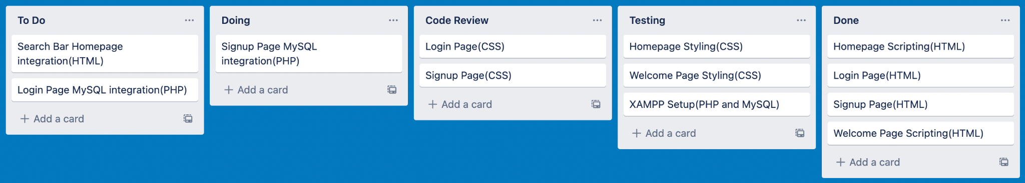

## Sprint Final:

