MAL Omics: Proteomics Analysis Report
COPDGene, SomaScan ($∼$4,979 proteins), $n=1,306$
Study. COPDGene is a longitudinal cohort study of current and former smokers enrolled at 21 US clinical centers. Subjects were seen at Phase 2 ($∼$2013–2017) and Phase 3 ($∼$2019–2022), approximately 5–6 years apart. Blood was drawn at Phase 2 and profiled by SomaScan, an aptamer-based platform that quantifies $∼$4,979 plasma proteins simultaneously as RFU (Relative Fluorescence Units). This analysis uses $n=1,306$ subjects with complete proteomics, phenotype, and MAL data.
MAL (Mechanically Affected Lung). Computed tomography (CT)-derived continuous score (range 0.01–0.40) measuring the fraction of lung volume under destructive mechanical stress. Higher MAL = more lung tissue under stress. MAL is computed from inspiratory/expiratory CT image registration and is distinct from standard emphysema measures (e.g., %LAA-950). Variable name in data: meanmal.
MAL is itself a strong predictor of who will develop worse emphysema over time: higher mechanical stress on lung tissue drives progressive structural damage. However, MAL requires specialized CT analysis and is not available from a routine blood draw.
Goal. (1) Identify which Phase 2 plasma proteins are associated with MAL, establishing that mechanical lung stress leaves a detectable signal in blood. (2) Use those proteins to build a Proteomic Risk Score (proRS) from a Phase 2 blood draw that approximates MAL and can predict who will develop worse emphysema by Phase 3. If successful, the proRS would allow MAL-like risk stratification without requiring CT image registration. The proteins themselves are not measured at Phase 3; they serve as baseline predictors of the CT density change that occurs between visits ($∼$6 years apart).
Outcome. Emphysema progression = change in CT lung density Phase 3 $−$ Phase 2 (Change_lung_density_vnb_P2_P3, Hounsfield Units [HU]). Negative = worsened. Mean $≈1$ HU (standard deviation [SD] 7) in this cohort; a negative value means the lung became less dense (more emphysematous) between visits.

Data Sources and Variable Names
Four CSV files were used. All joins are on sid.

data/csv_exports/prot.csv: SomaScan proteomics
Column | Description
sid | Subject identifier (join key)
X{seqID} | Raw RFU value for each protein (e.g. X10000.28). $∼$4,979 columns matching pattern ^X[0-9]. Renamed to log2_X{seqID} after log$​_{2}$ transform.

data/csv_exports/pheno_MAL.csv: Phenotypes and covariates
Column | Used as | Status
sid | Join key | Found
Change_lung_density_vnb_P2_P3 | Outcome: emphysema progression (HU) | Found
lung_density_vnb_P2 | Baseline lung density (HU) | Found
Age_P2 | Age (years) | Found
gender | Sex (coded 1/2) | Found
race | Race (coded 1/2) | Found
ATS_PackYears_P2 | Pack-years of smoking | Found
SmokCigNow_P2 | Current smoking (0/1) | Found
scanner_model_clean_P2 | CT scanner model | Found
FEV1_FVC_post_P2 | FEV$​_{1}$ (forced expiratory volume in 1 second) / FVC (forced vital capacity) ratio | Found
PC1 – PC5 | Ancestry principal components | Found
fev1_pp_gli_global_P2 | FEV$​_{1}$% predicted (GLI global reference) | Found
BMI_P2 | Body mass index | See CellData.csv below

data/Data/MAL.csv: MAL scores
Column | Description
sid | Subject identifier (join key)
meanmal | MAL score (continuous, range 0.01–0.40)

data/csv_exports/CellData.csv: Phase 2 BMI
Column | Used as | Note
sid | Join key
Phase_study | Phase filter | Rows with Phase_study == 2 used
BMI | BMI_P2 in analysis | All 1,306 analysis subjects present, no missingness

data/csv_exports/metadat5k.csv: Protein annotation
Column | Description
seqID | Protein sequence identifier; joins to log2_X{seqID}
EntrezGeneSymbol | HGNC (HUGO Gene Nomenclature Committee) gene symbol (e.g. ADIPOQ)
Target | Short protein name (e.g. Adiponectin)
TargetFullName | Full protein name
Join logic. Three-way inner join: prot $⋈_{\text{sid}}$ pheno $⋈_{\text{sid}}$ MAL. Metadata joined on seqID = sub("^log2_X", "", predictor).
File sizes: prot.csv has 5,670 subjects; MAL.csv has 5,024 subjects; pheno_MAL.csv has 10,652 subjects. After the 3-way inner join on sid: $n=4,630$.
Complete-case filter then requires non-missing values for all of: Change_lung_density_vnb_P2_P3 (Phase 3 outcome), lung_density_vnb_P2, meanmal, Age_P2, gender, race, ATS_PackYears_P2, SmokCigNow_P2, scanner_model_clean_P2, fev1_pp_gli_global_P2, FEV1_FVC_post_P2, and PC1–PC5.
This reduces the sample to $n=1,306$. The large drop ($4,630→1,306$) is driven primarily by the Phase 3 outcome: 8,912 of 10,652 subjects in pheno_MAL.csv (84%) have no Phase 3 CT scan recorded, meaning they did not return for the follow-up visit $∼$6 years later.

Table 1: Demographics
Study population after 3-way merge (proteomics $×$ phenotype $×$ MAL) and complete-case filtering.
Table 1. Baseline characteristics of COPDGene participants included in the proteomics analysis ($n=1,306$). Subjects had complete SomaScan plasma proteomics, phenotype data, and MAL score. Continuous variables: mean (SD); categorical: $n$ (%). MAL (Mechanically Affected Lung) = CT-derived score (range 0.01–0.40); higher values indicate more lung under destructive mechanical stress. Emphysema progression = CT lung density at Phase 3 minus Phase 2 ($ρ_{\text{P3}}−ρ_{\text{P2}}$, HU); negative values indicate worsening.
Characteristic | Overall ($n=1,306$)
Demographics
Age (years) | 65 (8)
Sex: male / female | 633 (48%) / 673 (52%)
Race: White / Black | 991 (76%) / 315 (24%)
Smoking
Current smoker | 445 (34%)
Pack-years | 43 (23)
Pulmonary function
FEV₁% predicted (GLI global) | 83 (24)
FEV₁/FVC | 0.69 (0.14)
CT imaging
Lung density Phase 2 (HU) | 83 (23)
MAL score | 0.04 (0.05)
Emphysema progression (HU) | 1 (7)
Anthropometrics
BMI (kg/m²) | 29 (6)
Note. Sex is coded 1/2 in the data; assumed Male/Female per COPDGene convention. Race coded 1/2; assumed White/Black. Emphysema progression mean of 1 HU (SD 7) reflects a near-zero mean; the distribution includes both progressors (negative $Δρ$) and improvers (positive $Δρ$).

Figure 1: Study Design
Requires a schematic (e.g., BioRender) illustrating the analysis flow: SomaScan proteomics $→$ differential expression $→$ GSEA (Gene Set Enrichment Analysis) / STRING $→$ adaptive LASSO (Least Absolute Shrinkage and Selection Operator) proRS (Proteomic Risk Score) $→$ emphysema progression association $→$ causal mediation.
Overview of the COPDGene MAL omics analysis pipeline. SomaScan plasma proteomics ($∼$4,979 proteins, Phase 2) are used to identify proteins associated with MAL (differential expression, GSEA, STRING network), build a proteomic risk score (adaptive LASSO), test whether the score predicts emphysema progression (Phase 3 minus Phase 2 CT density), and quantify mediation of the MAL effect through blood proteins (causal mediation analysis).

Figure 2: Protein Expression Landscape of MAL

A. Volcano Plot (protein $∼$ MAL)
Each dot is one protein. The $x$-axis ($\hat{β}$) shows how much a protein changes per one-unit increase in MAL after adjusting for age, sex, race, smoking, pack-years, BMI, scanner, and ancestry PCs. Positive $\hat{β}$ = protein is higher with more mechanical lung stress; negative = lower. $\hat{β}$ is defined as the change in log$​_{2}$ protein per one-unit increase in MAL. But MAL only ranges from 0.01 to 0.40 in this cohort, so a one-unit change never actually occurs. To express the effect in realistic terms, multiplying $\hat{β}$ by the full MAL range ($0.40−0.01=0.39$) gives the maximum expected protein change across the entire observed spread of MAL. For TNNT2 (Troponin T, the most significant protein): $0.227×0.39≈0.09$ log$​_{2}$-unit shift from the lowest to the highest MAL subject. The $y$-axis ($−\log_{10}$ $p$-value) is confidence: higher = more significant. The dashed horizontal line marks the FDR $<0.05$ threshold on the $p$-value scale. Dots above the threshold are coloured red (enriched) or blue (depleted); grey dots did not reach significance. A dot far right and high = reliably elevated with more MAL. A dot far left and high = reliably lower with more MAL.
How calculated. For each of 4,979 proteins:
$$\log_{2}(\text{protein}) ∼ β_{\text{MAL}}⋅\text{meanmal} + \text{age}+\text{sex}+\text{race}+\text{pack-years}+\text{smoking}+\text{BMI}+\text{scanner}+\text{PC1–PC5}$$
${\hat{β}}_{\text{MAL}}$ = change in log$​_{2}$ protein level per one-unit increase in MAL. FDR correction (Benjamini–Hochberg) across all 4,979 tests. FEV$​_{1}$% predicted is intentionally excluded: airflow obstruction lies on the causal pathway from mechanical stress to lung damage, so adjusting for it would remove the signal of interest.
Key result. 14 of 4,979 proteins significant at FDR $<$ 0.05 (6 positively associated, 8 negatively associated).
Differential plasma protein expression associated with Mechanically Affected Lung (MAL) score in COPDGene participants ($n=1,306$; 4,979 SomaScan proteins). Each point is one protein. $x$-axis: regression coefficient ($\hat{β}$) for log$​_{2}$ protein level per unit MAL, adjusted for age, sex, race, pack-years, smoking, BMI, CT scanner, and ancestry PCs (PC1–PC5). $y$-axis: $−\log_{10}$($p$-value); dashed line = FDR $<0.05$ threshold. Red = FDR $<0.05$, positively associated; blue = FDR $<0.05$, negatively associated; grey = not significant. Top 20 proteins by FDR labelled. 14 proteins reached FDR $<0.05$ (6 positively, 8 negatively associated with MAL).
Top enriched (higher with more MAL, FDR $<0.05$): TNNT2 (Troponin T, $β=0.23$), CRP ($β=0.35$), TIMP4 ($β=0.15$), LILRA5 ($β=0.12$), INHBB ($β=0.15$), PAK7 ($β=0.11$).
Top depleted (lower with more MAL, FDR $<0.05$, ordered by FDR): CACNA2D3 ($β=−0.13$), CNTN1 (contactin-1, $β=−0.06$), AGER (sRAGE, $β=−0.28$), COMP ($β=−0.17$), EDIL3 ($β=−0.21$), LPO ($β=−0.18$), ANTXR2 ($β=−0.11$), MRC2 ($β=−0.09$).

A2. Sensitivity Analysis: Adjusting for CAD and CHF
Several MAL-associated proteins (e.g., TNNT2, CRP) are established cardiovascular biomarkers, raising the question of whether the observed signals reflect cardiovascular comorbidity rather than mechanical lung injury. To evaluate this, the primary differential expression analysis was repeated with two additional covariates: history of coronary artery disease (CAD; CoronaryArtery_P2) and history of congestive heart failure (CHF; congestheartfail_slv_P2), both ascertained at the Phase 2 visit from CellData.csv. CAD and CHF data were complete for all $n=1,306$ analysis subjects (CAD: 7.5%, $n=98$; CHF: 1.1%, $n=15$).
The model for each protein was:
$$\log_{2}(\text{protein}) ∼ \text{MAL}+\text{age}+\text{sex}+\text{race}+\text{pack-years}+\text{smoking}+\text{BMI}+\text{scanner}+\text{PC1–PC5}+\text{CAD}+\text{CHF}$$
Results are saved to mal_de_sensitivity_cad_chf.csv.
Result. All 14 proteins significant in the primary analysis remained significant at FDR $<0.05$ after CAD/CHF adjustment (100% overlap; 0 proteins lost). Regression coefficients were virtually unchanged (median absolute $Δ\hat{β}=1.1\%$; $r=1.00$ between primary and adjusted estimates), indicating that MAL-associated protein signals are not explained by prevalent cardiovascular disease.

B. GSEA Barplot
GSEA asks whether an entire biological pathway shows a coordinated shift with MAL, rather than asking protein by protein. Each bar is one significant pathway. Bar pointing right (NES $>0$): the pathway’s proteins are on average higher in plasma with higher MAL. Bar pointing left (NES $<0$): lower. Longer bar = stronger shift. NES of $±2$ is a strong, consistent signal. padj is the Benjamini–Hochberg adjusted $p$-value across all pathways tested; only bars with padj $<0.05$ are shown.
How calculated. All 4,979 proteins ranked by their MAL $t$-statistic (most positively associated at top, most negatively at bottom). Gene sets tested: Hallmark, KEGG Legacy, Reactome (gene-set sizes 15–500).
NES (Normalized Enrichment Score): measures whether a gene set’s members concentrate at the top or bottom of the ranked list. NES $>0$ = enriched in high-MAL subjects; NES $<0$ = depleted. Normalization accounts for gene-set size so scores are comparable across pathways.
padj (adjusted $p$-value): fgsea tests hundreds of pathways at once. Without correction, many would appear significant by chance. padj is the Benjamini–Hochberg correction applied within each gene set collection (Hallmark, KEGG, Reactome separately). A padj $<0.05$ means fewer than 5% of pathways at this threshold are expected to be false positives. Only pathways with padj $<0.05$ are shown in the barplot.
Results. 11 pathways significant (padj $<0.05$). Eight are depleted (NES $<0$): glycosaminoglycan/keratan sulfate metabolism, carbohydrate and lipid metabolism, biological oxidations, branched-chain amino acid degradation, and fatty acid metabolism. Three are enriched (NES $>0$): antimicrobial peptides, chemokine receptor signalling, and complement/coagulation cascades (inflammatory/immune). Higher MAL is associated with lower circulating metabolic proteins and higher inflammatory proteins.
Gene Set Enrichment Analysis (GSEA): significant pathways associated with MAL. Proteins ranked by MAL $t$-statistic ($n=4,979$) and tested using fgsea against Hallmark, KEGG Legacy, and Reactome gene sets (sizes 15–500). NES = Normalized Enrichment Score; NES $>0$ = pathway proteins higher in high-MAL subjects (enriched); NES $<0$ = lower (depleted). padj = Benjamini–Hochberg adjusted $p$-value within each collection. Only pathways with padj $<0.05$ shown ($n=11$).
Collection | Pathway | NES | padj
Reactome | Diseases Assoc. with Glycosaminoglycan Metabolism | $−2.07$ | 0.011
Reactome | Keratan Sulfate / Keratin Metabolism | $−2.02$ | 0.022
KEGG | Valine, Leucine and Isoleucine Degradation | $−2.03$ | 0.028
Reactome | Biological Oxidations | $−1.85$ | 0.022
Reactome | Sensory Perception | $−1.86$ | 0.022
Reactome | Diseases of Metabolism | $−1.87$ | 0.011
Reactome | Metabolism of Carbohydrates and Derivatives | $−1.76$ | 0.019
Hallmark | Fatty Acid Metabolism | $−1.69$ | 0.039
Reactome | Antimicrobial Peptides | $+2.06$ | 0.011
Reactome | Chemokine Receptors Bind Chemokines | $+2.19$ | 0.011
KEGG | Complement and Coagulation Cascades | $+1.89$ | 0.028
Gene Set Enrichment Analysis (GSEA) of MAL-associated plasma proteins across Hallmark, KEGG Legacy, and Reactome collections. Proteins ranked by MAL $t$-statistic ($n=4,979$); bar length represents the Normalized Enrichment Score (NES). NES $>0$ = enriched in high-MAL subjects; NES $<0$ = depleted. Colour indicates direction. Only pathways with Benjamini–Hochberg adjusted $p<0.05$ are shown ($n=11$; 8 depleted, 3 enriched).

C. STRING Network
Protein–protein interaction network for the 14 MAL-associated proteins. Each node is one protein; node colour indicates direction of association with MAL (red = enriched, blue = depleted) and node size encodes $−\log_{10}(\text{FDR})$. An edge between two proteins indicates a known or predicted functional interaction in STRING. Edge thickness scales with the STRING combined confidence score. A cluster of connected nodes indicates those proteins share a biological process; isolated nodes had no qualifying interactions within this set.
How calculated. 14 FDR-significant proteins submitted to STRING v11.5 human database (human, species 9606). All interactions with combined confidence score $≥200$ drawn to reveal subnetwork structure; edge thickness proportional to score. Layout: Kamada–Kawai algorithm (igraph::layout_with_kk).
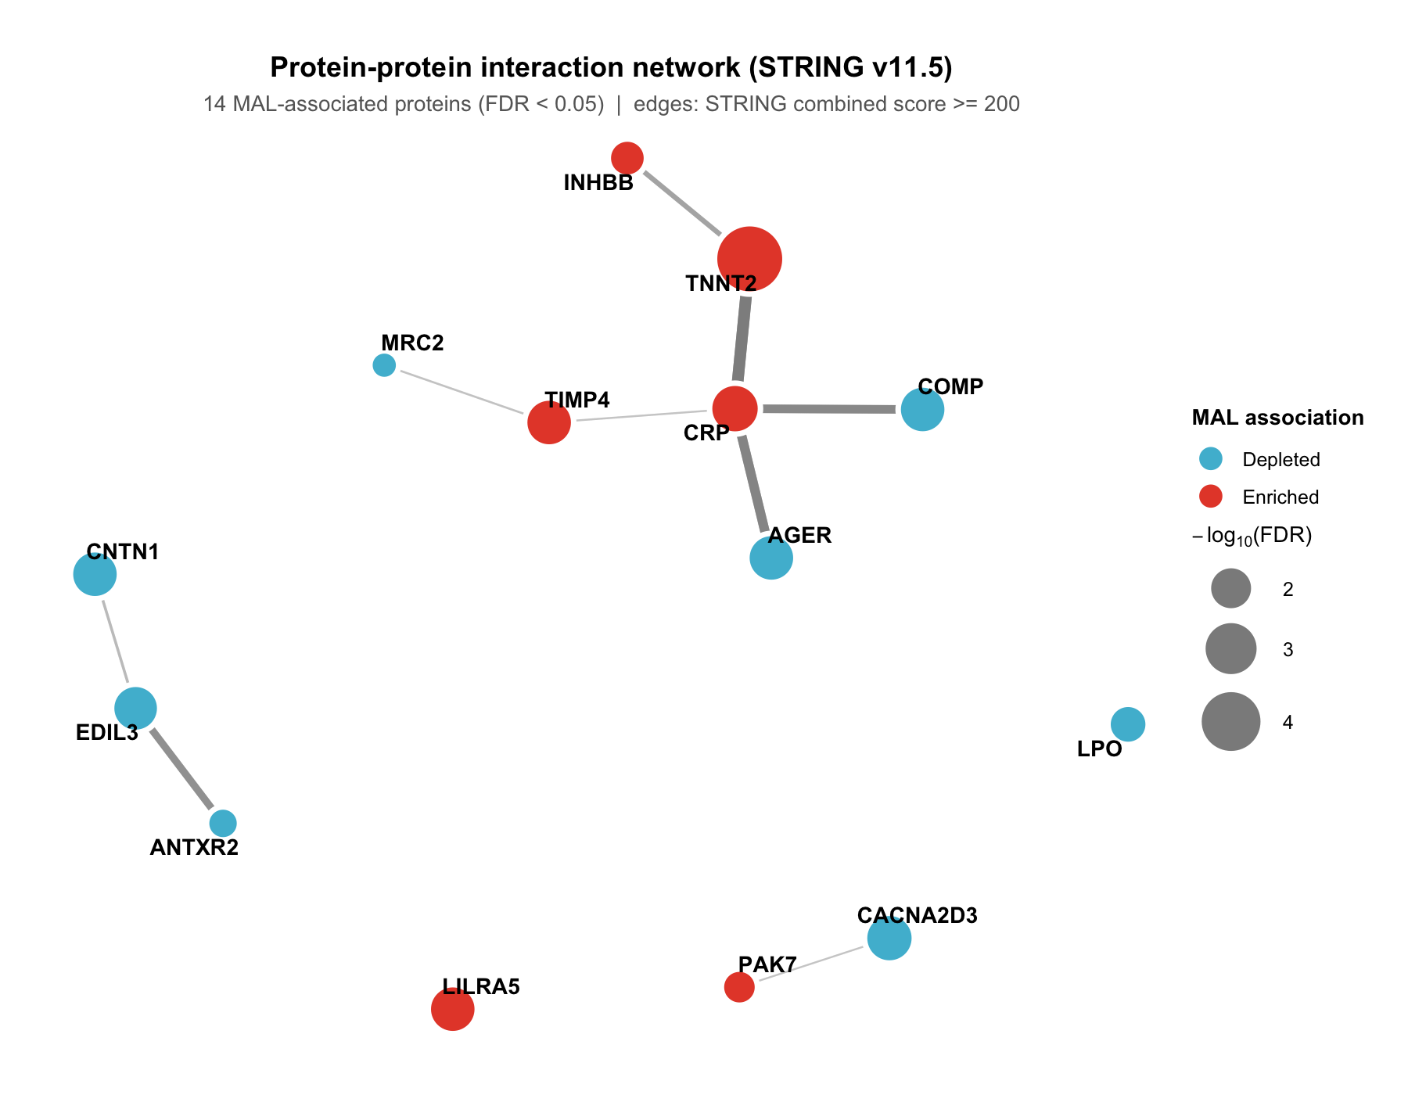
Protein–protein interaction network for the 14 plasma proteins significantly associated with MAL (FDR $<0.05$), constructed using STRING v11.5 (human, species 9606). Node colour: red = enriched with MAL, blue = depleted. Node size: $−\log_{10}(\text{FDR})$. Edges: STRING combined confidence score $≥200$; thickness proportional to score. Layout: Kamada–Kawai.

C2. MCL Clustering and Cluster Enrichment
Markov Cluster Algorithm (MCL) clustering (inflation parameter = 2, default) was applied to the STRING interaction network of the 14 MAL-associated proteins. MCL was run using the MCL R package (mcl(), addLoops=TRUE, inflation=2) on the binary adjacency matrix of the simplified subnetwork (combined score $≥200$). Only clusters with $≥3$ proteins were retained; pathway enrichment was retrieved from the STRING API across Gene Ontology, KEGG, Reactome, and PubMed literature co-citation (text mining); FDR computed by STRING using Benjamini–Hochberg against the human proteome background. Full results are in STRING_mcl_clusters.csv and STRING_cluster_enrichment.csv.
Two clusters with $≥3$ proteins emerged. Cluster 1 ($n=3$: AGER, COMP, CRP) co-enriches for published biomarker panels of carotid stenosis and osteoarthritis (FDR $=0.006$), reflecting shared involvement in vascular and cartilage stress signalling. Cluster 2 ($n=3$: ANTXR2, CNTN1, EDIL3) comprises extracellular matrix and cell adhesion proteins; no significant pathway enrichment was returned by STRING for this cluster. The remaining 8 proteins were unassigned.
MCL cluster enrichment summary. Top enriched term per cluster (lowest FDR). Clusters with $≥3$ proteins shown. Full results in STRING_cluster_enrichment.csv.
Cluster | $n$ | Members | Top term (source) | FDR
1 | 3 | AGER, COMP, CRP | Biomarker panel for carotid stenosis / osteoarthritis (PubMed co-citation) | 0.006
2 | 3 | ANTXR2, CNTN1, EDIL3 | No significant enrichment | –
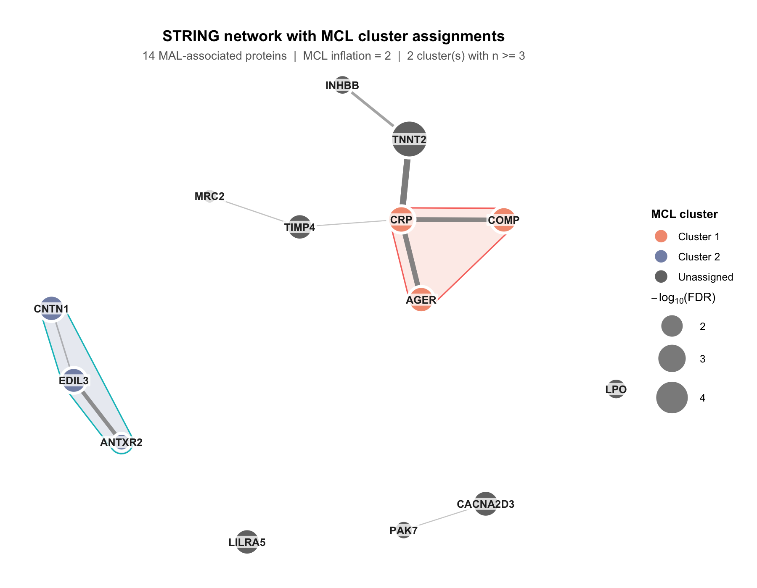
STRING network with MCL cluster assignments. Nodes represent the 14 MAL-associated proteins (FDR $<0.05$); edges: STRING combined score $≥200$; thickness proportional to score. Shaded hull indicates MCL cluster membership (inflation = 2). Cluster 1 (orange, $n=3$): AGER, COMP, CRP; co-cited as vascular/ cartilage biomarkers in PubMed (FDR $=0.006$). Cluster 2 (purple, $n=3$): ANTXR2, CNTN1, EDIL3; extracellular matrix and cell adhesion proteins; no significant pathway enrichment. Remaining 8 proteins unassigned (dark grey). Layout: Kamada–Kawai.

Proteomic Risk Score: Methods
A single proteomic risk score is constructed for mechanical lung stress and used for both the AIC model comparison and the causal mediation analysis.
MAL proteomic risk score (proRS). An adaptive LASSO ($α=1$) with MAL score (meanmal) as the outcome was fitted on 70% of the cohort (set.seed(42), $n_{\text{train}}=914$, $n_{\text{test}}=392$). SomaScan RFU values were log$​_{2}$-transformed. Clinical covariates (age, sex, race, pack-years, smoking status, CT scanner type, PC1–PC5, BMI) were included as unpenalised fixed effects. Ridge regression on residualised meanmal produced adaptive weights $w_{j}=1/|{\hat{β}}_{j}^{\text{ridge}}|$; 10-fold inner cross-validation selected $λ_{min}$; 572 proteins were retained. Test $R^{2}=0.233$.
Post-selection OLS refitting yielded unbiased ${\hat{β}}_{j}$, SE, 95% CI, and $p$-values for each protein. The standardised score is:
proRSi=j​βj⋅log2(proteinij) − xs
where $\overset{‾}{x}$ and $s$ are the mean and SD computed across all $n=1,306$ subjects (MAL_PRS_scaled). The cross-validation curve (Supplementary Figure C) shows MSE as a function of $log(λ)$, and Supplementary Figure D shows the concordance between MAL_PRS_scaled and CT-derived meanmal ($R^{2}=0.543$, $n=1,306$).

Association of Proteomic Risk Score with Emphysema Progression
The MAL proRS (MAL_PRS_scaled; 572 proteins, test $R^{2}=0.233$ vs. meanmal) is evaluated on the held-out 30% test set ($n=392$) to test whether the mechanistic protein signature of MAL independently predicts future emphysema progression beyond clinical risk factors. Three nested linear regression models use pctprog as the outcome; scanner is included in M2 as a technical confounder.
$$\begin{aligned}
\text{M1 (Clinical):} \quad
&\texttt{pctprog} \;\sim\;
\text{age} + \text{sex} + \text{race} + \text{smoking} +
\text{pack-years} + \text{BMI} + \text{scanner} \notag \\[4pt]
\text{M2 (proRS + scanner):} \quad
&\texttt{pctprog} \;\sim\;
\text{proRS} + \text{scanner} \notag \\[4pt]
\text{M3 (Clinical + proRS):} \quad
&\texttt{pctprog} \;\sim\;
\text{proRS} + \text{age} + \text{sex} + \text{race} +
\text{smoking} + \text{pack-years} + \text{BMI} + \text{scanner}
\notag
\end{aligned}$$
Model comparison for predicting emphysema progression (pctprog) by AIC (test set, $n=392$; lower = better fit). Proteomic Risk Score = adaptive LASSO targeting meanmal (MAL_PRS_scaled, $α=1$, 572 proteins, 10-fold inner CV; trained on 70%, evaluated on 30%). $Δ$AIC relative to M1 (clinical reference); $Δ≤−2$ indicates meaningful improvement.
Model | AIC | $Δ$AIC
M1: Clinical (age, sex, race, smoking, pack-years, BMI, scanner) | $2,259.2$ | Reference
M2: proRS + scanner | $2,286.6$ | $+27.4$
M3: Clinical + proRS | $2,245.7$ | $−13.5$
Effect sizes for MAL_PRS_scaled:
- M2: $\hat{β}=1.09\%$, 95% CI $[0.67, 1.51]$, $p<0.001$
- M3: $\hat{β}=0.81\%$, 95% CI $[0.40, 1.21]$, $p<0.001$
Key result. The MAL proteomic risk score adds independent predictive value for emphysema progression beyond clinical risk factors (M3: $\hat{β}=0.81\%$/SD, $p<0.001$; $Δ$AIC $=−13.5$, exceeding the $≤−2$ threshold). These proteins were selected to predict CT-derived mechanical lung stress, not emphysema progression, yet the score independently predicts future CT density loss beyond smoking history, age, BMI, and spirometry. This indicates that the blood protein signature of mechanical lung stress carries prognostic information not captured by standard clinical covariates.

Figure 3: Proteomic Signature of Mechanical Stress Predicts Emphysema Progression
Figure 3 shows a dose–response analysis of the MAL proteomic risk score against emphysema progression. Subjects were divided into 10 equal deciles of MAL_PRS_scaled ($≈131$ subjects per decile; D1 = lowest score, D10 = highest). The x-axis shows the mean proteomic risk score within each decile bin (SD units); the y-axis shows the mean pctprog (percentage of lung voxels showing emphysema progression) for that bin. A linear regression line with 95% confidence band is overlaid. Error bars on each point are 95% CI (mean $±1.96×$ SE). No covariates were adjusted.
How calculated. MAL_PRS_scaled is the standardised adaptive LASSO score described in the Proteomic Risk Score Methods section (572 proteins, outcome = meanmal, trained on 70% of the cohort). All $n=1,306$ subjects are ranked by their score and divided into 10 equal-sized groups (deciles; $≈131$ subjects each). Within each decile, the mean score (x) and mean pctprog (y) are computed. Error bars are 95% CI ($\text{mean}±1.96×$ SE, where SE $=\text{SD}/\sqrt{n}$). The overlaid line is a simple linear regression of pctprog on MAL_PRS_scaled across all $n=1,306$ subjects; the shaded band is the 95% confidence region. No covariates are adjusted in this descriptive plot. The D10/D1 ratio compares the mean pctprog in the highest vs. lowest decile; the trend $p$-value is from the regression slope.
Key result. The proteomic risk score shows a near-monotone dose–response with emphysema progression: subjects in the highest decile of the blood score had $3.1×$ more lung progression than those in the lowest (D10/D1 $=3.1×$, $p=1.52×{10}^{−40}$). This dose–response arises from a score derived entirely from plasma proteins targeting CT-measured mechanical stress, demonstrating that the blood signature of MAL independently stratifies patients by future emphysema progression.
Mean % of lung progressing to emphysema (pctprog, y-axis) across 10 equal deciles of the MAL proteomic risk score (MAL_PRS_scaled, x-axis, SD units; $n=1,306$). Each green square is the mean of one decile ($≈131$ subjects); error bars: 95% CI of the decile mean. Line: linear regression of pctprog on MAL_PRS_scaled across all subjects; shaded band: 95% confidence region for the regression line (i.e., uncertainty in the fitted mean at each score value, not a prediction interval for individual subjects). D10/D1 $=3.1×$, $p=1.52×{10}^{−40}$.

Table 2: Causal Mediation
The analysis decomposes the total effect of MAL on emphysema progression into a direct path (NDE) and a path through the blood protein score (NIE). NDE = how much of the MAL effect goes through pathways other than the protein score. NIE = how much goes through the protein score. All effects are in HU (Hounsfield Units), the CT density scale. More negative HU = lower lung density = more emphysema. A difference of 1 HU is a small change; the SD of progression in this cohort is $∼$7 HU.
- NDE = $−$0.55 HU, $p=0.941$: MAL’s direct effect on progression is non-significant once blood protein changes are accounted for. The 95% CI spans zero $[−14.96, 13.86]$, consistent with no independent direct effect.
- NIE = 13.93 HU, $p=0.002$: the protein risk score mediates a large and significant portion of the MAL effect. A one-unit increase in MAL is associated with 13.93 HU more progression through the protein pathway.
- Proportion mediated $≈100\%$: the indirect path through blood proteins explains essentially all of the MAL–progression relationship. The NDE is non-significant, consistent with complete mediation.
- Total effect = 13.38 HU: NDE + NIE; the protein pathway accounts for the entire effect.
How calculated. Pathway tested: MAL $→$ Proteomic Risk Score $→$ Emphysema Progression. Fitted using the medflex R package (natural effects framework) with robust sandwich standard errors.
Two models fitted internally by medflex:
$$\text{Imputation model: }Δρ ∼ \text{meanmal}×\text{proRS}+\text{covariates}$$
$$\text{Natural effects model: }Δρ ∼ {\text{meanmal}}_{0}+{\text{meanmal}}_{1}+\text{covariates}$$
${\text{meanmal}}_{0}$ is the MAL value at which the mediator (proRS) is set (direct path); ${\text{meanmal}}_{1}$ is the actual MAL value driving the outcome (indirect path). The difference between them isolates the mediated portion.
Table 2. Causal mediation of the MAL–emphysema progression relationship through the Proteomic Risk Score (proRS), estimated using the natural effects framework (medflex R package, robust sandwich SE, $n=1,306$). NDE (Natural Direct Effect) = portion of MAL’s effect on $Δ$CT lung density not operating through the proRS. NIE (Natural Indirect Effect) = portion operating through the proRS. Proportion mediated = NIE / total effect. All effects in HU (Hounsfield Units; negative = more emphysema).
Effect | Estimate (HU) | 95% CI | $z$ | $p$
Natural Direct Effect (NDE) | $−0.55$ | $[−14.96, 13.86]$ | $−0.07$ | $0.941$
Natural Indirect Effect (NIE) | $+13.93$ | $[5.26, 22.60]$ | $+3.15$ | $0.002$
Total effect | $+13.38$ | —
Proportion mediated | $≈100\%$
Key result. The proteomic risk score fully mediates the effect of MAL on emphysema progression (NIE = 13.93 HU, $p=0.002$). The direct path is non-significant once the protein pathway is accounted for (NDE = $−$0.55 HU, $p=0.941$), consistent with complete mediation.

Supplement

Supplementary Tables
- S1: All differential expression results (4,979 proteins): gene, target, $\hat{β}$, SE, $t$, $p$, FDR.
File: MAL_omics/mal_de_results.csv
- S2: proRS weights (MAL-targeting LASSO proteins): gene, target, ${\hat{β}}_{\text{OLS}}$, 95% CI, $p$.
File: MAL_omics/mal_risk_score_weights.csv
- S3: Per-protein mediation (MAL-targeting LASSO proteins): NDE, NIE, total, proportion mediated, NIE $p$.
File: MAL_omics/mal_mediation_supp.csv
- Of 199 converged proteins (from the 572 proRS proteins), 10 reached NIE $p<0.05$. Proportions mediated range from $−9\%$ to $18\%$; EPHB2 shows negative mediation (suppression).
Supplementary Table S3. Per-protein causal mediation: MAL $→$ individual protein $→$ emphysema progression. Only proteins with NIE $p<0.05$ shown ($n=10$ of 202 converged). NDE = Natural Direct Effect; NIE = Natural Indirect Effect. All effects in HU. Proportion mediated = NIE / (NDE + NIE). medflex, robust SE, $n=1,306$.
Gene | Target | NDE (HU) | NDE $p$ | NIE (HU) | NIE $p$ | % Mediated
TREM2 | TREM2 | $+13.67$ | $0.011$ | $+2.78$ | $0.012$ | $17\%$
MANSC4 | MANS4 | $+14.23$ | $0.008$ | $+1.73$ | $0.012$ | $11\%$
EPHB2 | EPHB2 | $+20.54$ | $<0.001$ | $−1.64$ | $0.016$ | $−9\%$
DEFA5 | HD-5 | $+14.61$ | $0.006$ | $+1.66$ | $0.017$ | $10\%$
ADH7 | ADH7 | $+15.01$ | $0.006$ | $+1.79$ | $0.021$ | $11\%$
ADAMTS5 | ADAMTS-5 | $+15.37$ | $0.004$ | $+1.22$ | $0.021$ | $7\%$
INHBB | Inhibin $β$B | $+13.07$ | $0.020$ | $+2.88$ | $0.022$ | $18\%$
SCG3 | SCG3 | $+13.46$ | $0.015$ | $+2.65$ | $0.029$ | $16\%$
MSMP | PSMP | $+13.80$ | $0.011$ | $+1.78$ | $0.034$ | $11\%$
PDCD1 | PD-1 | $+16.26$ | $0.002$ | $+0.76$ | $0.048$ | $4\%$

Supplementary Figures
- Supp Figure A: Forest plot, proteins $∼$ MAL. Top 30 proteins by $|t\text{-statistic}|$, showing $\hat{β}$ (log$​_{2}$ RFU per unit MAL) with 95% CI. Red = positively associated; blue = negatively associated with MAL.
- Supplementary Figure A. Forest plot of the top 30 proteins most significantly associated with MAL score (ranked by $|t\text{-statistic}|$). Points show $\hat{β}$ (log$​_{2}$ RFU per unit MAL) with 95% CI, from the model: $\log_{2}(\text{protein})∼\text{meanmal}+\text{age}+\text{sex}+\text{race}+\text{pack-years}+\text{smoking}+\text{BMI}+\text{scanner}+\text{PC1–PC5}$. Red = positively associated; blue = negatively associated with MAL. Vertical dashed line at zero.
- Supp Figure B: Forest plot, proteins $∼$ emphysema progression. Same 30 proteins, association with emphysema progression (Change_lung_density_vnb_P2_P3) adjusted for baseline lung density and covariates.
- Supplementary Figure B. Forest plot of the same top 30 MAL-associated proteins showing their association with emphysema progression. Points show $\hat{β}$ (log$​_{2}$ RFU per HU progression) with 95% CI, from the model: $\log_{2}(\text{protein})∼\text{Change_lung_density_vnb_P2_P3}+\text{lung_density_vnb_P2}+\text{age}+\text{sex}+\text{race}+\text{pack-years}+\text{smoking}+\text{BMI}+\text{scanner}+\text{PC1–PC5}$. Vertical dashed line at zero.
- Supp Figure C: Adaptive LASSO cross-validation curve. Mean squared error from 10-fold CV plotted against $log(λ)$ for the MAL-targeting adaptive LASSO. Shaded band: $±1$ SE. Dashed red line: selected $λ_{min}$ and the number of proteins retained at that penalty.
- Supplementary Figure C. Cross-validation curve for the adaptive LASSO (proRS_{MAL}). MSE (10-fold CV) is plotted against $log(λ)$; shaded band shows $±1$ SE. The dashed line marks $λ_{min}$, the penalty that minimises CV-MSE and determines how many proteins are retained in the risk score.
- Supp Figure D: Proteomic risk score vs. CT MAL score. Scatter of the MAL-targeting proteomic risk score (SD units, x-axis) against CT-derived meanmal (y-axis) for all $n=1,306$ subjects. Fitted regression line with 95% CI band shown. $R^{2}=0.543$ confirms that the blood protein signature captures a meaningful fraction of CT-measured MAL variance.
- Supplementary Figure D. Concordance between the MAL-targeting proteomic risk score (MAL_PRS_scaled, derived from 572 blood proteins) and the CT-derived MAL score (meanmal). Each point is one subject ($n=1,306$); regression line with 95% CI shown. $R^{2}=0.543$.

