React Higher Order Component

App.Js

import ClickCounter from "./components/ClickCounter";

import HoverCounter from "./components/HoverCounter.Js";

*function* App() {

  return

    <div className="app">

      <*ClickCounter*/>

      <*HoverCounter*/>

    </div>

}

export default App;

ClickCounter.Js

import React, { Component } from 'react'

export default *class* ClickCounter extends Component {

    state = {

        Count:0,

    };

    increamentCount = () *=>* {

        this.setState((*prevState*) *=>* ({Count: *prevState*.Count +1}));

    }

    render() {

*const*{Count} = this.state;  // distructuring Count from State  by using render() function

        return (

          <div>

            <button type="button"  onClick={this.increamentCount}>Clicked {Count} Times </button>

          </div>

        );

      } }

HoverCounter.Js

import React, { Component } from 'react'

export default *class* HoverCounter extends Component {

    state = {

        Count:0,

    };

    increamentCount = () *=>* {

        this.setState((*prevState*) *=>* ({Count: *prevState*.Count +1}));

    }

    render() {

*const*{Count} = this.state;  // distructuring Count from State  by using render() function

        return (

          <div>

            <h1 type="button"  onMouseHover={this.increamentCount}>Hovered {Count} Times </h1>

          </div>

        );

      }

}

Note: If you need another function then we will create another function. So, The same code is repeat again and again.

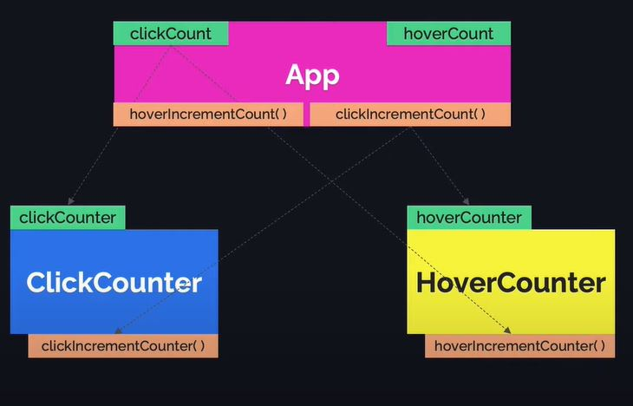

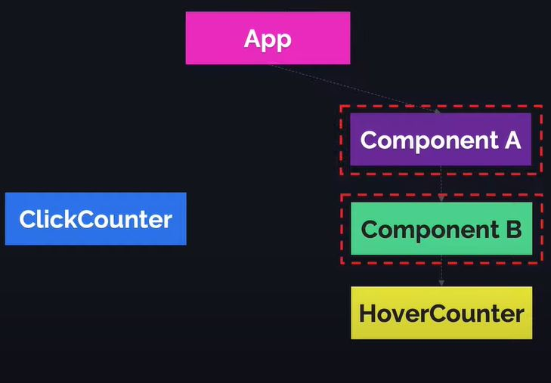

Higher Order Components:

A Higher Order Component is a function that takes component as a parameter and returns a new component.

Ex: Const newComponent = higherOrderComponent(OriginalComponent);