**Practice Software testing TEST PLAN**

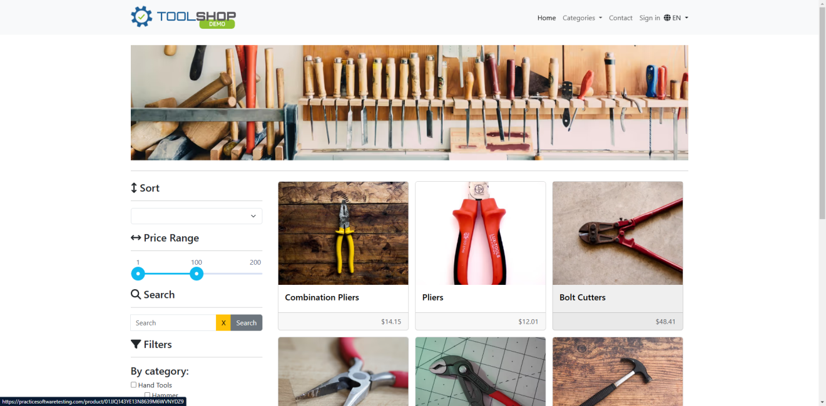

Done By

[Abdullah Aladham](https://www.linkedin.com/in/abdullah-aladham/)

Table of Contents

Introduction 3

1.1 Objectives 3

2 Scope 3

3 Assumptions / Risks 4

3.1 Assumptions 4

3.2 Risks 4

4 Test Approach 4

4.1 Test Automation 4

5 Test Environment 5

6 Milestones / Deliverables 5

6.1 Test Schedule 5

6.2 Deliverables 5

# Introduction

The Test Plan Created to organize all Efforts that are put in the project.

It includes the objectives, strategy, scope, schedule, risks and approach. This document will clearly identify what the test will be and what is out the scope.

## Objectives

Practice Software testing is a demo website which is dedicated for testing purposes, Which simulates an E-commerce website for selling Plier Tools and similar accessories, And this Website is Mainly built with PHP, Angular, HTML, and other languages or frameworks.

Phase 1 of Testing process will ensure manually that PST (Practice Software Testing) is reliable, efficient, and meets the user's requirements, and to identify the defects the software have to prevent them in the next version by reporting and addressing them to dev. team manually.

Phase 2 of the testing process Will be Automated tested.

Team Members

|  |  |
| --- | --- |
| **Member Name** | **Role** |
| Abdullah Al-adham | QA Engineer |
|  |  |
|  |  |

# Scope

The initial phase will include all ‘must have’ requirements. These and any other requirements that get included must all be tested. At the end of Phase 1, a tester must be able to:

1. Create a manual test with as many steps as necessary
2. Save it
3. Retrieve it and have the ability to view it when running the test
4. Enter results and appropriate comments
5. View results

As the team works with the product they will define the needs for the second phase.

Load testing will not be considered part of this project since the user base is known and not an issue.

Rewriting, moving or porting existing test cases from the existing Word documents is not considered part of this project.

# Assumptions / Risks

## Assumptions

This section lists assumptions that are made specific to this project.

1. Customers will remember username and password.
2. Customer will add products to cart.
3. Customers will smoothly interact with the site.
4. The design will be responsive to all viewports.

## Risks

The following risks have been identified and the appropriate action identified to mitigate their impact on the project. The impact (or severity) of the risk is based on how the project would be affected if the risk was triggered. The trigger is what milestone or event would cause the risk to become an issue to be dealt with.

|  |  |  |  |  |
| --- | --- | --- | --- | --- |
| # | Risk | Impact | Trigger | Mitigation Plan |
| 1 | Lack of documentation | High | Delays in implementation date | Asking the owners of the project for documentation |
| 2 | Changes to the functionality may negate the tests already written and we may loose test cases already written | High – to schedule and quality | Loss of all test cases | Export data prior to any upgrade, massage as necessary and re-import after upgrade. |
| 3 | Weekly delivery is not possible because the tester is not available | Medium | Product did not get delivered on schedule |  |
| 4 |  |  |  |  |

# Test Approach

The project is using an agile approach, with weekly iterations. At the end of each week the requirements identified for that iteration will be delivered.

Black box testing will play a large part of the testing as automation testing alone is not enough to cover all of bugs in the test object.

Tests for planned functionality will be created and added to PST

## Test Automation

Automated End to end tests are part of the Testing process, Will be done using Cypress Framework

## Manual Tests

Manual tests will be done in future since I don’t have manual test scenarios right now

# Test Environment

Laptop with 16GB Ram and Fiber Internet Connection

# Milestones / Deliverables

## Test Schedule

The initial test schedule follows……….

|  |  |  |  |  |
| --- | --- | --- | --- | --- |
| **Task Name** | **Start** | **Finish** | **Effort** | **Comments** |
| Test Planning |  |  |  |  |
| Review Requirements documents |  |  | 2 d |  |
| Create initial test estimates |  |  | 1 d |  |
| Staff and train new test resources |  |  |  |  |
| First deploy to QA test environment |  |  |  |  |
| Functional testing – Iteration 1 |  |  |  |  |
| Iteration 2 deploy to QA test environment |  |  |  |  |
| Functional testing – Iteration 2 |  |  |  |  |
| System testing |  |  |  |  |
| Regression testing |  |  |  |  |
| UAT |  |  |  |  |
| Resolution of final defects and final build testing |  |  |  |  |
| Deploy to Staging environment |  |  |  |  |
| Performance testing |  |  |  |  |
| Release to Production |  |  |  |  |

## Deliverables

|  |  |  |
| --- | --- | --- |
| **Deliverable** | **For** | **Date / Milestone** |
| Test Plan | Project Manager; QA Director; Test Team |  |
| Traceability Matrix | Project Manager; QA Director |  |
| Test Results | Project Manager |  |
| Test Status report | QA Manager, QA Director |  |
|  |  |  |
| Metrics | All team members |  |
|  |  |  |