1. Display the current working directory.
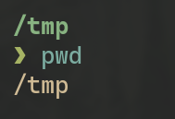

2. List all the contents of your current directory, including hidden files.

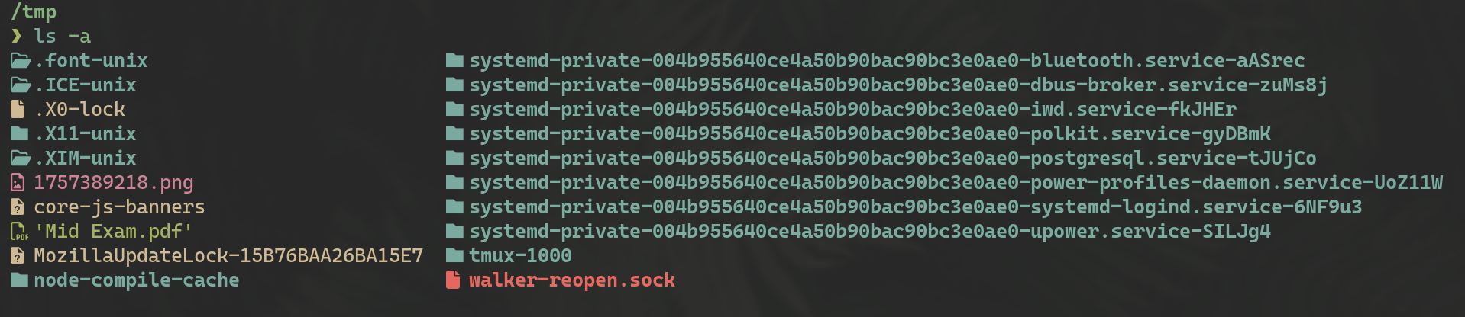
3. Change your directory to the `Desktop`.

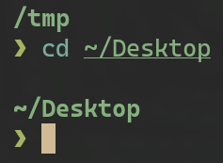
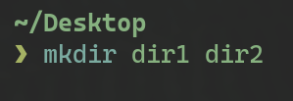
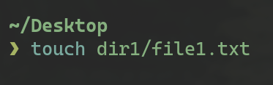
4. Create two directories named `dir1` and `dir2` on the Desktop.
5. Inside `dir1`, create a file named `file1.txt`.
6. Inside `dir2`, create a file named `file2.txt`.

7. Using nano or vim Write the numbers 1 to 9 into `file1.txt`.

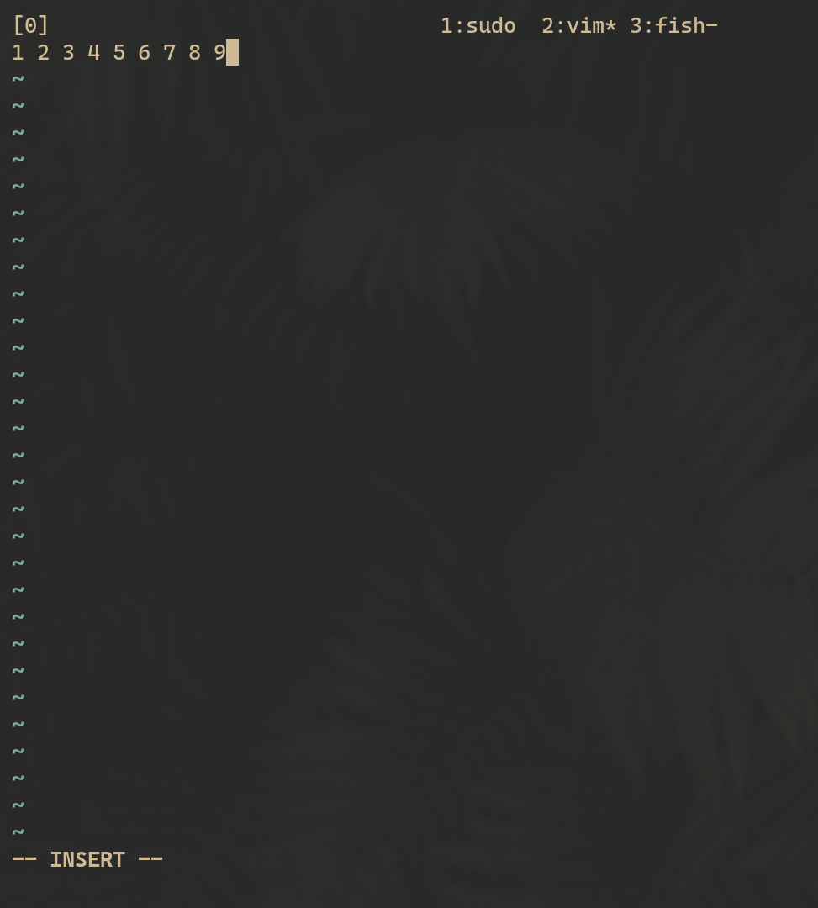

8. From the home directory Copy the contents of `file1.txt` into `file2.txt`.

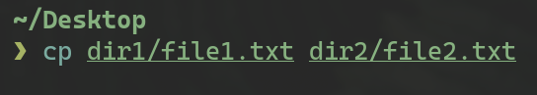

9. From the home directory, delete `file1.txt` inside `dir1`.

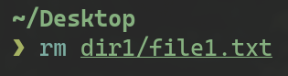

10. Remove the directory `dir1` from the Desktop.

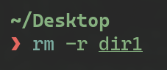

11. Redirect the output of the network configuration command to a file named `network_info.txt` on the Desktop

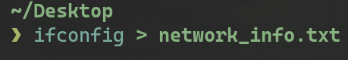

12. Open the Desktop folder and show all files with detailed information.

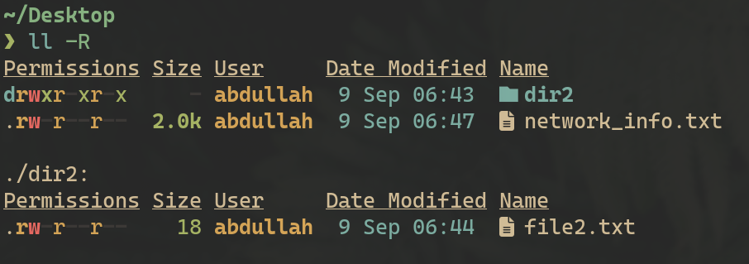

13. Create a new user with your name

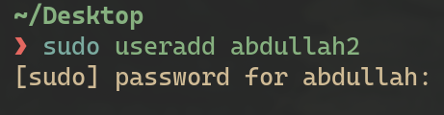

14. Set a password for your user.

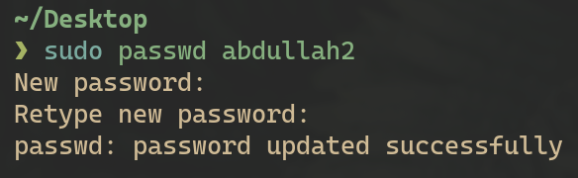

15. Open the file that contains user information and verify that your user has been added.

16. Add your user to the file that gives administrative privileges

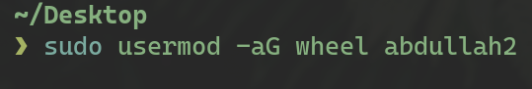

17. Switch to your user and confirm the user identity.

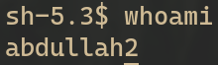

18. Create a new group named `testgroup`.

19. Add your user to `testgroup`.

20. Add the group `testgroup` to the file that gives administrative privileges.

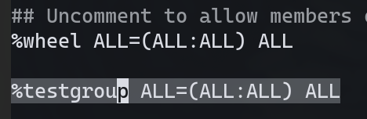

21. Remove your user from the file that gives administrative privileges

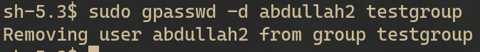

22. Check if your user still have administrative privileges

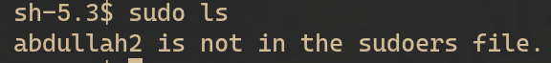

23. Check which groups your user belongs to.

24. Set the permissions of `file2.txt` on the Desktop to allow the owner to read, write, and execute; the group to read and execute; and others to read

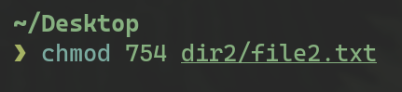

25. Check the permissions of `file2.txt` to verify the change.
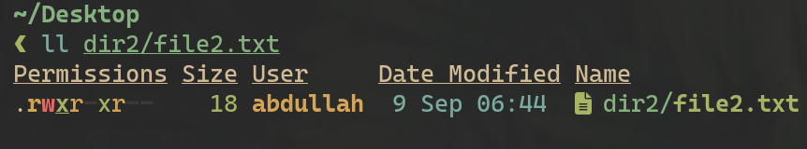

26. Change the ownership of `file2.txt` to your user.

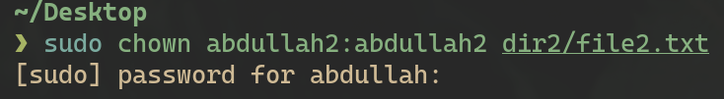

27. verify the ownership of `file2.txt`.
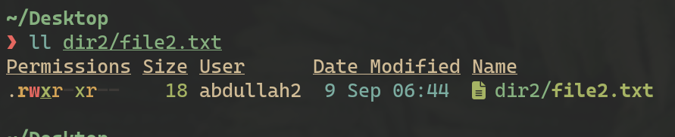

28. Change back the ownership of a file `file.txt`

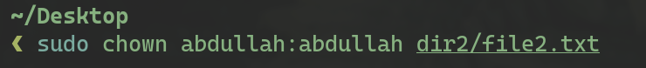

29. Grant write permission to everyone for ``file.txt`
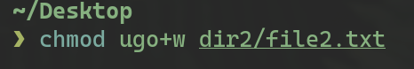

30. Remove the write permission for the group and others for ``file.txt`

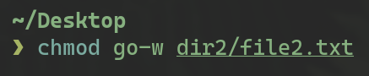

31. Delete `file.txt` after making the necessary ownership and permission changes.
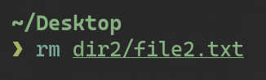

32. What command would you use to recursively change the permissions of all files and directories inside of a folder named `project`

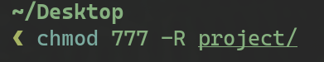

33. Install a system monitor tool that provides an interactive process viewer (htop)
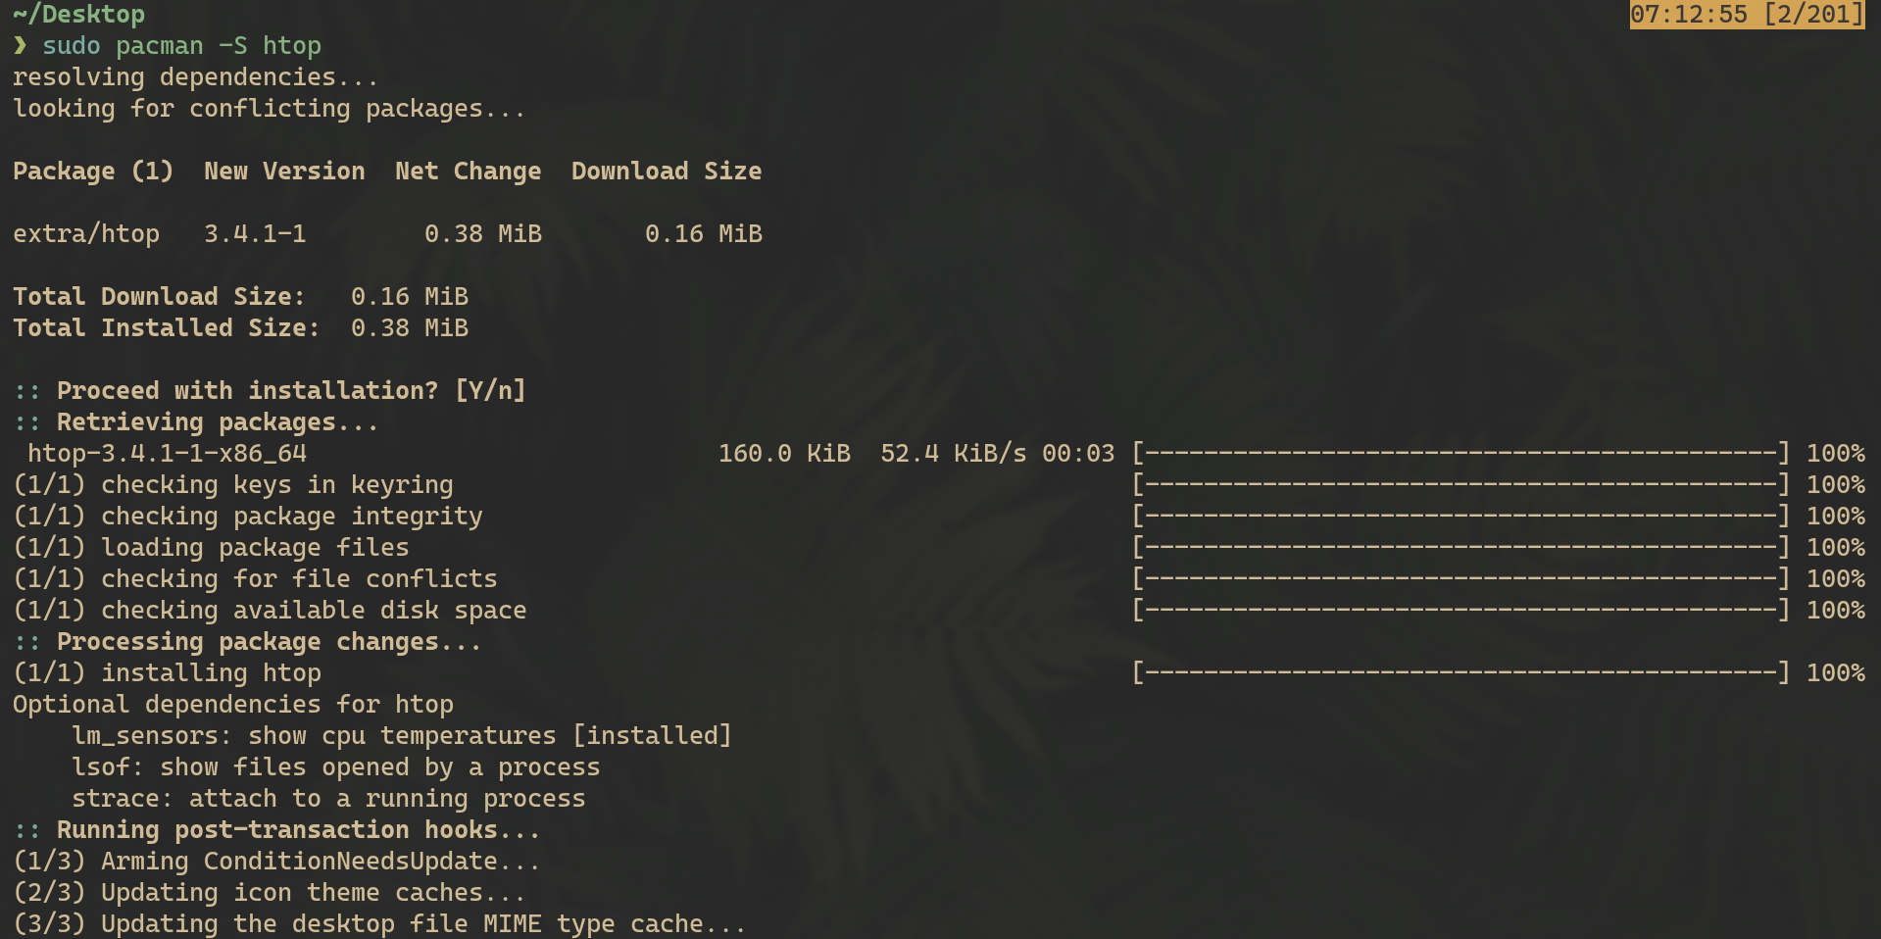

34. Display all running processes.
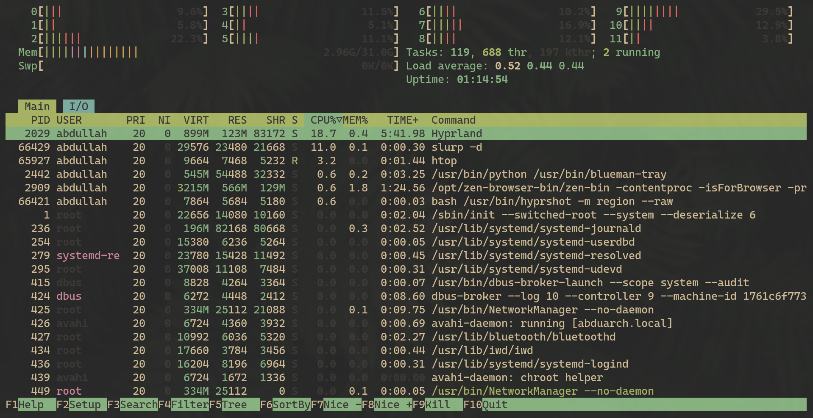

35. Display a tree of all running processes.
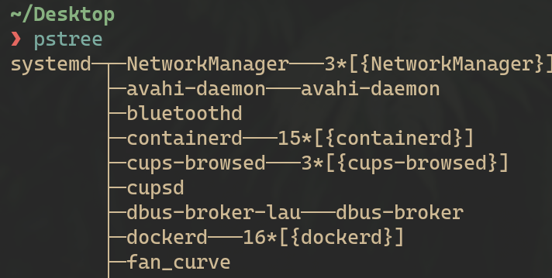

36. Open the interactive process viewer and identify a process by its PID.

37. Kill a process with a specific PID.
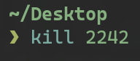

38. Start an application and stop it using a command that kills processes by name (xeyes)

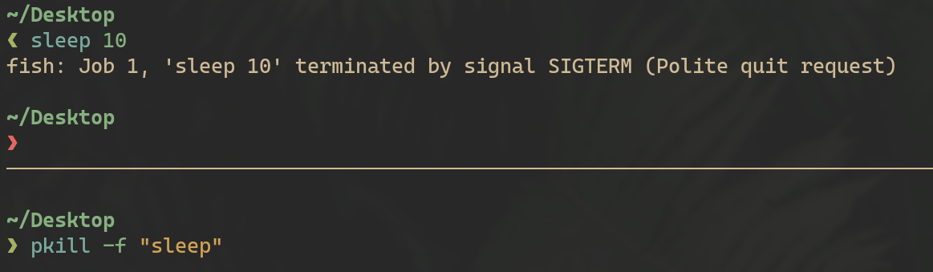

39. Restart the application, then stop it using the interactive process viewer.

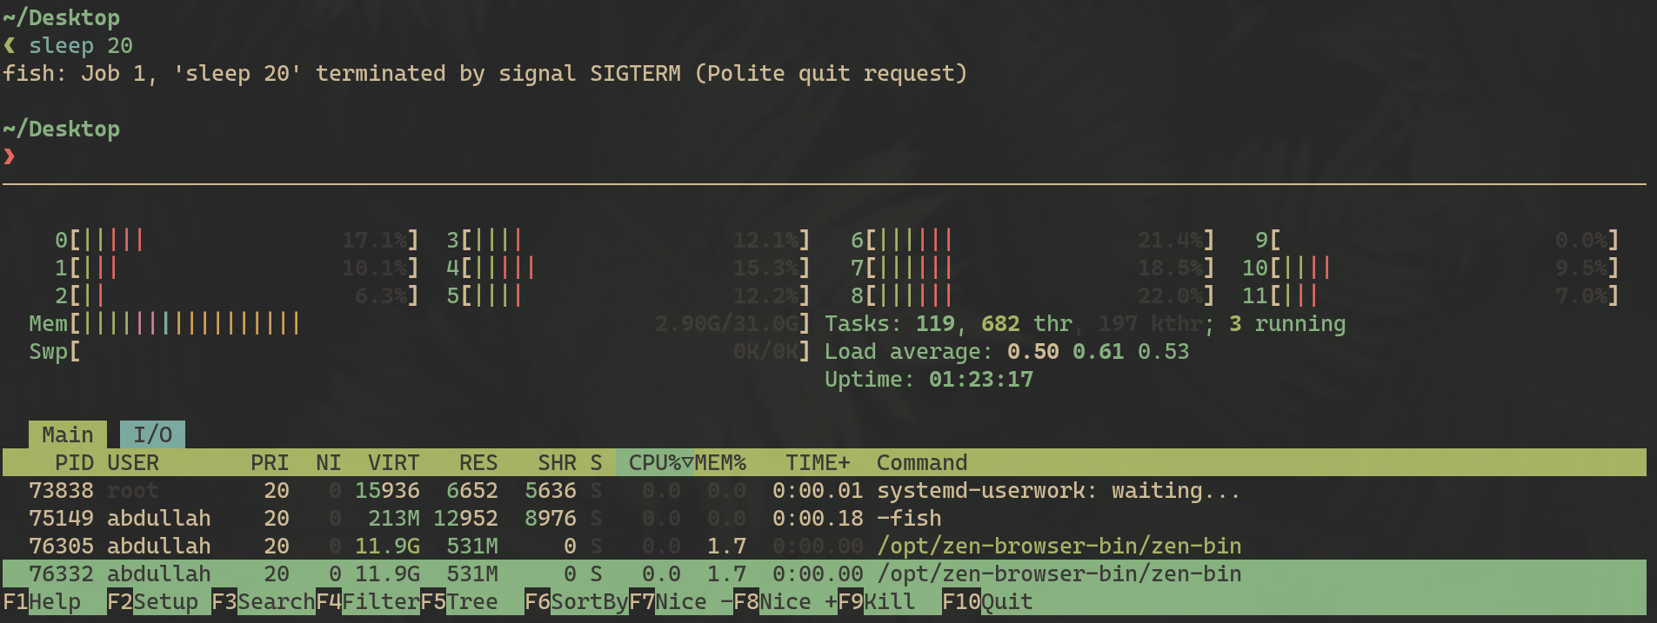

40. Run a command in the background, then bring it to the foreground (xeyes)
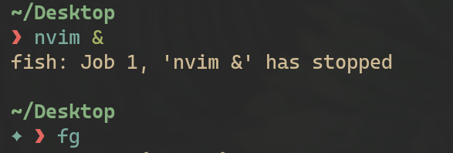

41. Check how long the system has been running.

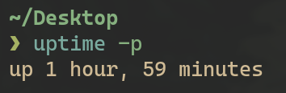

42. List all jobs running in the background.

43. Display the network configuration.
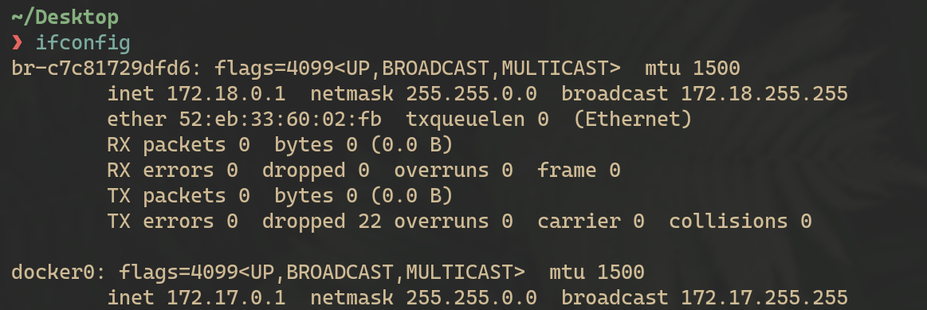

44. Check the IP address of your machine.

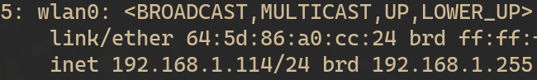

45. Test connectivity to an external server.
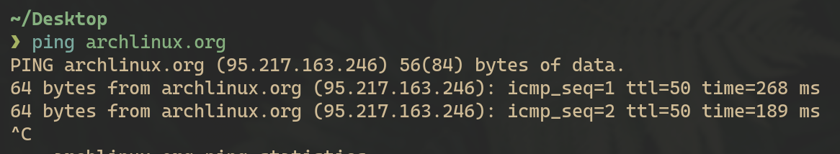

46. Display the routing table.
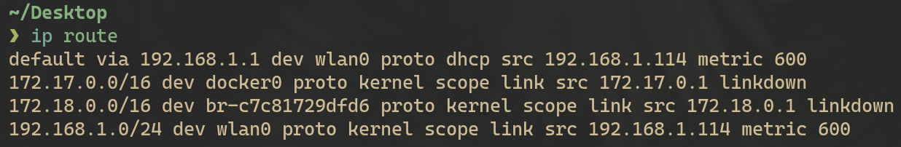

47. Check the open ports and active connections.
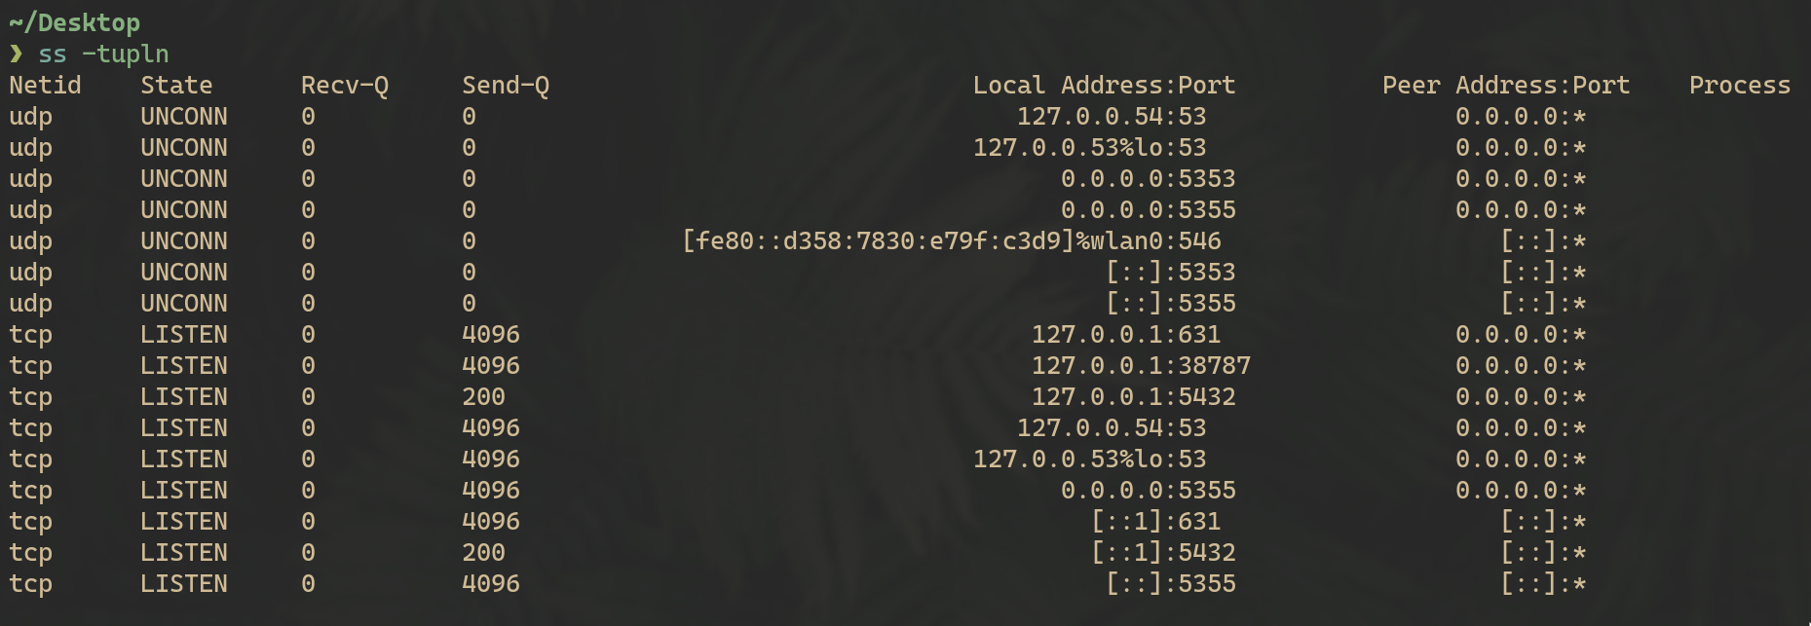

48. Show the IP address of the host machine and the VM, and verify if they are on the same network.

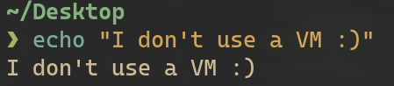

49. Trace the route to an external server.
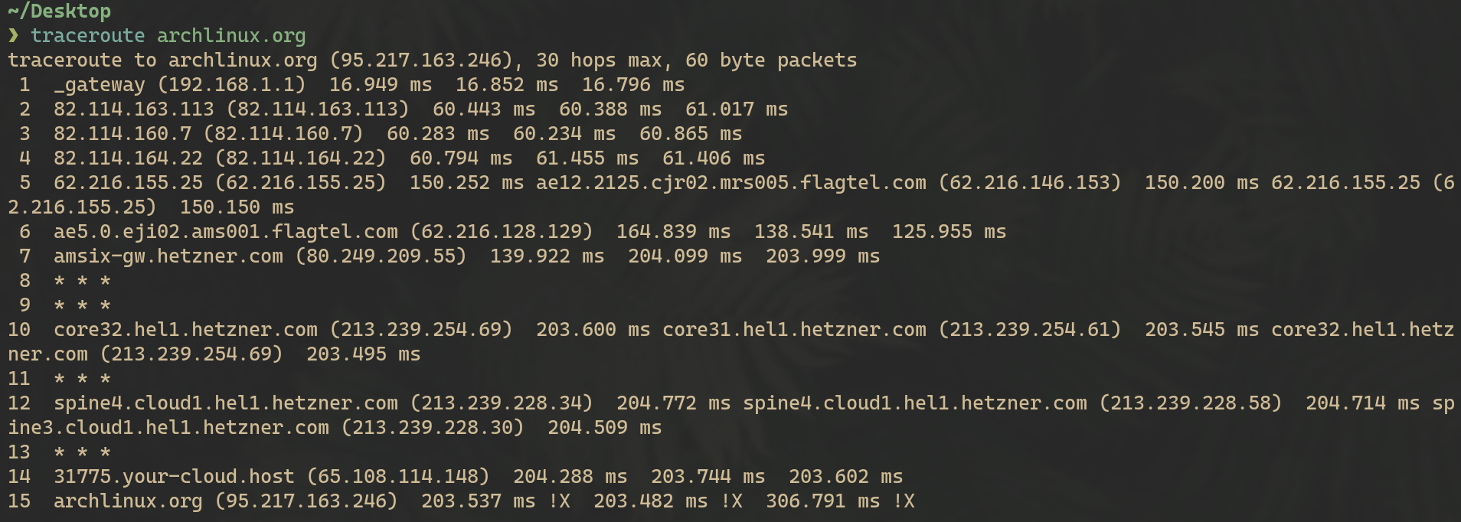

50. Find out the default gateway.
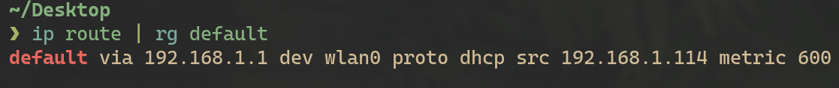

51. Check the MAC address of your network interface.

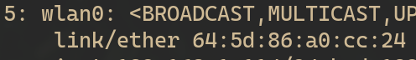

52. Ensure that the VM can access external networks.
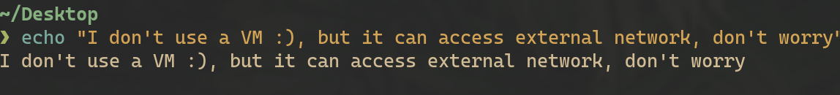

53. Enable the firewall.
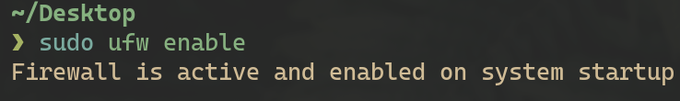

54. Allow SSH connections through the firewall.
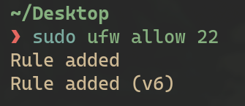

55. Deny all incoming traffic by default.
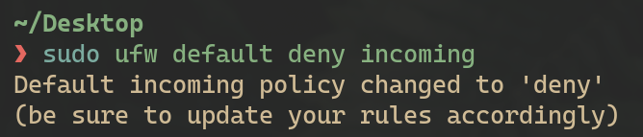

56. Allow HTTP and HTTPS traffic.
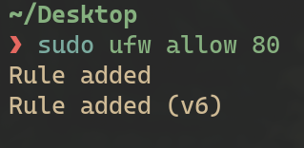

57. Allow port 20
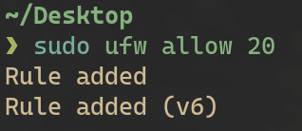

58. Reset the firewall settings.

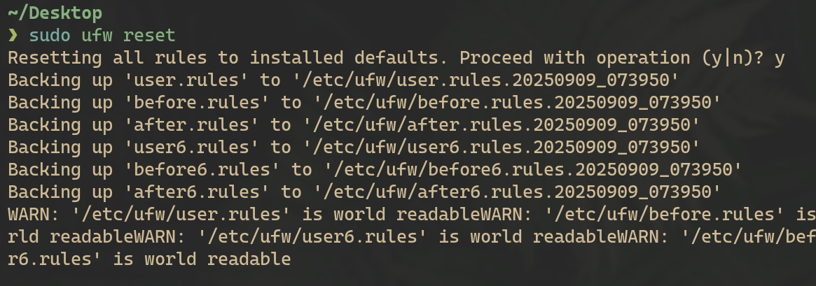

59. Delete a rule from the firewall.
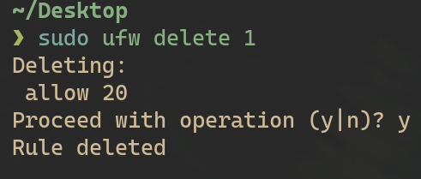

60. Disable the firewall.
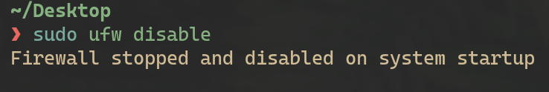

61. View the status of the firewall.
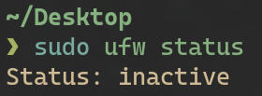

62. Log firewall activity and view it.
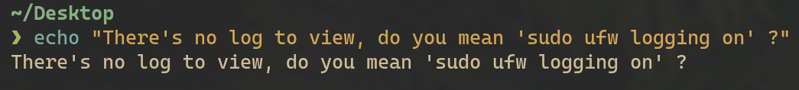

63. Delete the command history.
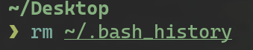

64. Search for a kali in /etc/passwd
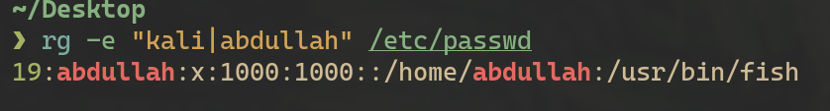

65. Search for a kali in /etc/group
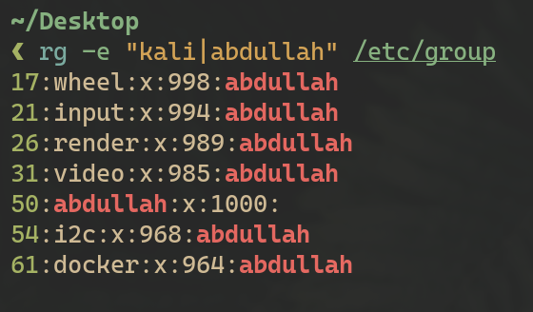

66. Locate the `passwd` file.

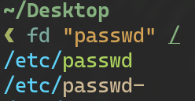

67. Locate the shadow file and open it.

68. Search for all configuration files in the `/etc` directory.

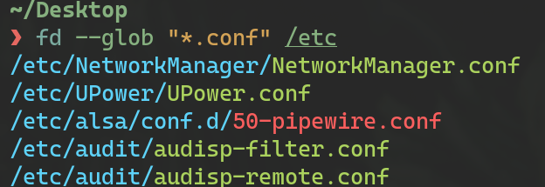

69. Search recursively for a specific word in the `/var/log` directory.
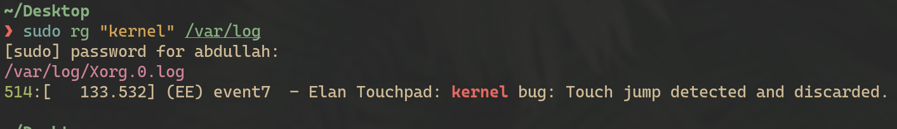

70. View the system’s kernel version.
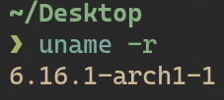

71. Display the system’s memory usage.

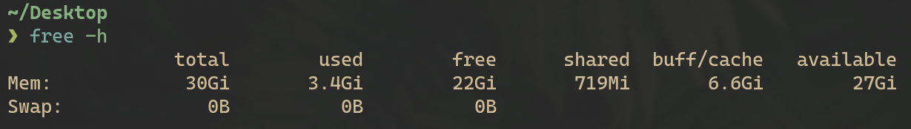

72. Show the system’s disk usage.

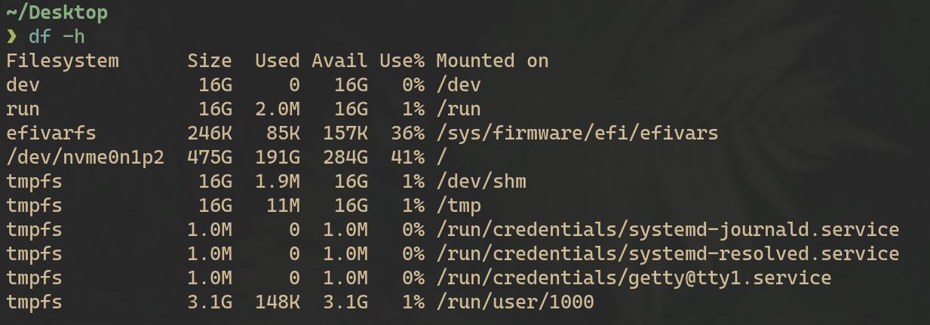
73. Check the system's uptime and load average.

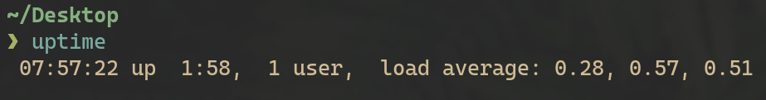

74. Display the current logged-in user

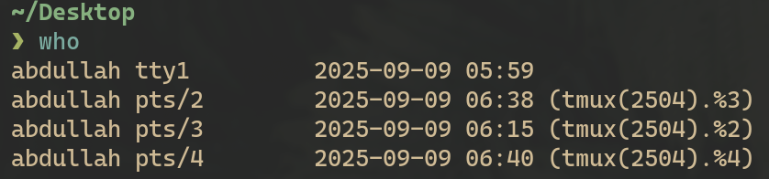

75. Check the identity of the current user.

76. View the `/var/log/auth.log` file.

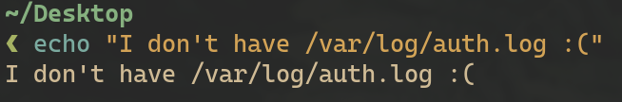
77. Shred the `auth.log` file securely.
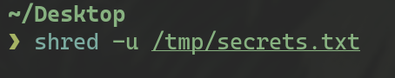

78. How do you lock a user account to prevent them from logging in
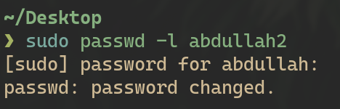

79. What command would you use to change a user's default shell

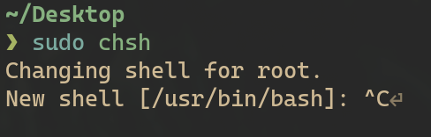

80. Display the system's boot messages.

