ALGORITHMS WEEK 2 LAB QUESTIONS

**Insertion Sort Algorithm**

**Question 1:** Sort the following sequence of numbers according to the insertion sort algorithms.

(Get out the flowchart of the algorithm. Put it in its place and sort it out)

|  |  |  |  |  |  |
| --- | --- | --- | --- | --- | --- |
| 5 | 2 | 4 | 6 | 1 | 3 |

**Answer:**

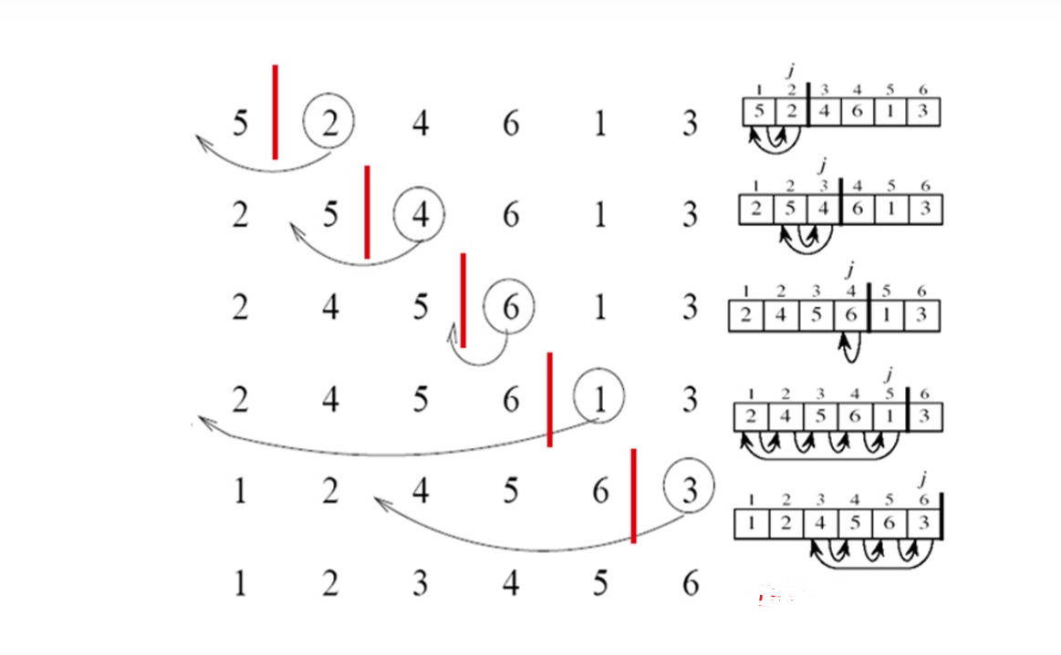

**Python Code:**

metin içeren bir resim

Açıklama otomatik olarak oluşturuldu

**Question 2:** 2n2+4n3-10n What is the runtime?

**Answer:** = Θ(n3)