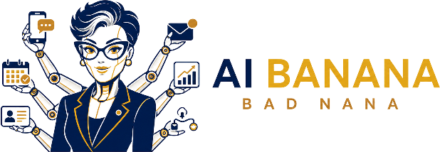

Shayla Davis
AI Workforce Strategist
Founder | AI Banana

Building Your AI Workforce™

Work ON your business... not IN it.

🌐 get-aibanana.com
📧 connect@get-aibanana.com
📞 855-970-NANA

Book Your Free AI Strategy Session

