DEEPSTAR 3.1
Interplanetary Explorer

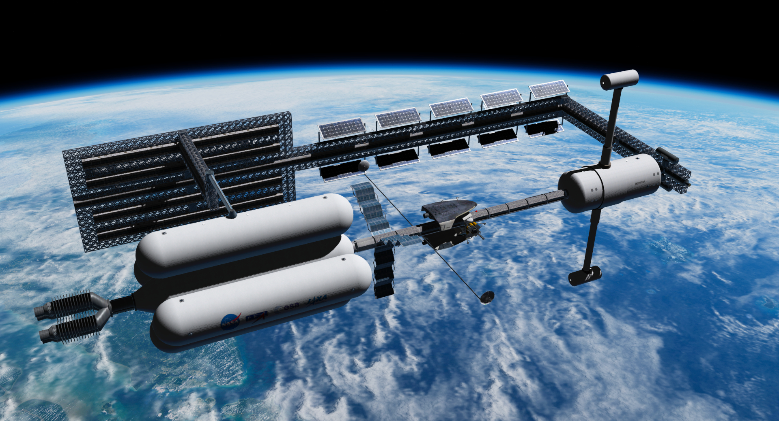
By Alain Hosking (80mileshigh) and Abdullah Radwan.
For Orbiter 2016 by Martin Schweiger.
October 2021

Deepstar represents a vision of planetary exploration for Orbiter 2016 with a near-tech aesthetic.
This release introduces active virtual cockpits for Deepstar, its non-atmospheric landers, and its atmospheric lifting bodies (aerolanders).
Additionally this release provides integration with Universal Cargo System for Orbiter and full sound integration XRSound via Dynamic XRSound.

Please note this add-on’s dependencies and installation requirements as described below.

Contents

Dependencies …………………………………………………………………. …….. p.2
Installation …………………………………………………………………….. p.3
Config Edits …………………………………………………………….……...……. p.3
D3D9 Client Settings ………………………………………………………………... p.5
Recommended Add-ons ……………………………………………………………... p.6
Vessel Key Commands, Frequencies and Special Features …………………………… p.7
UCSO Implementation ………………………………………………………………... p.12
Virtual Cockpits ……………………………………………………………………... p.13
Bases ………………………………………………………………………………… p.14
Known Issues …………………………………………………………………..…… p.15
Support ……………………………………………………………………………… p.16
Thanks ………………………………………………………………………………. p.16
Licence ………………………………………………………………………………. p.17
Appendix 1 Version History and Changes ……………………………………………. p.17
Appendix 2 Low-res (default) Mars Base Configurations………………………. …… p.19
Appendix 3 File List (v3.0 for uninstallation and v3.1) ……………………………… p.20

Dependencies

Jarmonik’s D3D9 graphics client.
Download: http://users.kymp.net/~p501474a/D3D9Client/
The Moon / Mars surface microtexture pack is also recommended.

Doug Beachy’s XRSound
Download: https://www.alteaaerospace.com/

Abdullah Radwan’s Dynamic XRSound
Download: https://www.orbithangar.com/showAddon.php?id=5376bb58-c52b-4708-a4eb-cdcb7eb1dc55

Note: You can use Deepstar with Orbiter Sound but you will need the following, installed in this order, assuming OrbiterSound is already installed: XRSound - Dynamic XRSound – SoundBridgeOS. The custom sound for rovers will not be heard, however, if you do this.

Abdullah Radwan’s Universal Cargo System for Orbiter
Download: https://www.orbithangar.com/showAddon.php?id=6f05850c-8b74-484b-a0c0-c6a908ccfe81
! Deepstar scenarios will crash without UCSO installed.

Fred18’s General Vehicle
Download: https://www.orbithangar.com/showAddon.php?id=eb4a7e79-9a2e-4600-8296-ee84ff97b9bf
! Deepstar scenarios will crash without General Vehicle installed.

Mars high resolution textures and surface elevation
Download: http://orbit.medphys.ucl.ac.uk/download.html
! Make sure you follow instructions for updating your Mars.cfg

The Mars bases in this add-on are positioned against this hi-res scenery, with locations corrected
by the orbiter-forum member Predattak. Thank you Predattak!

If you must use the default Mars textures see the Appendix 2 here for the v3.0 Mars Base configs.

Titan high resolution textures and surface elevation
Download: http://orbit.medphys.ucl.ac.uk/download.html
! Make sure install the new Titan.cfg linked above the download links.

The Titan base in this add-on requires this scenery to display correctly.
Installation

Please uninstall v3.0 first – we have changed the file naming for 3.1 so you can’t simply add the new components. See Appendix 3 for a full file list for v3.0 and v3.1.
Extract to your Orbiter 2016 folder (or to a temporary folder then copy across). The archive will extract to the correct folder structure.

Install the dependencies listed below if you are not already using them.

Config Edits – New in v3.1

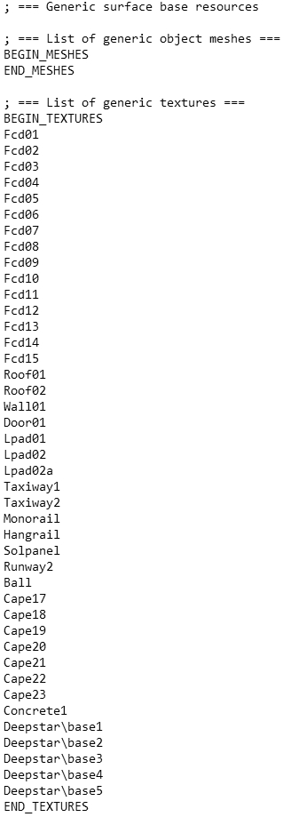
Once you have extracted or copied the files to your Orbiter installation you will need to make the following config file edits. If you’ve never opened a config file this can be done with any text editor, like Notepad.

1. From Orbiter’s top-level config folder, open base.cfg

After

; === List of generic textures ===
BEGIN_TEXTURES

and before

END_TEXTURES

add:

Deepstar\base1
Deepstar\base2
Deepstar\base3
Deepstar\base4
Deepstar\base5

My base.cfg looks like the image opposite:
This will enable night textures on Deepstar’s bases.
! Without this change some base meshes will appear blank.
2. Edit planetary configs to add base directories with context string.

You need to make a small edit to the config files of the following bodies in Orbiter’s top level config folder.

At the end of Moon.cfg add:

; === Surface Bases ===
; place additional bases or
; base directories in this list
BEGIN_SURFBASE
DIR Moon\Base
DIR Moon\Base\Deepstar CONTEXT Deepstar
END_SURFBASE

At the end of Ganymede.cfg add:

; === Surface Bases ===
; place additional bases or
; base directories in this list
BEGIN_SURFBASE
DIR Ganymede\Base\Deepstar CONTEXT Deepstar
END_SURFBASE

At the end of Mars.cfg add:

; === Surface Bases ===
; place additional bases or
; base directories in this list
BEGIN_SURFBASE
DIR Mars\Base
DIR Mars\Base\Deepstar CONTEXT Deepstar
END_SURFBASE

At the end of Phobos.cfg add:

; === Surface Bases ===
; place additional bases or
; base directories in this list
BEGIN_SURFBASE
DIR Phobos\Base\Deepstar CONTEXT Deepstar
END_SURFBASE

At the end of Titan.cfg add:

; === Surface Bases ===
; place additional bases or
; base directories in this list
BEGIN_SURFBASE
DIR Titan\Base\Deepstar CONTEXT Deepstar
END_SURFBASE

At the end of Triton.cfg add:

; === Surface Bases ===
; place additional bases or
; base directories in this list
BEGIN_SURFBASE
DIR Triton\Base\Deepstar CONTEXT Deepstar
END_SURFBASE

At the end of Vesta.cfg add:

; === Surface Bases ===
; place additional bases or
; base directories in this list
BEGIN_SURFBASE
DIR Vesta\Base\Deepstar CONTEXT Deepstar
END_SURFBASE

These edits will ensure the Deepstar bases only show up in the provided scenarios, or any scenario which includes the line ‘Context Deepstar’ in the environment block of a scenario file, like this:

BEGIN_ENVIRONMENT
System Sol
Date MJD 88535.3204946809
Context Deepstar
END_ENVIRONMENT

! You won’t see the bases without making these changes.

If you run into any problems just post in the Deepstar development thread: https://www.orbiter-forum.com/threads/deepstar-development.26879

D3D9 Client Settings

This add-on is designed around the capabilities of Jarmonik's dx9 graphics client, with bump mapping, terrain flattening and shader profiles.

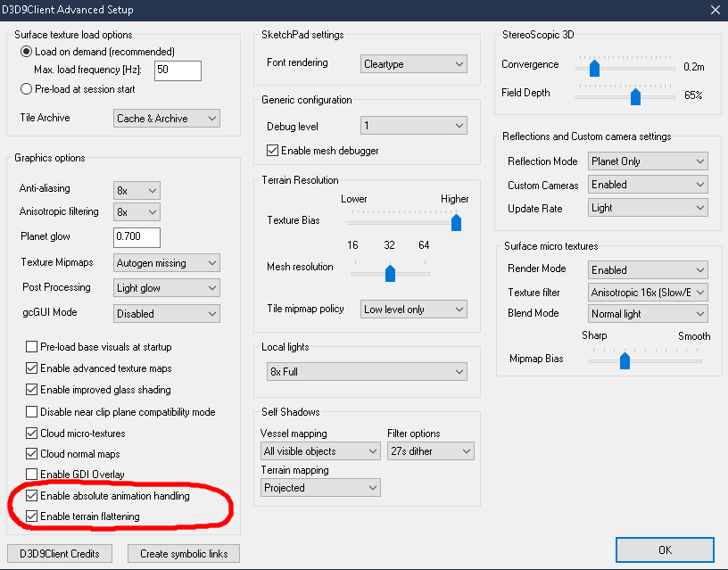
Use the following settings:

- Launch your Orbiter session using the Orbiter_ng launchpad.

- Check ‘Enable terrain flattening’ on the settings page at ‘Video’ > ‘Advanced’ in the Orbiter_ng launchpad.

- Check ‘Enable absolute animation handling’ on the settings page at ‘Video’ > ‘Advanced’ in the Orbiter_ng launchpad.

- Select ‘linear interpolation’ rather than ‘cubic interpolation’ at the launchpad’s ‘Visual effects’ tab to enable terrain flattening.

This add-on was completed and tested against D3D9 client version R4.25 (5 August 2021).
Recommended Add-ons

A number of scenarios here are set up with the latest version of TransX for planetary navigation (not the stock version) and Pursuit MFD for automated landings. These scenarios are clearly named. They will still load without the MFDs installed or selected.
TransX 2018.05.06
https://www.orbithangar.com/showAddon.php?id=3a9c2e73-adb6-486d-97bf-9b6bf886a495

Pursuit MFD 2016
https://www.orbithangar.com/showAddon.php?id=24eaf9c5-5ca8-4ddf-9b73-ccc136caefc2

Deepstar Marineris Base LV15 Surface Tiles
Following the release of Deepstar 3.0 the orbiter-forum member 4throck created Lv15 surface tiles for the Marineris base. Thank you 4throck!

Download: https://www.orbithangar.com/showAddon.php?id=ef8052b3-8bc8-4f42-8a7e-8740f475de71

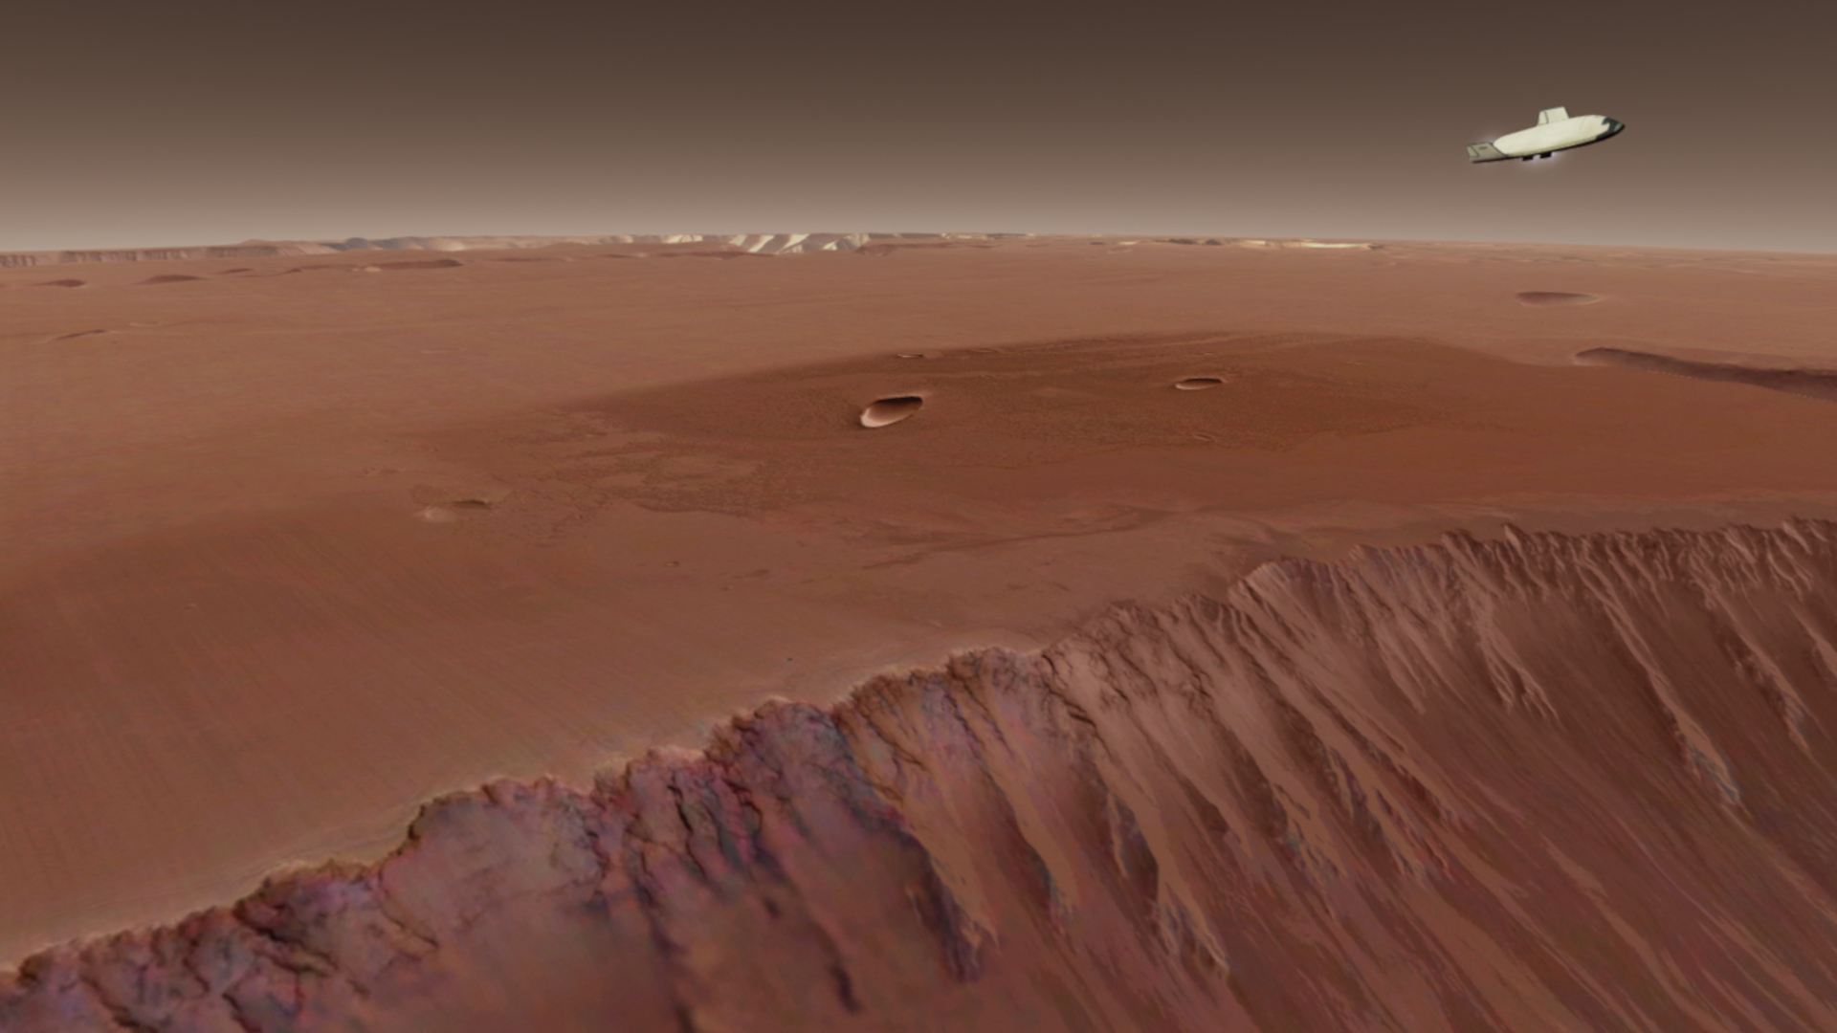
Minor Bodies high resolution textures and surface elevation
Download: http://orbit.medphys.ucl.ac.uk/download.html

The Minor Bodies high resolution pack includes a new texture for Vesta. This is nice but not essential to the experience of using Vesta Station in Deepstar 3.1

In creating Deepstar I also made use of Burntime Calculator 3.1, BaseSync 3.3, Glidescope 2.7, ModuleMessagingExt and RefuelMFDv003.
Atmospheric Data MFD v0.2 (for remote probe data) and Watchdog MFD (to stop time acceleration at specified moments) remain useful despite being designed for older versions of Orbiter.
All these MFDs are available at Orbit Hangar.
Vessel Key Commands, Frequencies and Special Features

New in v3.1 Docking Mode RCS

ALT + J – activate / deactivate docking mode RCS

Docking mode RCS is available for Deepstar, the landers, and aerolanders, reducing RCS thrust by half.

RCS mode status will be visible on all VC HUD modes if Docking Mode is active, while ‘RCS Normal’ will be read on the Docking HUD only, if the mode is deactivated.

! In the landers and aerolanders Docking Mode will switch thruster key mapping (both translation and rotation) so you can making an approach with Docking MFD as if you were using a forward facing dock.

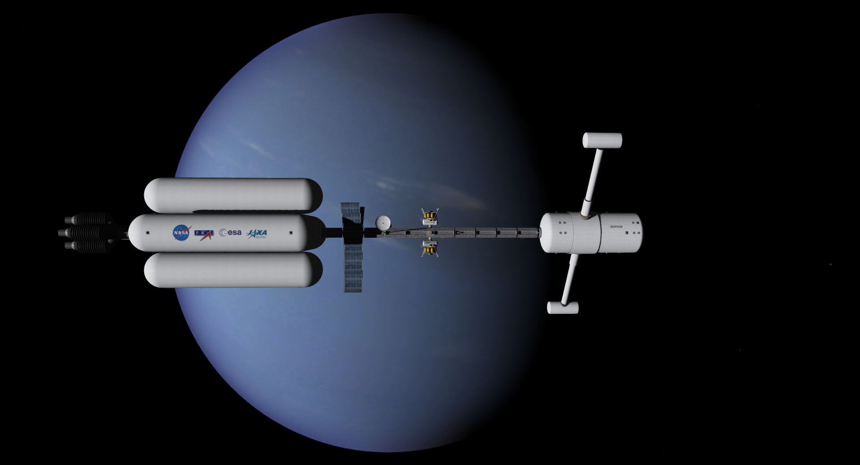
Deepstar Key Commands
CTRL+ 1 – rotate port dish
CTRL + 2 – rotate starboard dish
CTRL + G – start / stop spin gravity
CTRL + K – deploy / retract forward docking port
New in v3.1 CTRL + L – activate docking flood light when forward dock is activated and the ‘Local light sources’ checkbox is selected from the Visual effects tab of the Orbiter launchpad.

New in v3.1 SHIFT + C – activate UCSO dialogue (will appear on HUD in VC). See UCSO section below.
New in v3.1 Deepstar Docking Changes
Deepstar’s forward dock will now only become available when activated with the key command [K]. As a result it is now invoked as the vessel’s fifth dock, not its first as in previous versions.

! Please note you will need to switch Docking MFD to Dock 5 manually and that this setting is reset when switching VC modes with [F8]. Note also that Orbiter doesn’t save dock selection in scenario files so you will need to select Dock 5 manually at the start of all docking approach scenarios. Make sure to select Dock 5 when undocking the forward dock or you might throw off a lander!

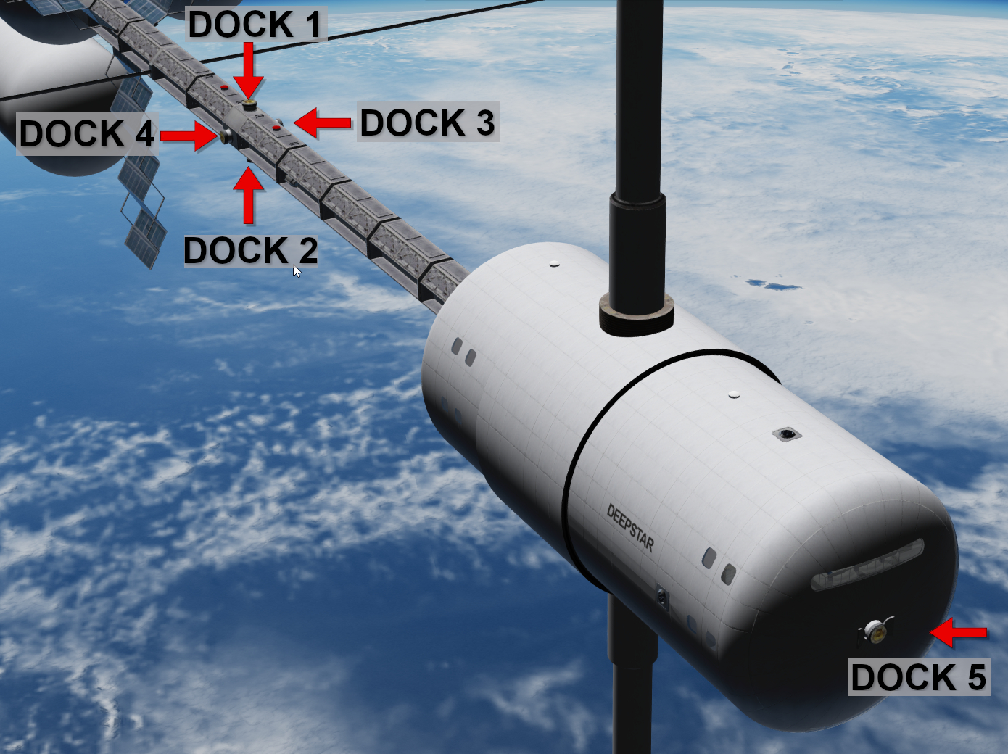
Deepstar Frequencies
XPDR 134.00
Dock 1 (zenith) IDS 134.10
Dock 2 (nadir) IDS 134.20
Dock 3 (port) IDS 134.30
Dock 4 (starboard) IDS 134.40
Dock 5 (forward) IDS 134.50

New in v3.1 Deepstar now features forward RCS clusters modeled on the vessel’s command section and RCS has been balanced in the new code.

Deepstar Probes Key Commands
CTRL + K – deploy / retract solar arrays
New in v3.1 Deepstar’s Probes are now UCSO payloads. Activate the UCSO dialogue by key command or VC HUD button and follow the options to select and release.

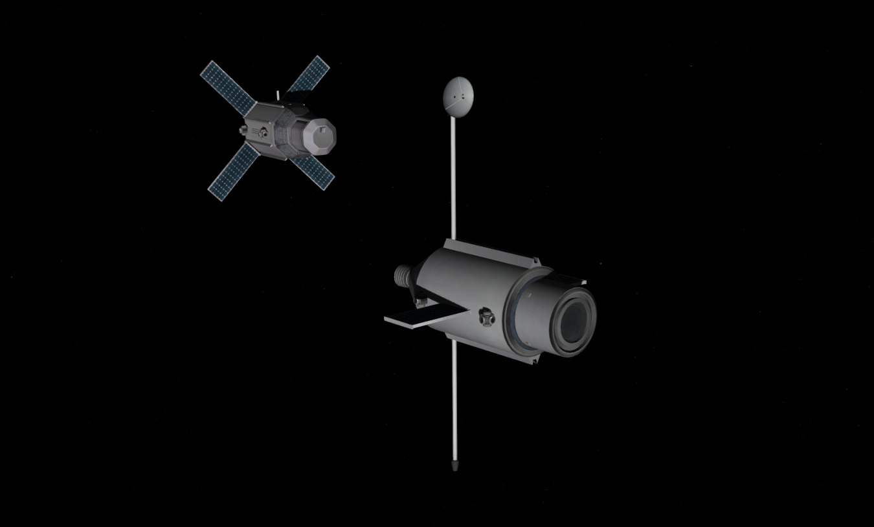
Deepstar Probes Frequencies
Probe 1 XPDR 132.05
Probe 2 XPDR 132.00

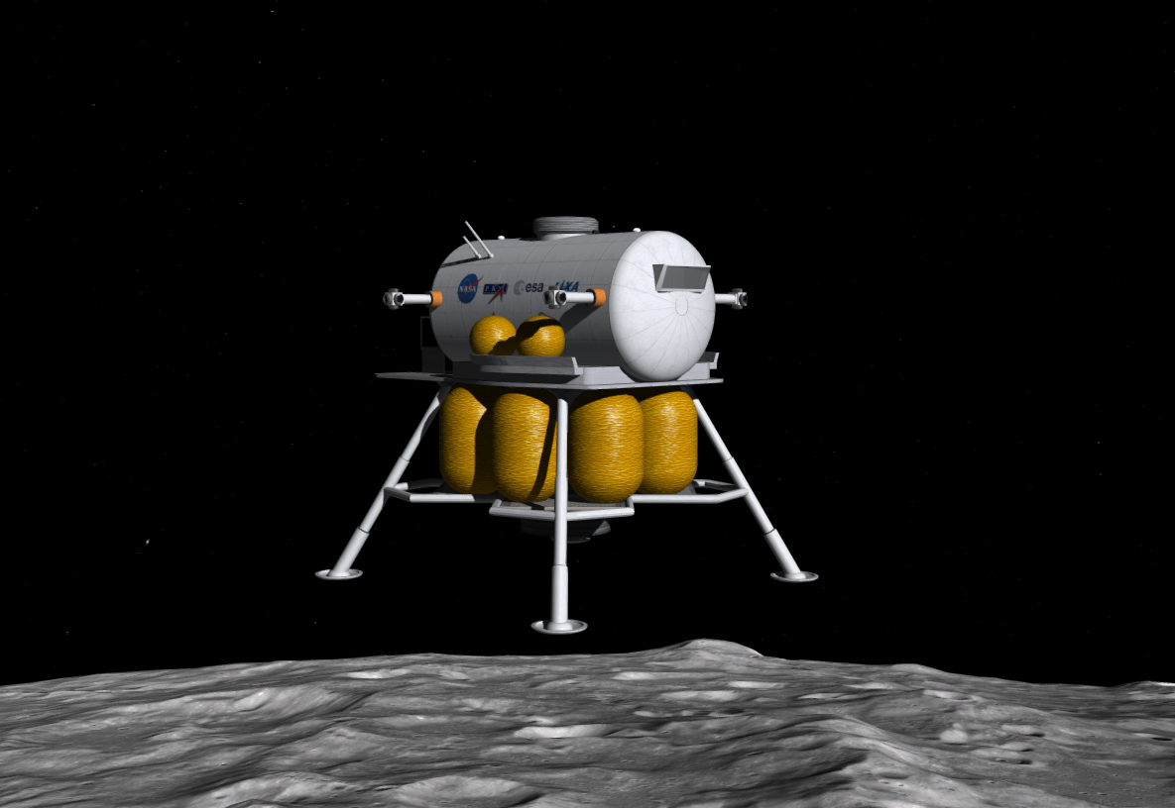
Deepstar Lander Key Commands
CTRL + Y – open / close egress hatch
New in v3.1 SHIFT + C – activate UCSO dialogue (will appear on HUD in VC). See UCSO section below.
Deepstar Lander Frequencies
Lander 1 XPDR 135.00
Lander 1 Dock IDS 135.10
Lander 2 XPDR 135.50
Lander 2 Dock IDS 135.60

Deepstar Aerolander Key Commands
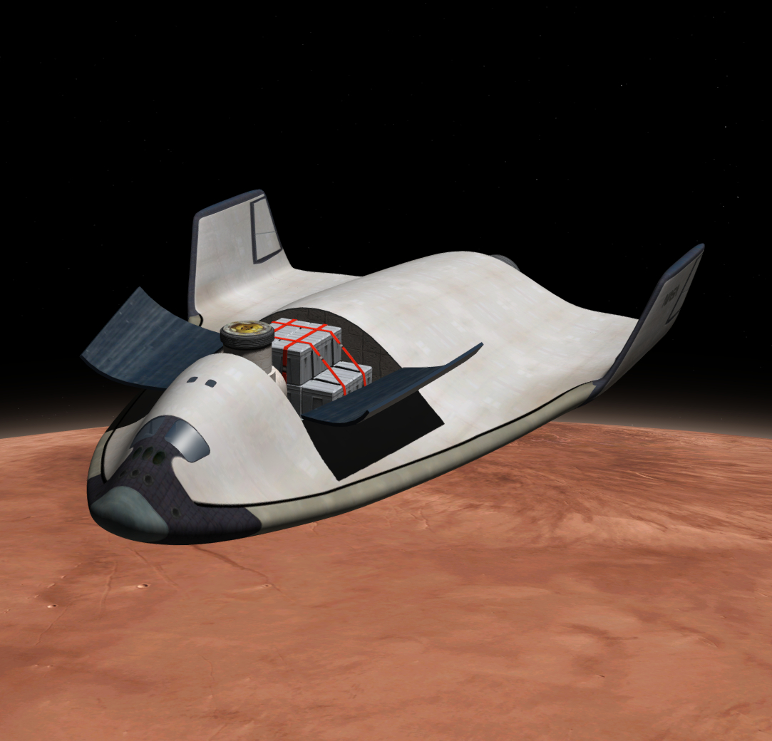
CTRL + B – air brake
CTRL + U – open / close payload bay doors and extend / retract dock
CTRL+ V – hover doors
New in v3.1 Hover engines are only available after hover doors are opened.

CTRL+ Y – open / close airlock and egress hatch and deploy / retract ladder

New in v3.1 The aerolanders are now coded to split control surfaces similar to old lifting body designs like the Northrop M2.

A new airbrake mesh has also been modeled.

New in v3.1 SHIFT + C – activate UCSO dialogue (will appear on HUD in VC). See UCSO section below.

New in v3.1 Aerolander Docking Changes
The aerolander dock will now only become available when the payload bay doors are opened with the key command [K].
New in v3.1 Forced landing status

Orbiter 2016 touchdown points for ground landing vessels have been implement. Landed vessels are forced to land status if no force is applied and the ground speed is less than 2 m/s (SleepyVessels module is no longer required).
Deepstar Aerolander Frequencies
Aerolander 1 XPDR 136.00
Aerolander 2 XPDR 136.50
Aerolander 2 Dock IDS 136.60

‘If the space shuttle and an F-35 would have a child ... it would look like the aerolander’ - Predattak
Earth Orbit Station Key Commands
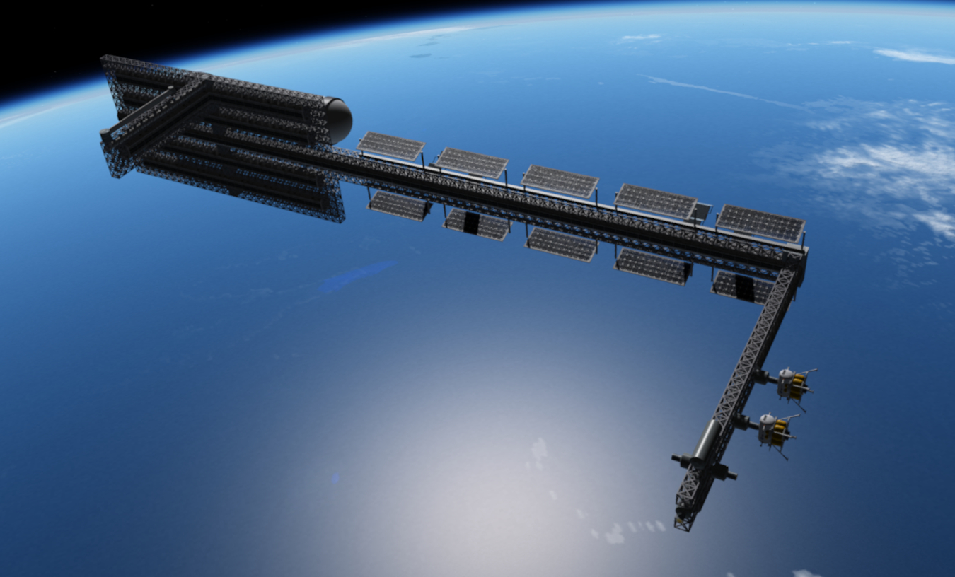
CTRL + G – deploy / retract refuelling boom
CTRL + K – start / stop solar array rotation
Earth Orbit Station Frequencies
XPDR 133.50
Dock 1 IDS 133.55
Dock 2 IDS 133.60
Dock 3 IDS 133.65
Dock 4 IDS 133.70
Dock 5 IDS 133.75

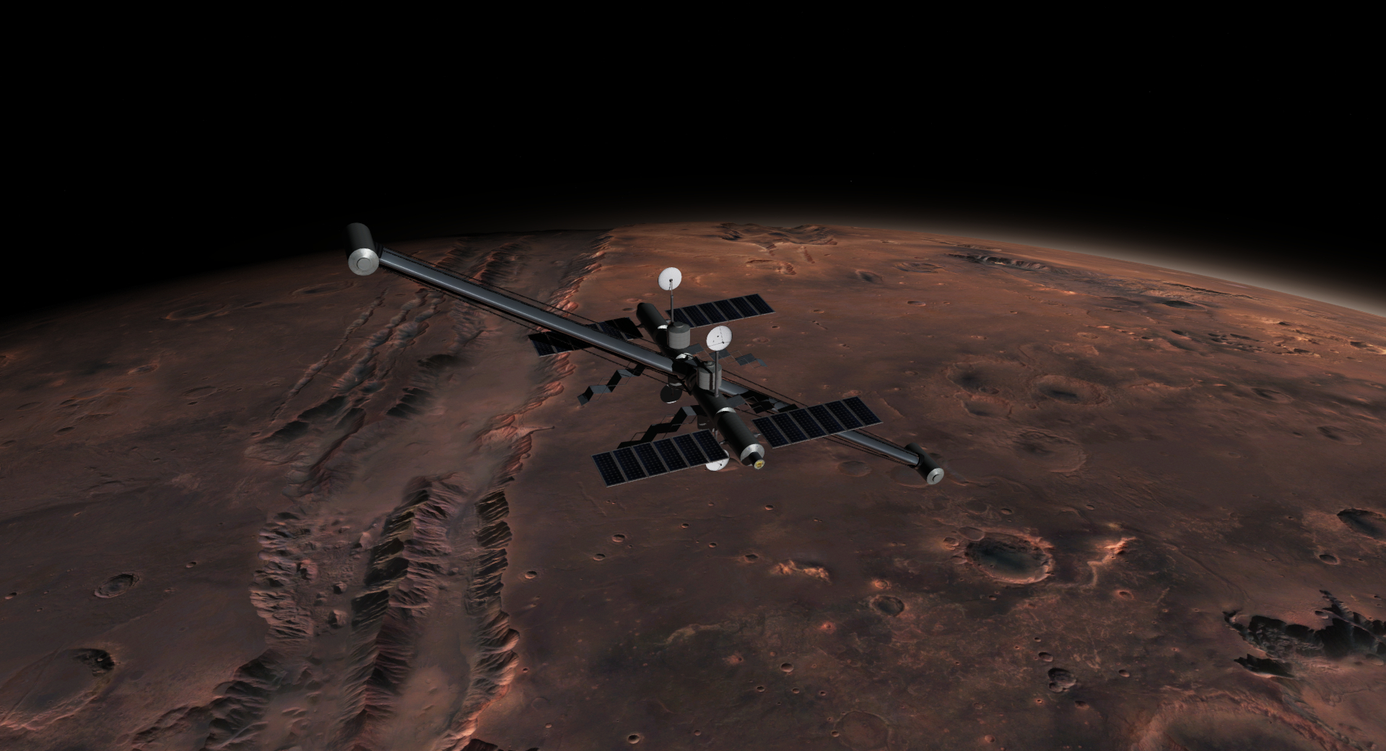
Mars Orbit Station Key Commands
CTRL + 1 – rotate forward dish
CTRL + 2 – rotate aft dish
CTRL + G – start / stop spin gravity
CTRL + K – start / stop solar array rotation
Mars Orbit Station Frequencies
XPDR 133.00
Dock 1 IDS 133.05
Dock 2 IDS 133.10

Uranus Orbit Station Key Commands
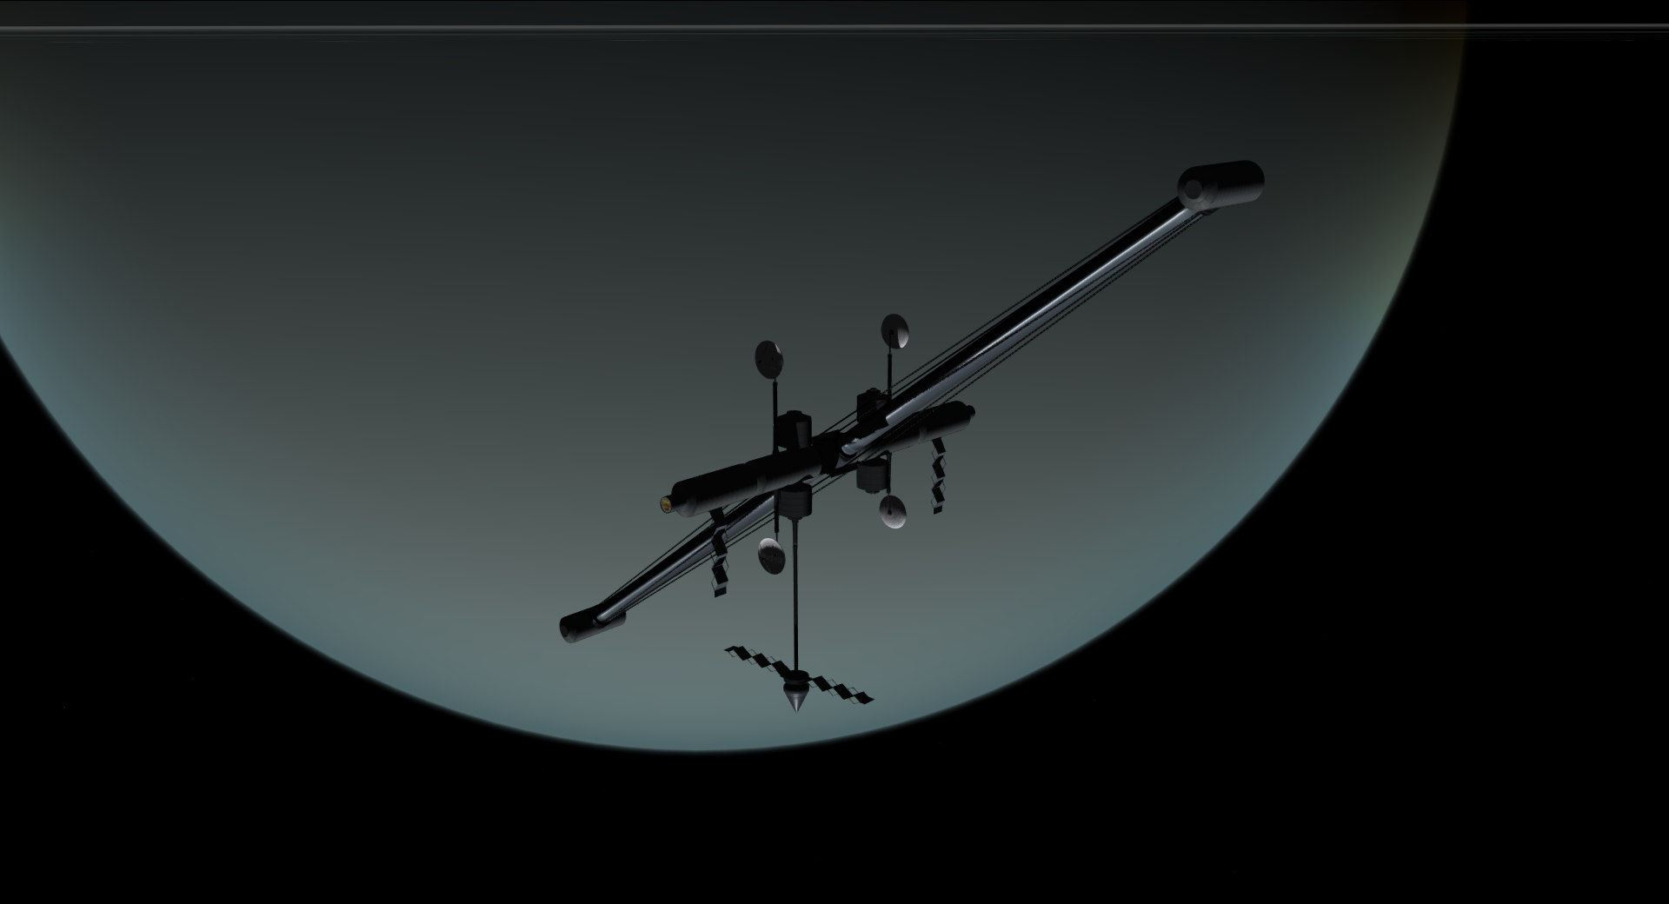
CTRL + 1 – rotate forward dish
CTRL + 2 – rotate aft dish
CTRL + G – start / stop spin gravity
Uranus Orbit Station Frequencies
XPDR 133.00
Dock 1 IDS 133.05
Dock 2 IDS 133.10

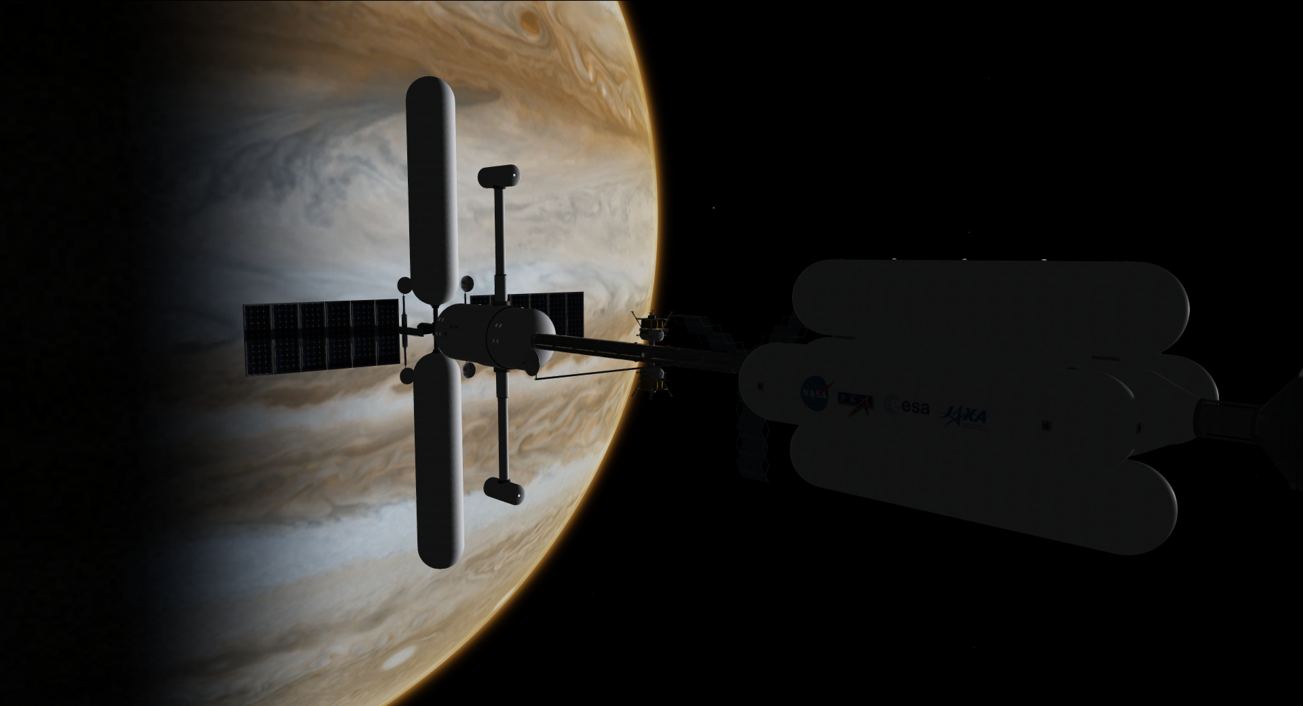
Jupiter Depot (Depot-01) Key Commands
CTRL + 1 – rotate port dish
CTRL + 2 – rotate starboard dish
CTRL + K – start / stop solar array rotation

Jupiter Depot (Depot-01) Frequencies
XPDR 128.00
Dock 1 IDS 128.05
Dock 2 IDS 128.10

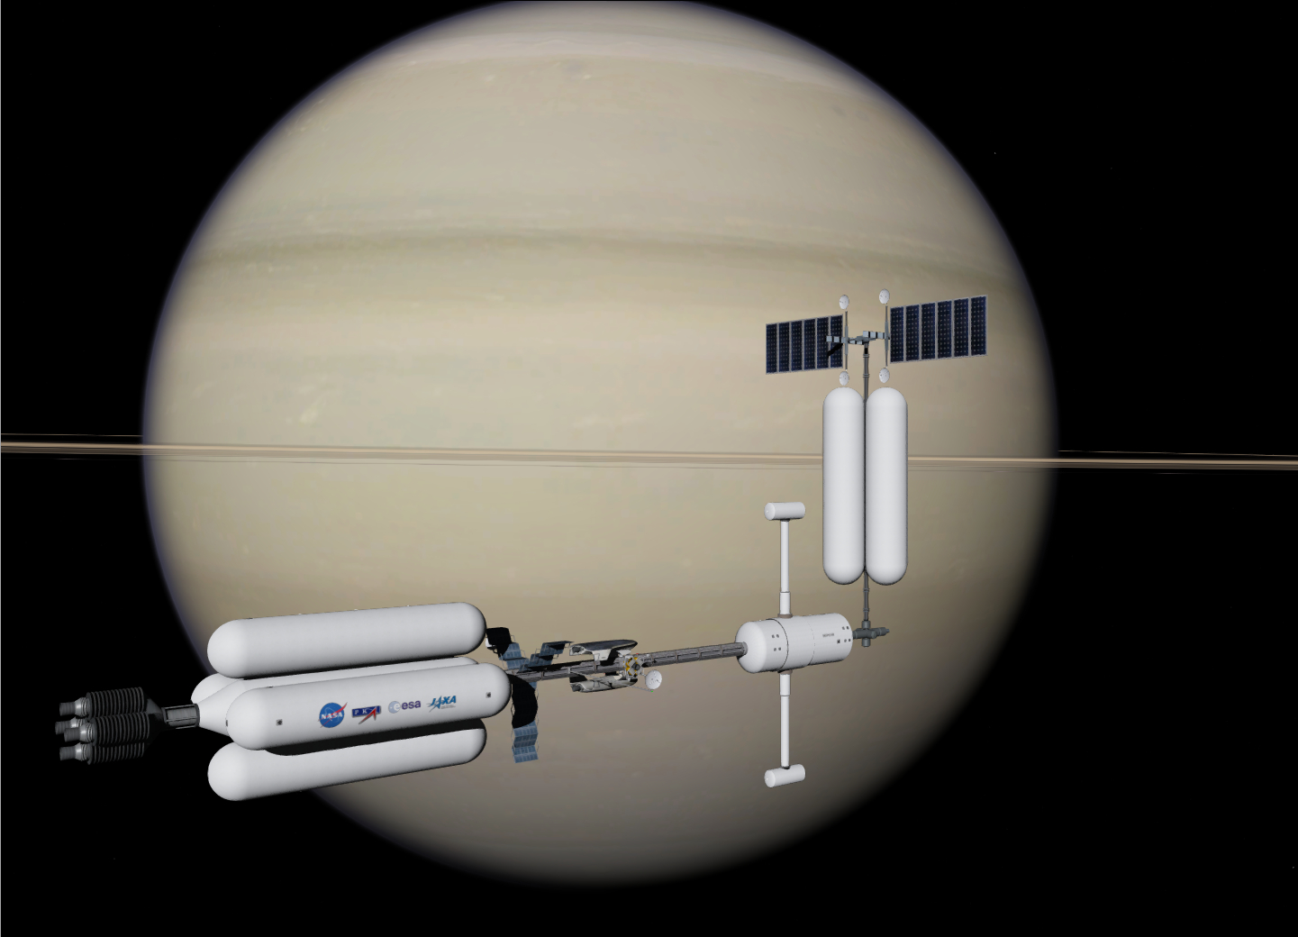
Saturn Depot (Depot-02) Key Commands
CTRL + 1 – rotate port dish
CTRL + 2 – rotate starboard dish
CTRL + K – start / stop solar array rotation

Saturn Depot (Depot-02) Frequencies
XPDR 128.00
Dock 1 IDS 128.05
Dock 2 IDS 128.10

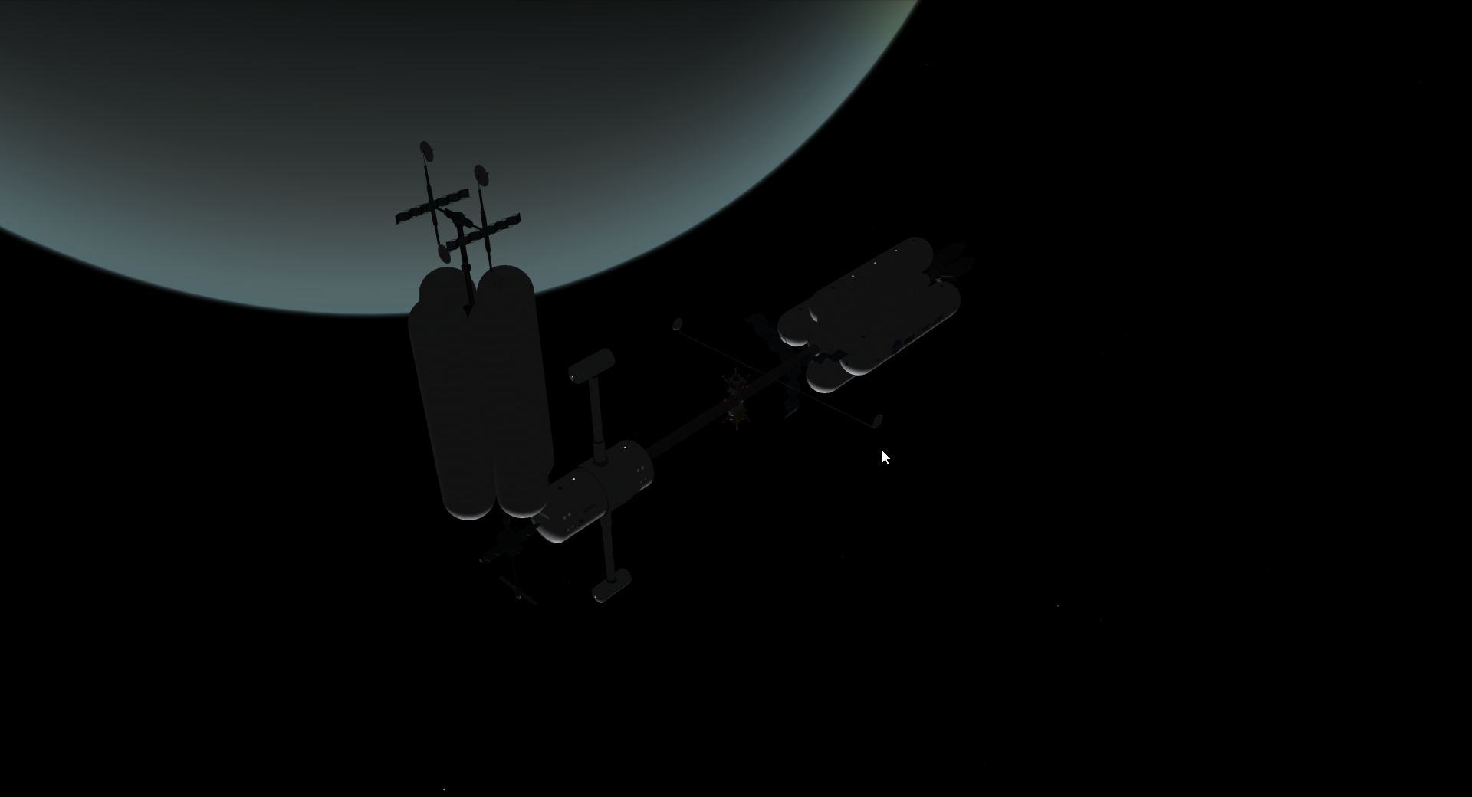
Uranus Depot (Depot-03) Key Commands
CTRL + 1 – rotate port dish
CTRL + 2 – rotate starboard dish

Uranus Depot (Depot-03) Frequencies
XPDR 128.00
Dock 1 IDS 128.05
Dock 2 IDS 128.10

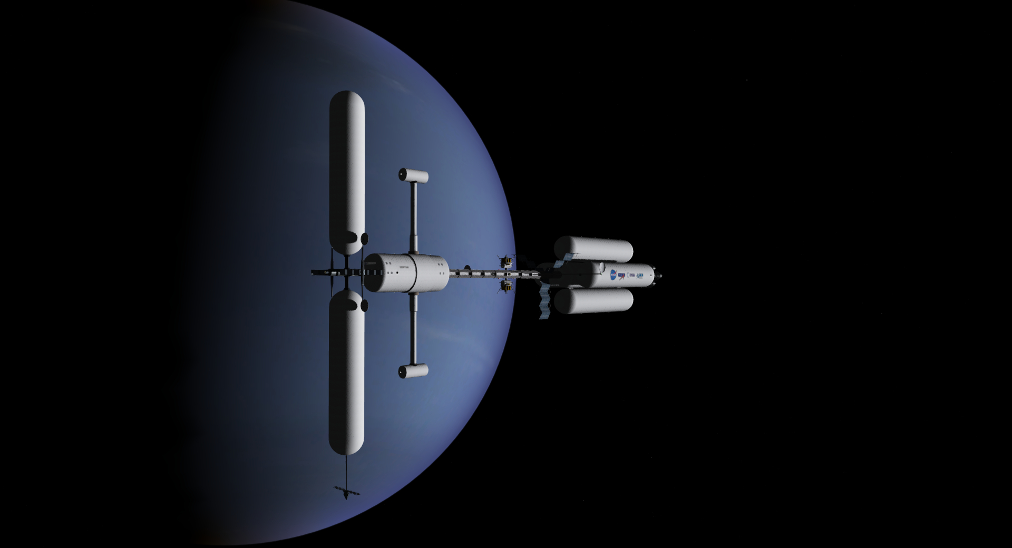
Neptune Depot (Depot-04) Key Commands
CTRL + 1 – rotate port dish
CTRL + 2 – rotate starboard dish

Neptune Depot (Depot-04) Frequencies
XPDR 128.00
Dock 1 IDS 128.05
Dock 2 IDS 128.10

Rover Key Commands
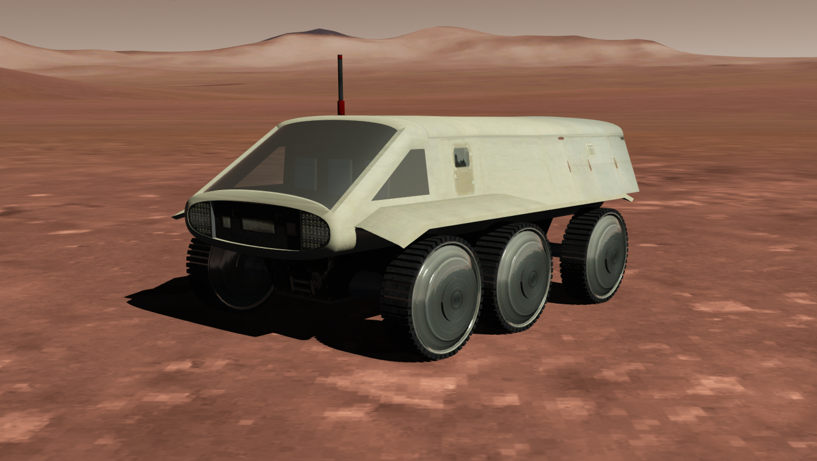
General Vehicle Standard commands:
NUMPAD8 – accelerate
NUMPAD2 – brake
NUMPAD4 – turn left
NUMPAD6 – turn right
NUMPAD5 – centre steering wheel
CTRL + NUMPAD4 – slow turn left
CTRL + NUMPAD6 – slow turn right
CTRL + NUMPAD2 – if vehicle is stopped it starts to move in reverse
CTRL+ L – toggle vehicle lights (when local light sources checkbox is selected from the Visual effects tab of the Orbiter launchpad).

UCSO Implementation
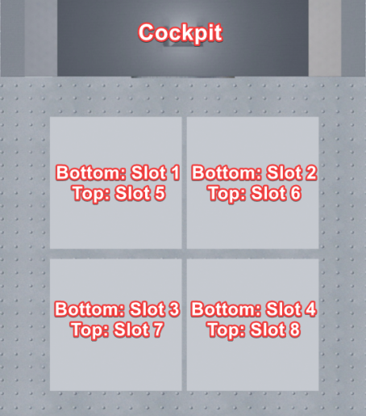Lander UCSO layout
Deepstar can now carry 144 UCSO payloads + 2 probes (72 + 1 on each side), numbered from forward to aft. Payloads are carried at positions along the truss with the fourth truss module from the command section used to attach the probes.

The landers can now carry 8 UCSO payloads. These are stacked internally behind the cockpit. Lander cargo can only be deployed on the ground

The aerolanders can now carry 15 normal UCSO payloads, or one custom payload mesh in a centre slot and two UCSO payloads adjacent the docking system. In addition to the spacehab mesh, a dedicated cargo mesh can be used with the aerolanders (Deepstar\CargoContainers.msh) as pictured in the aerolander section above. Three payloads in version 3.1 are unpacked from this mesh – an inflatable habitat, a kilopower reactor, and a Deepstar Rover (… for a holiday on Deimos?). See the UCSO config format to easily create new payloads.
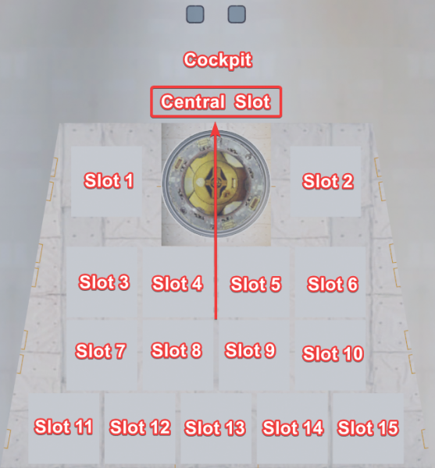Aerolander UCSO layout
Virtual Cockpits

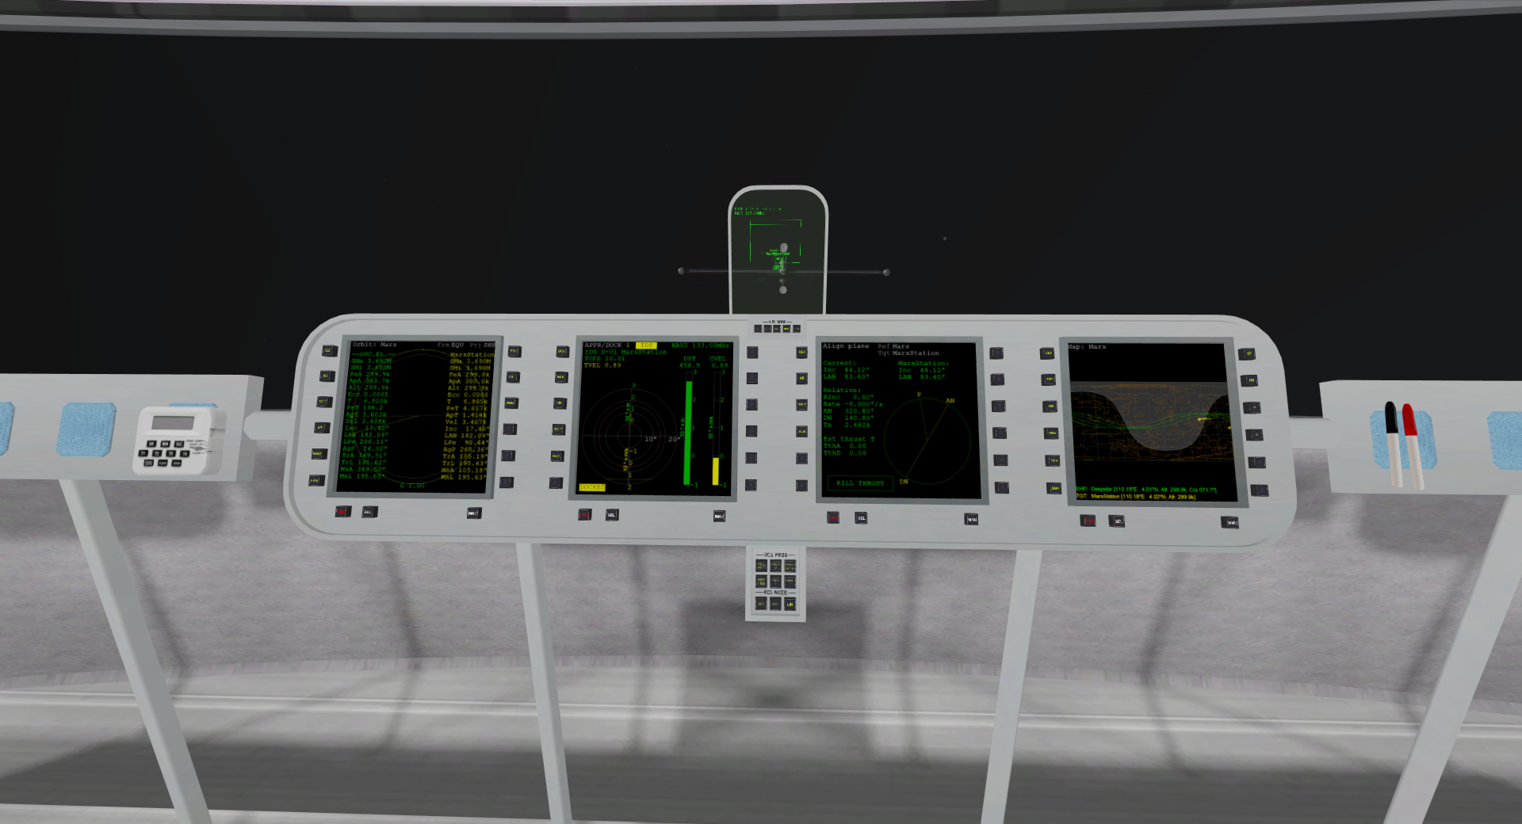
Virtual Cockpit Key Commands
F8 – cycle between VC and non-VC internal view modes.
New in v3.1 CTRL + ARROW –switch between seats and docking viewports.
New in v3.1 SHIFT + C – activate UCSO dialogue (will appear on HUD in VC).

New in v3.1 This release features active virtual cockpits with clickable buttons for MFD, Autopilot and HUD control, including a button to activate the UCSO dialogue on the HUD.
Note the INF button will display available commands on the HUD and non-VC interior view. This command list is permanently available on the non-VC interior view of the stations and depots.
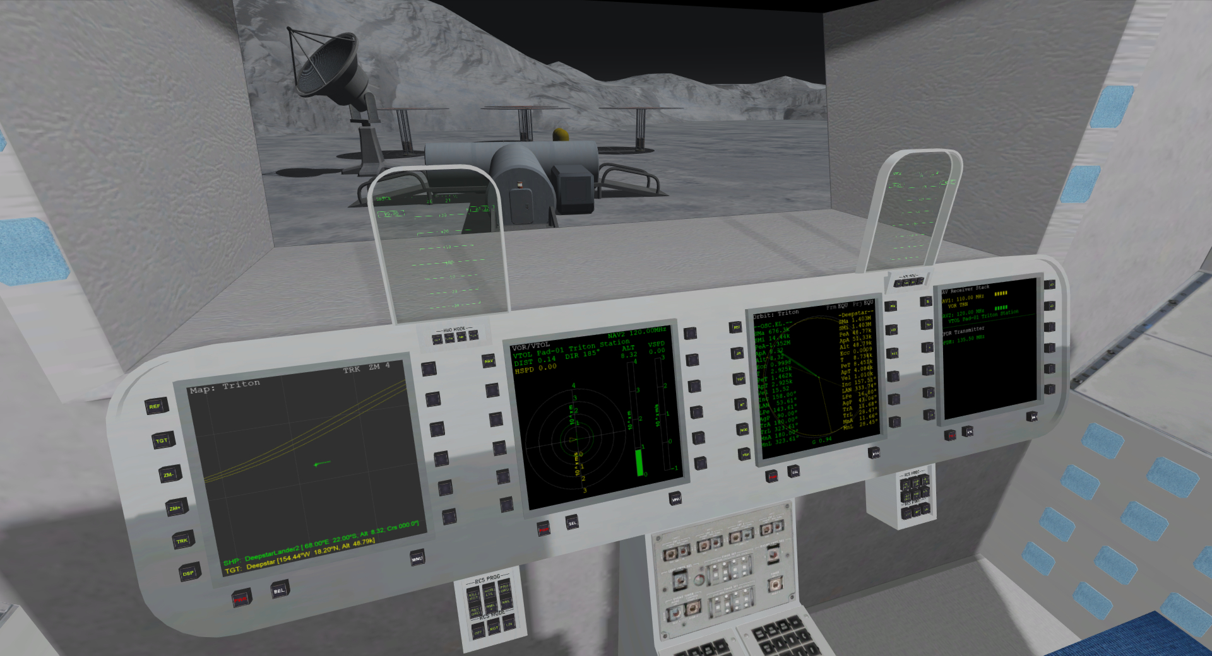
Tip: you can increase the resolution of VC MFDs in the Orbiter launchpad.
Go to Extra > Instrument and panels > MFD parameter configuration to set MFDs up to 1024x1024px in VC mode.

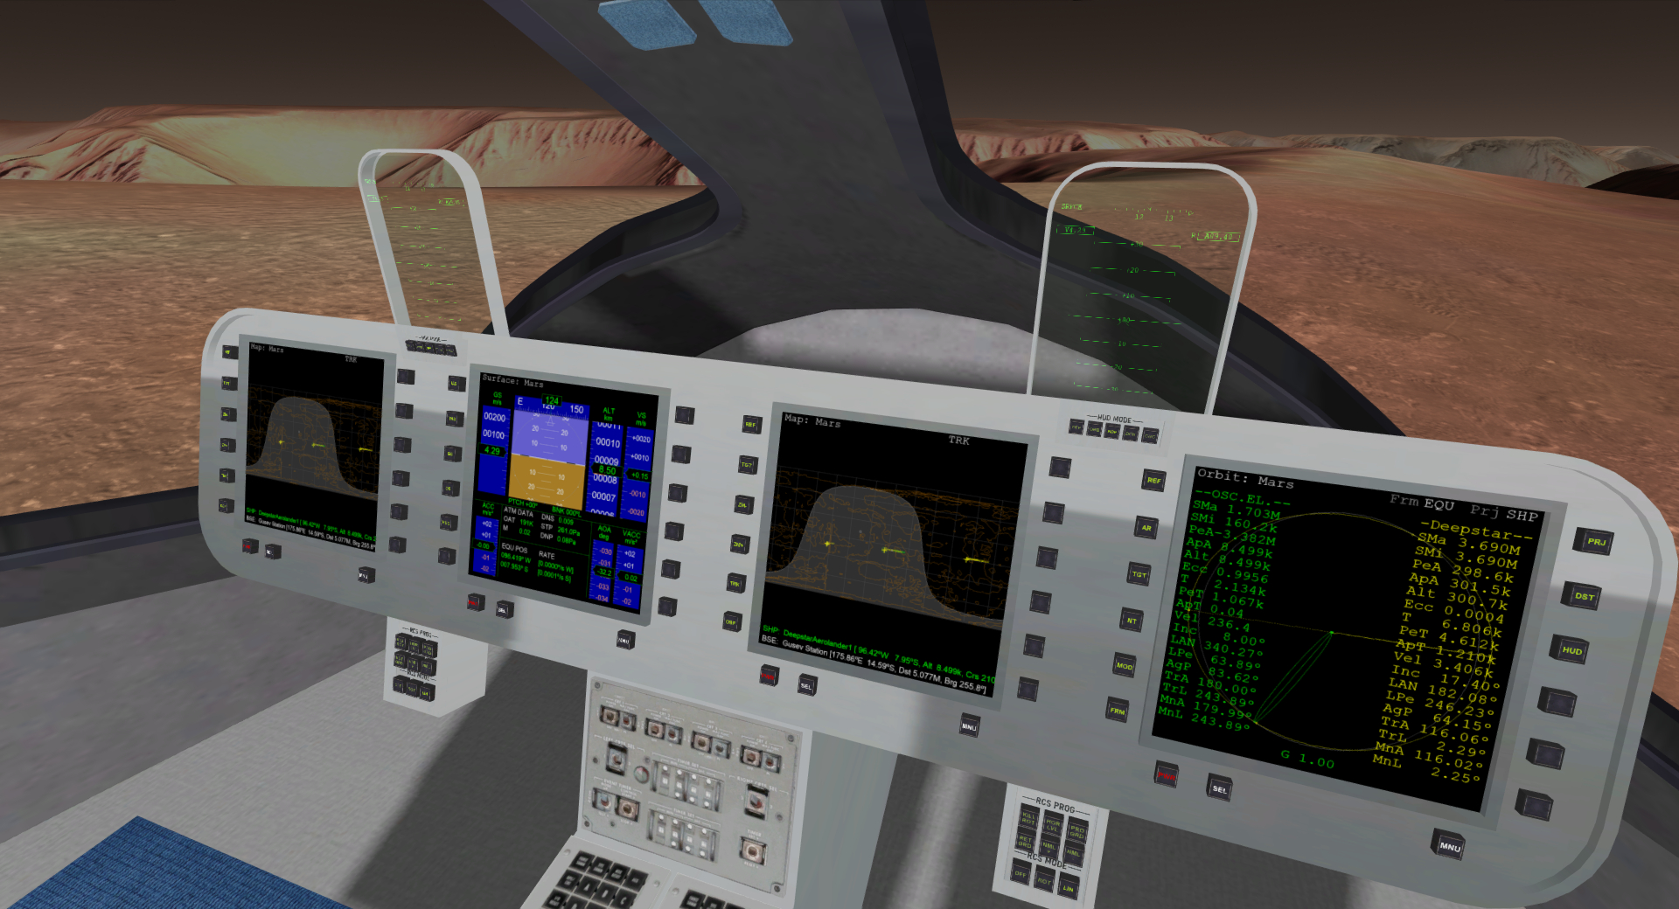
Setting a fast MFD refresh rate on the Parameters tab (I use 0.1) can help with MFD stability.

The VCs have been tested with TrackIR.

Bases
Deepstar 2.0 dropped off some 3d printers and now we have bases at Mars, Phobos, Vesta, Ganymede, Titan and Triton. ‘Titan Shores’ has retained its name from previous versions. The other bases use a ‘station’ nomenclature in the spirit of Antarctic research stations.

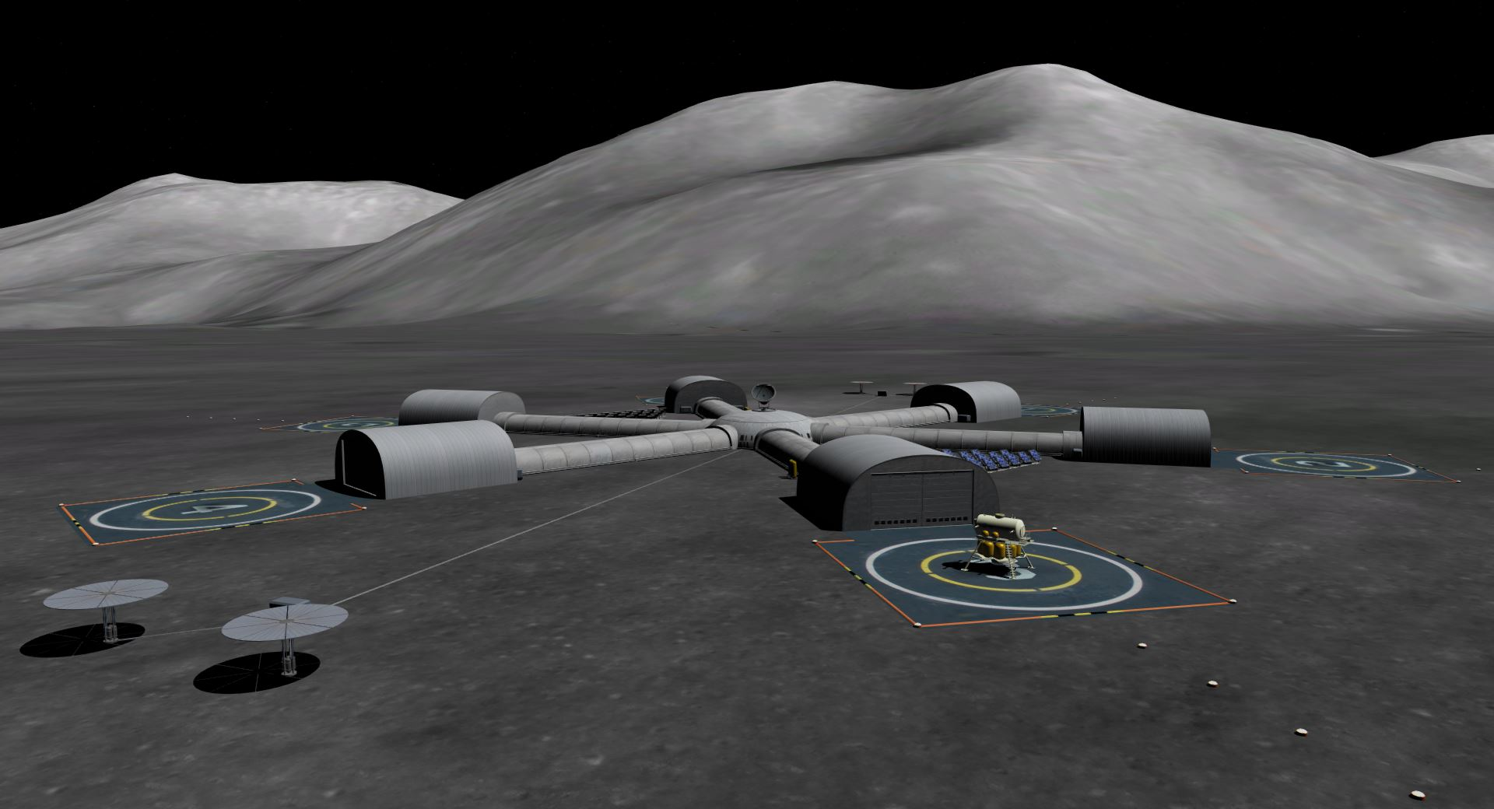
New in v3.1 Huygens Station (Moon)
VOR HYG 110.00
PAD 1 NAV 120
PAD 2 NAV 120.10
PAD 3 NAV 120.20
PAD 4 NAV 120.30
PAD 5 NAV 120.40
PAD 6 NAV 120.50

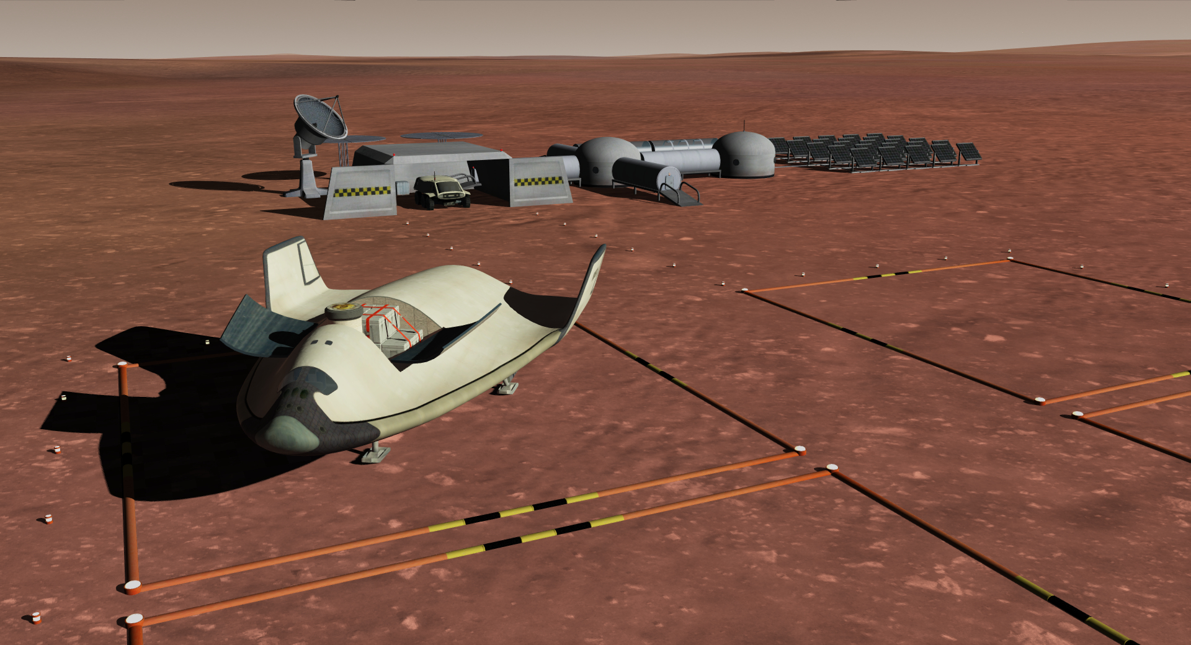
Gusev Station (Mars)
VOR GSV 110.00
PAD 1 NAV 120
PAD 2 NAV 120.10
PAD 3 NAV 120.20
PAD 4 NAV 120.30

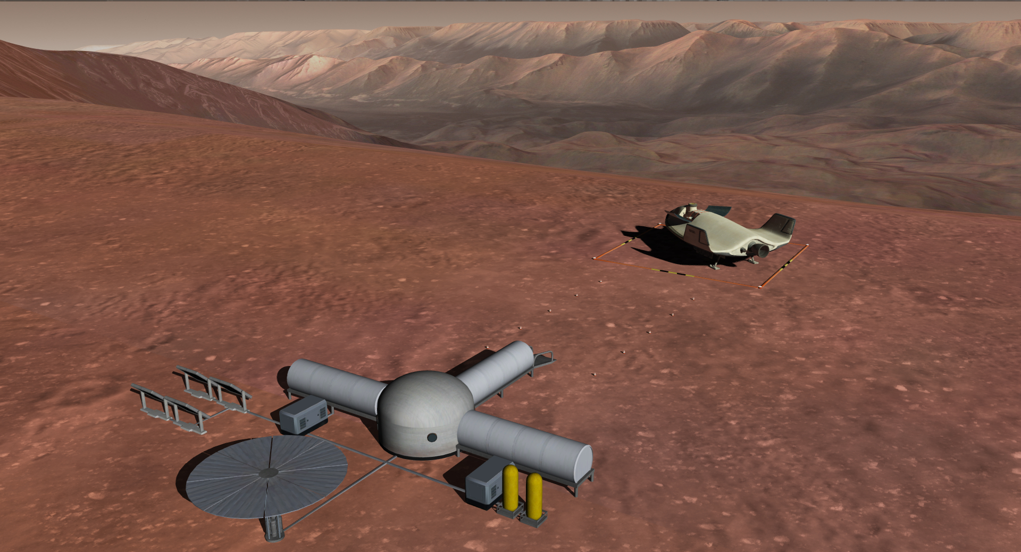
Marineris Station (Mars)
VOR MRN 110.00
PAD1 NAV 120.00

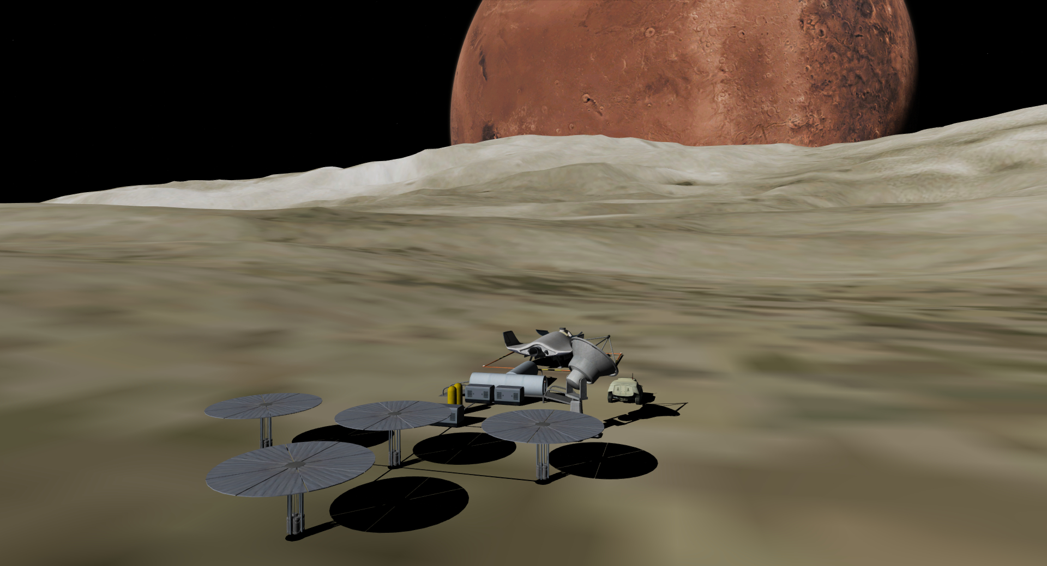
Stickney Station (Phobos)
VOR SKY 110.00
PAD1 NAV 120.00

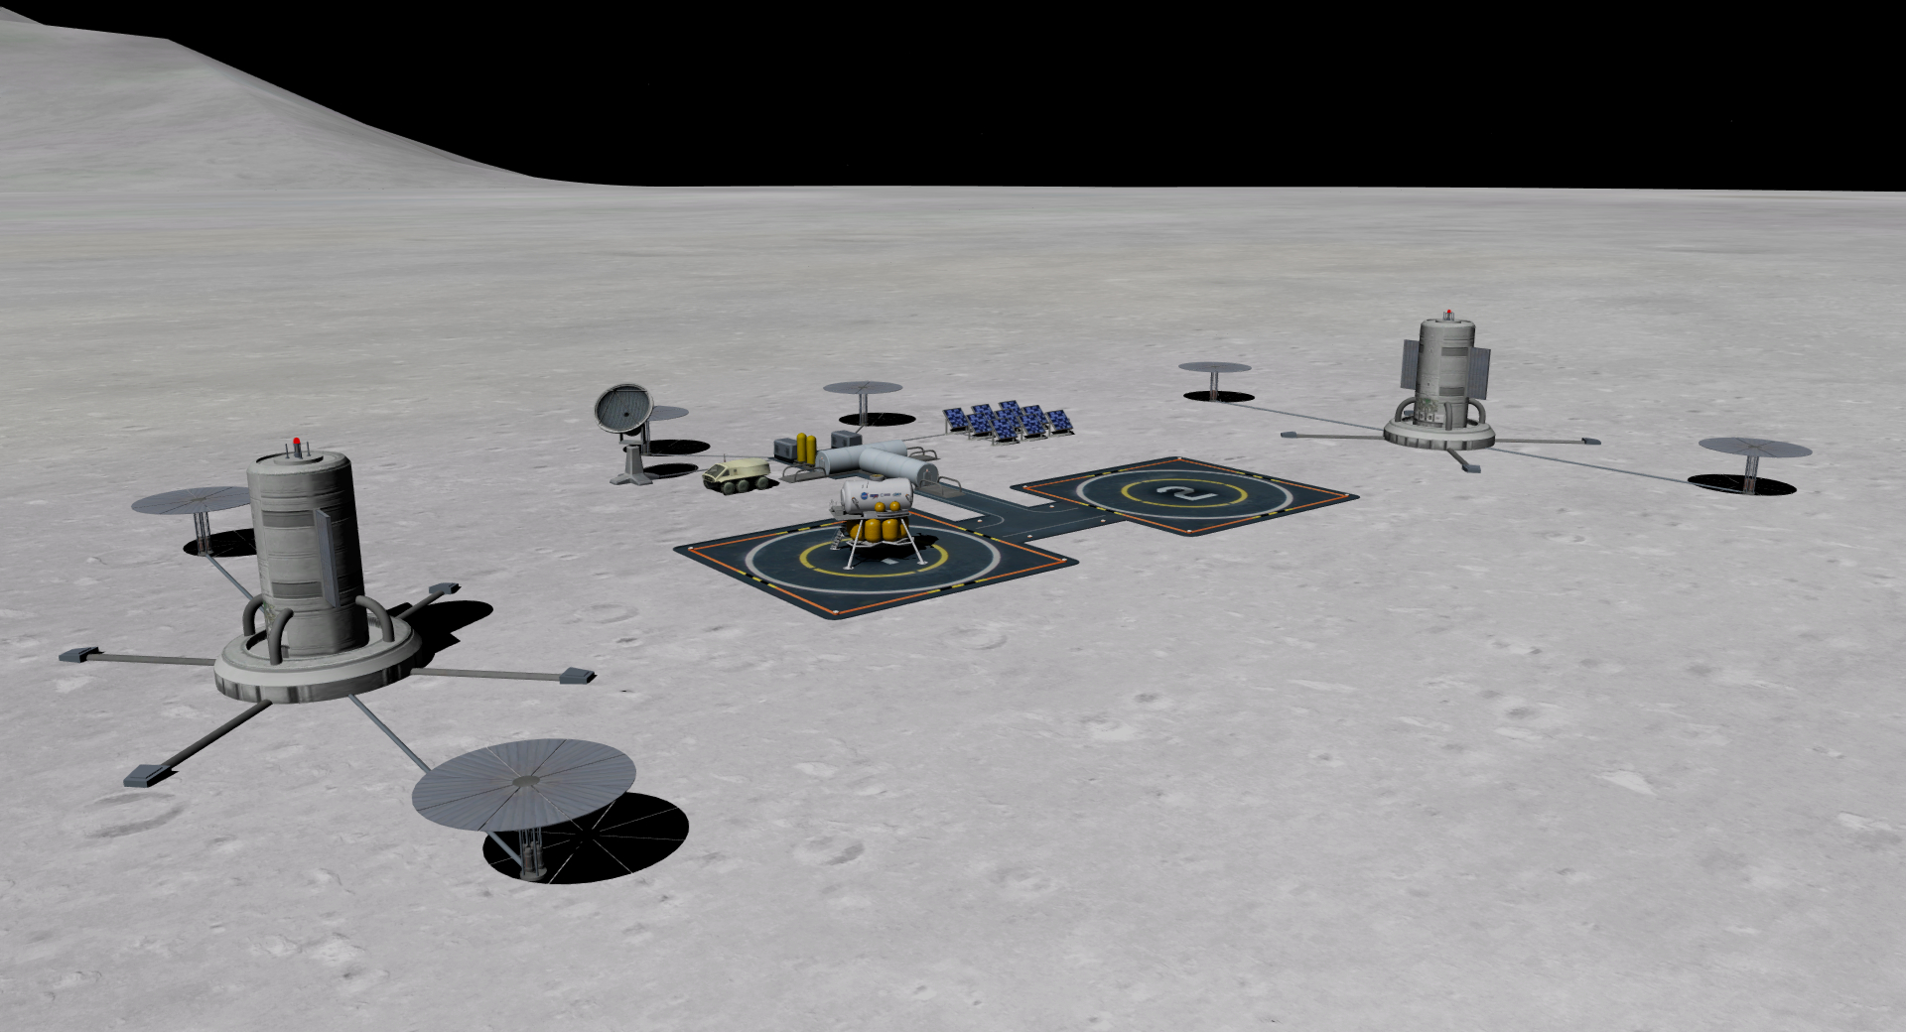
Vesta Station
VOR VST 110.00
PAD 1 NAV 120
PAD 2 NAV 120.10

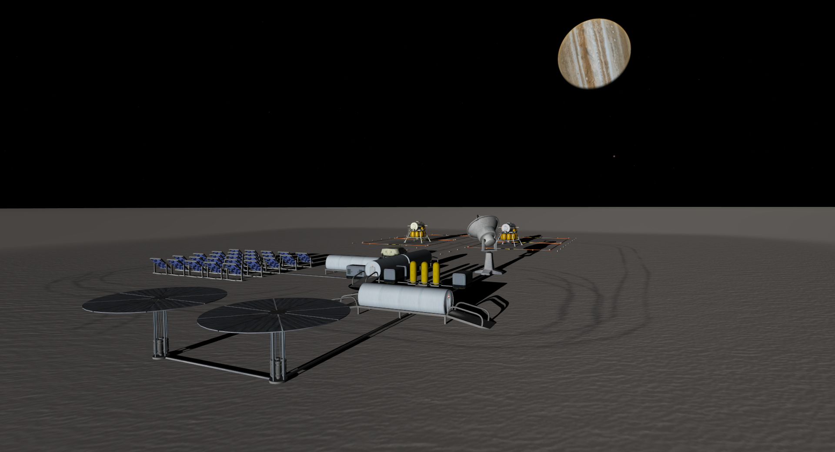
Ganymede Station
VOR GMD 110.00
PAD 1 NAV 120
PAD 2 NAV 120.10
PAD 3 NAV 120.20
PAD 4 NAV 120.30

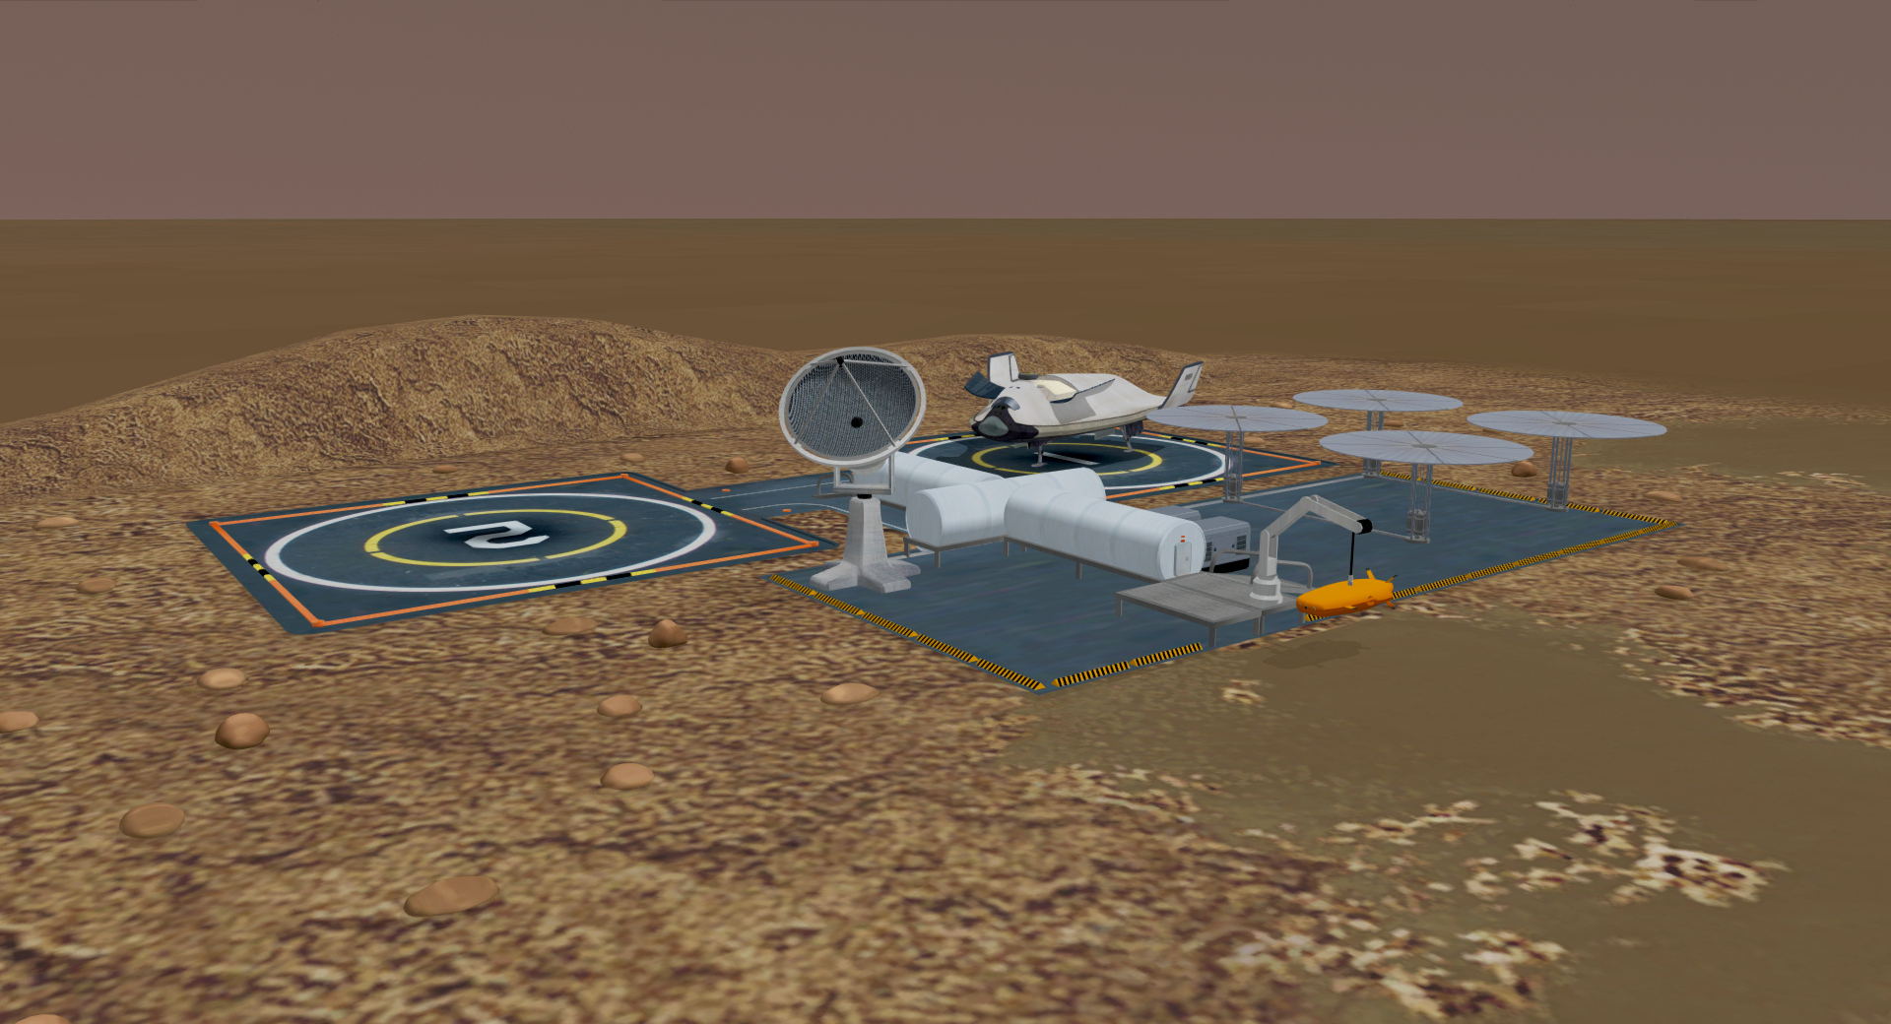
Titan Shores
VOR TNS 110.00
PAD 1 NAV 120
PAD 2 NAV 120.10

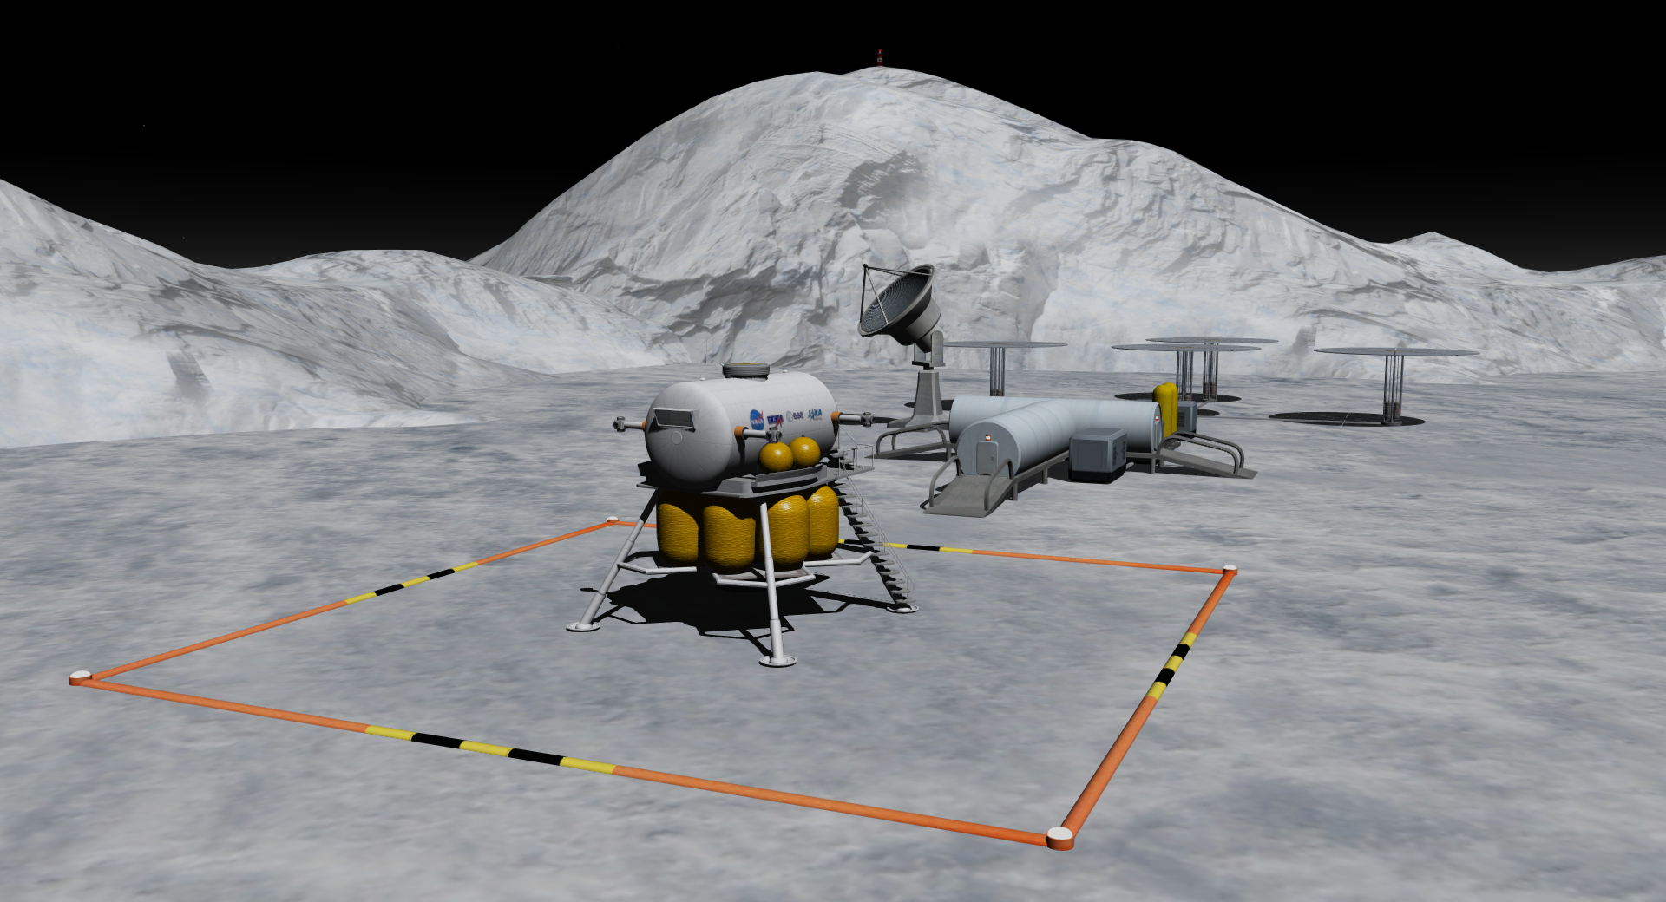
Triton Station
VOR TRN 110.00
PAD 1 NAV 120.10

Known Issues

- Switching between VC and non-VC views with F8 can interfere with certain MFDs. In addition to resetting dock selection in Docking MFD for Deepstar, VC switching in all vessels was found to affect the stock Transfer MFD. If you switch views before making a burn in Transfer MFD adjust the plan in your new view before making the burn (similar to the workaround for the known Orbiter bug found when restarting a saved scenario with Transfer MFD). Don’t switch views while a Transfer MFD burn is in progress. TransX and Pursuit MFD were not affected.
- Self-shadow artefacts will sometimes appear on Deepstar at certain angles and under certain lighting conditions. This may appear as wavy lines or concentric circles. This is a function of the large bounding boxes the D3D9 client defines with Deepstar and of the client’s use of a single shadow map per vessel. If this bothers you the solution is to simply switch self-shadows off on the D3D9 settings page shown above. I leave them on and feel the visual benefits outweigh the occasional artefact.
- The rover responds sluggishly on Phobos. The rover placed there now uses a config which doubles the vehicle’s acceleration but you might want to use 10x time acceleration to get up to speed.
Support
Please disregard any email addresses attached to my old add-ons. Those addresses are rarely attended and I apologise for any missed emails over the years.
The best way to get support from me, or the community if I’m in an inactive phase, is to post in the orbiter-forum development thread: https://www.orbiter-forum.com/threads/deepstar-development.26879

Thanks
Thanks to Abdullah for coming onboard with this release and helping me to realise a vision! See the version history / changelist appendix for a list of all the changes.
Thanks to the beta testing team for valuable feedback which shaped the final release.
Thanks to Martin and to the add-on developers whose work has made it possible for me to release my own.
Thanks to those members of the community who have helped with previous versions (Axel provided the thrust and weight figures for Deepstar and the landers which are still used).
A special thanks to the members of the community who have offered encouragement and feedback in the development thread.
Alain (80mileshigh), October 2021.
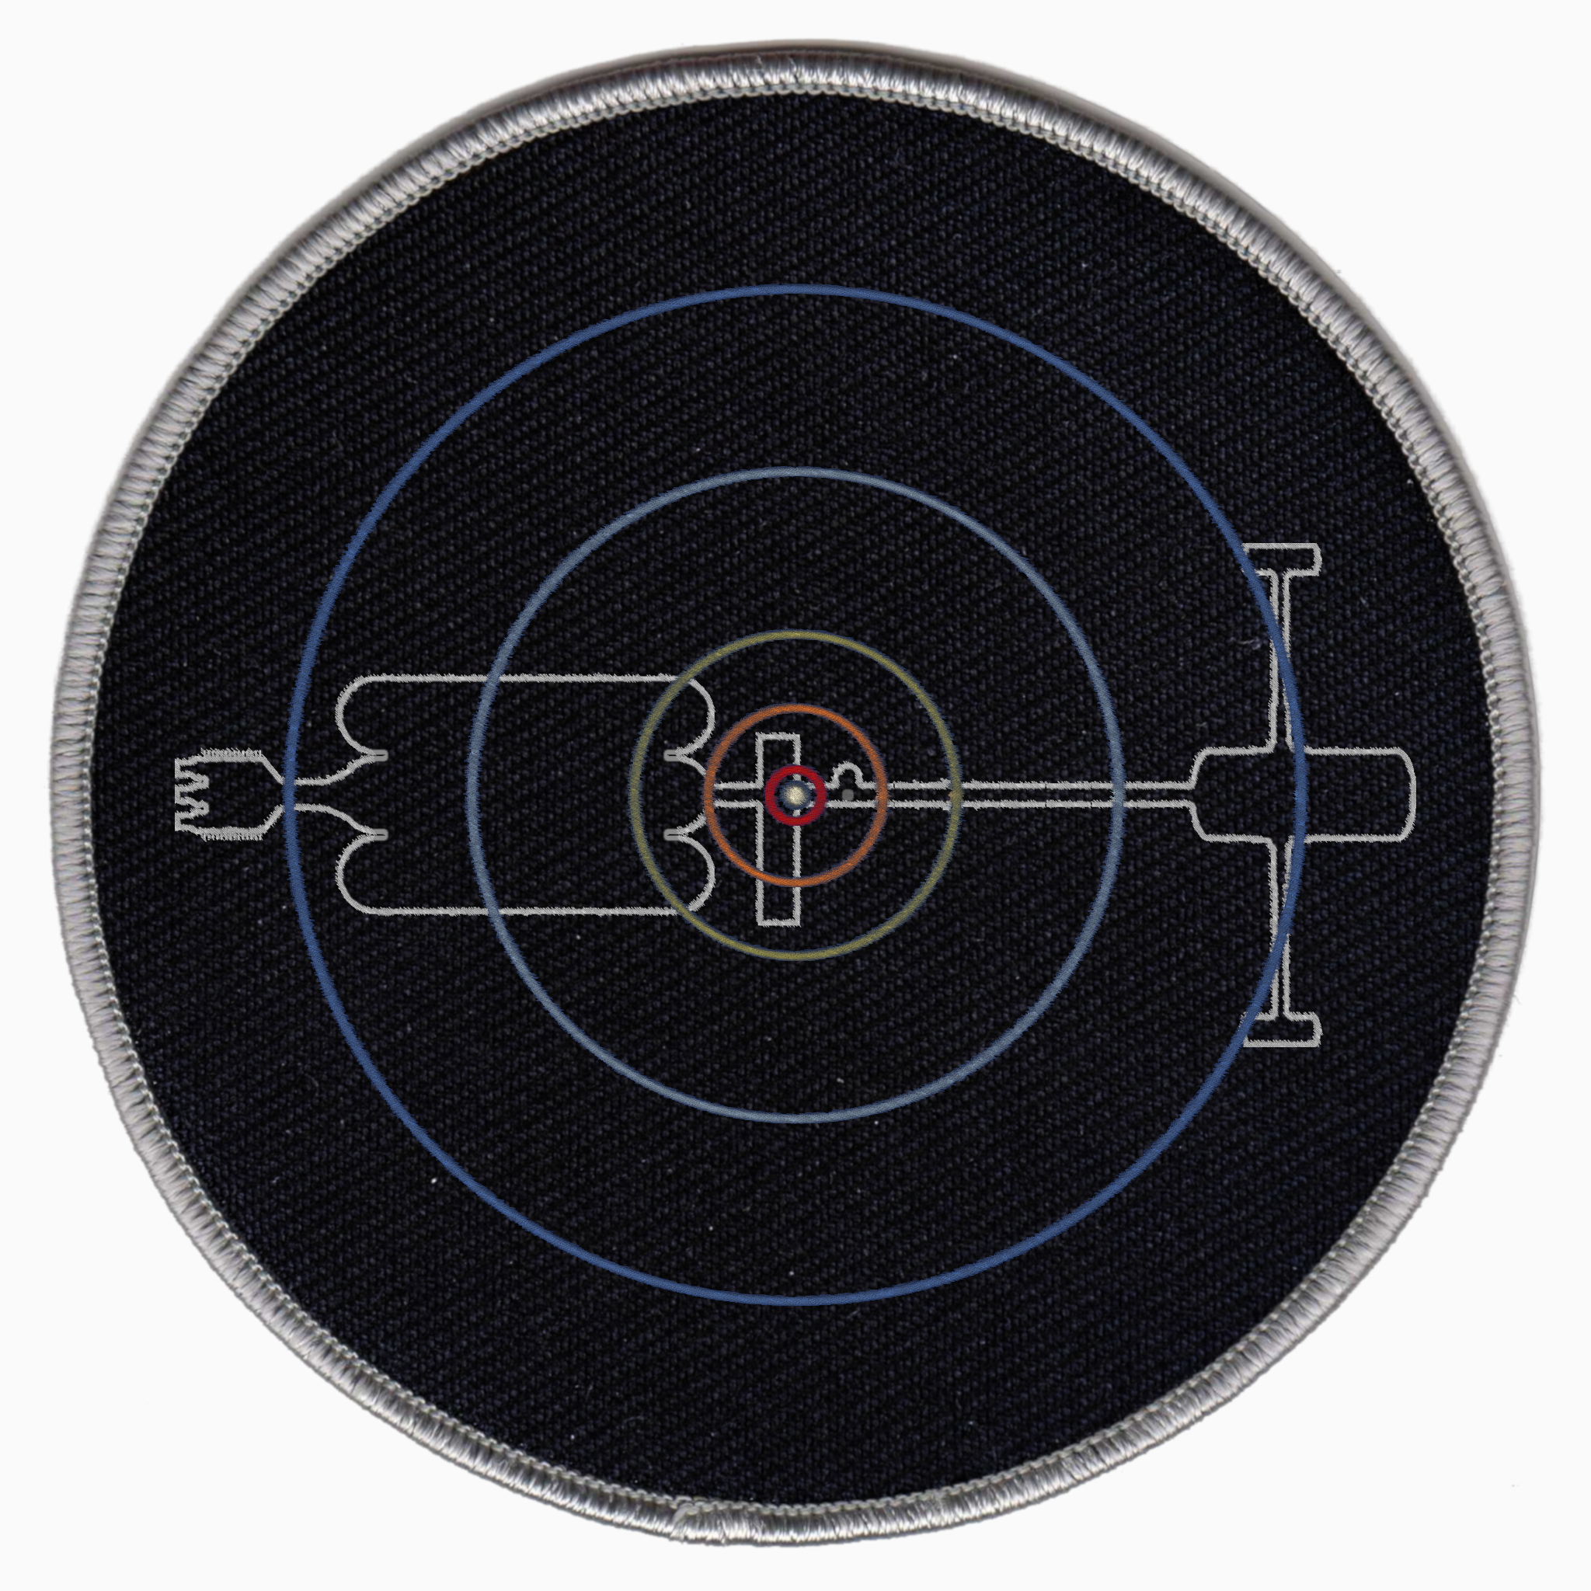

Licence
Deepstar 3.1 is free and open source under the GPLv3 licence. The source code can be found in the Deepstar GitHub repository. All contributions are appreciated.
Copyright © Alain Hosking and Abdullah Radwan
Appendix 1. Version History

Version 3.1 for Orbiter 2016 by 80mileshigh and Abdullah Radwan. September 2021.
Code: Custom C++ modules by Abdullah Radwan, GeneralVehicle, UCSO.
Changes: Complete conversion of SC4 configs to C++ by Abdullah with major improvements:
Deepstar RCS coded to mesh positions.
All vessels RCS balanced.
Docking RCS mode for Deepstar, lander and aerolander.
Deepstar forward dock only available when open.
Docking floodlight available when forward dock activated
Aerolander dock only available when payload bay doors open.
Aerolander hover engines only available when hover doors open.
Aerolander aerodynamic model based on shape.
Aerolander control surfaces custom coded.
UCSO integration for Deepstar, lander and aerolander with custom payloads.
Touchdown points and forced land status under 2m/s coded for landers / aerolanders.
Fully active virtual cockpits (full MFD, HUD and Autopilot control) with view switching in landers and aerolanders.
XRSound integration via Dynamic XRSound with custom sounds.
RCS on Deepstar command section modelled.
New texture for Deepstar name.
Virtual Cockpits remodelled with HUD and autopilot buttons.
Aerolander airbrake modelled and new textures for control surface / landing gear wells.
Mars base configurations adapted to hi-res texture / terrain using Predattak’s locations.
Vessel images for Orbiter scenario editor.
D3D9 ‘Metalness’ shader profiles.
Added Huygens Station lunar base
New Lander mesh with docking viewports.
Vessels: Deepstar, 2 landers, 2 aerolanders (+ Spacehabs), 3 orbital stations, 4 orbital propellant depots, 2 Probes, 2 rovers, UCSO inflatable habitat, UCSO kilopower reactor, UCSO rover.
Bases: Huygens Station (Moon), Gusev Crater and Vallis Marineris (Mars), Stickney Crater (Phobos) Vesta, Ganymede, Titan and Triton.
Scenarios: 62

Version 3.0 for Orbiter 2016 by 80mileshigh, December 31 2020.
Code: Spacecraft 4.dll and GeneralVehicle
Changes: Remodelled Deepstar based on 2.0 model concept with new proportions for all sections, new fusion drive model, inset RCS, reintroduced com-dish animations broken in v2.0.
Deepstar sized at 360.76m length with 68m hab radius (2rpm / 0.304g)
Introduce atmospheric landers (aerolanders) with spacehab payload, orbital stations, propellant depots, probes, new bases and a GeneralVehicle based rover.
New virtual cockpits (partially active, MFDs displayed, no clickable surfaces) with baked shadow textures and extra mesh detail.
Normal mapping for use with D3D9 client. Terrain flattening using D3D9 client.
Vessels: Deepstar, 2 landers, 2 aerolanders (+ Spacehabs), 3 orbital stations, 4 orbital propellant depots, 2 Probes, 2 rovers.
Bases: Gusev Crater and Vallis Marineris (Mars), Stickney Crater (Phobos) Vesta, Ganymede, Titan and Triton.
Scenarios: 60

Version 2.1 for Orbiter 2010 by by 80mileshigh and Axel. November 2012.
Code: dll based on Spacecraft3 using Artlav’s converter.
Changes: Thrust and weight configurations by Axel.
Removed beta modules Saturn.dll and Satsat.dll which created issues with Orbiter 2010
Vessels: No change from 2.0
Bases: No change from 2.0
Scenarios: 14

Version 2.0 for Orbiter 2006 by 80mileshigh. February 2008.
Code Spacecraft3.dll
Changes: Complete remodelling of Deepstar, landers and virtual cockpits.
Animated nose dock and communications dishes on Deepstar.
Animated hatch on landers.
Deepstar sized at 348.5m length with 68m hab radius (2rpm / 0.304g)
Included beta modules Saturn.dll and Satsat.dll which resolved issues in Orbiter 2006.
Vessels: Deepstar + two landers. Partially active virtual cockpits (MFDs displayed, no clickable surfaces).
Bases: Tohil Mons (Io). Fictional landing sites at Rhea, Titan, Titania and Triton.
Scenarios: 37

Version 1.0 for Orbiter 2005 by 80mileshigh. March 2006.
Proof of concept.
Code: Spacecraft2.dll
Vessels: Deepstar + two rudimentary landers. Passive virtual cockpits (mesh only, no MFDs) Animated hab rotation on Deepstar.
Deepstar vessel sized at 135.5m length with 28m hab radius (3rpm / 0.282g)
Bases: Tohil Mons (Io). Fictional landing sites at Rhea, Titan, Titania and Triton.
Scenarios: 35.

Appendix 2. Low-res (default) Mars Base Configurations

Here are the old Mars base configurations to be used if you choose to run Orbiter’s default low resolution textures and terrain for Mars:
Overwrite the following sections above ; === List of visuals === with these lines:
In Config\Mars\Base\Deepstar\GusevStationcfg:
BASE-V2.0
Name = Gusev Station
Location = +175.8492858 -14.6177637
Size = 100
;MapObjectsToSphere = TRUE

BEGIN_NAVBEACON
VOR GSV +175.8492858 -14.6177637 110.00 500
END_NAVBEACON

and in Config\Mars\Base\Deepstar\MarinerisStation.cfg

BASE-V2.0
Name = Marineris Station
Location = -85.274000 -6.320690
Size = 100
;MapObjectsToSphere = TRUE

BEGIN_NAVBEACON
VOR MRN -85.274000 -6.320690 110.00 500
END_NAVBEACON

Additionally, change the contents of Textures\Mars\Flat\Gusev.flt to:

Ellipse -1900 175.85 -14.619 1500

And change the contents of Textures\Mars\Flat\Gusev.flt

Ellipse 4310 -85.275000 -6.321000 400

Appendix 3. File List

Version 3.0 file list for uninstallation*

*does not include previously distributed GeneralVehicle and Spacecraft4 files. Do not uninstall GV.

Just delete the highlighted folders and files to quickly uninstall. A full list is provided here for completeness.

Archive: Deepstar3.0_201231.zip 74.3MB

Config\
Deepstar\
Deepstar-Aerolander-1.cfg
Deepstar-Aerolander-2.cfg
Deepstar-Lander-1.cfg
Deepstar-Lander-2.cfg
Deepstar-Probe1.cfg
Deepstar-Probe2.cfg
Deepstar.cfg
Deep_spacehab.cfg
Depot-01.cfg
Depot-02.cfg
Depot-03.cfg
Depot-04.cfg
Earth-Station.cfg
Mars-Station.cfg
Uranus-Station.cfg

Ganymede\Base\Deepstar3.0\Ganymede_Station.cfg

Mars\Base\Deepstar3.0\
Gusev_Station.cfg
Marineris_Station.cfg

Phobos\Base\Deepstar3.0\Stickney_Station.cfg

Spacecraft\
Deepstar-Aerolander-1.ini
Deepstar-Aerolander-2.ini
Deepstar-Lander-1.ini
Deepstar-Lander-2.ini
Deepstar-Probe1.ini
Deepstar-Probe2.ini
Deepstar.ini
Depot-01.ini
Depot-02.ini
Depot-03.ini
Depot-04.ini
Earth-Station.ini
Mars-Station.ini
Uranus-Station.ini

Titan\Base\Deepstar3.0\Titan_Shores.cfg

Triton\Base\Deepstar3.0\Triton_Station.cfg

Vessels\
Deepstar_Rover.cfg
Deepstar_Rover2.cfg

Vesta\Base\Deepstar3.0\Vesta_Station.cfg

Doc\
Deepstar3.0.pdf

Meshes\
Deepstar3.0\
Deepstar3.0.msh
Deepstar3.0_aerolander.msh
Deepstar3.0_aerolander_VC.msh
Deepstar3.0_Depot1.msh
Deepstar3.0_Depot2.msh
Deepstar3.0_Depot3.msh
Deepstar3.0_Depot4 - Copy.msh
Deepstar3.0_Depot4.msh
Deepstar3.0_Ganymede1.msh
Deepstar3.0_Ganymede2.msh
Deepstar3.0_Ganymede3.msh
Deepstar3.0_Ganymede_surface.msh
Deepstar3.0_Lander.msh
Deepstar3.0_Lander_VC.msh
Deepstar3.0_Mars1.msh
Deepstar3.0_Mars2.msh
Deepstar3.0_Mars3.msh
Deepstar3.0_Mars4.msh
Deepstar3.0_Mars_stn.msh
Deepstar3.0_Probe1.msh
Deepstar3.0_Probe2.msh
Deepstar3.0_rover.msh
Deepstar3.0_spacehab.msh
Deepstar3.0_station.msh
Deepstar3.0_Titan1.msh
Deepstar3.0_Titan2.msh
Deepstar3.0_Titan3.msh
Deepstar3.0_Titan4.msh
Deepstar3.0_Titan5.msh
Deepstar3.0_Titan_surface.msh
Deepstar3.0_Triton1.msh
Deepstar3.0_Triton2.msh
Deepstar3.0_Triton3.msh
Deepstar3.0_Triton_surface.msh
Deepstar3.0_Triton_surface2.msh
Deepstar3.0_Ur_Station.msh
Deepstar3.0_VC.msh
Deepstar3.0_Vesta1.msh
Deepstar3.0_Vesta2.msh
Deepstar3.0_Vesta3.msh
Deepstar3.0_Vesta_mine.msh

Scenarios
Deepstar3.0\
01 Luna\
01 - Lunar Transfer.scn
02 - Lunar Insertion.scn
03 - Lander to Brighton Beach.scn
02 Mars\
01 Mars Transfer (TransX).scn
02 Mars Encounter.scn
03 Mars Station Approach.scn
04 Phobos Transfer (TransX).scn
05 Phobos Breaking Burn.scn
06 Phobos Landing.scn
07 Deorbit to Gusev Station.scn
08 Gusev Approach.scn
09 Gusev Approach (Pursuit MFD).scn
10 Marineris Approach.scn
03 Vesta\
01 Vesta Transfer (TransX).scn
02 Vesta Enounter (TransX).scn
03 Vesta Orbit.scn
04 Vesta PDI (Pursuit MFD).scn
04 Jupiter\
01 Jupiter Transfer (TransX).scn
02 Jupiter Encounter.scn
03 Jupiter Depot Approach.scn
04 Ganymede Transfer (TransX).scn
05 Ganymede Orbit.scn
06 Ganymede PDI.scn
05 Saturn\
01 Saturn Transfer (TransX).scn
02 Jupiter Sling and Probe Launch (TransX).scn
03 Saturn Encounter (TransX).scn
04 Saturn Orbit.scn
05 Approach Saturn Depot.scn
06 Titan Transfer (TransX).scn
07 Titan Orbit.scn
08 Titan Landing.scn
06 Uranus\
01 Uranus Transfer (TransX).scn
02 Jupiter Gravity Assist (TransX).scn
03 Uranus Encounter (TransX).scn
04 Uranus Orbit.scn
05 Uranus Station Approach.scn
06 Uranus Depot Approach.scn
07 Neptune\
01 Neptune Transfer (TransX).scn
02 Neptune Encounter (TransX).scn
03 Neptune Orbit.scn
04 Neptune Depot Approach.scn
05 Triton Transfer (TransX).scn
06 Triton Orbit.scn
07 Lander to Triton Station (Pursuit MFD).scn
08 Bases\
01 Stickney Station (Phobos).scn
02 Gusev Station (Mars).scn
03 Marineris Station (Mars).scn
04 Vesta Station.scn
05 Ganymede Station.scn
06 Titan Shores.scn
07 Triton Station.scn
09 Orbital Stations\
01 Earth Station Approach.scn
02 Docked Mars Station.scn
03 Docked Uranus Station.scn
10 Depots\
01 Docked Jupiter Depot.scn
03 Docked Saturn Depot.scn
03 Docked Uranus Depot.scn
04 Docked Neptune Depot.scn
All Vessels 1.scn\
All Vessels 2.scn\

Sound\
_CustomVesselsSounds
Deepstar\
Deepstar-main.wav
Deepstar-silent.wav
Deepstar_Rover\
rover.wav
rover_start.wav
rover_stop.wav
Deepstar_Rover2\
rover.wav
rover_start.wav
rover_stop.wav
Deepstar_Rover.cfg
Deepstar_Rover2.cfg
Deepstar_Rover2_info.txt
Deepstar_Rover_info.txt

Textures\
Deepstar3.0
aerolander.dds
aerolander_norm.dds
bake10.dds
bake10_norm.dds
bake11.dds
bake11_norm.dds
bake5.dds
bake5_norm.dds
bake6.dds
bake6_norm.dds
bake7.dds
bake7_norm.dds
bake8.dds
bake8_norm.dds
bake9.dds
bake9_norm.dds
deep-station1.dds
deep-station1_norm.dds
deep-station2.dds
deep-station2_norm.dds
deep-station3.dds
deep-station4.dds
deep-station4_norm.dds
deephab.dds
deephab_norm.dds
deepstar-vc-tex.dds
deepstar-vc-tex_hr.dds
deepstar-vc-tex_hr3.dds
deepstar-vc-tex_hr3_norm.dds
deepstar-vc-tex_hr4.dds
deepstar-vc-tex_hr4_norm.dds
deepstar-vc-tex_hr_norm.dds
deepstar1.dds
deepstar11.dds
deepstar11_norm.dds
deepstar12.dds
deepstar12_norm.dds
deepstar13.dds
deepstar13_norm.dds
deepstar14.dds
deepstar14_norm.dds
deepstar16.dds
deepstar17.dds
deepstar17_norm.dds
deepstar18.dds
deepstar19.dds
deepstar19_norm.dds
deepstar1_norm.dds
deepstar2.dds
deepstar24.dds
deepstar26.dds
deepstar27.dds
deepstar29.dds
deepstar3.0_base.dds
deepstar3.0_base2.dds
deepstar3.0_base2_n.dds
deepstar3.0_base2_norm.dds
deepstar3.0_base3.dds
deepstar3.0_base3_n.dds
deepstar3.0_base3_norm.dds
deepstar3.0_base_n.dds
deepstar3.0_base_norm.dds
deepstar3.0_probes.dds
deepstar3.0_probes_norm.dds
deepstar3.0_rover.dds
deepstar3.0_rover2.dds
deepstar3.0_rover2_norm.dds
deepstar3.0_rover_norm.dds
deepstar30.dds
deepstar40.dds
deepstar57.dds
deepstar57_norm.dds
deepstar_aero_mfd.dds
deepstar_baked1.dds
deepstar_baked1_norm.dds
deepstar_baked2.dds
deepstar_baked2_norm.dds
deepstar_baked3.dds
deepstar_baked3_norm.dds
deepstar_baked4.dds
deepstar_detail.dds
deepstar_detail_norm.dds
deepstar_dock.dds
deepstar_dock_norm.dds
deepstar_lander_mfd.dds
deepstar_mfd.dds
deepstar_mplm.dds
deepstar_mplm2.dds
deepstar_mplm2_norm.dds
deepstar_mplm3.dds
deepstar_mplm3_norm.dds
deepstar_mplm_norm.dds
deepstar_seats.dds
deepstar_seats_norm.dds
deepstar_titan.dds
deepstar_titan2.dds
deepstar_titan2_norm.dds
deepstar_titan3.dds
deepstar_titan_norm.dds
deepstar_triton.dds
deepstar_triton2.dds
deepstar_triton3.dds
deepstar_triton3_norm.dds
deepstar_triton_norm.dds
deepstar_truss.dds
deepstar_truss_norm.dds
deepstar_vc_detail.dds
deepstar_vc_detail_norm.dds
deepworm.dds
ganymede_surface.dds
ganymede_surface_norm.dds

Mars\Flat\
Gusev.flt.
Marineris.flt

Vesta\Flat\vesta_stn.flt

Version 3.1 File List

Config\
Ganymede\Base\Deepstar\GanymedeStation.cfg

GC\
Deepstar_Aerolander1.cfg
Deepstar_Aerolander2.cfg
Deepstar_Deepstar.cfg
Deepstar_Depot1.cfg
Deepstar_Depot2.cfg
Deepstar_Depot3.cfg
Deepstar_Depot4.cfg
Deepstar_EarthStation.cfg
Deepstar_Lander1.cfg
Deepstar_Lander2.cfg
Deepstar_MarsStation.cfg
Deepstar_Rover1.cfg
Deepstar_Rover2.cfg
Deepstar_UranusStation.cfg
Deepstar_VenusStation.cfg
UCSO_DeepstarHabitat.cfg
UCSO_DeepstarProbe1.cfg
UCSO_DeepstarProbe2.cfg
UCSO_DeepstarSpacehab.cfg

Mars\Base\Deepstar\
GusevStation.cfg
MarinerisStation.cfg

Moon\Base\Deepstar\HugyensStation.cfg

Phobos\Base\Deepstar\StickneyStation.cfg

Titan\Base\Deepstar\TitanShores.cfg

Triton\Base\Deepstar\TritonStation.cfg

Vessels\
Deepstar\
Aerolander.cfg
Deepstar.cfg
Depot1.cfg
Depot2.cfg
Depot3.cfg
Depot4.cfg
EarthStation.cfg
Lander.cfg
MarsStation.cfg
Rover1.cfg
Rover2.cfg
UranusStation.cfg
VenusStation.cfg

UCSO\
DeepstarHabitat.cfg
DeepstarKilopower.cfg
DeepstarProbe1.cfg
DeepstarProbe2.cfg
DeepstarRover.cfg
DeepstarSpacehab.cfg

Vesta\Base\Deepstar\VestaStation.cfg

Doc\
Deepstar.pdf

Images\
Vessels\Deepstar\
Aerolander.bmp
Deepstar.bmp
Depot1.bmp
Depot2.bmp
Depot3.bmp
Depot4.bmp
EarthStation.bmp
Habitat.bmp
Kilopower.bmp
Lander.bmp
MarsStation.bmp
Probe1.bmp
Probe2.bmp
Rover.bmp
Spacehab.bmp
UCSORover.bmp
UranusStation.bmp
VenusStation.bmp

Meshes\
Deepstar\
Aerolander.msh
AerolanderVC.msh
CargoContainers.msh
Deepstar.msh
DeepstarVC.msh
Depot1.msh
Depot2.msh
Depot3.msh
Depot4.msh
EarthStation.msh
filenames.txt
Ganymede1.msh
Ganymede2.msh
GanymedeSurfaceStation.msh
InflatableHabitat.msh
Kilopower.msh
Lander.msh
LanderVC.msh
Mars1.msh
Mars2.msh
Mars3.msh
Mars4.msh
MarsStation.msh
Probe1.msh
Probe2.msh
Rover.msh
Spacehab.msh
Titan1.msh
Titan2.msh
Titan3.msh
Titan4.msh
Titan5.msh
Titan6.msh
TitanSurfaceStation.msh
Triton1.msh
Triton2.msh
Triton3.msh
TritonSurfaceStation1.msh
TritonSurfaceStation2.msh
UranusStation.msh
VenusStation.msh
Vesta1.msh
Vesta2.msh
Vesta3.msh
Vesta4.msh
VestaSurfaceStation.msh

Modules\
Deepstar\
Aerolander.dll
Deepstar.dll
Depot1.dll
Depot2.dll
Depot3.dll
Depot4.dll
EarthStation.dll
Lander.dll
MarsStation.dll
Probe1.dll
Probe2.dll
Spacehab.dll
UranusStation.dll
VenusStation.dll

Scenarios
Deepstar\
01 Luna\
01 Lunar Transfer.scn
02 Lunar Insertion.scn
03 Lander to Huygens Station (Pursuit MFD).scn
02 Mars\
01 Mars Transfer (TransX).scn
02 Mars Encounter.scn
03 Mars Station Approach.scn
04 Phobos Transfer (TransX).scn
05 Phobos Breaking Burn.scn
06 Phobos Landing.scn
07 Deorbit to Gusev Station.scn
08 Gusev Approach.scn
09 Gusev Approach (Pursuit MFD).scn
10 Marineris Approach.scn
11 Habitat Delivery.scn
03 Vesta\
01 Vesta Transfer (TransX).scn
02 Vesta Enounter (TransX).scn
03 Vesta Orbit.scn
04 Vesta PDI (Pursuit MFD).scn
04 Jupiter\
01 Jupiter Transfer (TransX).scn
02 Jupiter Encounter.scn
03 Jupiter Depot Approach.scn
04 Ganymede Transfer (TransX).scn
05 Ganymede Orbit.scn
06 Ganymede PDI.scn
05 Saturn\
01 Saturn Transfer (TransX).scn
02 Jupiter Sling and Probe Launch (TransX).scn
03 Saturn Encounter (TransX).scn
04 Saturn Orbit.scn
05 Approach Saturn Depot.scn
06 Titan Transfer (TransX).scn
07 Titan Orbit.scn
08 Titan Landing.scn
06 Uranus\
01 Uranus Transfer (TransX).scn
02 Jupiter Gravity Assist (TransX).scn
03 Uranus Encounter (TransX).scn
04 Uranus Orbit.scn
05 Uranus Station Approach.scn
06 Uranus Depot Approach.scn
07 Neptune\
01 Neptune Transfer (TransX).scn
02 Neptune Encounter (TransX).scn
03 Neptune Orbit.scn
04 Neptune Depot Approach.scn
05 Triton Transfer (TransX).scn
06 Triton Orbit.scn
07 Lander to Triton Station (Pursuit MFD).scn
08 Bases\
01 Huygens Station (Moon).scn
02 Stickney Station (Phobos).scn
03 Gusev Station (Mars).scn
04 Marineris Station (Mars).scn
05 Vesta Station.scn
06 Ganymede Station.scn
07 Titan Shores.scn
08 Triton Station.scn
09 Orbital Stations\
01 Earth Station Approach.scn
02 Docked Mars Station.scn
03 Docked Uranus Station.scn
10 Depots\
01 Docked Jupiter Depot.scn
03 Docked Saturn Depot.scn
03 Docked Uranus Depot.scn
04 Docked Neptune Depot.scn
All Vessels 1.scn\
All Vessels 2.scn\

XRSound\
Deepstar\
Engine.wav
Rover.wav

XRSound-Deepstar_Rover1.cfg
XRSound-Deepstar_Rover2.cfg

Textures\
Deepstar\
aerolander.dds
aerolander_logo.dds
aerolander_mfd.dds
aerolander_norm.dds
bake1.dds
bake10.dds
bake10_norm.dds
bake11.dds
bake11_norm.dds
bake1_norm.dds
bake2.dds
bake2_norm.dds
bake3.dds
bake3_norm.dds
bake4.dds
bake5.dds
bake5_norm.dds
bake6.dds
bake6_norm.dds
bake7.dds
bake7_norm.dds
bake8.dds
bake8_norm.dds
bake9.dds
bake9_norm.dds
base1.dds
base1_n.dds
base1_norm.dds
base2.dds
base2_n.dds
base2_norm.dds
base3.dds
base3_n.dds
base3_norm.dds
cargo_containers.dds
cargo_containers_norm.dds
deepstar1.dds
deepstar10.dds
deepstar11.dds
deepstar12.dds
deepstar13.dds
deepstar14.dds
deepstar15.dds
deepstar15_norm.dds
deepstar1_norm.dds
deepstar2.dds
deepstar3.dds
deepstar3_norm.dds
deepstar4.dds
deepstar4_norm.dds
deepstar5.dds
deepstar5_norm.dds
deepstar6.dds
deepstar6_norm.dds
deepstar7.dds
deepstar7_norm.dds
deepstar8.dds
deepstar9.dds
deepstar9_norm.dds
deepstar_details.dds
deepstar_details_norm.dds
deepstar_dock.dds
deepstar_dock_norm.dds
deepstar_mfd1.dds
deepstar_mfd2.dds
deepstar_mfd2_norm.dds
deepstar_mfd3.dds
deepstar_mfd3_norm.dds
deepstar_nameplate.dds
deepstar_vc_details.dds
deepstar_vc_details_norm.dds
ganymede_surface.dds
ganymede_surface_norm.dds
inflatable_habitat.dds
inflatable_habitat_norm.dds
lander_mfd.dds
mplm1.dds
mplm1_norm.dds
mplm2.dds
mplm2_norm.dds
mplm3.dds
mplm3_norm.dds
probes.dds
probes_norm.dds
rover1.dds
rover1_norm.dds
rover2.dds
rover2_norm.dds
seats.dds
seats_norm.dds
spacehab.dds
spacehab_norm.dds
station1.dds
station1_norm.dds
station2.dds
station2_norm.dds
station3.dds
station4.dds
station4_norm.dds
titan1.dds
titan1_norm.dds
titan2.dds
titan2_norm.dds
titan3.dds
triton1.dds
triton1_norm.dds
triton2.dds
triton3.dds
triton3_norm.dds
truss.dds
truss_norm.dds
vc.dds
vc_hr1.dds
vc_hr1_norm.dds
vc_hr2.dds
vc_hr2_norm.dds
vc_hr3.dds
vc_hr3_norm.dds

Mars\Flat\
Gusev.flt.
Marineris.flt

Vesta\Flat\vestaStation.flt

