**Cleaning and Transforming the data**

* The column worksite was spilt into two columns by using the comma as a delimeter and the two separate columns were given appropriate names.
* The entire range of cells having data was selected and converted into a tables.
* After converting to a table each and every column was filtered to remove nulls and irrelevant values.
* The vizualizations were created using pivot tables. Excel had a limitation of using only few types of vizualization when using pivot tables to analyze the data.

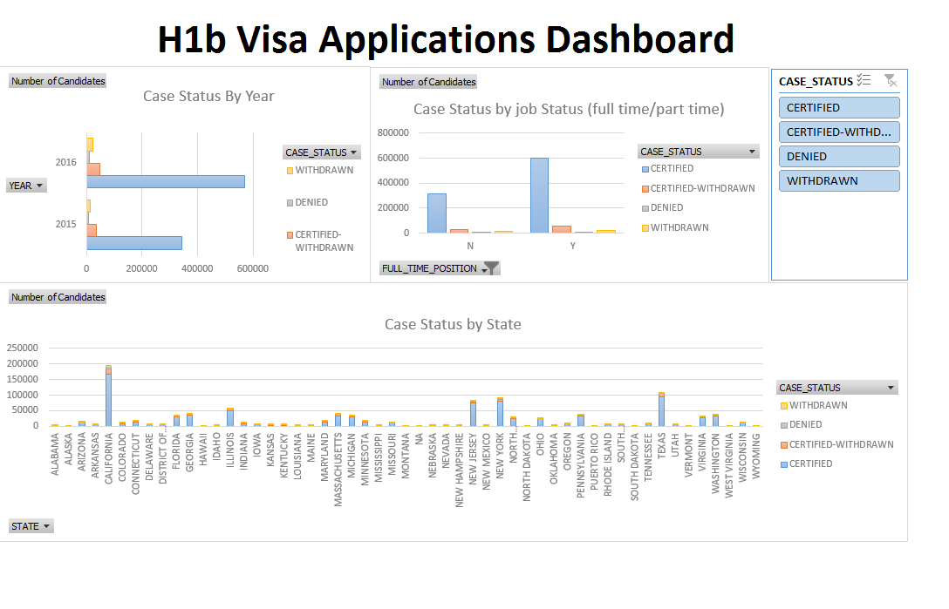

The Hib Visa Applications Analysis Dashboard using Excel

It has three charts.

* A bar chart that shows the number of records for each year by case status. It only shows the years 2015 and 2016.This is because excel has a limit of the number of rows that it can load (1048576). The number of rows in the data set was way more than 1048576. However, this dashboard shows only data for 1048576 records.
* A column chart that shows the case status by the position type (full time /part time)
* A stacked column chart that shows the cast status for each state.
* A slicer that allows to filter the data by the case status