**Cleaning and Transformation of data**

* The dataset is loaded into power BI as a text file as it is in the csv format.
* All the cleaning and transformations are done in the query editor window of Power BI. Prevailing wage and year were identified as text by Power Bi. These data type does not make sense and needs to be changed.
* Before changing the data type it is necessary to make sure that there are no data points that contains NA or any other values. If there are any text like values like NA and if an attempt is made to change the data type of the field to number than Power BI generates errors.
* Power Bi loaded the data set and did not recognize that it had headers so the first row was promoted as column headers.
* There were a lot of columns for which the purpose was not identified even after sufficient research. Power BI allows to delete those columns.
* One of the columns Worksite had city and state seperated by comma. This column was split into two by using comma as delimiter and they were given appropriate names.
* Removed rows that contained nulls in the year field.
* Created an index column that started with 1 and named it as record_number.

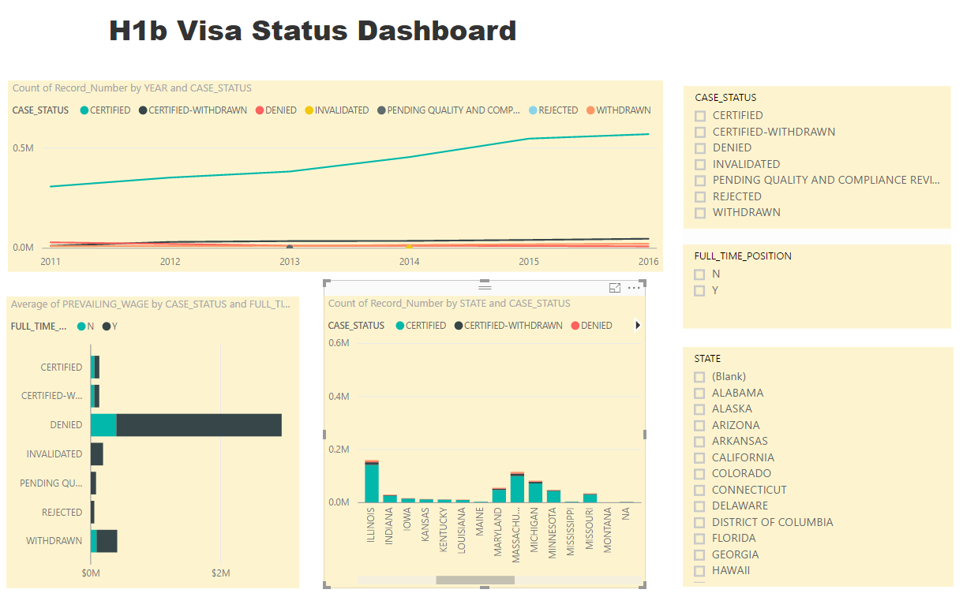

H1b Visa Application Analysis Dashboard using Power BI

It consists of three charts

* A line chart that shows the Number of applications from 2011 to 2016 by case status.
* A stacked bar chart that shows the average prevailing wage by case status. It is split into full time and part time positions.
* A stacked column chart that shows the number of applications by case status for eeach state.
* There are filters for case status, full time position and state that allows the users to filter the data in the viz by these fields.