Cleaning and Transforming data

* The data set was loaded into tableau. The text option was used as the data set was in a csv format.
* Filters were applied at the data source level to remove any nulls that would affect the analysis
* The column worksite had the city separated by comma. This column was split into two separate columns by using the comma as a delimiter. The separated columns were then given appropriate names.
* Data type conversions were done for few columns so that they have relevant data types.

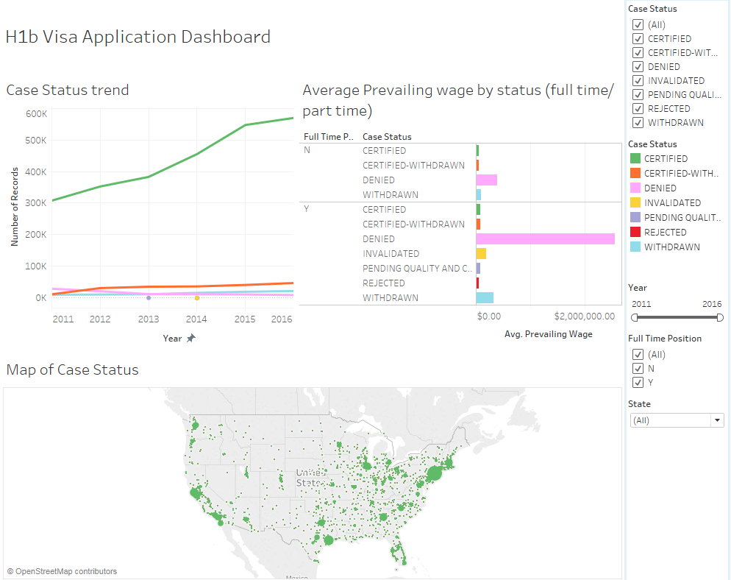

The above Dashboard contains three charts.

* There is a line chart that shows the number of candidates from the year 2011 to 2016 by the case status.
* There is a bar chart that shows the average prevailing wage for each case status. This is again split into full time and part time positions.
* There is a map that shows the number of candidates (count of records) and the case status.
* There are filters for case status, year, position type and state that allows the user to click on it and see the desired data. The filters were set to reflect on all the sheets.