**Transformations and cleaning**

* The dataset was loaded and the same transformation done in tableau was applied in excel.
* The range of cells containing data was selected and converted into a table. This helped to select each column and filter out the nulls and other irrelevant values from the column.
* Several columns were created using conditional and logical statements to provide categorization that helps in vizualization.
* The column AGE_GROUP was created with the Excel formula

=IF([@DRIVERAGE]<=2,"Infants",IF(AND([@DRIVERAGE]>2,[@DRIVERAGE] <=12), "Children", IF(AND([@DRIVERAGE]>12,[@DRIVERAGE]<=17),"Teenagers",IF(AND([@DRIVERAGE]>17,[@DRIVERAGE]<=25), "Youth",IF(AND([@DRIVERAGE]>25,[@DRIVERAGE]<=40),"Adults",IF(AND([@DRIVERAGE]>40,[@DRIVERAGE]<=60),"Middle Age",IF([@DRIVERAGE]>60,"Old")))))))

* The column HOV was created using the formula

=IF([@OCCUPANTS7]<=1,"Single Occupant","Multiple Occupants")

* The column speedlimit was created using the formula

=IF([@SPEEDLIMIT]<=20,"Low Speed",IF(AND([@SPEEDLIMIT]>20,[@SPEEDLIMIT]<=30),"Urban(30mph)",IF(AND([@SPEEDLIMIT]>30,[@SPEEDLIMIT]<=35),"Unpaved(35mph)",IF(AND([@SPEEDLIMIT]>35,[@SPEEDLIMIT]<=45),"Rural paved (45mph)",IF(AND([@SPEEDLIMIT]>45,[@SPEEDLIMIT]<=55),"Two lane(55mph)",IF(AND([@SPEEDLIMIT]>55,[@SPEEDLIMIT]<=65),"Four lane(65mph)",IF([@SPEEDLIMIT]>65,"Interstate(70mph)")))))))

* The column BAC level was created using the formula

=IF([@ALCRESULT]>=0.08,"illegal","legal")

* Pivot tables were used to analyse the data and the visualizations were created using the pivot tables.Excel has a limitation on the types of vizualization that can be used with pivot tables.

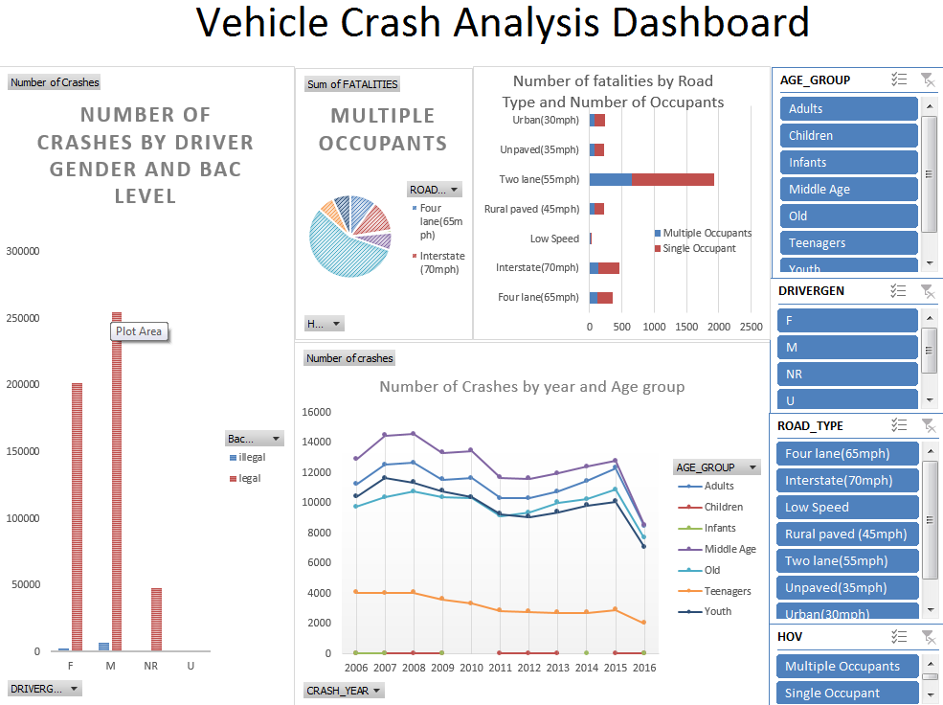

Dashboard for Vehicle Crash Analysis using Excel

It has 4 charts

* A clustered column chart that shows the Number of crashes by driver gender.
* A Pie chart that shows the composition of the number of fatalities by road types. This can be viewed for both Single and Multiple Occupants by using the slicer.
* A stacked bar chart that shows the number of fatalities for single and multiple occupants.
* Line chart that shows the number of crashes from 2006 till 2016 for all the age groups.