*Database*

*Samer Suleiman*

**Abdullah hisham rashid**

**22110056**

* **1- Introduction**

The Technical Template is a comprehensive document or guide for working on developing the database (Al_Awqaf), and it is also a documentation of the code and its parts that were worked on to produce the database as a result. The template is allocated to the project owners. As for (Al_Awqaf Database), it is allocated to the Ministry of Endowments from a minister, employees, and committee heads, despite their different powers. The assignment of the template does not depend only on the project owners, while it benefits database administrators, including developers and programmers, knowing that the Technical Template is a popular way to supplement or revise databases.

**Content of the technical report :**

This document is structured into several sections :

* **Physical** **Schema :** Provides an overview of the database's physical structure, including tables, views, and procedures.
* **Database Development :** Offers detailed insights into the development process, including database overview, security measures, and user interface design.
* **Maintenance :** Outlines procedures for database recovery, backups, and general maintenance to ensure the database's reliability and availability.
* **Testing** : Includes comprehensive testing protocols for data validation, output validation, security validation, GUI validation, and assessment of data extraction effectiveness.
* **Evaluation of Database Solution :** Evaluates the effectiveness of the database solution based on user and system requirements, suggests improvements, and assesses the impact of these improvements on the overall database performance.

**Those things that we will show deep down in this report.**

**Content of the Document :**

This report is super important for a few key reasons:

* **Clear Instructions :** It gives detailed info about how the database is set up, including its structure and features. This helps everyone understand how it works.
* **Guidance :** It's like a roadmap for database managers and developers. It explains how to build and maintain the database step by step.
* **Quality Check :** There's a big part about testing. This makes sure the database works correctly by checking things like data, outputs, security, and how easy it is to use.
* **Getting Better :** It also helps make the database even better over time. By evaluating what's working and what could be improved, it keeps things up-to-date and useful.

________________________________________________________________________

* **2- Physical Schema**

The image shows the physical schema for Al-Awqaf database that does not differ from the physical schema that was made in designing the ER diagram, it’s just made by SQL. The schema shows the table that were created to make the database such as : Mosque, Emam, Announcement, Outside-job, Emam-major, Emam-phone, Emam-job, Emam-announcement, However, it shows the relation that were made to achieve the goal of the database, also it shows the primary and the foreign key.

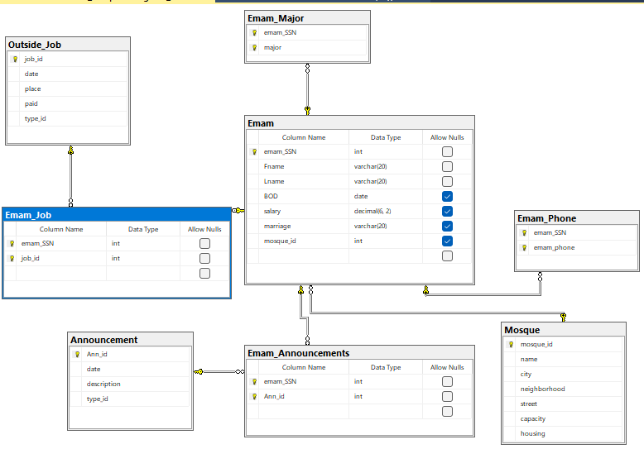

________________________________________________________________________

* **3- Database Development**
* **3.1 Database Overview**

|  |  |  |
| --- | --- | --- |
| **Table** | **Name** | **Description** |
|  | **Mosque** | **Purpose:** information about the mosque that every Emam is responsible for |
| **Attributes/datatype:** mosque_id [int], name [varchar], city [varchar], neighborhood [varchar] street [varchar], capacity [int], housing [varchar] |
| **Constraints:** all of them are not null except housing that have check constraint and capacity that does not have constraint |
| **Primary key:** mosque_id |
| **Foreign key:** none |
|  | **Emam** | **Purpose:** the main purpose for the database is for the Emam so Emam table is important to know information about him |
| **Attributes/datatype:** emam_SSN [int], Fname [varchar], Lname [varchar], BOD [date], salary [decimal], marriage [varchar], mosque_id [int] |
| **Constraints:** Fname and Lname have not null constraint and marriage have check constraint |
| **Primary key:** emam_SSN |
| **Foreign key:** mosque_id |
|  | **Announcement** | **Purpose:** one of the purposes for of the database is to send announcements for the Emam so this table was made for know the type of the announcement that differ between : Jomaa pray topic, warnings, calling |
| **Attributes/datatype:** Ann_id [int], date [date], description [varchar], type_id int |
| **Constraints:** only date and description have not null constraint |
| **Primary key:** Ann_id |
| **Foreign key:** none |
|  | **Outside-Job** | **Purpose:** this table was made for jobs that the ministry sends for the Emam and to know the type of the jobs that differ between : lecture, Honoring, Attend a conference, travel |
| **Attributes/datatype**: job_id [int], date [date], place [varchar], paid [varchar], type_id [int] |
| **Constraints:** date and place have no null and paid have check constraint |
| **Primary key:** job_id |
| **Foreign key:** none |
|  | **Emam-phone** | **Purpose:** it is a table that is a result for a multivalued attribute to avoid data redundancy |
| **Attributes/datatype:** emam_SSN [int], emam_phone [int] |
| **Constraints:** the emam_phone has a not null and a unique constraint |
| **Primary key:** a composite primary key consists of the two attributes |
| **Foreign key:** emam_SSN |
|  | **Emam-major** | **Purpose:** it is a table that is a result for a multivalued attribute to avoid data redundancy |
| **Attributes/datatype:** emam_SSN [int], major [varchar] |
| **Constraints:** major has a default constraint |
| **Primary key:** a composite primary key consists of the two attributes |
| **Foreign key:** emam_SSN |
|  | **Emam-Announcement** | **Purpose:** it is a table that is a result for a many-to-many relation |
| **Attributes/datatype:** emam_SSN [int], Ann_id [int] |
| **Constraints:** none |
| **Primary key:** a composite primary key consists of the two attributes |
| **Foreign key:** a composite foreign key consists of the two attributes |
|  | **Emam-job** | **Purpose:** it is a table that is a result for a many-to-many relation |
| **Attributes/datatype:** emam_SSN [int], job_id [int] |
| **Constraints:** none |
| **Primary key:** a composite primary key consists of the two attributes |
| **Foreign key:** a composite foreign key consists of the two attributes |

|  |  |  |
| --- | --- | --- |
| **View** | **Name** | **Description** |
|  | **Announcement_type_View** | This view shows the Announcement table with its announcement type not the type-id and the reason for putting the type-id in the basic table is to save space (memory), so this view was made to see the announcement type knowing that it is not much used.  type_id = 1 then 'Jomaa pray sermon'  type_id = 2 then 'Calling'  type_id = 3 then 'Warning' |
|  | **Outside_Job_View** | This view shows the outside-job table with its job type not the type-id and the reason for putting the type-id in the basic table is to save space (memory), so this view was made to see the job type knowing that it is not much used.  type_id = 1 then 'Lecture'  type_id = 2 then 'Honoring'  type_id = 3 then 'Attend a conference'  type_id = 4 then 'Travel' |
|  | **Emam_Announcement** | This view shows every Emam and his announcement that he has with the announcement detail (date, description, type_id) by using joins |
|  | **Emam_outside_job** | This view shows every Emam and his jobs that he is asked to do with its details (date, place, paid, type_id), either than imamate |

|  |  |  |
| --- | --- | --- |
| **Procedure** | **Name** | **Description** |
|  | **Insert_Mosque_With_Imam** | This procedure is for daily used process that when adding a new mosque to the data base to add a Emam is responsible for it. insert statement for mosque table and Emam table were used |
|  | **New_Announcement_To_Emam** | This procedure is for a daily used process that to send a new announcement to an Emam. Insert statement for announcement table and Emam-announcement table were used |
|  | **New_Job_To_Emam** | This procedure is for a daily used process that to send a new job to an Emam. Insert statement for outside-job table and Emam-job table were used |
|  | **Update_Emam_Salary** | This procedure is to update the Emam salary after its inserted, knowing that its usually used to adjust the salary for an Emam, either increase or decrease |

_________________________________________________________________________

* **3.2 Security**

|  |  |  |  |
| --- | --- | --- | --- |
| **Username** | **Privilege Command** | **Description** | **Screenshot** |
| **Mohammad** | grant select, insert, update, delete on Mosque to Mohammad | Mohammad as a minister has the privileges to access everything in mosque table and control all operations from viewing adding updating and deleting |  |
| grant select, insert, update, delete on Emam to Mohammad | Mohammad as a minister has the privileges to access everything in Emam table and control all operations from viewing adding updating and deleting |
| grant select, insert, update, delete on Emam-Announcement to Mohammad | Mohammad as a minister has the privileges to access everything in Announcement table and control all operations from viewing adding updating and deleting |
| grant select, insert, update, delete on Emam_Job to Mohammad | Mohammad as a minister has the privileges to access everything in outside-job table and control all operations from viewing adding updating and deleting |
| **Abdullah** | grant select, insert on Mosque to Abdullah | Abdullah as an employee hast the privilege to view all mosque detail and add new mosques to the database |  |
| grant select, insert, delete on Emam to Abdullah | Abdullah as an employee has the privilege to view and add all Emam information, however deleting Emam that has ended their work. But he is not allowed to update any thing in this table such as salary, |
| grant select, insert, update on Emam-Announcement to Abdullah | Abdullah as an employee has the privilege to view and add announcements for the Emam, however updating in his announcement. But he is not allowed to delete any announcement |
| grant select, insert, update on Emam_Job to Abdullah | Abdullah as an employee has the privilege to view and add jobs for the Emam, however updating in his jobs. But he is not allowed to delete any job for him |
| **Omar** | grant select on Emam_Announcement to Omar | Omar as Emam has the privilege to view the announcement that is sent to him by giving him the privilege to the view the view is created (Emam_Announcement) |  |
| grant select on Emam_outside_job to Omar. | Omar as Emam has the privilege to view the jobs that is sent to him by giving him the privilege to the view the view is created (Emam_outside_job) |

* **3.3 User Interface**
* 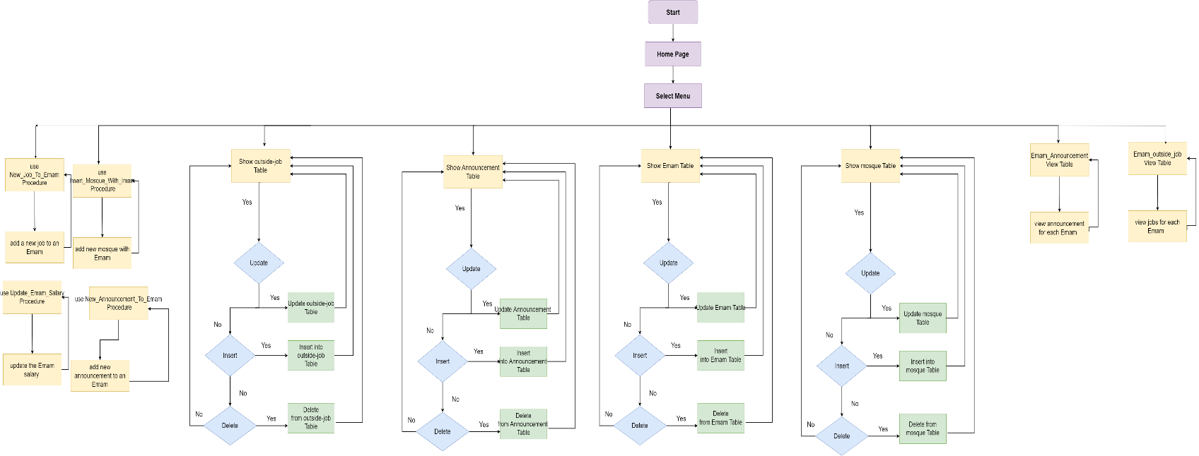**3.3.1 Flowchart and Data Movement Diagram**

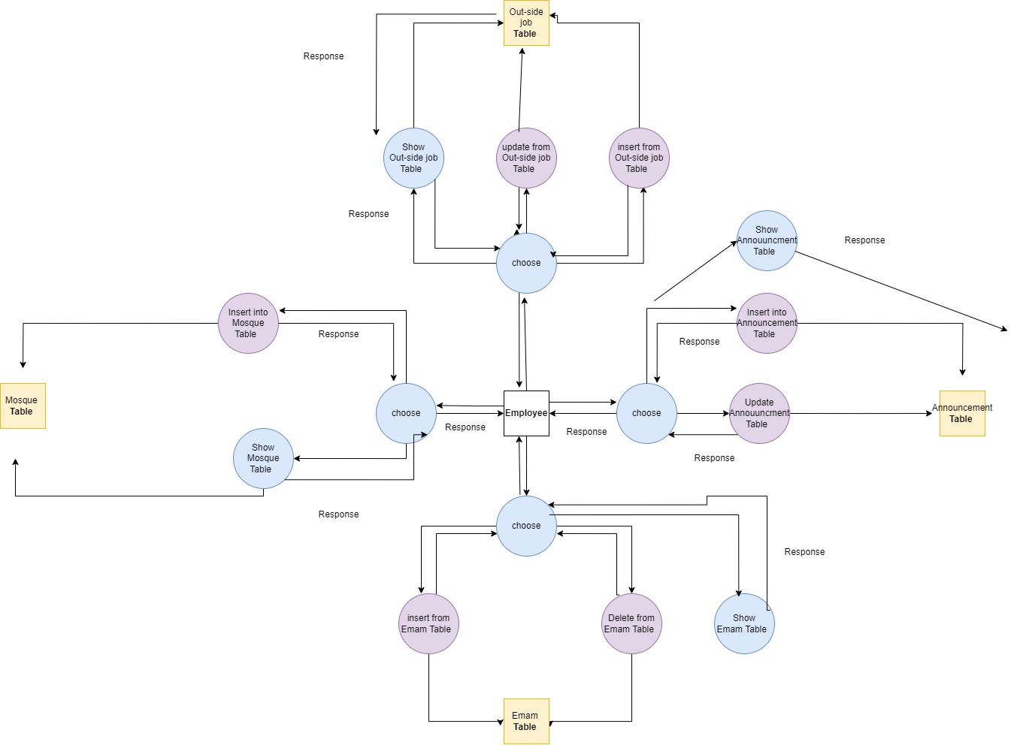



* **3.3.2 Interfaces Development**

|  |  |  |  |
| --- | --- | --- | --- |
| **Page ID** | **Title** | **Description** | **Screenshot** |
|  | The mosque that the Emam is responsible for | This page shows every Emam and the mosque he is responsible for, and in this page, you can know the information for the Emam. |  |
|  | Emam announcement | In this page you can see every Emam and his announcement id and if you want to know details about the announcement you can view the announcement page |  |
|  | Emam job | In this page you can view every Emam that is asked to do outside jobs and if you want to know details about the job you can view the job page |  |
|  | Emam major | This page can show each Emam and his studies that he has official certificate that he has from the university, knowing that the Emam can has more than one major |  |
|  | Mosques | This page has the different mosque that is in Al-Awqaf ministry, and ach mosque has its information |  |

* **4- Maintenance**
* **4.1 Database recovery & backups**

**Backup Procedure:** Data Protection Recuperation and backup are essential elements of data management. Making duplicate copies of data is part of the backup procedure to guard against data loss. These backup copies act as a safety measure, guaranteeing that a reliable backup is available even in the unlikely event that hardware breaks down, software bugs, or inadvertent deletion endanger the original data. Regular backups are usually scheduled by organizations to capture data changes over time. To lessen the chance of losing both the primary and backup data at the same time, these backups might be kept on different systems or media, like tapes or cloud storage (Anon., n.d.).

**Recovery:** Data Restoration In the event of data loss, the recovery procedure is activated. Companies recover information from backups, restoring it to the original location or another (Anon., n.d.).

**The importance of Database recovery & backups**

If the primary data source fails, the backup's objective is to produce a copy of the data that can be restored. Data corruption, hardware or software malfunctions, human error (virus or malware), or inadvertent data erasure are examples of primary data failures. Restoring data from a backup copy enables the company to recover from an unforeseen incident. Protecting against the loss or corruption of primary data requires keeping a copy of the data on an independent medium. A tape recorder, cloud storage container, disk storage system, or even something more substantial like an external drive or USB stick can be considered a supplementary media (Anon., n.d.).

**Backup Types**

* **Full Back up:** This kind of backup makes an exact duplicate of every piece of data in the database. It resembles taking a momentary snapshot of the entire database. The goal of a complete backup is to preserve the entirety of the database at a specific point in time. It includes all the views, tables, instructions, and other data.

**Example from Al-Awqaf database :**

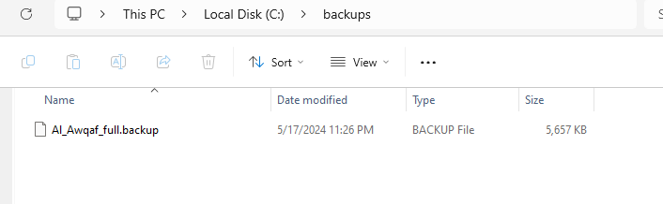

* **Differential Backup:** In a database, this kind of backup reduces backup space and time by preserving only the modifications made since the last complete backup. All that is stored in a differential backup is the modifications made to the database since the last full backup. It requires less time and has less storage space than a full backup.

**Example from Al-Awqaf database :**

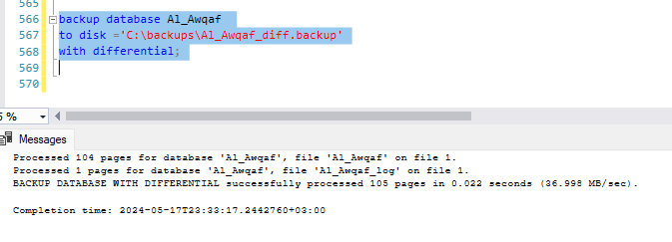

* **Transaction Log Backup:** Transaction Log Backup in SQL Server requires a transaction log backup. It keeps track of all database modifications, including inserts, updates, and deletions. To guarantee data consistency, you can restore a database to a particular point in time via regular transaction log backups. For databases that use the FULL or BULK_LOGGED recovery models, these backups are crucial. You can use Transact-SQL (T-SQL) or SQL Server Management Studio (SSMS) commands to perform a transaction log backup. To keep log files from growing, don't forget to plan regular backups and make sure the right permissions are in place for backup devices and file access (Anon., n.d.).

**Example from Al-Awqaf database :**

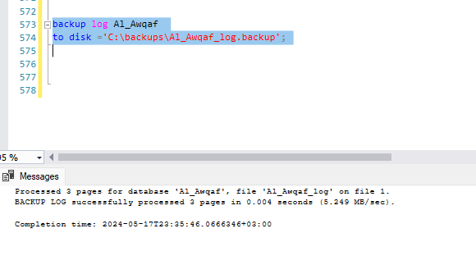

* **4.2 Database maintenance in general**

Ensuring the operational integrity of a database involves a set of tasks known as database maintenance. Database management systems such as Oracle and SQL Server need regular updates to stay current with new technologies and security threats.

Examples of database maintenance activities include backups, data export/import processes, index reviews, automated tasks like object autoruns or removals, and other similar tasks.

While database maintenance may not be widely recognized, many people understand the importance of backing up databases. Database maintenance encompasses numerous tasks essential for keeping data secure and functioning smoothly.

Data import and export operations are a crucial aspect of database management. These processes are important because they allow you to address issues with your systems, such as corrupted data or hardware failures. Additionally, you can use these operations to migrate data or create backups of specific database components on another machine.

Databases play a vital role in storing important information in a library, particularly when they feature a well-organized index that allows for quick record retrieval. As data is continually added, deleted, and moved, the database parameters can also be modified to reflect these changes.

(Anon., n.d.)

**The importance of data maintenance**

* **Keeps your data up to date:** Technology is advancing rapidly, and businesses are striving to keep pace. Staying current is essential for maintaining stability; without it, products or services become outdated and fail to meet modern demands, however, Regular database maintenance ensures your data remains up to date, allowing you to better serve your audience and maintain a competitive edge.
* **Data Recovery :** No matter how careful you are, accidents can still happen. Incidents or attacks can result in data loss, which can have serious negative consequences for you and your business. Database maintenance helps mitigate these risks by creating archival backups of crucial data. This improves the data recovery process and aids IT staff in recovering from events that damage the system.
* **Saves Time :** You may better utilize the time you spend on database maintenance activities creating a business plan or marketing strategy for your company. Database maintenance techniques that are automated are the most effective. As soon as they are activated, they begin clearing out your system, giving you more time to concentrate on other important duties.

(Anon., n.d.)

**How to maintain your database**

* Store Data in a Single File
* Use Descriptive Titles
* Consolidate Data with Regular Updates
* Draft a Database Maintenance Plan
* **Testing**
* **5.1 Data Validation**

|  |  |  |  |
| --- | --- | --- | --- |
| **Number** | **Type** | **Description** | **screenshot** |
|  | All cases of PK | The screenshot shows that that mosque-id is created as primary key and when trying to insert two different mosques with the same id it gives an error because it is primary key and when trying to set a null value for the mosque-id in an insertion for a mosque it gives an error because it is primary key. |  |
| The screenshot shows that that Emam-ssn is created as primary key and when trying to insert two different Emam with the same ssn it gives an error because it is primary key and when trying to set a null value for the Emam-ssn in an insertion for an Eamam it gives an error because it is primary key. |  |
| This screenshot shows that the table has composite primary key and in insertion process we can insert one of them and keep the other one null, so it gives an error. |  |
|  | All cases of FK | In the Emam table the mosque-id is foreign key and when we inserted an id for the mosque that does not exist (120) it gives an error because the foreign key should exist in the mosque table. |  |
| **On delete set null**  The mosque id in the Emam table is foreign key and when deleting the mosque (deleting the mosque id ) it should not delete the Emam records and that’s what the screenshot shows. |  |
| **On update cascade**  The mosque id in the Emam table is foreign key and when updating the mosque id it will change in the Emam records and that’s what the screenshot shows |  |
|  | Unique | In Emam phone table the phone number is unique and its not allowed to duplicate a value for an attribute that has a unique constraints and that’s what the screenshot shows |  |
|  | Default | In the Emam major table the major is settled Islamic law as default value so when not having a value for the major it will by default set it as Islamic law. |  |
|  | Not null | In the Announcement table the date attributes are given a not null constraint so when given a null value it will give an error and that’s what the screenshot shows |  |
|  | Check | In the outside job table, the paid attribute has a check constraints either paid or not paid and when entering other options it will give error and that’s what the screenshot shows |  |

* **5.2 Output Validation**

|  |  |  |  |
| --- | --- | --- | --- |
| **Number** | **Query Description** | **Screenshot (query + result)** | **Result validation** |
|  | This selection is to show the Emam ssn with there names and salary and the salary is descending ordered |  |  |
|  | Delete a Mosque from a mosque table |  |  |
|  | Update on Emam salary |  |  |
|  | Insert a new mosque to mosque Table |  |  |

* **5.3 Security Validation**

|  |  |  |  |
| --- | --- | --- | --- |
| **Number** | **Username** | **Description of privilege/no privilege** | **Screenshot (query + result)** |
|  | Mohammad | Mohammad as a Minister has the privilege of everything regarding to that he is the minister, so he has the privilege to select and insert and update and delete from any table in the database |  |
|  | Abdullah | Abdullah as an employee has different privileges not as much as the Minister.  Mosque: show /insert  Emam : show/insert/delete/update.  Announcement : show/insert/update/delete  Outside-job: show/insert/update/delete |  |
|  | Omar | Omar as an Emam has the privilege just to show the views (Emam-announcement /Emam-job) content (select) to see his records |  |

* **5.4 GUI Validation**

|  |  |  |
| --- | --- | --- |
| **Number** | **Description** | **Screenshot** |
|  | This screenshot shows all the tables of the system of Al-Awqaf database for the minister login that has the permission for everything in the system, that what indicate that the permissions in Al-Awqaf database is successfully done |  |
|  | This screenshot shows that how the minister can add an announcement for the Emam |  |
|  | This screenshot shows how the Emam is not able to delete or add an announcement to himself, regarding to the permissions that is done in Al-Awqaf database |  |
|  | This screenshot shows how the minister can update the salary of Emam |  |

* **5.5 Assess whether meaningful data has been extracted.**

To verify that the extracted data is useful, the database must be viewed in detailed form from Tables, views, and Relationships between the table.

**Tables**

**Mosque table :** for the ministry of Al-Awqaf it is important to know specific information about the mosque that it has in its database, and regarding to that we have the mosque_id, name, city, neighborhood, street, capacity, housing,

Reason for Mosque table : in Al-Awqaf ministry having online information about the mosque that are in Jordan such as the Emam that are responsible for and the capacity It saves them time and effort and prevents field visits to verify the latest developments in the mosque, or if they want to use it for religious occasions, they can specify the mosque they want to use only through the information in the data base.

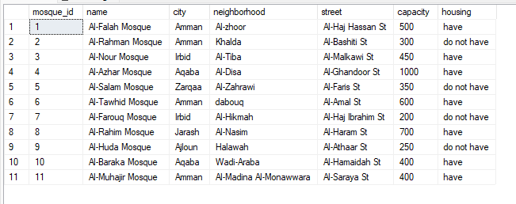

**Emam table :** for the Emam that the database is made for him, so it very important to know about him information, and regarding to that we have the emam_SSN, first name, Last name, birthdate, salary, marriage.

Reason for Emam table : all of the database is for the Emam and the main reason for it is to have the ability to send announcements and asked jobs for the Emams without the need of face to face request the thing that as we mention saves times and effort and make reaching to the Eamam is easy.

**Announcement table :**  the database is made for the Emam as we mention and it serves him that it delivers Announcement from the ministry to him throw his portal, so we need to know information about this announcement such as announcement id, date, description, type-id.

**Outside job table :** the database is made for the Emam as we mention and it serves him that it delivers job that he asked to do from the ministry to him throw his portal, so we need to know information about this job id, date, place, type-id.

**Views**

**Emam-Announcement** **:** its important for both (Ministiry of Al-Awqaf and the Emam) to see the announcement that the Emam has, and this is one of the reasons that the database is made for

Reason for Emam announcement view : as we mention the main reason for the database is to reach the Emam the announcement that he has the thing that make contacting with the Emam is more easy and saves time and effort for process of reaching the announcement to the Emam.

**Emam-job :** it’s important for both (Ministry of Al-Awqaf and the Emam) to see the jobs that the Emam is asked to do, and this is one of the reasons that the database is made for.

Reason for Emam job view : as we mention the main reason for the database is to reach the Emam the jobs that he is asked for to do other than Emamate the thing that make contacting with the Emam is more easy and saves time and effort for process of reaching the job that the Emam is asked for.

**Relation**

in the database there is meaning full relation that helps to extract meaning full data.

The Emam can have multiple announcements, and this gives the database the flexibility and the data redundancy are low. And also, the Emam can have multiple jobs, and also this gives the database the flexibility and the data redundancy are low.

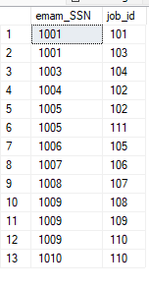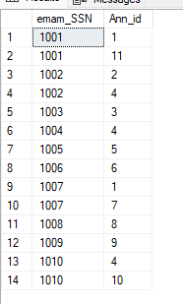

After going deep in the database and show what it gives data back, we can say that Al-Awqaf database is complete from all its sides, and it gives meaningful data that helps the ministry of Al-Awqaf to deal its relation with the Emam

* **5.6 Assess the effectiveness of testing.**

Testing is vital for ensuring a database's performance, security, and reliability. Effective database testing involves verifying data integrity, ensuring accurate data migration, and assessing the functionality of database operations. Through comprehensive testing methods such as data validation, schema verification, and performance testing, issues like bottlenecks, security risks, and data corruption can be detected and resolved early. Automated testing tools enhance this process by providing consistent and repeatable tests, which help maintain database quality throughout the development and deployment phases. Ultimately, thorough database testing contributes to the creation of dependable data management systems that efficiently and securely support business operations.

And this report we went through many steps to test the database that we will discuss in deep in this part.

**Data validation**

Data validation is important and its pre-stage for having a correct output for data, and it happen when checking constraint for the table such as :

**Primary key :** checking primary key is very important and primary key is considered the main structure for the database and with its destruction, it destroys everything (data integrity)

Primary key was checked in its all situations in Al-Awqaf database to make sure that every table are connected with the other correctly and some of making sure ways to know that everything is correct is to make an error here is some explanation :

**Foreign key :** connecting tables does not complete without having foreign keys, it complete the structure of the database without it we cant have a database with a meaningful data and in testing we have checked the foreign keys in Al-Awqaf database as showed :

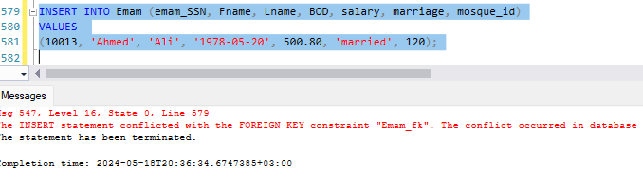

**Output validation.**

Checking output (data output) is as reaching the goal of the database, and it has to be meaningful and checking the data output be through using DML (select, insert, update, delete) and check if the information are meaningful or not, here is some out put from Al-Awqaf database that make me make sure that everything is ok and meaningful :

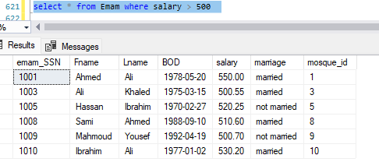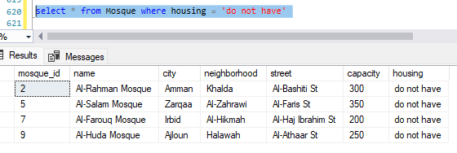

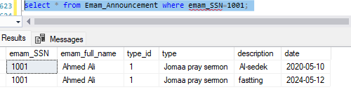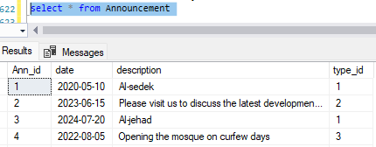

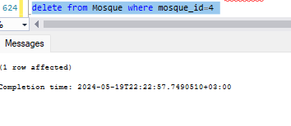

**Security validation**

Every database is made for a group of users that have privileges to deal with the database and checking the privileges of these users works on ensuring the project continues to operate and maintain its security

And in Al-Awqaf database we make sure that every user has his own privilege

**Mohammad :** Mohammad as a Minister has the privilege of everything regarding to that he is the minister, so he has the privilege to select and insert and update and delete from any table in the database

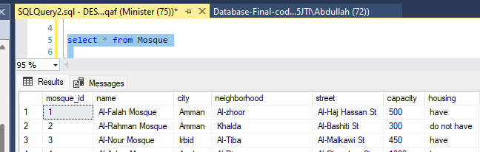

**Abdullah :** Abdullah as an employee has different privileges not as much as the Minister.

Mosque: show /insert

Emam : show/insert/delete/update.

Announcement : show/insert/update/delete

Outside-job: show/insert/update/delete

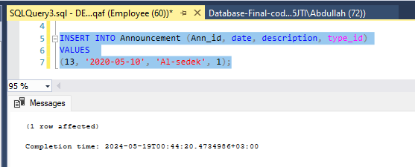

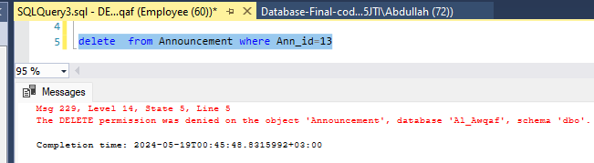

**Omar :** Omar as an Emam has the privilege just to show the views (Emam-announcement /Emam-job) content (select) to see his records

**Conclusion :** After going through all these steps of testing, we discover that without this process we may not reach the correct data (data integrity) nor the target of the desired database. This emphasizes the importance of the testing process and its benefits, and not to be lenient in not doing it.

* **6- Evaluation of database solution**
* **6.1 Effectiveness of the database solution based on user and system requirement.**

In the design stage of the Al-Awqaf database, a successful final stage (physical design) was reached, which helps in converting the database from design to code, and we will detail this stage now.

**Converting the physical design to code**

**Tables and data type and constraints**

Converting the tables from physical design to code was successfully done, and that what achieved reaching to system requirements, and this example shows the difference between the design and the code from Al-Awqaf database :

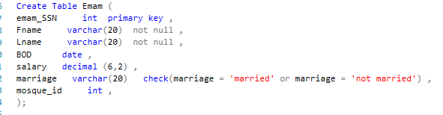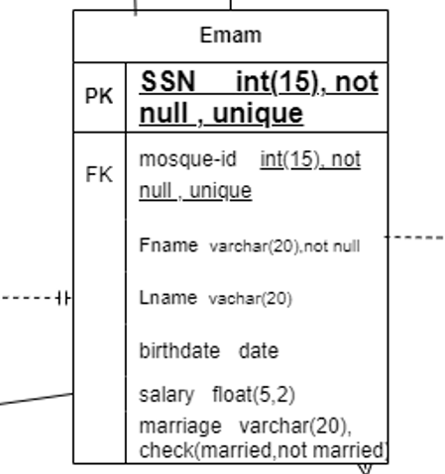

The verbatim conversion of the design )that was reached during the design preparation stage( into the code was completed successfully, taking into considerations reaching to the system and user requirements. This was done while considering the setting of the data type and the constraints to obtain correct and logical data free of errors.

**Converting relation into code and setting PK,FK**

Relations was converted successfully from the design to the code as shown :

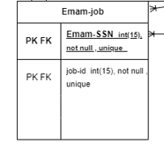

In schema and mapping the relation between the Emam table and the Job table was M:N, the thing that make us to have a new table, and the reason for that is to avoid data redundancy and this is what we mean when saying data redundancy :

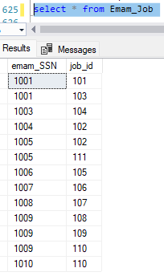

For the PK and FK, it was successfully settled between the tables as shown :

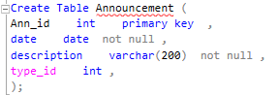 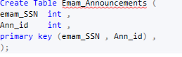

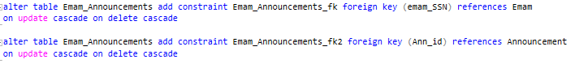

Primary key and foreign key were used to rewind data in select or views operations with the aim of linking them and rewinding logical data.

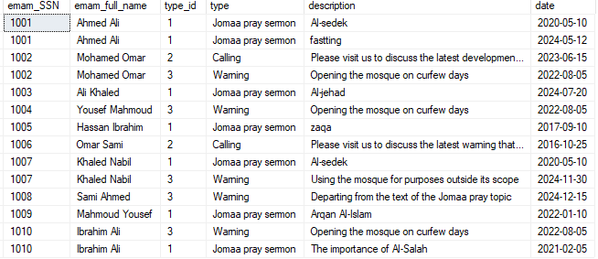

And this is an example for having logical and meaningful data and the reason for that is having the primary key and the foreign key in the database.

**Users and their privileges (security)**

as we mention in the mid report that the database (Al-Awqaf) and its user requirements targets two groups which is Al-Awqaf ministry(minister, employees) and the Emam, as for the ministry it deals with database as a system, but for the Emam he deals with database as an interface, so giving each side a privilege make the database success in reaching to its goal and that what we do in Al-Awqaf database as shown :

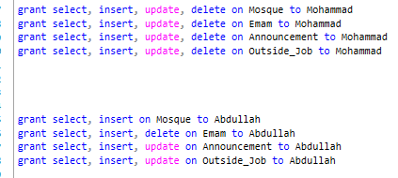



**Conclusion**

And from that we reach that the Effectiveness of the database solution based on user and system requirement was successfully reached and the goal of the database (reaching announcement and jobs to the Emam )was also successfully reached, and the reason for that is Follow the appropriate steps to convert design into code.

* **6.2 Suggested improvements**

after the success that was reached for the Al-Awqaf database dealing with the Emam we can improve the database easily as we mention in the mid assessment, and that is represented by adding to the database the employee for the mosque such as (muezzin, security guard) or adding more services for the Emam.

**muezzin**

The muezzin can be added to the Database, and the relationship between him and the ministry can be organized by also sending him important news and jobs, which will make it easier for the muezzin to receive news and communicate with the ministry.

**security guard**

the security guard does not differ from the muezzin, he is also can be added to the database to receive the jobs that he asked to do in the mosque that he is responsible about, such as the upcoming religion events that will happen in the mosque such as conferences or honoring Quran students , and the reason for that is to Preparation and readiness for the mosque.

**Services for the Emam**

such as having the ability to chat with the ministry for adding requests for him or adding Complaints, the thing that makes the Emam to communicate with the ministry is more easier.

* **6.3 Evaluation based on improvements needed.**

Adding those improvements that we mentioned to the database is more easier than building a new one because all the structure is already built and no need for big changes, and this is the small changes that every add needs.

**muezzin**

all it takes is adding a table for the muezzin having in it the information for him and the mosque that he is responsible for and having a table for the jobs and a table for the announcement that reaches to him, and PK,FK will be settled as done in the Emam.

**security guard**

the security guard does not differ than the muezzin, so adding him to the database just needs to add table for him having in it his information and the mosque that he is responsible for and a table for the jobs that he is asked to do.

**Services for the Emam**

All what it needs for letting the Emam to have a chat with the ministry is to add a table for him having in it his id and a description about what he wants to reach for the ministry such as requests, Complaints.

# References

Anon., n.d. *MAKE USE OF.* [Online]   
Available at: https://www.makeuseof.com/what-is-database-maintenance/

Anon., n.d. *NetApp.* [Online]   
Available at: https://www.netapp.com/cyber-resilience/data-protection/data-backup-recovery/what-is-backup-recovery/#:~:text=The%20purpose%20of%20the%20backup,or%20accidental%20deletion%20of%20data.

Anon., n.d. *SQL tips.* [Online]   
Available at: https://www.mssqltips.com/sqlservertutorial/8/sql-server-transaction-log-backups/