*Database*

*Samer Suleiman*

**Abdullah hisham rashid**

**22110056**

* **1. User Documentation**
* **1.1 System Overview**

**Introduction**

Al_Awqaf database is designed to manage the Emam affairs, by knowing the mosque that he is responsible about and the most important thing in the database is to reach the Emam the announcement (Jomaa pray sermon, warnings, callings) and the jobs that he is asked to do on his portal.

**System Components**

**Mosque Management:** the mosque table has the mosque information that the ministry cares about such as ID, name, location (city, neighborhood, street), capacity, and housing availability.

**Imam Information:** the Emam table has his information their Social Security Number (SSN), full name, date of birth, salary, marital status, and the mosque they serve.

**Announcement Management:** the announcement table is for the announcement that reaches the Emam, and it has its attribute such as ID, date, description, and type.

**Job:**  the outside job table is for the jobs that the Emam is asked to do and it has its own attributes such as ID, date, place, payment status, and type.

**Views:** Provides simplified and formatted views of data for easier interpretation and analysis. Views include:

Announcement_type_View: Displays announcements with their corresponding types.

Outside_Job_View: Presents outside jobs along with their types.

Emam_Announcement: Combines imam and announcement details.

Emam_outside_job: Integrates imam and their outside job information.

**Stored Procedures:** Implements reusable procedures to perform specific tasks, such as:

Insert_Mosque_With_Imam: Inserts Mosque and imam records simultaneously.

New_Announcement_To_Emam: Adds new announcements and associates them with specific imams.

New_Job_To_Emam: Inserts outside job details and links them to respective imams.

Update_Emam_Salary: Updates imam salaries.

**User Management:** Manages user access to the system, allowing different levels of permissions based on user roles. Like defining roles for Minister, Employee, and Emam with corresponding logins and privileges.

**Backup and Restore**: Facilitates database backup and restoration operations for data protection and disaster recovery purposes, and allows for full, differential, and transaction log backups.

**Conclusion:**

Al_Awqaf database offers a robust and organized system for managing mosque-related information, imam details, announcements, and outside engagements. With its structured architecture, the database ensures efficient data management, access control, and system reliability, catering to the needs of religious institutions in maintaining administrative records and facilitating smooth operations.

* **1.2 Using the system.**

The Al_Awqaf system has an intuitive user interface designed for various user roles, such as Imams, Employees, and Ministers. Access to pages and features that are intended to make their respective responsibilities easier is granted to each user role. A thorough explanation of the system's pages and features broken down by user role is provided below.

**Minister**

1. The dashboard  
     
   **Overview** : displays essential information and summaries, such as the overall number of mosques, Emams, current announcements for a particular Emam, and jobs that are requested of the Emam.

**Navigating :** having easy access to all the information in the database as we mention such as the Emam information and his announcement and asked jobs

2. Mosque Management:

**Add Mosque :** having the ability to add mosques n the database of Al-Awqaf

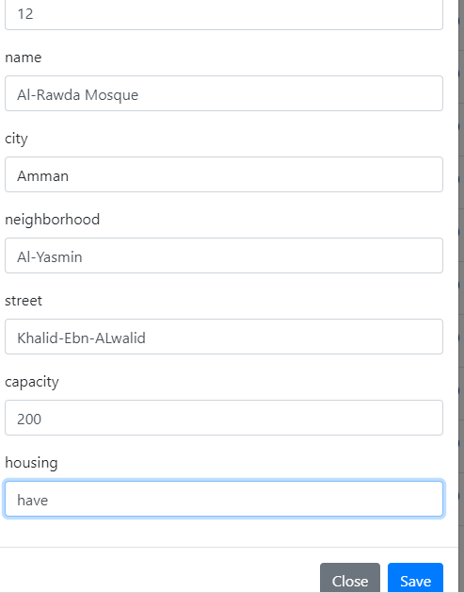



**Update Mosque :** the minister can update any of the mosque information using the interface



**Delete Mosque :** the minister can delete any mosque he wants by using the interface

**View Mosques :** as the interface shows the minister can have the ability to show all the existing mosques

3. Imam Management:

**Add Imam :** having the ability to enter new imam details and associate them with a mosque.

**Update Imam :** having the ability to update imam information, including salary updates.





**Delete Imam :** having the ability to remove any imam records he wants.

**View Imams :** having the ability to view any Emam record .

4. Emam-Announcements:

**Create Announcement :** having the ability to add any announcement for a particular Emam in the database.

**Update Announcement :** he can update any announcement to an Emam

**Delete Announcement :** he can delete any announcement to an Emam like deleting a warning for an Emam.

**View Announcements :** view all the announcement for a particular Emam.

5. Emam-Jobs:

**Add Job :** having the ability to add any job for a particular Emam in the database.

**Update Job :** he can update any job to an Emam

**Delete Job :** Option to remove outside job records.

**View Jobs :** view all the jobs for a particular Emam.

**Employee**

1. Dashboard:

**Overview:** shows pertinent data and summaries that are customized for employee jobs.

**Navigation:** Quick access to sections like Mosque Management, Imam Management, Announcements, and Outside Jobs.

2. Mosque Management:

**Add Mosque:** he can add a mosque to the database after having the permission from the ministry

**View Mosques:** List of all mosques with detailed information.

3. Imam Management:

**Add Imam:** Form to enter new imam details and associate them with a mosque.

**Delete Imam:** Option to remove imam records.

**View Imams:** List of all imams with personal and professional details.

4. Emam-Announcements:

**Create Announcement:** Form to enter new announcements for a particular Emam.

**Update Announcement:** having the ability to update any Emam announcement.

**View Announcements:** List of all announcements for a particular Emam.

5. Emam-Jobs:

**Add Job:** Form to enter new outside job details.

**Update Job:** Interface to update existing job for an existing Emam.

**View Jobs:** List of all outside jobs for a particular Emam.

**Emam**

1. Dashboard:

**Overview:** Displays personalized metrics and summaries relevant to the imam's activities such as the Announcements he has or the jobs he is Asked to do.

**Navigation:** Quick access to sections like Personal Profile, Announcements, and Outside Jobs.

2. Personal Profile:

**View Profile:** Detailed view of the imam's personal and professional information.

3. Emam-Announcements:

**View Assigned Announcements:** Announcements specifically assigned to the imam.

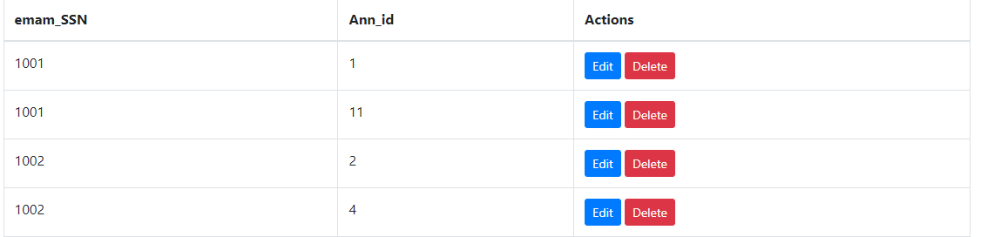

4. Outside Jobs:

**View Assigned Jobs:** Outside jobs specifically assigned to the imam.

**In summary:**  
In conclusion, Imams stand to gain a great deal from the Al-Awqaf database since it makes job assignments and critical announcements easily accessible to them. Through an intuitive interface designed with their needs in mind, the system makes sure Imams are aware of the most recent developments and assignments. The database helps Imams manage their responsibilities more effectively by centralizing and organizing vital information, which improves their capacity to serve their communities. Al-Awqaf's organized approach to data management facilitates accountability and transparency while streamlining communication, all of which support the organization's overarching goal of assisting and enabling Imams in their crucial tasks.

_____________________________________________________________________________

* **1.3 Frequently asked questions**

**Q1: What is the Al-Awqaf database?**

A1: The Al-Awqaf database is a comprehensive system designed to manage information related to mosques, and there Emams, and the announcements that the ministry want to reach it for the Emam, however it is the same for the outside job. It helps streamline communication and task management for Imams, ensuring they are well-informed and organized.

**Q2: Who can access the Al-Awqaf database?**

A2: The database can be accessed by designated users such as Minister, employees, and Imams. Each user type has specific permissions based on their role and responsibilities.

**Q3: What roles are available in the Al-Awqaf database, and what are their permissions?**

A3: There are three primary roles:

Minister (Mohammad): Has full permissions including select, insert, update, and delete on all tables.

Employee (Abdullah): Can select, insert, and update most tables but has restricted permissions on some.

Imam (Omar): Primarily has select permissions to view relevant information but can also access specific views.

**Q4: How do I log in to the Al-Awqaf database?**

A4: Each user is assigned a login with a unique username and password. For example, the Minister logs in as Minister with the password “minister123”, and similar credentials are provided for employees and Imams.

**Q5: How can I add a new mosque and its associated Imam?**

A5: You can use the stored procedure Insert_Mosque_With_Imam to add a new mosque and its Imam simultaneously. You need to provide details such as mosque ID, name, city, neighborhood, street, capacity, housing status, and Imam details (SSN, first name, last name, date of birth, salary, marriage status).

**Q6: How do I add a new announcement or job for an Imam?**

A6: You can use the procedures New_Announcement_To_Emam and New_Job_To_Emam. These procedures require details such as announcement/job ID, date, description, type, and the Imam’s SSN.

**Q8: How do I view announcements related to a specific Imam?**

A8: You can query the view Emam_Announcement to see announcements linked to specific Imams. For example, SELECT * FROM Emam_Announcement WHERE emam_SSN = 1001; will show announcements for the Imam with SSN 1001.

**Q9: How do I view outside jobs assigned to a specific Imam?**

A9: You can query the view Emam_outside_job to see outside jobs assigned to specific Imams. For example, SELECT * FROM Emam_outside_job WHERE emam_SSN = 1006; will show jobs for the Imam with SSN 1006.

________________________________________________________________________

* **1.4 Contact information**

Please contact our committed staff if you need technical assistance or have any questions about the Al-Awqaf database system:

* **Email:** support@alawqafdatabase.org
* **Phone:** +962 79 96 34 207
* **Operating Hours:** Sunday - Thursday, 8:00 AM to 5:00 PM

For additional resources, visit our online knowledge base or community forum to seek help or share experiences:

* **Knowledge Base:** www.alawqafdatabase.org/knowledgebase
* **Community Forum:** www.alawqafdatabase.org/forum