
Faculty of Science

Course: CSCI 2020u – Software System Development & Integration
Component: Assignment
Weight: 10%
Deadline: March 5, 2020 (due by 11:59pm)

Collaboration Policy
You are permitted to work on this assignment in a team, and submit the results as a team. For this sort of assignment, with an open-ended component, the collaboration between multiple team members can be beneficial. Between groups, however, please limit the discussion to the level of general strategy (not code). Groups of size 2 are recommended. Larger groups will be considered with the proviso that the marker will mark your assignment with higher expectations. In any case, be sure that all members of the team fully understand all code, otherwise they will miss intended learning objectives, which may be a considerable disadvantage at exam time.

How to Submit
You will maintain a git repository for this assignment, which is a public repository. To submit the assignment, create a single file ‘README.txt’ that contains instructions on how to download, compile, and run your codes for each question. A .zip, .7z, or .rar file will not be acceptable. Also submit this word file (once you complete) into related drop box on Blackboard before deadline.

Note: Comments are mandatory. Failure to properly document your program will result in a deduction on the marks you receive for this (and any other) assignment.

Remember:
You need to complete this file and submit it in related drop box on Blackboard, in addition to uploading your codes in your git repository, before deadline.

Question 1: Displaying Three Cards

Problem Description:
Display a frame that contains three labels. Each label displays a card, as shown in the figure below. The card image files are named 1.png, 2.png, ..., 54.png and stored in the image/card directory. All three cards are distinct and selected randomly.

The image icons can be found in the attached card folder.

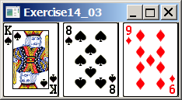

Your Task:
- Create three ImageView and set their icons using the images.
- Display three images from 54 image cards randomly.

Your Code:
Copy-paste your code here:

package sample;
import javafx.application.Application;
import javafx.geometry.Insets;
import javafx.scene.Scene;
import javafx.scene.image.Image;
import javafx.scene.image.ImageView;
import javafx.scene.layout.HBox;
import javafx.scene.layout.Pane;
import javafx.stage.Stage;
import java.io.FileInputStream;
import java.util.ArrayList;
public class Question1 extends Application {
@Override
public void start(Stage primaryStage) throws Exception{
//Array containing shuffled numbers from 1 - 52
ArrayList<Integer> cardNum = new ArrayList<>();
for (int i = 1; i < 53; i++) {
cardNum.add(i);
}
java.util.Collections.shuffle(cardNum);
//Selecting random cards to be displayed
ArrayList<Image> images = new ArrayList<>();
for (int i = 0; i < 3; i++) {
images.add(new Image(new FileInputStream("C:\\Users\\Abdullah Riaz\\Desktop\\Codes\\csci2020u\\" +
"assignment01\\Cards\\" + cardNum.get(i) + ".png")));
}
//Adding image objects to Image View
ArrayList<ImageView> imageViews = new ArrayList<>();
for (int i = 0; i < 3; i++) {
imageViews.add(new ImageView(images.get(i)));
}
//Setting the size of the cards
for (int i = 0; i < 3; i++) {
imageViews.get(i).setFitHeight(144);
imageViews.get(i).setFitWidth(108);
}
Pane pane = new HBox(10);
pane.setPadding(new Insets(10, 10, 10, 10));
pane.getChildren().addAll(imageViews);
Scene scene = new Scene(pane, 365, 250);
primaryStage.setTitle("Question 1");
primaryStage.setScene(scene);
primaryStage.show();
}
public static void main(String[] args) {
launch(args);
}
}

Screen shots:
Include two screen shots here:

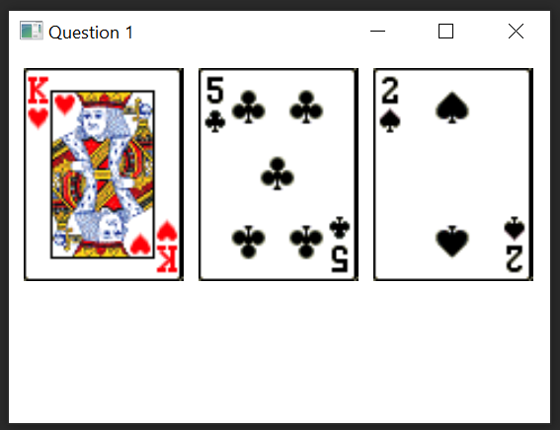

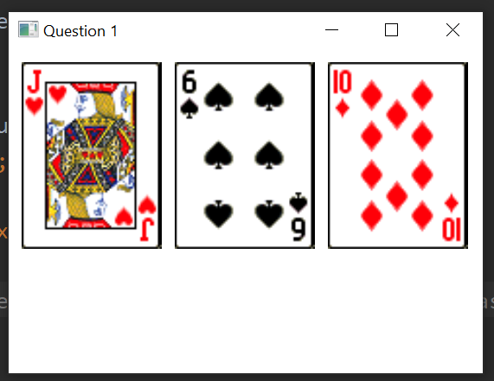

Question 2: Investment-Value calculator

Problem Description:
Write a program that calculates the future value of an investment at a given interest rate for a specified number of years. The formula for the calculation is as follows:

futureValue = investmentAmount * (1 + monthlyInterestRate)years*12

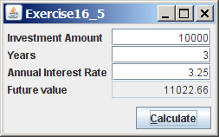

Your Task:
Use text fields for interest rate, investment amount, and years. Display the future amount in a text field when the user clicks the Calculate button, as shown in the figure.

Your Code:

import javafx.application.Application;
import javafx.event.ActionEvent;
import javafx.event.EventHandler;
import javafx.geometry.Pos;
import javafx.scene.Scene;
import javafx.scene.control.Button;
import javafx.scene.control.Label;
import javafx.scene.control.TextField;
import javafx.scene.layout.HBox;
import javafx.scene.layout.VBox;
import javafx.stage.Stage;
import java.lang.Math;
import java.text.DecimalFormat;
public class Q2 extends Application {
@Override
public void start(Stage primaryStage) throws Exception {
//creating the v and h boxes to put in the text and textfields into rows and columns
VBox vBox = new VBox();
vBox.setSpacing(10);
vBox.setAlignment(Pos.CENTER);
HBox hBox1 = new HBox();
HBox hBox2 = new HBox();
HBox hBox3 = new HBox();
HBox hBox4 = new HBox();
HBox hBox5 = new HBox();
hBox1.setSpacing(10);
hBox1.setAlignment(Pos.CENTER);
hBox2.setSpacing(10);
hBox2.setAlignment(Pos.CENTER);
hBox3.setSpacing(10);
hBox3.setAlignment(Pos.CENTER);
hBox4.setSpacing(10);
hBox4.setAlignment(Pos.CENTER);
hBox5.setSpacing(10);
hBox5.setAlignment(Pos.CENTER);
//columns/rows for the text/inputs/outputs
Label IALabel = new Label("Investment Amount");
TextField tfIA = new TextField();
tfIA.setAlignment(Pos.CENTER_RIGHT);
IALabel.setMinWidth(110);
Label YSLabel = new Label("Years");
TextField tfYS = new TextField();
tfYS.setAlignment(Pos.CENTER_RIGHT);
YSLabel.setMinWidth(110);
Label AIRLabel = new Label("Annual Interest Rate");
TextField tfAIR = new TextField();
tfAIR.setAlignment(Pos.CENTER_RIGHT);
AIRLabel.setMinWidth(110);
Label FVLabel = new Label("Future Value");
TextField tfFV = new TextField();
tfFV.setAlignment(Pos.CENTER_RIGHT);
tfFV.setEditable(false);
tfFV.setStyle("-fx-background-color: LIGHTGREY");
FVLabel.setMinWidth(110);
Label BLANKLabel = new Label(" "); //to make space for formatting
BLANKLabel.setMinWidth(200);
//adding the text/text fields to the hboxes(horizontally along each "row")
hBox1.getChildren().addAll(IALabel, tfIA);
hBox2.getChildren().addAll(YSLabel, tfYS);
hBox3.getChildren().addAll(AIRLabel, tfAIR);
hBox4.getChildren().addAll(FVLabel, tfFV);
//button
Button btCALC = new Button("Calculate");
hBox5.getChildren().addAll(BLANKLabel, btCALC);
//adding hboxes to the vbox, (placing the rows starting with the top)
vBox.getChildren().addAll(hBox1,hBox2,hBox3,hBox4,hBox5);
//adding function to th button
EventHandler<ActionEvent> calculate = new EventHandler<ActionEvent>() {
public void handle(ActionEvent e) {
//creating variables for the formula
Double A = Double.parseDouble(tfIA.getText());
double B = Math.pow((1 + (Float.parseFloat(tfAIR.getText()))/1200), (Float.parseFloat(tfYS.getText()))*12 );
double result = A*B;
//keeping the final result at 2 decimal place
DecimalFormat df = new DecimalFormat("#.00");
//setting the final value text field as the calculated result
tfFV.setText(Double.toString(
Double.parseDouble(df.format(result))
));
}
};
btCALC.setOnAction(calculate);
Scene scene = new Scene(vBox);
primaryStage.setScene(scene);
primaryStage.show();
}
}

Screen shots:

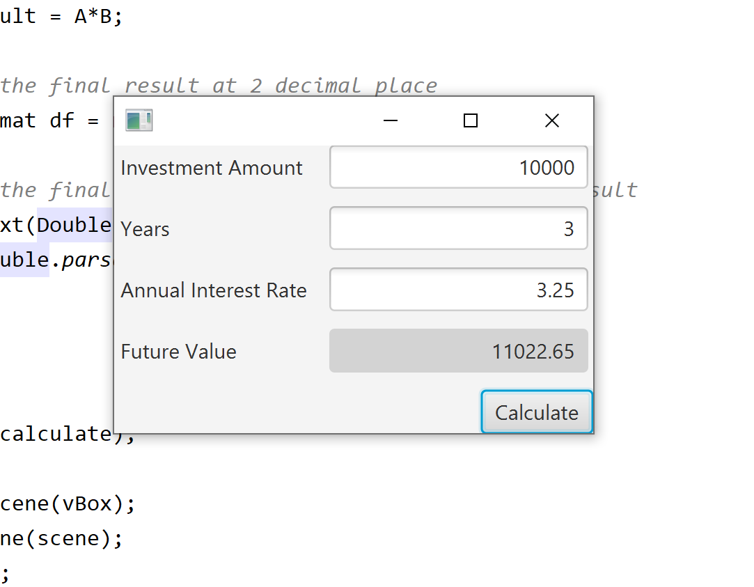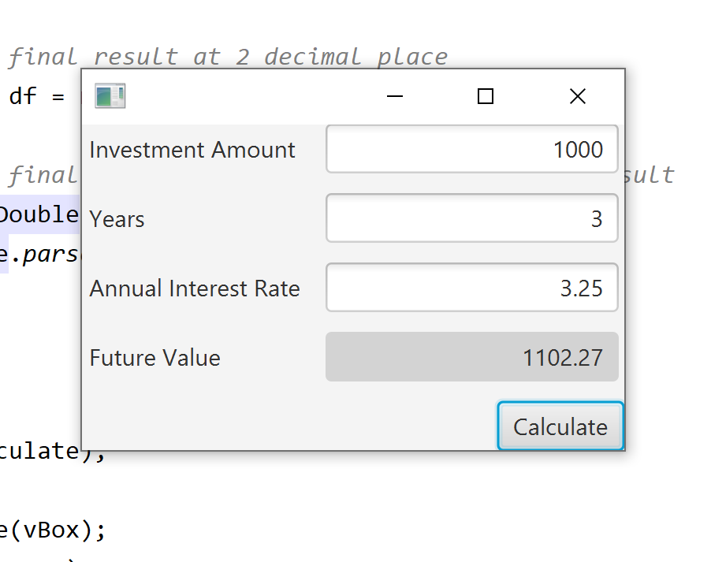

Question 3: Dragging Points on a Circle

Problem Description:
Draw a circle with three random points on the circle. Connect the points to form a triangle. Display the angles in the triangle. Use the mouse to drag a point along the perimeter of the circle. As you drag it, the triangle and angles are redisplayed dynamically.

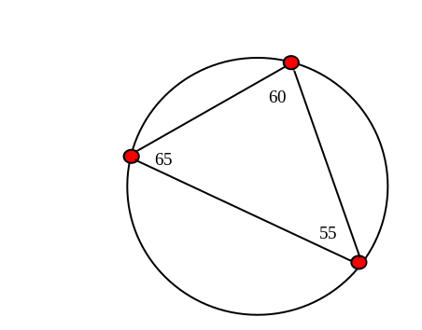

Here is the formula to compute angles:

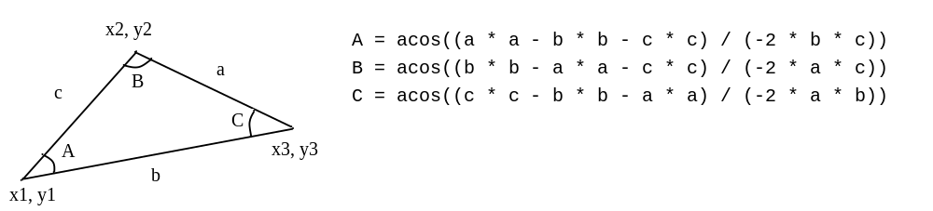

Your Code:

package sample;
import javafx.application.Application;
import javafx.geometry.Point2D;
import javafx.scene.Group;
import javafx.scene.Scene;
import javafx.scene.input.MouseEvent;
import javafx.scene.paint.Color;
import javafx.scene.shape.Circle;
import javafx.scene.shape.Line;
import javafx.scene.text.Text;
import javafx.stage.Stage;
import java.util.ArrayList;
public class Question3 extends Application {
@Override
public void start(Stage primaryStage) throws Exception {
//initialize group
Group group = new Group();
//initializing window stage
primaryStage.setWidth(500);
primaryStage.setHeight(500);
//initializing circles
Circle mainCircle = new Circle(250, 250, 150);
Circle miniCircle1 = new Circle(100, 250, 8);
Circle miniCircle2 = new Circle(250, 100, 8);
Circle miniCircle3 = new Circle(400, 250, 8);
mainCircle.setStroke(Color.BLACK);
mainCircle.setFill(Color.TRANSPARENT);
miniCircle1.setStroke(Color.BLACK);
miniCircle1.setFill(Color.RED);
miniCircle2.setStroke(Color.BLACK);
miniCircle2.setFill(Color.RED);
miniCircle3.setStroke(Color.BLACK);
miniCircle3.setFill(Color.RED);
//initializing lines that connect the miniCircles
Line line1 = new Line(); //miniCircles 1 and 2
Line line2 = new Line(); //miniCircles 2 and 3
Line line3 = new Line(); //miniCircles 3 and 1
line1.startXProperty().bind(miniCircle1.centerXProperty());
line1.startYProperty().bind(miniCircle1.centerYProperty());
line1.endXProperty().bind(miniCircle2.centerXProperty());
line1.endYProperty().bind(miniCircle2.centerYProperty());
line2.startXProperty().bind(miniCircle2.centerXProperty());
line2.startYProperty().bind(miniCircle2.centerYProperty());
line2.endXProperty().bind(miniCircle3.centerXProperty());
line2.endYProperty().bind(miniCircle3.centerYProperty());
line3.startXProperty().bind(miniCircle3.centerXProperty());
line3.startYProperty().bind(miniCircle3.centerYProperty());
line3.endXProperty().bind(miniCircle1.centerXProperty());
line3.endYProperty().bind(miniCircle1.centerYProperty());
//initializing the angle labels on each miniCircle
Text text1 = new Text("45"); //for miniCircle1
text1.xProperty().bind(miniCircle1.centerXProperty());
text1.yProperty().bind(miniCircle1.centerYProperty());
Text text2 = new Text("90"); //for miniCircle1
text2.xProperty().bind(miniCircle2.centerXProperty());
text2.yProperty().bind(miniCircle2.centerYProperty());
Text text3 = new Text("45"); //for miniCircle1
text3.xProperty().bind(miniCircle3.centerXProperty());
text3.yProperty().bind(miniCircle3.centerYProperty());
//mouse input for miniCircle1
miniCircle1.setOnMouseDragged((MouseEvent me) -> {
//finds the center of the mainCircle and sets it so that miniCircle1 can only go around mainCircle's radius
Point2D mainCenter = new Point2D(mainCircle.getCenterX(), mainCircle.getCenterY());
Point2D mouse = new Point2D(me.getX(), me.getSceneY());
Point2D centerToMouse = mouse.subtract(mainCenter);
Point2D centerToNewPoint = centerToMouse.normalize().multiply(mainCircle.getRadius());
Point2D newPoint = centerToNewPoint.add(mainCenter);
miniCircle1.setCenterX(newPoint.getX());
miniCircle1.setCenterY(newPoint.getY());
//calculates dist and angle to set the angles of the miniCircles
double d3 = calculateDistance(miniCircle1.getCenterX(),miniCircle1.getCenterY(),miniCircle2.getCenterX(),miniCircle2.getCenterY());
double d1 = calculateDistance(miniCircle2.getCenterX(),miniCircle2.getCenterY(),miniCircle3.getCenterX(),miniCircle3.getCenterY());
double d2 = calculateDistance(miniCircle3.getCenterX(),miniCircle3.getCenterY(),miniCircle1.getCenterX(),miniCircle1.getCenterY());
int A1 = (int) Math.round(calculateAngle(d1,d2,d3));
int A2 = (int) Math.round(calculateAngle(d2,d3,d1));
int A3 = (int) Math.round(calculateAngle(d3,d2,d1));
String sA1 = String.valueOf(A1);
String sA2 = String.valueOf(A2);
String sA3 = String.valueOf(A3);
//updates the angles to the current angle positions
text1.setText(sA1);
text2.setText(sA2);
text3.setText(sA3);
});
//mouse input for miniCircle2
miniCircle2.setOnMouseDragged((MouseEvent me) -> {
//finds the center of the mainCircle and sets it so that miniCircle2 can only go around mainCircle's radius
Point2D mainCenter = new Point2D(mainCircle.getCenterX(), mainCircle.getCenterY());
Point2D mouse = new Point2D(me.getX(), me.getSceneY());
Point2D centerToMouse = mouse.subtract(mainCenter);
Point2D centerToNewPoint = centerToMouse.normalize().multiply(mainCircle.getRadius());
Point2D newPoint = centerToNewPoint.add(mainCenter);
miniCircle2.setCenterX(newPoint.getX());
miniCircle2.setCenterY(newPoint.getY());
//calculates dist and angle to set the angles of the miniCircles
double d3 = calculateDistance(miniCircle1.getCenterX(),miniCircle1.getCenterY(),miniCircle2.getCenterX(),miniCircle2.getCenterY());
double d1 = calculateDistance(miniCircle2.getCenterX(),miniCircle2.getCenterY(),miniCircle3.getCenterX(),miniCircle3.getCenterY());
double d2 = calculateDistance(miniCircle3.getCenterX(),miniCircle3.getCenterY(),miniCircle1.getCenterX(),miniCircle1.getCenterY());
int A1 = (int) Math.round(calculateAngle(d1,d2,d3));
int A2 = (int) Math.round(calculateAngle(d2,d3,d1));
int A3 = (int) Math.round(calculateAngle(d3,d2,d1));
String sA1 = String.valueOf(A1);
String sA2 = String.valueOf(A2);
String sA3 = String.valueOf(A3);
//updates the angles to the current angle positions
text1.setText(sA1);
text2.setText(sA2);
text3.setText(sA3);
});
//mouse input for miniCircle3
miniCircle3.setOnMouseDragged((MouseEvent me) -> {
//finds the center of the mainCircle and sets it so that miniCircle3 can only go around mainCircle's radius
Point2D mainCenter = new Point2D(mainCircle.getCenterX(), mainCircle.getCenterY());
Point2D mouse = new Point2D(me.getX(), me.getSceneY());
Point2D centerToMouse = mouse.subtract(mainCenter);
Point2D centerToNewPoint = centerToMouse.normalize().multiply(mainCircle.getRadius());
Point2D newPoint = centerToNewPoint.add(mainCenter);
miniCircle3.setCenterX(newPoint.getX());
miniCircle3.setCenterY(newPoint.getY());
//calculates dist and angle to set the angles of the miniCircles
double d3 = calculateDistance(miniCircle1.getCenterX(),miniCircle1.getCenterY(),miniCircle2.getCenterX(),miniCircle2.getCenterY());
double d1 = calculateDistance(miniCircle2.getCenterX(),miniCircle2.getCenterY(),miniCircle3.getCenterX(),miniCircle3.getCenterY());
double d2 = calculateDistance(miniCircle3.getCenterX(),miniCircle3.getCenterY(),miniCircle1.getCenterX(),miniCircle1.getCenterY());
int A1 = (int) Math.round(calculateAngle(d1,d2,d3));
int A2 = (int) Math.round(calculateAngle(d2,d3,d1));
int A3 = (int) Math.round(calculateAngle(d3,d2,d1));
String sA1 = String.valueOf(A1);
String sA2 = String.valueOf(A2);
String sA3 = String.valueOf(A3);
//updates the angles to the current angle positions
text1.setText(sA1);
text2.setText(sA2);
text3.setText(sA3);
});
//off sets text so it doesn't overlap with the miniCircles
text1.setTranslateX(15);
text2.setTranslateX(15);
text3.setTranslateX(15);
//adding contents to the group
group.getChildren().addAll(line1,line2,line3,text1,text2,text3, mainCircle,miniCircle1,miniCircle2, miniCircle3);
//putting the group in the scene
Scene scene = new Scene(group);
primaryStage.setTitle("CircleWithTriangle");
primaryStage.setScene(scene);
primaryStage.show();
}
//to calculate the distance between 2 points
private double calculateDistance(double x1, double y1, double x2, double y2) {
double p1 = Math.pow((x2 - x1),2);
double p2 = Math.pow((y2 - y1),2);
double dist = Math.sqrt(p1 + p2);
return dist;
}
//calculating the angle
private double calculateAngle(double a, double b, double c) {
double p1 = (a*a - b*b - c*c);
double p2 = (-2*b*c);
double Ang = Math.toDegrees((Math.acos(p1/p2)));
return Ang;
}
public static int getRandomNumber() {
int result = (int) Math.random()*100;
return result;
}
}

Screen shots:

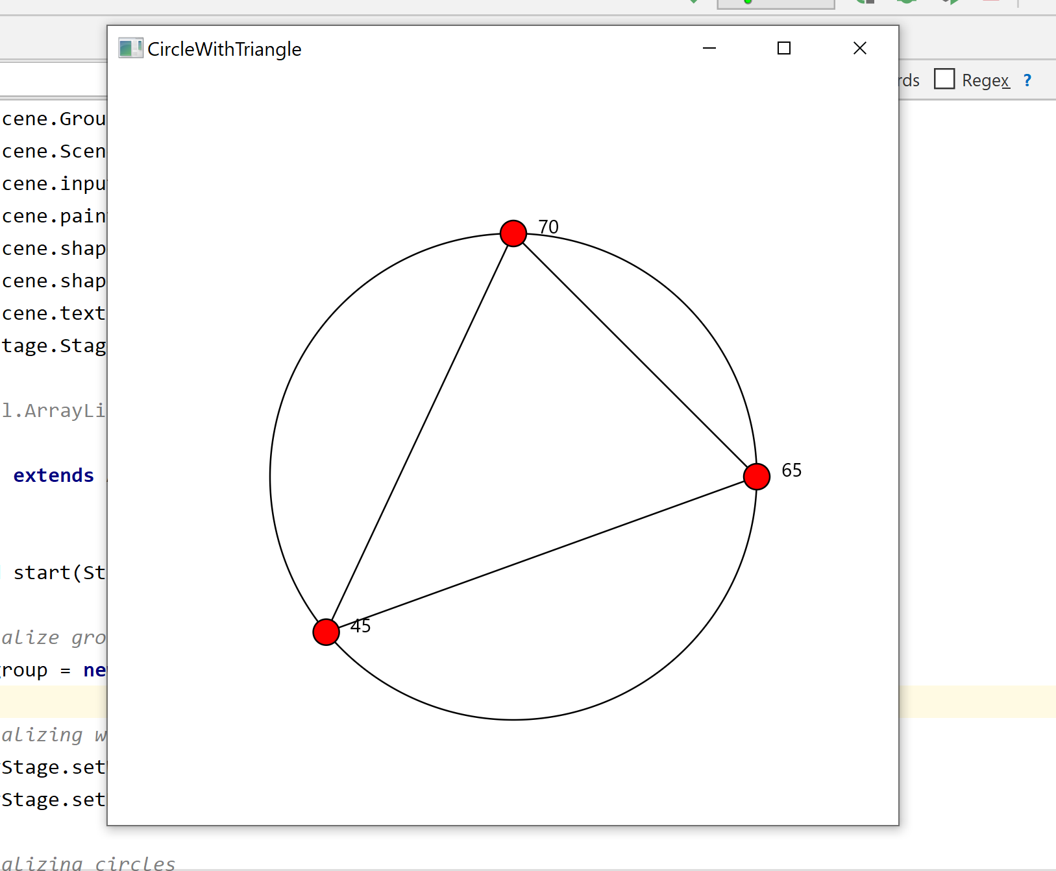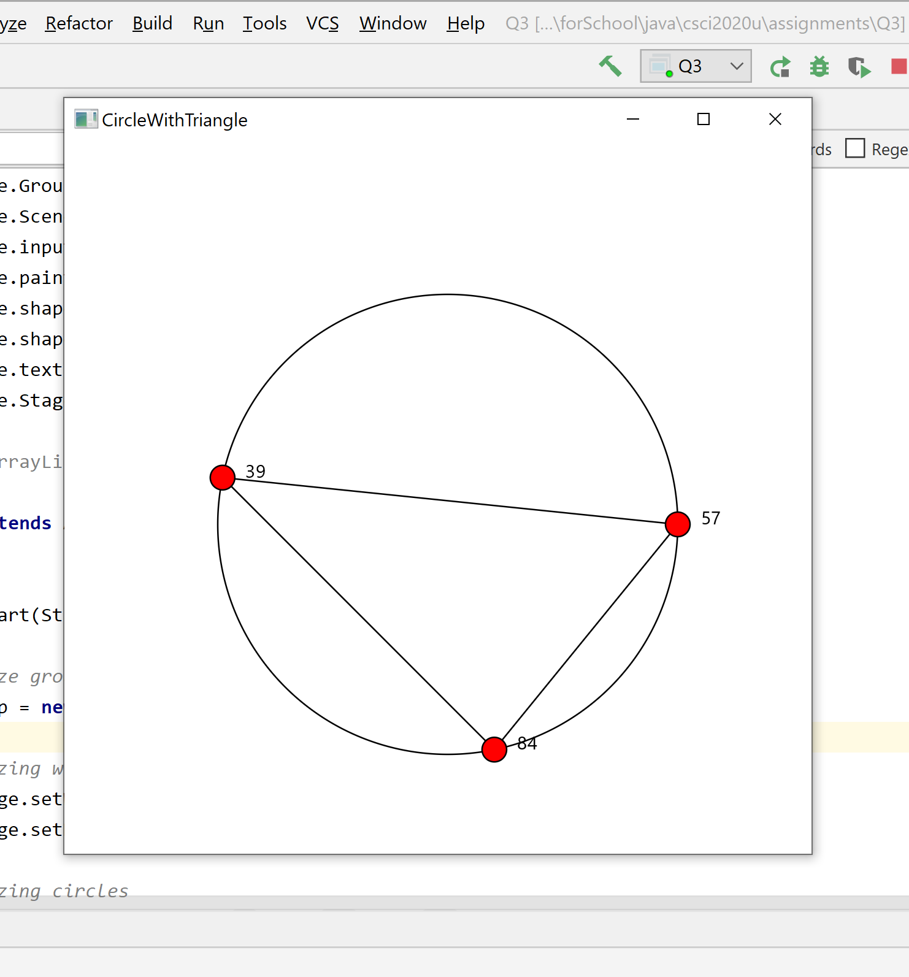

Question 4: Histogram

Problem Description:
Develop a program that displays a histogram to show the occurrences of each letter in a text area. The histogram should show the occurrences of each letter in a text file, as shown in the following figure. Assume that the letters are not case sensitive.

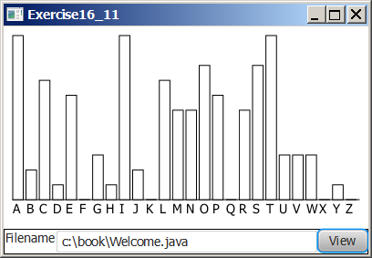

Your Task:
- Place a pane that will display the histogram in the center of the frame.
- Place a label and a text field in a panel, and put the panel in the south side of the frame. The text file will be entered from this text field.
- Pressing the Enter key on the text field causes the program to count the occurrences of each letter and display the count in a histogram.

Your Code:
Copy-paste your code here:
//Written by Michael Loo - 100702210
//and Abdullah Riaz Raja - 100693348
package sample;
import javafx.application.Application;
import javafx.scene.Scene;
import javafx.scene.canvas.Canvas;
import javafx.scene.canvas.GraphicsContext;
import javafx.scene.control.Button;
import javafx.scene.control.Label;
import javafx.scene.control.TextField;
import javafx.scene.layout.HBox;
import javafx.scene.layout.VBox;
import javafx.stage.Stage;
import java.io.File;
import java.io.FileNotFoundException;
import java.util.Scanner;
public class Question4 extends Application {
//global variables defining height and length of the canvas
int height = 400;
int length = 800;
//returns an array with the frequency of each letter regardless of upper/lower case
int[] getFrequency(Scanner text) {
int[] freq = new int[26];
//checks if end of file has been reached
while (text.hasNext()) {
String line = text.nextLine(); //stores the selected line as String
int num = 0;
//updates frequency of each character
for (int i = 0; i < line.length(); i++) {
num = (int) (line.charAt(i));
if ((num > 64) && (num < 91)) { //makes sure only A-Z are accounted for
freq[line.charAt(i) - 'A']++; //and all the other symbols are ignored
} else if ((num > 96) && (num < 123)) { //makes sure only a-z are accounted for
freq[line.charAt(i) - 'a']++;
}
}
}
return freq;
}
//returns a canvas to display
Canvas createHistogram(int[] freq) {
//finds max frequency for scaling purposes
int max = freq[0];
for (int i = 0; i < 26; i++) {
if (max < freq[i]) {
max = freq[i];
}
}
//setting up canvas
Canvas canvas = new Canvas(length, height);
GraphicsContext gc = canvas.getGraphicsContext2D();
gc.setLineWidth(1.5);
//draws 26 bars representing frequency of each letter
for (int i = 0; i < 26; i++) {
int barH = (freq[i] * 300/ max);
gc.strokeRect(10+i*30, height-barH-50, 25, barH);
}
//draws the x-axis (letter labels)
for (int i = 0; i < 26; i++) {
char letter = (char) ('A' + i);
gc.fillText(String.valueOf(letter), 20+i*30, height-30);
}
return canvas;
}
@Override
public void start(Stage primaryStage) throws FileNotFoundException {
VBox vbox = new VBox();
HBox hbox = new HBox();
//initial empty canvas
Canvas empty = new Canvas(length, height);
//user controls
Label fileName = new Label(" Filename");
fileName.setPrefWidth(70);
TextField pathField = new TextField();
pathField.setPrefWidth(700);
Button view = new Button("View");
view.setOnAction( e -> {
//takes user inputted path to the text file
String path = (pathField.getText());
//file is loaded
File srcFile = new File(path);
//read file
Scanner input = null;
try {
input = new Scanner(srcFile);
//initialize an array with frequency of each letter
int freq[] = getFrequency(input);
input.close();
//previous canvas is replaced with the new canvas containing the updated histogram
Canvas histogram = createHistogram(freq);
hbox.getChildren().clear();
vbox.getChildren().clear();
hbox.getChildren().addAll(fileName, pathField, view);
vbox.getChildren().addAll(histogram, hbox);
} catch (FileNotFoundException ex) {
System.out.println("Selected file does not exist");
}
});
//Displaying everything to the user
hbox.getChildren().addAll(fileName, pathField, view);
vbox.getChildren().addAll(empty, hbox);
Scene scene = new Scene(vbox);
primaryStage.setScene(scene);
primaryStage.setTitle("Question 4");
primaryStage.show();
}
public static void main(String[] args) { launch(args); }
}

Screen shots:
Include two screen shots here:

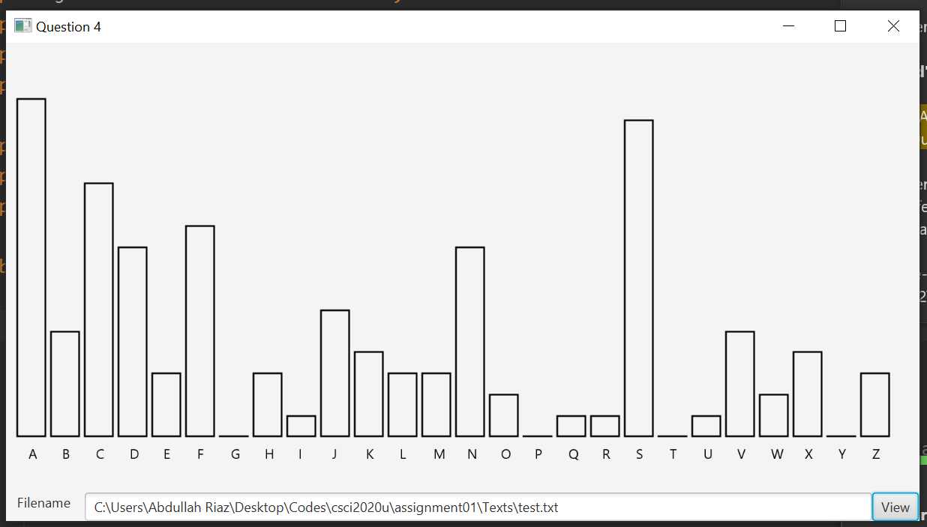

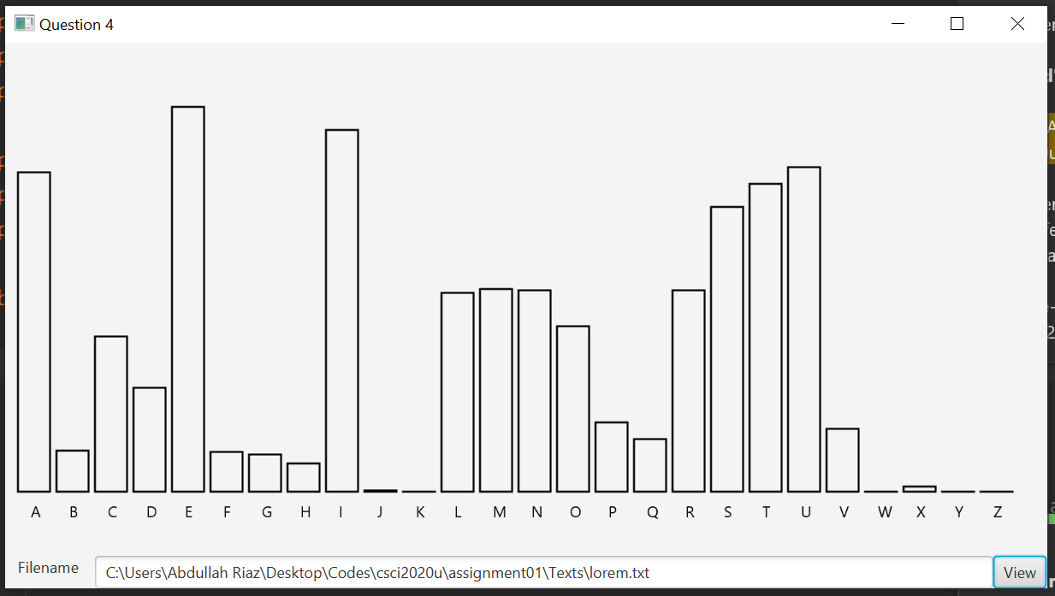

Remember:

You need to complete this file and submit it in related drop box on Blackboard, in addition to uploading your codes in your git repository, before deadline.

