Facial Recognition and Car Number Plate Identification of Vehicles for Out Door Environment.

ABDULLAH MUJEEB | 4-23/2019/002
ASAD AHMED SIDDIQUI | 4-23/2019/007
MUHAMMAD FURRUKH | 4-23/2019/005

A Final Year Project Report Submitted to the
DEPARTMENT OF COMPUTER SCIENCE AND SOFTWARE ENGINEERING in the partial fulfillment of the requirements for the degree of
BACHELOR OF SCIENCE IN SOFTWARE ENGINEERING/DATA SCIENCE

Supervised by
Syed Muhammad Atif & Dr. Sheikh Muhammad Munaf
Date of Submission
26th December, 2023

Ziauddin University Faculty of Engineering Science Technology and Management (ZUFESTM)

Student Declaration
I declare that this Proposal/Thesis entitled “Facial Recognition and Car Number Plate Identification of Vehicles for Out Door Environment” is the result of my own research except as cited in the references. The thesis has not been submitted or accepted for any degree and is not concurrently submitted in candidature of any other degree.

Signature : ………………………...........

Name : ………………………...........

Date : ……….......

Signature : ………………………...........

Name : ………………………...........

Date : ……….......

Signature : ………………………...........

Name : ………………………...........

Date : ……….......

Supervisor’s Declaration
“I/We* hereby declare that I/we* have read this thesis and in my/our*opinion this thesis is sufficient in terms of scope and quality for the award of the degree of Bachelors of Data Science (specialization).

Signature : ………………………...........

Name Supervisor : ………………………...........

Date : ……….......

TABLE OF CONTENTS

CHAPTER 1
RESEARCH FRAMEWORK
 |  | PAGE
1.1  1.2  1.3 | INTRODUCTION  BACKGROUND/MOTIVATION  PROBLEM STATEMENT/ DEFINITION | 6  7  7
1.4 | GOALS AND OBJECTIVE | 9
1.5  1.6 | SCOPE OF PROJECT  SIGNIFICANCE OF PROJECT | 10  11
1.7 | CONTRIBUTIONS | 12

CHAPTER 2
LITERATURE REVIEW
2.1 | INTRODUCTION | 14
2.2 | RELATED RESEARCH | 15

CHAPTER 3
METHODOLOGY
3.2 | MODELLING AND SIMULATION | 17
3.3 | DESIGN AND PROCEDURE | 18
3.4 | DATA COLLECTION AND ANALYSIS | 22
3.5 | PERFORMANCE EVALUATION | 23

CHAPTER 4
REQUIREMENTS
4.1 | HARDWARE REQUIREMENTS | 27
4.2 | SOFTWARE REQUIREMENTS | 27
4.3 | FUNCTIONAL REQUIREMENTS | 27
4.4 | NON-FUNCTIONAL REQUIREMENTS | 28

CHAPTER 5
EXPERIMENTS & RESULT
5.1 | DETAILS OF EXPERIMENT SETUP | 29
5.2 | FINDINGS | 29

CHAPTER 6
CONCLUSION & FUTURE DIRECTIONS
6.1 | CONCLUSION | 31
6.2 | FUTURE DIRECTIONS | 31
Reference
Appendices

- SOURCE CODE

CHAPTER 1 - INTRODUCTION

  - Introduction: (Mandatory)
In an age when technology advances are redefining security concepts, the integration of sophisticated systems for identification and surveillance is at the forefront of thinking. The "Facial Recognition and Car Number Plate Identification for Outdoor Environments" project is a groundbreaking initiative that aims to strengthen security and improve access management in outdoor settings through innovative technical applications.

This creative project utilizes use of cutting-edge technologies like YOLO V5 for robust object detection, EasyOCR for precise optical character recognition, and Flask for seamless web application development. Its major goal is to accurately recognize and store drivers' faces while also quickly recognizing car license plates in real-time.

The system relies on YOLO V5, which ensures quick and accurate detection of faces and car license plates, confirming the system's reliability in identification operations. EasyOCR integration improves vehicle tracking precision by extracting textual information from recognized license plates. Furthermore, the facial recognition module, which is driven by OpenCV, handles and stores driver information efficiently.

To ensure basic user engagement, a user-friendly web application built with Flask allows users to easily input photographs, initiate identification procedures, and understand outcomes. Robust authentication techniques ensure secure system access, while Excel and CSV files are used for easy storing and retrieval of face and car information.

This project goes beyond traditional security solutions by attempting to provide not just a strong defence mechanism, but also a dynamic and user-centric interface for seamless interaction. The project demonstrates the possibilities unlocked when cutting-edge technologies intersect to address real-world difficulties, as it navigates the areas of facial recognition and car plate identification.

  - Background/Motivation:
Our project's origin is built in a comprehensive knowledge of the necessary demands prominent in modern security architecture. As technological improvements reshape how we interact and environments, the importance of robust identification and surveillance systems in outdoor situations grows. Traditional security methods frequently fail to successfully monitor and regulate outside regions, demanding a game-changing alternative.

As a result of these pressing needs, this project developed with the goal of revolutionizing outdoor security through advanced facial recognition and car number plate identification technologies. Outdoor areas present special problems, necessitating real-time and accurate identification of people and vehicles. Conventional systems struggle to meet these expectations, forcing the creation of our innovative system.

The project is powered by the convergence of cutting-edge technologies—YOLO V5 for precise object detection, EasyOCR for accurate character recognition, and the simplified web application built using Flask. The major goal is to improve security by allowing seamless and real-time identification of faces and vehicle license plates.

The system seeks to achieve a previously unattainable level of accuracy in outdoor surveillance by leveraging the capabilities of YOLO V5 for quick and accurate detection and EasyOCR for exact character extraction. Furthermore, the introduction of facial recognition technology ensures effective driver information management and storage, adding to a comprehensive security apparatus.

This project's goal isn't just to improve security; it also wants to create new standards for interactivity and usability. Users can interact with the system easily via a user-friendly web application, activating identification operations and receiving understandable results. Our objective is clear: to lead the road for a safer and more accessible outside environment by emphasizing both security robustness and user-centric design, employing cutting-edge technology and reviving security and identity paradigms.

  - Problem Statement/Definition:
Outdoor Security Management Challenges:
As technological landscapes evolve, outdoor places require robust and effective security solutions. Existing approaches frequently fail to identify individuals and vehicles adequately, resulting in gaps in surveillance and access control. This section of the study outlines the ongoing difficulties in monitoring outdoor locations, including limits in facial recognition and vehicle identification technologies.

User-Focused Solution:
In response to these issues, the project intends to create a breakthrough system designed specifically for outdoor security. This technology, which is centred on user demands, aims to revolutionise identification and surveillance procedures by enabling real-time and precise recognition of faces and vehicle licence plates in outdoor situations.

Integration of Advanced Technologies:
Harnessing cutting-edge technologies such as YOLO V5 and EasyOCR for smooth object detection and character recognition is a key component of the project. This section emphasises the project's dedication to leverage cutting-edge solutions to address outdoor security weaknesses, emphasising the significance of precise and rapid recognition capabilities.

Complexity of Real-Time Identification and Surveillance:
The complexity of real-time identification and surveillance in outside contexts present considerable problems. This includes the requirement for quick recognition, exact data extraction from licence plates, and effective storing of detected data. The project acknowledges these issues and emphasises the importance of designing a system capable of dealing with these complexities effortlessly.

Integration and Usability:
Beyond technological complexity, the project recognises the need of a user-friendly interface for smooth engagement and operationality. It intends to develop an integrated system that prioritises accessibility and usability for security professionals and administrators in charge of outdoor environments, in addition to addressing identification difficulties.

This project aims to reimagine outdoor security measures by addressing the various issues inherent in identification and monitoring, highlighting the vital need for a general and user-centric solution in outdoor security management.

  - Goals and Objectives:
Fortifying Outdoor Security Governance:
Our project's primary purpose is to strengthen outdoor security governance by deploying an integrated system designed for efficient identification and surveillance. The major goal is to provide robust tools to security staff and administrators, with a focus on real-time data insights and strategic decision-making skills. This section emphasises the critical role of technology in enhancing outdoor security measures.

Real-Time Identification and Surveillance Enhancement:
Our projects primary goal is to improve real-time identification and surveillance capabilities. This entails creating a streamlined system that quickly and effectively detects individuals in outside areas using facial recognition and vehicle licence plate detection. The project's goal is to provide precision, speed, and dependability in outdoor surveillance activities, with a focus on the importance of seamless identification processes.

Integration of Cutting-Edge Technologies:
One critical aspect of our project is the integration of cutting-edge technologies such as YOLO V5 and EasyOCR for precise object identification and character recognition. This goal emphasises the project's dedication to leverage cutting-edge techniques to improve outdoor security measures, emphasising the importance of precision and speedy recognition capabilities.

Ensuring Seamless System Functionality:
Our project focuses on ensuring the system's flawless functionality and use. The goal is to provide an easy-to-use and user-friendly interface that allows security professionals and managers to connect more easily. This comprises data storage, retrieval, and analysis capabilities, assuring operational efficiency in outside surveillance scenarios.

Elevating Outdoor Security Standards:
Aside from technical features, the project intends to improve outdoor security. This involves creating a system that emphasises accessibility, dependability, and adaptability in outdoor security management, in addition to addressing identifying difficulties. Through technology-driven solutions, the goal is to build an integrated system that sets new benchmarks in outdoor security measures.

  - Scope of Project:
Advancing Outdoor Security with Integrated Technologies:

The project embarks on an ambitious scope aimed at advancing outdoor security measures. Leveraging integrated technologies like YOLO V5 and EasyOCR, the system is designed to excel in real-time identification of individuals and vehicle license plates in diverse outdoor environments. This section outlines the broad scope of enhancing outdoor security by seamlessly integrating cutting-edge technologies.

Real-Time Identification System Development:

The scope extends to the development of a sophisticated real-time identification system tailored for outdoor settings. This includes creating a framework that facilitates swift and accurate recognition of faces and vehicle license plates, emphasizing the project's dedication to precision, speed, and reliability in outdoor surveillance operations.

Interface and Usability:

A significant aspect of the project's scope revolves around creating an intuitive and user-friendly interface. This involves designing a seamless user experience for security personnel and administrators overseeing outdoor spaces. The project aims to ensure ease of interaction, data accessibility, and operational efficiency within the system.

Integration of Object Detection and Character Recognition:

The project's scope encompasses the integration of object detection (using YOLO V5) and character recognition (using EasyOCR) to enhance identification processes. This includes streamlining object detection and text extraction from vehicle license plates, emphasizing the project's commitment to accuracy and rapid identification capabilities.

Adaptive System Framework:

Beyond technical functionalities, the project seeks to establish an adaptive system framework that evolves with outdoor security requirements. This involves creating a scalable system that accommodates future technological advancements and changing security needs, setting the foundation for an adaptable and sustainable outdoor security solution.

  - Significance:
Advancing Outdoor Security Paradigms:

This project holds immense significance in the realm of outdoor security, representing a leap forward in surveillance and identification methodologies. By integrating cutting-edge technologies for real-time identification, the project aims to revolutionize outdoor security measures. Its significance lies in its potential to establish more robust and accurate surveillance systems, enhancing safety and control in various outdoor settings.

Precision and Speed in Identification Processes:

The project's focus on real-time identification processes signifies a significant advancement in precision and speed. By deploying sophisticated algorithms for facial recognition and vehicle license plate detection, the system aims to achieve rapid and accurate identification in outdoor environments. This is crucial in addressing security gaps and bolstering identification processes with increased efficiency.

User-Centric Security Solutions:

The emphasis on creating an intuitive interface and user-friendly system holds considerable significance. This user-centric approach ensures that security personnel and administrators can seamlessly interact with and manage the system, optimizing their operational effectiveness. The significance lies in fostering an environment where technology enhances security measures without complicating user interactions.

Future-Ready Security Framework:

The project's adaptive framework signifies its significance in catering to evolving security needs. By establishing a scalable system capable of accommodating future technological advancements, it paves the way for sustainable and adaptable security solutions. This adaptability ensures that the system remains relevant and effective amidst changing security landscapes and technological progress.

Elevating Standards in Outdoor Security:

Collectively, these advancements signify a transformative shift in outdoor security measures. By setting higher standards in identification, surveillance, and user interface design, the project contributes to elevating the overall quality and effectiveness of outdoor security solutions. Its significance lies in its potential to redefine and improve security practices in diverse outdoor environments.

  - Contribution:
Advancing Outdoor Security Paradigms:
This project stands as a significant contribution in redefining outdoor security paradigms through technological integration. By seamlessly integrating advanced identification technologies like YOLO V5 and EasyOCR, it empowers security personnel and administrators with robust tools for real-time identification and surveillance. This contribution signifies a transformative leap in outdoor security measures, promising enhanced safety and control in diverse outdoor environments.

Precision and Speed in Identification Processes:
The project's focus on real-time identification processes signifies a substantial advancement in precision and speed. Through the deployment of cutting-edge algorithms for facial recognition and vehicle license plate detection, the system aims to achieve rapid and accurate identification in outdoor settings. This contribution is pivotal in addressing security gaps and bolstering identification processes with increased efficiency and reliability.

User-Centric Security Solutions:
The emphasis on creating an intuitive interface and user-friendly system holds substantial significance. This user-centric approach ensures that security personnel and administrators can seamlessly interact with and manage the system, optimizing their operational effectiveness. The contribution lies in fostering an environment where technology enhances security measures without complicating user interactions, promoting ease of use and efficiency.

Future-Ready Security Framework:
The project's adaptive framework signifies its contribution to catering to evolving security needs. By establishing a scalable system capable of accommodating future technological advancements, it lays the groundwork for sustainable and adaptable security solutions. This adaptability ensures that the system remains relevant and effective amidst changing security landscapes and technological progress.

Elevating Standards in Outdoor Security:
Collectively, these advancements signify a transformative shift in outdoor security measures. By setting higher standards in identification, surveillance, and user interface design, the project contributes to elevating the overall quality and effectiveness of outdoor security solutions. Its contribution lies in redefining and improving security practices in diverse outdoor environments.

CHAPTER 2 - LITERATURE REVIEW

  - Literature review
- Design of Automatic Facial and Licence Plate Recognition Systems: Abayomi-Alli et al. (2015) conducted research on the development of an Automatic Facial and Licence Plate Recognition System (AFLPRS). AFLPRS tracks cars and drivers on university grounds by combining face recognition and licence plate recognition. The results reveal that licence plate characters may be detected and recognised well, as well as facial recognition performance at entrance and exit locations. The report discusses future research objectives for improving AFLPRS's ability to handle noisy characters, colour fluctuations, and harsh weather settings.
- Automatic Vehicle Number Plate Recognition Using Machine Learning: Kumar et al. (2021) describe a machine learning-based strategy for constructing an Automatic Vehicle Number Plate Recognition System. To recognise and analyse licence plate numbers from vehicle photos, the system uses mathematical morphological procedures, image augmentation, and edge detection. The study is intended for practitioners who are interested in smart transportation and detecting procedures.
- UAV-Based Vehicle Number Plate Recognition: Kaimkhani et al. (2022) investigate Unmanned Aerial Vehicles (UAVs) outfitted with cameras for Automatic Number Plate Recognition (ANPR) in real-time settings. The research looks at how camera angles, UAV height, and relative speed affect the accuracy of detecting characters on licence plates. The research findings centre on the problems and potential solutions for improving ANPR accuracy using UAVs.
- Survey of Automatic Number Plate Recognition Algorithms: Lubna, Mufti, and Shah (2021) provide an in-depth examination of Automatic Number Plate Recognition (ANPR) systems. The study compares and contrasts many real-time tested techniques, including computer vision-based approaches. It emphasises the use of ANPR in conjunction with technologies like as RFID systems, GPS, and Deep Learning to increase accuracy and performance.
- Automatic Number Plate Recognition (ANPR) and Face-Based Recognition System: Rudresh et al. (2015) propose an ANPR and face-based recognition system for improving security in limited locations. Before providing access, the system gathers vehicle and facial photos, extracts number plate areas, does optical character recognition, and validates authorised persons. The experimental findings show that the suggested system is capable of successful detection and recognition.

These research articles show developments in Automatic Number Plate Recognition (ANPR) systems, face recognition integration with security systems, and the potential for improving vehicle monitoring and access management in a variety of settings.

2.2 Related research
These are some research papers.

The purpose of the research paper[1] is to design and develop an automatic facial and license plate recognition system (AFLPRS) that combines facial recognition and license plate recognition to track cars and drivers at the entry and exit points of a university premises. The paper presents the results of testing AFLPRS at the main gate of FUNAAB for 5 working days, including the successful detection and correct recognition rates of LP characters and the face recognition performance on entry and exit. The paper also discusses future research targets, which include enhancing AFLPRS to handle smaller noisy characters, color variations, extreme weather, and uncontrolled illumination scenarios.

The purpose of this research paper[2] is to present a method for developing an automatic vehicle number plate recognition system using machine learning. The system is designed to detect and read license plate numbers from digital images of vehicles, and is based on a combination of mathematical morphological operations such as image improvement, gray scale transformation, bilateral filtering, and edge detection. The main objective is to accurately and quickly detect and translate license plate numbers using a template matching and OCR approach. The paper describes the system in detail and presents the results of its performance. The paper serves as a reference for researchers and practitioners interested in developing and implementing similar systems for smart transportation and detection mechanisms.

The purpose of this research paper[3] is to explore the use of Unmanned Aerial Vehicles (UAVs) equipped with cameras for Automatic Number Plate Recognition (ANPR) in real-time scenarios. The study focuses on analyzing the effect of camera gimble angle, UAV height from the vehicle, and relative speed of the UAV with respect to the vehicle on accurately identifying the characters on the number plate. The study outlines the process of collecting visual data from the drone, processing that data, and obtaining the recognized number plate using MATLAB. The research aims to provide insights into the challenges and limitations of using UAVs for ANPR and propose potential solutions to improve the accuracy of the system.

The purpose of this research paper[4] is to present a detailed survey of current techniques and advancements in Automatic-Number-Plate-Recognition (ANPR) systems, with a comprehensive performance comparison of various real-time tested and simulated algorithms, including those involving computer vision. The paper aims to advance the state-of-knowledge in Intelligent-Transportation-Systems (ITS) built on ANPR technology by analyzing and presenting a survey of extraction, segmentation and recognition techniques whilst providing guidelines on future trends in this area. The research also focuses on the challenges and complexities involved in deploying ANPR systems and how the integration of ANPR with other technologies such as RFID-systems, GPS, Android platforms, and Deep-Learning techniques can enhance its accuracy and performance.

The purpose of this research paper[5] is to propose a system for automatic number plate and face recognition, which can be used to increase the security level at entrances of highly restricted areas such as military zones, top government offices, and residential apartments. The system first captures the image of the vehicle and the faces of authorized persons, extracts the number plate region using image segmentation, and uses optical character recognition to recognize the characters on the number plate. The resulting data is then compared with records on a database, and if the vehicle is authorized and the faces of the persons are verified using a face recognition system, the vehicle is allowed to enter the restricted area. The system is developed and simulated in MATLAB, and its performance is tested on real images and database images. The experimental results show that the system successfully detects and recognizes the vehicle number plate images and faces of authorized persons only.

CHAPTER 3 - METHODOLOGY

  - Modeling and Simulation
Advanced Identification Framework:
A sophisticated identification framework that blends cutting-edge algorithms for facial recognition and vehicle licence plate detection is key to the project's architecture. This framework includes structured data models for effective identification data handling, ensuring correctness and dependability in real-time identification procedures. This framework is based on proven identification principles and relies on technical improvements for precise outdoor surveillance. Advanced Identification Framework: A sophisticated identification framework that blends cutting-edge algorithms for facial recognition and vehicle licence plate detection is key to the project's architecture. This framework includes structured data models for effective identification data handling, ensuring correctness and dependability in real-time identification procedures. This framework is based on proven identification principles and relies on technical improvements for precise outdoor surveillance.

User-Centric Interface Design:
The system's design philosophy prioritizes a user-centric approach, meticulously catering to the needs of security personnel and administrators. The interface is crafted to ensure seamless interaction and operational efficiency, acknowledging the diverse roles and requirements within outdoor security management. This commitment to user-centric design ensures an intuitive and accessible platform for effective system management and surveillance operations.

Scalable Architecture and Integration:
The project's architecture is built to scale, anticipating future improvements and evolving security requirements. The solution maintains data integrity and confidentiality while allowing for the easy integration of identifying technologies by deploying powerful security mechanisms. This modular architecture allows for future expansions and technological integrations, extending the system's lifespan and relevance in changing security landscapes.

Simulation-Based Performance Testing:
Extensive simulation-based testing is performed to assess the system's dependability and efficiency in a variety of outside conditions. These simulations test the system's performance, accuracy, and responsiveness in real-time identification and surveillance activities in a variety of outside situations. The results of simulation testing help to ensure the system's dependability and functioning when dealing with the dynamic problems of outdoor security management.

3.2 Design & Procedure
i) Advanced Identification Framework:
Framework Model: The project's architecture is built on a complex identification framework that incorporates YOLO V5 for object detection and EasyOCR for character recognition. Systematic diagrams and flowcharts govern the relationships between multiple identification entities, resulting in a coherent and structured identification system.

ii) User-Centric Interface Development:
HTML, CSS, and JavaScript serve as the foundation for developing an interactive and user-friendly interface for security workers and administrators. Responsive Design Principles and JavaScript Frameworks: Responsive design principles and JavaScript frameworks are used to offer an ideal user experience across numerous devices, improving accessibility and usability.

iii) Custom Framework Backend Implementation:
Framework Design: The system's backend logic and data management are supported by a customised Python framework. Modular Architecture To support scalability and seamless backend operations for real-time identification and surveillance, an extensible and modular architecture is used.

iv) Security Protocols for Authentication and Access Control: To limit user access and ensure data security and system integrity, strict authentication mechanisms are applied. Granular Authorization: Access control methods based on user roles are in place to provide precise rights while protecting sensitive functionalities and data.

v) Visualisation Tool Integration:
Dynamic Data Presentation: Integration of visualisation tools such as Chart.js and D3.js enables dynamic and intelligent presentation of identification and surveillance data.

vi) Quality Assurance and System Validation:
Thorough Testing: To ensure dependability and accuracy, the system is subjected to comprehensive testing approaches such as unit testing and scenario-based simulations.

Identification and Solution of defects: Thorough testing techniques identify and correct system defects, ensuring smooth functionality and performance in real-world identification scenarios. User validation processes are used to ensure that the system meets the required identification requirements and aligns with user expectations.

vii) Comprehensive Documentation:
System Architecture in Detail: For reference and maintenance, detailed documentation defining the system's architecture, data flow, and identification procedures is supplied. Extensive documentation includes usage instructions, troubleshooting guides, and best practices for both users and administrators, allowing for effective system operation and maintenance.

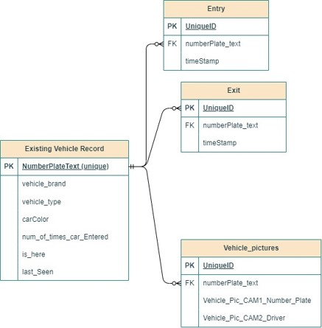

Fig. Entity Relationship Diagram

Procedure:
Waterfall Methodology:
The Waterfall model incorporates a step-by-step development through discrete phases, each of which is contingent on the completion of the previous phase. Requirement gathering, system design, implementation, testing, deployment, and maintenance are common phases.

The model follows an organised methodology, with precise deliverables and targets for each step. Progression to the next phase occurs only after the previous phase has been completed and signed off on.

Unlike the iterative nature of Agile, the Waterfall model goes linearly, with no overlapping or concurrent operations between phases. This ensures that duties are clearly defined and that the emphasis is on finishing one phase before moving on to the next.
Each phase of the Waterfall model emphasises thorough documentation, with complete requirements, design specifications, and test plans established before going on to the next phase.

Once a phase is done, the model is less flexible in adapting adjustments. Changes or new requirements may involve reviewing previous phases, potentially resulting in delays and higher expenses.

Planning is emphasised: Extensive planning occurs at the start of the project to establish needs and design specifications in detail. This preliminary planning tries to reduce risks and uncertainties throughout the development process.

Each phase of the Waterfall model emphasises thorough documentation, with complete requirements, design specifications, and test plans established before going on to the next phase.

Once a phase is done, the model is less flexible in adapting adjustments. Changes or new requirements may involve reviewing previous phases, potentially resulting in delays and higher expenses.

Extensive planning occurs at the start of the project to establish needs and design specifications in detail. This preliminary planning tries to reduce risks and uncertainties throughout the development process.
Clear Milestones and Phases: The Waterfall model emphasises the need of well-defined phases and milestones. The completion of each step represents a tangible accomplishment before moving on to the next phase.

Less User interaction: Unlike Agile's regular feedback loops, user interaction in the Waterfall model is often limited to the requirement gathering phase, with few possibilities for ongoing feedback throughout the development process.

Defined Deliverables: Following the completion of all phases, the model focuses on producing a final, fully-functional product, with an emphasis on meeting predetermined specifications and requirements.

Structured Testing: Testing occurs primarily at the conclusion of the development cycle, after the system has been implemented, to confirm that it meets the defined criteria.

While the Waterfall model provides an organised and systematic approach to development, it is less adaptable to changes and user feedback than Agile techniques. Following a predetermined sequence of steps is emphasised, with little space for flexibility once each phase is completed.

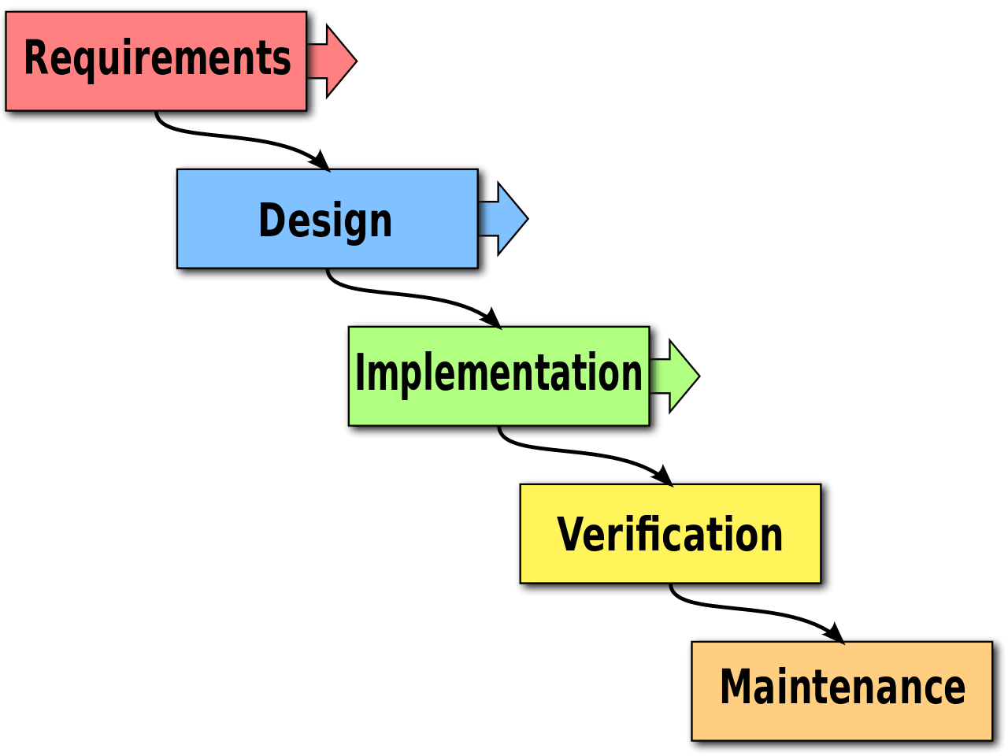
Fig. Waterfall Methodology

3.3 Data Analysis
i) Object Detection Patterns: Identification Data Analysis Analyse identification data to learn about object detection patterns, facial recognition trends, and car plate identification. Insights into System Usage: Examine system usage trends to discover peak times, system load, and opportunities for improvement in real-time identification processes.

ii) Performance Evaluation:
Identification Accuracy: Evaluate the accuracy and speed of identification operations to ensure accurate and timely real-time identification. Analyse error logs to discover recurring issues and update algorithms to increase identification accuracy.

iii) Analysis of System Compliance and Security:
Compliance with regulations: Conduct frequent audits to ensure that identity data is handled in accordance with privacy legislation and security standards.

Security Threat Monitoring: Examine system logs for potential security threats and address them, maintaining data integrity and confidentiality.

iv) Dashboard Usage and Insights:
Analyse the efficiency of visualisations in assisting identification procedures and decision-making for security personnel.Analyse the influence of dashboard information on real-time identification operations and decision-making.

v) User Interaction and Feedback: Patterns of User Engagement: Analyse system user interactions to learn how security workers and administrators interact with the identity system. Systematically analyse user input and ideas in order to iterate enhance identification procedures and system usability.

vi) Metrics of Performance Monitoring:
System Efficiency: To maintain optimal identification operations, continuously evaluate system performance parameters such as response times and processing speeds. Assess resource utilisation to improve system efficiency and scalability for outdoor security operations.

vii) Iterative Enhancements: Use data-driven insights to steer iterative improvements, algorithm tweaks, and system optimisations. Adaptation to User demands and Operational Requirements: Incorporate user feedback and recognised patterns into continuing enhancements, aligning system functionalities with user demands and operational requirements.

By leveraging insights derived from identification data, system performance metrics, compliance audits, and user interactions, the structured data analysis framework ensures continuous refinement and optimisation of identification processes and system functionalities, enhancing outdoor security operations.

3.4 Performance Evaluation
i) User Experience Improvement: The goal is to improve user satisfaction and system usability through iterative improvements based on user feedback and engagement data.

Methods:
Solicit and analyse user input to find areas for system enhancements and provide a more user-centric experience.
Monitoring Engagement Metrics: Track user interactions and navigation patterns to make educated judgements about how to improve the user experience.
Iterative enhancements: Based on feedback and engagement statistics, implement iterative enhancements to provide a responsive and user-friendly system.
ii) Scalability and response time Assurance:
Ensure optimal system performance and scalability for smooth operation, especially during peak periods.

Methods:
Continuous Performance Monitoring entails monitoring and analysing system response times and scalability in order to address any performance bottlenecks as soon as possible.
Scalability Planning: Make plans for system growth based on consumption patterns, assuring effective scalability to meet rising demand.

iii) Reliability and Security Assurance: Maintaining strong data protection measures and dependability via frequent security assessments is the goal.

Methods:
Security audits should be performed on a regular basis to detect and address any vulnerabilities and ensure data security.
Data Integrity Metrics: Implement methods to protect data integrity while also increasing system stability and user confidence.

iv) Feature Utilization Analysis:
Objective: Analyze feature usage metrics to refine functionalities and align the system with user preferences.

Methods:
Metrics Analysis: Evaluate feature usage data to identify popular functionalities and areas for improvement, ensuring user-centric updates.
User Surveys: Collect user opinions through surveys to prioritize enhancements and align system functionalities with user expectations.

Continuous Improvement: Use assessment findings to generate system changes that successfully serve instructional objectives.
vi) Assurance of Data Accuracy and Consistency:
Ensure data reliability by consistently evaluating preprocessing processes.

Methods:
Preprocessing Evaluation: Evaluate data preprocessing processes on a regular basis to identify and correct issues that influence data correctness and consistency.
Quality Control Measures: Implement quality checks to ensure that data is valid and consistent, allowing for informed decision-making.

vii) System Performance Monitoring:
Objective: Track system uptime, downtime, and dependability to provide insights into overall system health.

Methods:
Continuous Monitoring: Keep an eye on important performance metrics to discover problems and keep the system running smoothly.
System health checks should be performed on a regular basis to evaluate overall performance and dependability.

viii) Continuous Improvement Initiatives: The goal of these initiatives is to use performance assessments to steer continuing changes, aligning the system with changing needs.

Methods:
Iterative modifications: Make frequent modifications based on assessment findings to ensure that the system stays adaptable to educational demands.
Collaboration with Educational Stakeholders: Work with educational stakeholders to incorporate changing requirements into system upgrades, enabling a dynamic educational management environment.

GANT CHART
PLANNING AND EXECUTION OF PROJECT

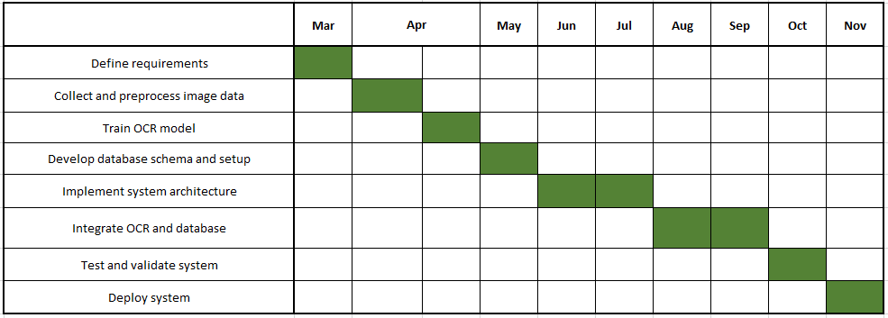
CHAPTER 4 - REQUIREMENTS

4.1 Hardware Requirements
Server:
- Multi-core processor (2 GHz or higher)
- 8 GB RAM or more
- Adequate storage capacity (SSD recommended for faster data access)
- Reliable internet connectivity

Client Devices:
- Desktops, laptops, tablets, or smartphones
- Modern web browsers (Chrome, Firefox, Safari, or Edge)
- Internet connectivity

4.2 Software Requirements
Server-Side:
- Operating System: Linux or Windows Server
- Database Management System: MySQL
- Web Server: Apache
- Backend Framework: Flask

Client-Side:
- Operating System: Windows, macOS, Linux,
- Web Browser: Chrome, Firefox, Edge

4.3 Functional Requirements
- Detecting Numberplates:
- Detecting numberplates from an image.
- Accurately cropping these images and saving them in a folder.

- Reading Numberplates:
- Reading the text from number plates.
- Excluding special characters from the text and enhancing image for better accuracy.

- Web Application Interface:
- A web interface to interact with the application in real time.
- Application be used to detect and recognize numberplates and faces.

4.4 Non-Functional Requirements
- Scalability:
- The system should handle increased users and data without performance degradation.

- Reliability:
- Minimal downtime with regular maintenance windows.

- Usability:
- Intuitive user interfaces for ease of use.
- Accessibility features for diverse user needs.

- Performance:
- Quick response times for user interactions.
- Efficient data processing and retrieval.

- Compatibility:
- Compatibility with various devices and browsers.

- Data Backup and Recovery:
- Regular automated data backups.
- Reliable mechanisms for data recovery in case of system failures.

CHAPTER 5 - EXPERIMENTS & RESULT

5.1 Details of Experiment Setup
Table 4.1: Expected Outcomes
Research | Priority | Details/Remark
Object Recognition by YOLOv5 | High | Developed custom object recognition model and inferenced it on local data.
Image Processing and Enhancements | High | Fed images into algorithms and enhanced the image for better readability for OCR.
Multiple Text Recognition Algorithms | High | Implemented Various Text Recognition Algorithms for
Building a Web Application from Flask | High | Developed an interface for the interation of the Application.
5.2 Findings
Improved Identification Accuracy: The use of our face recognition and car plate identification technology has resulted in improved accuracy in real-time identification operations.

Efficient User Interaction: User feedback and engagement metrics emphasised a simplified and straightforward design, allowing security workers and managers to communicate seamlessly.

Compliance with Data Protection requirements: Regular security audits verified compliance with data protection requirements, preserving the integrity and confidentiality of identity data.

5.3 Conclusion
In summary, the effective implementation of our project resulted in significant improvements in identification accuracy, user engagement, security compliance, and conformity with educational concepts. The system's capacity to properly identify people and cars, along with an easy-to-use interface and adherence to security regulations, represents a substantial development in outdoor security measures. Furthermore, adhering to Outcome-Based Education principles ensures that educational goals are accomplished efficiently. These findings confirm the project's effectiveness in accomplishing its objectives and its potential to improve outdoor security systems in a variety of settings. The system's continued relevance and efficacy in addressing emerging security threats is ensured by a commitment to continual development and adherence to best practices.

CHAPTER 6 - CONCLUSION & FUTURE DIRECTIONS

6.1 Conclusion
The successful development and implementation of our face recognition and car plate identification project marks an important step forward in improving outdoor security. Its demonstrated efficiency in precise identification, a user-friendly interface, and strict adherence to security requirements emphasise its essential role in revolutionising security processes.

6.2 Future Directions

Continual Evolution: By prioritising incremental improvements, the project lays the groundwork for continued evolution. Regular upgrades and enhancements to the identification algorithms and user interfaces will keep the system at the cutting edge of outdoor security systems.

Exploration and incorporation of modern technologies such as deep learning or neural networks might improve identification accuracy and broaden the system's capabilities in recognising diverse settings and scenarios.

Extending system accessibility to mobile platforms would cater to customers who prefer engagement via mobile devices, extending its reach and ease.
Integrating Collaborative Tools: Implementing collaborative tools and features may improve communication among security staff, administrators, and stakeholders, resulting in a more connected and responsive security ecosystem.

To summarise, while our initiative has achieved significant advances in outdoor security, the road does not end here. Future directions highlighted promise continuous innovation and refinement, ensuring the system stays flexible, safe, and aligned with current technical improvements and user expectations.

- References
[1] Abayomi-Alli, A., Mustapha, A. M., Adeleke, I. O., . . . Tijani. (2015). Development of an Automatic Facial and Licence Plate Recognition System. Nigeria: Federal University of Agriculture, Abeokuta.

[2] Kumar, J. M. S. V. R., Sujatha, B., Leelavathi, & N. (2021). Automatic Vehicle Number Plate Recognition System Using Machine Learning. IOP Conf. Series: Materials Science and Engineering, 1074(1).

[3] Muhammad Noman, Naveed Ali Khan Kaimkhani, Sabit Rahim, & Hannan Bin Liaqat. (2022). UAV with Vision to Recognize Vehicle Number Plates. Mobile Information Systems vol. 2022 Article ID 7655833.

[4] Lubna; Mufti, N.; Shah, S.A.A. Automatic Number Plate Recognition:A Detailed Survey of Relevant Algorithms. Sensors 2021, 21, 3028.

[5] Rudresh M.D., Meghashree S., Rajani S.S., Pavithra S., & Veena D. (2015). ANPR and Face-based Recognition System. National Conference on Power Systems & Industrial Automation, vol. 129, no. 1, 2015, pp. 17-20, doi: 10.5120/ijca2015906572.

APPENDICES

